Sean Gordon

Arch 321

Module 4, Lecture 2 Response

This lecture focused on the development of the idea of the shopping mall, and the variables that changed to start their spread.

The first department store is considered to be Au Bon Marche, built in France in 1876. This store used price tags rather than bartering, so an individual customer knew they were getting the same deal as everyone else. Further examples of retail stores are Marshall Fields Wholesale and Carson, Pirie, Scott, both in Chicago.

In 1954, congress attempted to stimulate investment in manufacturing by accelerating the depreciation process for new construction. This allowed people to recoup losses in significantly less time, as buildings that might not return on investment for 40 years now only took 7. The result was a building bonanza, developers taking advantage of the new bill to offset their income with the depreciation. Income from tenants, while normally being taxed, could be written off using the cost accrued from building depreciation.

Victor Gruen was one of the pioneers of shopping malls, bringing urban elements to the suburb that he thought of as a ‘hellish landscape’. These malls were designed to block out the outside world and keep people inside looking at stores for as long as possible. The idea was that when a mall was built, people would move into the homes built nearby in order to move closer to amenities.

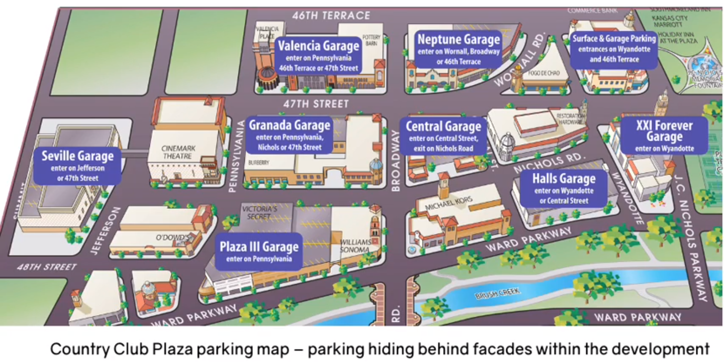

This plan for a series of shops with space specifically made for cars showed the importance of cars in society at the time. It is interesting to see an early build of the current shopping system.

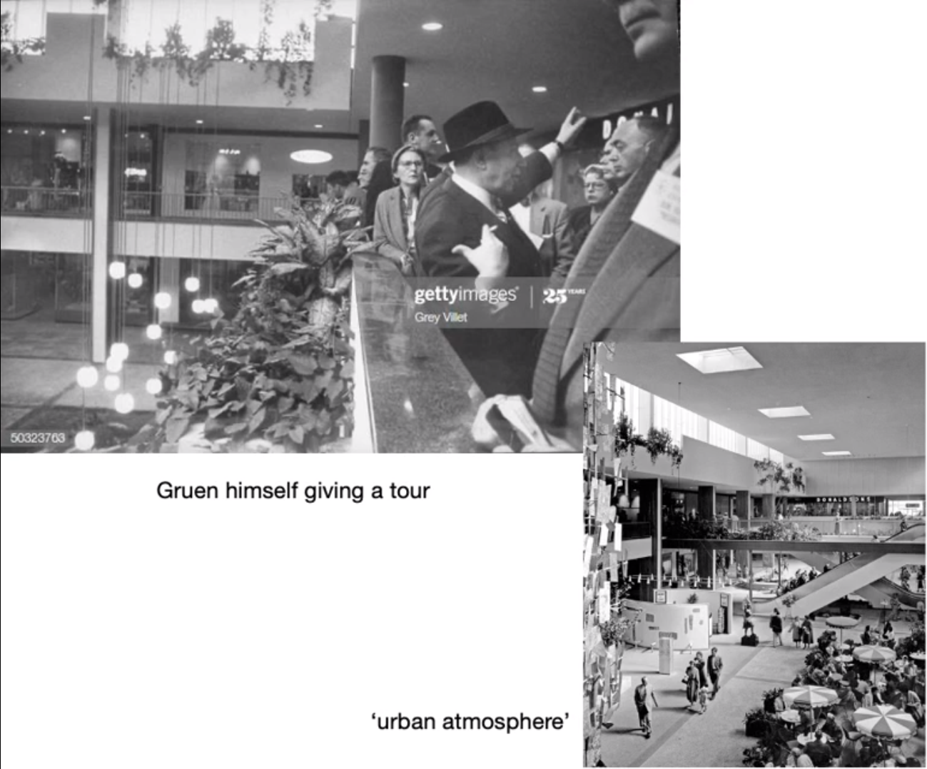

The urban atmosphere present inside Gruen’s malls was an interesting concept, remaining indoors but keeping an outdoor feel. The inclusion of so much greenery and unnecessary things like umbrellas really sold the atmosphere