Sean Gordon

Arch 321

Module 4, Lecture 3 Response

This lecture focused on the responses to the period of urban crisis, both from people affected by it and from people looking to study it.

During the 1960s, the city became an object of study, theory, and scientific analysis. Architects were writing books and conducting studies about design and life in a city. The belief was that urban analysis was a way to fix some of the problems that spawned as suburbs changed the urban map.

Jane Jacobs was an urban activist during this period. She wrote ‘The Death and Life of Great American Cities’, a manifesto of her ideas on what a city embodies and should embody. She believed ‘eyes on the street’ made a city a better and safer place, with more people interacting and watching out for each other at ground level improving crime rates and generally making the city more pleasant. She preferred the older, denser style of city construction, with buildings overlooking the streets where communities could form. She opposed large, complex urban renewal projects, and wanted diverse communities.

Around this time the idea of 5 analytical categories of a city arose. Paths, edges, districts, nodes, and landmarks were 5 components that built the mental idea of a city in each resident’s mind. These helped reinforce the idea of a collage city, embracing the mess and conflicting agendas that make up such an area.

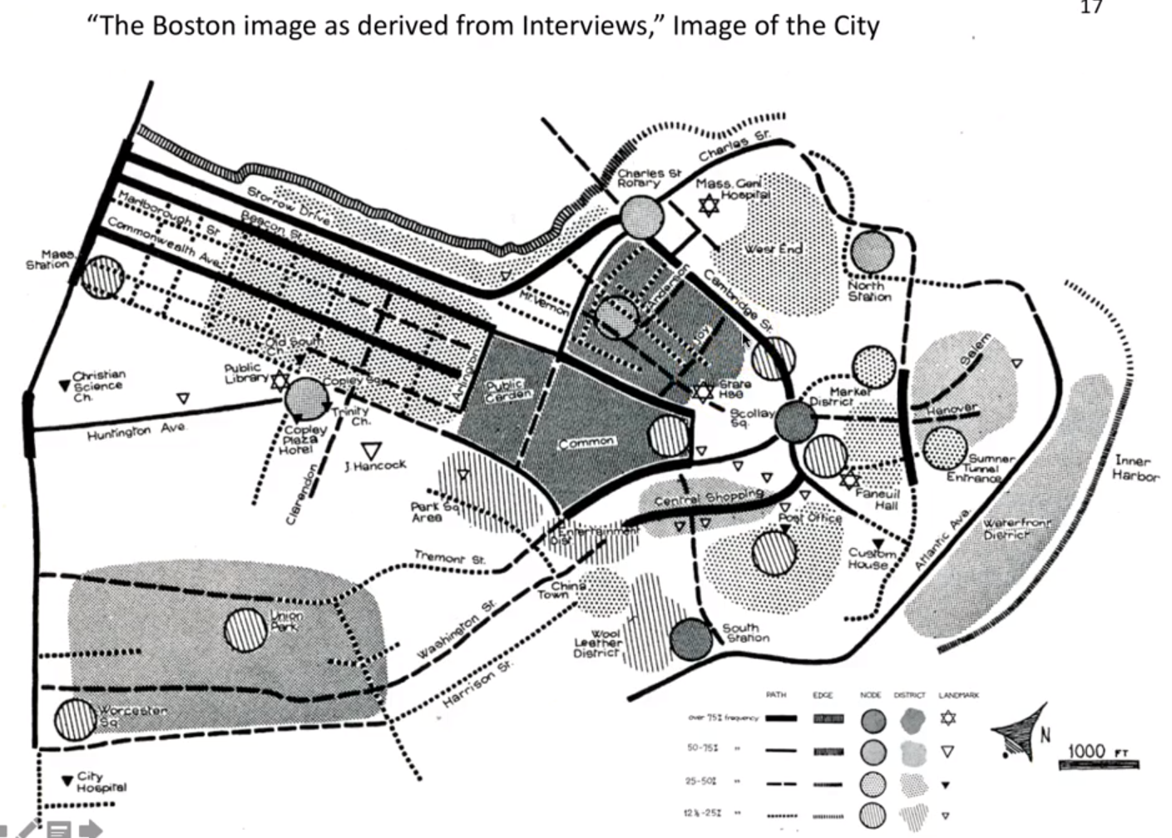

The public’s mental map of Boston, drawn from many surveys on the residents themselves. It is interesting to see how different sections are divided up differently than they are physically.

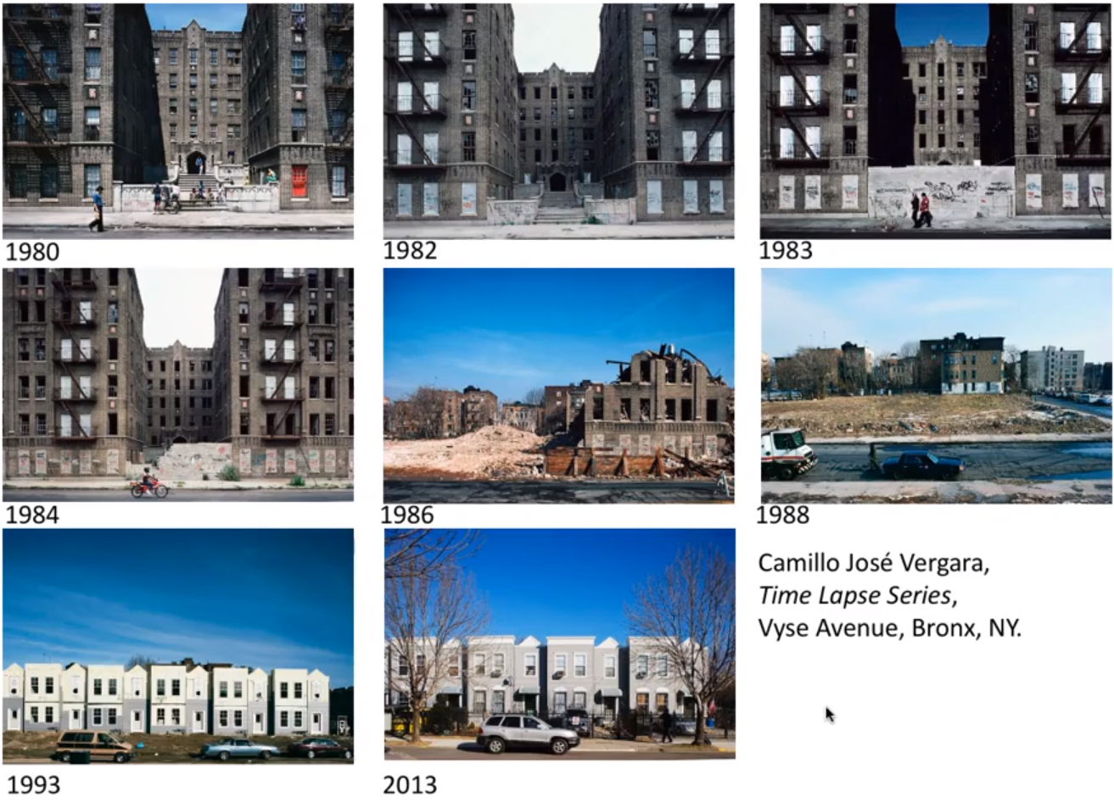

An interesting view of how the same section in a city might change overtime. This specific perspective shows the extreme change of a particular plot of land over many years.