Sean Gordon

Arch 321

Module 4, Lecture 4 Response

This lecture focused on postmodernism, with its differences from modernism and the new styles it brings.

Postmodernism dropped many of the principles of modernism. The style favored acknowledging styles of the past and taking inspiration from the buildings surroundings rather than painting a utopian vision on cleanliness and orderliness. There was no unified style in postmodernism, but there was a large reintroduction of symbolism. Postmodernism embraced the fact that general architecture is messy.

Robert Venturi and Denise Scott-Brown wrote *Complexity and Contradiction in Architecture, 1966*. This text introduced the comparison between complexity and contradiction vs simplification, favoring the idea of including ‘both-and’ rather than ‘either-or’ when designing buildings. The couple also wrote *Learning from Las Vegas, 1972*, shining light on the rich and varied architecture in Las Vegas that modernism was turning a nose to.

Postmodernism has a large goofy element to it, rather than strict clean lines and controlled spaces. It embraces chaos, in some ways even amplifying it, adding strange shapes and unnecessary curves or patterns to add style to the buildings. Bright color splashes are added to break up areas, and some things are designed to look almost accidental. Many building elements are not functional at all, and are purely symbolism, such as the Swan Hotel in Florida.

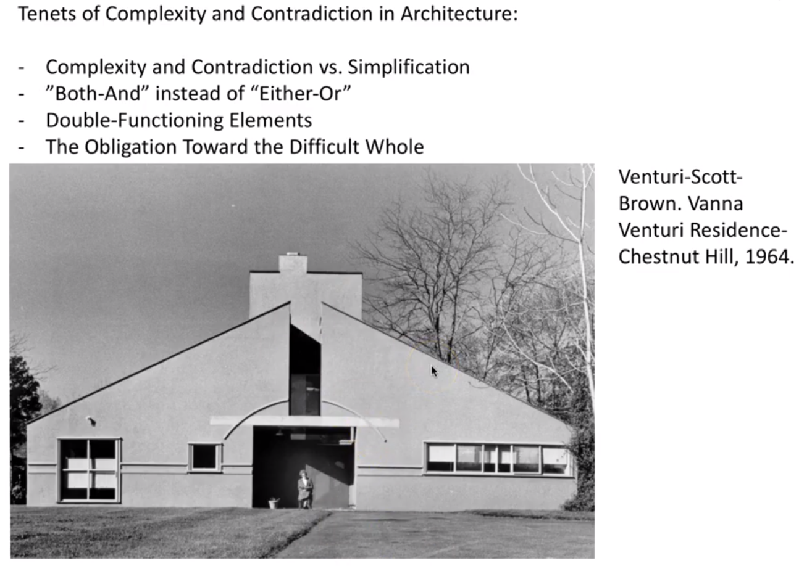

This example of Venturi-Scott-Brown’s work encapsulated much of their ideology with postmodernism. The example of the faux arch over the doorway really stands out to me, as it is functionally completely worthless, but symbolizes structural integrity.

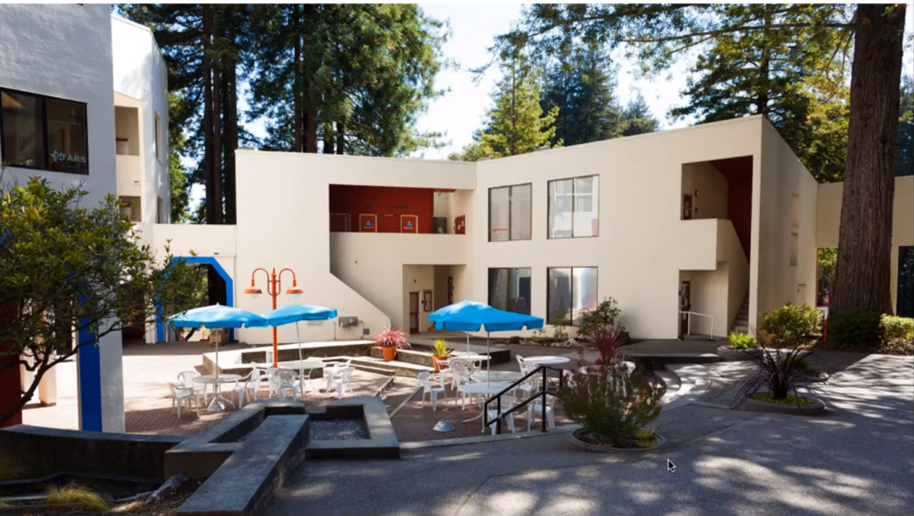

An example of a set of buildings made in the postmodern style. The area has a playful tone to it, rather than the serious undertone of the 50s. It is exceptionally vibrant and embraces chaos.