CprE 288 Fall 2018 – Homework 1
Due Sun. September 2 (on Canvas by midnight: 11:59pm)
Notes:
- Homework must be typed and submitted as a PDF or Word Document (i.e. .doc or .docx) only.
- If collaborating with others, you must document who you collaborate with, and specify in what way you collaborated (see last page of homework assignment), review the homework policy section of the syllabus: http://class.ece.iastate.edu/cpre288/syllabus.asp for further details.
- Review University policy relating to the integrity of scholarship. See (“Academic Dishonesty”): http://catalog.iastate.edu/academic_conduct/#academicdishonestytext
- Late homework is accepted within two days from the due date. Late penalty is 10% per day. Except on Exam weeks.
- Note: Code that will not compile is a typo. Answering a question as “will not compile” will be marked incorrect. Contact the Professor if you think you have found a typo.

Note: Unless otherwise specified, all problems assume the TM4C123 is being used

Question 1 (10 pts)
The purpose of this question is to refresh your understanding of numeric representation from the prerequisite courses.
Complete the table below. Assume ASCII encoding of characters, and a 2’s complement encoding of negative numbers. Recall what you have learned about 2’s complement encoding from other courses. When representing a number in hexadecimal or binary, use the proper number of digits for the TM4C123 architecture (depends on type of variable). The first row has been completed for you.
 | Value of x
 | x (decimal) | x (hex) | x (binary)
signed char x = 60; | 60 | 0x3c | 0b111100
unsigned char x = 'S'; | 83 | 0x53 | 0b01010011
unsigned char x = '8'; | 56 | 0x38 | 0b00111000
short x = 0xEECE; | 61134 | 0xEECE | 0b1110111011001110
signed char x = 0b00111001; | 57 | 0x39 | 0b00111001
unsigned short x = 0x2050 + 0x2041; | 16529 | 0x4091 | 0b0100000010010001
signed char x = 0x8 + 4; | 12 | 0xC | 0b00001100
signed char x = 0x68 / 8; | 13 | 0xD | 0b00001101
signed short x = -1; | -1 | 0xFFFFFFFF | 0b1111
signed char x = 20; | 20 | 0x14 | 0b00010100
signed char x = -128; | -128 | 0xFFFFFF80 | 0b10000000

Question 2 (5 pts)
Technology advancements. Search for on-line articles to answer the follow questions. Properly cite the articles that you use to obtain your information to receive credit. For proper formatting, see the IEEE citation reference manual:
https://ieee-dataport.org/sites/default/files/analysis/27/IEEE%20Citation%20Guidelines.pdf.
Note, while Wikipedia is discouraged for citations used within published academic papers, it can be useful for obtaining an overview on a topic. If you use a Wikipedia article, then use this guide for properly citing your “source”: http://www.wikihow.com/Cite-a-Wikipedia-Article-in-MLA-Format

- Which chip is thought to be the first microprocessor? How many transistors roughly did it use? (2pts)

Intel 4004.
2,300 transistors.

David Law, “1971: Microprocessor Integrates CPU Function onto a Single Chip,” computerhistory.org. [Online]. Available: http://www.computerhistory.org/siliconengine/microprocessor-integrates-cpu-function-onto-a-single-chip. [Accessed Sept. 3, 2018]

- Haswell (microarchitecture): For the 18 core version of the Haswell E7 microprocessor, how many transistors roughly did it use, and what is its maximum worst-case power consumption (called TDP or thermal design power)? (2pts)

5.56 billion transistors.
165W.

Hassan Mujtaba, “1971: Microprocessor Integrates CPU Function onto a Single Chip,” wccftech.com. [Online]. Available: https://wccftech.com/intel-unleashes-haswell-ex-xeon-e7-v3-processors-18-cores-45-mb-l3-cache-12-tb-ddr4-memory-support-57-billion-transistors. [Accessed Sept. 3, 2018]

- With respect to number of transistors, how many processors from part a) could fit into a processor of the type from part b)? (1pts)

2417391 microprocessors = (5.56 * 10^9) /2300

Question 3 (10 pts)
Throughout this class you will be heavily using the textbook and TM4C123G datasheet as a reference to learn about and design systems using the TMG4C123G microcontroller. The TM4C123G datasheet can be found on the course webpage here: http://class.ece.iastate.edu/cpre288/resources.asp
Online Reading: Read Chapter 2: Fundamental Concepts: Sections 2.0 – 2.4: http://users.ece.utexas.edu/~valvano/Volume1/E-Book/C2_FundamentalConcepts.htm
Text Book Reading: Read Chapter 1 – 1.2 and Section 2.1., Scan Section 2.6 – 2.6.3.
Data Sheet Reading: Read Chapter 1 (pages 45-48), Scan Chapter 22 and 23 of TM4C123G Datasheet
Answer the following questions using the textbook and datasheet
- What is the maximum clock speed of the CPU of TM4C123G? (2pts)

80 MHz

- How many package pins does the TM4C123G microcontroller have? (2pts)
105

- What are the types and sizes of memory available, and the uses for each type of memory? (2pts)
32kb of single cycle SRAM: Contains cache data
256kb of Flash: Storage
2kb EEPROM: Storing lesser amounts of dynamic data

- Give the special/alternative functions for each General Purpose I/O Port or Port’s pin: (2 pts)

      - Port A, wire 0 (PA0): U0Rx or CAN1Rx

      - Port B, wire 3 (PB3): I2C0SCL or T3CCP0

      - Port D, wire 5 (PD5): USB0DP or U6Tx or WT4CCP1

      - Port E, wire 2 (PE2): AIN1

- The textbook describes two programing models: Direct Register Access (DRA) and Software Driver (SD). This course will only use the Direct Register Access programming model. Briefly describe each of these models. (Note: not covered in the assigned readings) (2pts)

DRA: Program writes directly to registers using addresses
SD: Program writes indirectly to registers using higher level calls to functions

Question 4 Embedded Applications (5 pts)
a) Give four appliances/products, with an embedded-processor, you use in daily life (1pt)

Smartphone, GPS, watches, printer

b) Find an article on an embedded system application you are interested (4pts).
https://www.nytimes.com/2018/08/22/technology/personaltech/samsung-galaxy-note9-review.html?rref=collection%2Ftimestopic%2FMobile%20Phones&action=click&contentCollection=timestopics&region=stream&module=stream_unit&version=latest&contentPlacement=4&pgtype=collection

i) Properly cite this article. (1pt)
Brian X. Chen, “Samsung’s Galaxy Note9: Too Much Phone for Most of Us,” nytimes.com, Aug. 22, 2018. [Online]. Available: https://www.nytimes.com/2018/08/22/technology/personaltech/samsung-galaxy-note9-review.html?rref=collection%2Ftimestopic%2FMobile%20Phones&action=click&contentCollection=timestopics&region=stream&module=stream_unit&version=latest&contentPlacement=4&pgtype=collection. [Accessed Sept. 3, 2018].

ii) Give a brief description of the application. (1pts)

Pricey Samsung smartphone, 6.4 inch screen, 4,000mAh battery, 1TB storage, “excellent” camera.

iii) What needs does the User(s) have? (1pts)

High performance phone, large storage and battery life, systems for an on the go lifestyle.

iv) How does the application help meet the Users’ needs? (1pts)

Basically a portable pc, extremely powerful, super fast processing speeds.

Question 5 (5 pts)
Find an on-line article on Endianness (e.g. little-endian and big-endian). Briefly summarize the concept of Endianness, and difference between little-endian and big-endian. Properly cite the article you use to obtain your information to receive credit.

"Endian" and "endianness" (or "byte-order") describe how computers organize the bytes that make up numbers.

Little-endian - storing bytes in order of least-to-most-significant
Big-endian - storing bytes in order of most-to- least-significant

Multiple Contributors, “Endianness,” developer.mozilla.org, Apr. 20, 2016. [Online]. Available: https://developer.mozilla.org/en-US/docs/Glossary/Endianness. [Accessed Sept. 3, 2018].

Question 6: Review Basics (15 pts)
a. Fill in the units? (7pts)
ms 10⁻³ seconds (answer given)
µs _ 10⁻⁶ seconds
ns _ 10⁻⁹ seconds
kB _ 2¹⁰ Bytes
MB 2²⁰ Bytes
GB _ 2³⁰ Bytes
kHz_ 10³ Hz
MHz 10⁶ Hz

b. Period or frequency (3pts)
i) What is the period of a 2 MHz clock?
5 * 10⁻⁷ seconds

ii) What is the frequency of a clock with a 1 ns period?
1 * 10⁹ Hz

iii) How many positive edges of a 4 MHz clock will occur in 4 ms?
16,000 positive edges = (.004 s)/(.00000025 Hz)

c. Digital logic (5pts)
i) Briefly describe how a multiplexer works? (1pt)
Device that uses logic gates to select between several inputs using selector signals.

ii) What is the minimum number of select bits (wires) need for the multiplexer below? Why? (2pts)
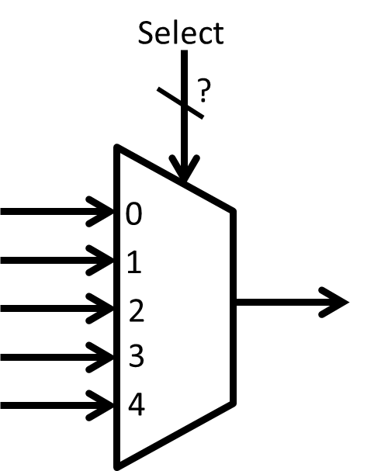
The mux requires 3 select bits for the 5 inputs, as for 2^{n} inputs to a mux, n select bits are spacer required.
iii) A clock signal is given as an input to an AND gate, as shown below. What value needs to be placed on the other input to allow the clock signal to propagate through the AND gate? Why? (2pts)
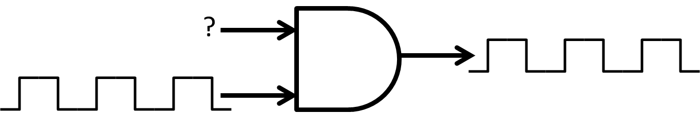
The other signal must be high, as AND gates only output high when both inputs are high. An spacer AND gate with one permanently high input functions as a wire.

Collaboration Documentation
List the people (First and Last name) you collaborated with: .
For each collaborator, describe the manner in which you collaborated:
1)
2)
3)

