Sean Gordon
Arch 321
Module 2, Lecture 2 Response
Housing act of 1937 helped people build housing. Tower in the park idea pushed for very tall housing, spread out so that there was a huge amount of light and air. Made very plainly so the government didnt spend excess money that could be used elsewhere. Buildings were made ina cruciform shape to maximize space and airflo.
The concept was very noble, but often the execution was lacking.
St louis post war rebuild was very ambitious, one of the largest in the world. Some plans never came to fruition, bit others were completed spectacularly. Pruitt igoe was a symbol of rebirth, an oasis in the desert for those that lived in the slums. At one point it was an electric, lively place full of communities. However, it no was no longer maintained, and living conditions deteriorated.
Because of the mistakes of the past, the housing act of 1954 asked cities to produce a workable program to receive money to demolish to avoid clearing large neighborhood tracks without redevelopment.
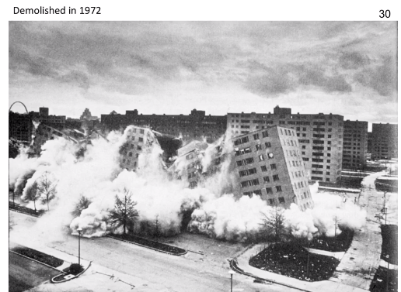

Symbol of the death of modern architecture dream
