# Installing the App in Mozu store:

Mozu will have to add our app to your store. Once that is done, go into the MozuAdmin -> Settings -> Applications. Click 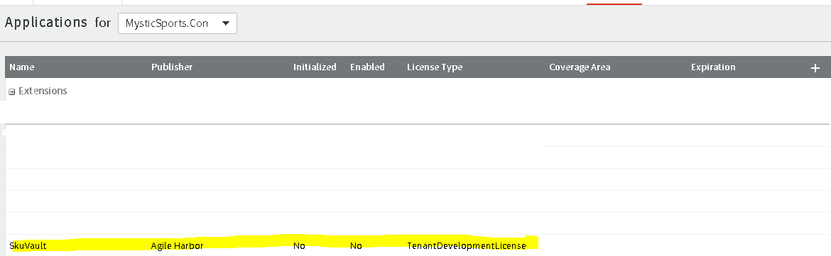

Click Enable App.

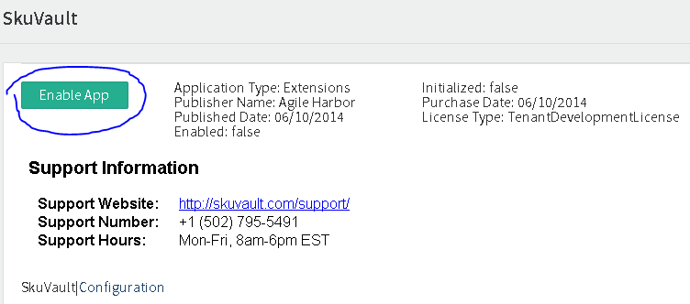

Our application name is SkuVault, namespace is agileharbor.skuvaultapp and application id is 3fd5d6e7e5ee4070b670a3340066de0d.

All inventory for sync should be in the 'Warehouse-01' location inside of Mozu.

# Installing an app in SkuVault

Go to <https://app.skuvault.com> Login to your SkuVault account. Go to Admin->Channel Accounts. Create a new Mozu Channel Account. Enter your Mozu login credentials and click next:

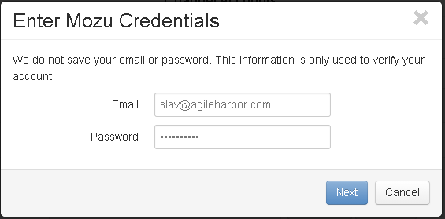

Choose your Store from the drop-down list. Then Choose Master Catalog from the drop-down list. Then choose Catalog. Then Choose Site. Then choose Location.

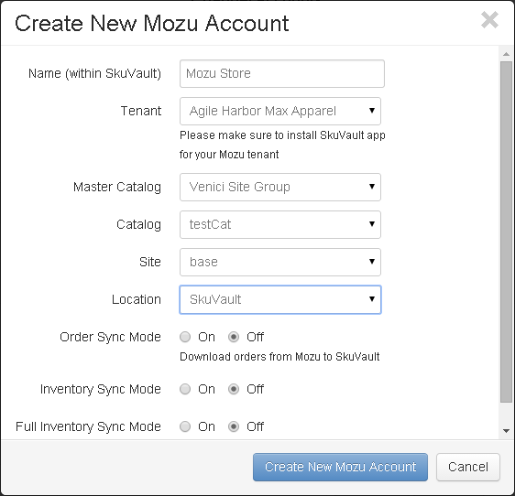

Enable any applicable syncs. Then click Create New Mozu Account.

