Transistor Berechnung

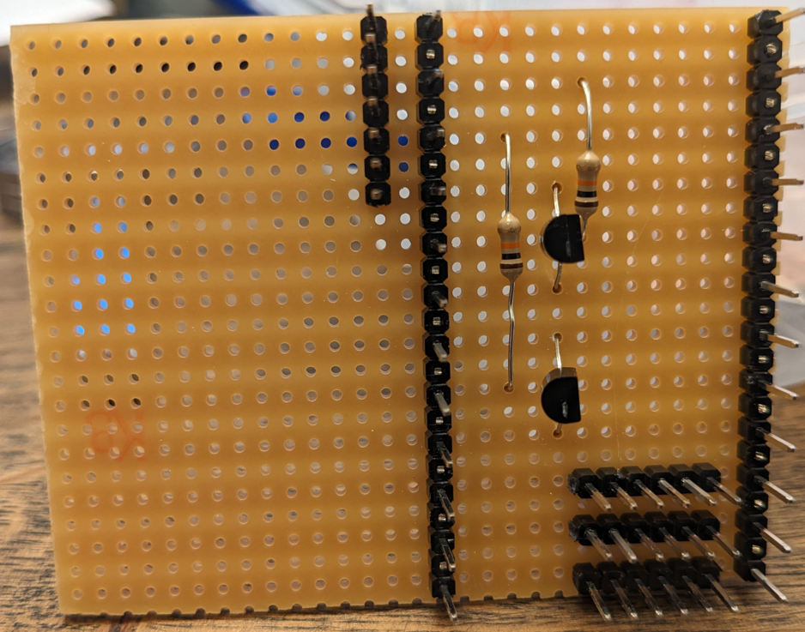

14: M2

15: M1

14: S2

13: S1/a

12: GND

11: 5V

10: 9V

9: n/a

8: n/a

7: Led grün+

5: n/a

6: n/a

4: Led rot+

3: C2

2: C1

1: n/a

|  |  |  |  |  |
| --- | --- | --- | --- | --- |
| Pin |  | Pin |  |  |
| 1 |  | 16 | 5V |  |
| 2 |  | 15 |  |  |
| 3 |  | 14 |  |  |
| 4 |  | 13 |  |  |
| 5 |  | 12 |  |  |
| 6 |  | 11 |  |  |
| 7 |  | 10 |  |  |
| 8 |  | 9 |  |  |

|  |  |  |  |
| --- | --- | --- | --- |
| Open (S1) | Close (S2) |  |  |
|  |  |  |  |
|  |  |  |  |
|  |  |  |  |
|  |  |  |  |
|  |  |  |  |
|  |  |  |  |
|  |  |  |  |