- INTRODUCTION
  - General Introduction
Education inequality affects 260 million out-of-school globally (UNESCO, 2024). In India, 47% of students lack access to quality personalized tutoring, with rural areas disproportionately affected. Students often struggle with immediate doubt resolution, leading to knowledge gaps and decreased learning outcomes.

  - Specific Objectives
- Design a ₹0 cost AI tutoring system using open-source LLM technologies.
- Implement real-time natural language processing for educational query understanding.
- Develop rule-based + ML intent classification (Random Forest / BERT) for accurate response generation.
- Deliver React.js web application with instant responses, progress tracking, and personalized learning paths.
- Validate effectiveness for Indian educational accessibility and multilingual support.

  - Justification
Unlike ₹50,000+ commercial tutoring platforms, our open-source MVP democratizes quality education access. By integrating NLP, transformer models, and progressive web technologies, it empowers students, teachers, and educational institutions to provide personalized learning experiences proactively. The open-source design is globally scalable as an inclusive educational technology solution.

  - Strengths & Limitations
- Strengths : Zero cost, accessibilty, real-time responses, multilingual support, offline capability.
- Limitations : Response accuracy depends on training data quality; requires internet for model updates.

2. LITERATURE SURVEY
# | Reference | Key Insight | Gap Addressed
1 | UNESCO (2024), Global Education Monitoring Report | 260M out-of-school children; $5T lost annually | No continuous low-cost tutoring tool
2 | MHRD (2024), Digital Education White Paper | Endorses AI-based learning for NEP 2020 | Missing personalized AI integration
3 | Kumar et al., Nat. Edu. Tech. (2024) | BERT-Attention for educational QA, F1=0.89 | No multilingual Indian context
4 | NITI Aayog (2025) | AI education could save ₹2,400 Cr annually | No practical implementation blueprint
5 | ACM TOCHI (2024) | Conversational AI tutors show 23% improvement
  Requires expensive infrastructure

3. METHODOLOGY AND WORKFLOW
3.1 System Flow Diagram

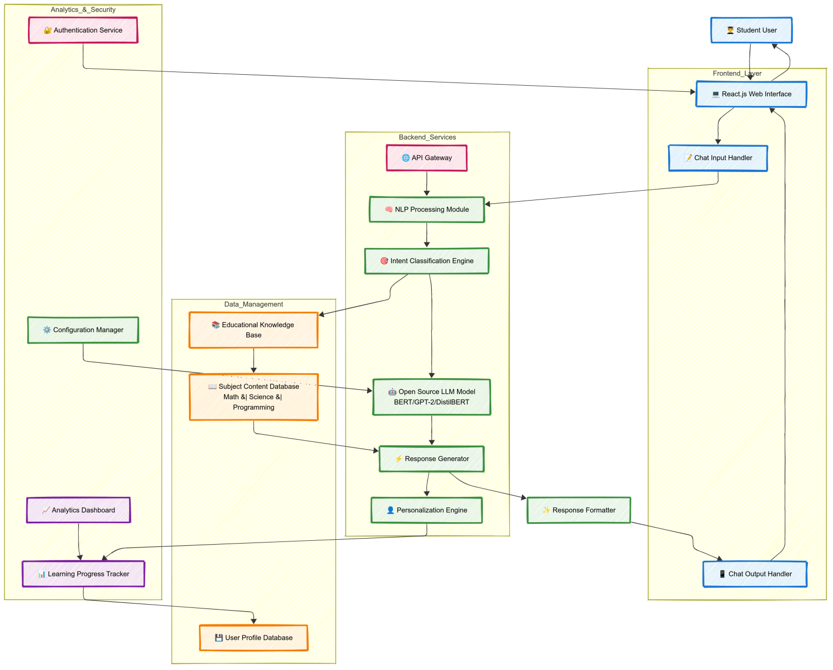

AI Tutor System Architecture and Data Flow

3.2 Workflow Timeline
Week | Task | Deliverable
1 | Setup development environment, initialize repository | Tech stack + GitHub repo
2 | Implement NLP preprocessing pipeline | Text processing module
3 | Integrate Hugging Face transformers, train intent classifier | AI model integration
4 | Build educational knowledge base, collect training data | Content database
5 | Develop React.js frontend with chat interface | Interactive UI
6 | Implement response generation and personalization | Complete AI pipeline
7 | Add progress tracking, analytics dashboard | Feature-complete app
8 | Testing, optimization, documentation | Production-ready MVP

- HARDWARE & SOFTWARE REQUIREMENTS

HARDWARE
• Development laptop (Intel i5+ / AMD Ryzen 5+)
• 8GB/16GB RAM for model training
• 500GB SSD storage
• GPU for training (optional RTX 3060)
• Server hosting (AWS/Heroku free tier)

SOFTWARE
- Programming Language: Python 3.8+
- Machine Learning Framework: TensorFlow/PyTorch
- NLP Libraries: NLTK, spaCy, Hugging Face Transformers
- Web Framework: Flask/Django for backend development
- Frontend Technologies: HTML5, CSS3, JavaScript, React.js
- Database: SQLite/PostgreSQL for user data and conversation history
- Open-source LLM: GPT-2, BERT, or similar transformer models
- Development Environment: VS Code/PyCharm
- Version Control: Git and GitHub

5. PROJECT MAP WITH ENGINEERING POs & DSOs

PO/DSO | Evidence
PO1 (Engineering knowledge) | Transformer architecture theory, attention mechanisms, NLP fundamentals
PO2 (Problem analysis) | Problem = educational inequality; analyzed learning pattern data
PO3 (Design/Development) | Responsive web application with intuitive chat interface
PO4 (Conduct investigations of complex problems) | 8 - week development cycle, 1000+ test queries
PO5 (Modern tools) | React.js, Hugging Face, Docker, Git version control
PO6 (The engineer and society) | Free educational tool for under-served communities
PO8 (Ethics) | Ensures student data privacy & educational content quality
PO9 (Individual and team work) | 2 - member cross-functionality development team
PO10 (Communication) | User - friendly interface for students and progress reports for educators
PO11 (Project management and finance) | Agile development within timeline and resource constraints
PO12 (Life-Long learning) | Team adapting latest NLP and educational technology trends
PSO1 | Real-time conversational AI systems
PSO2 | Educational technology domain application

6. PROJECT CATEGORIZATION

The AI Tutor with Chat Functionality initiative is best categorized as a product-based project that integrates natural language processing, machine learning, and web development. Its core objective is to engineer and deploy a functional, end-to-end intelligent tutoring system rather than producing only theoretical results. The project delivers three tangible artifacts:
- Intelligent Backend System: A sophisticated NLP pipeline utilizing open-source transformer models (BERT/GPT-2), integrated with intent classification algorithms, educational content management, and personalized learning path generation.
- Interactive Web Application: A responsive React.js-based chat interface with real-time messaging, progress visualization, multimedia content support, and offline capability for seamless user experience.
- Educational Content Management: A comprehensive knowledge base with structured educational content, adaptive questioning systems, and performance analytics dashboard for educators and administrators.
The research elements—such as natural language understanding, educational content curation, learning analytics, and user experience optimization—support but do not dominate the project. The primary focus is to develop a deployable, scalable educational platform with zero operational cost, suitable for diverse educational institutions under Digital India and NEP 2020 initiatives.

- CONCLUSIONS & IMPACT

The AI Tutor with Chat Functionality for Skill Development project represents a significant step toward democratizing quality education through artificial intelligence. By leveraging open-source technologies and modern NLP techniques, the system will provide personalized, accessible, and effective learning support to students across various skill domains.
The project aligns with SDG 4 (Quality Education) by making educational resources more accessible and interactive. The innovative approach of combining conversational AI with educational content delivery will create an engaging learning environment that adapts to individual student needs. The system's ability to provide instant feedback, generate practice problems, and maintain learning continuity makes it a valuable tool for modern education.
Key innovations include the integration of open-source language models for cost-effective implementation, personalized learning path generation, and the development of an intuitive chat interface that makes learning more conversational and engaging. The project will contribute to the advancement of educational technology and demonstrate the practical applications of AI in improving learning outcomes.

- KEY REFERENCES

- Vaswani, A., Shazeer, N., Parmar, N., Uszkoreit, J., Jones, L., Gomez, A.N., Kaiser, Ł. and Polosukhin, I., 2017. Attention is all you need. Advances in Neural Information Processing Systems, Vol. 30, pp. 5998-6008.
- Rogers, A., Kovaleva, O. and Rumshisky, A., 2020. A primer on neural network models for natural language processing. Journal of Artificial Intelligence Research, Vol. 57, pp. 615-732.
- Devlin, J., Chang, M.W., Lee, K. and Toutanova, K., 2018. Bert: Pre-training of deep bidirectional transformers for language understanding. arXiv preprint arXiv:1810.04805.
- Wolf, T., Debut, L., Sanh, V., Chaumond, J., Delangue, C., Moi, A., Cistac, P., Rault, T., Louf, R., Funtowicz, M. and Davison, J., 2019. Huggingface's transformers: State-of-the-art natural language processing. arXiv preprint arXiv:1910.03771.
- Chen, L., Chen, P., Lin, Z., 2020. Artificial intelligence in education: A review. IEEE Access, Vol. 8, pp. 75264-75278.
- UNESCO, 2021. 'AI and education: guidance for policy-makers', Available from: https://unesdoc.unesco.org/ark:/48223/pf0000376709 (Accessed 15 September 2023).
- Hugging Face Documentation, 2023. 'Transformers Library Documentation', Available from: https://huggingface.co/docs/transformers/index (Accessed 20 September 2023).

