**Edit by: *mtam*:).**

**PASCAL**

1. [**https://www.hsg.edu.vn/index.php/hsg/baitap/2**](https://www.hsg.edu.vn/index.php/hsg/baitap/2)

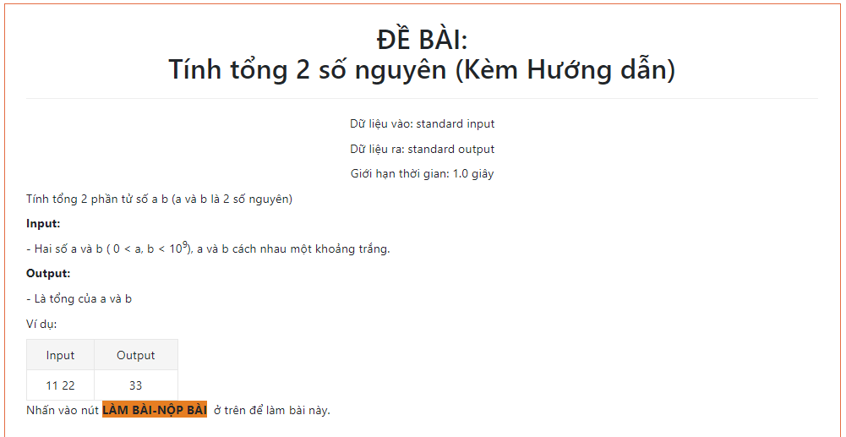

**Code:**

**{\***

**Bai Tính tổng 2 số nguyên (Kèm Hướng dẫn)**

**\*}**

**Program bt_test;**

**var a,b:longint;**

**BEGIN**

**readln(a,b);**

**if (b<(exp(10*ln(9)))) and (a>0) then write(a+b) else write(0);**

**END.**

1. [**https://www.hsg.edu.vn/index.php/hsg/baitap/18**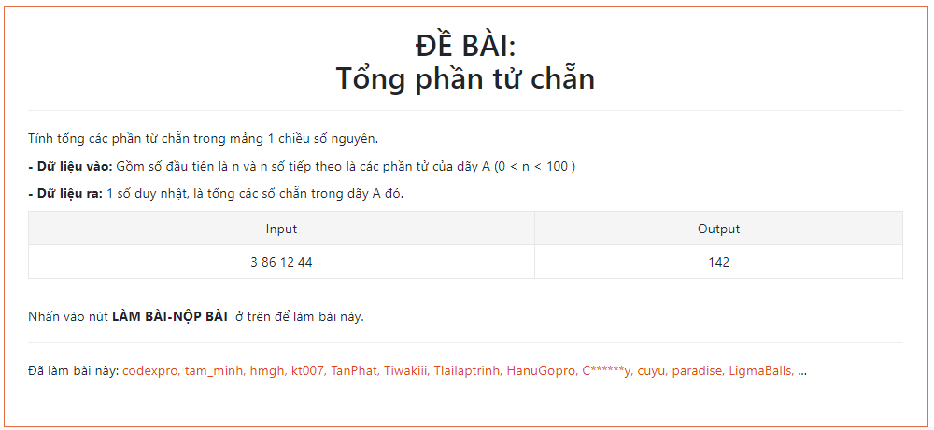](%20https://www.hsg.edu.vn/index.php/hsg/baitap/18)

**Code:**

**{\***

**Bai Tổng phần tử chẵn *}**

**Program bt_test;**

**uses crt;**

**var A:array[1..100] of longint;**

**n,sum:longint;**

**i:byte;**

**BEGIN**

**clrscr;**

**read(n);**

**if (n>0) and (n<100) then**

**begin**

**for i:=1 to n do**

**begin**

**read(A[i]);**

**if A[i] mod 2 = 0 then sum:=sum+A[i];**

**end;**

**write(sum);**

**end**

**else write(0);**

**END.**

**3.https://www.hsg.edu.vn/index.php/hsg/baitap/19**

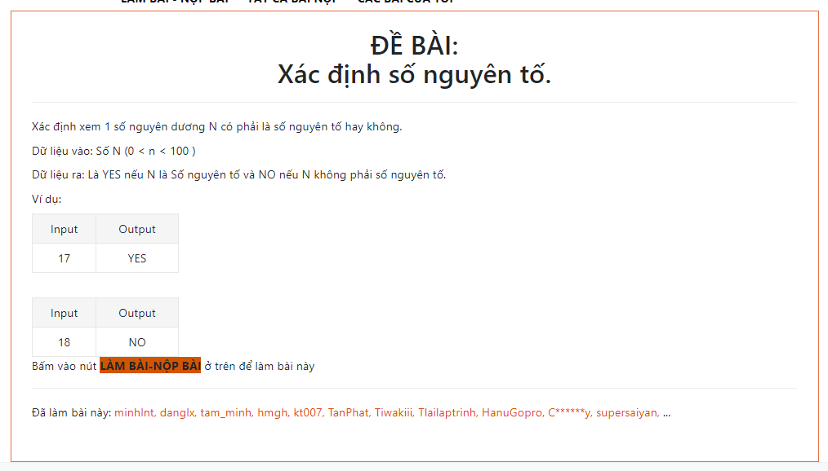

**Code**

**Program bt_test;**

**var n:word;**

**i,dem:byte;**

**BEGIN**

**read(n);**

**if (n>0) and (n<100) then**

**begin**

**if (n<=3) then**

**begin**

**if (n=2) or (n=3) then write('YES') else write('NO');**

**end**

**else**

**begin**

**for i:=2 to n-1 do**

**begin**

**if n mod i = 0 then dem:=dem+1;**

**end;**

**if dem > 0 then write('NO') else write('YES');**

**end;**

**end**

**else write(0);**

**END.**

**4.**[**https://www.hsg.edu.vn/index.php/hsg/baitap/20**](https://www.hsg.edu.vn/index.php/hsg/baitap/20)

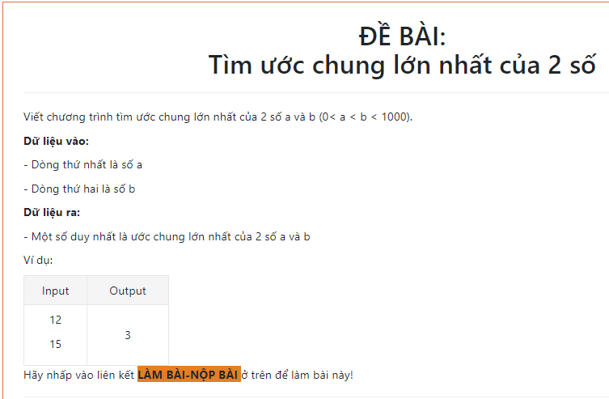

**Code:**

**{\***

**Bai Tìm ước chung lớn nhất của 2 số *}**

**Program bt_test;**

**var a,b:longint;**

**BEGIN**

**readln(a,b);**

**if (a>0) and (a<b) and (b<1000) then**

**begin**

**while (a<>b) do**

**begin**

**if (a>b) then a:=a-b else b:=b-a;**

**end;**

**write(a);**

**end**

**else write(0);**

**END.**

**5.** [**https://www.hsg.edu.vn/index.php/hsg/baitap/21**](https://www.hsg.edu.vn/index.php/hsg/baitap/21)

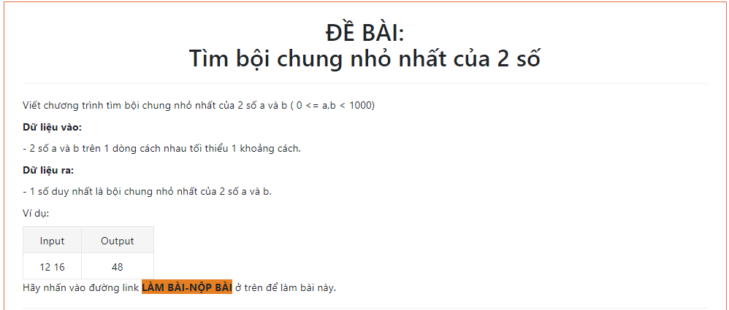

**Code:**

**var a,b,x:longint;**

**begin**

**read(a,b);**

**if (a>0) and (b<1000) then begin**

**x:=a*b;**

**while (a<>b) do**

**begin**

**if a>b then a:=a-b else b:=b-a;**

**end;**

**writeln(x div a);**

**end**

**else write(0);**

**end.**

**6.** [**https://www.hsg.edu.vn/index.php/hsg/baitap/18**](https://www.hsg.edu.vn/index.php/hsg/baitap/18)

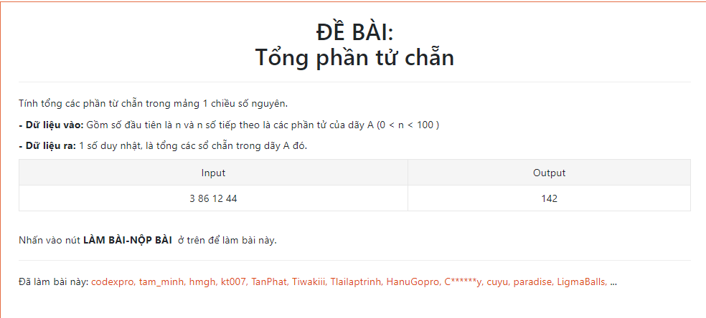

**Code:**

**var ans,i,n:longint;**

**a:array[1..100] of longint;**

**begin**

**read(n);**

**if (n>0) and (n<100) then begin**

**for i:= 1 to n do**

**begin**

**read(a[i]);**

**if a[i]>0 then if (a[i]) mod 2 =0 then ans:=ans+a[i];**

**end;**

**write(ans);**

**end;**

**end.**

**7.** [**https://www.hsg.edu.vn/index.php/hsg/baitap/19**](https://www.hsg.edu.vn/index.php/hsg/baitap/19)

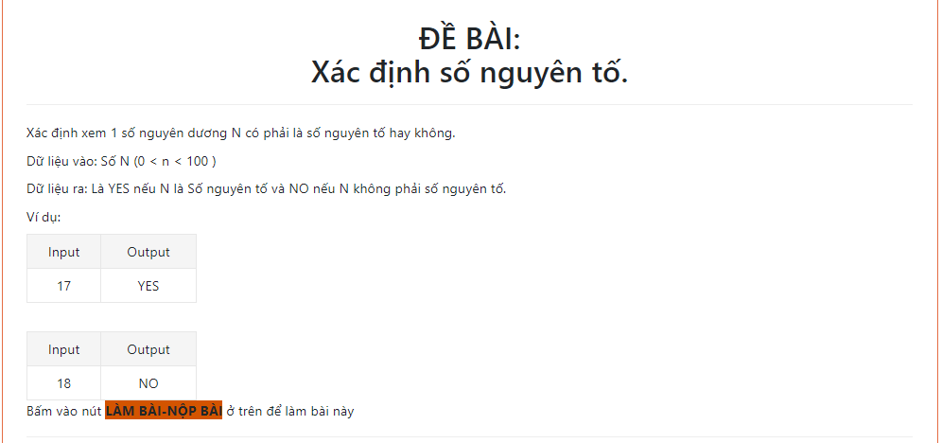

**Code:**

**var i,n:longint;**

**function kiemtra(n:longint):boolean;**

**begin**

**if n=1 then exit(false) else if n=2 then exit(true) else**

**for i:= 2 to n div 2 do if n mod i = 0 then**

**begin**

**kiemtra:=false;**

**exit;**

**end;**

**kiemtra:=true;**

**end;**

**begin**

**read(n);**

**if (n>0) and (n<100) then**

**if (kiemtra(n)) then write('YES') else write('NO');**

**end.**

**8.** [**https://www.hsg.edu.vn/index.php/hsg/baitap/23**](https://www.hsg.edu.vn/index.php/hsg/baitap/23)

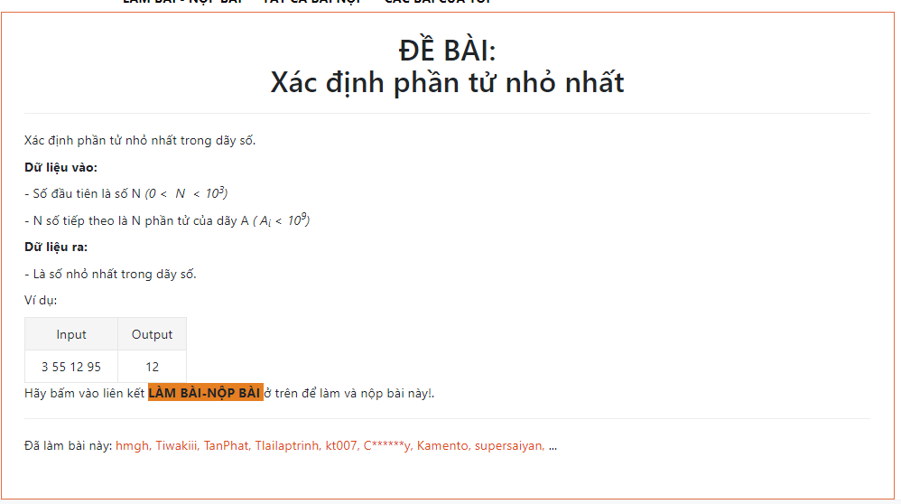

**Code:**

**var i,max,n:longint;**

**a:array[1..100000000] of longint;**

**begin**

**read(n);**

**for i:= 1 to n do**

**begin**

**read(a[i])**

**end;**

**max:=a[1];**

**for i:= 1 to n do if a[i]<max then max:=a[i];**

**write(max);**

**end.**

**9.** [**https://www.hsg.edu.vn/index.php/hsg/baitap/3**](https://www.hsg.edu.vn/index.php/hsg/baitap/3)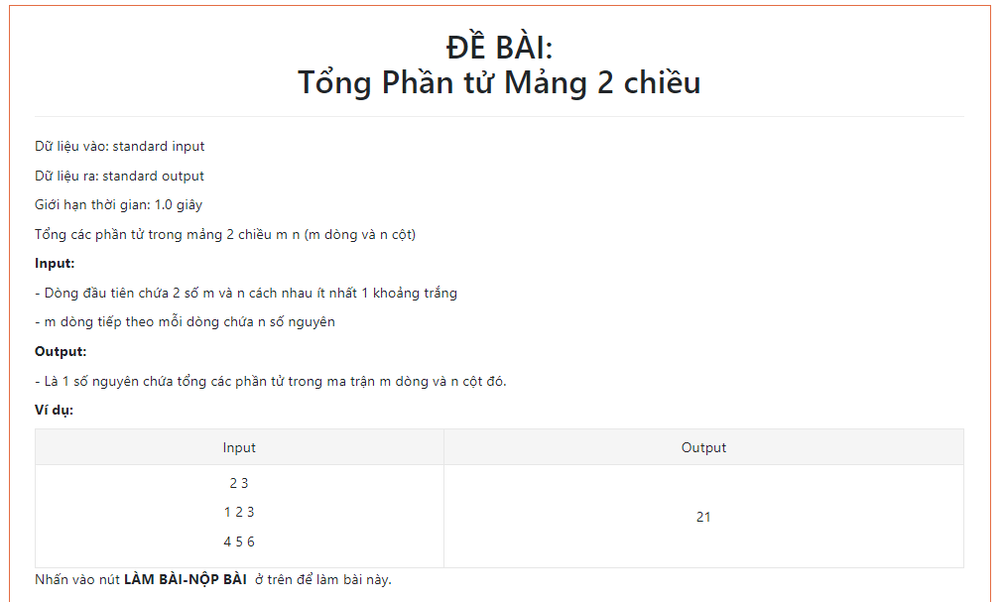

**Code:**

**var i,j,max,n,m:longint;**

**a:array[1..1000,1..1000] of longint;**

**begin**

**readln(n,m);**

**for i:= 1 to n do**

**for j:=1 to m do**

**begin**

**read(a[i,j]);**

**max:=max+a[i,j];**

**end;**

**write(max);**

**end.**

**10.** [**https://www.hsg.edu.vn/index.php/hsg/baitap/34**](https://www.hsg.edu.vn/index.php/hsg/baitap/34)

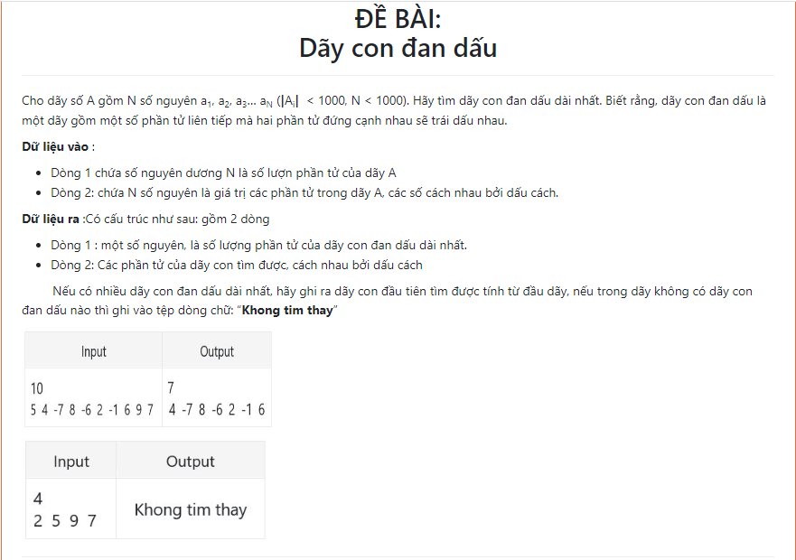

**Code:**

**var// fi,fo:text;**

**cd,max,ddau,x,i,j,n:longint;**

**a:array[1..1001] of longint;**

**begin**

**readln(n);**

**for i:= 1 to n do read(a[i]);**

**//assign(fi,'DANDAU.INP'); reset(fi);**

**//assign(fo,'DANDAU.OUT'); rewrite(fo);**

**//readln(fi,n);**

**//for i:=1 to n do read(fi,a[i]);**

**i:=0;**

**x:=1;**

**max:=0;**

**while i<n do**

**begin**

**i:=i+1;**

**if a[i]*a[i+1]>=0 then**

**begin**

**if x>max then**

**begin**

**max:=x;**

**ddau:=i-max;**

**x:=1;**

**end**

**else**

**x:=1;**

**end**

**else begin x:=x+1; end;**

**end;**

**if max=1 then write('Khong tim thay')**

**else begin**

**writeln(max);**

**for i:= ddau+1 to ddau+max do write(a[i],' ');**

**end;**

**//close(fi); close(fo);**

**end.**

**11.** [**https://www.hsg.edu.vn/index.php/hsg/baitap/31**](https://www.hsg.edu.vn/index.php/hsg/baitap/31)

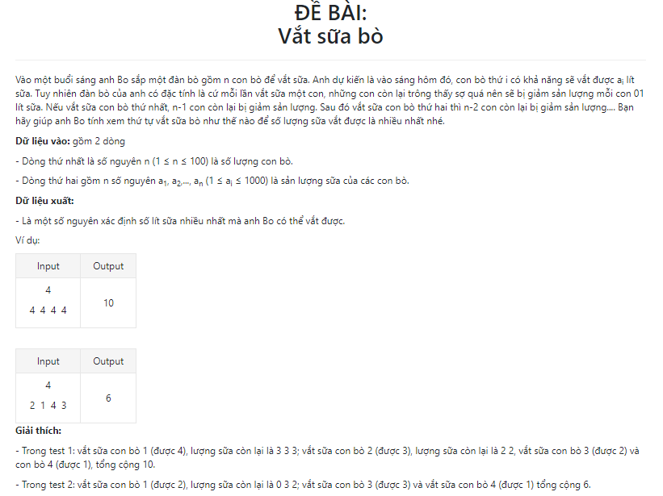

**Code:**

**var sum,i,j,n:longint;**

**a:array[1..1000] of longint;**

**procedure sort(l,r: longint);**

**var**

**i,j,x,y: longint;**

**begin**

**i:=l;**

**j:=r;**

**x:=a[(l+r) div 2];**

**repeat**

**while a[i]<x do**

**inc(i);**

**while x<a[j] do**

**dec(j);**

**if not(i>j) then**

**begin**

**y:=a[i];**

**a[i]:=a[j];**

**a[j]:=y;**

**inc(i);**

**j:=j-1;**

**end;**

**until i>j;**

**if l<j then**

**sort(l,j);**

**if i<r then**

**sort(i,r);**

**end;**

**begin**

**readln(n);**

**if (n>=1) and (n<=1000) then begin**

**for i:= 1 to n do read(a[i]);**

**sort(1,n);**

**for i:= n downto 1 do**

**begin**

**if a[i]-j>0 then sum:=sum+(a[i]-j);**

**j:=j+1;**

**end;**

**write(sum);**

**end;**

**end.**

**12.** [**https://www.hsg.edu.vn/index.php/hsg/baitap/22**](https://www.hsg.edu.vn/index.php/hsg/baitap/22)

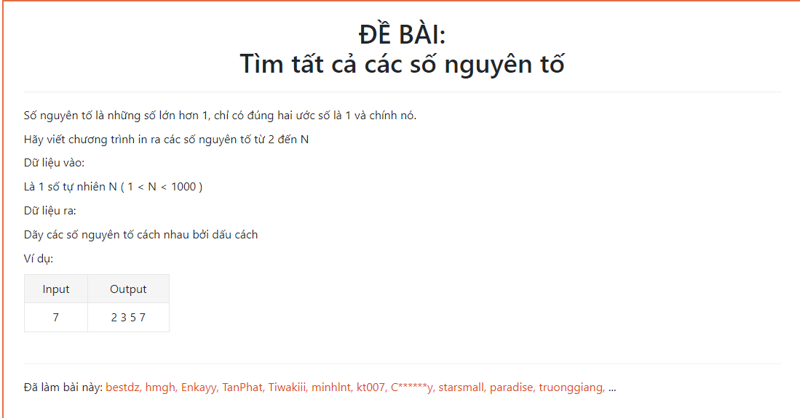

**Code:**

**var i,j,n:longint;**

**a:array[1..10000] of boolean;**

**begin**

**readln(n);**

**if (n>1) and (n<1000) then**

**begin**

**fillchar(a,sizeof(a),true);**

**a[1]:=false;**

**for i:= 2 to n do**

**if a[i] then**

**begin**

**j:=i+i;**

**while j<=n do**

**begin**

**a[j]:=false;**

**j:=j+i;**

**end;**

**end;**

**for i:= 2 to n do if a[i] then write(i,' ');**

**end;**

**end.**

**13.** [**https://www.hsg.edu.vn/index.php/hsg/baitap/36**](https://www.hsg.edu.vn/index.php/hsg/baitap/36)

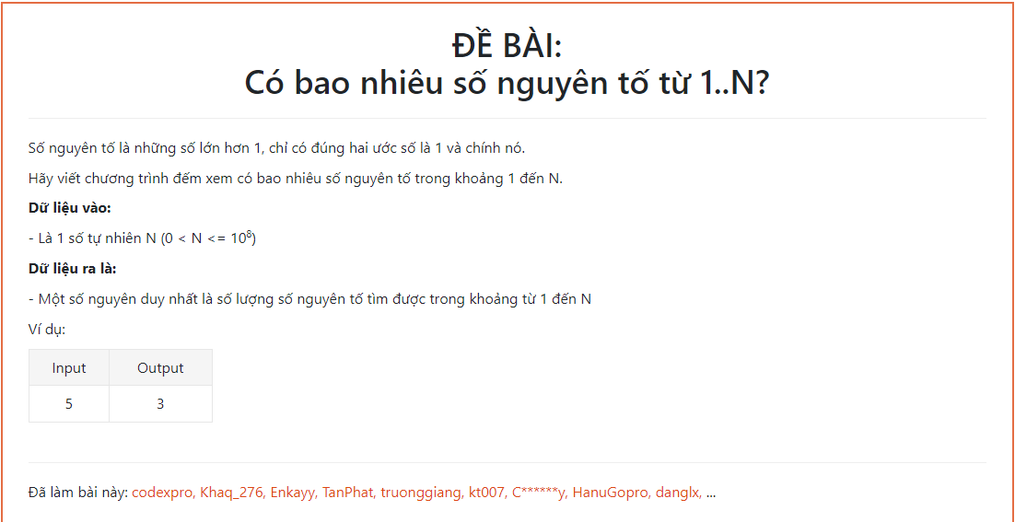

**Code:**

**var dem,i,j,n:longint;**

**a:array[1..100000000] of boolean;**

**begin**

**readln(n);**

**if (n>0) and (n<=100000000) then**

**begin**

**fillchar(a,sizeof(a),true);**

**a[1]:=false;**

**for i:= 2 to n do**

**if a[i] then**

**begin**

**inc(dem);**

**j:=i+i;**

**while j<=n do**

**begin**

**a[j]:=false;**

**j:=j+i;**

**end;**

**end;**

**writeln(dem);**

**end;**

**end.**

**14.** [**https://www.hsg.edu.vn/index.php/hsg/baitap/27**](https://www.hsg.edu.vn/index.php/hsg/baitap/27)

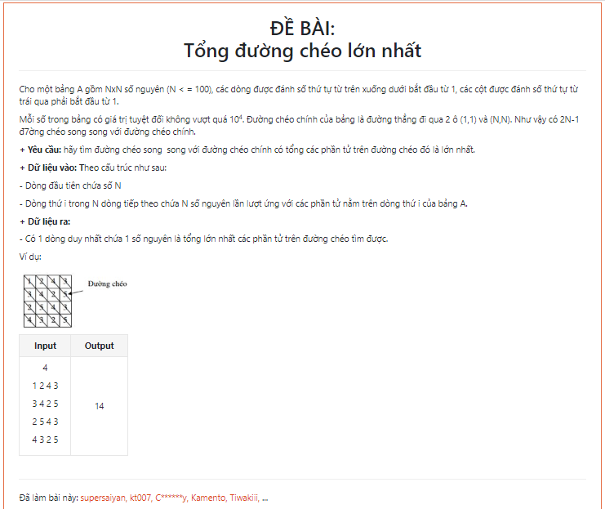

**Code:**

**var max,n,i,j:longint;**

**a:array[1..1000,1..1000] of longint;**

**begin**

**readln(n);**

**if n<=100 then begin**

**//nhap mang**

**for i:=1 to n do for j:=1 to n do read(a[i,j]);**

**//tim tong tat ca cac duong cheo**

**for i:=2 to n do**

**begin**

**for j:= 2 to n do**

**begin**

**a[i,j]:=a[i-1,j-1]+a[i,j];**

**end;**

**end;**

**//Tim duong cheo lon nhat**

**j:=n;**

**for i:= 1 to n do if a[i,j]>max then max:=a[i,j];**

**//in ra mang**

**{writeln;**

**for i:=1 to n do**

**begin**

**for j:=1 to n do write(a[i,j], ' ');**

**writeln;**

**end;}**

**//in ra ket qua**

**write(max);**

**end;**

**end.**

**15.** [**https://www.hsg.edu.vn/index.php/hsg/baitap/37**](https://www.hsg.edu.vn/index.php/hsg/baitap/37)

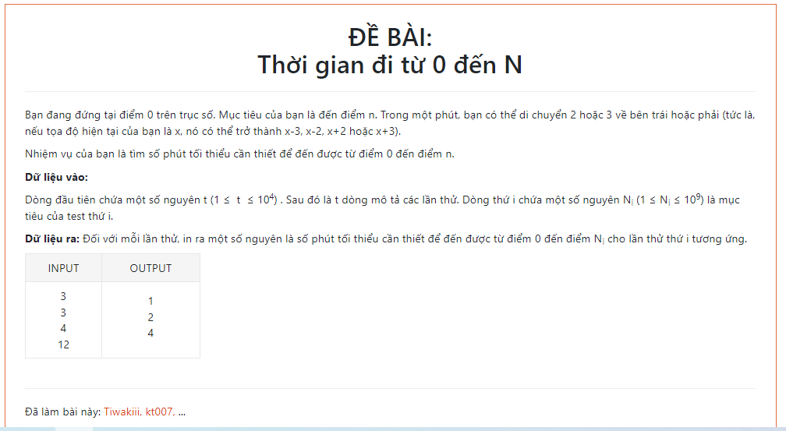

**Code:**

**var k,t,i:longint;**

**a:array[1..100000] of longint;**

**check:boolean;**

**Begin**

**readln(t);**

**if (t>=1) and (t<=10000) then begin**

**for i:= 1 to t do begin**

**readln(a[i]);**

**if (a[i]<1) or (a[i]>1000000000) then check:=true;**

**end;**

**if check=false then begin**

**for i:= 1 to t do**

**begin**

**k:=0;**

**// a[i]:=abs(a[i]);**

**while a[i]<>0 do**

**begin**

**if a[i]=1 then begin**

**if k=0 then**

**begin**

**a[i]:=0;**

**k:=k+2;**

**end**

**else begin**

**a[i]:=a[i]+3;**

**k:=k-1;**

**end**

**end**

**else if a[i]=2 then begin**

**a[i]:=0;**

**inc(k);**

**end**

**else if a[i]=4 then begin**

**a[i]:=0;**

**k:=k+2;**

**end**

**else // if a[i] mod 3 = 0 then**

**begin**

**k:=k+(a[i] div 3);**

**a[i]:=a[i] mod 3;**

**end;**

**//writeln(k, ' ',a[i]);**

**{ else begin**

**a[i]:=a[i]-3;**

**inc(k);**

**end;}**

**// write(k,' ');**

**end;**

**//writeln(999999997 div 3);**

**//writeln(999999997 mod 3);**

**writeln(k);**

**end;**

**end;**

**end;**

**End.**

**16.** [**https://www.hsg.edu.vn/index.php/hsg/baitap/41**](https://www.hsg.edu.vn/index.php/hsg/baitap/41)

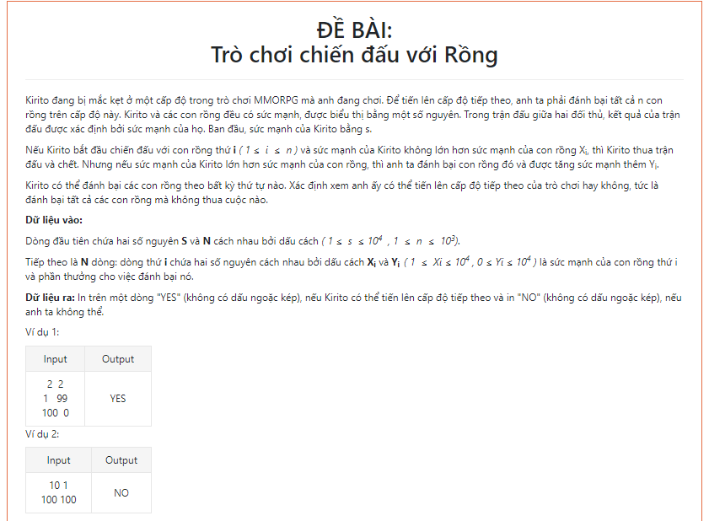

**Code:**

**var s,n,i:longint;**

**a,b:array[1..10000] of longint;**

**check:boolean;**

**procedure Sort(l,r: Integer);**

**var**

**i, j, x,y ,z: integer;**

**begin**

**i := l; j := r; x := a[(l+r) DIV 2]; repeat**

**while a[i] < x do i := i + 1;**

**while x < a[j] do j := j - 1;**

**if i <= j then**

**begin**

**y:= a[i]; a[i]:= a[j]; a[j]:= y;**

**z:= b[i]; b[i]:=b[j]; b[j]:=z;**

**i:= i + 1; j:= j - 1;**

**end;**

**until i > j;**

**if l < j then Sort(l, j);**

**if i < r then Sort(i, r);**

**end;**

**Begin**

**readln(s,n);**

**if (s>=1) and (s<=10000) and (n>=1) and (n<=1000) then begin**

**for i:= 1 to n do begin**

**read(a[i]); readln(b[i]);**

**if (a[i]<1) or (a[i]>10000) or (b[i]<0) or (b[i]>10000) then check:=true;**

**end;**

**if check=false then begin**

**sort(1,n);**

**check:=false;**

**for i:= 1 to n do begin**

**if s>a[i] then s:=s+b[i]**

**else begin**

**check:=true;**

**break;**

**end;**

**end;**

**if check then write('NO')**

**else write('YES');**

**end;**

**end;**

**End.**

**17.** [**https://www.hsg.edu.vn/index.php/hsg/baitap/33**](https://www.hsg.edu.vn/index.php/hsg/baitap/33)

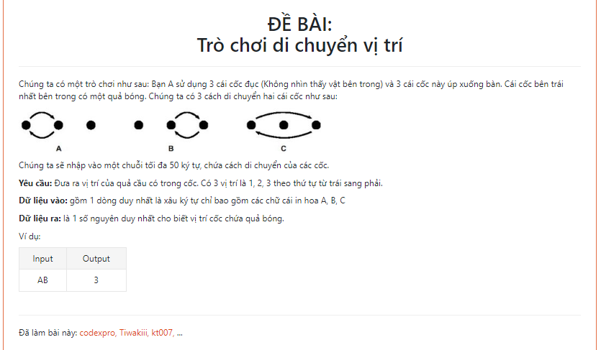

**Code:**

**var s:ansistring;**

**i:longint;**

**a:array[1..3] of byte;**

**procedure plc(i,j:longint);**

**var tmp:longint;**

**begin**

**tmp:=a[i];**

**a[i]:=a[j];**

**a[j]:=tmp;**

**end;**

**Begin**

**read(s);**

**a[1]:=1;**

**for i:= 1 to length(s) do**

**if s[i]='A' then plc(1,2)**

**else if s[i]='B' then plc(2,3)**

**else plc(1,3);**

**for i:= 1 to 3 do**

**if a[i]=1 then writeln(i);**

**End.**

**18.** **https://www.hsg.edu.vn/index.php/hsg/baitap/30**

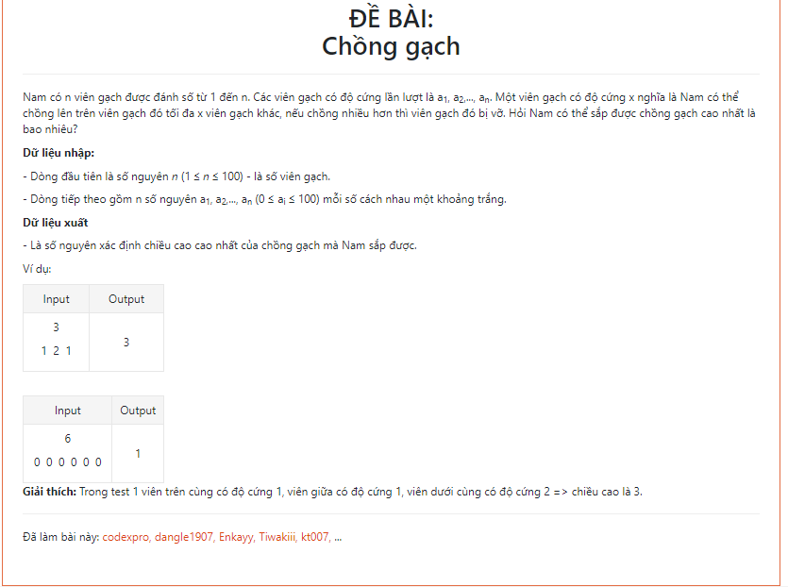

**Code:**

**var n,i,k,j:longint;**

**f,a:array[1..1000] of longint;**

**check:boolean;**

**procedure Sort(l,r: Integer);**

**var**

**i, j, x,y: integer;**

**begin**

**i := l; j := r; x := a[(l+r) DIV 2]; repeat**

**while a[i] < x do i := i + 1;**

**while x < a[j] do j := j - 1;**

**if i <= j then**

**begin**

**y:= a[i]; a[i]:= a[j]; a[j]:= y;**

**i:= i + 1; j:= j - 1;**

**end;**

**until i > j;**

**if l < j then Sort(l, j);**

**if i < r then Sort(i, r);**

**end;**

**Begin**

**readln(n);**

**if (n>=1) and (n<=100) then begin**

**for i:= 1 to n do begin**

**read(a[i]);**

**if (a[i]<0) or (a[i]>100) then**

**check:=true;**

**end;**

**if check=false then begin**

**sort(1,n);**

**//for i:= 1 to n do writeln(a[i],' ');**

**f[n]:=a[n];**

**k:=1;**

**for i:= n-1 downto 1 do**

**begin**

**if f[i+1]-1>=0 then begin**

**f[i]:=a[i];**

**inc(k);**

**for j:=i+1 to n do f[j]:=f[j]-1;**

**for j:= i+1 to n do**

**if f[j]=0 then check:=true;**

**if check=true then break;**

**end**

**else break;**

**end;**

**write(k);**

**// for i:= 1 to n do writeln(f[i],' ',k);**

**end;**

**end;**

**End.**

**19.** **https://www.hsg.edu.vn/index.php/hsg/baitap/32**

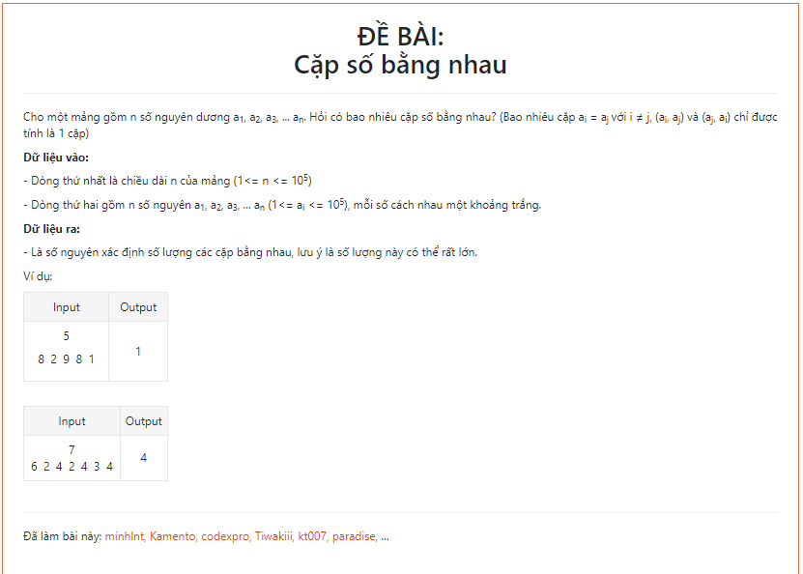

**Code:**

**var n,x,i,j:longint;**

**a:array[1..100000] of longint;**

**check:boolean;**

**function giaithua(n:longint):longint;**

**var i,x:longint;**

**begin**

**x:=1;**

**for i:= n downto 1 do x:=x*i;**

**exit(x);**

**end;**

**function tohop(n:longint):longint;**

**begin**

**exit(giaithua(n) div ((giaithua(n-2))*giaithua(2)));**

**end;**

**procedure Sort(l, r: Integer);**

**var**

**i, j, x, y: integer;**

**begin**

**i := l; j := r; x := a[(l+r) DIV 2];**

**repeat**

**while a[i] < x do i := i + 1;**

**while x < a[j] do j := j - 1;**

**if i <= j then**

**begin**

**y := a[i]; a[i] := a[j]; a[j] := y;**

**i := i + 1; j := j - 1;**

**end;**

**until i > j;**

**if l < j then Sort(l, j);**

**if i < r then Sort(i, r);**

**end;**

**Begin**

**read(n);**

**if (n>=1) and (n<=100000) then begin**

**for i:= 1 to n do begin**

**read(a[i]);**

**if (a[i]<1) or (a[i]>100000) then**

**check:=true;**

**end;**

**if check=false then**

**begin**

**sort(1,n);**

**//for i:= 1 to n do writeln(a[i],' ');**

**a[n+1]:=maxlongint;**

**x:=0;**

**for i:= 1 to n-1 do begin**

**for j:= i+1 to n do**

**begin**

**// writeln(a[i],' ',a[j],' ',a[i]=a[j],' ',(a[j]<>a[j+1]));**

**if (a[i]=a[j]) and (a[j]<>a[j+1]) and (a[i]<>a[i-1]) then**

**begin**

**x:=x+(((j-i+1)*(j-i)) div 2);**

**//writeln(tohop(j-i+1),' ',a[i],' ',a[j]);**

**end;**

**end;**

**end;**

**writeln(x);**

**end;**

**end;**

**End.**

**20.** **https://www.hsg.edu.vn/index.php/hsg/baitap/46**

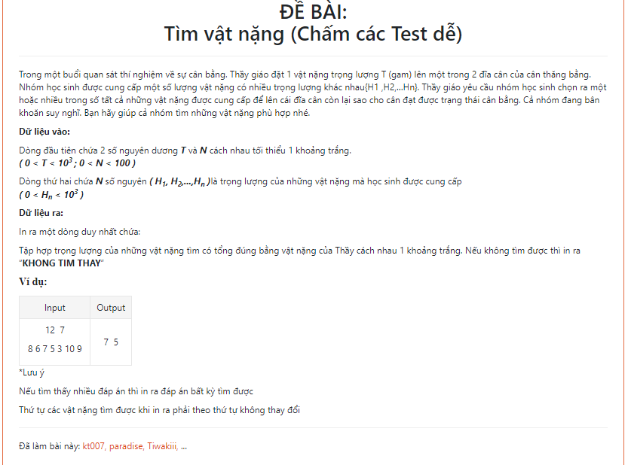

**Code:**

**//uses crt;**

**var t,j,n,i:longint;**

**k,f,a:array[1..100] of longint;**

**check:boolean;**

**procedure sort(l,r: longint);**

**var**

**i,j,x,y: longint;**

**begin**

**i:=l;**

**j:=r;**

**x:=a[(l+r) div 2];**

**repeat**

**while a[i]<x do**

**inc(i);**

**while x<a[j] do**

**dec(j);**

**if not(i>j) then**

**begin**

**y:=a[i];**

**a[i]:=a[j];**

**a[j]:=y;**

**inc(i);**

**j:=j-1;**

**end;**

**until i>j;**

**if l<j then**

**sort(l,j);**

**if i<r then**

**sort(i,r);**

**end;**

**begin**

**//clrscr;**

**readln(t,n);**

**if (t>0) and (t<=1000) and (n>0) and (n<100) then begin**

**for i:=1 to n do begin**

**read(a[i]);**

**if (a[i]<0) or (a[i]>=1000) then check:=true;**

**end;**

**if check=false then begin**

**check:=false;**

**//sort(1,n);**

**for i:= n downto 2 do**

**begin**

**f[i]:=a[i];**

**fillchar(k,sizeof(k),0);**

**k[i]:=i;**

**for j:=i-1 downto 1 do**

**begin**

**if f[i]+a[j]<=t then**

**begin**

**k[j]:=j;**

**f[i]:=f[i]+a[j];**

**// writeln(a[i],' ',a[j],' ',f[i]);**

**end;**

**if f[i]=t then check:=true;**

**end;**

**if check then break;**

**end;**

**if check then begin**

**for i:= 1 to n do if k[i]<>0 then write(a[i],' ')**

**end**

**else write('KHONG TIM THAY');**

**//writeln(k[i],' ',a[i],' ');**

**//writeln;**

**//for i:=1 to n do write(a[i],' ');**

**end;**

**end;**

**end.**

**21.** **https://www.hsg.edu.vn/index.php/hsg/baitap/47**

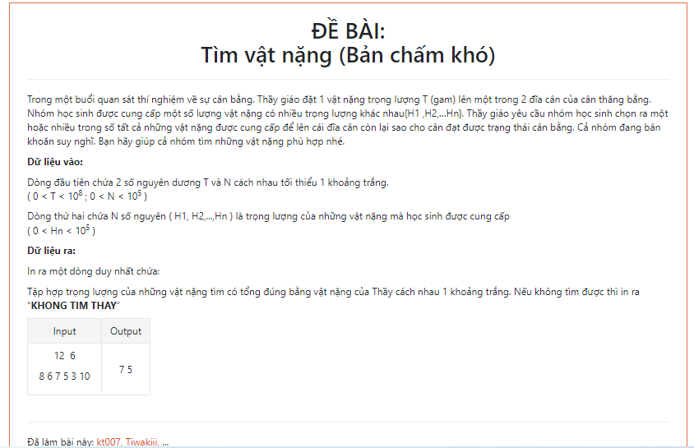

**Code:**

**//uses crt;**

**var s,tong,n,i:longint;**

**x,a:array[0..1000000] of longint;**

**check:boolean;**

**procedure print;**

**var i:longint;**

**begin**

**if check=false then**

**begin**

**for i:= 1 to n do**

**if x[i]=1 then write(a[i],' ');**

**//writeln;**

**check:=true;**

**end;**

**end;**

**procedure try(i:longint);**

**var j:longint;**

**begin**

**if check=false then begin**

**// writeln(tong,' ',i,'dau');**

**for j:= 1 downto 0 do**

**begin**

**x[i]:=j;**

**tong:=tong+x[i]*a[i];**

**if (tong=s) then begin**

**print;**

**end**

**else if (tong<s) and (i<n) then try(i+1);**

**tong:=tong-x[i]*a[i];**

**// writeln(tong,' ',i,'cuoi');**

**end;**

**end;**

**end;**

**begin**

**//clrscr;**

**readln(s,n);**

**//s:=50949;**

**//n:=9999;**

**//for i:=1 to 100000 do a[i]:=i;**

**//for i:=1 to 100 do write(a[i],' ');**

**if (s>0) and (s<100000000) and (n>0) and (n<100000) then begin**

**for i:=1 to n do begin**

**read(a[i]);**

**if (a[i]<=0) or (a[i]>=100000) then check:=true;**

**end;**

**if check=false then begin**

**try(1);**

**if check=false then write('KHONG TIM THAY');**

**end;**

**end;**

**end.**

**Bài toán người du lịch**

Cho N thành phố đánh số từ 1 đến N và các tuyến đường giao thông hai chiều giữa chúng, mạng lưới giao thông này được cho bởi mảng C[1..N,1..N], ở dây Cij=Cji là chi phí đi đoạn đường trực tiếp từ thành phố I đến thành phố j.

Một người du lịch xuất phát từ thành phố 1, muốn đi thăm tất cả các thành phố còn lại mỗi thành phố đúng 1 lần và cuối cùng quay lại thành phố 1. Hãy chỉ ra cho người đó hành trình với chi phí ít nhất.

**Input:** Tệp văn bản **TSP.INP** có dạng

- Dòng đầu chứa số N (1<N<=20) là số thành phố.

- N dòng tiếp theo, mỗi dòng N số mô tả mảng C.

**Output:** Tệp văn bản **TSP.OUT** có dạng

- Dòng đầu tiên là chi phí ít nhất.

- Dòng thứ 2 mô tả hành trình.

|  |  |  |
| --- | --- | --- |
| **TSP.INP** | **TSP.OUT** | **Hình minh hoạ** |
| **4**   |  |  |  |  | | --- | --- | --- | --- | | **0** | **20** | **35** | **42** | | **20** | **0** | **34** | **30** | | **35** | **34** | **0** | **12** | | **42** | **30** | **12** | **0** | | **97**  **1 🡪 2 🡪 4 🡪3 🡪 1** |  |
| **4**   |  |  |  |  | | --- | --- | --- | --- | | **0** | **20** | **35** | **10** | | **20** | **0** | **90** | **50** | | **35** | **90** | **0** | **12** | | **10** | **50** | **12** | **0** | | **117**  **1 🡪 2 🡪 4 🡪3 🡪 1** |  |

**Quay lui nhanh can**

**Code:**

**uses crt;**

**var fi,fo:text;**

**n,i,j,cmin,min,sum:longint;**

**c:array[1..100,1..100] of longint;**

**free:array[1..100] of boolean;**

**truoc,x:array[1..100] of longint;**

**function find(a,b:longint):longint;**

**begin**

**if a<=b then exit(a)**

**else exit(b);**

**end;**

**function try(i:longint):longint;**

**var v,j:longint;**

**begin**

**if sum+cmin*(n-i+1)>min then exit**

**else begin**

**for j:=1 to n do begin**

**if free[j] then begin**

**x[i]:=j;**

**free[j]:=false;**

**sum:=sum+c[x[i-1]][j];**

**if i=n then**

**if sum+c[x[n]][x[1]]<min then begin**

**min:=sum+c[x[n]][x[1]];**

**//truy vet**

**for v:=1 to n do truoc[v]:=x[v];**

**end**

**else**

**else try(i+1);**

**sum:=sum-c[x[i-1]][j];**

**free[j]:=true;**

**end;**

**end;**

**end;**

**end;**

**begin**

**clrscr;**

**cmin:=maxlongint;**

**min:=maxlongint;**

**assign(fi,'TSP.INP'); reset(fi);**

**assign(fo,'TSP.OUT'); rewrite(fo);**

**readln(fi,n);**

**for i:=1 to n do**

**for j:=1 to n do begin**

**read(fi,c[i][j]);**

**if c[i][j]<>0 then cmin:=find(cmin,c[i][j]);**

**end;**

**fillchar(free,sizeof(free),true);**

**x[1]:=1;**

**free[1]:=false;**

**//writeln(cmin);**

**try(2);**

**writeln(fo,min);**

**truoc[n+1]:=1;**

**for i:=1 to n+1 do begin**

**write(fo,truoc[i]);**

**if i<>n+1 then write(fo,'-->');**

**end;**

**writeln;**

**for i:=1 to n do begin**

**for j:=1 to n do write(c[i][j],' ');**

**writeln;**

**end;**

**close(fi); close(fo);**

**end.**

**Cho 1 số nguyên n được nhập từ bàn phím in ra tất cả chuỗi nhị phân độ dài n**

**Code:**

**var fi,fo:text;**

**n:longint;**

**x:array[1..100] of longint;**

**procedure print;**

**var j:longint;**

**begin**

**for j:=1 to n do write(fo,x[j],' ');**

**writeln(fo);**

**end;**

**function try(i:longint):longint;**

**var j:longint;**

**begin**

**for j:=0 to 1 do begin**

**x[i]:=j;**

**if i=n then print**

**else try(i+1);**

**end;**

**end;**

**begin**

**assign(fi,'NHIPHAN.INP'); reset(fi);**

**assign(fo,'NHIPHAN.OUT'); rewrite(fo);**

**read(fi,n);**

**try(1);**

**close(fi); close(fo);**

**end.**

**Bài 1. Nén và giải nén**  
 Một xâu kí tự có thể "nén" theo cách sau: Một xâu con gồm n>1 kí tự giống nhau, chẳng hạn gồm n kí tự "a" sẽ được ghi thành na. Ví dụ xâu 'aaaabbcd' sẽ được nén thành 4a2bcd. Hãy viết chương trình nén và giải nén. (Chú ý trong các xâu được nén phải không có chữ số).  
**Dữ liệu vào:** Cho trong tệp string.INP gồm 2 dòng:

Dòng 1: là văn bản cần nén

Dòng 2: văn bản cần giải nén

**Kết quả:** Ghi vào tệp String.Out gồm 2 dòng

Dòng 1: là văn bản đã nén

|  |  |
| --- | --- |
| string.INP | String.Out |
| aaaabbcd  3a2b | 4a2bcd  aaabb |

Dòng 2: văn bản đã giải nén

**Code:**

uses crt;

var fi,fo:text;

s,x:ansistring;

a:array['a'..'z'] of longint;

procedure nen;

var k,j:longint;

i:char;

ans,c:ansistring;

begin

for j:= 1 to length(s) do a[s[j]]:=a[s[j]]+1;

for i:= 'a' to 'z' do begin

c:='';

if a[i]<>0 then begin

if a[i]<>1 then str(a[i],c);

ans:=ans+c+i;

end;

end;

writeln(fo,ans);

end;

procedure giainen;

var f,ans:ansistring;

i,j,k,a:longint;

begin

x:=' '+x;

writeln(x);

for i:=1 to length(x) do begin

if (x[i]>='A') and (x[i]<='z') then begin

j:=1;

f:='';

while (x[i-j]>='0') and (x[i-j]<='9') do begin

f:=x[i-j]+f;

inc(j);

end;

val(f,a);

for k:=1 to a do ans:=ans+x[i];

end;

end;

write(fo,ans);

end;

begin

clrscr;

assign(fi,'string.INP'); reset(fi);

assign(fo,'string.OUT'); rewrite(fo);

readln(fi,s);

readln(fi,x);

nen;

giainen;

close(fi); close(fo);

end.

**Bài 2. Rút gọn xâu**

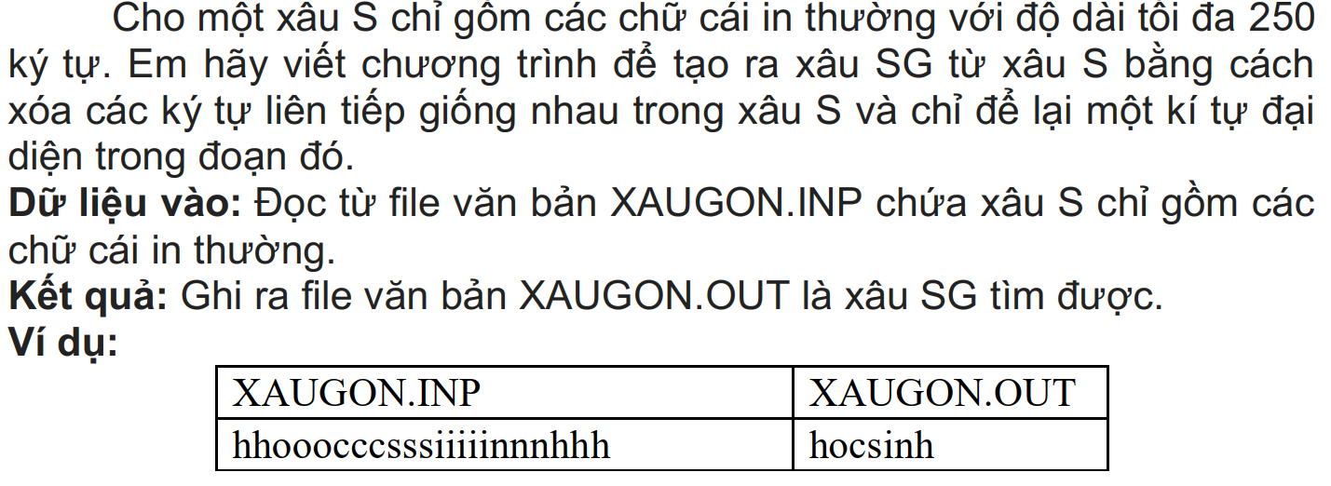

Code:

var fi,fo:text;

s:string;

procedure rutgon;

var i,j,k:longint;

ans:string;

a:array['a'..'z'] of longint;

begin

//writeln(s);

//k:=1;

for i:=1 to length(s) do begin

// if i=k then begin

for j:=i to length(s) do begin

//write(s[i],' ',s[j],' - ');

if (s[i]<>s[j]) and (s[i]<>s[i-1]) and (s[i]<>s[i+1]) then begin

ans:=ans+s[i];

break;

end

else if (s[i]=s[j]) and (s[j]<>s[j+1]) and (s[i-1]<>s[j]) then begin

ans:=ans+s[i];

k:=j+1;

break;

end;

end;

// end;

end;

write(fo,ans);

end;

begin

assign(fi,'XAUGON.INP'); reset(fi);

assign(fo,'XAUGON.OUT'); rewrite(fo);

read(fi,s);

rutgon;

close(fi); close(fo);

end.

**In ra hoán vị của các số từ 1 đến n**

Code:

Var fi,fo:text;

n:longint;

check:array[1..100] of boolean;

a:array[1..100] of longint;

procedure print;

var i:longint;

begin

for i:=1 to n do write(a[i],' ');

writeln;

end;

function try(i:longint):longint;

var j:longint;

begin

for j:=1 to n do begin

if check[j]=false then begin

check[j]:=true;

a[i]:=j;

if i=n then print

else try(i+1);

check[j]:=false;

end;

end;

end;

{procedure print;

var i:longint;

begin

for i:=1 to n do write(a[i],' ');

writeln;

end;

function try(i:longint):longint;

var j:longint;

begin

for j:=1 to n do begin

if (check[j]=false) then begin

check[j]:=true;

a[i]:=j;

if i=n then print

else try(i+1);

check[j]:=false;

end;

end;

end;}

begin

assign(fi,'HOANVI.INP'); reset(fi);

assign(fo,'HOANVI.OUT'); rewrite(fo);

read(fi,n);

try(1);

close(fi); close(fo);

end.

Dãy con tăng dài nhất

Code:

uses crt;

var n,i,j:longint;

f,a:array[1..1000] of longint;

function max(a,b:longint):longint;

begin

if a>=b then exit(a) else exit(b);

end;

begin

clrscr;

readln(n);

for i:=1 to n do f[i]:=1;

for i:=1 to n do read(a[i]);

for i:=1 to n do

for j:=1 to i do begin

if a[i]>a[j] then f[i]:=max(f[i],f[j]+1);

end;

for i:=1 to n do write(f[i],' ');

end.

Bài toán cái túi

uses crt;

var n,s,i,j:longint;

v,w:array[0..1000] of longint;

f:array[0..1000,0..1000] of longint;

function max(a,b:longint):longint;

begin

if a>=b then exit(a) else exit(b);

end;

begin

clrscr;

read(n,s);

for i:=1 to n do begin

read(v[i]);

readln(w[i]);

end;

for i:=1 to n do begin

for j:=1 to s do begin

f[i][j]:=f[i-1][j];

if j>=w[i] then f[i][j]:=max(f[i][j],f[i-1][j-w[i]]+v[i]);

end;

end;

{writeln(n,' ',s);

for i:=1 to n do begin

for j:=1 to s do write(f[i][j],' ');

writeln;

end;}

write(f[n][s]);

end.

Quy hoạch động tập con có tổng bằng S

Code:

uses crt;

var n,s,i,j:longint;

a:array[0..1000] of longint;

f:array[0..1000] of boolean;

begin

clrscr;

readln(n,s);

for i:=1 to n do read(a[i]);

fillchar(f,sizeof(f),false);

f[0]:=true;

for i:= 0 to n do begin

for j:= s downto a[i] do begin

if f[j-a[i]] then f[j]:=true;

end;

end;

write(f[s]);

end.

Xâu con đối xứng dài nhất

Code

var fi,fo:text;

s,x:ansistring;

i,j:longint;

f:array[0..100,0..100] of longint;

function max(a,b:longint):longint;

begin

if a>=b then exit(a) else exit(b);

end;

begin

assign(fi,'LCS.INP'); reset(fi);

assign(fo,'LCS.OUT'); rewrite(fo);

readln(fi,s);

readln(fi,x);

writeln(s);

writeln(x);

fillchar(f,sizeof(f),0);

for i:=2 to length(x) do begin

for j:=2 to length(s) do begin

if x[i-1]=s[j-1] then f[i][j]:=f[i-1][j-1]+1

else f[i][j]:=max(f[i-1][j],f[i][j-1]);

end;

end;

write(f[length(x)][length(s)]);

close(fi); close(fo);

end.

Đề thi hsg 2023

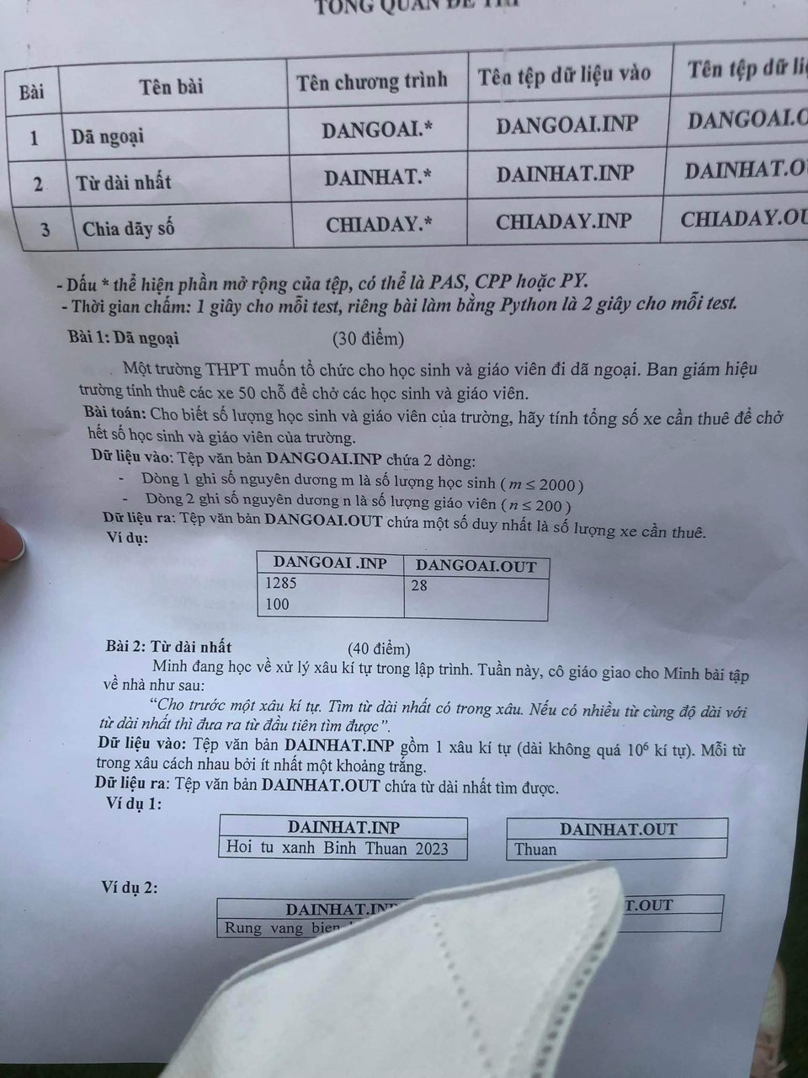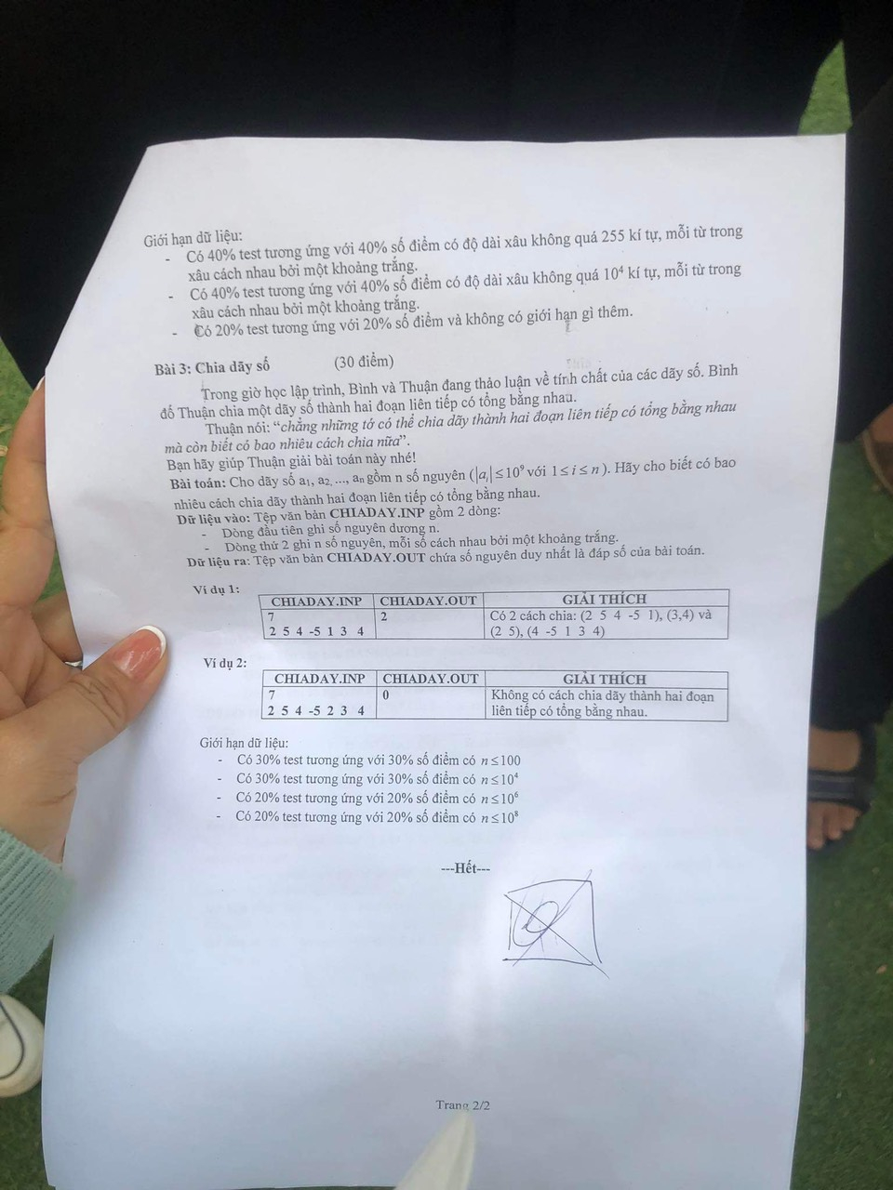

Bài 1:

Code

var m,n,ans:longint;

fi,fo:text;

begin

assign(fi,'DANGOAI.INP'); reset(fi);

assign(fo,'DANGOAI.OUT'); rewrite(fo);

readln(fi,n);

read(fi,m);

if (n+m) mod 50 = 0 then write(fo,(n+m) div 50) else write(fo,((n+m) div 50) +1);

close(fi); close(fo);

end.

Bài 2:

Code

var fi,fo:text;

s:ansistring;

v,max,dem,k,i,j:longint;

begin

assign(fi,'DAINHAT.INP'); reset(fi);

assign(fo,'DAINHAT.OUT'); rewrite(fo);

read(fi,s);

k:=1;

s:=' '+s;

for i:= 1 to length(s) do begin

if s[i]=' ' then begin

dem:=i-k-1;

k:=i;

if dem>max then begin

max:=dem;

v:=i;

end;

end;

end;

// write(max);

for i:= v-max to v-1 do write(fo,s[i]);

close(fi); close(fo);

end.

Bài 3:

Code

var fi,fo:text;

n,i,sum,dem:longint;

f,a:array[0..100000000] of longint;

begin

assign(fi,'CHIADAY.INP'); reset(fi);

assign(fo,'CHIADAY.OUT'); rewrite(fo);

readln(fi,n);

for i:=1 to n do begin

read(fi,a[i]);

f[i]:=f[i-1]+a[i];

end;

for i:=n downto 2 do begin

sum:=sum+a[i];

if sum=f[i-1] then dem:=dem+1;

end;

write(fo,dem);

close(fi); close(fo);

end.