**Programming Test: Learning Activations in Neural**

**Networks**

**Name: Shwetha S Kulloli**

**Contact:9035252757**

**Email id:** [**shwethak205@gmail.com**](mailto:shwethak205@gmail.com)

---------------------------------------------------------------------------------------------------------------------

**Bank Note Authentication**

**PROBLEM DEFINITION:** The data set consists of the physical parameters of three species of flower Versicolor, Setosa and Virginica. The numeric parameters which the dataset contains are Sepal width, Sepal length, Petal width and Petal length.

**OBJECTIVE:** The goal here is to predict the class of Iris given Sepal and Petal lengths and width

**TYPE OF PROBLEM:** Classification

**BASIC DATA ANALYSIS :**

The dataset provided has 150 rows

Dependent Variables : Sepal length.Sepal Width,Petal length,Petal Width

Independent/Target Variable : Class

Missing values : None

**DATA PRE-PROCESSING:**

1. Converted the data into single column
2. One Hot encoding was performed on class labels
3. Splitting the dataset into Training and Testing

**ALGORITHM :**

The model was built using basic Keras neural network using the Sequential model API.

**MODEL BUILDING:**

1. Initialized the sequential model.
2. Added the input layer and the first hidden layer using activation function “Relu” .
3. Added the output layer with activation function “Softmax”.
4. Compiled with optimizer = 'adam', loss = 'binary_crossentropy' and metrics as accuracy
5. Trained the model on the training set with validation_data = (X_test,Y_test),batch_size = 5, epochs = 200, verbose=2.

Evaluated Train and test accuracy and loss

**Plot of Model Accuracy Vs Epoch**

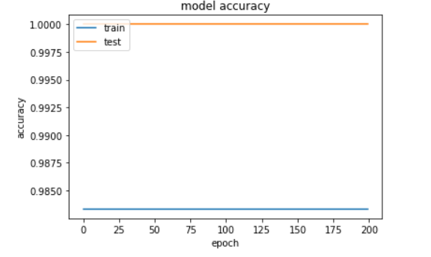

**Plot of Model Loss Vs Epoch**

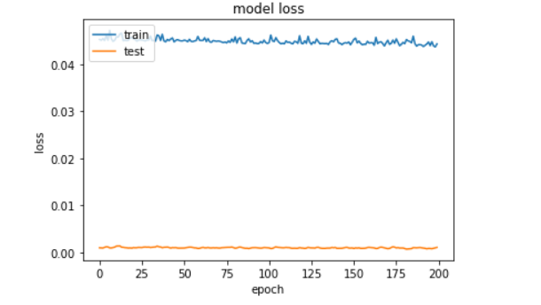

**MODEL SUMMARY:**

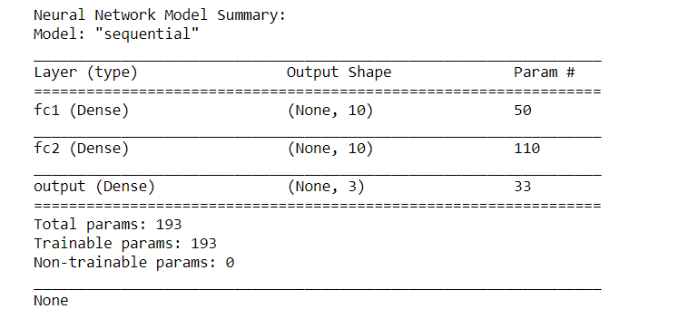

**RESULT OBTAINED:**

Training accuracy: **0.9833**

Training loss: **0.043**

Test accuracy: **1.0000**

Test loss: **0.0010**

**Conclusion:**

The accuracy of the model is 98% which indicates that model Predict the species of an iris using the measurements