**Programming Test: Learning Activations in Neural**

**Networks**

**Name: Shwetha S Kulloli**

**Contact:9035252757**

**Email id:** [**shwethak205@gmail.com**](mailto:shwethak205@gmail.com)

---------------------------------------------------------------------------------------------------------------------

**MNSIT**

**PROBLEM DEFINITION:** The [MNIST dataset](https://en.wikipedia.org/wiki/MNIST_database)  stands for the Modified National Institute of Standards and Technology dataset. The task is to classify a given image of a handwritten digit into one of 10 classes representing integer values from 0 to 9.

**OBJECTIVE:** The goal here is to classify a given image of a handwritten digit into one of 10 classes representing integer values from 0 to 9.

**DATASET INFORMATION:**

There are 60,000 examples in the training dataset and 10,000 in the test dataset and that images are indeed square with 28×28 pixels.

we can load the images and reshape the data arrays to have a single-color channel.

**DATA PRE-PROCESSING:**

1. **SCALING:** Normalize the pixel values of the grayscale images and that can be done by rescaling them to range [0,1].It involves 2 steps:
2. Conversion of the datatype of unsigned integers into float.
3. Dividing the pixel values by the maximum value which is 255
4. **ENCODING :** One hot encoding is used to convert categorical variables into numerical for prediction.Encoding was performedby using a function to_categorical().

**ALGORITHM:**

The model was built using Convolution Neural Network

**MODEL BUILDING:**

**Steps to build CNN**

1. Provide the input image into convolution layer.
2. Take convolution with featured kernel/filters.
3. Apply pooling layer to reduce the dimensions.
4. Add these layers multiple times.
5. Flatten the output and feed into a fully connected layer.
6. Train the model with backpropagation using logistic regression.

* The Convolution2D which the first hidden layer consist of 32 filters/output channels, having the size of 3×3 and “relu” as activation function.
* The MaxPooling is a second layer which is used to make assumptions about the features so it reduces the over-fitting problem and reduces the training time.
* The third layer is a hidden layer Convolution2D with 64 filters/output channels with the size of 3×3 and an activation function. Because it is not the first layer there is no need for input_shape parameters.
* The forth layer is a MaxPooling layer.
* The sixth layer converts the 2D matrix data to a vector called Flatten. It allows the output to be processed by a fully connected neural network.
* The seventh is a fully connected layer with 128 neurons.
* The final layer is the output layer and it used the activation function as “softmax” as it
* as it is a multi-classification task where output layer needs to predict the probability for 10 classses.
* Compiled with optimizer = 'adam', loss = 'binary_crossentropy' and metrics as accuracy,f1 score, precision and recall.
* During the traing the epoch=10 and batchsize=200.
* Model was evaluated and saved.

**Model Summary:**

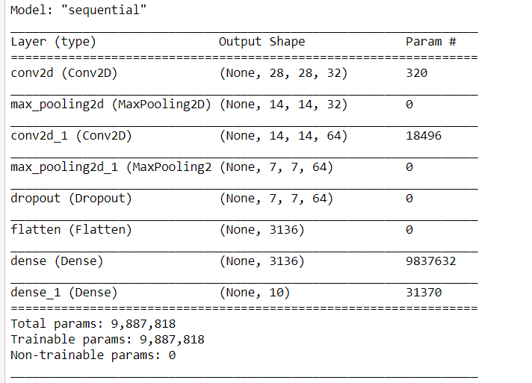

**RESULTS:**

Train accuracy: **0.9948**

Train loss: 0.0151

Test Accuracy: **0.9725**

Test loss: 0.0266

**Conclusion:**

The accuracy of the model is 99% which indicates that model efficiently recognizing handwritten digits in images.