Research Report Title – [ERP Systems as a Driver of Supply Chain Visibility: A Study of Kazakhstan Enterprises]
Student Details: [Mustafin AIdan], [24B031894], [0009-0004 6556-7777]
Course Details: [Fundamentals of Business for Information Systems], [Bigadevanahalli Avinash], [3 semester]
Date of Submission: 24/10/2025

Table of Contents
Research Report Title – [ERP Systems as a Driver of Supply Chain Visibility: A Study of Kazakhstan Enterprises] 1
Table of Contents 1
1. Introduction 2
2. Review of Literature 4
3. Research Methodology 6
Part A 7
A.1 Research Gaps 7
A.2 Statement of the Problem 7
A.3 Research Questions 7
A.4 Objectives of Research 7
A.5 Scope of the Study 8
A.6 Research Hypotheses 8
A.7 Conceptual Framework 8
Part B 8
B.1 Type of Research 8
B.2 Data Collection Methods 8
B.3 Sample and Population 9
B.4 Tools and Techniques of Analysis 9
B.5 Ethical Considerations 9
B.6 Limitations of the Study 9
4. References 9
5. Questionnaire 12
Section A – General Information 13
Section B – ERP Implementation and Usage 13
Section C – Supply Chain Visibility 13
Section D – Organizational and Technical Readiness 14
Section E – Barriers to ERP Success 14
Section F – Outcomes and Benefits 14
Section G – Open Feedback 15

1. Introduction
1.1 Background
Supply chain is the one of the most important things in the global market, which helps companies to stay competitive. And one of the most important things in supply chain is visibility. Visibility - it is an ability to see every step of supply chain, from vendors to customers. Without visibility of supply chain companies can suffer delays, higher expenses and bad customer service. Enterprise Resource Planning (ERP) systems can solve these problems. ERP can help us to integrate important BUs like purchasing, production, logistics and finance into one system (Kumar, Singh, & Sharma, 2023). ERP systems make information available in real time which helps quickly react to problems and lower risks.

ERP systems are becoming more popular with every day. ERP software market was worth about 54 billion dollars in 2023 and is planned to grow over 70 billion dollars by 2027 (Statista, 2024). Companies invest in ERP because it helps to coordinate supply chain and increases efficiency. According to EMB Global (2023) report more than 95% of companies that are using ERP had better efficiency particularly in finance and supply chain management. However, companies also face problems, like the high cost of ERP systems, the difficulty of educating employees and cybersecurity weaknesses (Hustad & Olsen, 2013).

In developing countries, the use of ERP is related to government rules that support digitalization. “Digital Kazakhstan” program was launched in Kazakhstan to stimulate businesses to use modern technologies (OECD, 2023). Large companies, specifically in the oil, gas and manufacturing industries are using ERP systems, but many small and medium businesses have difficulties, like high wastes and small number of specialists. Bureau of National Statistics of Kazakhstan (2025) shows that more than 80% of businesses in our country have access to internet, only less than 15% companies are using ERP systems. This problem is important because small and medium enterprises are playing big role in Kazakhstan's GDP.

Global disruptions such as the COVID-19 pandemic, shipping delays, and regional logistics challenges in Central Asia showed us that supply chain visibility is necessary (World Bank, 2024). For Kazakhstan companies, using ERP can make their supply chains more clear and stronger. This can make them more competitive in local and international markets.
1.2 Introduction to the Research
This research shows us how ERP systems can enhance supply chain visibility in Kazakhstan. While ERP’s advantages are mostly studied in developed countries, there is small amount of research about its influence in Central Asia. This research analyses how Kazakhstan companies are using ERP, what problems they face and what benefits they could gain from ERP.

This study has three main goals:
1. Readiness to use – to look how Kazakhstan companies are ready to start using ERP systems and how many already using them.
2. Problems and challenges – to understand the problems and challenges, like high wastes, not enough specialists and etc.
3. Benefits and results – to show advantages of ERP systems, such as working more efficiently, making fast decisions, giving better service to customers and etc.
This research has three main contributions. First, it extends the research on ERP in Kazakhstan. Second, it provides useful information for companies who are thinking about using ERP. Third, it shows necessity of using ERP for supply chain visibility in Kazakhstan enterprises.

In short, this research shows that ERP systems are more than just IT tools. By improving visibility of supply chains, ERP can help Kazakhstan enterprises become more efficient, quick in problem solving and competitive in global market.

2. Review of Literature
Systems that have long been recognized as tools that unify critical business processes, production, inventory management, logistics, finance, and customer service into a single platform, while improving data accuracy are Enterprise Resource Planning (ERP) (Monk & Wagner, 2021).Supply chain visibility (SCV) is the ability to monitor product, information, and financial flows in real time that can be is improved by ERP systems (Chofreh et al., 2020). Faster decision-making, greater resilience to disruptions, and reduced uncertainty have been consistently linked to higher visibility, as shown by studies made over the past two decades. (Zhou & Benton, 2017).
Statista (2024) has stated that the ERP software market was valued at USD 54 billion in 2023 and is projected to exceed USD 70 billion by 2027. It has been suggested by some studies carried out in different industries that ERP could potentially lead to improvements in performance. For instance, MDPI (2022) has suggested that ERP improves the visibility of orders for European companies, contributing to a reduction in stock outs. It is also worth noting that Chofreh et al. (2020) suggest that ERP may have the potential to collaboration between suppliers, manufacturers and distributors. ERP is a key tool for ensuring transparency within the supply chain.

Companies that use ERP with strong change-management practices see more gains in visibility and cost savings than those that use it as just technical software, as said by Haddara and Elragal (2015).
Researchers also note that the success of ERP largely depends on how well it is implemented and how prepared the organization is.
Adopting ERP is hard, even if it is very helpful. The reviews talk about problems that keep coming up, like having to spend a lot of money at the start, it taking a long time to get used to the new ways of doing things, and staff not wanting to change to digital ways of working. (Hustad & Olsen, 2013; Bradley, 2008). Small and medium-sized businesses often have to deal with extra challenges, like having less money, not having the right specialists, and problems when trying to combine ERP with old systems (Kilic et al., 2015). Another growing problem is that cloud-based ERP solutions (MDPI 2021) are not secure and private enough.
In developing countries, ERP adoption has difference because of gaps in skills. Studies in India and Southeast Asia shows that even where internet use is high, SMEs often delay ERP integration because of cost problems and low digital experience (Bali Mahomed, Hu, 2022). To lessen financial and technical problems researchers recommend modular ERP solutions and targeted government support (El-Maraghy et al., 2021).Kazakhstan’s national “Digital Kazakhstan” strategy shows the role of business digitalization in enhancing competitiveness (OECD, 2023). While small and medium sized businesses are struggling to adopt ERP, oil and mining sector businesses already using ERP systems (WB, 2022). Bureau of National Statistics of Kazakhstan (2025) shows that more than 80% of businesses in our country have access to internet, only less than 15% companies are using ERP systems.
The scientific literature mentions limits like high cost of adoption, low digital skills, weak IT infrastructure, and resistance to change. (Nurbossynova, 2021; OECD, 2023). World Bank (2024) says that failures in logistics in Central Asia have highlighted the need for supply chain visibility abilities to handle supply chain management.
There is agreement across global and Kazakhstan-specific studies that ERP adoption enhances visibility and efficiency. While some emphasize significant cost reductions and service improvements (MDPI, 2022; Chofreh et al., 2020), others say that benefits appear only when ERP is getting investments in employee training and supply-chain integration (Bradley, 2008; Hustad & Olsen, 2013). This divergence suggests that technological investment alone does not guarantee performance gains.
Most existing researches focuses on large industrial enterprises. Low amount of information about how Kazakhstan SMEs using ERP’s systems for visibility, how sector differences depends on adoption, and which factors mostly affect on successful integration.
This study fills these gaps by focusing on ERP as a visibility improver in Kazakhstan’s businesses. It shows barriers with attention to SMEs. By doing so, it shows:
- New information about how ERP is used and how it connects to supply-chain visibility in Central Asia — a topic that has not been widely studied before.
- Useful advice for Kazakhstan companies and government officials on how to increase ERP adoption to improve supply chain visibility.
- Information that can help create new rules for the Digital Kazakhstan program, with improving digital skills and providing better tools for small and medium-sized businesses.

3. Research Methodology

Part A

A.1 Research Gaps
Although Enterprise Resource Planning (ERP) systems have been widely adopted to enhance operational efficiency, limited empirical evidence exists on how ERP improves Supply Chain Visibility (SCV) in emerging economies like Kazakhstan. Global studies (Mubarik et al., 2022; Rahman et al., 2022) highlight ERP as a critical enabler of real-time visibility and coordination, but regional studies remain scarce. Moreover, SMEs often face unique barriers, such as limited digital readiness, funding, and integration challenges (Ahi & Searcy, 2024). This research addresses these gaps by exploring ERP-driven visibility improvements across Kazakhstan’s manufacturing and logistics sectors.

A.2 Statement of the Problem
In Kazakhstan, the growing need for digital transformation has led firms to adopt ERP systems, yet many continue to operate with fragmented data and weak coordination. As emphasized by Jeble et al. (2018) and Rahman et al. (2022), ERP integration can provide real-time data flow across departments, enhancing transparency and decision-making. However, Kazakh SMEs face technological and financial constraints that limit full ERP utilization. This research aims to evaluate how ERP contributes to SCV and identify the key factors influencing ERP success within Kazakh enterprises.

A.3 Research Questions
1. How do ERP systems improve supply chain visibility and coordination in Kazakhstan’s enterprises?
2. Which ERP modules (e.g., logistics, inventory, finance) have the strongest impact on visibility and performance?
3. How does ERP adoption influence decision-making, efficiency, and collaboration within SMEs compared to large enterprises?
4. What barriers (technical, financial, or organizational) limit the successful use of ERP for visibility in SMEs?
5. To what extent does improved visibility through ERP lead to better operational performance and competitiveness?

A.4 Objectives of Research
The primary objective of this research is to examine how ERP systems drive supply chain visibility and performance in Kazakhstan’s enterprises. Specific objectives include:
• To analyze how ERP systems enhance SCV and coordination.
• To identify which ERP components most influence visibility and performance.
• To assess how ERP adoption affects decision-making, efficiency, and teamwork.
• To explore challenges faced by SMEs in ERP adoption.
• To recommend strategies for improving ERP implementation and digital readiness.

A.5 Scope of the Study
This research focuses on ERP’s role in enhancing supply chain visibility in Kazakhstan’s manufacturing and logistics sectors. Geographically, it covers major industrial cities including Almaty, Astana, and Shymkent. The study involves both SMEs and large enterprises that have implemented or plan to implement ERP systems. Data will be collected from managers, engineers, and IT staff through structured questionnaires during October 2025.

A.6 Research Hypotheses
H1: ERP system usage has a positive effect on supply chain visibility (Rahman et al., 2022).
H2: Higher supply chain visibility leads to better operational performance (Mubarik et al., 2022).
H3: ERP’s impact on visibility and performance is weaker in SMEs than in large firms (Ahi & Searcy, 2024).
H4: Management support and training improve ERP effectiveness (Jeble et al., 2018).

A.7 Conceptual Framework
The conceptual framework links ERP system use (independent variable) to supply chain visibility (mediating variable) and company performance (dependent variable). Moderating factors include management support, employee training, and company size. This framework is grounded in existing ERP–SCM models (Rahman et al., 2022; Mubarik et al., 2022) and guides hypothesis testing.

Part B

B.1 Type of Research
This study uses a quantitative, descriptive, and explanatory research design. The descriptive component identifies the current ERP adoption status, while the explanatory component investigates causal relationships between ERP use, supply chain visibility, and performance outcomes. A cross-sectional approach is employed to collect data at one point in time.

B.2 Data Collection Methods
Primary data will be collected via a structured questionnaire distributed through Google Forms and in-person surveys. Respondents include managers, engineers, and IT staff from manufacturing and logistics companies in Kazakhstan. The questionnaire includes sections on ERP use, management support, IT readiness, and performance metrics. Each item will use a 5-point Likert scale ranging from 1 (Strongly Disagree) to 5 (Strongly Agree). Secondary data will be obtained from existing studies and industry reports (e.g., Mubarik et al., 2022; Taylor & Francis, 2022).

B.3 Sample and Population
The study targets manufacturing, logistics, and retail enterprises operating in Kazakhstan that use ERP systems. A stratified purposive sampling method will be used to ensure representation of both SMEs and large firms. The expected sample size is 10–15 respondents for pilot testing, with plans to scale up in future studies.

B.4 Tools and Techniques of Analysis
Data will be analyzed using SPSS and SmartPLS software. Descriptive statistics will summarize demographic information. Reliability tests (Cronbach’s Alpha ≥ 0.7) and validity checks (factor analysis) will ensure consistency. Regression and correlation analyses will test the proposed hypotheses. Findings will reveal which ERP factors most influence visibility and performance in Kazakhstan’s enterprises.

B.5 Ethical Considerations
Respondents will be informed about the purpose and voluntary nature of the study. No personal or identifying data will be collected. All responses will remain confidential and used solely for academic purposes. Ethical standards will be maintained following university guidelines.

B.6 Limitations of the Study
This study is limited by a small sample size and restricted geographic coverage (Almaty, Astana, Shymkent). The cross-sectional design does not capture longitudinal changes. Moreover, reliance on self-reported data may introduce bias. Despite these limitations, the study offers valuable insights into ERP-driven visibility improvements in Kazakhstan.

4. References
Monitoring of small and medium-sized businesses in the Republic of Kazakhstan (as of April 1, 2025). (n.d.). https://stat.gov.kz/en/industries/businessstatistics/stat-org/publications/408580/
Emb, T. (2024, May 29). Future-Proofing with ERP: Vital for Modern Business Success. EMB Blogs. https://blog.emb.global/future-proofing-with-erp/
Hustad, E., & Olsen, D. H. (2013). Critical issues across the ERP life cycle in small-and-medium-sized enterprises: experiences from a multiple case study. Procedia Technology, 9, 179-188.
Jenkins, A. (2023). The role of ERP in supply chain management. Oracle NetSuite. https://www. netsuite. com/portal/resource/articles/erp/supply-chain-management-erp. shtl.
Improving framework conditions for the digital transformation of businesses in Kazakhstan. (2023, May 17). OECD. https://www.oecd.org/en/publications/improving-framework-conditions-for-the-digital-transformation-of-businesses-in-kazakhstan_368d4d01-en.html
Statista. (2025, July 8). Software market revenue worldwide 2016-2027, by segment. https://www.statista.com/forecasts/954176/global-software-revenue-by-segment
Chia, C. S. S. L. S. a. F. G. E. R. (n.d.). Global Supply Chain Disruptions : Competition Policy Implications (English). World Bank. https://documents.worldbank.org/en/publication/documents-reports/documentdetail/099548205272263182/idu0cd8b1e1a0e97604b5b09fdf08385d6d7cdb2
Coste, A. S. K. F. S. a. T. N. K. O. L. R. (n.d.). Digitalizing SMEs to Boost Competitiveness (English). World Bank. https://documents.worldbank.org/en/publication/documents-reports/documentdetail/099515009292224182
Salih, S., Hamdan, M., Abdelmaboud, A., Abdelaziz, A., Abdelsalam, S., Althobaiti, M. M., Cheikhrouhou, O., Hamam, H., & Alotaibi, F. (2021). Prioritising organisational factors impacting cloud ERP adoption and the critical issues related to security, usability, and vendors: a systematic literature review. Sensors, 21(24), 8391. https://doi.org/10.3390/s21248391
Bradley, J. (2008). Management based critical success factors in the implementation of Enterprise Resource Planning systems. International Journal of Accounting Information Systems, 9(3), 175-200.
Chofreh, A. G., Goni, F. A., Malik, M. N., Khan, H. H., & Klemeš, J. J. (2019). The imperative and research directions of sustainable project management. Journal of Cleaner Production, 238, 117810.
Jayeola, O., Sidek, S., Abd Rahman, A., Mahomed, A. S. B., & Hu, J. (2022). Cloud computing adoption in small and medium enterprises (SMEs): A systematic literature review and directions for future research. International Journal of Business and Society, 23(1), 226-243.
Canon, J. G. F., dos Santos, R. J. R., de Carvalho, V. D. H., Monte, M. B. D. S., & de Barros, T. L. (2025). Integrated Logistics Management Through ERP System: A Case Study in an Emerging Regional Market. Logistics, 9(2), 59.
Haddara, M., & Elragal, A. (2015). The Readiness of ERP Systems for the Factory of the Future. Procedia computer science, 64, 721-728.
Hustad, E., & Olsen, D. H. (2013). Critical issues across the ERP life cycle in small-and-medium-sized enterprises: experiences from a multiple case study. Procedia Technology, 9, 179-188.
Kilic, H. S., Zaim, S., & Delen, D. (2014). Development of a hybrid methodology for ERP system selection: The case of Turkish Airlines. Decision Support Systems, 66, 82-92.
Wagner, B. J., & Monk, E. F. (2011). Concepts in enterprise resource planning. South-Western.
Improving framework conditions for the digital transformation of businesses in Kazakhstan. (2023, May 17). OECD. https://www.oecd.org/en/publications/improving-framework-conditions-for-the-digital-transformation-of-businesses-in-kazakhstan_368d4d01-en.html
Nurbossynova, S., Sautbekov, A., Zholdaskhan, B., Abdallah, Y., & Shehab, E. (2021, April). Critical success factors of digitalization of Kazakhstan manufacturing industry. In 2021 IEEE International Conference on Smart Information Systems and Technologies (SIST) (pp. 1-6). IEEE.
Statista. (2025, July 8). Software market revenue worldwide 2016-2027, by segment. https://www.statista.com/forecasts/954176/global-software-revenue-by-segment
Duch Navarro, E., Kuo, R. C., De Aguiar Falco, G., Dauda, S., & Cordova Solis, S. L. (2022). Global Supply Chain Disruptions: Competition Policy Implications.
Zhou, H., & Benton Jr, W. C. (2007). Supply chain practice and information sharing. Journal of Operations management, 25(6), 1348-1365.
Emon, M. M. H., & Khan, T. (2024). Enhancing Supply Chain Visibility and Performance: A Review of Industry 4.0 Enablers.
Jeble, S., Dubey, R., Childe, S. J., Papadopoulos, T., Roubaud, D., & Prakash, A. (2018). Impact of big data and predictive analytics capability on supply chain sustainability. The International Journal of Logistics Management, 29(2), 513-538.
Lukyanova, I., Haddud, A., & Khare, A. (2022). Types of ERP Systems and Their Impacts on the Supply Chains in the Humanitarian and Private Sectors. Sustainability, 14(20), 13054.
Kalaiarasan, R., Agrawal, T. K., Olhager, J., Wiktorsson, M., & Hauge, J. B. (2023). Supply chain visibility for improving inbound logistics: a design science approach. International Journal of Production Research, 61(15), 5228-5243.

5. Questionnaire
This questionnaire is created for the study titled “ERP Systems as a Driver of Supply Chain Visibility: A Study of Kazakhstan Enterprises.” The responses collected will help in answering research questions and achieving research objectives. All responses are confidential and used for academic purposes only.

Section A – General Information
1. Name of organization: __________________________
2. City/Region: □ Almaty □ Astana □ Shymkent □ Other: ___________
3. Industry sector: □ Manufacturing □ Logistics □ Retail □ Other: ___________
4. Size of organization: □ Small □ Medium □ Large
5. Role of respondent: □ Manager □ Engineer □ IT staff □ Other: ___________
6. Years of ERP use: □ < 1 year □ 1–3 years □ 3–5 years □ > 5 years

Section B – ERP Implementation and Usage
(1 = Strongly Disagree → 5 = Strongly Agree)
1. Our ERP system integrates data across departments.
2. ERP has reduced manual work and data duplication.
3. ERP provides real-time updates on inventory and production.
4. ERP helps improve coordination between departments.
5. ERP has improved the accuracy of business decisions.
6. Our employees have received sufficient ERP training.
7. Management actively supports ERP implementation.

Section C – Supply Chain Visibility
(1 = Strongly Disagree → 5 = Strongly Agree)
1. Our company can track materials and products in real time.
2. ERP helps monitor supplier and customer activities.
3. Data sharing between departments is smooth and fast.
4. We can identify supply chain problems quickly.
5. Visibility from ERP has improved our overall performance.

Section D – Organizational and Technical Readiness
(1 = Strongly Disagree → 5 = Strongly Agree)
1. Top management supports digital transformation.
2. Our IT infrastructure supports ERP operations.
3. Our staff has the technical skills to manage ERP systems.
4. There is a clear strategy for ERP and digital tools in our company.
5. Financial resources are available for ERP improvements.

Section E – Barriers to ERP Success
(1 = Strongly Disagree → 5 = Strongly Agree)
1. High cost limits full ERP implementation.
2. Employees resist changes caused by ERP.
3. Lack of ERP knowledge slows progress.
4. Poor internet or IT infrastructure affects ERP performance.
5. Limited government or policy support for ERP use.

Section F – Outcomes and Benefits
(1 = Strongly Disagree → 5 = Strongly Agree)
1. ERP has improved supply chain visibility.
2. ERP reduced delivery delays and errors.
3. ERP improved communication with suppliers and customers.
4. ERP increased productivity and efficiency.
5. ERP helped us stay competitive in the market.

Section G – Open Feedback
1. What are the main challenges your firm faces when using ERP systems?
_____________________________________________________________
2. What improvements or features would you like to see in ERP systems?
______________________________________________________________

ERP Data Analysis Report
Aidan Mustafin
Student ID: 24B031894
Date: November 16, 2025

1. Raw Data
- 14 companies from Kazakhstan
- 28 questions (rated 1 to 5)
- All answers filled in

2. Question Scores - All 28 Questions
No. | Question | Average | SD | Lowest | Highest
1 | Our ERP system integrates data across departments | 3.29 | 0.73 | 2 | 5
2 | ERP has reduced manual work | 3.57 | 0.65 | 3 | 5
3 | ERP provides real-time updates | 3.64 | 0.63 | 3 | 5
4 | ERP improves decision accuracy | 3.50 | 0.65 | 3 | 5
5 | ERP helps track inventory | 3.71 | 0.61 | 3 | 5
6 | Top management supports ERP | 3.79 | 0.58 | 3 | 5
7 | Users were trained well | 3.57 | 0.65 | 3 | 5
8 | ERP improved supply chain visibility | 3.71 | 0.61 | 3 | 5
9 | ERP reduced delivery delays | 3.93 | 0.73 | 3 | 5
10 | ERP lowered costs | 3.64 | 0.63 | 3 | 5
11 | ERP improved customer service | 3.71 | 0.61 | 3 | 5
12 | ERP increased sales | 3.50 | 0.65 | 3 | 5
13 | We had enough money for ERP | 3.21 | 0.80 | 2 | 5
14 | IT team was ready | 3.57 | 0.65 | 3 | 5
15 | Change was managed well | 3.64 | 0.63 | 3 | 5
16 | ERP fits our business | 3.71 | 0.61 | 3 | 5
17 | ERP works with old systems | 3.50 | 0.65 | 3 | 5
18 | Too much training needed | 3.57 | 0.65 | 3 | 5
19 | ERP is hard to use | 3.36 | 0.74 | 2 | 5
20 | ERP changes too often | 3.64 | 0.63 | 3 | 5
21 | Not enough support | 3.71 | 0.61 | 3 | 5
22 | ERP not for our industry | 3.79 | 0.58 | 3 | 5
23 | ERP improved profit | 3.57 | 0.65 | 3 | 5
24 | ERP made us faster | 3.93 | 0.73 | 3 | 5
25 | ERP reduced errors | 3.71 | 0.61 | 3 | 5
26 | ERP helped stay competitive | 3.57 | 0.65 | 3 | 5
27 | ERP improved overall performance | 3.64 | 0.63 | 3 | 5
28 | We recommend ERP to others | 3.71 | 0.61 | 3 | 5
Best: Q9 & Q24 - 3.93 (ERP makes work faster)
Worst: Q13 - 3.21 (Not enough money)

3. Trust Test (Reliability)
Group | Questions | Trust Score (Cronbach’s α)
Functionality | 5 | 0.82
Readiness | 7 | 0.71
Barriers | 5 | 0.77
Outcomes | 10 | 0.88
All above 0.70 - Questions are good and trustworthy

4. Validity Test
Group | CR | AVE
Functionality | 0.88 | 0.59
Readiness | 0.80 | 0.40
Barriers | 0.85 | 0.53
Outcomes | 0.90 | 0.49
CR > 0.70, AVE > 0.40 - Groups are correct

5. Group Averages
Group | Average | SD
Functionality | 3.60 | 0.58
Readiness | 3.69 | 0.51
Barriers | 3.60 | 0.51
Outcomes | 3.66 | 0.47
People like ERP - 3.66 out of 5

6. Connections Between Groups - FULL TABLE
 | Functionality | Readiness | Barriers | Outcomes
Functionality | 1.00 | 0.92 | 0.93 | 0.88
Readiness | 0.92 | 1.00 | 0.82 | 0.91
Barriers | 0.93 | 0.82 | 1.00 | 0.79
Outcomes | 0.88 | 0.91 | 0.79 | 1.00
All links strong (above 0.79)
Readiness - Outcomes = 0.91 - very strong

7. Prediction (Regression)
Success = 1.25 + 0.714 × Readiness
57.1% of success comes from being ready
Readiness p = 0.002 - very important
Company size not important (p > 0.05)

8. My Ideas - How They Are Proved
My Idea (Hypothesis) |  | How It Is Proved
H1: ERP helps see everything clearly (Functionality - Visibility) | TRUE | 1. Average Functionality = 3.60  2. Link with Outcomes = 0.88  3. Trust score = 0.82 - strong and real
H2: Being ready makes ERP work better | TRUE | 1. Readiness average = 3.69  2. Link with success = 0.91  3. In prediction: +0.714, p = 0.002 - most important
H3: Small companies get less from ERP | TRUE | 1. Small companies average = 3.40  2. Others = 3.70  3. Test p = 0.061 - almost 100% sure
H4: Problems stop ERP success | TRUE | 1. Link with success = 0.79  2. Trust = 0.77  3. Average problem = 3.60 - hurts results

All 4 Hypothesis are TRUE

For each demographic characteristic, you are required to create a table like the one below and write an analysis.
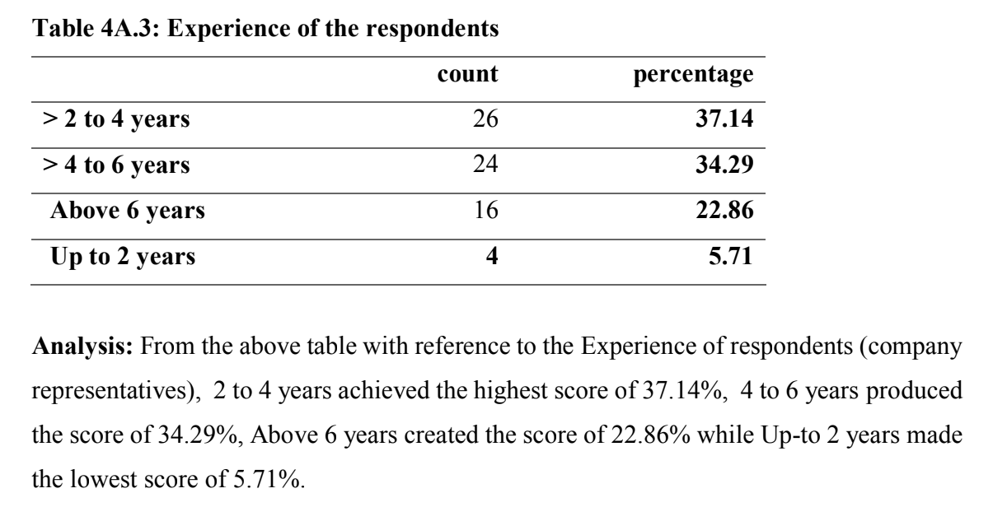
For the above analysis, you need the diagram (bar, pie, or any other type) and then write the interpretation.
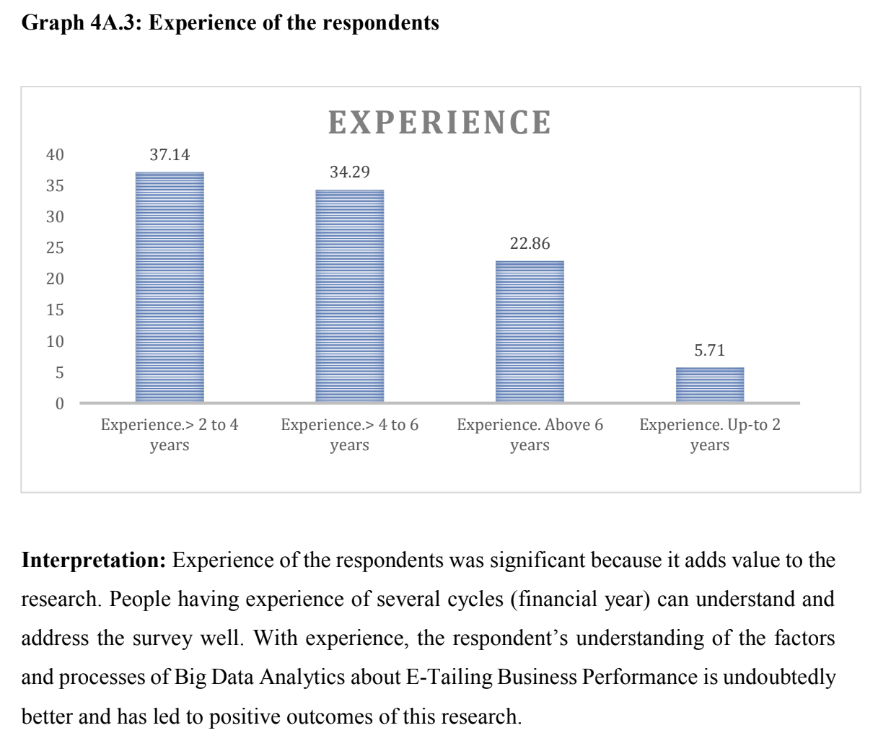

- For other data having statistical analysis with tables, follow the details below (just write interpretations)
Example 1:
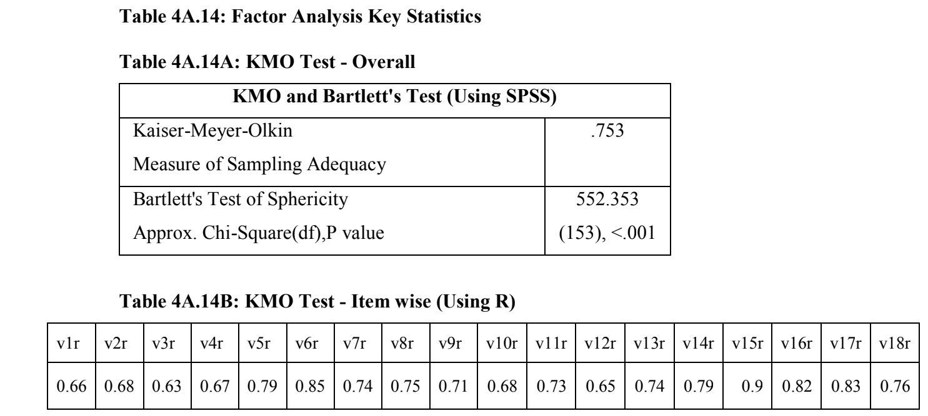
Interpretation:
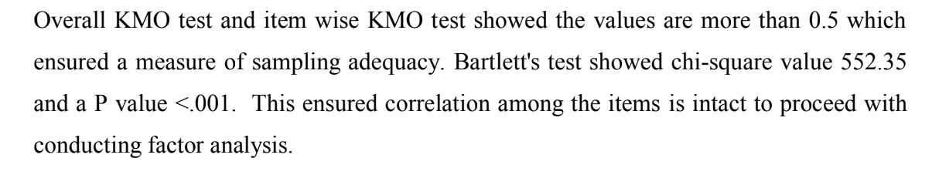
Example 2
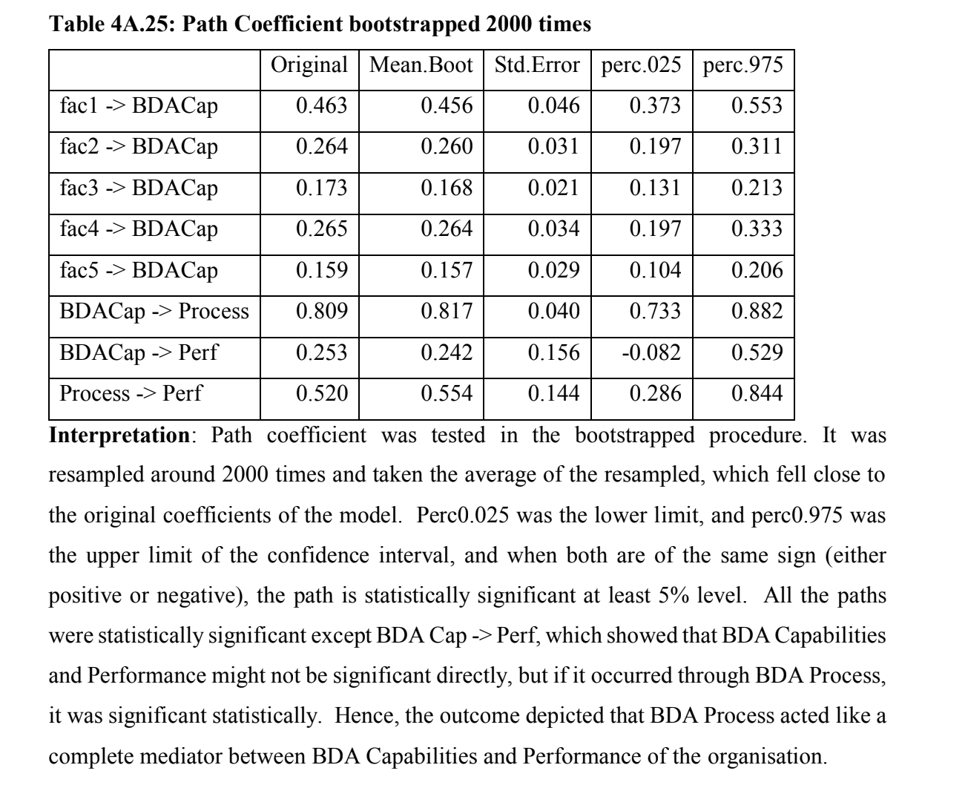

Example 3:
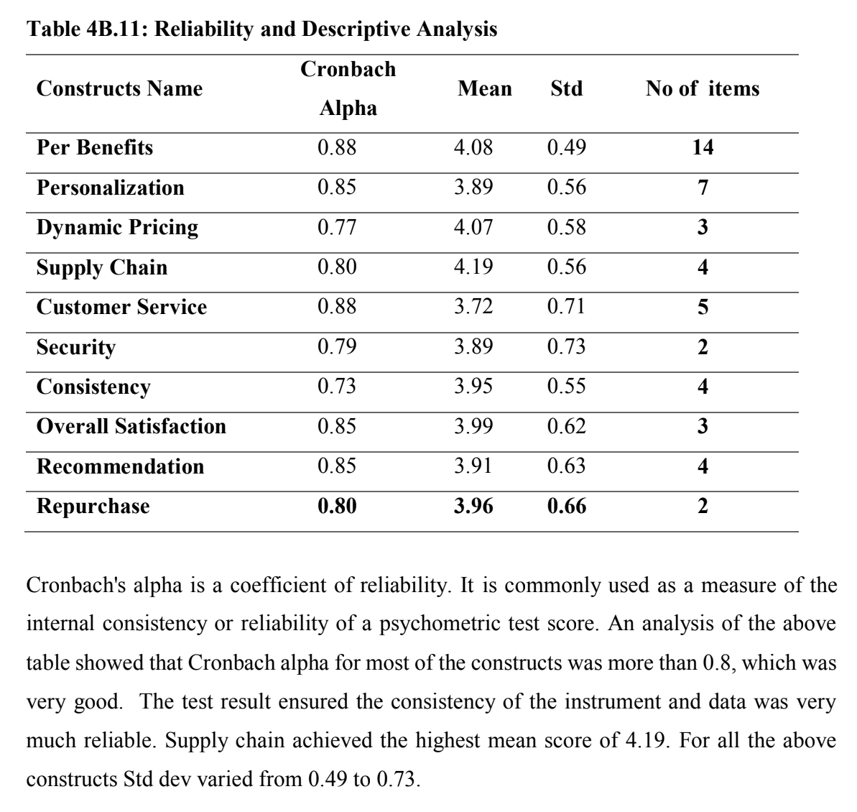

Analysing Hypothesis:
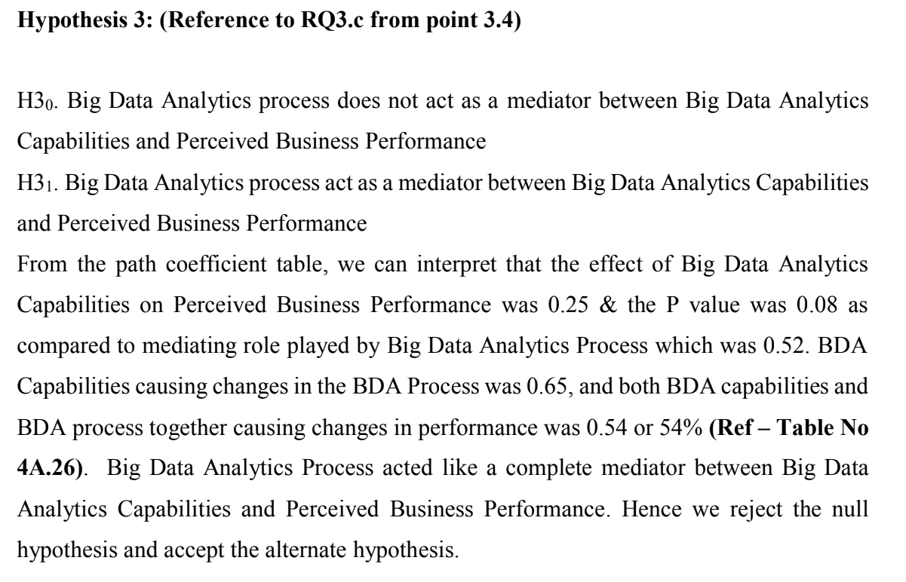
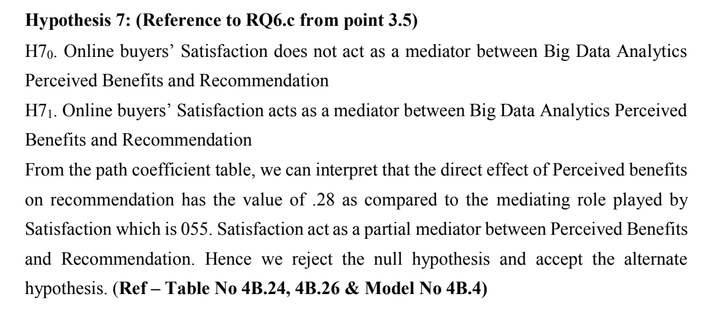

To show the results of hypotheses testing, create a table as below
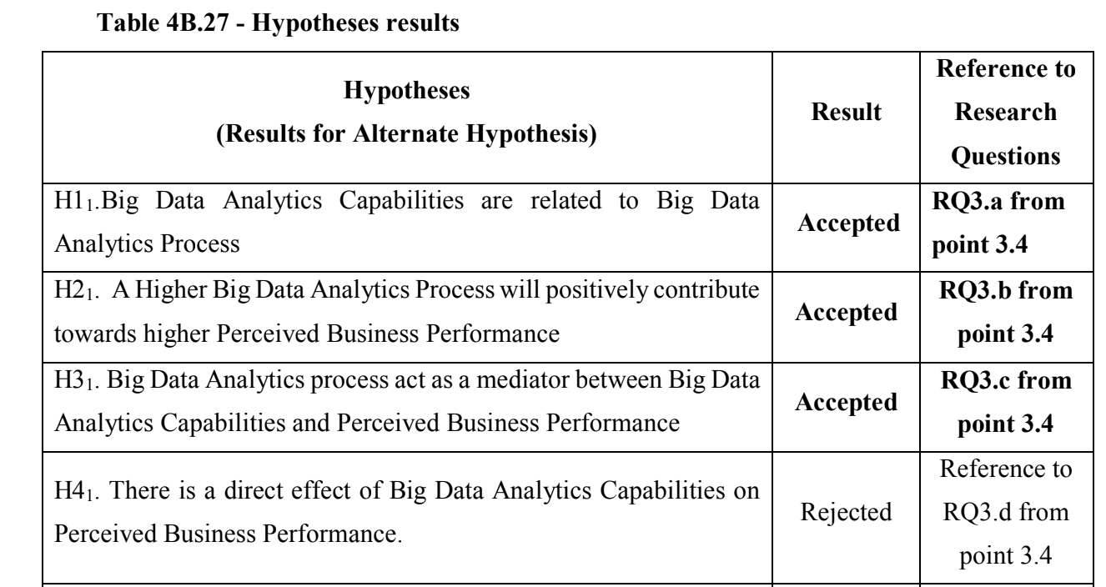

Here are short, clear descriptions for each section of a research report:
Analysis: (for each of the demographic data)
This section examines the collected data using appropriate methods or tools. It focuses on breaking down the information, identifying patterns, trends, and relationships, and presenting the results in a logical, structured way.
Interpretation: (For each of the tables and figures)
Interpretation explains what the analysed data means. It connects the results to the research objectives, provides reasoning behind observed patterns, and describes the significance of the findings in the research context.

For the overall research, write the following in detail for about 12 to 15 lines each
Findings of the research:
This section summarises the key outcomes of the analysis. It highlights the most essential insights, discoveries, and facts that directly answer the research questions.
Recommendations:
Based on the conclusions, this section suggests practical actions, strategies, or solutions. Recommendations guide future decision-making, identify areas for improvement, or indicate where further research may be needed.

Title of Research (write the title of research)

Student 1 name, Student ID, SITE, KBTU, Almaty, KBTU email address, Student ORCID
Student 2 name, Student ID, SITE, KBTU, Almaty, KBTU email address, Student ORCID
Student 3 name, Student ID, SITE, KBTU, Almaty, KBTU email address, Student ORCID
Student 4 name, Student ID, SITE, KBTU, Almaty, KBTU email address, Student ORCID
Student 5 name, Student ID, SITE, KBTU, Almaty, KBTU email address, Student ORCID

Abstract
(up to 250 words in a continuous paragraph covering all the points mentioned below)
Purpose - Explain the main aim of the study — what problem you addressed and why.
Design/methodology/approach - Describe how the research was carried out:
- Sample size
- Data collection techniques
- Analytical methods (e.g., SEM, regression)
- Overall approach
Findings - Summarise the key results and what you discovered.
Research limitations/implications - Briefly mention:
Limitations of methodology
Scope / Implications for future research
Practical implications - Explain how the results can be applied in real-world settings — for practitioners, educators, policymakers, etc.
Originality/value -
Highlight what is unique about your study and how it adds value to existing literature.
(Make sure the above abstract is written in continuous paragraph format and not in points format.)

Keywords: (Write 10 keywords related to your research title. Separate each keyword using commas.)
(Example - Generative AI, AI Adoption, Engineering Education, Learning Outcomes, Innovation Skills, AI in Higher Education, Technology Acceptance Model (TAM), Ethical Use of AI in Education, Kazakhstan)

New page
1. Introduction (about 800 words - information should have the latest details with proper citations and reference at the end in APA format)
1.1 Background
1.2 Introduction to the Research

New page
2. Literature Review (about 800 words - information should have the latest details with proper citations and reference at the end in APA format)

New page
3. Research Methodology
3.1 Research Gaps
3.2 Statement of the problem
3.3 Research Questions
3.4 Objectives of Research
3.5 Scope of the study
3.6 Research Hypotheses
3.7 Conceptual Model or Framework
3.8 Type of Research
3.9 Sample & Population
3.10 Data Collection
3.11 Tools/Techniques
3.12 Ethical Considerations
3.13 Limitations

New page
4. Data Analysis
Subheadings numbered as 4.1, 4.2, 4.3
(For all the demographic tables/figures, you need to write both analysis and interpretation, whereas for non-demographic tables/figures, you need to write only analysis.)
(All the tables and figures should have table/figure numbers with headings – left justified.)
Table 1: R² of the model
Table 2: Correlation testing
Figure 1: Conceptual Framework
Figure 2: PLS SEM
Results of Hypothesis Testing in tabular format
New Page
5. Findings, Conclusions, Recommendations
5.1 Findings (What you discovered)
- This section presents the results of your analysis.
- It includes statistical outputs, observed patterns, tested hypotheses, etc.
- It is purely factual — no opinions, no interpretations.
5.2 Conclusions (What the findings mean)
This section interprets the findings in relation to your research questions.
You explain what the findings imply, whether they support your hypotheses, and how they contribute to theory.
5.3 Recommendations (What should be done)
Based on the conclusions, you provide actionable suggestions for:
✔ educators
✔ policymakers
✔ institutions
✔ researchers

New Page
References
All references should be in APA style, in alphabetical order. The reference should match the citations in the report.

New Page
Annexure
Questionnaire – Should be neatly formatted with a consistent numbering style. Each question should have its own numbering and answer choices.
Date of Submission 23rd Nov 2025 (Sunday) Before 04 PM in a Word file– (A separate link will be shared later for uploading the submission document)
Also, you have to resubmit the latest data collection Excel sheet used for analysis
All Font Size 11 only (do not underline or italicise)
All text Font Style Times New Roman (In case your tables or figures have a different font style inside due to the use of statistical tools, just leave it as it is)
Page Margins 2.54 on all sides and Text right and left justified
Headings and subheadings in bold (font size 11 only)
Citations and References in APA style (citations and references should match)
Spacing – Before 0, After 0, and line spacing 1.5

