7.8 DOES THE ANTAGONIST IMPROVE ACROSS SESSIONS?
Section 7.3 notes that the antagonist's memory of its last prediction is cleared on re-entry, because that prediction was about a building that no longer exists. That observation is correct, and it raises a question the baseline never answered. The game tells the player on every death screen that their pages survive and so does its model of them. Nothing in the project had tested whether retaining that model makes the antagonist measurably better at catching the same player.
Experiment E13 measures it directly. One scripted player is run through twelve consecutive sessions. Everything is reset between sessions except the predictor, which keeps the counts it has accumulated. Each condition is paired with a control in which the predictor is wiped between sessions. The control is necessary rather than decorative: a trend on its own would prove nothing, because a scripted player settling into a stable route would produce the same curve without any learning at all. With the control in place, retained learning is the only difference between the two lines.
Two worlds are measured, because the answer differs between them and the difference is the substantive finding. In the first the player returns to the same facility each session. In the second the facility is regenerated between sessions, which is what the build described in Chapter 6 actually does.
Table 7.3: Captures per 1000 moves across twelve consecutive sessions (mean of 12 seeds, 400 moves per session)
Condition | First 3 sessions | Last 3 sessions | Change
Same facility, model retained | 538 | 575 | +6.9%
Same facility, model wiped (control) | 507 | 505 | -0.3%
Regenerated facility, model retained | 496 | 424 | -14.5%
Regenerated facility, model wiped (control) | 517 | 519 | +0.3%

The antagonist does improve, but only when the building stays put. Returning to the same facility, captures rise +6.9 per cent from the first three sessions to the last three, while the control stays flat within noise at -0.3 per cent. The predictor is accumulating a usable model of this particular player across runs, and the player is measurably worse off on their twelfth visit than on their first.
Carrying that model into a regenerated facility is worse than forgetting it. Captures fall 14.5 per cent against a control that is flat at +0.3 per cent. The cause is structural rather than statistical. The predictor is keyed on room indices, and regeneration changes what an index refers to, so its contexts are not so much wrong as about a building that no longer exists. It spends the better part of a session unlearning them.
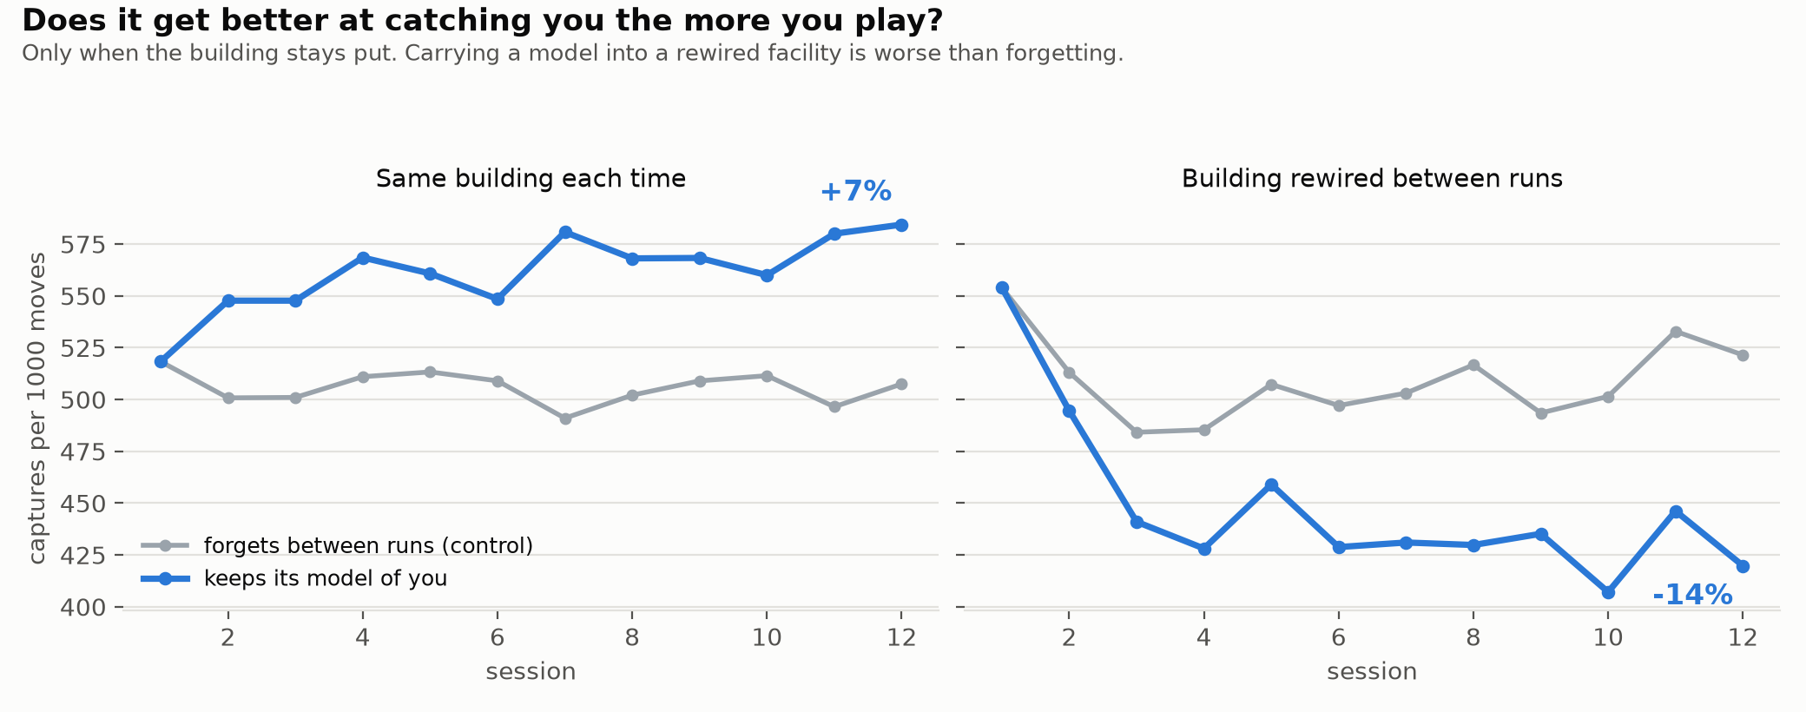
Figure 7.3: Captures per 1000 moves across consecutive sessions. The grey line is the control, which forgets between sessions. Retained learning helps in a fixed building and hurts in a regenerated one.
This is a finding about the design as much as about the model, and it cuts against the build described in Chapter 6. A new facility on every run was introduced so that the layout could not be memorised by the player, which it achieves. The measurement here shows that it also places the antagonist in the one condition where its retained model is a liability, so the sentence the game delivers at its most dramatic moment is, as shipped, not true. Two routes close the gap. The facility can be held fixed across a run of sessions, so that the retained model refers to a building that still exists; or the predictor can be re-keyed on features that do not depend on the layout, such as door degree, distance to the current objective and turn direction, so that what it learns about a player transfers between buildings. The second is the more interesting question and is recorded in Section 8.2 as future work.

