SOIL COLLECTION

PROBLEM STATEMENT:
Design and manufacture a soil collection module to collect and store different samples of soil.

AIM:
To apply innovative ideas in designing as well as to improve manufacturing skills.

SPECIFICATION:

Weight - as minimum as possible
Dimensions – it should fit in a 40*40 cm box
The soil collected must be from a depth of 5 cm or deeper.

MOTIVATION:

Due to overpopulation, there is a shortage of space to live on Earth. Also, many people are not getting home to live in due to space shortage. We can get space but then we will give birth to another crisis named Deforestation. According to national reports, it is estimated that no less than 150 million people are homeless. However, about 1.6 billion, more than 20 percent of the world’s population lack adequate housing. So we are in need to find a place for living similar to Earth. Thus many space authorities are planning to civilize some other planets so that people could live there. To live there we must know about the atmosphere there and the type of land as well. Thus we came to the design of a module that can store the soil samples from various areas and analyze them.

PRE PROJECT RESEARCH:
We had made four designs for the soil collection module:
- Archimedes screw system
- Lead screw with turf tec tubular soil sampler
- Rack and pinion
- JCB type system
• Archimedes Principle
In this principle, a screw-type system was designed and it was hollow from inside as well as was supported by a shaft on the top plywood. On the screw, there were turns of a specific pitch. So basically we had to make pitches on a cylindrical component with a cone at one of its end which is difficult to manufacture. And there was a system of sliders on the top which was to be fixed by a Vega motor and traveling a motor on a motor was also a difficult construction task. Also, the slide will not be able to take that much load of a cylinder that thick. There was a problem with the mounting also.
Secondly, we were not knowing how to pour soil into the container. We also proposed a design in which a simple worm gear and spur gear system was mounted with a motor, but to construct such a mechanism in such a small space ( cone at the end of the cylinder) was difficult, and if made we had to change the dimensions of the system which was out of the restricted dimensions given so this idea was dropped.
Drawback
- To construct such a mechanism was a bit complicated
- It also does not gain a particular height
- We were also not getting an idea of how to pour soil into the container.

• Lead Screw with Turf tec Tubular Soil Collection

The basic idea of this was to use the lead screw and collect the soil using turf tec tubular soil sampler. Now turf tec tubular sampler is a rounded cylindrical component that requires pushing of the orifice, having a sharper circular structure so it can penetrate through rocks or stones while collecting soil. One can also use the step to do it. The soil will be collected in the cylindrical portion and one can take it out manually.

Drawback
- No appropriate method to collect soil from the sampler using automation
- It will rotate continuously so the soil is not collected

• Rack and Pinion

A rack and pinion is a type of linear actuator that comprises a circular gear (the pinion) engaging a linear gear (the rack), which operates to translate rotational motion into linear motion. Driving the pinion into rotation causes the rack to be driven linearly. Driving the rack linearly will cause the pinion to be driven into the rotation. This rack and pinion mechanism were to be used to actuate the auger in a vertical direction.

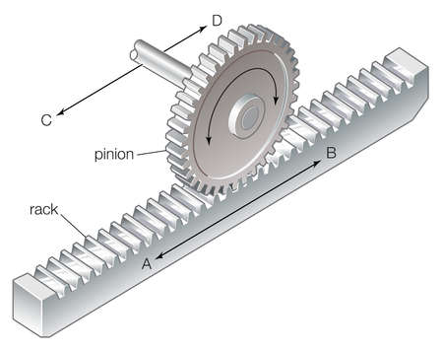

Drawback
- Not enough torque provided to penetrate through the soil to a depth as mentioned in the problem statement

• JCB Type

In this design, we used a JCB bucket for digging the soil and the design of an arm to support and move the bucket was made.

Drawback
- It is not able to collect soil if the type of soil is very hard
- It is not able to collect the soil up to 5 cm
- As it is to be controlled by the pneumatics and it is difficult to design in the space given

After the team meeting we decided the pros and cons of the project so we started extracting the advantages of the ideas we submitted, and then decided to change the design a little bit with the combination of ideas and came to a conclusion and with a new design, so here are the parts we used for the final design.

PART | DIMENSION | DESCRIPTION
Tauren | SHAFT DIA= 8mm | RPM=100  Torque= 90 kg-cm
Upper wood | 300*300 mm | Mounting of motor and the whole assembly
Lead screw | Length=330 mm  Dia = 20 mm | To convert rotational motion into translational motion
Lead nut | Top= 40*40 mm  Length 80 mm | To mount the johnson motor and auger
Johnson motor | RPM = 60 | To give motion to the auger(rotational)
CNC Bearing | 10 mm inner Diameter  35*40 mm area | For smoothening the motion of the lead screw
Vega motor | RPM= 10 | For controlling the rotation of the soil collection module
Collection module | 200*200 mm  With a 100*100 mm cut section | Module:- for the slot for the collection of the soil  Slot:- for the inlet of the auger inside the soil.
Auger | Length = 300 mm  Dia. = 25 mm  The screw at the bottom Dia. 6mm | To penetrate the soil and collect the soil in the profile.

Designing:
We decided to make use of an auger(drill) to collect the soil. The auger would be rotated with the help of a motor. Since higher torque was required, we used a lead screw and a lead nut instead of rack and pinion. This arrangement was joined with the auger with the help of an L-Clamp connected to the lead nut through a wooden ply. To prevent the rotation and allow only vertical motion of the lead nut around the lead screw, we decided to use a couple of CNC bearings for support. Shafts were passed through these bearings and supported with the shaft supporters on the plywood at the top. We used Johnson motor and Tauren motor to provide more torque to auger and lead screw respectively. The soil storage was placed below the auger and lead screw arrangement. This unit consists of 3 containers and a slot through which the auger would collect the soil. Here, the storage unit was placed in such a way that the center of the slot coincided with the axis of the auger. This container can be rotated for collecting the soil through the slot and then storing it in different containers. For collecting the soil, the auger penetrates the soil through the slot in a clockwise sense, the soil gets collected in the auger and the lead nut is again lifted so the auger comes out of the soil. After acquiring required height, the storage unit can be rotated so the auger can come exactly above one of the containers. Then, the auger would be rotated in an anti-clockwise sense to remove the soil from the auger into the container.
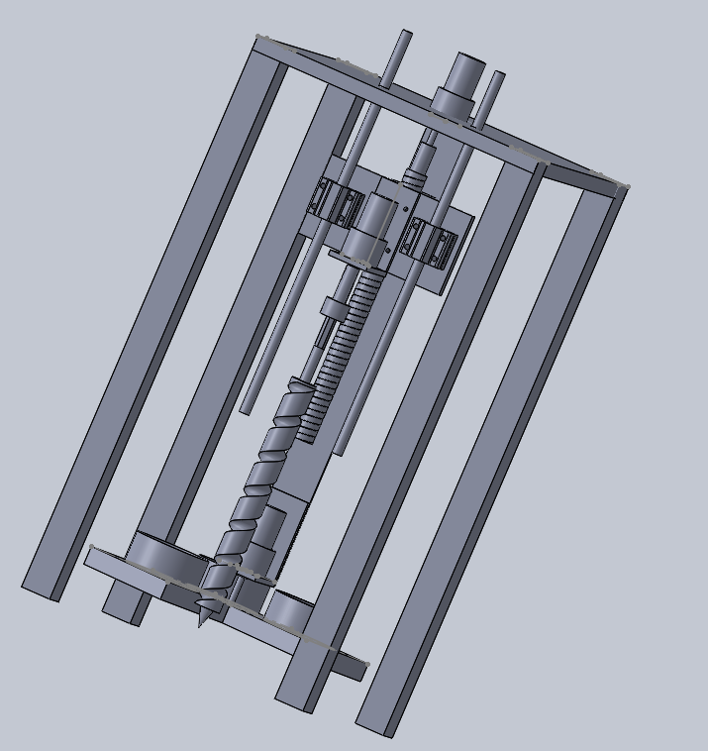
Components used:
Auger:-
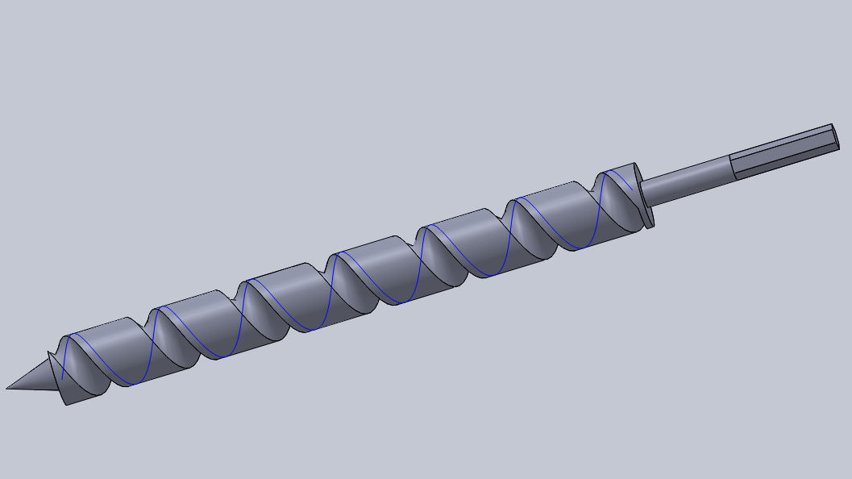
It is a tool resembling a large corkscrew, for boring holes in wood as well as soil. While boring holes in the soil, the soil gets collected in its pitch.

Lead Screw and Lead Nut:-
This arrangement was used to multiply the applied torque on the soil to make drilling easier.
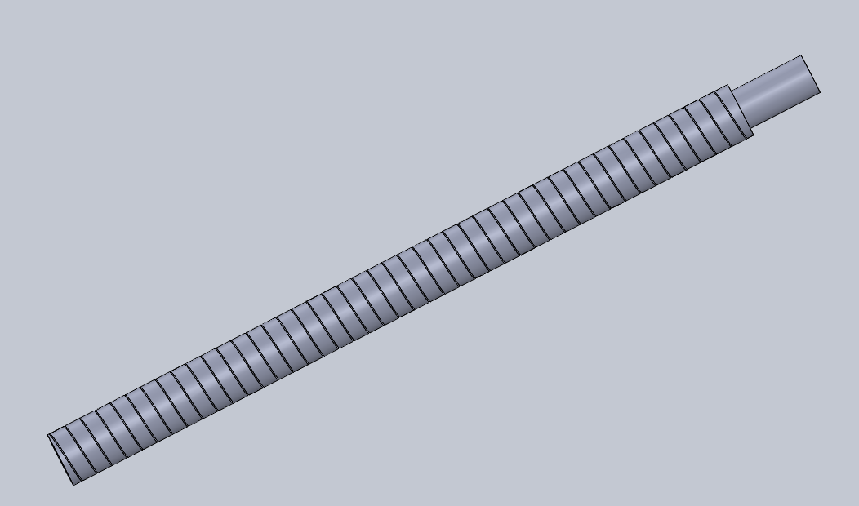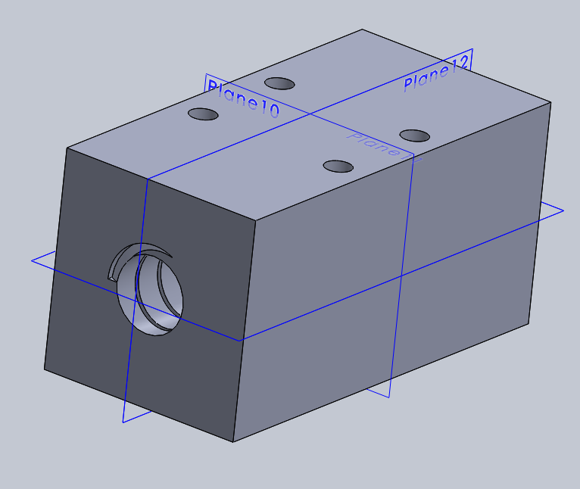
The lead screw would be rotated with the help of a taurin motor. We kept the lead screw fixed as we wanted the motion of the lead nut in a vertical direction. To prevent the rotation of a lead nut, a couple of CNC bearings were used as shown in Solidworks design.
CNC Bearings:-
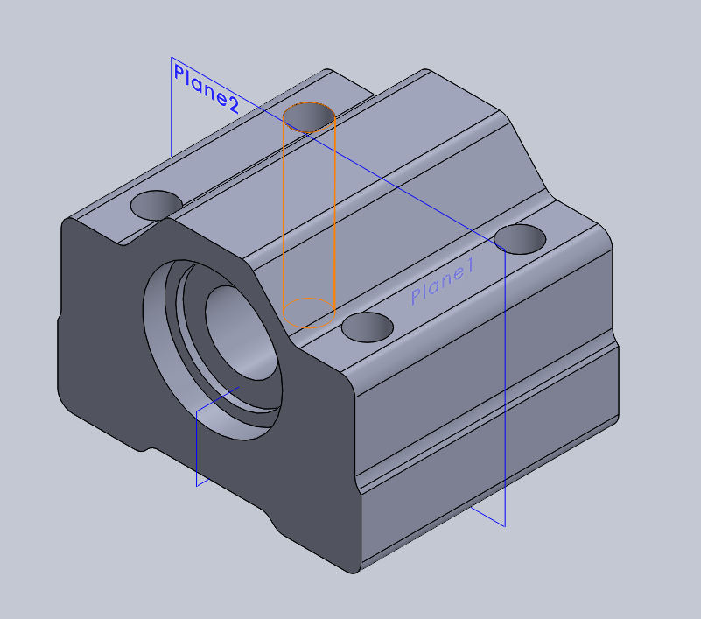
CNC bearings were supported on the wooden ply attached to the lead nut. A shaft passed through each bearing and this shaft was fixed at the top of the module so that the CNC bearing can translate freely in the vertical direction.

Soil Storage unit:-
This unit consists of 3 cylindrical containers of diameter 72.75mm each. The containers are supported on a square wooden ply base of dimension 20*20 sq cm. This base is divided into 4 parts, 1 slot for the auger to collect soil and the rest for containers. This unit is rotated with help on a motor of 10 rpm. A coupler is manufactured for coupling of motor and wooden base.
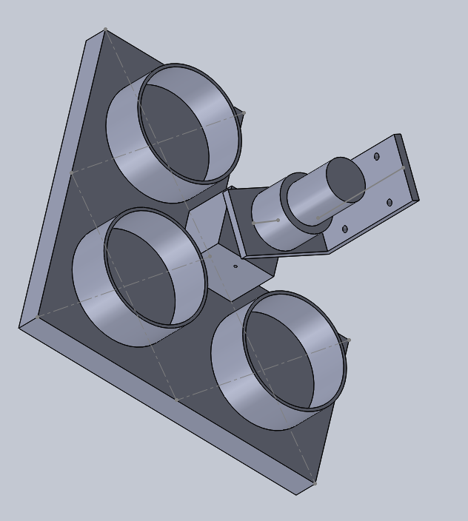

Couplers:-
- Storage unit coupler:
This coupler was manufactured from teak wood of 4cm * 4cm and of appropriate height. A hole of 6mm was drilled in one surface of the coupler for penetrating the shaft of the motor into it. This coupler was joined to a storage unit with rivets.
- Coupler for auger:
This coupler was made of aluminum and was used to couple the motor with an auger.
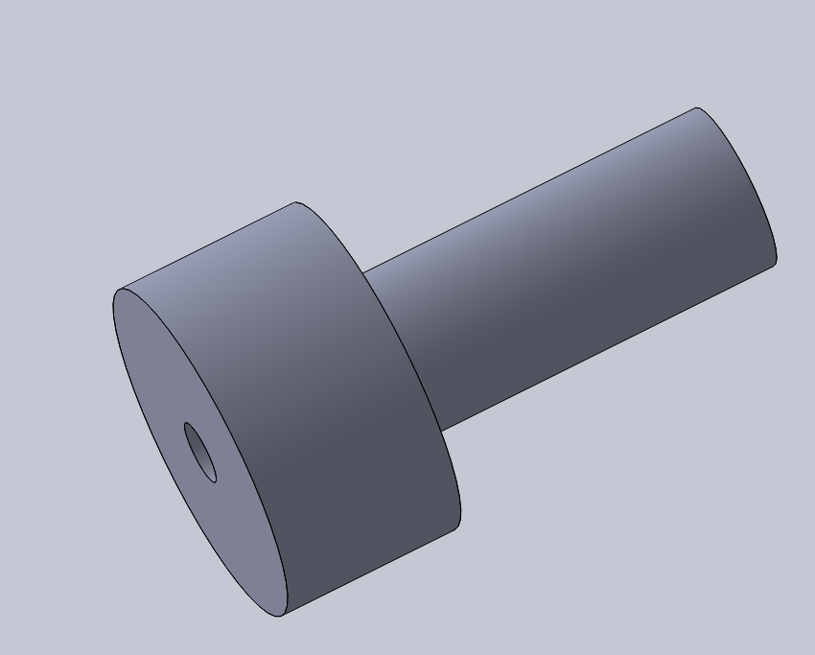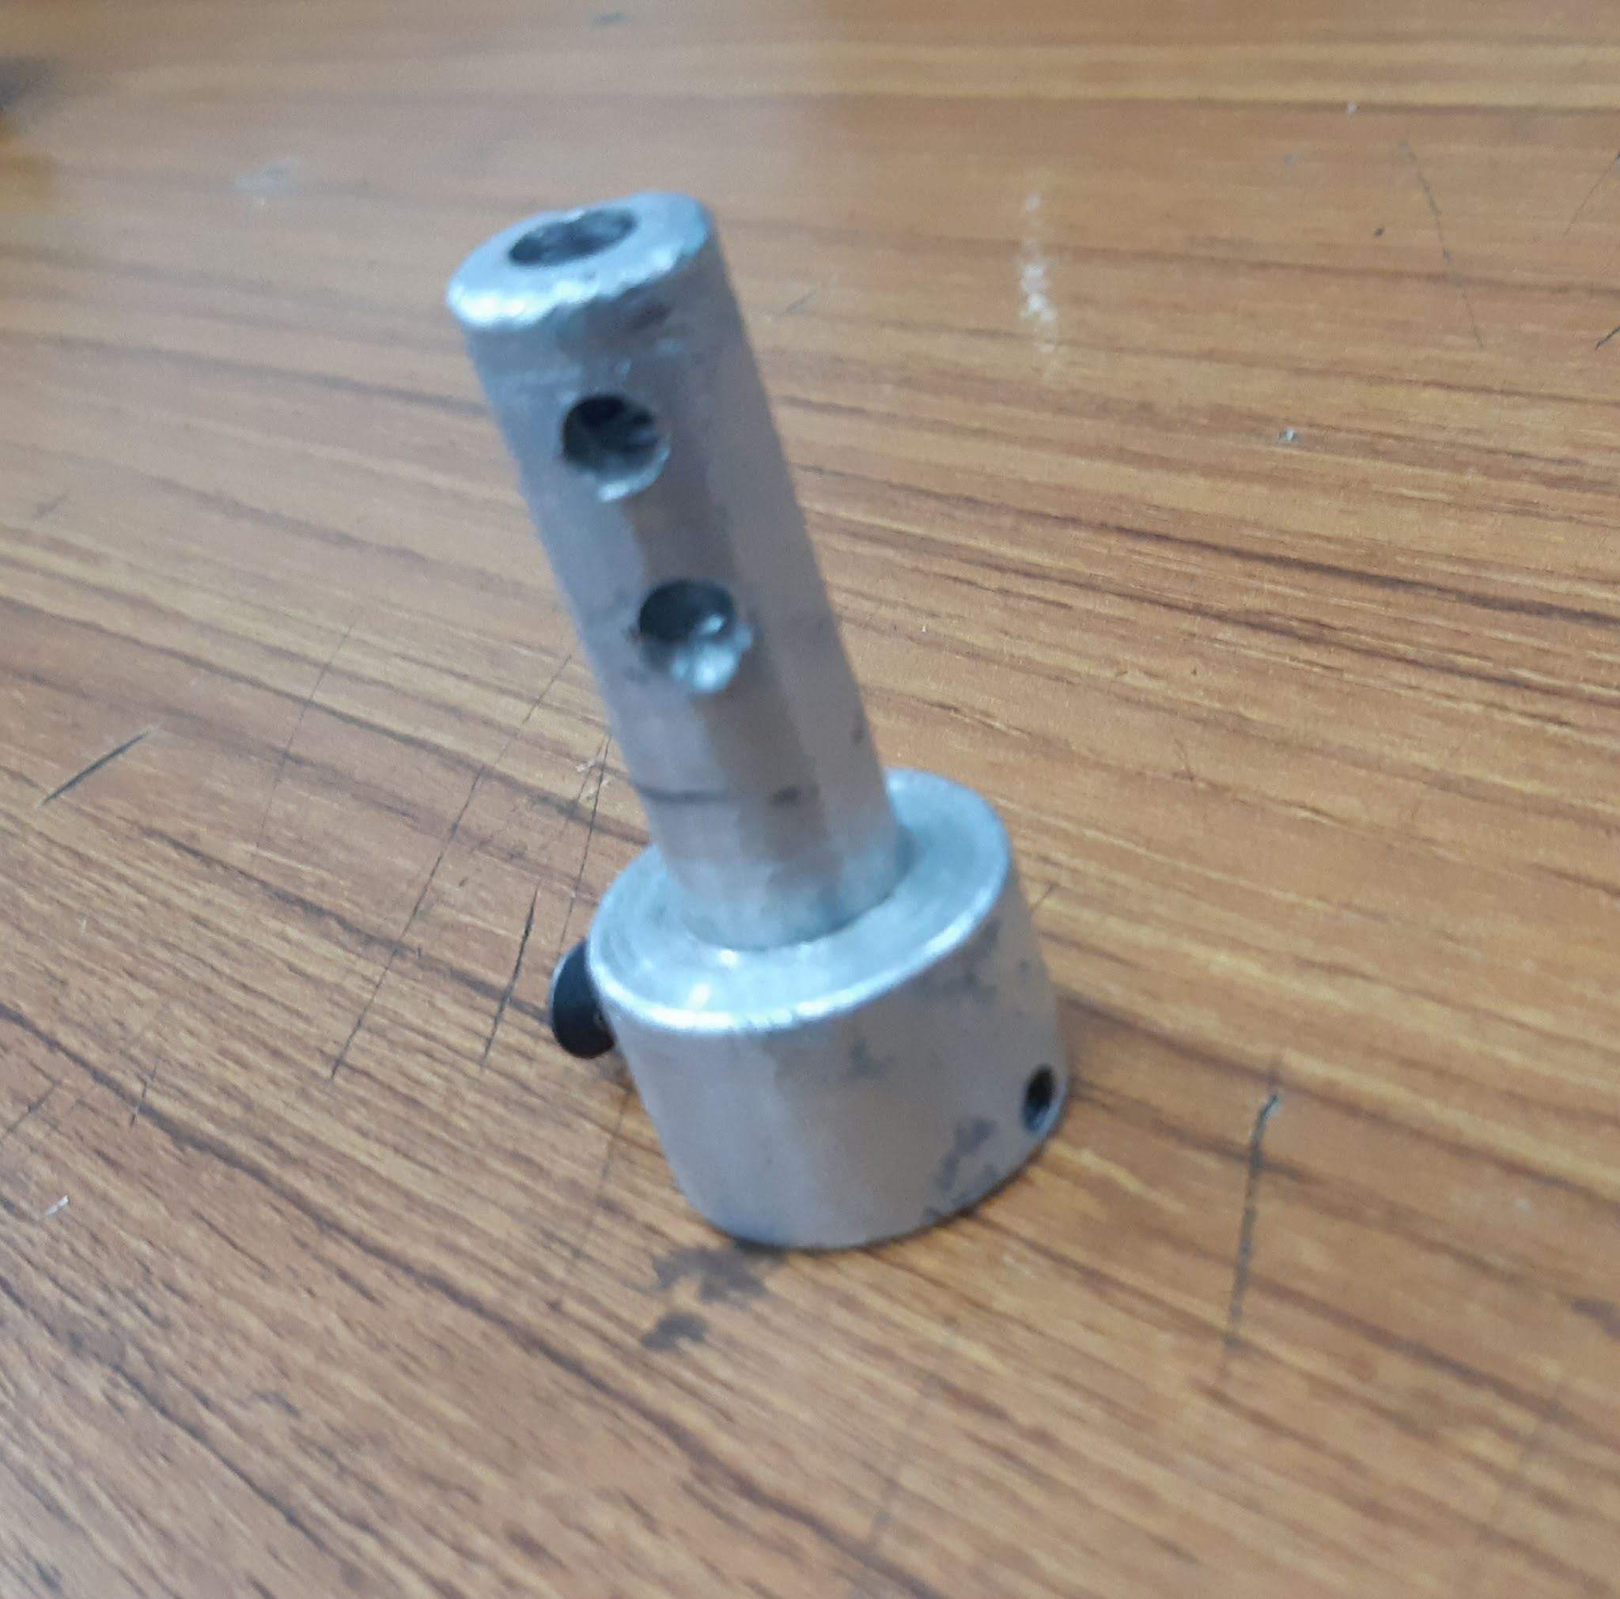
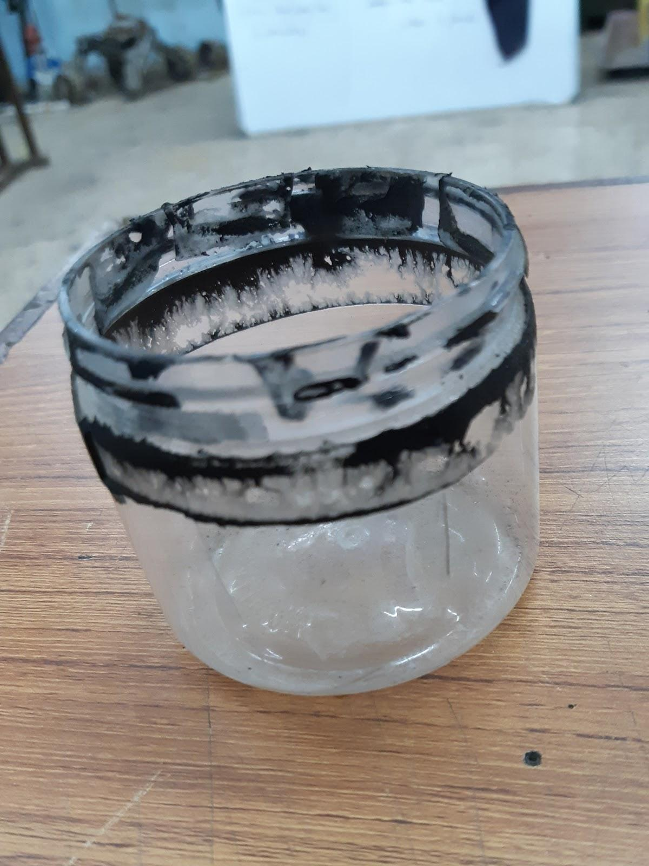
Container:-
Three plastic containers were used to store the soil. The diameter of each container is 72.75mm. The height of the container is 7cm.

Assembly:
- Firstly, we assembled the CNC bearings and the L-clamp with the wooden ply.
- We inserted the lead screw in the lead nut and then joined the lead nut with the wooden ply so that the L-clamp can be connected to the nut through the ply.
- We made holes in the topmost plywood for supporting the Tauren motor. Then, we coupled the shaft of Tauren with the lead screw.
- After this, we drilled holes for the support shafts that would pass through the CNC bearings.
- We mounted the johnson motor on the L-clamp and coupled it with the auger.
- We joined the coupler with the soil storage unit along with the vega motor and L-clamp. With this L-clamp, we joined the wooden support that would connect the top ply and the soil storage unit.
- Later on, we decided to attach a brush to the CNC shaft. This brush will remain fixed as the shaft is also fixed and will remove the soil when the auger rotates in an anticlockwise direction making a collection of soil easier.
- Finally, we did all the wiring required to supply power to all the three motors.
Calculation:
Torque required to raise the load :
T_{r}=F.d_{m}/2.[{L+𝝅fd_{m}secα}/{𝝅d_{m}-flsecα}] +T_{c}
d_{m}=mean diameter=36.77
f=coefficient of thread friction=0.15
f_{c}=coefficient of collar friction=0.1
F=load=50N
T_{c}=friction torque of thrust collar
2α=thread angle=29° for acme thread
l=pitch*no. of starts =6.04
T_{c}=Ff_{c}d_{c}/2 d_{c}=mean diameter
T_{r}=1915.2298*10⁻⁴ Nm

Problems Faced and Solutions Taken:
- The CNC bearings were difficult to join to the lead nut surface as drilling holes in the lead nut of 4 cm thickness is a very difficult task. Since 4 holes were pre-drilled on nuts, we decided to manufacture a wooden ply of 80 mm height and width such that it could accommodate 2 CNC bearings and one L-Clamp. This wooden ply was fixed with a lead nut with the help of bolts.
- We faced difficulty in making a fermo for the johnson motor that was to be attached to the auger, as the holes made did not coincide with the ones in the motor. So, we had to make another fermo to match the holes.
- The coupler that was to be used for the auger turned out to be eccentric. We thought of manufacturing a coupler with wood but that would not provide enough support and the threadings would also not last longer hence another aluminum coupler was provided.
- Initially, we had taken the johnson motor for a lead screw but after our first testing, we decided to take Tauren motor because johnson motor couldn't provide sufficient torque to the lead screw.
- After the first testing, we found that our lead nut got stuck at the bottom of the lead screw because its pitch was slightly different at the bottom. Since we had used a Tauren motor, it provided very much torque and the nut went to the extreme bottom. Because of very much force, the Allen bolt came out of the lead screw and threadings got damaged. After that, we found that the lead nut also got internally damaged making it difficult to use again.

