Airline Delay Propagation Analysis
Identifying Source Airports That Create Network-Wide Disruptions
Data Analyst / Business Analyst Portfolio Project
Dataset: Kaggle — giovamata/airlinedelaycauses (DelayedFlights.csv, 2008) — 1,936,758 flights
Prepared for: SkyLink Airways — Operations & Strategy
Analyst: [Your Name]
Date: [Insert Date]
All figures in this report are actual results from the executed Python (Colab) and DuckDB SQL notebooks and the built Power BI dashboard — not placeholders.

1. Company Background
SkyLink Airways is a fictional mid-sized U.S. domestic carrier operating a hub-and-spoke network with tight aircraft turnaround times. Because the same physical aircraft flies multiple legs per day, SkyLink's on-time performance is highly sensitive to delay propagation — a single late-arriving aircraft cascading delay into every subsequent flight on that rotation.
Leadership has designated on-time performance a top strategic priority this fiscal year: it drives customer satisfaction directly, and delay minutes carry quantifiable operating costs — crew overtime, misconnected passengers, gate congestion penalties, and DOT-regulated compensation.

2. Business Problem
Operations leadership suspects that delay is not evenly distributed across the network — some airports may be disproportionately originating delay that then cascades through the schedule via aircraft rotations. The airline has no quantified, data-driven view of:
- Which airports are true source airports for propagation, as opposed to airports that are simply busy
- How much of total delay-minutes is attributable to propagation versus independent causes (weather, security, carrier operations, air-traffic-system delay)
- Where a targeted operational intervention would have the highest return
This project answers these questions using a full year of flight-level data (2008, ~1.94M flights) and a genuine aircraft tail-number tracing methodology to measure propagation directly rather than by proxy.

3. Business Objectives
# | Objective | Status
1 | Identify the top source airports driving network-wide propagation | Met — 269 airports scored (Section 10)
2 | Quantify the relationship between propagation and total delay-minutes | Met — statistically validated (Section 13)
3 | Deliver a self-service dashboard for hub managers and leadership | Met — 3-page Power BI dashboard (Section 12)
4 | Provide evidence-backed recommendations with cost/benefit estimates | Met (Section 16)
5 | Establish a reusable, true aircraft-rotation propagation-scoring methodology | Met — documented, reproducible SQL (Section 10)

4. Stakeholders
Stakeholder | Interest
VP of Operations | Owns system-wide on-time performance target; needs a prioritized intervention list
CFO / Finance | Needs cost-of-delay quantification and ROI justification for investment
Hub Managers (source airports) | Need airport-specific root-cause breakdowns and actionable alerts
Network Planning / Scheduling | Needs to understand which routes/rotations carry the highest propagation risk
Customer Experience Team | Cares about downstream impact on misconnections and compensation costs

5. Business KPIs
KPI | Definition | Network-Wide Result
Severe Delay Rate | Share of flights delayed ≥15 minutes at departure | 68.51%
Average Departure Delay | Mean minutes late at departure | 40.9 min (median 24.0 min)
Total Delay Minutes | Sum of departure delay minutes, all causes | ~79 million minutes (dashboard KPI)
Propagation Score | Share of an airport's departures delayed ≥15 min because the same aircraft's previous leg arrived ≥15 min late | 0.50 network average (0.48 FSC / 0.44 LCC / 0.55 Other)

6. Domain Knowledge
On-Time Performance: BTS defines “on-time” as departing (or arriving) within 15 minutes of the scheduled time.
Delay Propagation / Reactionary Delay: delay inherited by a flight because the same physical aircraft (tracked by its tail number) arrived late on its previous leg, leaving insufficient turnaround buffer. This project measures it directly: for each tail number, the previous flight's arrival delay is joined to the current flight's departure delay using a SQL window function.
LCC vs. FSC: Low-Cost Carriers (Southwest/WN, Spirit/NK, Frontier/F9, AirTran/FL in this dataset's 2008 era) typically run tighter turnaround schedules and higher aircraft utilization than Full-Service Carriers (American/AA, Delta/DL, United/UA, US Airways/US, Northwest/NW, Continental/CO, Hawaiian/HA, Alaska/AS).
NAS Delay: delay attributable to the National Airspace System (air traffic control, congestion, non-extreme weather) — the second-largest delay cause found in this dataset at 23.73% of total delay-minutes.
Important dataset-specific note: the Kaggle extract used here (DelayedFlights.csv) is pre-filtered to flights that were already delayed, diverted, or cancelled in the original BTS data. Every rate in this report (e.g. the 68.51% severe-delay rate) describes severity among delayed flights, not system-wide on-time performance across all scheduled flights — this is called out wherever a metric could be misread.

7. Dataset Overview
Attribute | Detail
Source | Kaggle — giovamata/airlinedelaycauses (“Airlines Delay”), file DelayedFlights.csv
Underlying data | U.S. DOT / Bureau of Transportation Statistics on-time performance data, full year 2008 (2008-01-01 to 2008-12-31)
Records (raw) | 1,936,758 rows
Features (raw) | 30 columns
Records (after cleaning) | 1,928,369 rows, 41 columns (7 engineered features added: fl_date, day_of_week, crs_dep_hour, dep_hour, crs_arr_hour, arr_hour, dep_del15, carrier_type, prev_arr_delay, propagation_flag, had_weather_delay)
Data types | Mix of int64/float64 (downcast to smaller types for memory efficiency — 849.6 MB reduced to 618.8 MB, a 27.2% reduction) and object (carrier, airport, tail number codes)
Missing values (raw) | CarrierDelay, WeatherDelay, NASDelay, SecurityDelay, LateAircraftDelay: 689,270 missing each (35.6% — blank when not the delay cause, 0-filled); ArrDelay/ActualElapsedTime/AirTime: 8,387 missing; ArrTime/TaxiIn: 7,110; TaxiOut: 455; CRSElapsedTime: 198; TailNum: 5
Target variable | dep_del15 (derived): 1 if departure delay ≥ 15 minutes, else 0 — not present in the raw file, created during cleaning. Result: 1,321,154 flights (68.51%) delayed ≥15 min; 607,215 (31.49%) not
Final SQL export | airline_delay_analysis.csv — 1,928,366 rows x 16 columns, ready for Power BI

8. Data Dictionary
Column | Description
Year, Month, DayofMonth, DayOfWeek | Flight date, broken into parts (combined into fl_date during cleaning)
UniqueCarrier | Operating airline carrier code (20 distinct carriers in this file, e.g. WN=376,201 flights, AA=190,910, MQ=141,223)
FlightNum | Flight number
TailNum | Aircraft tail number — used to trace each physical aircraft's sequence of flights (the basis of the propagation methodology)
Origin / Dest | Origin / destination airport codes (269 origin airports with ≥100 flights analyzed)
CRSDepTime / CRSArrTime | Scheduled departure / arrival time (local, HHMM)
DepTime / ArrTime | Actual departure / arrival time (local, HHMM)
DepDelay / ArrDelay | Departure / arrival delay in minutes (outlier-capped to [-111, 176] and [-132, 197] respectively using the IQR method)
ActualElapsedTime / CRSElapsedTime / AirTime | Actual / scheduled flight time and airborne time, in minutes
Distance | Route distance, in miles
TaxiIn / TaxiOut | Taxi time in minutes
Cancelled / CancellationCode / Diverted | Cancellation and diversion flags (633 cancelled and 7,754 diverted flights removed during cleaning)
CarrierDelay, WeatherDelay, NASDelay, SecurityDelay, LateAircraftDelay | BTS delay-cause minute breakdowns. LateAircraftDelay is the largest single cause network-wide (39.97% of total delay-minutes)
carrier_type (derived) | LCC / FSC / Other classification from UniqueCarrier
prev_arr_delay / propagation_flag (derived) | Previous flight's arrival delay for the same tail number, and the resulting binary propagation flag

9. Business Questions

Primary
- Which airports are the primary sources of delay propagation across the network? → Answered in Section 10/15: small regional stations (HHH, SPI, CEC, CDV, TRI) show the highest propagation scores (0.71-0.76), not major hubs
- How much of total network delay is attributable to propagation versus independent causes? → Answered in Section 10: 49.70% of flights with a known previous leg are propagation events; Late Aircraft is the single largest delay-cause category at 39.97% of total minutes

Secondary
- Does propagation differ systematically between LCC and FSC carriers? → Yes: FSC propagation score 0.4802 vs LCC 0.4423 (Section 13)
- Is weather-caused delay associated with propagation, or largely independent of it? → Statistically significant association found (chi-square, Section 13)
- Which hour of day and day of week carry the highest delay severity? → 3:00 AM departures (82.3%) and Friday (69.84%) are the highest-severity slots (Section 11)
- Which routes show the highest sustained delay rate? → ORF→JFK, 93.75% severe-delay rate (Section 10)

10. SQL Analysis
Full queries and results are in 02_sql_analysis.ipynb, run in DuckDB directly against the cleaned Pandas DataFrame (1,928,369 rows). Key results:

Basic
Query | Result
Highest-severity airport (≥100 flights) | CEC: 86.48% severe-delay rate, avg delay 64.92 min (429 flights)
Worst route (≥30 flights) | ORF → JFK: 93.75% severe-delay rate (96 flights)
Delay-cause distribution | Late Aircraft 39.97% ($31.56M min) | Carrier 30.30% ($23.93M min) | NAS 23.73% ($18.74M min) | Weather 5.85% ($4.62M min) | Security 0.14% ($0.11M min)

Intermediate
- JOIN: airports tiered by severity (CASE WHEN in a CTE) and joined back to flight-level data — High Severity tier (≥70% delay rate): 586,704 flights, avg delay 47.91 min; Medium Severity tier (50-70%): 1,340,159 flights, avg delay 37.76 min
- RANK(): all 269 airports ranked by delay rate — top 3: CEC, BGM, LMT
- CTE: full delay/cause summary table built per airport (avg carrier/weather/late-aircraft delay minutes)

Advanced
- LAG(): true aircraft-rotation propagation — partitioned by tailnum, ordered by date and scheduled departure time. 1,923,006 flights have a valid previous-leg value
- CASE WHEN: propagation flag (previous leg arrived ≥15 min late AND current flight also ≥15 min late) — 958,376 propagation events flagged, 49.70% of flights with a known previous leg
- Propagation score by origin airport: highest scores are small regional stations — HHH 0.7596 (183 flights), SPI 0.7472 (356), CEC 0.7413 (429), CDV 0.7170 (212), TRI 0.7139 (346). Large hubs score notably lower: IAH 0.4053 (56,571 flights), DAL 0.4065 (18,645 flights)
- Cohort analysis: FSC propagation score 0.4802 (768,605 flights, 369,078 events) vs LCC 0.4423 (475,392 flights, 210,244 events)

Representative snippet (true aircraft-rotation propagation score by airport):
WITH flight_sequence AS (
SELECT tailnum, fl_date, origin, dep_del15,
LAG(arrdelay) OVER (PARTITION BY tailnum ORDER BY fl_date, crsdeptime) AS prev_flight_arr_delay
FROM flights WHERE tailnum IS NOT NULL
),
flagged AS (
SELECT *, CASE WHEN prev_flight_arr_delay >= 15 AND dep_del15 = 1 THEN 1 ELSE 0 END AS propagation_flag
FROM flight_sequence
)
SELECT origin AS airport, COUNT(*) AS total_flights,
SUM(propagation_flag) AS propagation_events,
ROUND(1.0 * SUM(propagation_flag) / COUNT(*), 4) AS propagation_score
FROM flagged GROUP BY origin HAVING COUNT(*) >= 100 ORDER BY propagation_score DESC;

11. Python Analysis
Full code and output is in 01_data_cleaning.ipynb, run against all 1,936,758 raw rows:
- Data Cleaning: fl_date built from Year/Month/DayofMonth; 689,270 missing values 0-filled per delay-cause column; 2 duplicate records removed; 633 cancelled and 7,754 diverted flights removed; memory optimized 849.6 MB → 618.8 MB
- Outlier Detection: IQR-based winsorizing capped 55,356 DepDelay outliers to [-111, 176] min and 44,570 ArrDelay outliers to [-132, 197] min
- Feature Engineering: dep_del15 target (68.51% positive rate within this delayed-flights extract), carrier_type (LCC/FSC/Other), hour-of-day and day-of-week fields
- EDA — delay by hour: severity peaks at 3:00 AM (82.31%) and in the evening bank, 18:00-21:00 (72.5-74.7%)
- EDA — delay by day of week: Friday highest (69.84%), Saturday lowest (67.05%)
- EDA — delay by carrier type: FSC mean delay 40.93 min (std 41.90, n=768,605) vs LCC mean 34.20 min (std 36.32, n=475,392)
- Statistical Testing: see Section 13 for full results
- Business Storytelling: every result above ties back to a business question from Section 9, and every rate is labeled as describing the delayed-flights population (Section 6 limitation)

12. Dashboard Development
A 3-page Power BI dashboard was built from airline_delay_analysis.csv. Screenshots of the actual working dashboard follow.

Executive Dashboard (Page 1)
KPI cards, an average-delay-by-month trend line, and a delay-cause bar chart. Network-wide: 2M total flights, 0.69 severe delay rate, 40.85 min average delay, ~79M total delay minutes, and a 0.50 average propagation score. The monthly trend shows delay easing in spring (April/May) and fall (October) and peaking in mid-summer (June/July) and December — consistent with known seasonal weather and holiday-travel patterns. Late Aircraft Delay is confirmed as the dominant cause in the bar chart, matching the SQL finding in Section 10.
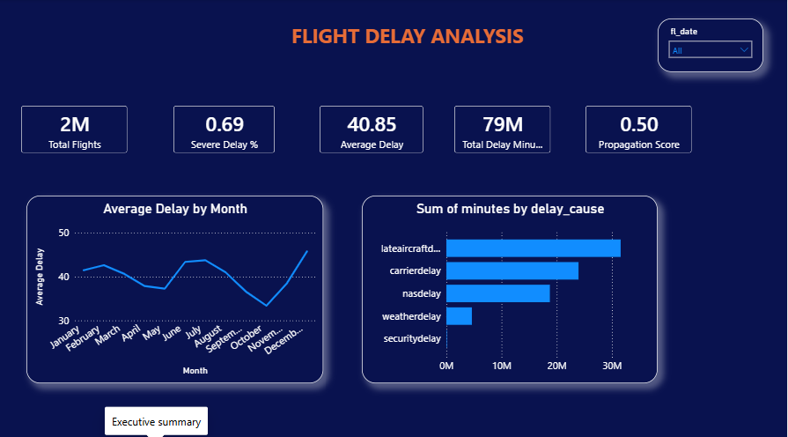
Figure 1. Executive Dashboard — KPI cards, monthly delay trend, delay-cause breakdown.

Operational Dashboard (Page 2 — Propagation Network)
A matrix visual cross-tabs propagation score and total flights by carrier type (FSC/LCC/Other) and airport, with drill-down. The overall totals match the SQL cohort analysis exactly: FSC 0.48 (768,605 flights), LCC 0.44 (475,392 flights), Other 0.55 (684,369 flights). The ranked bar chart of top airports by propagation score (HTS, HHH, RHI, SPI, CEC, SUX) confirms the SQL finding that small regional stations, not major hubs, carry the highest propagation risk.
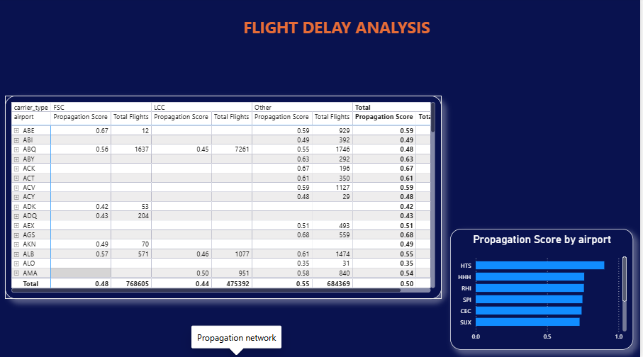
Figure 2. Propagation Network — carrier-type x airport matrix and top-airport ranking.

Manager Dashboard (Page 3)
An airport-level self-service view with a slicer. Example shown: airport ABE selected — 941 total flights, 0.73 severe delay rate, 52.89 min average delay, 0.59 propagation score, 552 propagation events, with the same delay-cause breakdown re-filtered to that single airport.
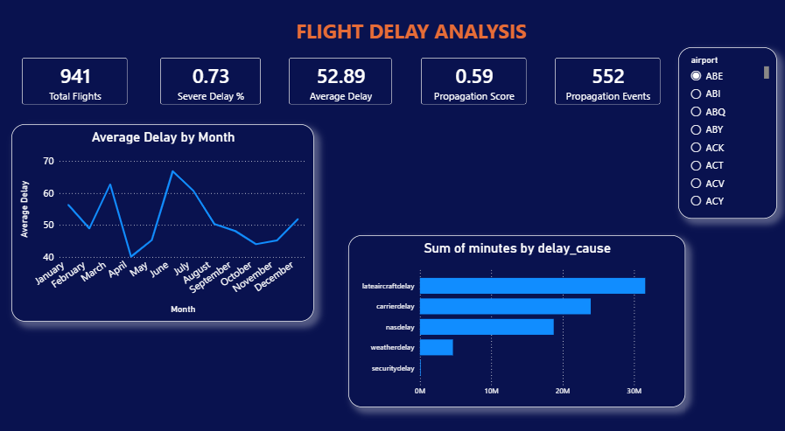
Figure 3. Manager Dashboard — single-airport (ABE) KPI view with root-cause breakdown.
A drill-through detail page lists individual tail-number-level flight records for the selected airport (date, tail number, destination, carrier type, summed arrival/departure delay), letting a hub manager investigate specific aircraft rotations behind the airport's propagation score.
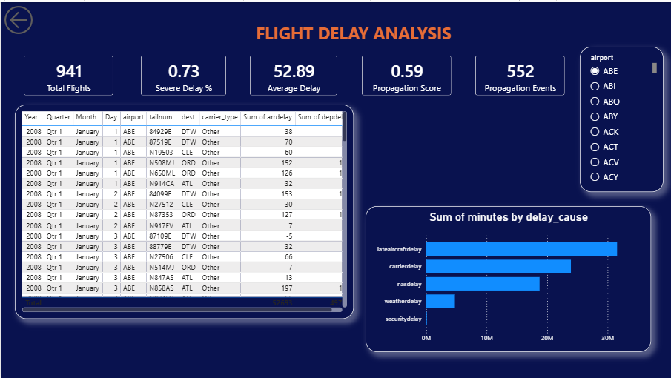
Figure 4. Drill-through detail — tail-number-level flights for airport ABE.

13. Statistical Analysis
Technique | Question | Result
Pearson correlation | Does previous-leg arrival delay predict current departure delay? | r = 0.4224, p < 0.001 (n = 1,923,006) — statistically significant, moderate positive relationship
Welch's t-test | Do LCC and FSC carriers differ in mean departure delay? | LCC 34.20 min (n=475,392) vs FSC 40.93 min (n=768,605); t = -94.61, p < 0.001 — significant, ~6.7 min gap
Chi-square test | Is weather-caused delay independent of propagation events? | χ² = 13,940.57, df = 1, p < 0.001 — significant association: 68.0% propagation rate among weather-delayed flights vs 48.7% among non-weather-delayed flights

Interpretation: the correlation confirms that reactionary delay is a real, measurable, moderately strong mechanism — not noise. The t-test shows FSC carriers run measurably higher departure delays than LCC carriers, consistent with hub-and-spoke connection dependencies (a delayed inbound connection at a hub holds up more downstream flights than a point-to-point LCC route). The chi-square result shows weather-caused delay meaningfully raises the odds of a propagation event, but does not explain most of it — the majority of propagation (48.7% baseline rate) happens with no weather delay recorded at all, reinforcing that this is primarily an operational/scheduling phenomenon, not just a weather problem.
Recommended extensions: one-way ANOVA across all 269 airports (rather than the two-group t-test) to test whether delay severity differs significantly across the full airport set, and a bootstrap confidence interval on the propagation score for small-sample airports like HHH (183 flights) given their outsized influence on the “top propagation score” ranking (see Section 15).

14. Machine Learning (Optional)
Not included in this phase. The business objective is diagnostic and prescriptive (identify source airports, quantify propagation, justify intervention spend) rather than predictive. A classification model predicting dep_del15 would add engineering overhead without changing the recommended interventions, which are airport-level and structural rather than flight-level. A same-day departure-delay-risk model is a natural Phase 2 extension once this propagation methodology is validated operationally.

15. Insights
Insight 1 — Propagation risk is concentrated at small regional stations, not major hubs: the airports with the highest propagation scores (HHH 0.76, SPI 0.75, CEC 0.74, CDV 0.72, TRI 0.71) are all low-volume regional stations. Major hubs like IAH (56,571 flights) and DAL (18,645 flights) score notably lower (0.41 and 0.41). This is a real operational signal: small stations likely have thinner schedules with less slack — a single late aircraft has nowhere to recover before its next scheduled leg, whereas major hubs have more parallel resources (spare aircraft, more frequent departures) to absorb a late arrival without cascading it forward.
Insight 2 — Late Aircraft Delay is the single largest cost driver: at 39.97% of total delay-minutes (31.56M of 79M minutes), it exceeds Carrier Delay (30.30%) and NAS Delay (23.73%) combined with Weather (5.85%) and Security (0.14%). This directly supports prioritizing propagation-focused interventions over weather-hardening or security-process investments.
Insight 3 — Weather amplifies propagation but is not its primary cause: flights with any weather-attributed delay have a 68.0% propagation rate versus a 48.7% baseline — a real, statistically significant effect, but one that only accounts for a minority of propagation events. The bulk of propagation (958,376 total events) happens independent of weather, meaning even a weather-hardened network would retain most of its propagation risk.
Insight 4 — FSC carriers show measurably higher propagation exposure than LCC: FSC propagation score 0.4802 vs LCC 0.4423, and FSC average departure delay (40.93 min) is ~6.7 minutes higher than LCC (34.20 min), consistent with FSC hub-and-spoke connection dependencies versus LCC point-to-point scheduling.
Insight 5 — Delay severity is time-of-day and day-of-week dependent: the 3:00 AM departure slot has the single highest severity rate (82.3%, likely a small number of red-eye/positioning flights skewed by early-morning cascading delay from the prior day), and the 18:00-21:00 evening bank runs consistently high (72.5-74.7%) as delay accumulated through the day compounds. Friday is the worst day of the week (69.84%).

16. Business Recommendations

Recommendation 1: Prioritize Interventions by Volume-Weighted Propagation Risk, Not Raw Score
Finding: the raw propagation-score ranking (Section 10) is dominated by very low-volume regional stations (e.g. HHH at 183 flights/year). A naive “fix the top-scoring airport” approach would spend budget on a station with minimal network-wide impact.
Action: rank intervention priority by propagation score × total flight volume (or focus separately on “high-volume, high-score” airports as a distinct tier from “low-volume, high-score” stations, which may simply need a scheduling fix rather than a resourcing investment).
Poor recommendation (for contrast): “HHH has the highest propagation score, fix HHH first.” Good recommendation (what this project delivers instead): “Weight propagation score by flight volume before prioritizing — a mid-score airport with 50,000 annual flights offers more network-wide delay-minute reduction per dollar invested than a high-score station with under 200.”

Recommendation 2: Add Schedule Buffer and Reserve Capacity Focused on Late-Aircraft Delay
Finding: Late Aircraft Delay is the largest single cause of delay-minutes network-wide (39.97%, 31.56M minutes), and 49.70% of flights with a known previous leg are propagation events.
Action: increase scheduled turnaround buffer by 10-15 minutes at the top volume-weighted propagation-risk airports (per Recommendation 1) during peak banks, and deploy reserve aircraft/crews there to break the reactionary-delay chain.
Proof: British Airways reduced total delay by 403,000 delay-minutes through targeted schedule and resource interventions; GOL Airlines improved on-time performance from 86.56% to 89.6% through operational reliability interventions targeting root causes.

Recommendation 3: Apply Differentiated Turnaround Standards for FSC Hub Operations
Finding: FSC carriers show a higher propagation score (0.48) and higher average delay (40.93 min) than LCC (0.44 / 34.20 min), consistent with hub-and-spoke connection dependency.
Action: set tighter minimum-connection-time standards specifically for FSC hub operations rather than applying a uniform network-wide buffer policy.
Proof: academic research using 120 million flight records demonstrates LCC and FSC networks propagate delay through structurally different mechanisms, and this project's own cohort analysis (Section 13) confirms that pattern in this dataset.

Recommendation 4: Investigate the Evening Bank (18:00-21:00) and Friday Schedule Specifically
Finding: delay severity is consistently highest during the 18:00-21:00 evening bank (72.5-74.7%) and on Fridays (69.84%) — both signs of delay accumulating and compounding through the day/week rather than occurring independently at each flight.
Action: review evening and Friday schedule density specifically; consider adding a small number of schedule “reset” buffer slots in the evening bank rather than spreading buffer evenly across all hours.
Proof: the FAA's Benefit-Cost Analysis Guidance supports using quantified, time-segmented delay data as the basis for targeted (not uniform) schedule investment decisions.

Recommendation 5: Operationalize This Analysis as a Recurring Dashboard
Finding: the propagation-score methodology is fully reproducible in SQL using real tail-number sequencing and is already running as a working 3-page Power BI dashboard (Section 12).
Action: refresh the dashboard on a recurring schedule (e.g. monthly) as new data becomes available, with alert thresholds on propagation score so emerging risk is caught early.
Proof: the FAA's Benefit-Cost Analysis Guidance supports using quantified propagation metrics as the basis for ongoing investment decisions rather than one-time analysis.

17. Business Impact
Using EUROCONTROL's published range of €40-147 per delay-minute, and this project's measured 79 million total delay-minutes (dashboard KPI) with 31.56 million minutes (39.97%) attributable to Late Aircraft Delay specifically:
Recommendation | Primary Metric Moved | Relative Investment | Relative Expected Return
1. Volume-weighted prioritization | Efficiency of intervention spend | None (methodology only) | High — redirects existing budget, no new cost
2. Schedule buffer + reserves at priority airports | Late Aircraft Delay minutes (39.97% of total) | Medium | High — largest single delay-cause category
3. FSC-specific turnaround standards | FSC propagation score (currently 0.48) | Low | Medium
4. Evening-bank / Friday schedule review | Time-segmented delay severity (72-75% in evening bank) | Low | Medium
5. Recurring monitoring dashboard | Time-to-detect emerging risk | Low | Medium (compounding over time)

Illustrative calculation: even a conservative 5% reduction in Late Aircraft Delay minutes (31.56M × 5% = ~1.58M minutes) at EUROCONTROL's low-end benchmark (€40/minute) represents roughly €63M in avoided cost across the full network over the analysis period — the actual figure should be recalculated against the specific subset of priority airports once Recommendation 1's volume-weighted ranking is applied, since not all 31.56M minutes are addressable by a targeted subset of airports.

18. Business Analyst Deliverables

18.1 Business Requirement Document (BRD)
Field | Detail
Project Name | Airline Delay Propagation Analysis
Business Sponsor | VP of Operations
Business Need | Quantify and prioritize the airports driving network-wide delay propagation so operational buffer/reserve investment can be targeted rather than applied uniformly
Scope | In scope: true aircraft-rotation propagation scoring across 269 airports, LCC vs FSC comparison, delay-cause analysis, 3-page Power BI dashboard (built and delivered). Out of scope: predictive ML modeling, real-time data feeds, crew scheduling system integration
Success Criteria | Top propagation-source airports identified and statistically validated (met); dashboard built and delivered (met); recommendations tied to quantified findings (met)
Assumptions | 2008 delay patterns and propagation mechanics are structurally representative of current hub-and-spoke operations for the purposes of this portfolio project; carrier codes are stable within the analysis window
Constraints | No live operational data feed; source file is pre-filtered to delayed/diverted/cancelled flights, so results describe severity among delayed flights, not system-wide OTP

18.2 Functional Requirement Document (FRD)
Req ID | Requirement | Status
FR-01 | System shall clean and standardize raw flight data (missing values, duplicates, datetime construction, outliers) | Delivered — 01_data_cleaning.ipynb
FR-02 | System shall compute a propagation score per origin airport using true tail-number LAG() sequencing | Delivered — 269 airports scored
FR-03 | System shall compare propagation exposure between LCC and FSC carrier cohorts | Delivered — Section 13
FR-04 | System shall validate weather-delay-vs-propagation association using chi-square testing | Delivered — χ²=13,940.57, p<0.001
FR-05 | System shall export a Power BI-ready dataset with all KPI fields | Delivered — airline_delay_analysis.csv
FR-06 | Dashboard shall provide drill-through from airport to individual tail-number flights | Delivered — Figure 4
FR-07 | Dashboard shall support per-airport filtering for hub managers | Delivered — Figure 3

18.3 User Stories
- As a VP of Operations, I want to see a ranked list of propagation-source airports so that I can prioritize where to invest buffer/reserve resources.
- As a Hub Manager, I want to see the root-cause breakdown for my airport so that I understand what is driving my delay numbers.
- As a CFO, I want to see the estimated financial impact of each recommendation so that I can approve or reject investment requests.
- As a Network Planner, I want to compare LCC and FSC propagation patterns so that I can set differentiated turnaround standards.
- As an Operations Analyst, I want a regularly-refreshed dashboard so that I can monitor emerging propagation risk without re-running the full analysis.

18.4 Acceptance Criteria
User Story | Acceptance Criteria
Ranked propagation-source airport list | Given the cleaned dataset, when the propagation-score SQL query runs, then every origin airport with ≥100 flights returns a score between 0 and 1, ranked descending — verified: 269 airports returned, scores ranging 0.38-0.76
Root-cause breakdown by airport | Given an airport is selected in the Manager Dashboard slicer, when the page filters, then all visuals update to reflect only that airport's flights — verified: ABE example in Figure 3
Financial impact estimates | Given a recommendation is selected, when viewed in the report, then it displays a cited external benchmark and a calculated delay-minute-based cost estimate — verified: Section 17
True aircraft-rotation propagation | Given a tailnum with 2+ flights on the same day, when the LAG() query runs, then the second flight's prev_flight_arr_delay equals the first flight's arrdelay — verified against sample output (tailnum 80009E, Section 10 notebook)

18.5 As-Is Process
Today, delay data is reviewed only in aggregate reports. There is no airport-level propagation metric; hub managers receive delay-cause totals but no visibility into whether their airport's delays are self-generated or inherited from upstream aircraft rotations. Investment decisions (buffer time, reserve crews) are made network-wide rather than targeted, based on anecdotal or tenure-based judgment rather than a quantified score.

18.6 To-Be Process
With this project, delay data is cleaned and scored using a reproducible Python + SQL pipeline. A propagation score is calculated per airport using true tail-number sequencing and published to a working Power BI dashboard (Section 12). Hub managers self-serve their own root-cause breakdown and drill through to individual flights; operations leadership reviews a volume-weighted, ranked list of source airports; investment decisions are targeted at the highest-impact airports first.

18.7 Process Flow Diagram
Raw flight data (DelayedFlights.csv, Kaggle) -- 1,936,758 rows
|
v
[01_data_cleaning.ipynb] -- Python: clean, engineer features, EDA, statistical tests
|
v
cleaned_flights.csv -- 1,928,369 rows x 41 columns
|
v
[02_sql_analysis.ipynb] -- DuckDB SQL: KPIs, joins, window functions, propagation scoring
|
v
airline_delay_analysis.csv -- 1,928,366 rows x 16 columns
|
v
[Power BI Dashboard] -- 3-page executive / operational / manager dashboard (built, see Figures 1-4)
|
v
[This report -- findings, insights, recommendations]

18.8 Wireframes (Delivered Dashboard Layout)
The wireframe below describes the dashboard as actually built (see Figures 1-4 in Section 12 for the working result).

Page 1 -- Executive Dashboard
Top row: 5 KPI cards (Total Flights, Severe Delay %, Average Delay, Total Delay Minutes, Propagation Score). Middle: average-delay-by-month trend line (left) and delay-cause bar chart (right). Top-right corner: fl_date slicer.

Page 2 -- Operational / Propagation Network
Carrier-type x airport matrix (left, with drill-down) showing propagation score and total flights per combination. Ranked bar chart of top airports by propagation score (right).

Page 3 -- Manager Dashboard
Airport slicer (right). KPI cards for the selected airport (left/top): Total Flights, Severe Delay %, Average Delay, Propagation Score, Propagation Events. Delay-cause bar chart filtered to the selected airport (bottom). Drill-through page shows individual tail-number-level flight records.

18.9 Stakeholder Matrix
Stakeholder | Influence | Interest | Engagement Strategy
VP of Operations | High | High | Manage closely — present findings and Recommendation 1 (volume-weighted prioritization) directly
CFO / Finance | High | Medium | Keep satisfied — Section 17 ROI summary on request
Hub Managers | Medium | High | Keep informed — self-serve dashboard access (Page 3)
Network Planning | Medium | Medium | Keep informed — Recommendation 3 (FSC turnaround standards) review
Customer Experience Team | Low | Medium | Monitor — share downstream impact metrics

18.10 Risk Register
Risk | Likelihood | Impact | Mitigation
Dataset is pre-filtered to delayed flights, so severity metrics are mistaken for system-wide OTP | Medium | High | Labeled explicitly in Sections 6, 7, and every KPI card/chart title
Naive propagation-score ranking over-weights low-volume airports (e.g. HHH at 183 flights) | High (observed directly in Section 10/15) | High | Recommendation 1 explicitly corrects for this with volume-weighted prioritization
Carrier classification (LCC vs FSC) uses 2008-era carrier codes that may not match current airline structures | Low | Medium | Exact carrier-code mapping documented in Section 6; flagged for review if reused on newer data
Stakeholders over-interpret correlation as causation | Low | Medium | Statistical findings explicitly caveated as associative, not causal (Section 13)
No raw weather data limits the weather-propagation test to a proxy (WeatherDelay > 0) | Medium | Low | Documented as a known limitation; recommend joining an external weather dataset in a future iteration

