E-Commerce Sales and Delivery Performance Analysis
Business Analytics Project Report: MySQL and Excel

Item | Detail
Data source | Brazilian E-Commerce Public Dataset by Olist (Kaggle)
Period analysed | September 2016 to October 2018
Records analysed | 550,759 rows across 8 tables; 96,478 delivered orders; 93,358 customers
Tools | MySQL 8 (Workbench), Microsoft Excel

Contents
- Company Background
- Business Problem
- Business Objective
- Stakeholders
- Business KPIs
- Domain Knowledge
- Dataset Overview
- Business Questions and Findings
- SQL Analysis
- Dashboard Development
- Business Recommendations
- Business Impact
- Conclusion and Future Scope

1. Company Background
Data owner: Olist is a Brazilian e-commerce company that connects small and medium merchants with large online marketplaces. It published a public dataset of about 100,000 anonymised orders placed between 2016 and 2018, covering customers, sellers, products, payments, deliveries and reviews. The dataset is available on Kaggle as the Brazilian E-Commerce Public Dataset by Olist.
Project context (simulated business scenario). The project is framed as work done by an analyst in the Commercial and Operations Analytics team of an online marketplace. Leadership wants to understand sales performance, delivery reliability, customer satisfaction and customer retention from a single, trustworthy set of numbers.

2. Business Problem
The marketplace is growing quickly, but leadership cannot yet answer three questions:
- Delivery reliability. How often are orders late, where and when, and does it hurt customer satisfaction?
- Customer retention. How many customers come back after their first order? Growth that depends only on new customers is expensive and fragile.
- Visibility. Data is spread across nine separate tables, so there is no single view that links sales, delivery, payments, sellers and reviews.
Problem statement: Where, when and why does the marketplace lose customer satisfaction and repeat business, and what actions would improve revenue quality and customer experience?

3. Business Objective
Primary objective: Identify the main drivers of customer dissatisfaction and weak retention, and recommend prioritised, measurable actions.

# | Objective | Measured by
1 | Measure overall sales performance and growth | Revenue, orders, AOV, monthly trend
2 | Find the products and regions that drive revenue | Category and state revenue share, Pareto analysis
3 | Quantify delivery performance and its link to reviews | Late %, delivery days, review score by delay
4 | Identify the best and weakest sellers | Seller revenue, review score, late %
5 | Measure retention and segment customers | Repeat rate, cohort retention, RFM segments
6 | Deliver a one-page executive dashboard and an action plan | Excel dashboard, recommendations

Stakeholders

Stakeholder | Interest | What they need from this analysis
Executive leadership (CEO, COO) | Growth, profitability, brand | One-page KPI view; top risks and opportunities
Logistics and operations | Delivery speed and reliability | Late % by state and month; where to add capacity
Seller / marketplace management | Seller quality and compliance | Seller scorecards; list of weak sellers
Customer experience and support | Satisfaction, complaints | What drives low reviews; which orders to watch
Marketing and CRM | Acquisition cost, retention | Repeat rate, cohort retention, RFM segments
Category / merchandising managers | Assortment | Category revenue, concentration, review quality
Finance | Revenue quality, payment mix | Revenue trend, payment methods, freight share
Data / BI team | Reliable, reusable data | Clean data model and documented SQL

5. Business KPIs
All KPIs use delivered orders unless stated. “Suggested target” values are analyst proposals for discussion, not company targets.
KPI | Definition | Result | Suggested target
Total revenue | Sum of item prices (freight excluded) | R$ 13,221,498 | Track monthly growth
Delivered orders | Orders with status “delivered” | 96,478 | n/a
Unique customers | Distinct customer_unique_id | 93,358 | n/a
Average order value (AOV) | Revenue / delivered orders | R$ 137.04 | Maintain or grow
Average delivery time | Days from purchase to delivery | 12.5 days | Reduce on slow routes
Estimated delivery time | Days promised at purchase | 24.4 days | Calibrate by route
Late delivery rate | Delivered on a date after the estimated date | 6.77% | Below 5%
Average review score | Mean of order-level review scores (1 to 5) | 4.16 | 4.3 or higher
Repeat customer rate | Customers with 2 or more delivered orders | 3.00% | 5% or higher
Freight share of revenue | Freight / item revenue | 16.6% | Monitor by region
Order completion rate | Share of all orders delivered | 97.02% | Maintain

6. Domain Knowledge

6.1 Industry terminology
Term | Meaning
Marketplace | Online platform where many independent sellers list products
Seller / merchant | Business that sells on the marketplace and ships the product
GMV | Gross merchandise value, the total value of goods sold
AOV | Average order value
SKU | Stock keeping unit, a unique product variant
Freight | Shipping fee charged to the customer
Last-mile delivery | Final leg of delivery from the local hub to the customer
Estimated delivery date (EDD) | Delivery date promised to the customer at purchase
Boleto | Brazilian bank-slip payment, paid in cash or through online banking
Instalments (parcelamento) | Splitting a card payment into monthly parts, very common in Brazil
Voucher | Gift or promotional credit used as payment
Cohort | Group of customers who first purchased in the same month
RFM | Recency, Frequency, Monetary value: a customer segmentation method
Review score / CSAT | Customer satisfaction rating after delivery
Churn | A customer who stops buying

6.2 Business workflow
- The customer browses the marketplace and places an order.
- Payment is processed (card, boleto, voucher or debit) and the order is approved.
- The seller is notified, then prepares and packs the items.
- The order is handed to a logistics partner (carrier).
- The carrier delivers to the customer and the delivery date is recorded.
- The customer receives a satisfaction survey and leaves a review score.
- A repeat purchase, return or complaint follows.
The dataset records each step: purchase, approval, carrier hand-over, customer delivery, estimated date and review.

6.3 Common challenges in this industry
- Distance and infrastructure. Long routes to the North and Northeast raise delivery time and freight cost.
- Peak demand. Events such as Black Friday create volume spikes that strain carriers.
- Seller quality control. Customers judge the marketplace, not the individual seller.
- Low repeat purchase. Many marketplace customers buy once, driven by price or a single need.
- Payment friction. Boleto must be paid before approval, which delays processing.
- Fraud and chargebacks on card payments.
- Cancellations and stock-outs when sellers cannot fulfil an order.

6.4 Industry regulations (Brazil)
This is general context, not legal advice.
Regulation | Relevance
LGPD (Law 13.709/2018) | Brazil’s data protection law: customer data must be collected and used lawfully. The dataset used here is anonymised
Consumer Defence Code (CDC) | Protects consumers. Article 49 gives a 7-day right of withdrawal for distance purchases
Decree 7.962/2013 (E-commerce Decree) | Requires clear product, price and delivery information and accessible customer service
PCI DSS | Industry standard for storing and processing card data
Central Bank payment rules | Govern payment arrangements, including boleto and instant payments

6.5 Business metrics used
Revenue, AOV, order volume, delivery time, late delivery rate, review score, negative review rate, repeat rate, cohort retention, RFM segments, revenue share (Pareto) and freight share.

7. Dataset Overview
Item | Detail
Source | “Brazilian E-Commerce Public Dataset by Olist”, published on Kaggle
Licence | Listed on Kaggle as CC BY-NC-SA 4.0 (non-commercial, share-alike). Check the dataset page for current terms
Time period | 4 September 2016 to 17 October 2018 (order purchase dates)
Files in the source | 9 CSV files. Eight are used. The geolocation file (about 1 million rows) is not used and is not included in this repository
Number of records (8 tables used) | 550,759 rows. Core tables: 99,441 orders, 112,650 order items, 99,441 customer IDs
Number of features (8 tables used) | 47 columns
Target variable | None. This is descriptive and diagnostic analysis. Possible targets for future modelling: late delivery (is_late) and low review score

7.1 Records, features and data types
File | Records | Features | Data types | Missing cells
olist_customers_dataset | 99,441 | 5 | 2 ID, 3 text | 0
olist_sellers_dataset | 3,095 | 4 | 1 ID, 3 text | 0
olist_products_dataset | 32,951 | 9 | 1 ID, 1 category, 7 numeric | 2,448
olist_orders_dataset | 99,441 | 8 | 2 ID, 1 category, 5 datetime | 4,908
olist_order_items_dataset | 112,650 | 7 | 3 ID, 3 numeric, 1 datetime | 0
olist_order_payments_dataset | 103,886 | 5 | 1 ID, 1 category, 3 numeric | 0
olist_order_reviews_dataset | 99,224 | 7 | 2 ID, 1 numeric, 2 text, 2 datetime | 145,903
product_category_name_translation | 71 | 2 | 2 text | 0

7.2 Missing values and how they were handled
Table / column | Missing | % | Cause | Treatment
orders.order_approved_at | 160 | 0.16% | Orders not approved or cancelled | Loaded as NULL
orders.order_delivered_carrier_date | 1,783 | 1.79% | Not shipped yet | Loaded as NULL
orders.order_delivered_customer_date | 2,965 | 2.98% | Not delivered. 8 of these orders have status “delivered” (data error) | NULL. The 8 orders are excluded from delivery analysis
products.product_category_name | 610 | 1.85% | Category not recorded | Labelled “unknown”
products name length, description length, photos | 610 each | 1.85% | Same 610 products | Not used
products weight and dimensions | 2 each | 0.01% | Not recorded | Not used
reviews.review_comment_title | 87,656 | 88.34% | Optional free text | Removed from the cleaned file (not needed)
reviews.review_comment_message | 58,247 | 58.70% | Optional free text | Removed from the cleaned file (not needed)

7.3 Other data quality findings
- 814 review IDs appear more than once. The pair (review_id, order_id) is unique, so reviews were averaged per order.
- 775 orders have no items, so they cannot produce revenue.
- 2,961 orders have more than one payment record and 547 orders have more than one review. Both were aggregated per order before joining.
- Two product categories had no English translation and were added manually.
- Table relationships are clean: 0 orphan product, seller or order references.
- September to December 2016 and September to October 2018 contain very few orders, so trend charts use January 2017 to August 2018.

8. Business Questions and Findings
Business rules. Revenue is the sum of item prices in delivered orders (freight excluded). An order is late if it was delivered on a date after the estimated delivery date. Customers are counted by customer_unique_id. Each answer below comes from one of the 20 SQL queries (Q1 to Q20) described in Section 10.
# | Business question | Finding
1 | How big is the business? | 96,478 delivered orders, 93,358 customers, R$ 13.22M revenue, AOV R$ 137.04
2 | How many orders fail to complete? | 97.02% are delivered. 0.63% are cancelled and 0.61% are unavailable
3 | How are sales trending? | Revenue grew from R$ 112K (Jan 2017) to a R$ 988K peak in Nov 2017. In 2018 it stayed between roughly R$ 0.83M and 0.98M per month. Jan to Aug 2018 revenue was R$ 7.2M against R$ 3.0M a year earlier (+141%)
4 | How did each year perform? | 2017: 43,428 orders and R$ 5.96M. 2018 (to August): 52,783 orders and R$ 7.22M. AOV stayed near R$ 137
5 | Which weekday is busiest? | Monday (15,701 orders). Saturday is lowest (10,555)
6 | When do customers buy? | Activity runs from 10:00 to 21:00 with peaks near 11:00 and 16:00. The 3:00 to 5:00 period is almost empty
7 | Which categories drive revenue? | health_beauty (R$ 1.23M, 9.3%), watches_gifts (8.8%), bed_bath_table (7.7%). The top 3 hold 25.9%
8 | Is revenue concentrated (80/20)? | Yes. 18 of 74 categories (24%) generate about 81% of revenue
9 | Which states matter and where is delivery weak? | São Paulo (SP) is 38% of revenue (R$ 5.07M). Late rates are highest in MA (17.4%), CE (13.8%), BA (12.2%) and RJ (12.1%), against 4.5% in SP. Average delivery takes 8.7 days in SP but 19 to 21 days in BA, CE and MA
10 | How do customers pay? | Credit card is 78.5% of payment value, boleto 18.0%, voucher 2.2%, debit 1.4%
11 | Do customers use instalments? | Yes, mostly for larger tickets. The average payment is R$ 95.60 when paid in full and R$ 330.87 for 7 to 10 instalments
12 | Is delivery improving? | Average delivery fell to 7.7 days by Aug 2018. But the late rate spiked to 12.4% (Nov 2017), 14.1% (Feb 2018) and 19.0% (Mar 2018), against roughly 2% to 7% in normal months
13 | Do late orders get worse reviews? | Yes. 2.27 stars (late) against 4.29 (on time). Negative reviews (1 to 2 stars): 62.4% against 9.2%
14 | How fast does satisfaction drop with delay? | 4.32 (very early), 4.04 (on the date), 3.29 (1 to 3 days late), 2.11 (4 to 7 days), 1.70 (8+ days late)
15 | Who are the top sellers? | The top seller earned R$ 227K (1.7% of revenue). 8 of the top 10 are in SP. One top-10 seller has a 3.35 review score despite R$ 187K revenue
16 | Which sellers have the worst experience? | 10 sellers with 30+ orders score 2.27 to 3.08 and are late on up to 32% of items. Together they hold 855 orders and R$ 113K
17 | What share of customers buy again? | 3.00% (2,801 of 93,358)
18 | How many orders do customers place? | 97.0% place one order, 2.8% two, 0.2% three, 0.05% four or more. Repeat customers produce 5.5% of revenue
19 | Do cohorts come back? | Average month-1 retention is below 1% for every cohort (about 0.5%)
20 | Which customer segments matter? | Champions: 16.5% of customers, 31.5% of revenue. At-risk big spenders: 15.6% of customers, 30.6% of revenue, about 394 days since last purchase
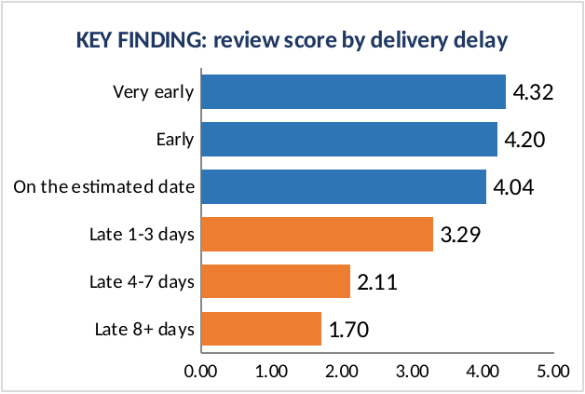
Average review score by delivery delay (Excel chart)
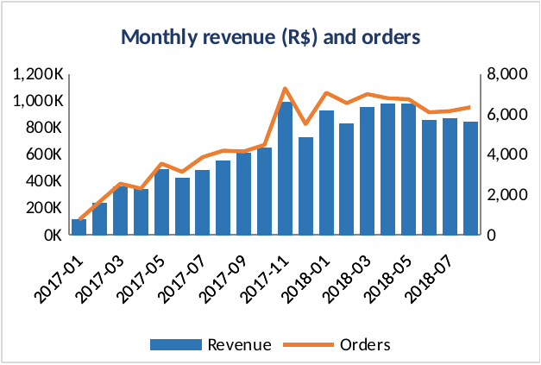
Monthly revenue and orders (Excel chart)

9. SQL Analysis
All data preparation and analysis was done in MySQL 8 using four scripts in the sql/ folder.

9.1 Database design
Eight tables were created in a database named olist_db.
Design choice | Reason
Primary keys on every table (composite keys for order items, payments and reviews) | Guarantees one row per real record
CHAR(32) for IDs | The IDs are fixed-length hashes
CHAR(5) for zip prefixes | Keeps leading zeros, such as 09790
DECIMAL(10,2) for prices, freight and payments | Exact money values with no rounding drift
DATETIME for all timestamps | Allows date arithmetic such as DATEDIFF
Indexes on join and filter columns (customer, product, seller, status, purchase date) | Faster joins on 100,000+ row tables

9.2 Loading the data
Each file was loaded with LOAD DATA LOCAL INFILE. Empty cells in date and number columns were converted to NULL with NULLIF. A closing query compares the loaded row count of every table against the expected count, and all 8 tables returned OK:
Table | Rows loaded
customers | 99,441
sellers | 3,095
category_translation | 73
products | 32,951
orders | 99,441
order_items | 112,650
order_payments | 103,886
order_reviews | 99,224

9.3 Data quality checks
# | Check | Result
A1 | Date range of orders | 4 Sep 2016 to 17 Oct 2018
A2 | NULL dates in orders | 160 approval, 1,783 carrier, 2,965 delivery
A3 | Delivered orders without a delivery date | 8 (excluded from delivery analysis)
A4 | Orders without items | 775
A5 | Orphan product, seller and order references | 0, 0, 0
A6 | Products without a category | 610 (labelled “unknown”)
A7 | Orders with more than one review | 547 (averaged per order)
A8 | Orders with more than one payment | 2,961 (summed per order)
A9 | Orders delivered before they were purchased | 0
A10 | Payment types present | credit_card, boleto, voucher, debit_card and 3 rows of not_defined

9.4 Analysis tables
Two tables were built to make the analysis simple and safe.
- order_summary: one row per order, with delivery days, delay days, a late flag, revenue, freight, payments and average review.
- item_detail: one row per item sold, with English category, seller state and the order’s delivery and review fields.
Avoiding double counting. An order can have several items, several payments and several reviews. Joining these tables directly would repeat rows and inflate revenue. Items, payments and reviews were therefore aggregated to one row per order first and joined afterwards. A control query confirms the result: revenue in the raw items table and in item_detail is identical at R$ 13,591,643.70, with 99,441 rows in order_summary and 112,650 in item_detail.

9.5 SQL techniques used
Technique | Where used
Multi-table joins (JOIN, LEFT JOIN) | Building order_summary and item_detail
Aggregation (SUM, COUNT DISTINCT, AVG) | KPI, state, category, seller queries
Common table expressions (WITH) | Monthly trend, Pareto, repeat customers, cohorts, RFM
LAG() | Month-over-month revenue growth (Q3)
RANK() | Category revenue ranking (Q7)
Running totals (SUM() OVER) | Cumulative revenue (Q3), Pareto cumulative share (Q8)
FIRST_VALUE() | Cohort retention percentage (Q19)
NTILE(5) | Recency and spend scores for RFM (Q20)
CASE WHEN | Delay buckets, instalment groups, ABC class, RFM segments
Date functions (DATEDIFF, DATE_FORMAT, HOUR, DAYNAME) | Delivery time, lateness, time patterns
HAVING and LIMIT | Seller filters (30+ orders), top 10 lists

9.6 Query catalogue
Q | Excel sheet | Business question | Main technique
1 | 01_KPI_Summary | Headline KPIs | Aggregation
2 | 02_Order_Status | Order status mix | Window total
3 | 03_Monthly_Trend | Monthly orders, revenue, growth | CTE, LAG, running total
4 | 04_Yearly_Summary | Yearly performance | Aggregation
5 | 05_Weekday_Pattern | Orders by weekday | Group by
6 | 06_Hourly_Pattern | Orders by hour | Group by
7 | 07_Category_Performance | Revenue by category | RANK, share of total
8 | 08_Pareto_ABC | 80/20 rule and ABC class | Cumulative window, CASE
9 | 09_State_Performance | Revenue and delivery by state | Multi-metric aggregation
10 | 10_Payment_Types | Payment method mix | Join, window share
11 | 11_Credit_Installments | Instalment groups | CASE
12 | 12_Delivery_Trend | Delivery time and late % by month | Aggregation
13 | 13_Late_vs_OnTime | Reviews for late vs on-time orders | CASE
14 | 14_Delay_Buckets | Review score by delay bucket | Subquery, CASE
15 | 15_Top_Sellers | Top 10 sellers | Aggregation, LIMIT
16 | 16_Risky_Sellers | Lowest-rated sellers (30+ orders) | HAVING
17 | 17_Repeat_Customers | Repeat customer rate | CTE
18 | 18_Order_Frequency | Customers by number of orders | CTE, CASE
19 | 19_Cohort_Retention | Retention by first-purchase month | CTE, FIRST_VALUE
20 | 20_RFM_Segments | Customer segments | CTE, NTILE

10. Dashboard Development
Tool: Microsoft Excel.

10.1 Workbook structure
Sheet | Purpose
One_Page_Dashboard | Executive dashboard: 6 KPI cards, 3 insights, 6 charts on one screen
Full_Dashboard | Longer version with 10 charts
Cohort_Heatmap | Retention grid by first-purchase month, with colour scale
About | Business rules and definitions
01 to 20 | One sheet per SQL result, formatted as Excel tables

10.2 Design choices
- Audience: executives who need the story on one screen.
- Layout: KPI cards, three key insights, then six charts in two rows of three.
- Colour: navy and blue for normal values, orange to highlight problems (late deliveries, poor reviews).
- Date range: monthly charts use January 2017 to August 2018, because other months have very few orders.

10.3 Dashboard contents
Element | Source sheet | Purpose
Total revenue, orders, AOV, delivery time, late %, review score | 01_KPI_Summary | Headline numbers
Monthly revenue and orders | 03_Monthly_Trend | Growth and plateau
Review score by delivery delay | 14_Delay_Buckets | The central finding
Top 10 categories | 07_Category_Performance | Where revenue comes from
Highest late % by state | 09_State_Performance | Where delivery is weakest
Payment method share | 10_Payment_Types | Payment mix
RFM segments | 20_RFM_Segments | Customers by value
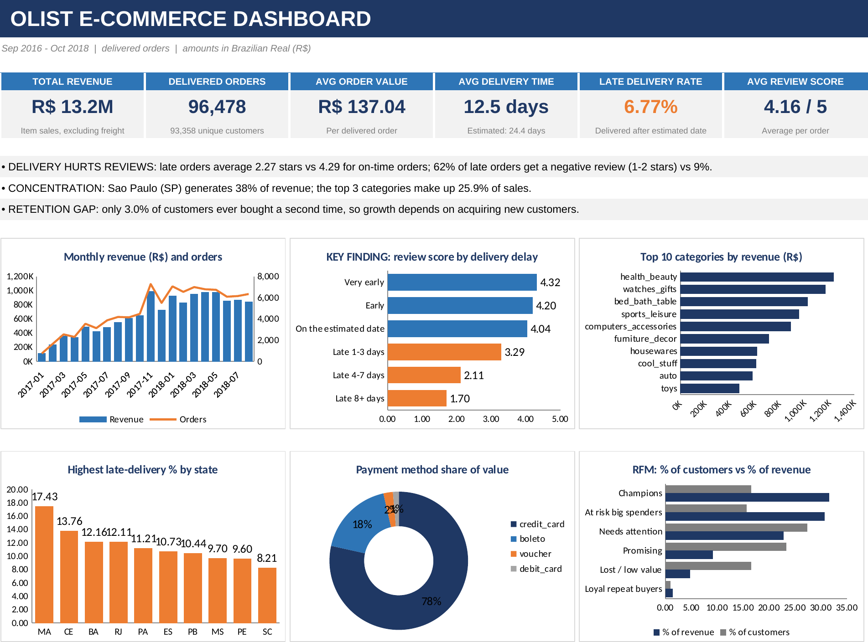
One-page Excel dashboard
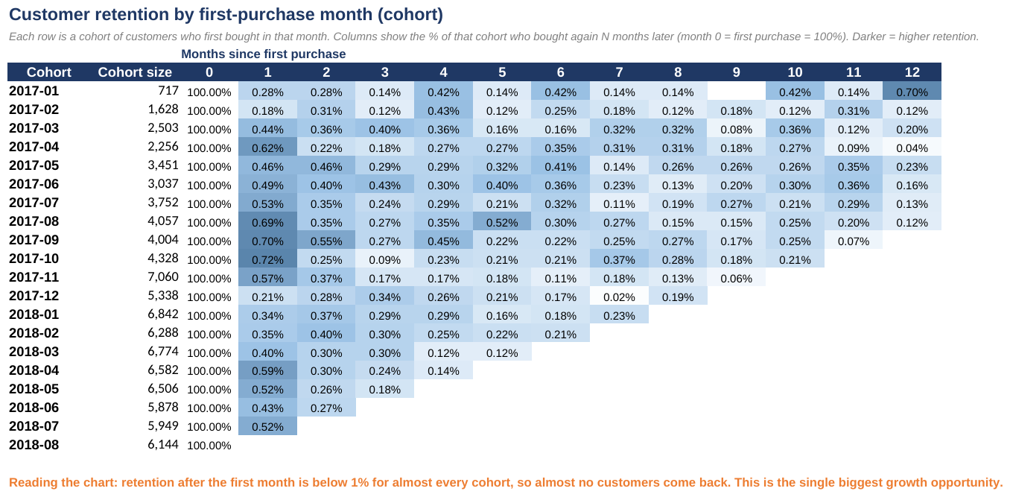
Cohort retention heat map (Excel)

10.4 Validation: dashboard against SQL results
Measure | SQL result (Q1) | Dashboard card
Total revenue | 13,221,498.11 | R$ 13.2M
Delivered orders | 96,478 | 96,478
Average order value | 137.04 | R$ 137.04
Average delivery time | 12.5 | 12.5 days
Late delivery rate | 6.77 | 6.77%
Average review score | 4.16 | 4.16 / 5
Review score for 8+ days late (Q14) | 1.70 | 1.70
The cards and charts read straight from the query-result sheets, so the dashboard and the SQL output cannot disagree.

11. Business Recommendations
Rank | Recommendation | Evidence | Owner | KPI to track
1 | Stop the worst delays. Monitor open orders as they approach the promised date, alert customers early, and escalate any order more than 3 days overdue | Orders 8+ days late: 2,862, with 79% negative reviews and a 1.70 score | Logistics | Orders 4+ days late; late %
2 | Prepare for peaks. Agree extra carrier capacity before November and run daily late-order reviews in peak months | Late rate hit 12.4% (Nov 2017), 14.1% (Feb 2018) and 19.0% (Mar 2018) | Logistics, Seller management | Late % in peak months
3 | Fix regional delivery. Add regional carriers or hubs for MA, CE, BA, AL, SE and RJ, and recruit sellers closer to these regions | Late rates of 12% to 21% against 4.5% in SP. Delivery takes 8.7 days in SP but 19 to 25 days in these northern states. 8 of the top 10 sellers are in SP | Logistics, Marketplace | Late % and delivery days by state
4 | Run seller scorecards. Track review score and late % per seller. Warn and coach the weakest, and set minimum standards for high-revenue sellers | 10 sellers score 2.27 to 3.08. A top-10 seller scores 3.35 | Seller management | Seller review score; late item %
5 | Build a retention programme. Send a second-purchase offer in the first 30 to 60 days and use CRM follow-up | Only 3.0% repeat. Month-1 retention is about 0.5% | Marketing / CRM | Repeat rate; month-1 retention
6 | Win back at-risk big spenders with a targeted offer | 14,563 customers (15.6%) hold 30.6% of revenue and have been inactive about 394 days | Marketing / CRM | Reactivation rate
7 | Review the delivery promise. Test tighter, route-based estimates on fast routes while protecting the late tail | Estimate 24.4 days against 12.5 days actual. 71,303 orders (74%) arrive 8+ days early | Logistics, Product | Late %; conversion in a test
8 | Review freight in distant regions. Test free-shipping thresholds or subsidies for high-freight states | Freight is 13.9% of revenue in SP but 26% in MA | Pricing, Finance | Freight %; conversion
9 | Protect core categories. Focus on the 18 A-class categories and fix quality in bed_bath_table (3.92 score, #3 by revenue) | 24% of categories give about 81% of revenue | Merchandising | Category review score

- Quick wins (0 to 30 days): late-order alerts, seller watch-list, retention email trial.
- Medium term (1 to 3 months): peak plan, seller scorecard, win-back campaign.
- Longer term (3 to 12 months): regional logistics, delivery promise redesign, freight tests.

12. Business Impact
These are scenario estimates calculated from the SQL results to size the opportunity. They are not forecasts and assume the relationships in the data would hold.
Scenario | Assumption | Estimated effect
Cut late orders by 25% | 1,634 of 6,534 late orders become on-time, taking the on-time review average (4.29 instead of 2.27) | Average review rises from 4.16 to about 4.19
Cut late orders by 50% | 3,267 late orders become on-time | Average review rises to about 4.23, with about 1,700 fewer 1 to 2 star reviews
Raise repeat rate by 1 point | 934 extra repeat customers at the current AOV of R$ 137.04 | About R$ 128K extra revenue (about 1.0% of the total)
Reactivate 5% of at-risk big spenders | 728 customers at their average spend of R$ 278 | About R$ 202K extra revenue (about 1.5% of the total)
Fix or exit the 10 weakest sellers | Replace their 855 orders with average-quality service | Protects about R$ 113K revenue (0.9%) and removes a source of 1 to 2 star reviews
Caveats. The review improvement is an upper-bound illustration, because part of the review gap may be caused by other factors such as the product or the seller. Revenue figures exclude freight and profit, because the data has no cost information. Results should be tested with a pilot before budget is committed.
Strategic value. The main benefit is a shift from relying on new-customer growth to protecting satisfaction and repeat business, which lowers acquisition cost over time.

13. Conclusion and Future Scope

13.1 Conclusion
The marketplace is large and growing, with R$ 13.2 million in revenue from 96,478 delivered orders. The analysis shows that its main weakness is experience and loyalty rather than sales volume:
- Delivery drives satisfaction. Late orders score 2.27 stars against 4.29, and the score keeps falling as delays grow, from 4.32 for very early deliveries to 1.70 for orders 8 or more days late.
- Delivery problems are concentrated in specific regions (the North, Northeast and Rio de Janeiro), specific months (peak periods) and a small group of weak sellers.
- Very few customers return. Only 3.0% buy a second time, so growth depends on constant new-customer acquisition.
- Revenue is concentrated in São Paulo (38%) and in 18 of 74 categories (about 81%).
- There is real upside. About 31% of revenue sits with high-spend customers who have gone quiet, and delivery promises are very cautious (74% of orders arrive 8 or more days early).
Acting first on late-delivery control, regional logistics, seller standards and retention offers the highest expected return.

13.2 Future scope
Area | Idea
Predictive modelling | Predict late delivery and negative reviews, for example in Python, to flag at-risk orders before delivery
Forecasting | Forecast monthly demand and delivery load for peak planning
Text analytics | Analyse the Portuguese review comments to find the complaint themes behind low scores
Geospatial analysis | Use the geolocation file to study seller-to-customer distance, delivery time and freight
Customer lifetime value | Estimate CLV and acquisition payback by segment
Market basket analysis | Find products bought together for bundles
Experiments | A/B test delivery promises, free-shipping thresholds and win-back offers
BI tools | Rebuild the dashboard in Power BI or Tableau and schedule the SQL refresh
Profitability | Add cost and margin data to move from revenue to profit analysis

