PROJECT
LINEAR REGRESSION MODEL ON HOUSING DATASET
NAME: SURYANSH SINGH
ROLL NO.: 125CS0099

INTRODUCTION AND OBJECTIVES
The objective of this project is to build a Linear Regression model entirely from scratch (without using external machine learning libraries like scikit-learn) to predict the sale price of properties in New York City

Data Cleaning and Preprocessing
To prepare the dataset for modelling some preprocessing is required like processing the null points and duplicate rows
- null points : I removed the null points in the pincode column as these are random values and assign mean value to the pincode column will not make sense. For other cases I have replaced the null point by the columns mean
- duplicate row : I have removed the duplicate rows. To prevent reprocessing of same data point

Data Analysis & Feature Selection
I have use correlation function of pandas(specifically pearson correlation method) to find the correlation between the sales price and the other numerical columns
I selected the following four features as the independent variables ($X$) for my model:
- block
- borough_x
- yearbuilt
- longitude
While the overall correlation scores in this dataset were relatively. these four features provided the strongest mathematical signals for the model to learn from.

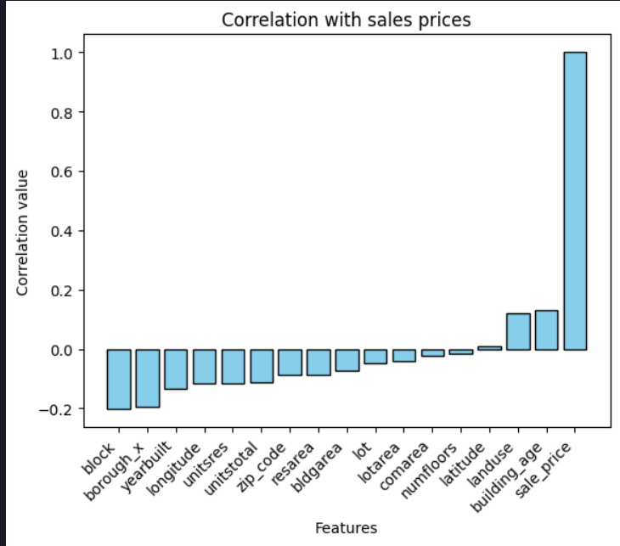
Model Implementation (From Scratch)
Because I was not allowed to use sklearn, the Linear Regression model was written entirely from scratch using numpy , pandas and matplotlib
Gradient Descent Algorithm:
The core of the model is a Gradient Descent loop designed to minimize the Mean Squared Error
The core of the model is a custom Gradient Descent loop designed to minimize the Mean Squared Error (MSE).
- Initialization: The model weights were initialized at zero.
- Hypothesis: At each step, predictions were calculated using the dot product: y = X.W
- Update Rule: The slope of the error (gradients) was calculated using calculus. The weights were then updated in the opposite direction of the slope using a learning rate step of 0.01
- Tries: The model trained for 1,000 iterations to find the optimal line of best fit.

Conclusion
The Mean Squared Error dropped rapidly during the first 100 tries as the model took its largest steps toward accuracy. The curve then completely flattened out, indicating that the algorithm successfully converged on the optimal weights for the four selected features and minimized the error as much as mathematically possible for a linear relationship.

