**Ahmed Nouralla – B19-02 – AI Assignment 1 Report.**

* Source code files are included in the same archive with this report.
* **Algorithms description:**
  + **Backtracking search $\text{(backtracking.pl)}$:**
    - The idea was to use a recursive predicate $\text{go(}\text{StepCount}\text{, Path, }\text{NextMove}\text{, Protected)}$ that explores the (auto-generated) map, by trying all possible valid paths while counting the number of steps along the way, minimizing $\text{StepCount}$, keeping the state of actor (whether he is $\text{Protected}$ from covid or not), and storing the $\text{Path}$ list.
    - Since the number of recursive calls will be huge (even for 9*9 lattice, the unguided search is expensive and better algorithms exist for shortest path problems), some optimizations were implemented to make it faster for typical cases, but the upper-bound complexity didn’t change.
    - Example of such optimizations was to try the recursive calls that are more likely to get the actor home first, by realizing the position vector from the actor current location to home and guiding the search.
  + **A* search**
* **Statistical comparison** (average running time for normal, hard, and impossible maps)

|  |  |  |
| --- | --- | --- |
|  | **Variant 1** | **Variant 2** |
| **Backtracking** |  |  |
| **A\*** |  |  |

* **PEAS description with respect to the actor agent.**
  + **Performance measure:** the number of steps needed to reach home, whether the actors can reach it or not.
  + **Environment:** 9*9 square lattice, representing physical spots.
  + **Actuators:** the actor can **move** horizontally, vertically, and diagonally.
  + **Sensors:** the actor can perceive objects around him, from different distances.
* 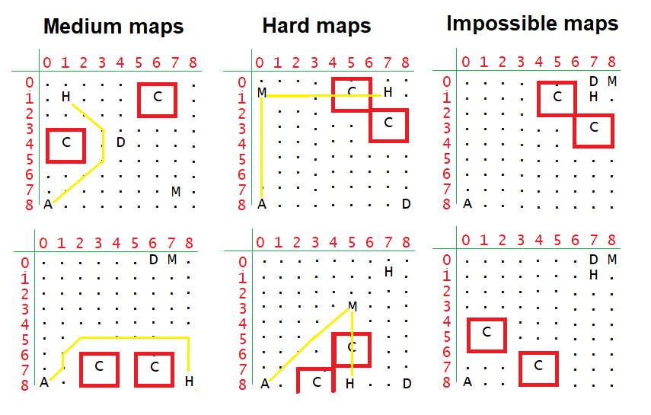**Graphical representation for sample maps used for testing:**