So, let’s start.

Firstly, we should check our file. I mean what type of this file.

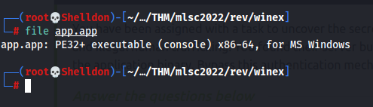

If we look, we can see it is PE32+ executable, 64 bits and for Windows.

We can run .exe files with **wine.** If you do not have wine, just paste this command “apt install wine”.

Then we should run our app. We should type **id** of user. If we type for example: 1, 2 or 3, we will see “Invalid” message.

Let’s use ghidra and analyst app.

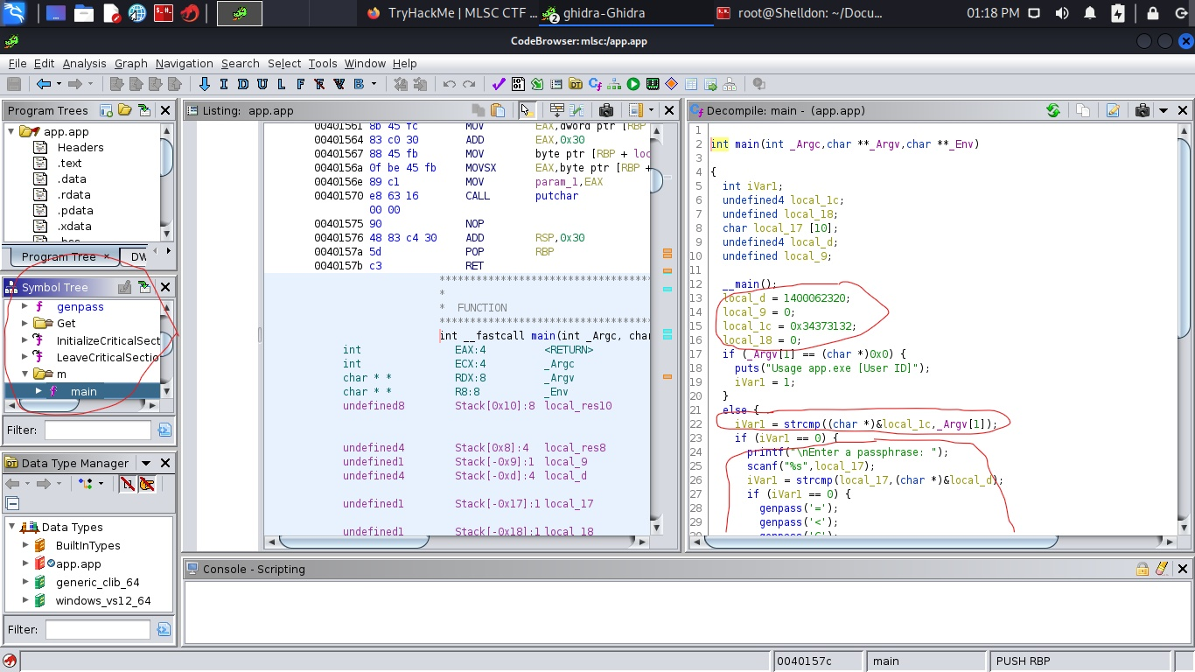

After analyzing we must find the main **function.** After finding main we have some values. First – **4712**, and second value equals to “**SsAp**”.

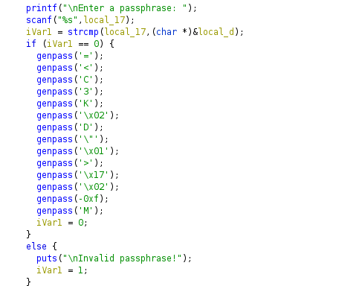

After successfully checking passphrase, we must get flag.

Let’s use these values.

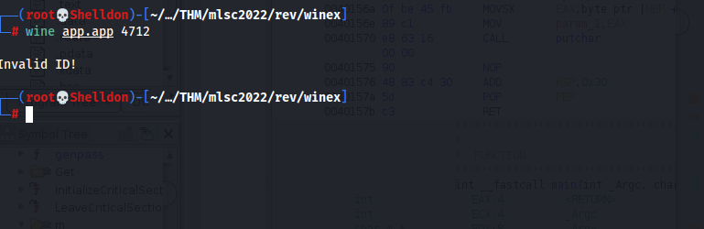

So, it is incorrect. I have one idea. Let’s try with radar2.

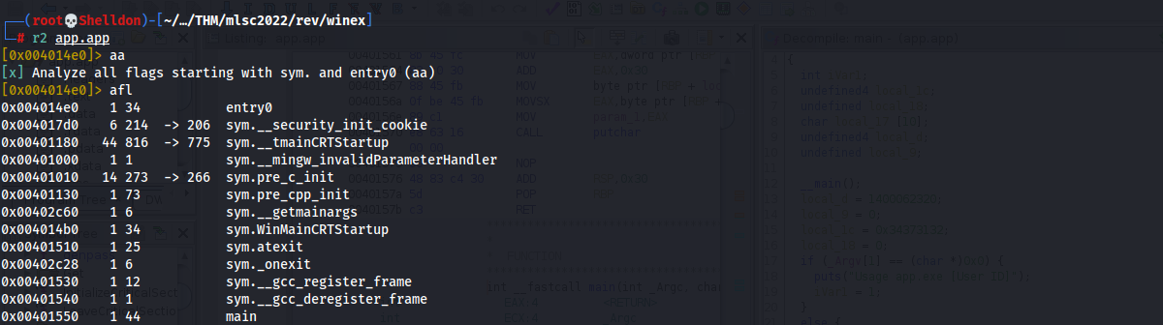

Run radar2 with this command: **r2 <file name>**

**aa – analyze our app**

**afl – show functions**

We have some main functions. We can use command: **afl | grep “main”** so that see all main functions.

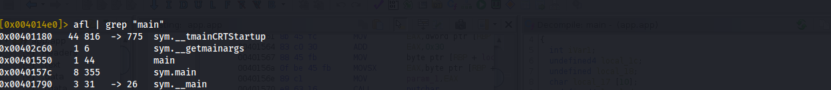

**sym.main** is our main.

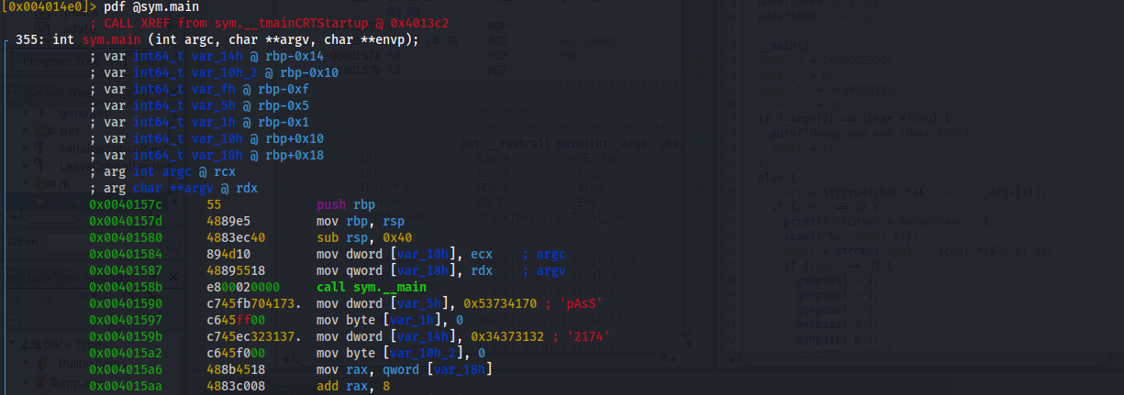

Disassemble function and let see what happens there. If you look to red strings, we see “**pAsS**” and **2174**. Cool we find correct values. Let’s try with these values.

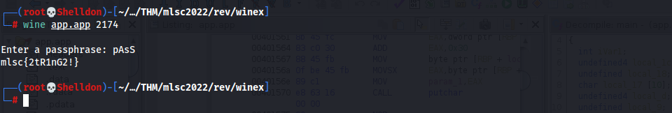

Nice job! We get a flag