***Youssef Mohamed Alshaarawi 75***

***Yahia Mohamed Elsaadawy 71***

***Heap & Sorting Report***

# Introduction

**The (binary) heap data structure is an array object that we can view as a nearly complete binary tree as shown in Figure 1. Each node of the tree corresponds to an element of the array. The tree is completely ﬁlled on all levels except possibly the lowest, which is ﬁlled from the left up to a point. An array A that represents a heap is an object with two attributes: A.length, which (as usual) gives the number of elements in the array, and A.heap-size, which represents how many elements in the heap are stored within array A. There are two kinds of binary heaps: max-heaps and min-heaps. In both kinds, the values in the nodes satisfy a heap property, the speciﬁcs of which depend on the kind of heap. In a max-heap, the max-heap property is that for every node i other than the root, A[parent[i]] ≥ A[i] (1) that is, the value of a node is at most the value of its parent.**

# Test:



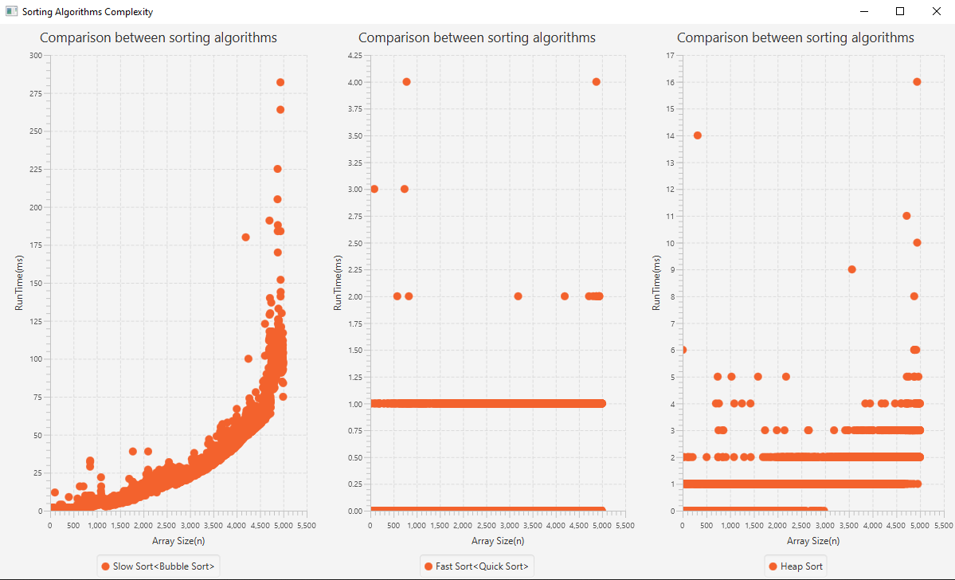Comparison between all sorting algorithms: (all code used included in the project)