***Youssef Mohamed Alshaarawi 75***

***Yahia Mohamed Elsaadawy 71***

***Heap & Sorting Report***

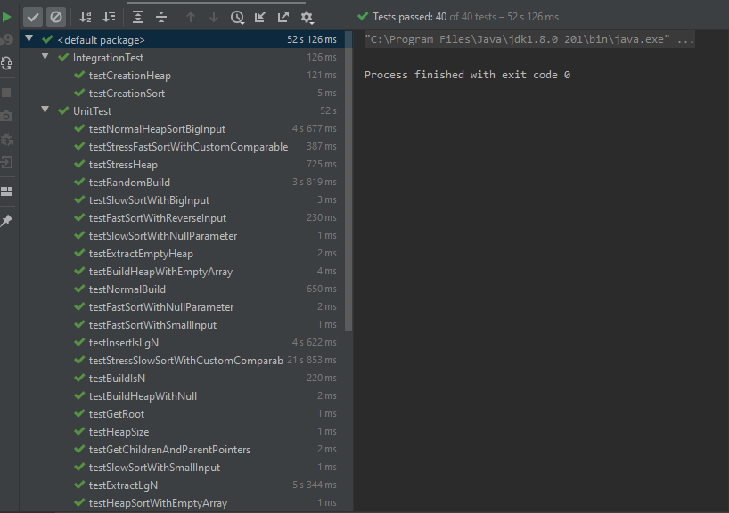**Test:**

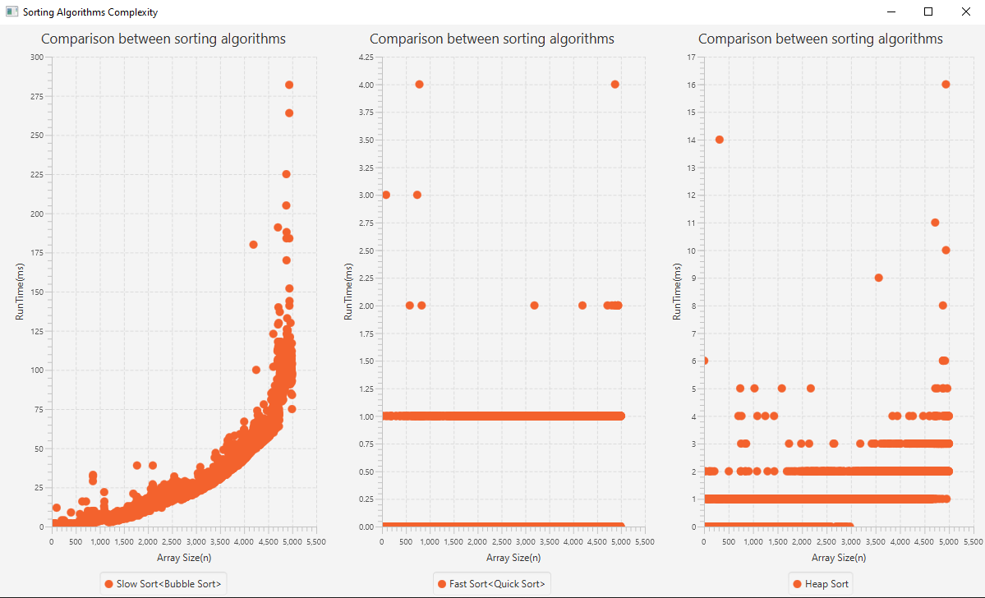**Comparison between all sorting algorithms:** (all code used included in the project)