**Memory Game**

**Name***: Youssef Mohamed Abdelfattah Alshaarawi*

**ID*:*** *80*

**Subject*:*** *Computer and Society*

**Introduction:**

Find the Pair is a challenging concentration memory game that requires players to spot the identical pairs in each level. Match pairs of shapes together with the help of your memory.

It is a game which aims finding all matching pairs of pictures. At start all pictures are face down, click the boxes to uncover them if the last pictures don't match, the will again turn face down, repeat till you uncover all the pairs.

It is implemented by HTML, CSS, JAVASCRIPT.

**Design Overview:**

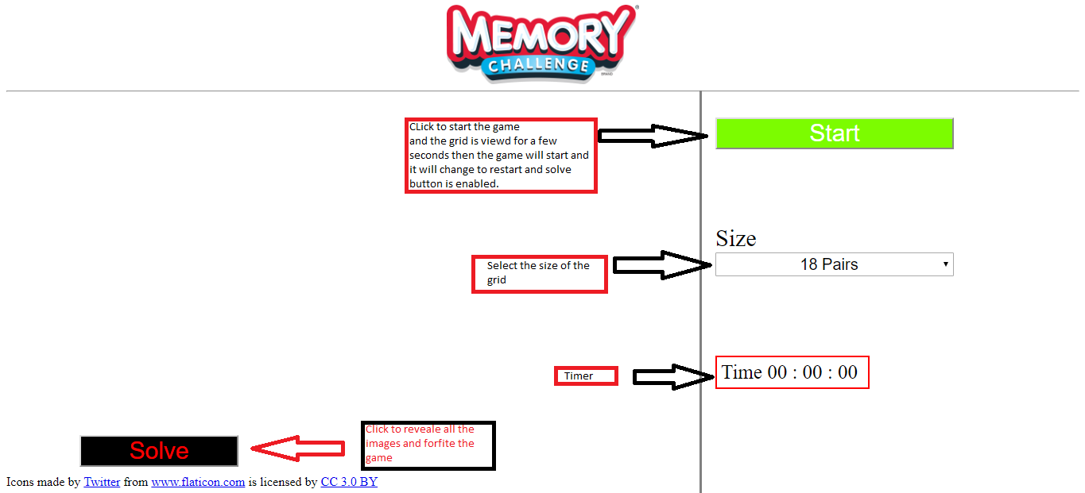

**User Manual:**

1. Select the size of the grid

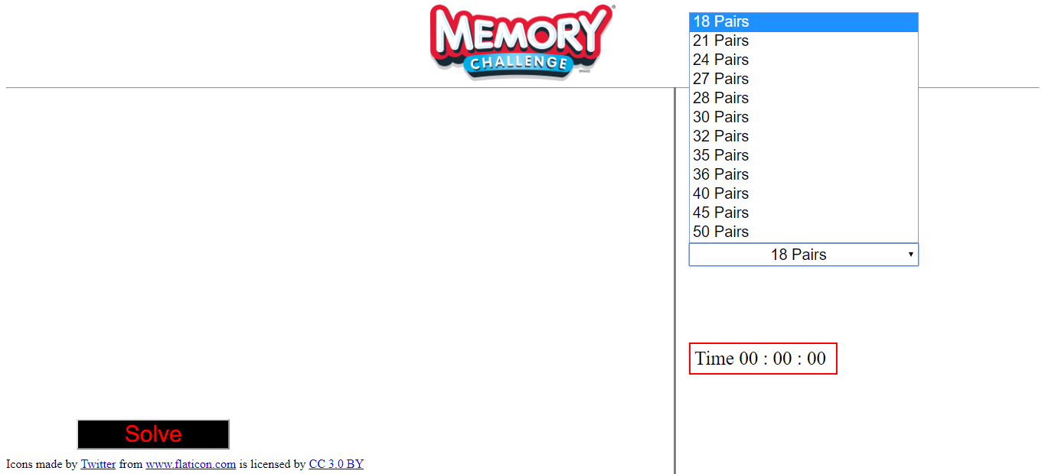

1. Press Start to play and quickly remember where the pairs at

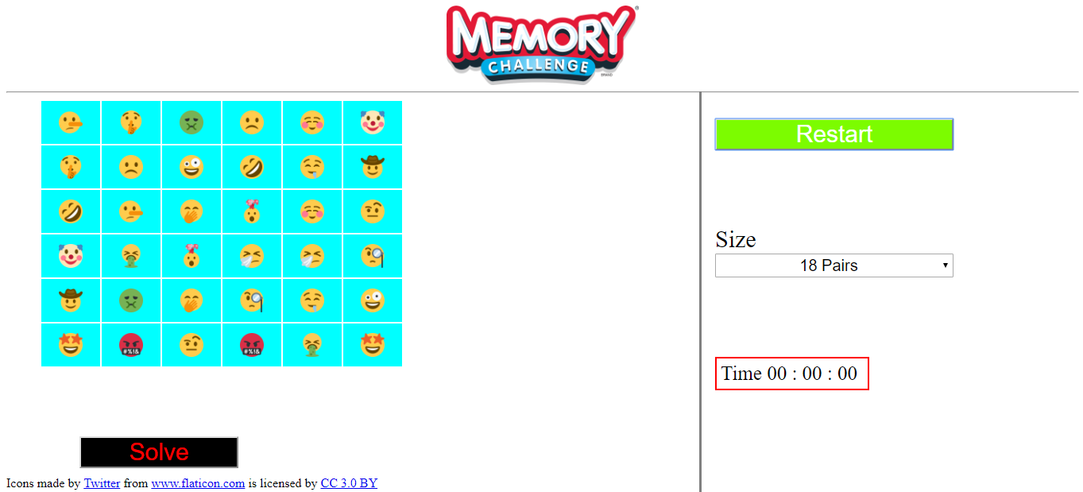

1. When the pictures disappear and timer start the game is begin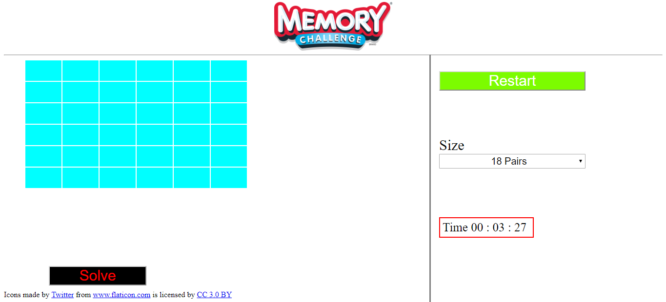
2. Click on the cells so the picture is revealed.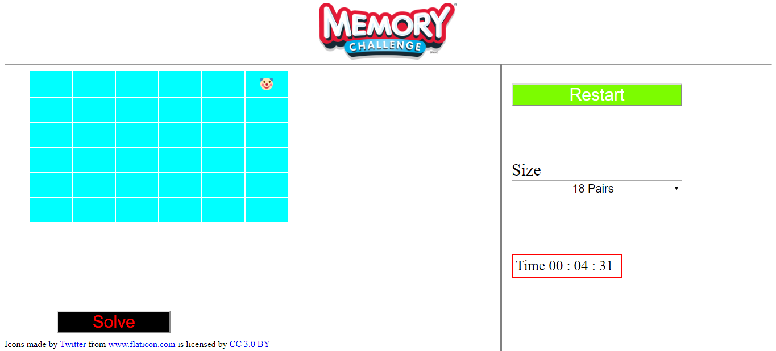
3. Try to find its pair pic. 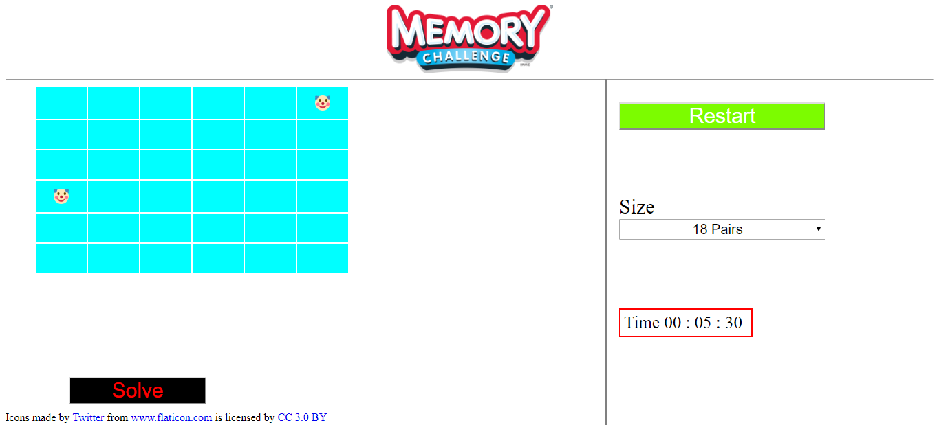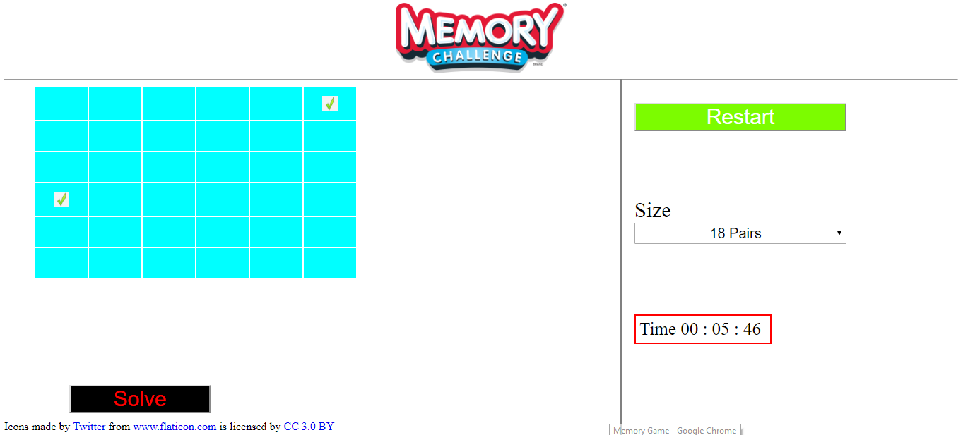
4. Continue till you finish the game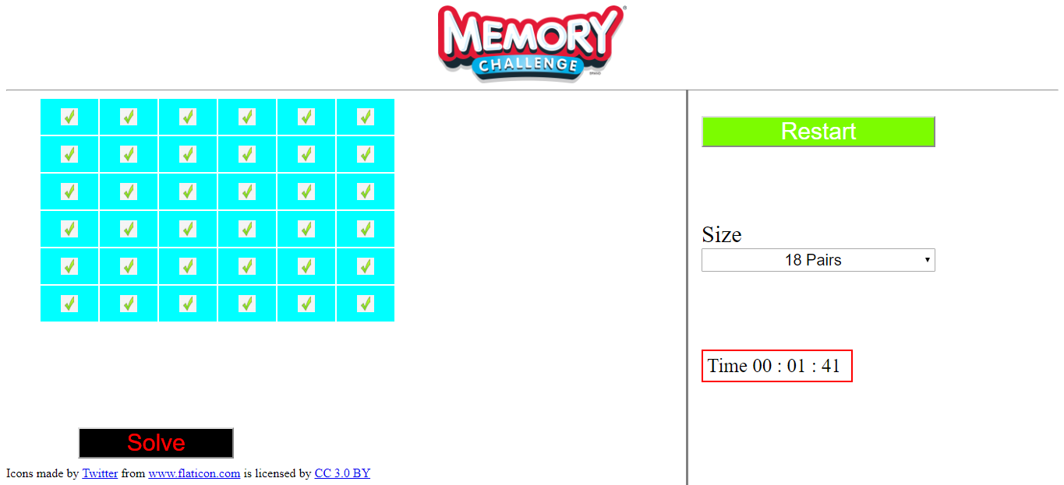

**Used data Structures:**

* 2D array to store images number for each cell
* Array to prevent repeating an image more than twice
* Table in HTML to view the images and be the grid of the game