Part 0 Description of algorithm.
Goal of algorithm create mosaic that is picture that consist of small elements (hexagon). To create an art Genetic Algorithm was used. Genetic algorithm works with chromosome. Chromosome is arrays of codes for colors for each hexagon on picture. Array of 100 chromosomes is a population. Genetic algorithm will perform selection, crossover and mutation on array of 100 chromosomes during one iteration until it will find population member that same as initial picture (according to fitness function). Consider implementation of those functions.
First of all to create picture chromosome is used. Chromosome is array of colors for hexagons on the picture. To create chromosome it need size of element and initial picture. First of all it calculates number of hexagons in a row and in a column. Then it initialize chromosome with colors and creates picture based on chromosome. To draw picture rom chromosome function fill_image_with_hexagons() calculate coordinates of hexagon with use of position of color in array of color and depends on size of element, whether it is even or odd row. Coordinates of hexagon was previously calculated and shown in picture.
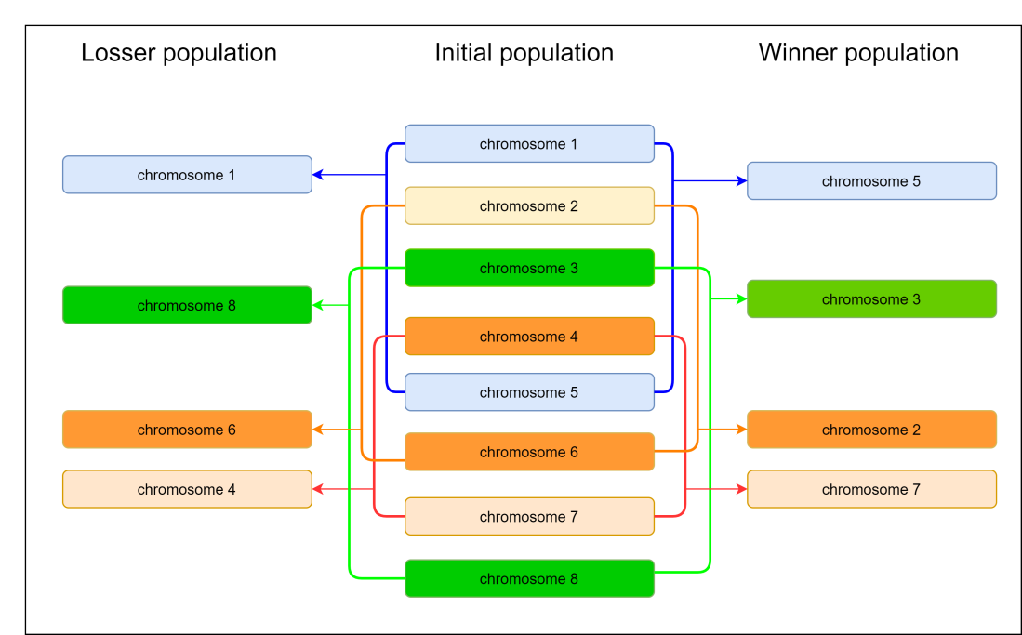
Selection is a tournament. Algorithm randomly takes two members from population and compares them with use of fitness function calculated before. Winner of this tournament will have higher fitness function then opponent. Finally, when initial population becomes empty, selection will divide initial population into two arrays. First array contain winners and second array is remain part of population. Example of selection is shown on the picture.
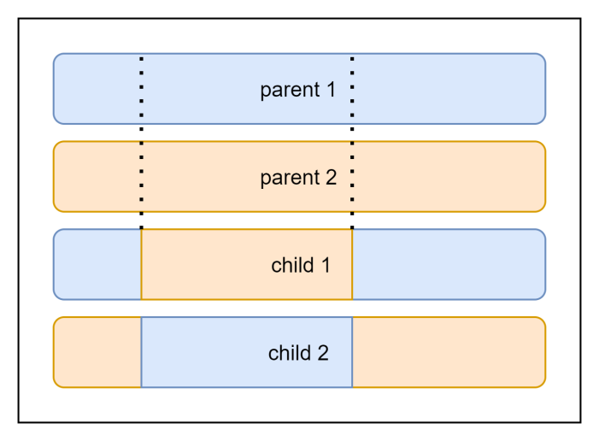
Crossover operation takes pairs of chromosomes and then picks randomly two points. Crossover takes half of initial population which is winner population provided be selection function. Before it performs operations on chromosomes function will randomly choose two points that belong to interval from 0 to length of chromosome. Then it takes two neighbor chromosomes that are called parents and create new chromosomes that are called children with use of those two points and parents. So, two children will contain parts of parents. First child take values from first parent’s chromosomes from 0 to first lowest randomly chosen point and from second point to last element and from second parent it takes values from first randomly chosen point to second one. Result of this operation is new population that contains all children and parents. Furthermore size of population same as it was initially. Example of crossover shown on picture.
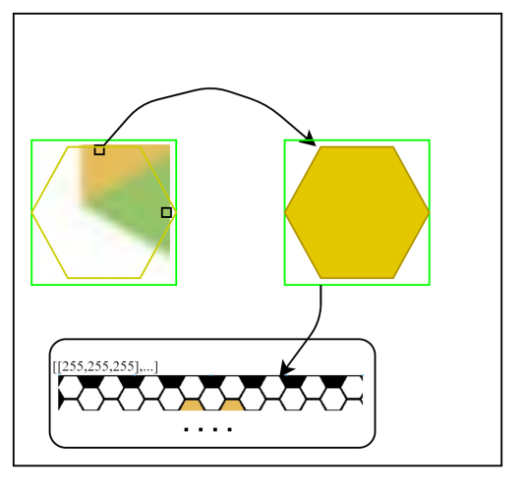
Mutation is a process of randomly choosing elements from chromosomes and changing its color. Mutation takes losers that are chosen (by function selection) from population created by crossover function. During mutation it randomly picks hexagons for mutation. Each chosen hexagon is assigned with new color. New color is chosen inside of square with size equal to hexagon. Changes are applied to the array of colors and then function fill_image_with_hexagons() will draw new picture. Number of changed chromosomes by default is 10% of all chromosomes.
Previously algorithm use fitness function. Fitness function takes original image and obtained image in matrix form and apply ssim. Result of ssim function is number from -1 to 1, where negative value means that pictures are different. Fitness value should be more then or equal 0.8.
Part 1 Examples
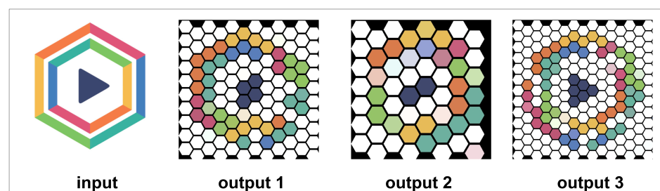
Example 1
Consider example 1. Output picture 1 was obtained with element size equals to. Output picture 2 was obtained with element size equal to. Output image consist of elements with size.

Part 2 What is art.
I consider art is personal view of reality.
If we consider problem of creation of image from particleas we will find that this process is art because operator need to find colors that more sutable.

(2) Provide 3 to 5 examples of input test images and corresponding output images.
(3) What is art for you. Elaborate on your reasonings of why you consider your work art.
Please add visuals and graphics (wherever applicable) to support your material.
➢ Code should be submitted with comments and a readme file with a clear description of test
function simulation.
➢ Report as well as code files should be zipped for submission and named with your name and
surname

