How to design a cube’s inlet/function

V0, 31.08.2018

B. Diederich

# Introduction

The UC2 Toolbox serves as a base system which acts as the skeleton for holding dindividual functions. Each block has in its base version a edge-length of 50 mm and can be produced using off-the-shelf 3D printers. Those cubes are mounted on a grid acting as a base-plate. Fixed positioning is assured by relying on magnetic fit, where the cubes have inbuilt screws, fitting directly on the ball-magnets pressed into the base-plate.

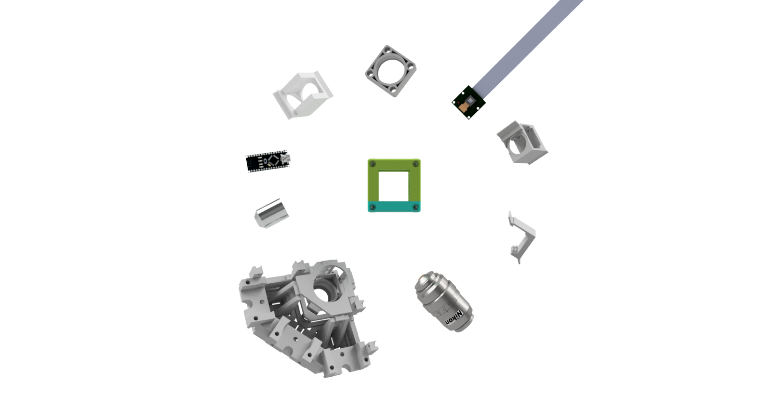The skeleton itself is not ready for optical experiments yet. Therefore we have to place individual functions inside the cubes (e.g. cameras, lenses, mirrors, light sources, etc.). There is a list of available inlets to realize basic experiments already. But most devices won’t follow these dimensions, which makes customized adapters necessary.

This should give a basic guide on how to design a function which fits into the UC2 cube. Basically there are two ways to mount stuff inside a cube.

1. 5mm Rod-System for use with popular Cage Systems
2. Integrated “rail”-system to slide in customized functions

# 1 – ROD-SYSTEM

We integrated the rod-system from the popular cage system available for example from Thorlabs, Edmund Optics or Qioptiq. This means, that one can put lens which are already available in the optical lab directly into the cubes without any redesigning of the parts. Problem with these rods is, that they are measured in inch not mm. Thus, Thorlabs has rods with 2inch=50,8mm not fitting into our cubes, which need <50mm to work correctly.

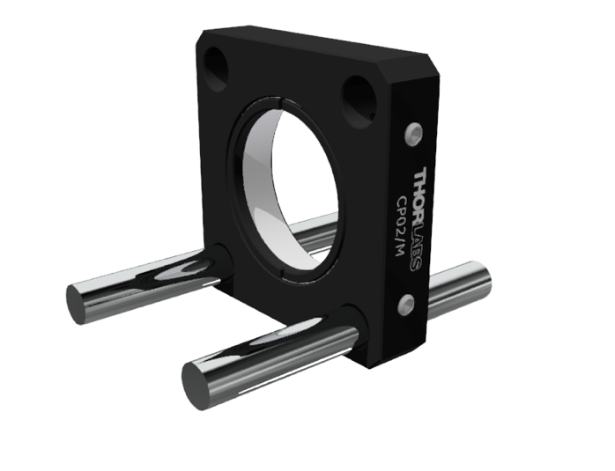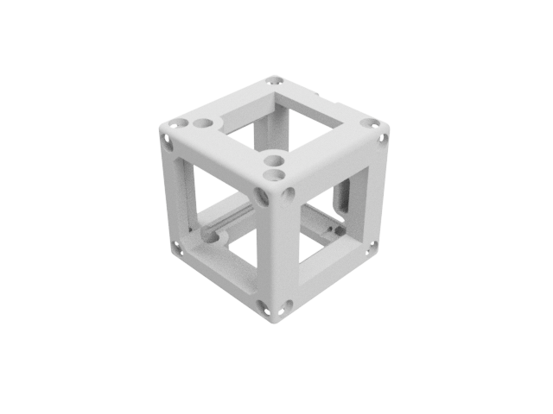

THORLABS CP02-M

Base CUBE

# 2 – INLET SYSTEM

Some components won’T fit intoe the Thorlabs cage system because of their footprint. Therefore we designed a sliding system which can hold basically every component, like the Raspberry’s camera for example. It is slightly bigger as distances between the rods, thus not “slidable” using the rods. The dimensions can be extracted from the CAD technical drawing below. The major importance is, that the “wings” can slide freely in the adapter, but are not too loose to loose contact. We designed a set of adapters for multiple purposes. Mirrors, camera adapters or filter mounts are just a few of them. This adapter is customizable to fit everybodies individual needs. Therefore we invite you to freely modify it to your needs and publish your results.



Raspi-Camera Adapter

Base CUBE

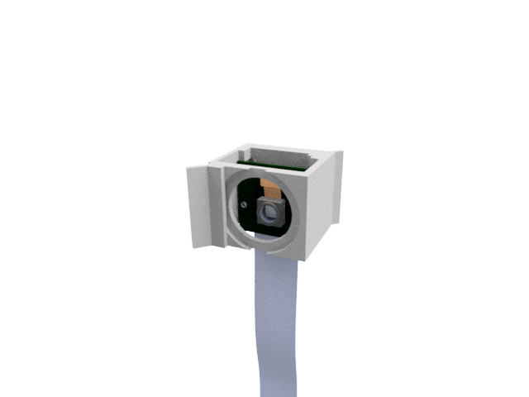

The shape of the inlet or the adapter which fits into the sliding system looks as follow:



## Dimensions of the inlet System

This is an example for a mirror-mount. It can be modified to your needs of course.

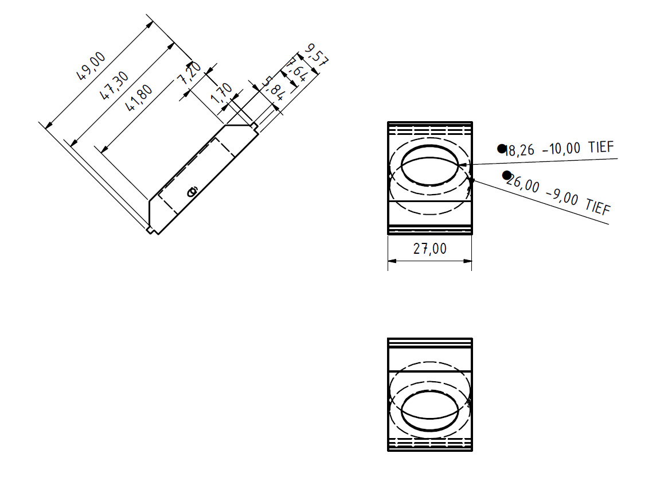

Slide

- Fit into Cube