Use a cellphone Lens As a Microscope

Get an old cellphone Camera and use it as a simple microscope.

The basic concept is to negate the refractive power of the objective lens of a cellphone camera by mounting a 2nd lens from an old cellphone camera inversely in front of the camera. This produces a -1:1 imaging system with a large field of view and a very low price.

Benedict Diederich

V0; 05.12.18

# Table of Content

Table of Content 2

Motivation 3

Goals 3

Bill of Materials 4

Step by Step guide for extracting the lens (LG G5) 6

1st Step – Prepare everything 6

1st Step – separate soldered lens from Sensor PCB 6

3rd Step – separate Sensor and lens 7

4th Step – Remove IR Filter (Optional) 7

5th Step – Solder lens on PCB for controling XYZ-movement (Optional) 8

6th Step – Testing 8

Theoretical 9

Useful links and Resources 9

Links 9

# Motivation

* Build a cheap cellphone microscope.
* How is it working
* What do we need to accomplish that?

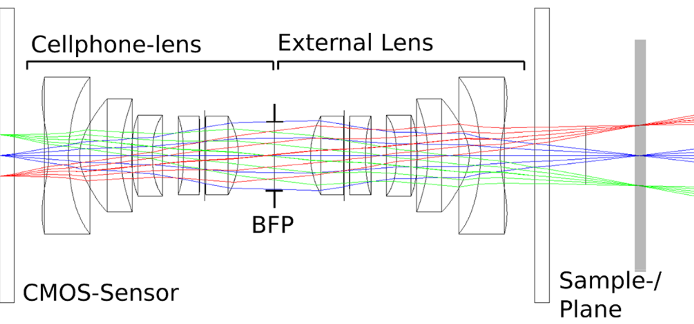

Goals  
At the end you should have learned the following:

* Get the lens
* Mount it on the cellphone camera
* Image stuff
* Understand the imaging theory

# Bill of Materials

|  |  |  |  |
| --- | --- | --- | --- |
| Quantity | Description/Name | Image | Price |
| 1 | iPhone 6 camera module   * 1/2.4 f#, very cheap * <https://www.ebay.de/itm/Fur-iPhone-6-Plus-HauptKamera-Ruckkamera-Rear-Back-Camera-Module-Flex-Original/153155444315?hash=item23a8c69e5b:g:q6UAAOSwQf9be44Z:rk:1:pf:0> | Fuer-iPhone-6-Plus-HauptKamera-Rueckkamera-Rear-Back-Camera-Module-Flex-Original | 5-12€ |
| 2 | LG G6 H870 Medium Rückseite Kamera Modul   * 1/2.4 f#, X/Y/Z voice-coil actuator * <https://www.ebay.de/itm/LG-G6-H870-medium-back-side-camera-flex-cable-module-contact/391883007082?epid=2231365189&hash=item5b3e0c246a:g:bjoAAOSwiqdaoeUs:rk:3:pf:0> | https://www.ng-mobile.de/vario/ebay/P1320298_6897.JPG | 15€ |
| 1 | Huawei P20 Camera Lite   * 1/1.6 f# * https://www.ebay.de/itm/Fur-Huawei-P20-Lite-Reparatur-Back-Kamera-Cam-Flex-Ersatzteil-Hauptkamera-Camera/362329660012?hash=item545c87da6c:g:96kAAOSwTFhbBqtt:rk:23:pf:0 | Original-Huawei-P20-Lite-Haupt-Kamera-Hintere-Camera-Flex-Hauptkamera-Back | 16€ |
| 1 | Huawei P20 Pro   * https://www.ebay.de/itm/Original-Huawei-P20-Pro-Haupt-Kamera-Flex-Hinten-Ruck-Foto-Main-Camera-Back-Rear/273577104409?hash=item3fb2775419:g:Rt8AAOSwIw1b-TC6:rk:26:pf:0 | https://i.ebayimg.com/images/g/Rt8AAOSwIw1b-TC6/s-l1600.jpg | 60€ |

# Step by Step guide for extracting the lens (LG G5)

Attention: Take care of your fingers! Don’t cut yourself!

## 1st Step – Prepare everything

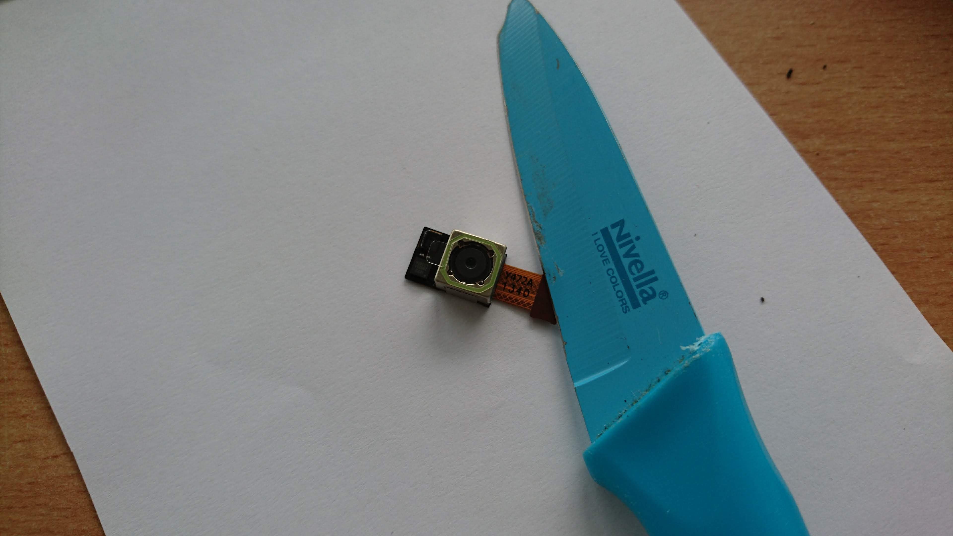

## 1st Step – separate soldered lens from Sensor PCB

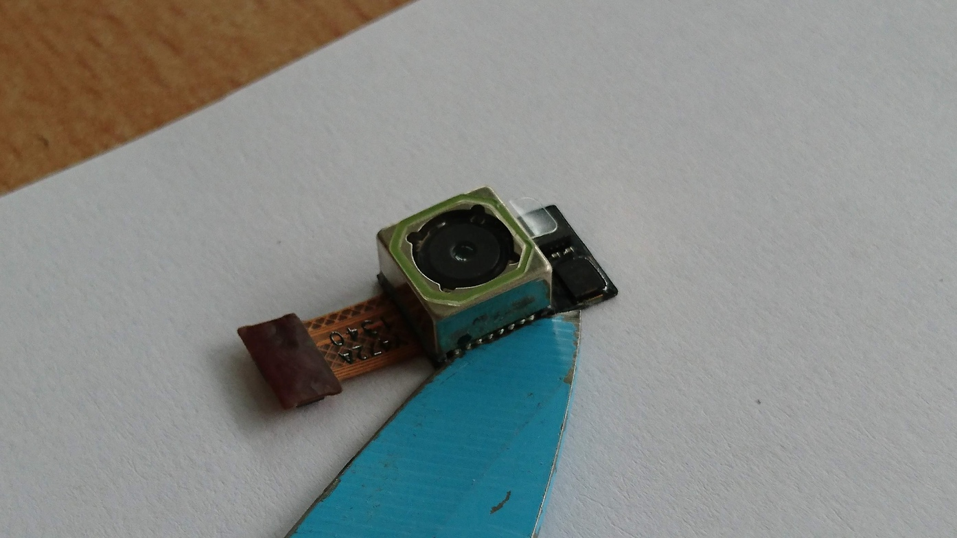

You could melt the soldering, but a sharp knife will do the same job.

## 3rd Step – separate Sensor and lens

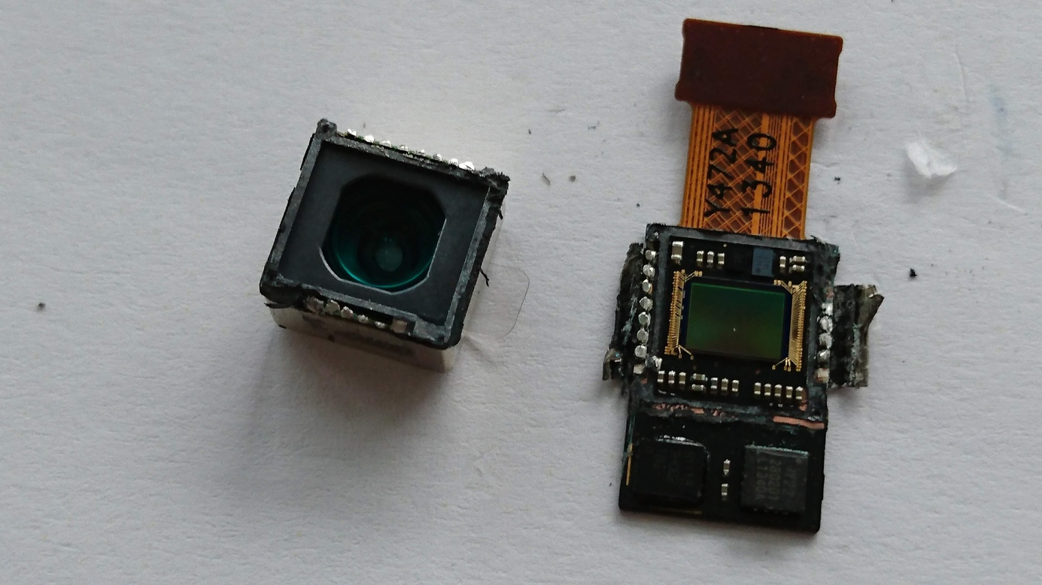

## 4th Step – Remove IR Filter (Optional)

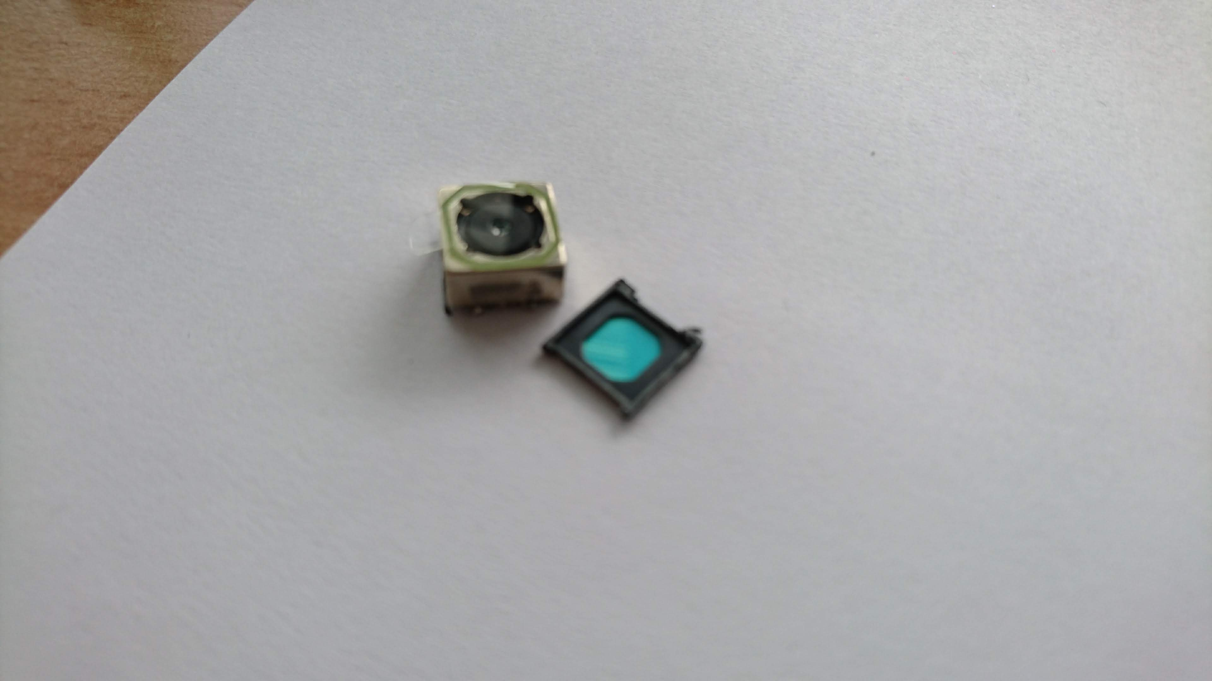

## 5th Step – Solder lens on PCB for controling XYZ-movement (Optional)

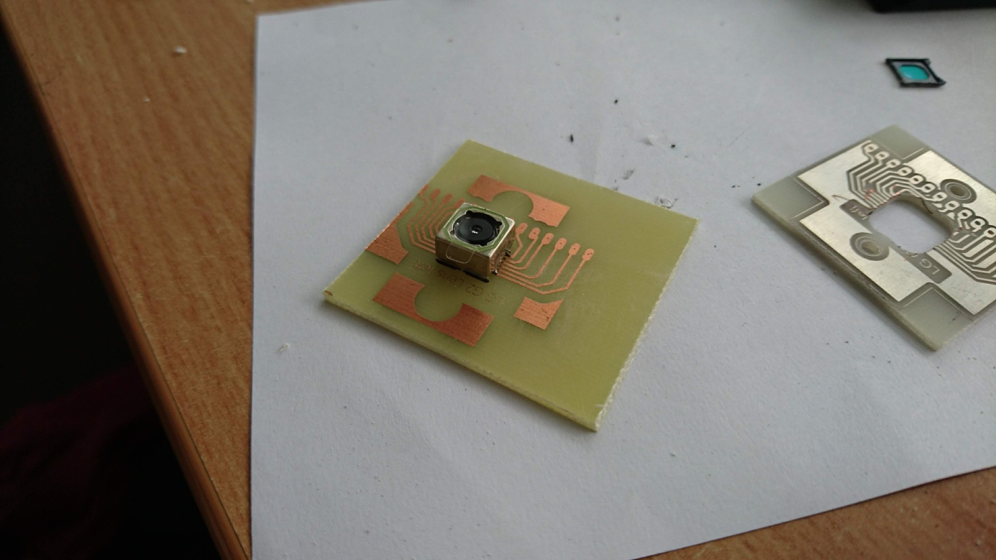

## 6th Step – Testing

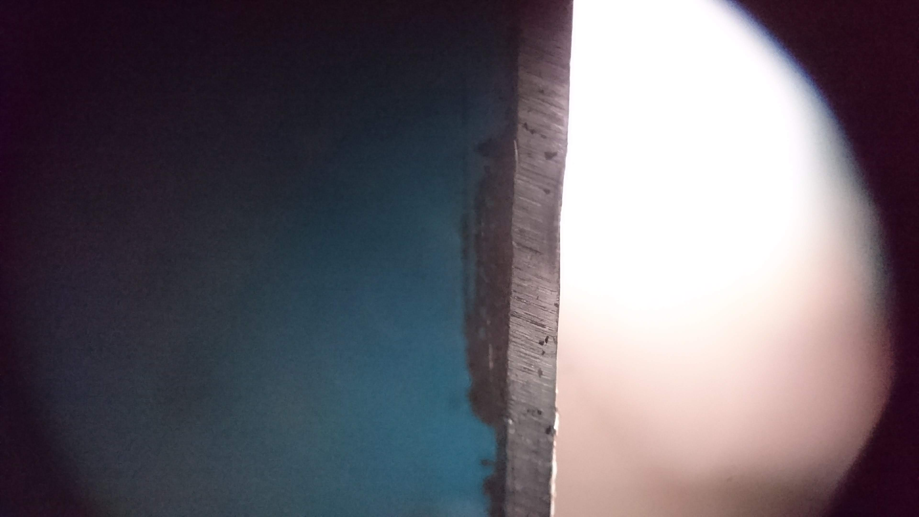

You can simply take some blutek or douple-sided sticky tape to mount the lens directly in front of the cellphone camera. The image above is the blade of the knife we used above. The better the entrance pupil of the cellphone matches the exit pupil of the cellphone lens, the better the image gets.

# Theoretical



The lens assures a -1:1 imaging system and is almost free of any aberation up to an NA of 1/(2*f#)=0.315 in Case of the Huawei P20. The field of view – depending on which camera is used – can be up to 12x7mm^2.

More theoretical aspects are coming soon!

# Useful links and Resources

## Links

* Cellphone Microscope relying on setup above:
  + <https://journals.plos.org/plosone/article?id=10.1371/journal.pone.0192937>
* Cellphone Microscope where idea originally came from:
  + <https://www.ncbi.nlm.nih.gov/pmc/articles/PMC4031072/>
* FPM Setup where they used cellphone lenses:
  + <https://www.ncbi.nlm.nih.gov/pmc/articles/PMC4206303/>