**Exercise 1: Write a Java program that displays your first name and second name on one line using two print statements. First print statement will print your first name and second print statement will print surname, but the two names must be printed in the output on the same line.**

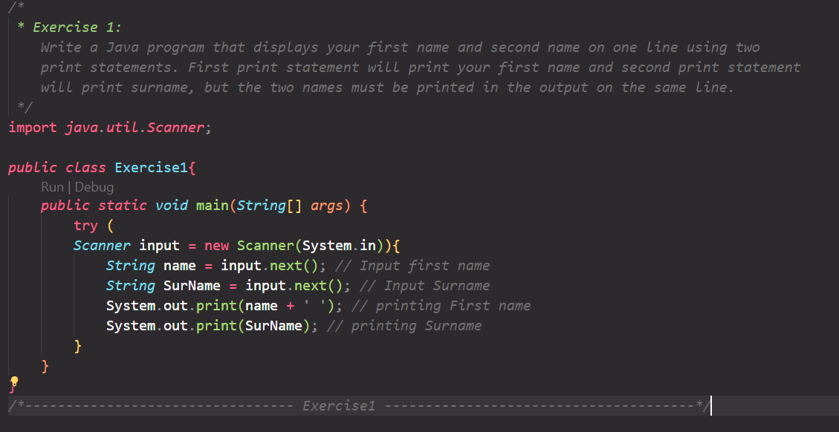

**Output:**

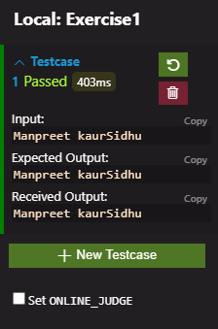

**Exercise 2:** **Write a Java program that displays your first name and second name on two lines using a single print statement. First name should be on line 1 and surname should be on line 2. Use print statement only once.**

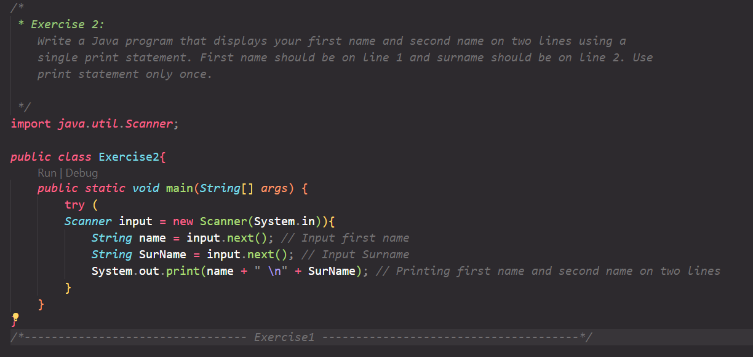

**Output:**

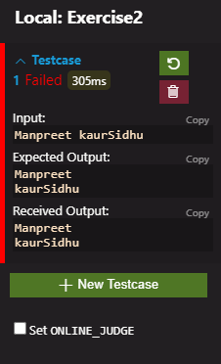

**Exercise 3: Write a Java program that calculates the area of a triangle. The program must declare three variables, base, perpendicular and area. The base and perpendicular have values 2.5 and 3.0 respectively. Area is 1/2*base*perpendicular. The program must print Area at the output.**

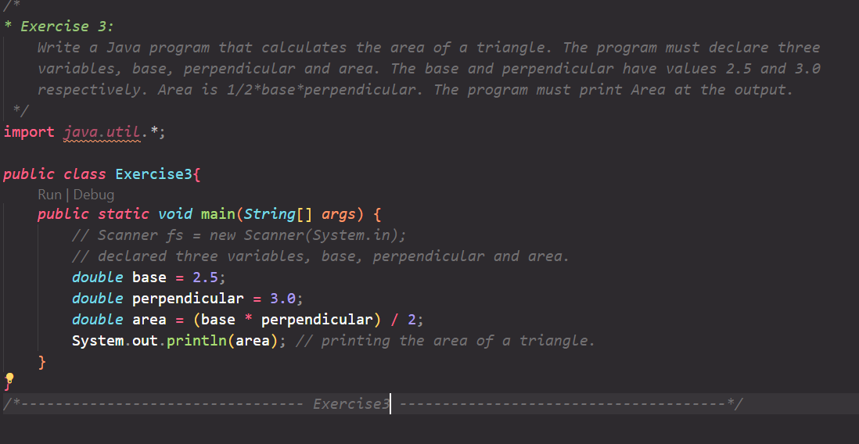

**Output:**

