**CURRICULUM VITAE**

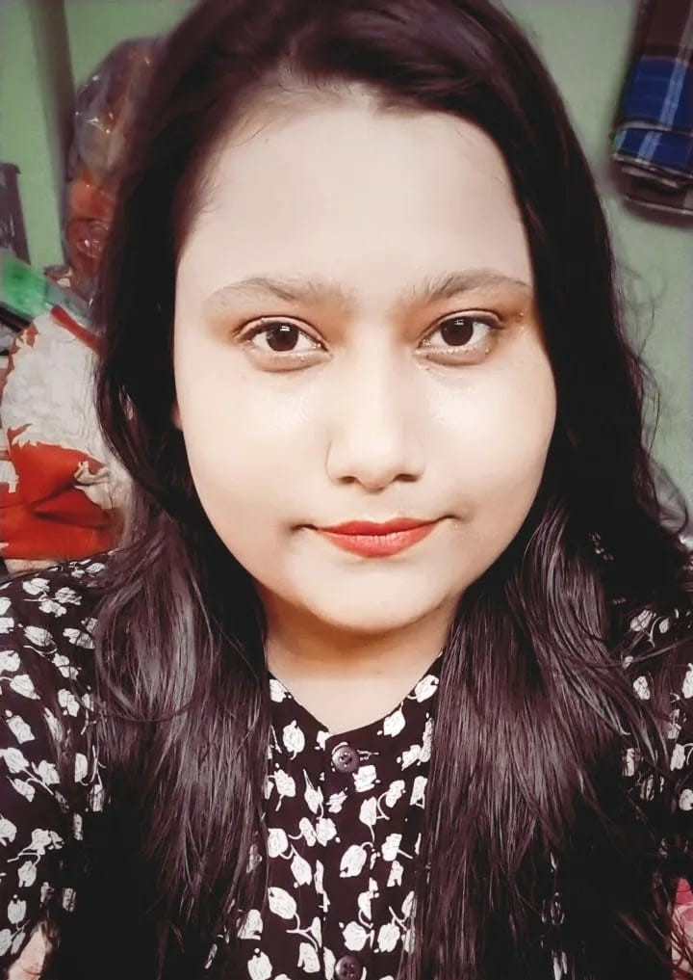

**MASUDA PARVEEN**

D/O MD SAMSUL

ADD: 18/H/8, CHATU BABU LANE KOLKATA-14

1. mail:-masudarehman236@@gmail.com

**OBJECTIVES:**

**To be challenging professional competitive industry and to achieve the target set by the superiors, Determine combined with the dedication has rewarded me in the past and with the same confidence.**

**QUALIFICATION:**

* **Pursuing Graduation (B.A-III Year) to Maulana Azad College.**
* **Intermediate 2016 (from Anjuman Islamia Girl's High School with 63%).**
* **10th passed 2014 (from Anjuman Islamia Girl's High School with 81% ).**

**EXTRA QUALIFICATIONS:-**

* **BASIC Knowledge of computers and work with 1 years Cloud Beds Software (Hotelier software, includes Cashier and accounting).**

**WORK EXPERINCE:-**

**• Worked in Spice Klub as a Receptionist for 2 and half years**

**• Worked in Hard Rock cafe Kolkata as an RSA & Hostess for 3 years**

**• Worked as a Front office & Receptionist in North Goa in three Properties one owner (Golden Sands Resort, Rai Resort, The Sunset) for 1 years.**

**• Worked in Hotel Park Victoria as a FRONT DESK EXECUTIVE (park street Kolkata) since June 2020 to till 31th Dec 2022.**

**• Re-join in Spice Klub again as a Receptionist (Continue Working).**

**Strengths:-**

* **A good team player and positive attitude.**
* **Evergreen quest of knowledge.**
* **Ability to strike a friendly chord with any kind of personality and versatility.**

**LANGUAGE KNOWN:-**

* **English.**
* **Hindi.**
* **Bengali.**

**Declaration:-**

**I hereby declare that all the information given on the above are genuine and true to the best of my knowledge.**

**Place …………………**

**Signature …………….**

**Date ………………….**