1.For applying erosion and dilation, we just need follow bellow formulas:

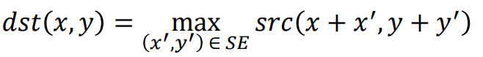

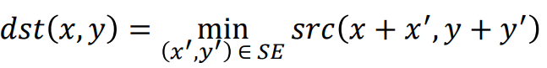

Based on the question, we will use reflect padding in our image. Simply, in our windows, we will multiply our image window to our kernel, furthermore, we will get max or min from our result to set its value for our final answer:

Base image + padding:

|  |  |  |  |  |  |  |  |  |  |
| --- | --- | --- | --- | --- | --- | --- | --- | --- | --- |
| 20 | 20 | 20 | 20 | 20 | 20 | 20 | 20 | 10 | 20 |
| 10 | 10 | 10 | 10 | 20 | 10 | 10 | 20 | 10 | 20 |
| 20 | 20 | 20 | 20 | 20 | 20 | 20 | 20 | 10 | 20 |
| 10 | 10 | 10 | 10 | 20 | 10 | 20 | 20 | 10 | 20 |
| 10 | 10 | 10 | 20 | 30 | 10 | 20 | 20 | 10 | 20 |
| 10 | 10 | 10 | 30 | 10 | 10 | 30 | 10 | 20 | 10 |
| 10 | 10 | 10 | 30 | 10 | 30 | 20 | 20 | 10 | 20 |
| 20 | 20 | 20 | 20 | 20 | 20 | 10 | 20 | 10 | 20 |
| 20 | 20 | 20 | 30 | 20 | 10 | 30 | 10 | 30 | 10 |
| 20 | 20 | 20 | 20 | 20 | 20 | 10 | 10 | 10 | 20 |

Kernel:

|  |  |  |
| --- | --- | --- |
| 1 | 1 | 1 |
| 1 | 0 | 0 |
| 1 | 0 | 0 |

For instance, if we want erosion from top left part:

|  |  |  |  |  |  |  |  |  |  |  |
| --- | --- | --- | --- | --- | --- | --- | --- | --- | --- | --- |
| 20 | 20 | 20 |  | 1 | 1 | 1 |  | 20 | 20 | 20 |
| 10 | 10 | 10 | * | 1 | 0 | 0 | = | 10 | 0 | 0 |
| 20 | 20 | 20 |  | 1 | 0 | 0 |  | 20 | 0 | 0 |

After that, we need to find minimum value on the above matrix which is ‘**10**’ in that specific sample. At the end, we will set result [0,0] = 10.

Final answer to erode:

|  |  |  |  |  |  |  |  |
| --- | --- | --- | --- | --- | --- | --- | --- |
| 10 | 10 | 10 | 10 | 20 | 10 | 10 | 10 |
| 10 | 10 | 10 | 10 | 10 | 10 | 10 | 10 |
| 10 | 10 | 10 | 10 | 20 | 10 | 10 | 10 |
| 10 | 10 | 10 | 10 | 10 | 10 | 10 | 10 |
| 10 | 10 | 10 | 10 | 10 | 10 | 10 | 10 |
| 10 | 10 | 10 | 10 | 10 | 10 | 10 | 10 |
| 10 | 10 | 10 | 10 | 10 | 10 | 10 | 10 |
| 20 | 20 | 20 | 20 | 10 | 10 | 10 | 10 |

Final answer to dilation:

|  |  |  |  |  |  |  |  |
| --- | --- | --- | --- | --- | --- | --- | --- |
| 20 | 20 | 20 | 20 | 20 | 20 | 20 | 20 |
| 20 | 20 | 20 | 20 | 20 | 20 | 20 | 20 |
| 20 | 20 | 20 | 20 | 30 | 20 | 20 | 20 |
| 10 | 10 | 10 | 20 | 30 | 20 | 20 | 20 |
| 10 | 20 | 30 | 30 | 30 | 30 | 30 | 20 |
| 20 | 30 | 30 | 30 | 30 | 30 | 30 | 20 |
| 20 | 30 | 30 | 30 | 30 | 30 | 30 | 20 |
| 20 | 20 | 20 | 30 | 20 | 20 | 30 | 20 |

2. For finding image borders we just need to consider the following kernels:

|  |  |  |  |  |  |  |  |  |  |  |  |  |  |  |
| --- | --- | --- | --- | --- | --- | --- | --- | --- | --- | --- | --- | --- | --- | --- |
| 0 | 0 | 0 |  | 0 | 0 | 0 |  | 0 | 0 | 0 |  | 0 | -1 | 0 |
| -1 | 1 | 0 |  | 0 | 1 | -1 |  | 0 | 1 | 0 |  | 0 | 1 | 0 |
| 0 | 0 | 0 |  | 0 | 0 | 0 |  | 0 | -1 | 0 |  | 0 | 0 | 0 |

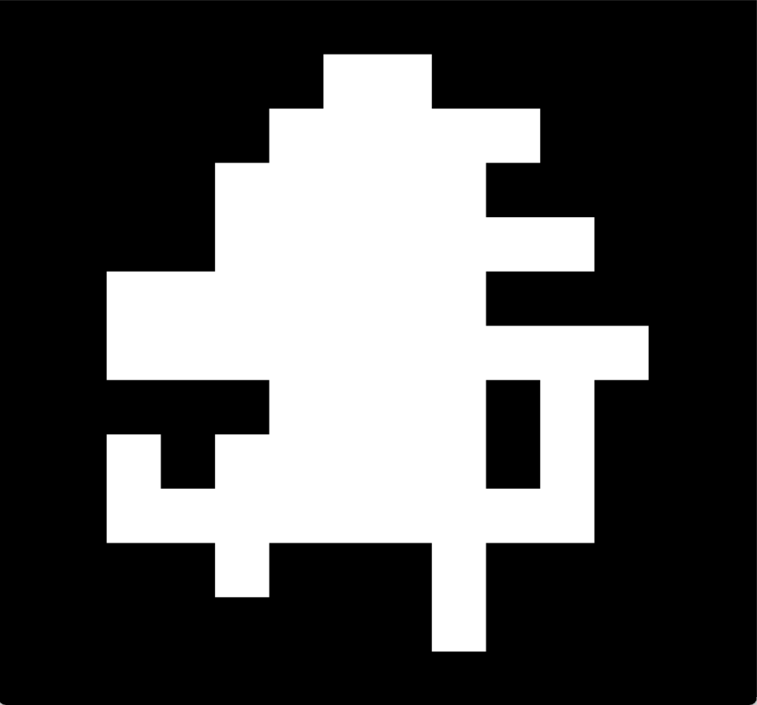 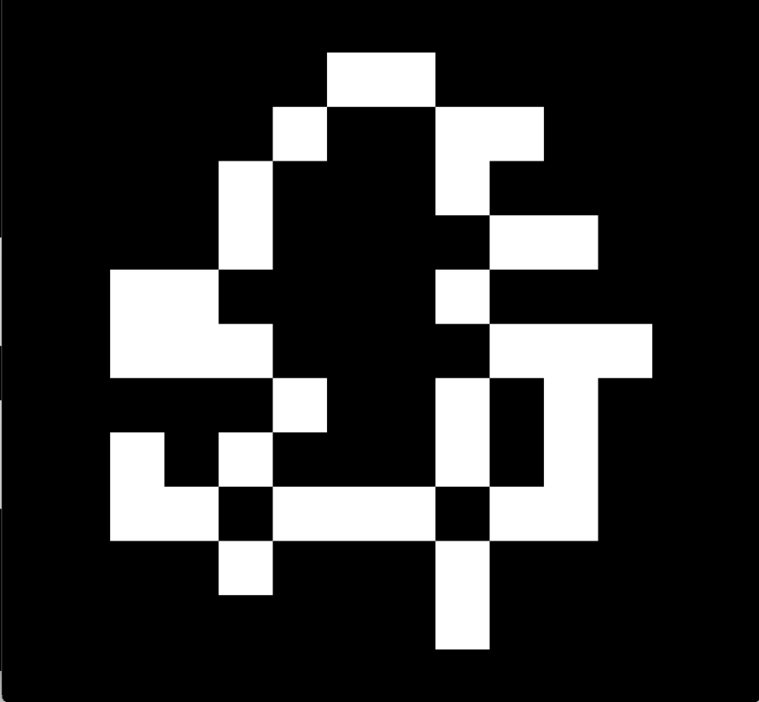

The Left image shows our original image and the Right image shows our final answer after we used the above kernels on our basic image.

Our solution demonstrates that, for Finding borders we need to discover pixel situations which are located in the borders of our image. Regularly, they have a pixel which is surrounding them and their value is equal to zero.

For better understanding, let’s check Hit and Miss formula:



In one of our kernel samples, B1 andB2 are something like bellow:

B1 (which pixel must be equal to one):

|  |  |  |
| --- | --- | --- |
| 0 | 0 | 0 |
| 0 | 1 | 0 |
| 0 | 0 | 0 |

B2 (which pixel must be equal to zero):

|  |  |  |
| --- | --- | --- |
| 0 | 1 | 0 |
| 0 | 0 | 0 |
| 0 | 0 | 0 |

We need to calculate erosion of our input image with B1 and input image’s complement with B2 and in continue, we will We find the commonality of them.

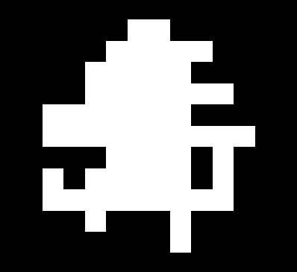 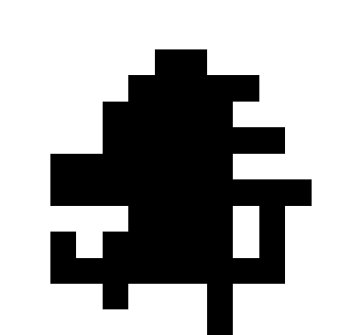 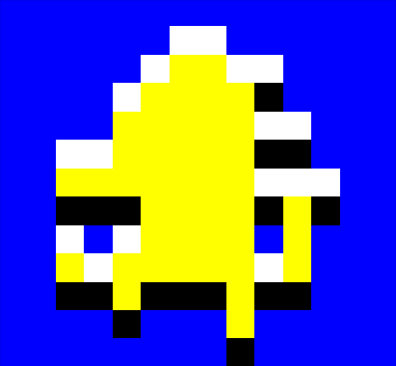

Left image is result for erosion with input image with B1, middle image is result for erosion with input image with B2 and right image is, areas which they are “white”, are the commonality of left and middle images.

Erosion B1 with our input image is equal to the input image in this example, and for B2, we just need to shift down our input image then find the complement of that image which we just need to swap all of 255 and 0 to each other.

So, we will continue our procedure for other kernels and at the end, we will merge all of white pixel to creating our final answer.