
COMSATS University, Islamabad Pakistan

HALO
(Hospital AI Liaison & Operations)
Version 1.0

By

Ihtisham Ul Islam CIIT/SP23-BSE-016/ISB
Shahid Nabi CIIT/SP23-BSE-042/ISB

Supervisor
Dr. Tehseen Riaz Abbasi

Bachelor of Science in Software Engineering (2023-2027)

The candidate confirms that the work submitted is their own and appropriate
credit has been given where reference has been made to the work of others.


COMSATS University, Islamabad Pakistan

HALO
(Hospital AI Liaison & Operations)

A project presented to
COMSATS University, Islamabad

In partial fulfillment
of the requirement for the degree of

Bachelor of Science in Software Engineering (2023-2027)

By

Ihtisham Ul Islam CIIT/SP23-BSE-016/ISB
Shahid Nabi CIIT/SP23-BSE-042/ISB

DECLARATION
We hereby declare that this software, neither whole nor as a part, has been copied out from any source. It is further declared that we have developed this software and accompanied report entirely on the basis of our personal efforts. If any part of this project is proved to be copied out from any source or found to be a reproduction of some other, we will stand by the consequences. No Portion of the work presented has been submitted of any application for any other degree or qualification of this or any other university or institute of learning.

Ihtisham Ul Islam Shahid Nabi

--------------------------- -----------------------

CERTIFICATE OF APPROVAL
It is to certify that the final year project of BS (SE) HALO was developed by
IHTISHAM UL ISLAM (CIIT/SP23-BSE-016) and SHAHID NABI (CIIT/SP23-BSE-042) under the supervision of Dr. Tehseen Riaz Abbasi and that in his opinion; it is fully adequate, in scope and quality for the degree of Bachelor of Science in Software Engineering.

---------------------------------------
Supervisor

---------------------------------------
External Examiner

---------------------------------------
Head of Department
(Department of Computer Science)

EXECUTIVE SUMMARY
Hospital appointment management in Pakistan continues to rely heavily on manual, telephone-based processes handled by reception staff during fixed working hours. These methods impose significant administrative burdens on hospital personnel, restrict patient access outside business hours, and frequently result in scheduling errors, miscommunications, and missed appointments. The absence of automated systems leads to double-bookings, high no-show rates, and fragmented record-keeping that prevents real-time visibility into appointment availability.

HALO (Hospital AI Liaison & Operations) is an agentic conversational appointment management platform designed to address these challenges for hospitals operating in Pakistan. The platform automates routine appointment-related interactions through conversational artificial intelligence capable of handling bookings, rescheduling, and cancellations without human intervention. Patients can interact with the HALO AI agent through a web-based text or voice interface embedded in hospital websites, or by dialing a hospital-provided phone number that connects directly to the AI agent. The system supports bilingual communication in English and Urdu to accommodate Pakistan's linguistic diversity.

HALO operates as a multi-tenant Software-as-a-Service (SaaS) platform, allowing multiple hospitals to onboard and maintain isolated data environments under a shared infrastructure. Hospital managers are provided with role-based dashboards to monitor appointments, manage doctor schedules, and record walk-in patients. A centralized administrative layer oversees hospital onboarding, subscription management, and platform governance. By reducing administrative workload, improving appointment accessibility, and minimizing scheduling conflicts, HALO establishes a scalable and efficient digital foundation for appointment management in the Pakistani healthcare system.

Abstract
The healthcare sector in Pakistan faces persistent operational inefficiencies in managing patient appointments due to heavy reliance on manual telephone-based or form-based scheduling systems. These traditional practices place significant administrative burden on hospital staff, restrict patient access to services outside working hours, and frequently result in scheduling errors and communication delays. To address these challenges, this project proposes HALO, an agentic conversational appointment management platform designed specifically for hospitals operating in Pakistan. HALO will automate routine appointment-related interactions through conversational artificial intelligence capable of handling bookings, rescheduling, and cancellations without human intervention. The system will provide patients with voice-based and text-based interaction modes accessible through hospital website integrations, as well as a dedicated telephony-based interaction channel that allows patients to connect directly to the HALO AI agent via a hospital-provided phone number and will support bilingual communication such as English and Urdu. Real-time verification of doctoral availability and automated slot allocation will ensure accurate scheduling while minimizing conflicts and double bookings. The platform will include role-based management tools allowing hospital managers to monitor appointments, manage doctor schedules, and record in-person walk-in appointments when required. A centralized administrative layer will oversee hospital onboarding, subscription management, platform configuration. Unlike marketplace-based healthcare platforms, HALO will operate as a white-label solution, enabling individual hospitals to maintain institutional identity while benefiting from shared infrastructure. By reducing administrative workload, improving appointment accessibility, and minimizing scheduling errors, HALO aims to establish a scalable and efficient digital foundation for appointment management in the Pakistani healthcare system.

Acknowledgement
All praise is to Almighty Allah who bestowed upon us a minute portion of His boundless knowledge by virtue of which we were able to accomplish this challenging task.

We are greatly indebted to our project supervisor Dr. Tehseen Riaz Abbasi. Without his personal supervision, advice and valuable guidance, completion of this project would have been doubtful. We are grateful to them for their encouragement and continual help during this work.

And we are also thankful to our parents and family who have been a constant source of encouragement for us and brought us with the values of honesty & hard work.

Ihtisham Ul Islam Shahid Nabi

--------------------------- ---------------------------

Abbreviations
Abbreviation | Full Form
SRS | Software Requirements Specification
HALO | Hospital AI Liaison & Operations
AI | Artificial Intelligence
NLU | Natural Language Understanding
FSM | Finite State Machine
SaaS | Software as a Service
API | Application Programming Interface
RBAC | Role-Based Access Control
JWT | JSON Web Token
TLS | Transport Layer Security
NLP | Natural Language Processing
KPI | Key Performance Indicator
UI | User Interface
UX | User Experience
FR | Functional Requirement
NFR | Non-Functional Requirement
ACID | Atomicity, Consistency, Isolation, Durability
HTTPS | Hypertext Transfer Protocol Secure
TTS | Text-to-Speech
STT | Speech-to-Text

Table of Contents
Abstract v
1 Chapter 1: Introduction and Problem Definition 1
1.1 Overview of the Project 1
1.2 Vision Statement 1
1.3 Problem Statement 2
1.4 Problem Solution 2
1.5 Objectives of the Proposed System 3
1.6 Scope 3
1.6.1 Limitations/Constraints 4
1.7 Modules 4
1.7.1 Module 1: User Profiling & Access Control (Admin & Hospital Manager) 4
1.7.2 Module 2: Hospital Tenant Onboarding (Hospital Manager) 4
1.7.3 Module 3: Platform Administration (Admin) 5
1.7.4 Module 4: Clinical Resources (Hospital Manager) 5
1.7.5 Module 5: AI-Driven Appointments (Patient & AI agent) 5
1.7.6 Module 6: Operations Console (Hospital Manager) 6
1.7.7 Module 7: Search & Filter 6
1.7.8 Module 8: Report & Analytics 6
1.7.9 Module 9: Notifications & Reminders 7
1.7.10 Module 10: Billing & Subscription 7
1.8 Related System Analysis/Literature Review 7
1.8.1 Literature Review 7
1.8.2 Related System Analysis 8
1.9 Tools and Technologies 9
1.10 Project Contribution 9
1.11 Relevance to Course Modules 10
2 Chapter 2: Requirement Analysis 11
2.1 User Classes and Characteristics 11
2.2 Operating Environment 12
2.3 Design and Implementation Constraints 12
2.4 Use case Diagram 13
2.5 Requirement Identifying Technique 17
2.6 Functional Requirements 23
2.7 Non-Functional Requirements 59
2.7.1 Reliability 59
2.7.2 Usability 59
2.7.3 Performance 59
2.7.4 Security 60
2.8 External Interface Requirements 60
2.8.1 User Interfaces Requirements 60
2.8.2 Software interfaces 60
2.8.3 Hardware interfaces 61
2.8.4 Communications interfaces 61
3 References 62
4 Plagiarism Report 63

List of Figures

Figure 1 - Use Case Diagram — Administrator 14
Figure 2 - Use Case Diagram — Hospital Manager 15
Figure 3 - Use Case Diagram — Patient 16
Figure 4 - Mockup M1 : Unified Login Screen 23
Figure 5 - Mockup M2 : Forgot Password Screen 24
Figure 6 - Mockup M3 : Admin Profile Screen 25
Figure 7 - Mockup M4 : Hospital Manager Profile Screen 27
Figure 8 - Mockup M5 : Hospital Registration Step 1 28
Figure 9 - Mockup M6 : Hospital Registration Step 2 30
Figure 10 - Mockup M7 : Hospital Registration Step 3 31
Figure 11 - Mockup M8 : Application Status Tracking Screen 32
Figure 12 - Mockup M9 : Admin Dashboard 33
Figure 13 - Mockup M10 : Pending Hospital Applications List 34
Figure 14 - Mockup M11 : Hospital Application Detail Screen 35
Figure 15 - Mockup M12 : All Hospitals Management Screen 36
Figure 16 - Mockup M13 : Platform Configuration Screen 37
Figure 17 - Mockup M14 : Doctor Management List Screen 38
Figure 18 - Mockup M15 : Add/Edit Doctor Profile Screen 39
Figure 19 - Mockup M16 : Doctor Schedule Configuration Screen 41
Figure 20 - Mockup M17 : Department Management Screen 42
Figure 21 - Mockup M18 : Hospital Website Landing Page 43
Figure 22 - Mockup M19 : HALO Chat Widget Text Mode 44
Figure 23 - Mockup M20 : HALO Chat Widget Voice Mode 46
Figure 24 - Mockup M21 : Booking Confirmation Summary 47
Figure 25 - Mockup M22 : Phone Number Display and Dial 48
Figure 26 - Mockup M23 : Hospital Manager Dashboard 49
Figure 27 - Mockup M24 : Daily Schedule and Calendar View 51
Figure 28 - Mockup M25 : Walk-in Patient Entry Form 52
Figure 29 - Mockup M26 : Appointment Search and Filter Screen 53
Figure 30 - Mockup M27 : Doctor and Department Search Screen 54
Figure 31 - Mockup M28 : Admin Analytics Dashboard 55
Figure 32 - Mockup M29 : Hospital Manager Analytics Dashboard 56
Figure 33 - Mockup M30 : Notification Center Screen 57
Figure 34 - Mockup M31 : Notification Preferences Screen 58
Figure 35 - Mockup M32 : Admin Subscription Management Screen 59
Figure 36 - Mockup M33 : Hospital Manager Subscription Screen 60
Figure 37 - Turnitin plagiarism report 65

Chapter 1: Introduction and Problem Definition
This chapter provides a comprehensive introduction to the HALO platform. It begins with an overview of the system and its domain context, followed by the vision statement, problem definition, proposed solution, objectives, scope, constraints, modules, related system analysis, tools and technologies, and the project's academic and technical contribution.

Overview of the Project
HALO (Hospital AI Liaison & Operations) is a web-based, artificially intelligent appointment management platform built to modernize how hospitals in Pakistan handle patient scheduling. The platform replaces conventional telephone-based and manual reception workflows with an autonomous conversational agent capable of booking, rescheduling, and cancelling appointments through natural language dialogue which will be available around the clock without human intervention.

The system is designed as a multi-tenant SaaS solution, enabling multiple hospitals to operate independently on a shared infrastructure while maintaining complete data isolation. Each participating hospital receives a dedicated AI-powered interface embeddable on its existing website, along with a hospital-provided phone number that connects directly to the HALO AI agent through telephony infrastructure. The platform supports bilingual interaction in English and Urdu which also includes code-switching expressions common in Pakistan and ensuring accessibility for diverse patient populations.

Hospital managers are equipped with role-based operational dashboards to monitor daily appointments, manage doctor profiles and schedules, and record walk-in patients. A centralized administrative layer manages hospital onboarding, verification, subscription plans, and system-wide governance. The modular architecture of HALO is designed to support future enhancements such as mobile applications, expanded language support, and integration with external hospital management systems.

Vision Statement
For hospitals, clinics, and healthcare administrative teams across Pakistan who need an efficient and reliable way to manage patient appointments and routine communication, the Hospital AI Liaison & Operations (HALO) platform is a software-as-a-service, artificial intelligence assisted appointment management system that enables automated booking, rescheduling, cancellations, reminders, and bilingual patient interaction through web-based conversational interfaces and telephony-based as well. Unlike traditional manual call handling, static appointment forms, or third-party marketplace platforms, our product provides hospitals with a dedicated, white-label, conversational appointment solution that reduces administrative workload, improves patient accessibility, minimizes scheduling conflicts, and supports continuous appointment services in a scalable and cost-aware manner suitable for the Pakistani healthcare environment.

Problem Statement
Pakistani hospitals face significant operational challenges in managing patient appointments due to continued reliance on manual, telephone-based or form-based scheduling systems. Appointment requests are typically handled by reception staff during working hours only, leading to call congestion, unanswered inquiries, and extended waiting times when multiple patients attempt to book appointments simultaneously. These inefficiencies reduce patient satisfaction and delay access to healthcare services. Receptionists often balance in-person responsibilities alongside telephone scheduling, increasing the likelihood of missed calls, incomplete information exchange, and data entry errors. The absence of automated scheduling tools results in frequent problems such as double-bookings and miscommunication regarding doctor availability, particularly when schedule changes occur unexpectedly. Most hospitals lack after-hours appointment booking facilities, forcing patients to delay care or make unnecessary physical visits for scheduling purposes. Additionally, manual systems do not provide automated reminders, contributing to high appointment no-show rates that disrupt physician schedules and waste hospital resources. The use of fragmented record-keeping methods, including paper registers and disconnected spreadsheets, prevents accurate real-time visibility into appointment availability. Language diversity further complicates appointment management when communication occurs exclusively in English or Urdu, limiting effective access for certain patient groups. Collectively, these challenges increase administrative costs, reduce operational efficiency, and hinder optimal utilization of healthcare resources. An automated, bilingual, and continuously available appointment management system is required to address these limitations and improve healthcare service delivery in Pakistan.

Problem Solution
The HALO platform is designed to address the limitations of manual appointment management by introducing an agentic conversational system that automates routine scheduling tasks while supporting hospital-specific operational workflows. Each participating hospital will be provided with a dedicated interface integrated into its existing website, enabling deployment without extensive technical modifications.
HALO will employ conversational artificial intelligence to guide patients through appointment booking processes, including doctor selection by specialty or name, real-time availability checking, slot recommendation, and booking confirmation. The system will support voice-based interaction using speech recognition and synthesis, text-based interaction through a chatbot interface, and telephony-based voice interaction through a hospital-provided phone number connected directly to the HALO AI agent, with bilingual support. Automated validation mechanisms will ensure that appointment slots are allocated accurately based on up-to-date doctor schedules, preventing double-bookings and scheduling conflicts. Confirmation and reminder notifications will be issued through supported communication channels to reduce missed appointments. Routine appointment handling will be fully automated, while hospital staff will retain the ability to record in-person walk-in appointments through management dashboards when required. Hospital managers will access role-based dashboards providing visibility into daily schedules, appointment status, and doctor availability. A centralized administrative module will manage hospital onboarding, verification, and subscription plans, ensuring consistent system governance. HALO will function as a multi-tenant software-as-a-service platform, allowing multiple hospitals to operate independently while sharing core infrastructure. By automating repetitive administrative processes and extending appointment services beyond conventional working hours, the system will improve operational efficiency, reduce administrative workload, and enhance patient access to healthcare services.

Objectives of the Proposed System
The primary objectives of the HALO platform are as follows:

- (Automation): Minimize manual telephone workload for receptionists by automating routine inquiries and booking tasks.
- (Accessibility): Ensure 24/7 service availability, allowing patients to book appointments regardless of hospital working hours.
- (Accuracy): Eliminate double-booking and scheduling errors through real-time database synchronization and automated slot validation.
- (Inclusivity): Bridge the communication gap by providing robust bilingual support (English and Urdu) across both voice and text channels
- (Operational Efficiency): Streamline workflows with a centralized dashboard that unifies online bookings and physical walk-in data.
- (Scalability): Deploy a multi-tenant architecture that enables rapid onboarding of new hospitals with standard web integrations.
- (Engagement): Reduce appointment "no-shows" via automated, multi-channel reminders (Email, In-App).
- (Cost Optimization): Reduce administrative overhead, allowing hospitals to reallocate human resources to critical care areas.
- (Patient Experience): Enhance patient satisfaction through natural conversational interactions, eliminating complex form-filling and navigation barriers.
- (Reliability): Ensure deterministic, auditable scheduling behavior independent of AI outputs.

Scope
The scope of the HALO project covers the design and development of a web-based, artificial intelligence assisted appointment scheduling platform for hospitals operating in Pakistan. The system enables hospitals to register, undergo administrative verification, and create a dedicated instance to efficiently manage appointments. It provides a bilingual interface in English and Urdu and operates continuously, including outside regular working hours. Hospital Managers can configure hospital departments and doctor profiles, set consultation schedules and operational rules, access dashboards to monitor appointments, and manually add walk-in patients. Patients can access hospital-specific links embedded on hospital websites, interact with a conversational agent via text or voice through a web-based interface, or initiate interaction by dialing a hospital-provided phone number that connects directly to the HALO AI agent, and book, reschedule, or cancel non-emergency appointments based on real-time doctor availability. Platform Admins manage hospital approvals, system configurations, and platform governance. The system also includes features such as an automated appointment scheduling engine to prevent double bookings, notifications and reminders via email and simulated messaging channels, and a multi-tenant architecture ensuring logical data isolation for each hospital. HALO will not perform medical diagnosis, emergency handling, or clinical decision-making, and integration with external hospital management systems is excluded in the current scope.

Limitations/Constraints
The HALO platform is designed to automate administrative appointment management processes; however, the system operates under certain limitations and constraints that define its functional boundaries.
- The artificial intelligence agent will not perform medical symptom analysis, disease diagnosis, or clinical decision-making, as the system is limited strictly to administrative appointment scheduling tasks.
- The system will not handle medical emergencies, urgent care requests, or critical patient situations that require immediate medical intervention or emergency response coordination.
- The system will support English and Urdu languages exclusively during the initial phase and will not accommodate additional regional or international languages.
- Appointment categorization and specialist selection are based on patient-provided information; the system cannot validate medical necessity or assess the clinical appropriateness of requested appointments.
- The platform will not include native mobile applications for Android or iOS devices and will be accessible through web browsers on desktop and mobile devices.

Modules
The HALO system is structured into well-defined functional modules, each responsible for a specific aspect of the platform’s operation.

Module 1: User Profiling & Access Control (Admin & Hospital Manager)
This module establishes secure authentication, role-based authorization, session management, and audit logging mechanisms to protect platform access for administrative users.

- Create and maintain user profiles containing essential identity and contact information.
- Register hospital managers securely using verified email addresses.
- Log in and log out securely with encrypted password handling.
- Enforce role-based access control to restrict system features based on assigned user roles.
- Associate each user’s profile with a predefined role such as Hospital Manager or Administrator.
- Update limited profile attributes such as name, contact details, and notification preferences.

Module 2: Hospital Tenant Onboarding (Hospital Manager)
This module handles hospital registration, verification, and configuration required before operational use.

- Register a hospital by providing basic organizational and contact information.
- Categorize hospitals by facility type, such as general hospitals or specialty clinics.
- Upload hospital specific documents and license.
- Submit hospital registrations for administrative approval prior to activation.
- Check the status of submitted application via application ID.
- Manage core hospital profile information upon post-activation.
- Generate a unique hospital identifier to ensure logical data isolation within the multi-tenant architecture.

Module 3: Platform Administration (Admin)
This module provides centralized control and oversight across the platform.
- Review and approve hospital registrations.
- Reject invalid or incomplete hospital applications.
- Deactivate or suspend hospital access.
- Configure system-wide parameters across the platform.
- View summarized platform-level statistics and oversight data.

Module 4: Clinical Resources (Hospital Manager)
This module manages all doctor-related information required for appointment scheduling.

- Create and maintain doctor profiles within the hospital system.
- Configure consultation fees and appointment durations per doctor.
- Define doctor’s working schedules, break, and leave periods.
- Configure appointment slot intervals for each doctor.
- Modify or deactivate existing doctor profiles as needed.
- Configure email and alert templates.

Module 5: AI-Driven Appointments (Patient & AI agent)
This module provides an AI-powered conversational agent for patients to interact with the appointment system, enabling booking, rescheduling, and cancellation through natural language dialogue while managing underlying scheduling logic to ensure data consistency and conflict prevention.

- Interact with the appointment system through a web-based conversational interface supporting both text and real-time voice communication.
- Initiate appointment-related interactions through a hospital-provided phone number via telephony infrastructure.
- Communicate with the conversational agent in English or Urdu, including common code-mixed expressions to book/reschedule/cancel/query appointment.
- Interpret patient inputs using an AI-based NLU pipeline comprising intent classification and named entity recognition, with a Finite State Machine (FSM) managing dialogue flow to ensure valid conversation progression and prevent unsupported or ambiguous interactions.
- View available appointment slots grouped by date and time in a structured format.
- Collect required booking information progressively, prompting patients only for missing fields such as name, contact number, email, age, and visit reason.
- Generate a unique appointment reference identifier upon successful booking for use in future interactions.
- Trigger automated notifications to patients and hospital staff upon booking, rescheduling, or cancellation via supported channels such as SMS and email.

Module 6: Operations Console (Hospital Manager)
This module provides operational control interfaces for hospital managers, including basic analytics and reporting capabilities.

- View daily appointment schedules through a consolidated dashboard.
- Manually enter and register walk-in patient appointments.
- Synchronize manual and automated bookings in real time.
- Configure basic operational settings for the hospital instance.
- View appointment volume statistics and basic analytics.

Module 7: Search & Filter
This module provides structured search and filtering capabilities across hospitals, doctors, departments, and appointments to enhance data accessibility and operational efficiency.

- Search for doctors by name, specialty, or department via the conversational agent.
- Search for appointments by reference ID, date, doctor name, patient name, or status.
- Filter results by time slots, departments, and availability status.
- Apply combined filters for refined and targeted result sets.
- Reflect real-time updates in search results based on live data changes.
- Integrate search and filter functionality across all operational dashboards.

Module 8: Report & Analytics
This module provides data-driven insights into system usage and hospital operations by analyzing appointment activity, doctor utilization, and peak-hour traffic trends.

- Generate appointment volume reports displaying total, completed, and cancelled counts for selected time periods.
- Analyze doctor utilization based on booking frequency and availability patterns.
- Identify peak-hour traffic trends across patient appointments.
- View summarized operational dashboards tailored for hospital managers and administrators.
- Display real-time KPIs for hospital managers, including today's appointments, online bookings, walk-in bookings, and active doctors.
- Display real-time KPIs for administrators, including total hospitals, active hospitals, total appointments, and total platform users.
- View platform-wide statistics and aggregated usage data for administrative oversight.
- Export analytical reports in PDF or CSV format for academic and operational use.

Module 9: Notifications & Reminders
This module manages appointment-related communications using email and in-app notifications, keeping implementation simple and cost-effective for academic evaluation.

- Generate in-app appointment confirmation for patients immediately upon successful booking.
- Send email confirmations containing appointment details and unique reference numbers to patients and hospital managers.
- Deliver reminder alerts to patients via email 24 hours prior to scheduled appointments.
- Log notification delivery status for transparency and record-keeping purposes.
- Notify hospital managers via in-app alerts upon appointment booking, cancellation, or rescheduling events.

Module 10: Billing & Subscription
This module demonstrates SaaS subscription logic for hospitals using HALO services.

- Select from subscription tiers (Basic / Standard / Premium) for hospital access to HALO services.
- Simulate subscription activation and expiry scenarios for demonstration purposes.
- Manually manage hospital subscription plans, including assigning new plans, extending existing plans, and suspending active plans.

Related System Analysis/Literature Review

Literature Review
The development of HALO draws upon academic and industry research spanning conversational AI, healthcare informatics, natural language processing, and SaaS architecture.

Research by Laranjo et al. ("Conversational Agents in Healthcare," npj Digital Medicine, 2018) established that AI-based conversational agents can effectively reduce administrative workloads in clinical settings while improving patient engagement. This validates HALO's core approach of deploying an autonomous conversational agent for appointment scheduling.

Ahmed et al. ("Conversational AI in Healthcare: Applications and Future Directions," ICAIM, 2024) demonstrate that integrating NLU pipelines with healthcare scheduling systems can significantly improve slot utilization rates and reduce no-show incidents when combined with automated reminders.

Khan and Rahman ("Digital Transformation in Pakistani Healthcare: Challenges and Opportunities," Journal of Medical Systems, 2023) specifically contextualize the digital health gap in Pakistan, noting that most facilities operate with minimal automation and that bilingual AI solutions present a viable path toward democratizing healthcare access.

The WHO Digital Health Implementation Framework (2023) provides guidelines relevant to multi-tenant healthcare platform governance that informed HALO's administrative module design, particularly around data isolation, hospital verification, and role-based access control.

Radford et al. (OpenAI, "Whisper: Robust Speech Recognition via Large-Scale Weak Supervision," 2022) validate the use of Whisper AI as a reliable multilingual speech recognition engine, supporting HALO's Urdu-language voice interaction capability.

Related System Analysis
Based on the top-rated and popular related systems operating in digital healthcare appointment management globally and regionally, the following table highlights their weaknesses and the corresponding proposed solutions implemented within HALO.

Table 1.1 Related System Analysis with proposed HALO solutions
Application Name | Weakness | Proposed Project Solution
Doctolib  https://www.doctolib.com/ | • No conversational voice-based AI for natural appointment booking.  • Limited language localization for non-European patient populations. | • HALO will provide voice-enabled conversational artificial intelligence for appointment handling (Module 5).  • The system will support bilingual interaction in English and Urdu to improve accessibility (Module 5).
Zocdoc  https://www.zocdoc.com/ | • Marketplace-centric architecture restricts hospital ownership of appointment workflows.  • Limited flexibility in customizing scheduling logic per hospital. | • HALO will deliver hospital-owned appointment systems with independent branding and control (Module 3).  • The platform will allow configurable scheduling rules per hospital through a dedicated scheduling engine (Module 4).
Marham.pk  https://www.marham.pk/ | • Appointment handling depends on human call-center agents.  • No dedicated AI instance tailored to individual hospital operations. | • HALO will deploy autonomous voice and text AI agents operating without staff involvement (Module 2).  • The system will provide per-hospital AI instances with customized knowledge and doctor data (Module 3).
Oladoc  https://www.oladoc.com/ | • Appointment capacity is constrained during peak hours due to semi-manual workflows.  • Limited automated follow-up and reminder mechanisms. | • HALO will support fully automated end-to-end appointment scheduling without human intervention (Module 5).  • The platform will deliver automated confirmations and reminder notifications to reduce missed appointments (Module 9).

Tools and Technologies
Below are all the hardware/software tools and technologies with version number which will be used in implementation of our project

Table 1.2 Tools and Technologies for HALO Project
Tools &  Technologies | Tools | Version | Rationale
 | Visual Studio Code | 1.113 | IDE
 | Microsoft Word | 365 | Documentation and report writing
 | Microsoft Project | 2016 | Gantt Chart and Work Breakdown Structure
 | Figma | V126.1.2 | Interface design and prototyping
 | Canva | V3.0 | Mockup creation and visual design
 | Postman | 10.2 | API testing and development
 | Docker Desktop | 24.1 | Containerization and deployment
 | Git | 2.4 | Version control system
 | GitHub | 3.5.7 | Repository hosting and collaboration
 | Technology | Version | Rationale
 | Next.js | 14.6 | frontend + backend API routes
 | Tailwind CSS | 3.3 | Styling and responsive design
 | TypeScript | 5.2 | Type-safe JavaScript development
 | HTML | V5 | Markup language for web interfaces
 | CSS | V3 | Styling and layout design
 | Node.js | 20.2 LTS | Backend server development
 | Express.js | 4.3 | RESTful API development
 | FastAPI | 0.104 | AI service API development
 | Python | 3.11 | AI model integration and processing
 | PostgreSQL | 7.8 | SQL document storage
 | Web RTC | - | Voice input/output processing
 | Ollama | V0.5.x | Multilingual model
 | Vicuna | 13B-v1.5 | Conversation Generation
 | Redis | 8.0 | Session caching
 | JWT | - | Stateless authentication
 | TLS | 1.3 | Data encryption protocol
 | LangChain | 0.1.4 | AI models orchestration
 | Whisper AI | Large-v3 | Urdu language speech recognition

Project Contribution
The HALO platform moves beyond standard digitization to provide an AI-assisted, deterministic appointment system. Key technical and conceptual contributions include:
- Unified Multimodal AI: Introduces a synchronized interface where voice and text operate simultaneously, allowing users to switch modes seamlessly without losing context.
- Localized Bilingual NLU: Implements a specialized Natural Language Understanding model optimized for Urdu and English, specifically handling code-switching common in Pakistan.
- Autonomous Slot Negotiation: Unlike static forms, the AI agent actively negotiates alternative times when requested slots are unavailable, mimicking a human receptionist.
- Zero-Friction "White-Label" Injection: utilizing a novel embeddable widget architecture that injects complex AI functionality into legacy hospital websites without backend restructuring.
- Hybrid Real-Time Synchronization: Bridges physical and digital queues by instantly updating availability when walk-ins are logged, preventing conflicts common in disconnected systems.
Contribution Impact: These innovations lower the technical barrier for hospitals and democratize access for patients with low literacy, transforming passive booking forms into an active, intelligent service.

Relevance to Course Modules
This project applies core concepts from the following academic modules:
- Artificial Intelligence & NLP: Implemented LLMs, Speech-to-Text, and Text-to-Speech pipelines for the conversational voice agent.
- Software Architecture: Applied Multi-Tenant Architecture to ensure data isolation between hospitals within a shared SaaS infrastructure.
- Web Engineering: Used Next.js/Node.js for full-stack development of the admin dashboards and embeddable widgets.
- Database Systems: Designed complex relational schemas to manage dynamic schedules and ensure ACID compliance for booking transactions.
- Human-Computer Interaction (HCI): Designed user-friendly and easy to access interfaces to maximize accessibility for non-technical users.
- Information Security: Integrated Role-Based Access Control (RBAC) to secure sensitive administrative and patient data.
- Operating Systems & System Programming: Applied process management concepts through multi-threaded Node.js architecture handling concurrent patient conversations using event loop and worker threads.
- Professional Ethics & Legal Compliance: Adhered to healthcare data privacy regulations designing minimal data collection policies storing only essential patient contact information.
- Software Quality Assurance (SQA): Considered validation rules, error handling, and controlled state transitions (FSM-based dialogue) to ensure predictable and testable system behavior.
- Software Engineering (SE): Applied modular system design, requirement decomposition (FRs), and phased development using clearly defined functional modules aligned with sprint-based planning.
- Data Structures & Algorithms: Used efficient data structures for appointment slot management, conflict detection, and fast retrieval of doctor availability information.

Chapter 2: Requirement Analysis
This chapter presents the complete requirement analysis for the HALO platform. It identifies user classes, defines the operating environment and constraints, presents use case diagrams for all three actors. The Mockup-Based Requirement Analysis technique is used to derive functional requirements from each UI screen, while the Event-Response Table technique captures backend-driven behaviors for the AI-driven appointment module. The chapter concludes with non-functional requirements covering reliability, usability, performance, and security, followed by external interface specifications.

User Classes and Characteristics
HALO is designed to serve three distinct user classes, each with clearly defined roles, responsibilities, access levels, and interaction patterns with the platform. The table below summarizes their characteristics.

Table 1: User Classes and Characteristics
User Class | Description
Administrator | The Administrator is the owner and sole operator of the HALO SaaS platform. This user class is responsible for reviewing and approving hospital registration applications, rejecting invalid submissions, deactivating or suspending hospital accounts, configuring system-wide platform parameters, and monitoring aggregated platform-level statistics. The Administrator does not interact with any hospital\'s patient-facing appointment operations and has no access to patient data. Access is restricted exclusively to the centralized Admin Control Panel. There is a single Administrator account for the entire platform. High technical proficiency is assumed.
Hospital Manager | The Hospital Manager is a verified staff member aka end user representing a registered hospital tenant on the HALO platform. This user class is responsible for configuring and maintaining the hospital\'s operational profile, managing doctor profiles and consultation schedules, monitoring daily appointment activity through an operational dashboard, manually entering walk-in patient appointments, and managing billing and subscription settings. Hospital Managers interact with the system on a daily basis and are expected to possess moderate technical proficiency. Each approved hospital tenant has one designated Hospital Manager account activated upon administrative approval.
Patient | The Patient is also as an end user who interacts with the HALO conversational AI agent to book, reschedule, or cancel non-emergency appointments at a registered hospital. Patients access the system through a hospital-specific web-embedded chat interface supporting text and real-time voice communication, or via a hospital-provided phone number connected to the HALO telephony channel. Patients do not require a registered account and interact through guided conversational flows conducted in English or Urdu. This user class has the highest interaction frequency across the platform. Patients do not access any administrative or management dashboards. Low to moderate technical proficiency is assumed. The system is designed to accommodate users with limited digital literacy.

Operating Environment
The following operating environment requirements define the platforms, hardware, and network conditions under which HALO must operate correctly and consistently.

- HALO is a web-based platform. It must operate correctly on modern desktop and laptop environments running Microsoft Windows 10/11, macOS 12 and above, and Ubuntu 20.04 LTS and above.
- The system must function seamlessly across the following web browsers: Google Chrome (v110+), Mozilla Firefox (v110+), Microsoft Edge (v110+), and Apple Safari (v16+). No browser-specific plugin or extension shall be required.
- The Hospital Manager and Administrator interfaces must be fully accessible and usable on tablet devices (minimum 768px viewport width) through a responsive web layout. Mobile browser access is supported for read-only views.
- The Patient-facing HALO conversational widget is embedded into hospital websites and must load correctly on any device with a modern browser, including smartphones, supporting screen widths from 320px and above.
- The backend API server runs on Node.js (v20.2 LTS) with Express.js (v4.3). The AI service layer runs on FastAPI (v0.104) with Python (v3.11). Both are deployed in Docker containers (v24.1) and hosted on a cloud infrastructure provider.
- The primary database is PostgreSQL (v15+). Redis (latest) is used for session caching. Both database services are hosted on the same cloud environment as the backend.
- The telephony interface requires the hospital to possess a configured SIP/VoIP number. The HALO AI agent connects to this number via Twilio or an equivalent telephony API. Patients dial this number directly from any standard telephone or mobile phone.
- The bilingual NLU pipeline (English and Urdu) requires the Whisper AI (Large-v3) model for speech recognition and the Vicuna (13B-v1.5) model via Ollama for conversational generation. These AI services run on the FastAPI microservice layer.
- The system requires a stable internet connection for all AI-driven appointment interactions and administrative operations. A minimum upload/download speed of 5 Mbps is recommended for the voice interaction mode.
- HALO operates as a multi-tenant SaaS platform. Each registered hospital tenant is logically isolated within the shared infrastructure. No cross-tenant data access is permitted at any layer.

Design and Implementation Constraints
The development of HALO is subject to the following technical and operational constraints that restrict the options available to developers and define the non-negotiable boundaries of implementation.

- The frontend must be developed using Next.js (v14.6) with Tailwind CSS (v3.3) and TypeScript (v5.2). No alternative frontend framework is permitted.
- The backend API must be built using Node.js (v20.2 LTS) with Express.js (v4.3) following RESTful JSON conventions. The AI microservice must use FastAPI (v0.104) with Python (v3.11).
- All data storage must be used in PostgreSQL exclusively. MongoDB or any NoSQL solution is not permitted for primary data storage.
- The conversational AI pipeline must use LangChain (v0.1.4) as the orchestration framework. The NLU layer must implement intent classification and named entity recognition. Dialogue state management must use a Finite State Machine (FSM) to ensure deterministic and auditable conversation flows.
- The speech recognition component for Urdu and English voice input must use Whisper AI (Large-v3). Text-to-Speech output must use a WebRTC-compatible synthesis engine.
- Authentication must use JWT (stateless tokens) with SSL/TLS encryption on all data in transit. No plain HTTP communication is permitted.
- The platform must enforce role-based access control (RBAC) at the API level. Endpoints accessible to a Hospital Manager must not be reachable by a Patient, and vice versa.
- HALO supports English and Urdu exclusively. No additional language is in scope for this version.
- No native mobile application (Android or iOS) is in scope. The system is accessible through web browsers on all device types.
- The platform must not perform medical diagnosis, clinical decision-making, or emergency handling. The AI agent is strictly limited to administrative appointment scheduling tasks.
- Multi-tenancy requires strict logical data isolation per hospital at the database schema level using tenant identifiers. Shared infrastructure is used but no tenant may access another tenant's data.
- Billing and subscription simulation is used for academic evaluation. No live payment gateway integration is required in this release.
- Patient data collected shall be limited to name, contact number, email, age, and visit reason while no clinical or medical data shall be stored.

Use case Diagram
Three use case diagrams are presented below, one per actor. Each diagram defines the scope of that actor's interactions with HALO. The system boundary encloses all use cases. Inclusion and extension relationships are shown where applicable. These diagrams are the basis for the functional requirements in Section 2.6.
Actor 1: Administrator
The Administrator interacts with the platform at a governance level with no involvement in hospital-level appointment operations.
The Administrator interacts with the platform at a governance level with no involvement in hospital-level appointment operations.
Use cases: Login, Logout, Manage Profile, Review Pending Hospital Application, Approve Hospital Registration, Reject Hospital Registration, Suspend Hospital Account, Reactivate Hospital Account, View Platform Statistics (KPIs), Configure Platform Settings, Manage Hospital Subscription Plans (Assign / Extend / Suspend), Generate Platform-Wide Reports, View Platform Notifications.

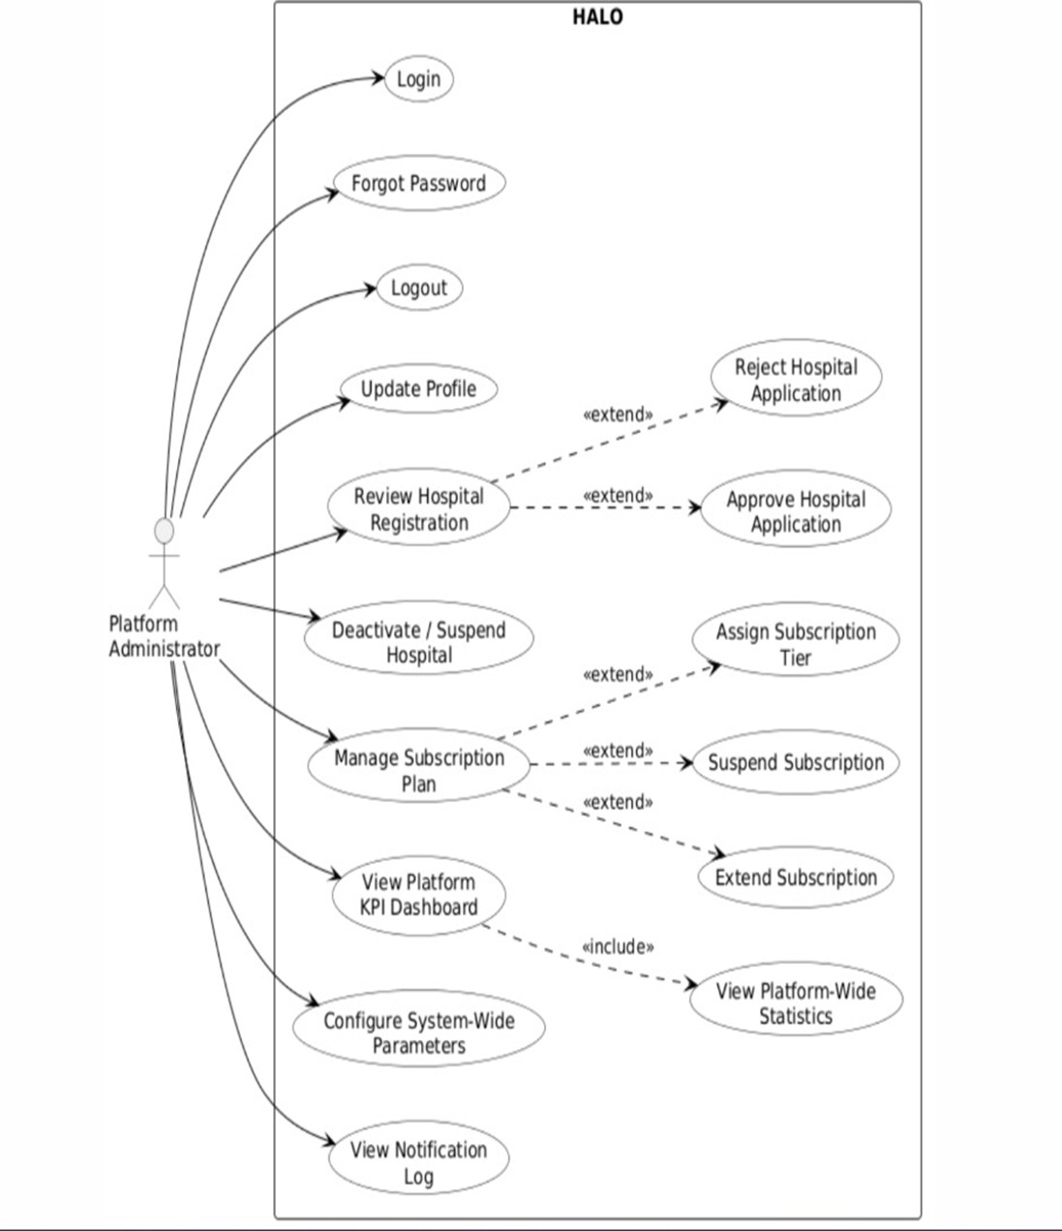
Figure 1 - Use Case Diagram : Administrator

Actor 2: Hospital Manager
The Hospital Manager interacts with the system at the hospital-tenant level and manages all clinical and operational configuration.
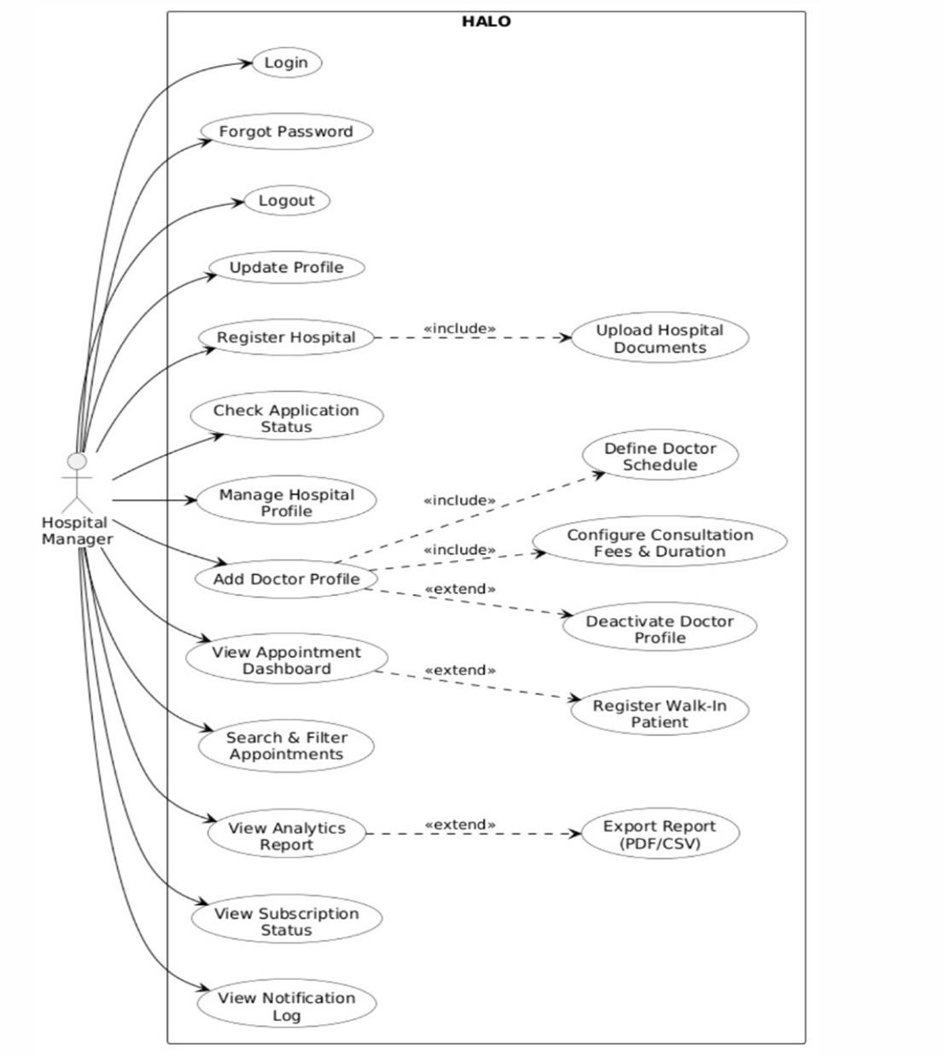
Figure 2 - Use Case Diagram : Hospital Manager

Actor 3: Patient
The Patient interacts exclusively through the HALO conversational agent embedded in the hospital website or accessed via the hospital telephone number.
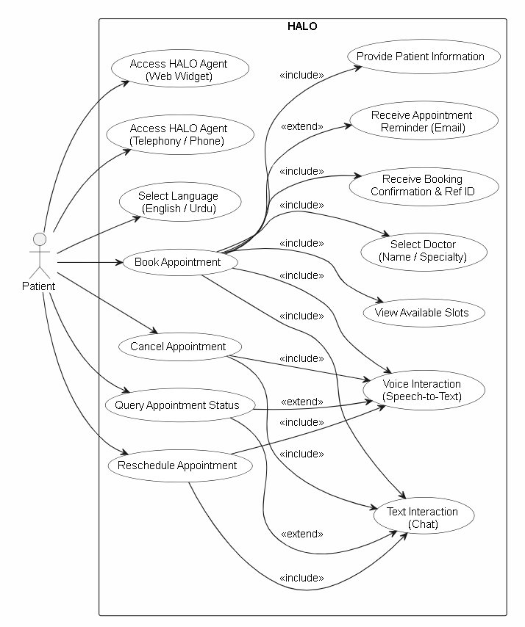
Figure 3 - Use Case Diagram : Patient

Requirement Identifying Technique
Two complementary techniques are used together to ensure no requirement is missed, one for everything the user sees and interacts with, and one for everything the system handles automatically in the background.
Technique 1: Mockup-Based Requirement Analysis
For every core screen in HALO, a dedicated mockup is developed in Figma. Each screen is assigned to a Mockup ID from M1 onwards. Once the mockup is ready, every interactive elements like input fields, buttons, dropdowns, data tables, KPI cards, navigation controls, and toggle switches are examined and converted into a written functional requirement. This ensures that every visible system’s behavior is formally documented. All requirements derived using this technique are recorded in Section 2.6.
The process followed these steps:
Step 1: Identified all key screens across all ten HALO modules for all three actors.
Step 2: Assigned a sequential Mockup ID (M1, M2, ..., M33) to each screen.
Step 3: Build the screen in Figma showing all UI elements and interactive components.
Step 4: For each significant element, derived one or more feature-level requirements.
Step 5: Documented each requirement in the format: Feature | FR-ID Statement | Business Rule.
The following is the complete list of screens identified across all ten modules:
Module 1 : User Profiling & Access Control: M1: Unified Login Screen, M2: Forgot Password Screen, M3: Admin Profile Screen, M4: Hospital Manager Profile Screen.
Module 2 : Hospital Tenant Onboarding: M5: Hospital Registration Step 1 : Organizational Info, M6: Hospital Registration Step 2 : Document Upload, M7: Hospital Registration Step 3 : Review and Submit, M8: Application Status Tracking Screen.
Module 3 : Platform Administration: M9: Admin Dashboard, M10: Pending Hospital Applications List, M11: Hospital Application Detail Screen, M12: All Hospitals Management Screen, M13: Platform Configuration Screen.
Module 4 : Clinical Resources: M14: Doctor Management List Screen, M15: Add/Edit Doctor Profile Screen, M16: Doctor Schedule & Availability Configuration Screen, M17: Department Management Screen.
Module 5 : AI-Driven Appointments: M18: Hospital Website Landing Page with HALO Widget, M19: HALO Chat Widget : Text Mode, M20: HALO Chat Widget : Voice Mode, M21: Appointment Booking Confirmation Summary (in-chat), M22: Phone Number Display and Dial Trigger Screen.
Module 6 : Operations Console: M23: Hospital Manager Dashboard, M24: Daily Appointment Schedule and Calendar View, M25: Walk-in Patient Entry Form.
Module 7 : Search & Filter: M26: Appointment Search and Filter Screen, M27: Doctor and Department Search Screen.
Module 8 : Report & Analytics: M28: Admin Analytics Dashboard, M29: Hospital Manager Analytics Dashboard.
Module 9 : Notifications & Reminders: M30: Notification Center Screen, M31: Notification Preferences and Settings Screen.
Module 10 : Billing & Subscription: M32: Admin Subscription Management Screen, M33: Hospital Manager Subscription and Billing Screen.

Technique 2: Event Response Table (Backend Process Requirements)
Several HALO behaviors are not triggered by any user interface interaction. The AI agent processes a booking, triggering a 24-hour reminder automatically, forfeiting an unconfirmed appointment slot, detecting a scheduling conflict, and handling telephony events while none of these have a screen element that directly triggers them. They occur based on internal system events. The Event-Response Table documents exactly these situations. Each row identifies what event occurred, the system's state before the event, the required system response, the resulting state, and exception handling. This keeps all backend business logic formally specified alongside the frontend requirements.
To capture these processes, the Event Response Table technique is used. Because it is effective for modelling backend or real-time system behaviors where user interface interactions are not directly involved.
Table 2.2: Event-Response Table: AI-Driven Appointment Booking Processes (Module 5)
Event Name | Trigger | Source | System State (Before) | Response | System State (After) | Exception Handling
Patient Initiates Conversation | Patient opens HALO widget or calls hospital number | Web Widget / Telephony Interface | Agent idle. Hospital active and verified. | 1. Detect input channel (text/voice/telephony). 2. Load hospital knowledge base. 3. Greet patient in detected language. 4. Start FSM session. | FSM session active. Greeting delivered. | If hospital is inactive or suspended, display unavailability message. Do not initiate session.
Appointment Slot Requested | Patient specifies doctor, date, and time via conversation | FSM Dialogue Engine | FSM in slot-selection state. Doctor profile and schedule loaded. | 1. Query real-time slot availability. 2. Validate requested slot is open. 3. Present confirmation prompt to patient. 4. Collect missing fields (name, contact, email, age, reason). | FSM in pre-confirmation state. Slot temporarily held. | If slot is unavailable, suggest next 3 available slots. If doctor not found, re-prompt with alternatives.
Appointment Booking Confirmed | Patient confirms all booking details via conversation | FSM Confirmation State | Patient details collected. Slot available and held. | 1. Create appointment record in database. 2. Generate unique reference ID. 3. Mark slot as booked. 4. Send email confirmation to patient and hospital. 5. Trigger in-app notification to Hospital Manager. 6. End FSM session gracefully. | Appointment status = Confirmed. Slot = Booked. Reference ID issued. | If email delivery fails, log failure and retry once. Reference ID is still issued. If database write fails, release slot and re-prompt patient.
Appointment Rescheduled | Patient provides reference ID and requests new time | FSM Rescheduling State | Existing confirmed appointment found via reference ID. | 1. Validate reference ID. 2. Check new slot availability. 3. Release original slot. 4. Book new slot. 5. Update appointment record. 6. Send updated confirmation to patient and hospital. | Appointment status = Rescheduled. Old slot = Available. New slot = Booked. | If new slot unavailable, suggest alternatives. If reference ID invalid, prompt patient to re-enter.
Appointment Cancelled | Patient provides reference ID and requests cancellation | FSM Cancellation State | Existing confirmed appointment found. | 1. Validate reference ID. 2. Update appointment status to Cancelled. 3. Release slot. 4. Send cancellation confirmation to patient and hospital. 5. Log cancellation reason if provided. 2. Notify user 3. Provide rescheduling option | Appointment status = Cancelled. Slot = Available. | If reference ID invalid or appointment already cancelled, inform patient. Do not process duplicate cancellations.
Duplicate Booking Detected | Patient attempts to book same doctor on same day with same contact | FSM Booking Validation Layer | Slot selection completed. Patient details collected. | 1. Check existing appointments for same patient-doctor-date combination. 2. Alert patient of existing booking. 3. Offer to reschedule or cancel existing. 4. Halt new booking flow. | FSM returned to slot-selection state. Existing booking unchanged. | If patient insists on new booking despite duplicate, escalate to informational warning and abort.
Doctor Unavailability Detected | Requested slot conflicts with doctor's break, leave, or existing appointment | Schedule Validation Engine | Slot request received in FSM. | 1. Flag slot as unavailable. 2. Retrieve next 3 available slots for same doctor. 3. Present alternatives to patient. 4. Continue FSM flow with selected alternative. | FSM returned to slot-confirmation state with alternative slot. | If no slots available for that doctor in the next 7 days, suggest a different doctor of the same specialty.
Telephony Call Connected | Patient calls hospital-provided phone number | Twilio Telephony API | HALO telephony channel active. Hospital verified. | 1. Answer call via HALO AI agent. 2. Greet patient via speech synthesis. 3. Detect Urdu or English from first utterance. 4. Initiate FSM voice session. | FSM voice session active. Language detected. | If speech recognition fails after 3 attempts, provide DTMF fallback menu. If telephony service unavailable, log failure and alert Hospital Manager.

Derived Functional Requirements from Events
Event analysis supports the derivation of clear functional requirements as follows:
Table 2.3: Functional Requirements Derived from Event–Response Table 2.2
Event | Functional Requirement (FR-ID: Statement) | Business Rule
Patient Initiates Conversation | ER1.1: The system shall load the hospital's knowledge base and initiate a bilingual greeting within 2 seconds of session start. | Session must not initiate if hospital is inactive or subscription is expired.
Appointment Slot Requested | ER1.2: The system shall query real-time slot availability and present a pre-confirmation prompt only when the requested slot is open and all required patient fields are collected. | Slot must be validated against live doctor schedule, not a cached copy.
Appointment Booking Confirmed | ER1.3: The system shall generate a unique appointment reference ID, persist the booking record, and deliver email confirmation to patient and hospital within 30 seconds of confirmation. | Reference ID must be alphanumeric, unique per hospital tenant, and at minimum 8 characters.
Appointment Rescheduled | ER1.4: The system shall release the original slot to available status and assign the new slot to the appointment record atomically within the same database transaction. | Both operations must succeed or both must be rolled back. No orphaned bookings permitted.
Appointment Cancelled | ER1.5: The system shall mark the appointment as cancelled, release the slot, and send notification to both patient and Hospital Manager within 30 seconds of cancellation. | Cancellations within 2 hours of appointment time must be logged with a late-cancellation flag for hospital reporting purposes.
Duplicate Booking Detected | ER1.6: The system shall block the new booking and inform the patient of the existing appointment when a same patient-doctor-date match is detected, presenting rescheduling options. | Duplicate check is based on patient contact number and appointment date only. Same patient, different doctor = permitted.
Doctor Unavailability Detected | ER1.7: The system shall automatically present the next 3 available slots for the requested doctor when the requested slot is unavailable, without requiring the patient to restart the conversation. | If no slots exist within 7 days for the requested doctor, the system must suggest an alternative doctor of the same specialty.
Duplicate Booking Detected | ER1.8: The system shall answer the telephony call, detect the patient's language from the first utterance, and initiate a voice-based FSM session within 3 seconds of call connection. | If speech recognition fails 3 consecutive times, the system must switch to a DTMF keypad fallback menu.

Table 2.4: Event-Response Table: Notifications, Reminders and Subscription Processes (Modules 8, 9, 10)

Event Name | Trigger | Source | System State (Before) | Response | System State (After) | Exception Handling
24-Hour Appointment Reminder | System scheduler runs 24 hours before each confirmed appointment | Background Job Scheduler | Appointment status = Confirmed. Patient email on record. | 1. Retrieve all appointments scheduled within next 24 hours. 2. Send reminder email to each patient with appointment details and reference ID. 3. Send in-app notification to Hospital Manager. 4. Log notification delivery status. | Reminder sent. Notification log updated. | If email delivery fails, retry once after 30 minutes. Log failure with appointment ID. Do not retry more than twice.
Hospital Application Submitted | Hospital Manager completes and submits registration form | Hospital Onboarding Module | Application status = Draft. Documents uploaded. | 1. Validate all mandatory fields are complete. 2. Set application status to Under Review. 3. Generate application ID. 4. Send in-app notification to Administrator. 5. Send acknowledgement email to Hospital Manager. | Application status = Under Review. Admin notified. | If mandatory documents are missing, block submission and highlight incomplete fields. Do not send to admin.
Hospital Subscription Expires | System scheduler detects subscription end date reached | Background Job Scheduler | Hospital status = Active. Subscription end date = today. | 1. Set hospital status to Subscription Expired. 2. Disable patient-facing HALO widget for that hospital. 3. Notify Hospital Manager via email and in-app alert. 4. Notify Administrator via in-app alert. | Hospital status = Subscription Expired. Widget disabled. | If scheduler fails, check every 6 hours. Log all expiry events. Do not disable hospital without confirmed schedule job completion.
Walk-in Appointment Recorded | Hospital Manager submits walk-in entry form | Operations Console | Appointment slot selected. Walk-in patient details entered. | 1. Validate doctor availability for selected slot. 2. Create appointment record with source = Walk-In. 3. Mark slot as booked. 4. Update today's appointment count on dashboard. 5. Confirm entry to Hospital Manager. | If new slot unavailable, suggest alternatives. If reference ID invalid, prompt patient to re-enter. | If selected slot is already booked, display conflict error and suggest next available slot for the same doctor.
Report Export Requested | Hospital Manager or Administrator clicks Export (PDF or CSV) | Reports & Analytics Screen | Report data computed and displayed on screen. | 1. Compile report data into selected format (PDF or CSV). 2. Generate file with timestamp and hospital/platform scope. 3. Trigger browser download. 4. Log export event with user ID and timestamp. | Report file downloaded. Export logged. | If report contains no data, inform user and abort export. If file generation fails, display error and allow retry.

Derived Functional Requirements from Events
Event analysis supports the derivation of clear functional requirements as follows:

Table 2.5: Functional Requirements Derived from Table 2.4
Event | Functional Requirement (FR-ID: Statement) | Business Rule
24-Hour Appointment Reminder | ER2.1: The system shall automatically send an email reminder to the patient and an in-app notification to the Hospital Manager 24 hours before each confirmed appointment. | Reminder must include appointment reference ID, doctor’s name, date, time, and hospital address.
Hospital Application Submitted | ER2.2: The system shall set the application status to Under Review, generate a unique application ID, and notify the Administrator within 60 seconds of a complete registration submission. | All mandatory fields and at least one document must be present before submission is accepted.
Hospital Subscription Expires | ER2.3: The system shall disable the patient-facing HALO widget and notify both the Hospital Manager and Administrator when a hospital's subscription end date is reached. | Widget deactivation must occur automatically without manual admin intervention. Reactivation requires a new subscription to be assigned by the Administrator.
Walk-in Appointment Recorded | ER2.4: The system shall validate slot availability, create the walk-in appointment record, and update the Hospital Manager's dashboard appointment count in real time upon walk-in entry submission. | Walk-in appointments must be flagged with source = Walk-In in all reports and search results.
Report Export Requested | ER2.5: The system shall generate and deliver the requested report in the selected format (PDF or CSV) within 10 seconds of the export request. | Exported report must include the generation timestamp, scope (platform-wide or hospital-specific), and the requesting user's role.
Appointment Cancelled | ER1.5: The system shall mark the appointment as cancelled, release the slot, and send notification to both patient and Hospital Manager within 30 seconds of cancellation. | Cancellations within 2 hours of appointment time must be logged with a late-cancellation flag for hospital reporting purposes.

Functional Requirements
This section documents all functional requirements derived from the 33 mockup screens identified in Section 2.5. Requirements follow the feature-level format from the template. Each mockup is referenced by its assigned ID and screen name. The figure number in each heading is a placeholder for the corresponding Figma screen image to be inserted in the final document.
Module 1: User Profiling & Access Control
Mockup M1 : Unified Login Screen
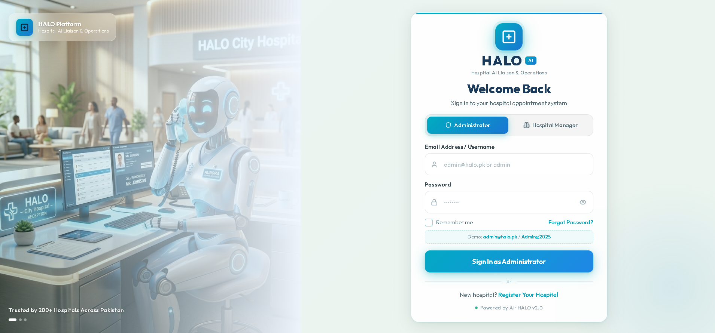
Figure 4 - Mockup M1 : Unified Login Screen
Table 2.6: Functional Requirements Derived from Mockup M1 (Unified Login Screen)
Feature (derived from UI) | Functional Requirement (FR-ID: Statement) | Business Rule
Role Selection Toggle | FR1.1: The system shall allow the user to select their role (Administrator or Hospital Manager) before entering login credentials. | Role selection determines the post-login dashboard destination.
Email Input Field | FR1.2: The system shall require the user to enter a registered email address to proceed with login. | Email must match a registered account in the system.
Password Input Field | FR1.3: The system shall allow the user to enter their password with a show/hide toggle. | Password input field must mask characters by default.
Sign In Button | FR1.4: The system shall validate credentials against stored records and redirect the authenticated user to the role-appropriate dashboard. | Account must be locked after 5 consecutive failed login attempts.
Forgot Password Link | FR1.5: The system shall navigate the user to the Forgot Password screen when the link is clicked. | Link is accessible without prior authentication.

Mockup M2 : Forgot Password Screen
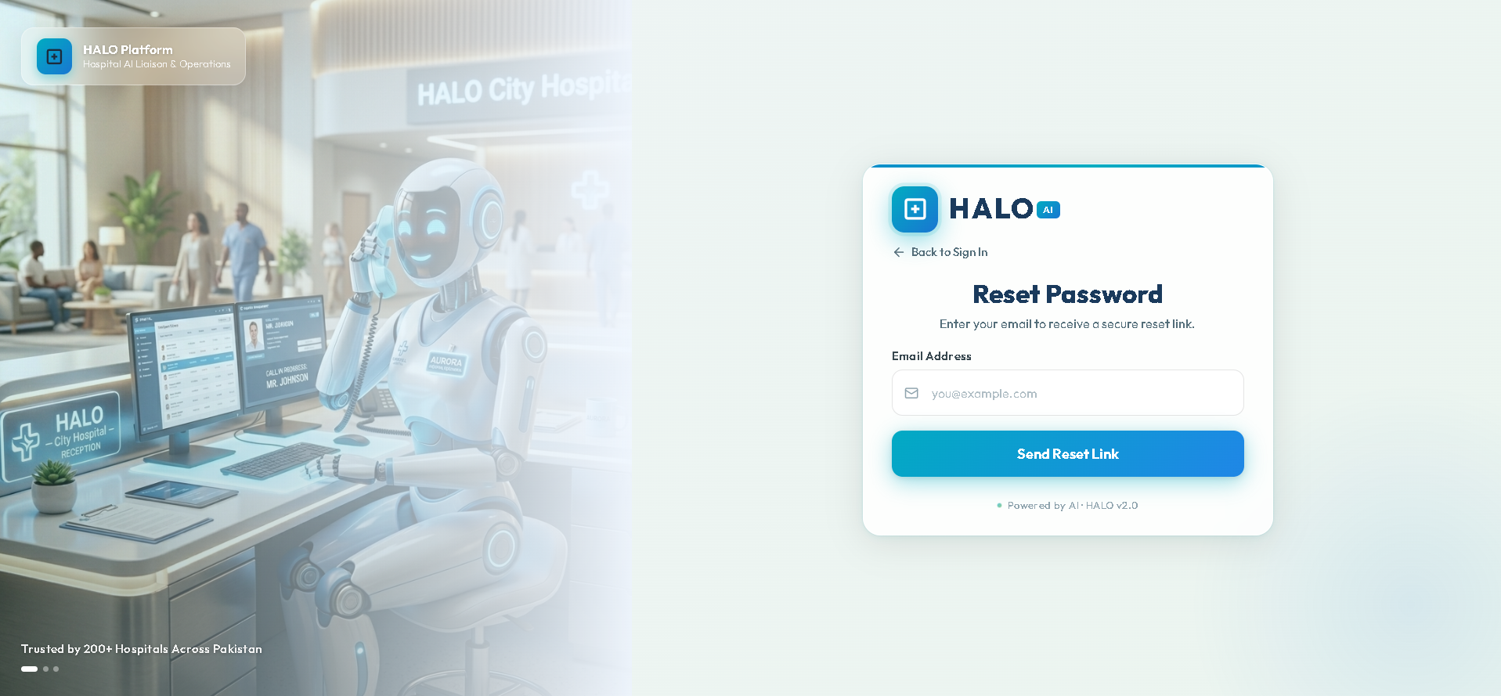
Figure 5 - Mockup M2 : Forgot Password Screens
Table 2.7: Functional Requirements Derived from Mockup M2 (Forgot Password Screen)
Feature (derived from UI) | Functional Requirement (FR-ID: Statement) | Business Rule
Email Input Field | FR1.6: The system shall require the user to enter their registered email address to initiate password recovery. | If the email is not registered, display a generic message to prevent account enumeration.
Send Reset Link Button | FR1.7: The system shall send a password reset link to the entered email address within 60 seconds of submission. | Reset links must expire after 15 minutes. Only one active link per account at a time.
New Password and Confirm Password Fields | FR1.8: The system shall allow the user to set a new password after clicking the reset link, requiring password and confirmation fields to match. | New password must meet minimum security standards: at least 8 characters, one uppercase, one number.

Mockup M3 : Admin Profile Screen
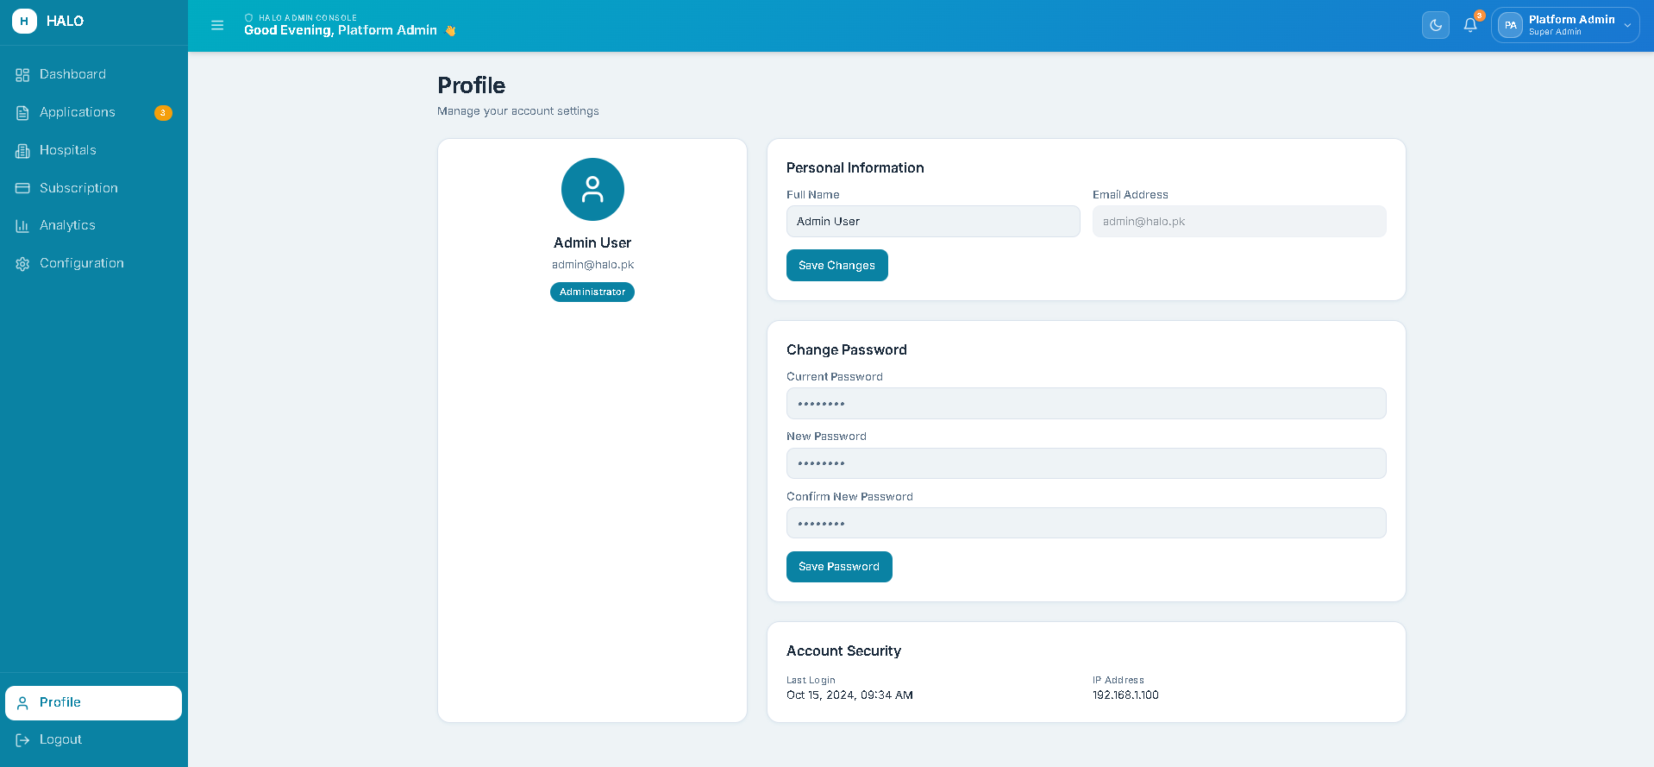
Figure 6 - Mockup M3 : Admin Profile Screen

Table 2.8: Functional Requirements Derived from Mockup M3 (Admin Profile Screen)
Feature (derived from UI) | Functional Requirement (FR-ID: Statement) | Business Rule
Profile Info Display | FR1.10: The system shall allow the Administrator to update their display name. | Name must not be empty and must not contain special characters.
Edit Name Field | FR1.2: The system shall require the user to enter a registered email address to proceed with login. | Email must match a registered account in the system.
Change Password Button | FR1.11: The system shall prompt the Administrator to enter their current password before allowing a new password to be set. | New password must differ from the previous password.
Logout Button | FR1.12: The system shall terminate the Administrator's session, clear all cookies and tokens, and redirect to the login screen upon logout. | Session data must be completely cleared server-side on logout.

Mockup M4 : Hospital Manager Profile Screen
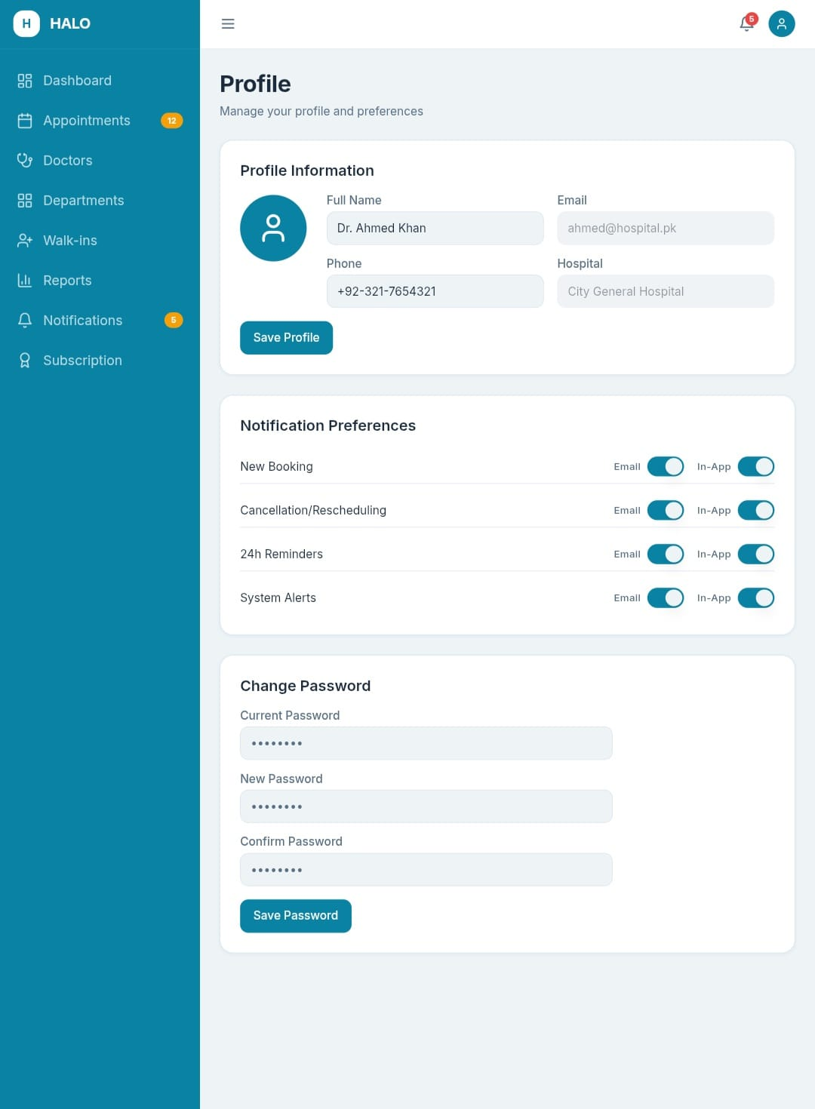
Figure 7 - Mockup M4 : Hospital Manager Profile Screen

Table 2.9: Functional Requirements Derived from Mockup M4 (Hospital Manager Profile Screen)
Feature (derived from UI) | Functional Requirement (FR-ID: Statement) | Business Rule
Profile Info Display | FR1.13: The system shall display the Hospital Manager's full name, email address, phone number, hospital name, and role label. | Hospital name is read-only and set during onboarding.
Edit Contact Details | FR1.14: The system shall allow the Hospital Manager to update their name and phone number. | Phone number must be a valid Pakistani format (10–11 digits).
Notification Preference Toggle | FR1.15: The system shall allow the Hospital Manager to toggle email and in-app notification preferences on or off. | At least one notification channel must remain enabled at all times.
Logout Button | FR1.16: The system shall terminate the Hospital Manager's session and redirects to the login screen. | Session must be invalidated server-side immediately on logout.

Module 2: Hospital Tenant Onboarding
Mockup M5 : Hospital Registration Step 1: Organizational Info
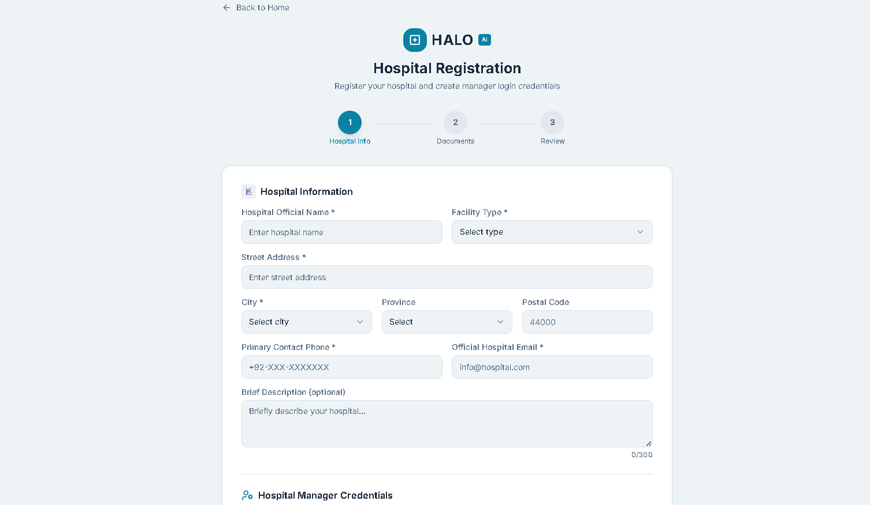
Figure 8 - Mockup M5 : Hospital Registration Step 1
Table 2.10: Functional Requirements Derived from Mockup M5 (Hospital Registration Step 1)
Feature (derived from UI) | Functional Requirement (FR-ID: Statement) | Business Rule
Hospital Name Field | FR2.1: The system shall require the Hospital Manager to enter the official hospital name. | Hospital name must be unique across the platform.
Facility Type Dropdown | FR2.2: The system shall allow the Hospital Manager to categorize their hospital by facility type (General Hospital, Specialty Clinic, Teaching Hospital, Day Care Center). | Facility type selection is mandatory.
Address Fields | FR2.3: The system shall require entry of the hospital's complete address including street, city, and province. | City field must match a valid Pakistani city from a predefined list.
Contact Number and Email Fields | FR2.4: The system shall require a primary contact phone number and official email address for the hospital. | Contact email must be different from the Hospital Manager's personal login email.
Progress Indicator (Step 1 of 3) | FR2.5: The system shall display a 3-step progress indicator showing the user's current position in the registration flow. | User must not be able to jump to Step 3 without completing Steps 1 and 2.
Next Button | FR2.6: The system shall validate all mandatory fields before navigating to Step 2. | All mandatory fields must be non-empty. Inline error messages must appear for each invalid field.

Mockup M6 : Hospital Registration Step 2: Document Upload
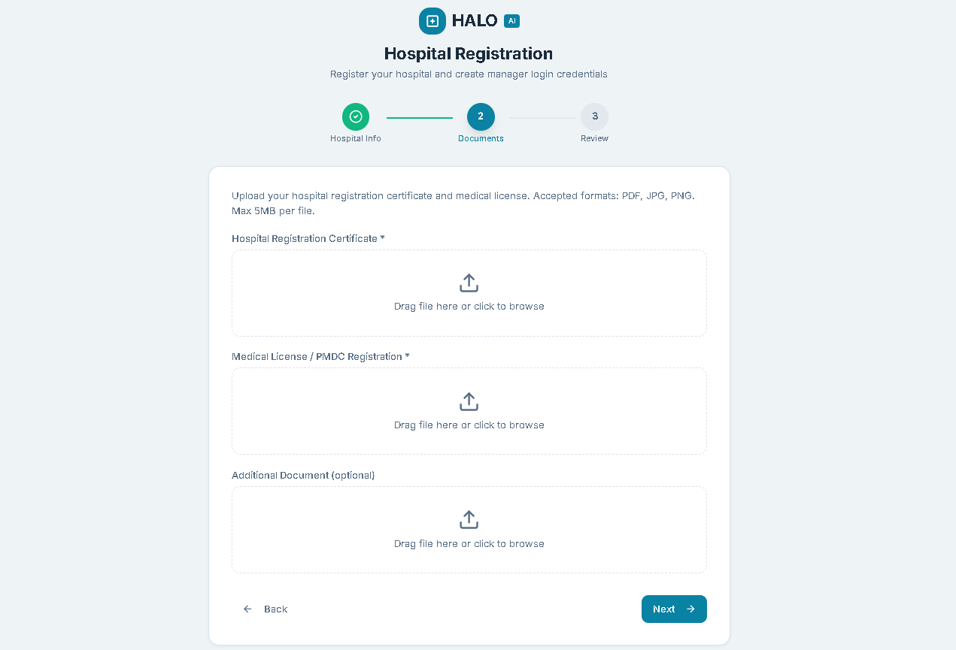
Figure 9 - Mockup M6 : Hospital Registration Step 2
Table 2.11: Functional Requirements Derived from Mockup M6 (Hospital Registration Step 2)
Feature (derived from UI) | Functional Requirement (FR-ID: Statement) | Business Rule
Document Upload Area (License) | FR2.7: The system shall allow the Hospital Manager to upload the hospital registration certificate and medical license as PDF or image files. | Each file must not exceed 5MB. Supported formats: PDF, JPG, PNG.
Upload Status Indicator | FR2.8: The system shall display an upload progress indicator and a success or failure status for each uploaded file. | Failed uploads must display a descriptive error message and allow retry.
Document Type Label | FR2.9: The system shall require the Hospital Manager to label each uploaded document by type from a predefined dropdown. | At least one license document is mandatory before the form can proceed.
Back Button | FR2.10: The system shall allow the user to navigate back to Step 1 without losing entered data. | Data entered in Step 1 must be preserved on back navigation.

Mockup M7 : Hospital Registration Step 3: Review and Submit
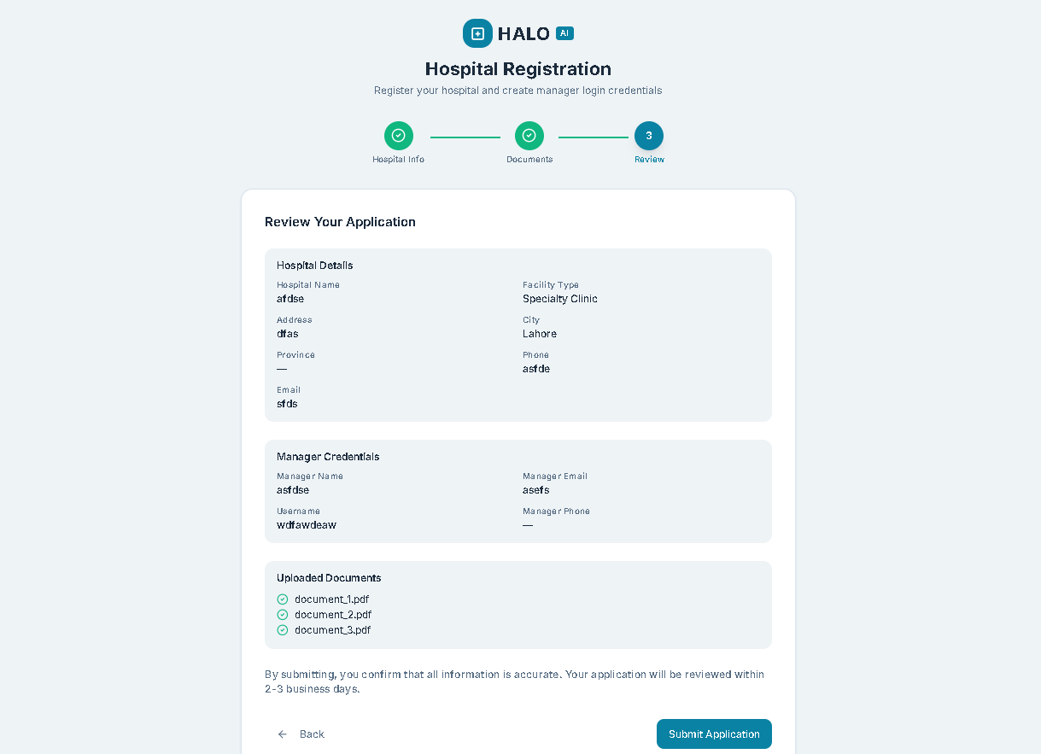
Figure 10 - Mockup M7 : Hospital Registration Step 3
Table 2.12: Functional Requirements Derived from Mockup M7 (Hospital Registration Step 3)
Feature (derived from UI) | Functional Requirement (FR-ID: Statement) | Business Rule
Summary Review Panel | FR2.11: The system shall display a read-only summary of all information entered in Steps 1 and 2 before final submission. | All entered data and uploaded document names must be visible in the summary.
Edit Links (per section) | FR2.12: The system shall allow the Hospital Manager to navigate back to any previous step to correct details before submission. | Edits made from the review screen must not reset other steps' data.
Submit Application Button | FR2.13: The system shall submit the completed registration form, set the application status to Under Review, generate a unique Application ID, and display it to the user upon successful submission. | Duplicate submissions from the same Hospital Manager account are not permitted while an application is Under Review.

Mockup M8 : Application Status Tracking Screen
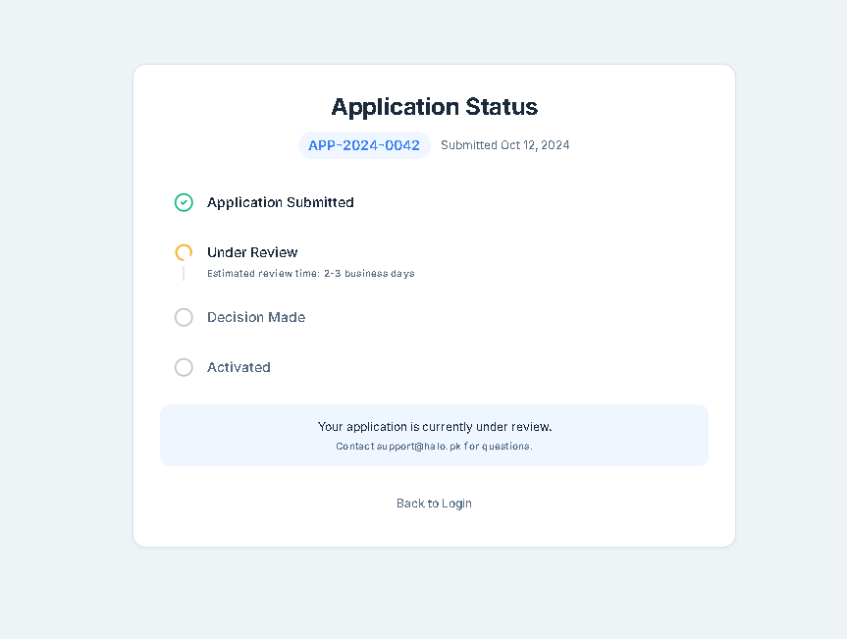
Figure 11 - Mockup M8 : Application Status Tracking Screen
Table 2.13: Functional Requirements Derived from Mockup M8 (Application Status Tracking Screen)
Feature (derived from UI) | Functional Requirement (FR-ID: Statement) | Business Rule
Application ID Display | FR2.14: The system shall display the unique Application ID assigned upon submission, along with the current status (Under Review, Approved, Rejected). | Application ID must be visible at all times after submission.
Status Timeline Indicator | FR2.15: The system shall display a visual timeline showing the progress of the application through review stages. | Timeline must update in real time without requiring page refresh.
Rejection Reason Display | FR2.16: The system shall display the Administrator's rejection reason when the application status is Rejected. | Rejection reason must be entered by the Administrator during the review action.

Module 3: Platform Administration
Mockup M9 : Admin Dashboard
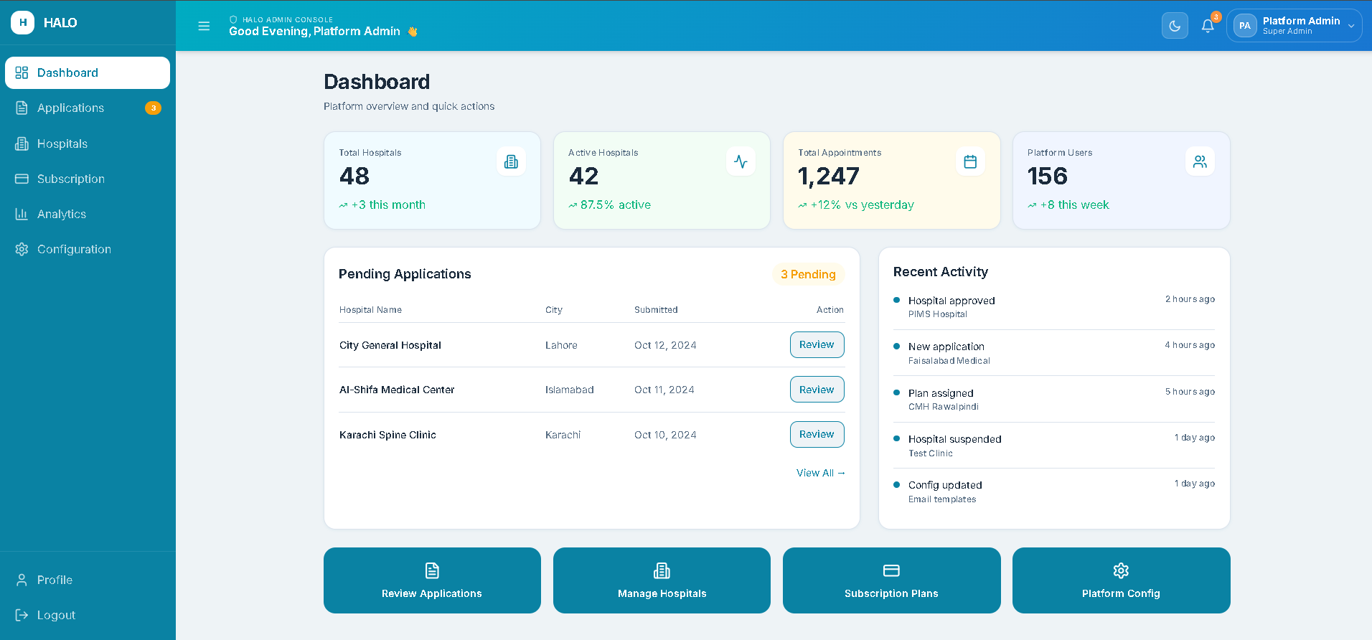
Figure 12 - Mockup M9 : Admin Dashboard
Table 2.14: Functional Requirements Derived from Mockup M9 (Admin Dashboard)
Feature (derived from UI) | Functional Requirement (FR-ID: Statement) | Business Rule
KPI Card: Total Hospitals | FR3.1: The system shall display the total number of hospitals registered on the platform (all statuses combined) as a KPI card. | Count must include active, pending, suspended, and rejected hospitals.
KPI Card: Active Hospitals | FR3.2: The system shall display the count of currently active and verified hospital tenants as a KPI card. | Only hospitals with status = Active are counted.
KPI Card: Total Appointments | FR3.3: The system shall display the total number of appointments processed platform-wide as a KPI card, with a date filter (today, this week, this month). | Count must include confirmed, rescheduled, cancelled, and completed appointments.
KPI Card: Total Platform Users | FR3.4: The system shall display the total number of registered Hospital Manager accounts across all tenants. | Deactivated accounts must be excluded from the count.
Pending Applications Alert | FR3.5: The system shall display a notification badge or alert card showing the number of hospital applications awaiting review. | Badge must update in real time without page refresh.
Recent Activity Feed | FR3.6: The system shall display a chronological list of recent platform events including new registrations, approvals, rejections, and subscription changes. | Activity feed must show the last 20 events with timestamps.
Quick Navigation Shortcuts | FR3.7: The system shall provide quick-access navigation buttons to Pending Applications, Manage Hospitals, Platform Configuration, and Subscription Management directly from the dashboard. | Navigation must not require more than one click from the dashboard.
Left Navigation Sidebar | FR3.8: The system shall provide navigation buttons to Dashboard, Hospitals, Applications, Subscription, Analytics, Configuration, Profile ,and Logout options directly from the sidebar. | -

Mockup M10 : Pending Hospital Applications List
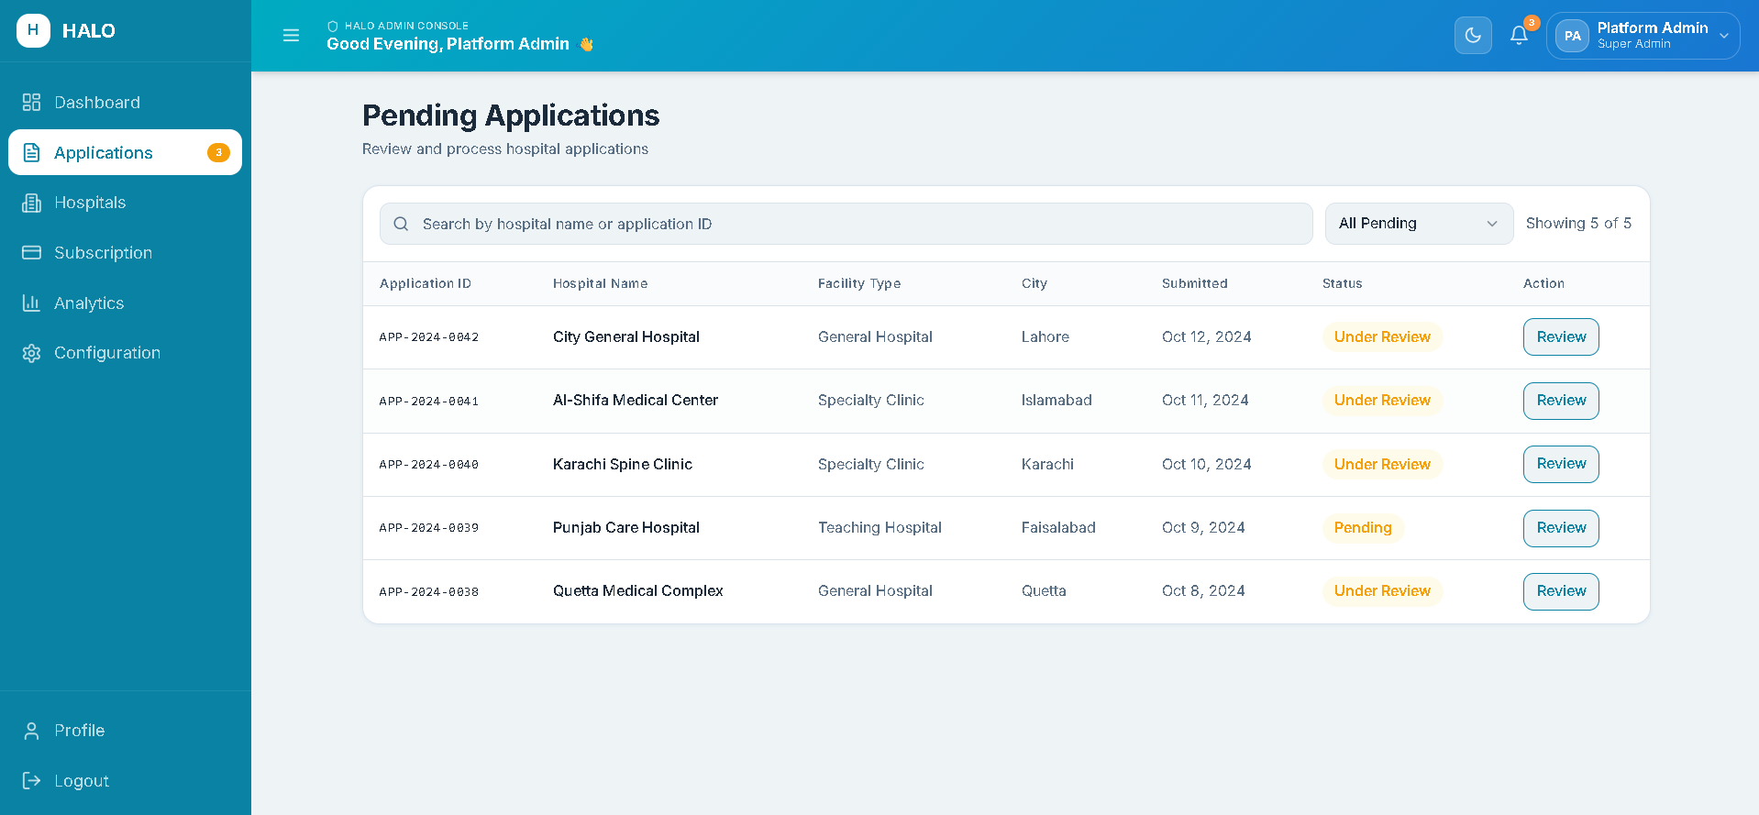
Figure 13 - Mockup M10 : Pending Hospital Applications List
Table 2.15: Functional Requirements Derived from Mockup M10 (Pending Applications List)
Feature (derived from UI) | Functional Requirement (FR-ID: Statement) | Business Rule
Applications Table | FR3.8: The system shall display all pending hospital applications in a sortable table showing Application ID, Hospital Name, Facility Type, Submission Date, and Status. | Table must be sorted by submission date in descending order by default.
Search Field | FR3.9: The system shall allow the Administrator to search pending applications by hospital name or application ID. | Search must be case-insensitive and return results as the user types.
View Details Button | FR3.10: The system shall navigate to the Application Detail Screen when the Administrator clicks View on any application row. | Each row must have a clearly visible View button.
Status Filter Dropdown | FR3.11: The system shall allow the Administrator to filter applications by status (Under Review, On Hold, All Pending). | Default view shows all pending applications.
Pagination Controls | FR3.12: The system shall paginate the applications list, displaying a maximum of 15 records per page with previous and next navigation. | Total application count must be displayed above the table.
Mockup M11 : Hospital Application Detail Screen
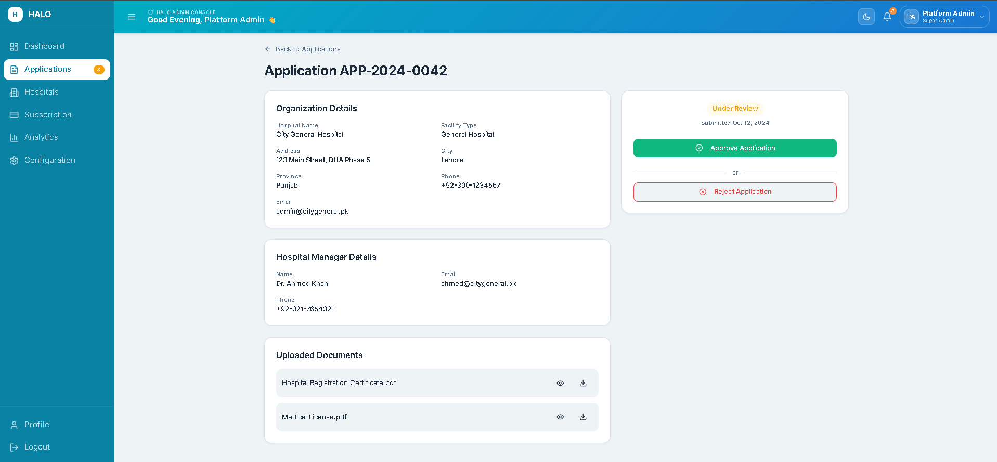
Figure 14 - Mockup M11 : Hospital Application Detail Screen
Table 2.16: Functional Requirements Derived from Mockup M11 (Application Detail Screen)
Feature (derived from UI) | Functional Requirement (FR-ID: Statement) | Business Rule
Hospital Information Panel | FR3.13: The system shall display all submitted hospital information including name, facility type, address, contact details, and Manager name on the detail screen. | All submitted data must be read-only from the Admin's perspective.
Document Viewer | FR3.14: The system shall allow the Administrator to view or download each uploaded document directly from the detail screen. | Documents must open in the browser or download as the original file type.
Approve Button | FR3.15: The system shall set the application status to Approved, activate the hospital tenant, and notify the Hospital Manager via email and in-app notification when the Approve button is clicked. | Approval must trigger automatic hospital tenant creation including a unique tenant identifier.
Reject Button with Reason Field | FR3.16: The system shall require the Administrator to enter a rejection reason before confirming rejection, then set the status to Rejected and notify the Hospital Manager. | Rejection reason field must accept minimum 20 characters.
Back to List Button | FR3.17: The system shall navigate back to the Pending Applications List without losing the current list state (scroll position and filters). | Back navigation must not reload the full list data.

Mockup M12 : All Hospitals Management Screen
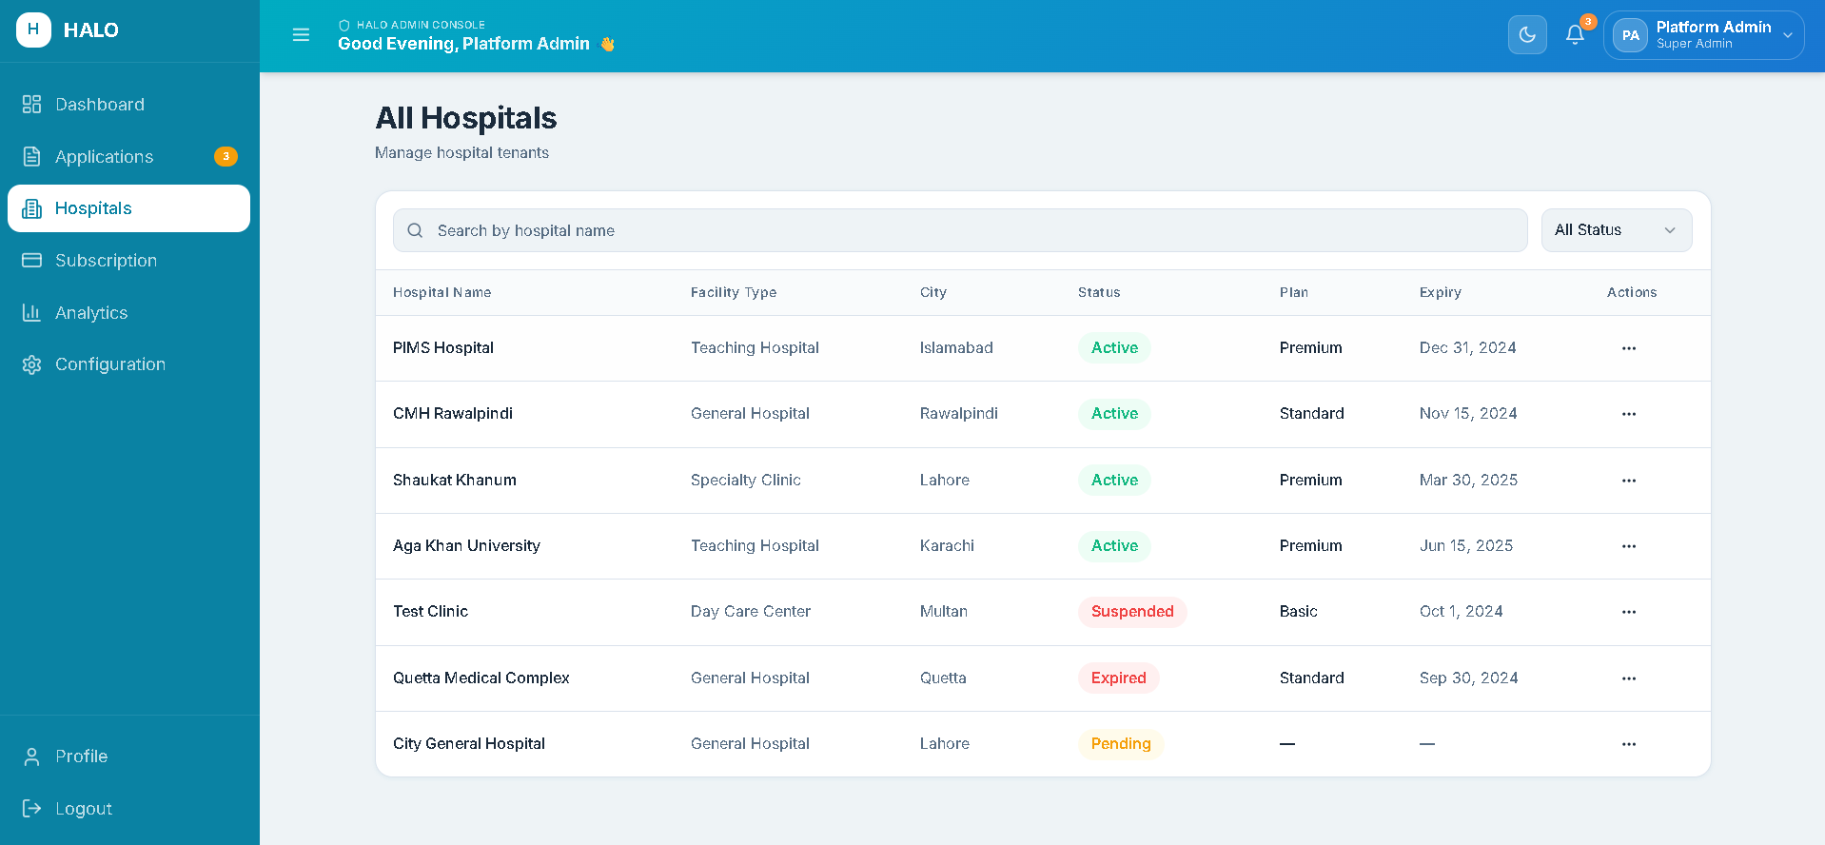
Figure 15 - Mockup M12 : All Hospitals Management Screen

Table 2.17: Functional Requirements Derived from Mockup M12 (All Hospitals Management Screen)
Feature (derived from UI) | Functional Requirement (FR-ID: Statement) | Business Rule
Hospitals Table | FR3.18: The system shall display all registered hospitals in a table showing Hospital Name, Facility Type, Status, Subscription Plan, and Registration Date. | Table must be filterable by status (Active, Suspended, Expired, All).
Status Badge per Row | FR3.19: The system shall display a color-coded status badge (Active = green, Suspended = orange, Expired = red) for each hospital in the table. | Status badges must reflect the current real-time status.
Suspend Hospital Action | FR3.20: The system shall allow the Administrator to suspend an active hospital after confirmation, setting its status to Suspended and disabling its HALO widget. | Suspension must require a confirmation dialog with a reason field.
Reactivate Hospital Action | FR3.21: The system shall allow the Administrator to reactivate a suspended hospital, provided the hospital has a valid active subscription. | Reactivation without a valid subscription must be blocked with an informative message.
Hospital Detail View Link | FR3.22: The system shall navigate to a read-only hospital profile view when the Administrator clicks a hospital name. | Hospital profile view must include all onboarding information and subscription history.

Mockup M13 : Platform Configuration Screen
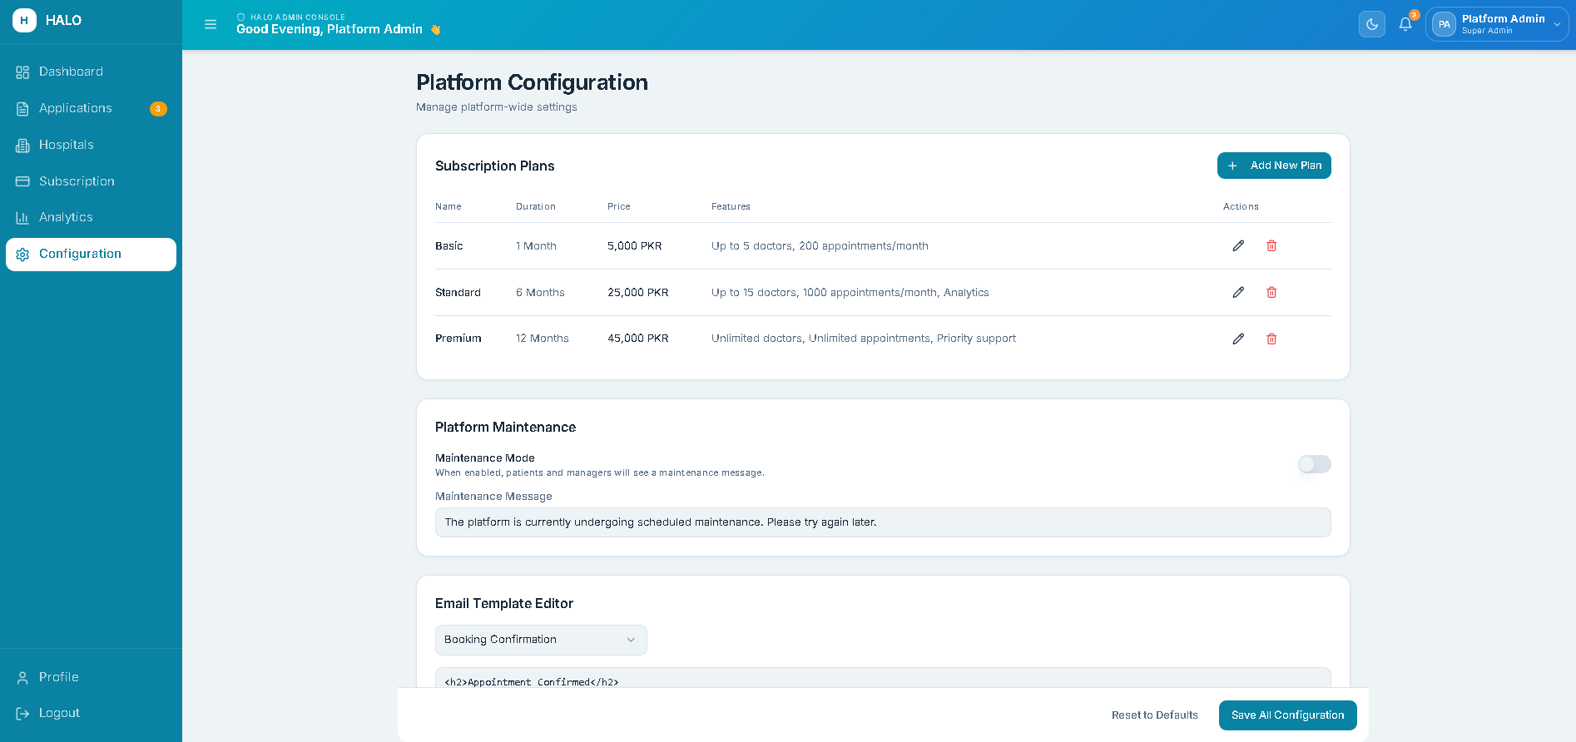
Figure 16 - Mockup M13 : Platform Configuration Screen
[Figure 2.16: Mockup M13 : Platform Configuration Screen]
Table 2.18: Functional Requirements Derived from Mockup M13 (Platform Configuration Screen)
Feature (derived from UI) | Functional Requirement (FR-ID: Statement) | Business Rule
Subscription Plan Editor | FR3.23: The system shall allow the Administrator to define and edit subscription plan names, durations, and feature access levels (Basic, Standard, Premium). | At least one active subscription plan must exist at all times.
Platform Maintenance Toggle | FR3.24: The system shall allow the Administrator to enable a platform maintenance mode that disables all patient-facing widgets and displays a maintenance message to Hospital Managers. | Maintenance mode must not affect ongoing administrator sessions.
Email Template Configuration | FR3.25: The system shall allow the Administrator to edit the default email templates used for appointment confirmations, reminders, and notifications. | Template changes must take effect immediately for all subsequent emails.
Save Configuration Button | FR3.26: The system shall persist all platform configuration changes immediately upon clicking Save and display a success confirmation to the Administrator. | A save confirmation toast must appear for 3 seconds after successful save.

Module 4: Clinical Resources
Mockup M14 : Doctor Management List Screen
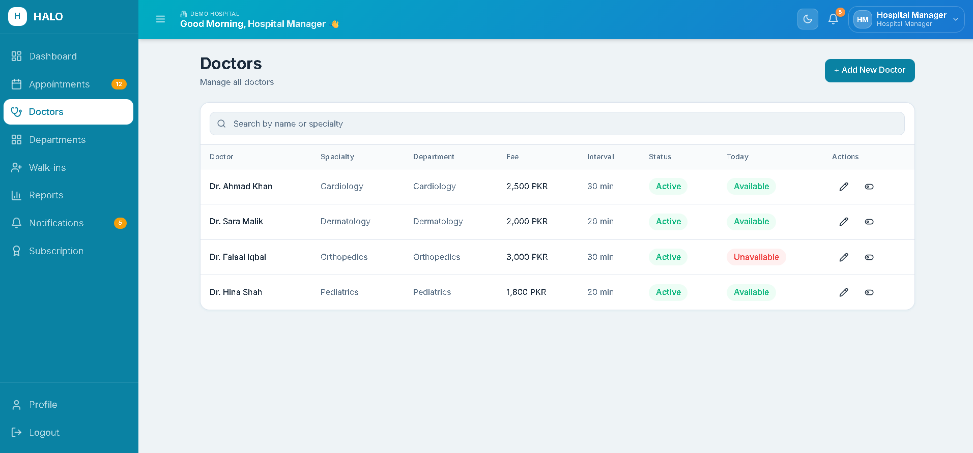
Figure 17 - Mockup M14 : Doctor Management List Screen
[Figure 2.17: Mockup M14 : Doctor Management List Screen]
Table 2.19: Functional Requirements Derived from Mockup M14 (Doctor Management List Screen)
Feature (derived from UI) | Functional Requirement (FR-ID: Statement) | Business Rule
Doctor List Table | FR4.1: The system shall display all doctors registered under the hospital in a table showing Doctor Name, Specialty, Department, Status (Active/Inactive), and Consultation Fee. | Table must be sorted alphabetically by doctor name by default.
Add New Doctor Button | FR4.2: The system shall navigate the Hospital Manager to the Add Doctor Profile screen when the Add New Doctor button is clicked. | Button must be visible only to authenticated Hospital Managers of an active hospital.
Edit Doctor Action | FR4.3: The system shall allow the Hospital Manager to navigate to the Edit Doctor Profile screen for any doctor in the list. | Edits must be reflected immediately in the doctor's availability for patient bookings.
Deactivate Doctor Toggle | FR4.4: The system shall allow the Hospital Manager to deactivate a doctor's profile, preventing new appointments from being booked for that doctor. | Deactivation must display a warning if the doctor has confirmed future appointments.
Doctor Search Field | FR4.5: The system shall allow the Hospital Manager to search doctors by name or specialty in real time. | Search must filter the list as the user types with a minimum of 2 characters.

Mockup M15 : Add/Edit Doctor Profile Screen
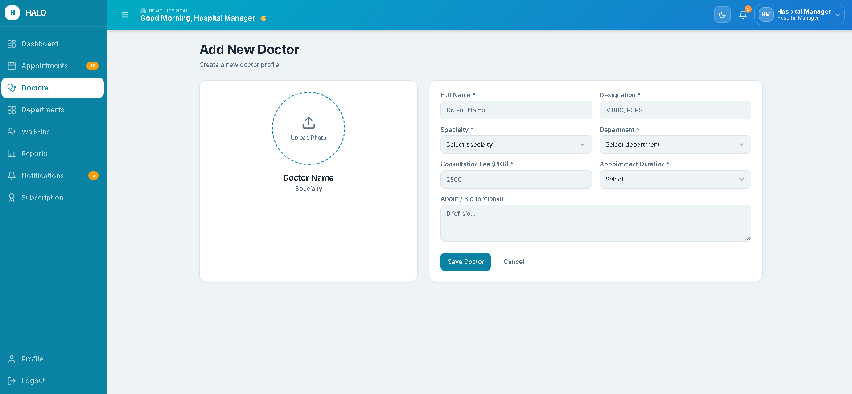
Figure 18 - Mockup M15 : Add/Edit Doctor Profile Screen
Table 2.20: Functional Requirements Derived from Mockup M15 (Add/Edit Doctor Profile Screen)
Feature (derived from UI) | Functional Requirement (FR-ID: Statement) | Business Rule
Full Name and Designation Fields | FR4.6: The system shall require the Hospital Manager to enter the doctor's full name and professional designation (e.g., MBBS, FCPS). | Both fields are mandatory.
Specialty and Department Dropdowns | FR4.7: The system shall require the Hospital Manager to assign the doctor to a specialty and a department from predefined hospital lists. | Department must belong to the hospital tenant. Specialty must be from the system's master specialty list.
Consultation Fee and Duration Fields | FR4.8: The system shall require entry of the doctor's consultation fee (PKR) and standard appointment duration (in minutes). | Consultation fee must be a positive number. Duration must be 10, 15, 20, 30, 45, or 60 minutes.
Profile Photo Upload | FR4.9: The system shall allow the Hospital Manager to upload a profile photo for the doctor. | Photo must be JPEG or PNG, maximum 2MB, minimum resolution 200x200 pixels.
Save Doctor Button | FR4.10: The system shall validate all mandatory fields and persist the doctor record, confirming with a success message. | Duplicate doctor names within the same hospital tenant must trigger a warning (not a block).
Slot Interval Configuration | FR4.11: The system shall allow the Hospital Manager to configure the appointment slot interval for this doctor (e.g., every 15 minutes, every 30 minutes). | Slot interval must be consistent with the appointment duration set for the doctor.

Mockup M16 : Doctor Schedule & Availability Configuration Screen
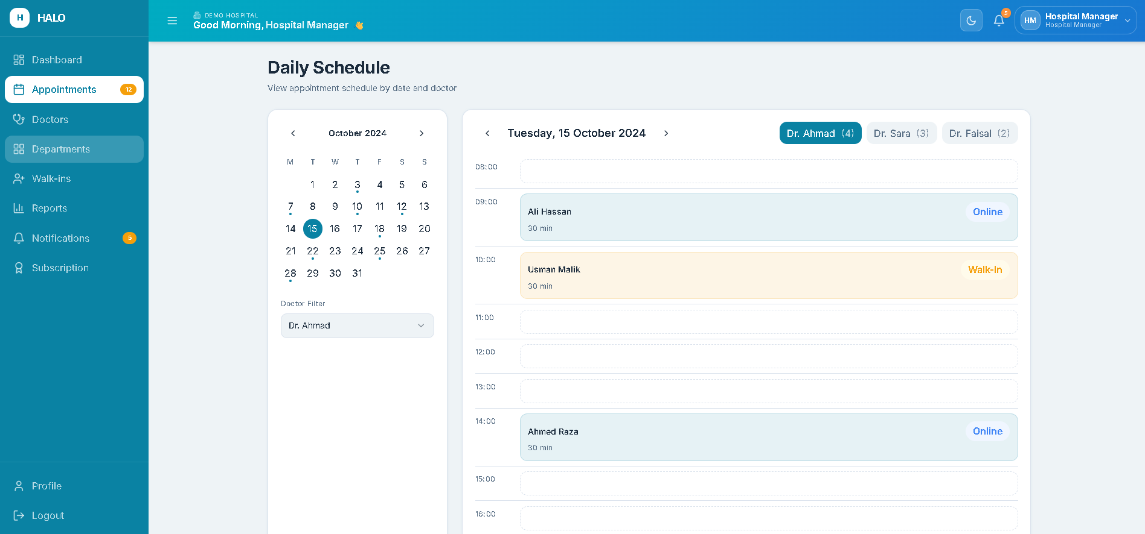
Figure 19 - Mockup M16 : Doctor Schedule Configuration Screen
Table 2.21: Functional Requirements Derived from Mockup M16 (Doctor Schedule Configuration Screen)
Feature (derived from UI) | Functional Requirement (FR-ID: Statement) | Business Rule
Weekly Schedule Grid | FR4.12: The system shall display a 7-day weekly grid allowing the Hospital Manager to mark working days and set start/end consultation hours per day. | At least one working day must be configured before the schedule can be saved.
Break Period Configuration | FR4.13: The system shall allow the Hospital Manager to define one or more break periods per working day (e.g., lunch break from 13:00 to 14:00). | Break periods must not overlap with each other. Break times must fall within the working hours of that day.
Leave Period Calendar | FR4.14: The system shall allow the Hospital Manager to mark specific dates as leave/holiday for a doctor, blocking all bookings on those dates. | Leave dates must be entered at least 1 day in advance. Past dates cannot be marked as leave.
Save Schedule Button | FR4.15: The system shall persist the complete schedule configuration and immediately update available slots visible to the HALO conversational agent. | Schedule changes must propagate to the booking engine within 60 seconds.
Schedule Conflict Warning | FR4.16: The system shall display a warning if a schedule change would affect already-confirmed appointments, listing the impacted appointments. | Schedule change must not automatically cancel confirmed appointments, only display the warning.

Mockup M17 : Department Management Screen
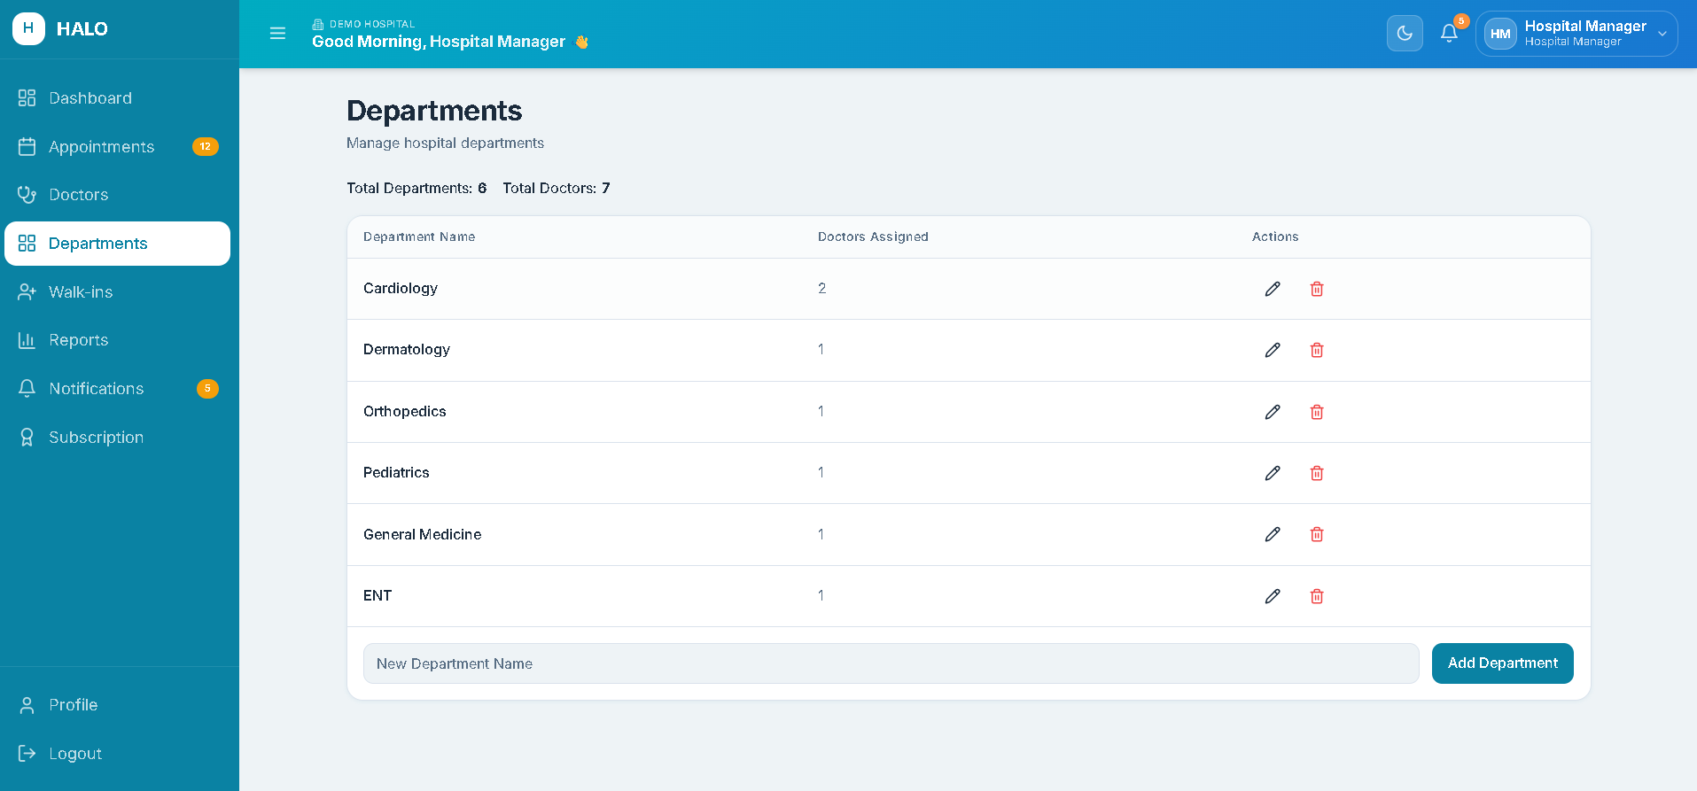
Figure 20 - Mockup M17 : Department Management Screen
Table 2.22: Functional Requirements Derived from Mockup M17 (Department Management Screen)
Feature (derived from UI) | Functional Requirement (FR-ID: Statement) | Business Rule
Department List | FR4.17: The system shall display all departments configured for the hospital in a list showing department name and number of assigned doctors. | Each hospital tenant has its own isolated department list.
Add Department Field | FR4.18: The system shall allow the Hospital Manager to add a new department by entering a department name and clicking Add. | Department name must be unique within the hospital tenant. Maximum 50 characters.
Edit and Delete Department Actions | FR4.19: The system shall allow the Hospital Manager to rename or delete a department. | Departments with assigned doctors cannot be deleted. The system must display a warning listing the assigned doctors before blocking the delete action.
Department Count Summary | FR4.20: The system shall display the total number of active departments and the total number of doctors across all departments as a summary at the top of the screen. | Summary counts must update immediately after any add, edit, or delete action.

Module 5: AI-Driven Appointments
Mockup M18 : Hospital Website Landing Page with HALO Widget
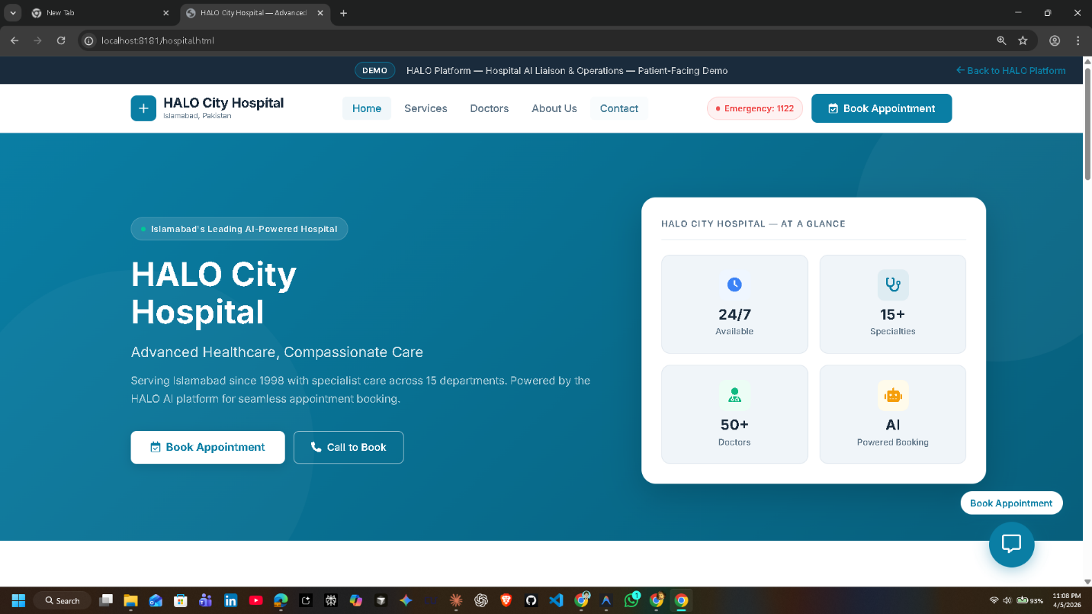
Figure 21 - Mockup M18 : Hospital Website Landing Page
Table 2.23: Functional Requirements Derived from Mockup M18 (Hospital Website Landing Page)
Feature (derived from UI) | Functional Requirement (FR-ID: Statement) | Business Rule
Floating HALO Chat Button | FR5.1: The system shall display a floating chat button labeled "Book Appointment" on the hospital website that opens the HALO conversational widget. | The widget must load within 2 seconds of the page finishing loading.
Phone Number Display Card | FR5.2: The system shall display the hospital's dedicated HALO phone number prominently on the landing page with a "Call to Book" label. | The phone number must be displayed in a clickable format that triggers the device dialer on mobile devices.
Widget Mode Toggle (Text / Voice) | FR5.3: The system shall allow the patient to choose between text chat and voice interaction mode before or during the conversation. | Mode switch must not reset the active conversation session.
Hospital Branding Area | FR5.4: The system shall display the hospital's name, logo (if configured), and a brief description within the widget header area. | Hospital branding data is pulled from the hospital profile configured by the Hospital Manager.

Mockup M19 : HALO Chat Widget : Text Mode
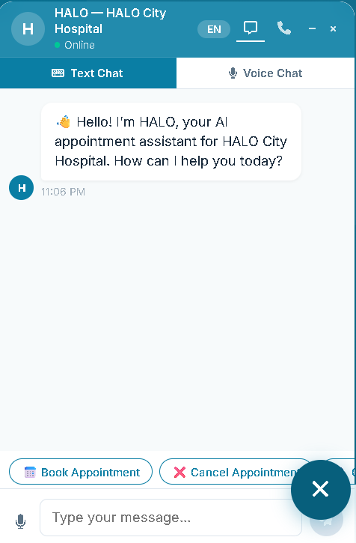
Figure 22 - Mockup M19 : HALO Chat Widget Text Mode
Table 2.24: Functional Requirements Derived from Mockup M19 (HALO Chat Widget Text Mode)
Feature (derived from UI) | Functional Requirement (FR-ID: Statement) | Business Rule
Conversation Message Thread | FR5.5: The system shall display the conversation as a scrollable message thread with agent messages on the left and patient messages on the right, each with a timestamp. | Messages must persist for the duration of the browser session. Refreshing the page clears the session.
Text Input Field and Send Button | FR5.6: The system shall allow the patient to type a message in a text input field and submit it by pressing Enter or clicking the Send button. | Input field must support a maximum of 500 characters per message.
Language Indicator | FR5.7: The system shall display the currently detected language (English or Urdu) in the widget header and allow the patient to manually switch language. | Language switch must take effect from the next agent response.
Quick Reply Chips | FR5.8: The system shall display contextual quick-reply option chips (e.g., "Book Appointment", "Cancel Appointment", "Check Availability") above the input field at conversation start and at relevant points in the dialogue. | Quick-reply chips must correspond to valid FSM transitions only.
Appointment Slot Cards | FR5.9: The system shall display available appointment slots as structured cards showing date, time, doctor name, and specialty when a slot selection step is reached in the conversation. | Slot cards must reflect live availability at the time of display.
Typing Indicator | FR5.10: The system shall display an animated typing indicator when the AI agent is processing a response. | Typing indicator must appear within 500ms of the patient's message submission.
Close and Minimize Controls | FR5.11: The system shall provide close and minimize controls for the chat widget that do not terminate the session until the browser tab is closed or the session timeout (15 minutes inactivity) is reached. | During a session timeout, the system must display an informational message and clear the conversation.
Voice Mode Button | FR5.12: The system shall display a button to shift to voice mode from chat mode.

Mockup M20 : HALO Chat Widget : Voice Mode
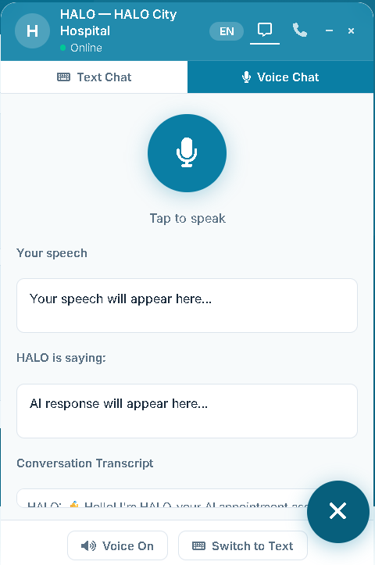
Figure 23 - Mockup M20 : HALO Chat Widget Voice Mode
Table 2.25: Functional Requirements Derived from Mockup M20 (HALO Chat Widget Voice Mode)
Feature (derived from UI) | Functional Requirement (FR-ID: Statement) | Business Rule
Microphone Activation Button | FR5.12: The system shall allow the patient to activate voice input by clicking the microphone button, which starts real-time speech capture via WebRTC. | Microphone must request browser permission on first use. If permission denied, display a clear instruction message.
Real-Time Speech Transcript | FR5.13: The system shall display a real-time transcription of the patient's speech in the conversation thread as they speak. | Transcription must update in near real time with a maximum 500ms lag.
Voice Output (Text-to-Speech) | FR5.14: The system shall play the agent's response as synthesized speech in the patient's detected language while also displaying it as text. | Patient must be able to mute voice output without switching to text-only mode.
Voice Activity Indicator | FR5.15: The system shall display an animated visual indicator (pulsing ring or waveform) while the microphone is active and capturing audio. | Indicator must stop immediately when the patient stops speaking or clicks the microphone button again.
Fallback to Text Button | FR5.16: The system shall provide a clearly visible button to switch from voice mode to text mode at any point without losing conversation context. | Switching modes must not reset the active FSM session state.

Mockup M21 : Appointment Booking Confirmation Summary (In-Chat)
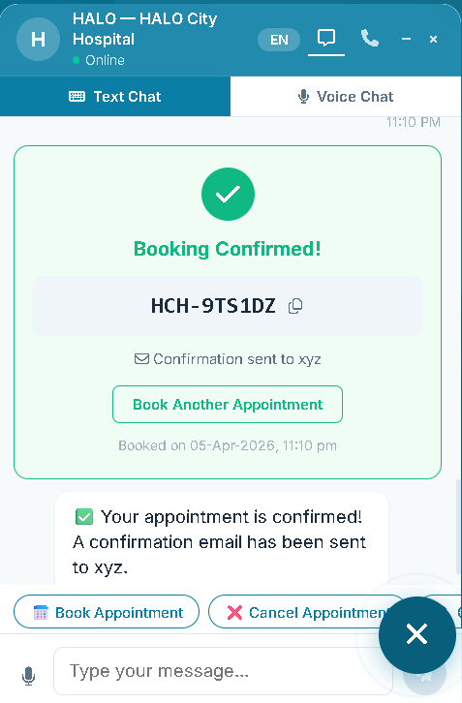
Figure 24 - Mockup M21 : Booking Confirmation Summary
Table 2.26: Functional Requirements Derived from Mockup M21 (Booking Confirmation Summary)
Feature (derived from UI) | Functional Requirement (FR-ID: Statement) | Business Rule
Booking Details Summary Card | FR5.17: The system shall display a structured confirmation card in the chat showing doctor name, specialty, date, time, patient’s name, and visit reason before final confirmation. | All fields collected during the conversation must be present in the summary card.
Confirm Booking Button | FR5.18: The system shall finalize the booking, generate a reference ID, and display it in the chat when the patient clicks Confirm. | Reference ID must be displayed in a highlighted, copyable format.
Edit Details Option | FR5.19: The system shall allow the patient to trigger a re-entry of any booking field (e.g., date, time) by clicking Edit on the summary card before confirmation. | Edits via the summary card must re-enter the corresponding FSM dialogue step without restarting the session.
Email Confirmation Notice | FR5.20: The system shall inform the patient that a confirmation email will be sent to their provided email address after booking is confirmed. | If no email was collected, prompt for email before confirming.

Mockup M22 : Phone Number Display and Dial Trigger Screen
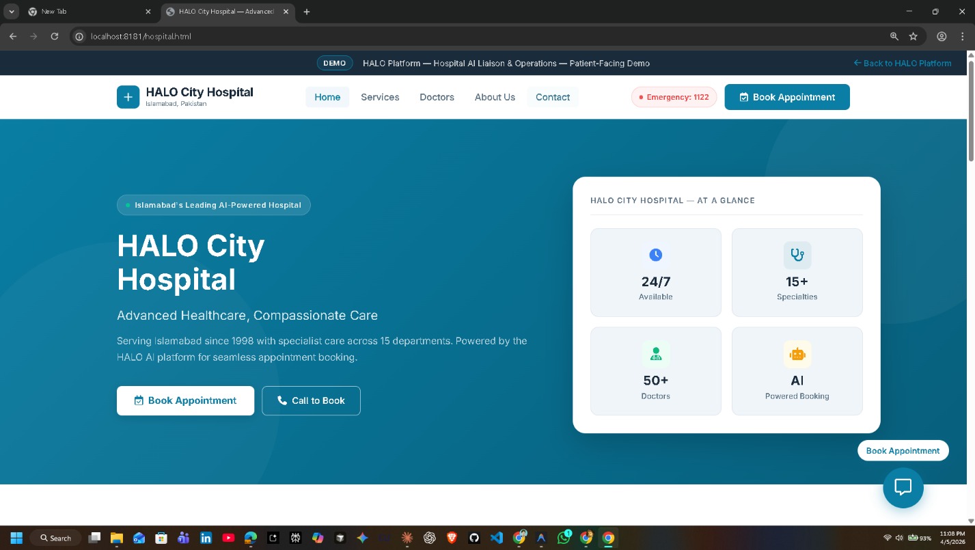
Figure 25 - Mockup M22 : Phone Number Display and Dial
Table 2.27: Functional Requirements Derived from Mockup M22 (Phone Number Display Screen)
Feature (derived from UI) | Functional Requirement (FR-ID: Statement) | Business Rule
Hospital Phone Number Display | FR5.21: The system shall display the hospital's dedicated HALO telephony number in large, readable text within the widget. | Phone number format must follow Pakistani standard notation.
Click-to-Call Button | FR5.22: The system shall provide a "Call Now" button that triggers the device's native dialer application with the hospital number pre-filled when clicked on a mobile device. | On desktop, the button must display the number in a copyable format.
Call Instructions Text | FR5.23: The system shall display a short instructional message (e.g., "Call this number to speak with our AI booking assistant") alongside the phone number. | Instructions must be available in both English and Urdu.

Module 6: Operations Console
Mockup M23 : Hospital Manager Dashboard
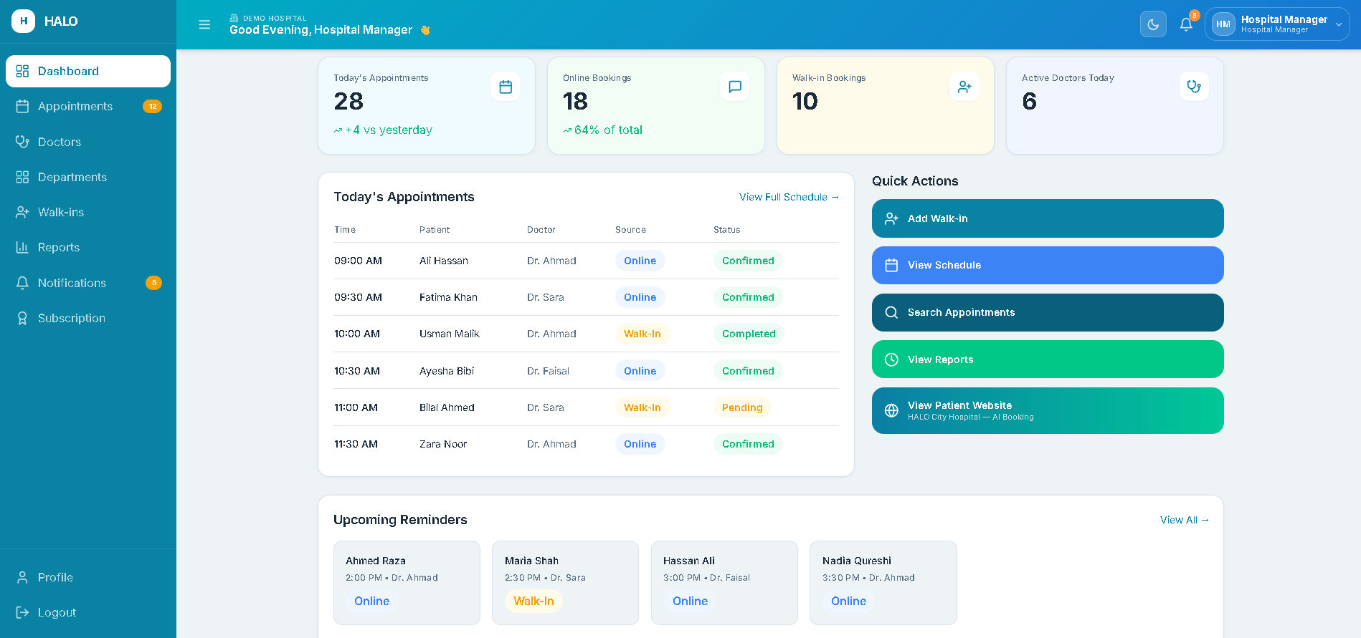
Figure 26 - Mockup M23 : Hospital Manager Dashboard
Table 2.28: Functional Requirements Derived from Mockup M23 (Hospital Manager Dashboard)
Feature (derived from UI) | Functional Requirement (FR-ID: Statement) | Business Rule
KPI Card: Today's Appointments | FR6.1: The system shall display the total number of confirmed appointments scheduled for the current day as a KPI card. | Count must update in real time as new appointments are booked or cancelled.
KPI Card: Online Bookings | FR6.2: The system shall display the count of appointments booked via the HALO conversational agent (source = Online) for the current day. | Excludes walk-in appointments.
KPI Card: Walk-in Bookings | FR6.3: The system shall display the count of appointments entered manually as walk-ins for the current day. | Excludes online bookings.
KPI Card: Active Doctors | FR6.4: The system shall display the number of doctors with an active schedule for the current day. | A doctor is considered active if they have at least one working hour configured for today and their profile is not deactivated.
Upcoming Appointments List | FR6.5: The system shall display the next 5 upcoming appointments for today in chronological order with patient name, doctor name, and time. | Clicking any appointment row must navigate to the full appointment detail view.
Quick Actions Bar | FR6.6: The system shall provide quick-action buttons for Add Walk-in, View Schedule, Search Appointments, and View Reports directly from the dashboard. | Quick actions must navigate to the corresponding screen with one click.
Notification Bell Icon | FR6.7: The system shall display a notification bell icon with an unread count badge in the dashboard header that opens the Notification Center on click. | Badge must update in real time for new appointment events.

Mockup M24 : Daily Appointment Schedule and Calendar View
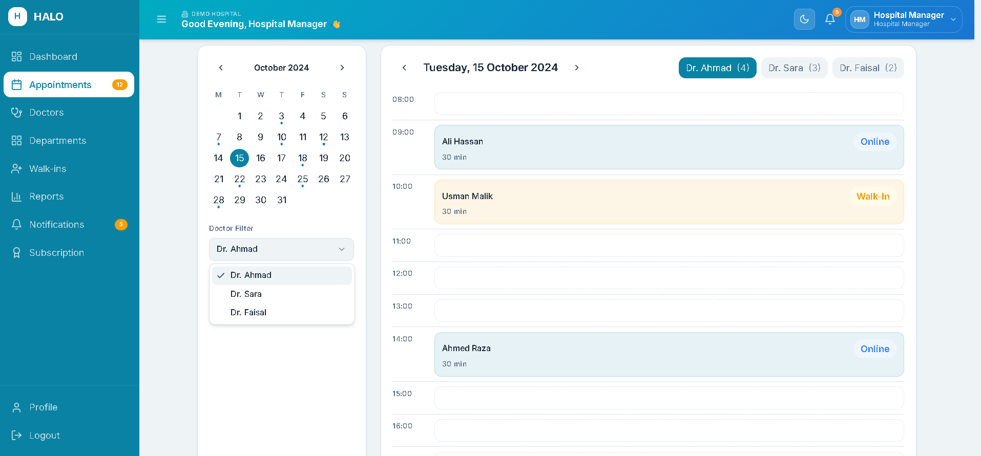
Figure 27 - Mockup M24 : Daily Schedule and Calendar View
Table 2.29: Functional Requirements Derived from Mockup M24 (Daily Schedule View)
Feature (derived from UI) | Functional Requirement (FR-ID: Statement) | Business Rule
Date Navigation Controls | FR6.8: The system shall allow the Hospital Manager to navigate between dates using previous/next day controls and a date picker calendar. | Calendar must highlight dates with confirmed appointments.
Doctor Filter Dropdown | FR6.9: The system shall allow the Hospital Manager to filter the daily schedule view by a specific doctor or view all doctors simultaneously. | Default view shows all doctors for the selected date.
Appointment Timeline View | FR6.10: The system shall display appointments for each doctor in a time-blocked timeline layout showing appointment slots, patient name, booking source (Online/Walk-in), and status. | Booked slots must be visually distinct from available slots using color coding.
Appointment Detail Panel | FR6.11: The system shall display a side panel or modal with full appointment details when the Hospital Manager clicks on any appointment slot. | Detail panel must include patient name, contact, visit reason, booking time, source, and reference ID.
Cancel Appointment Action | FR6.12: The system shall allow the Hospital Manager to cancel any confirmed appointment from the schedule view, triggering a cancellation notification to the patient. | Cancellation by Hospital Manager must require a reason entry.
Real-time Appointment Counters | FR6.13: The system shall display real-time numeric badges (indicators) on the sidebar and doctor selection tabs to show the total count of pending or active appointments. | Badges must update immediately when a new appointment is booked or a status is changed.
Global Search/Quick Action Overlay | FR6.14: The system shall provide search functionality (accessible via the header or sidebar) to allow the Hospital Manager to quickly find specific patients or departments. | Search results must be filtered based on the Hospital Manager’s assigned facility (Demo Hospital).
Appointment Category Visualization | FR6.15: The system shall visually differentiate between "Online" bookings and "Walk-In" patients using specific label tags and distinct background colors within the timeline. | Online appointments must be color-coded in Blue, and Walk-ins must be color-coded in Orange for instant identification.

Mockup M25 : Walk-in Patient Entry Form
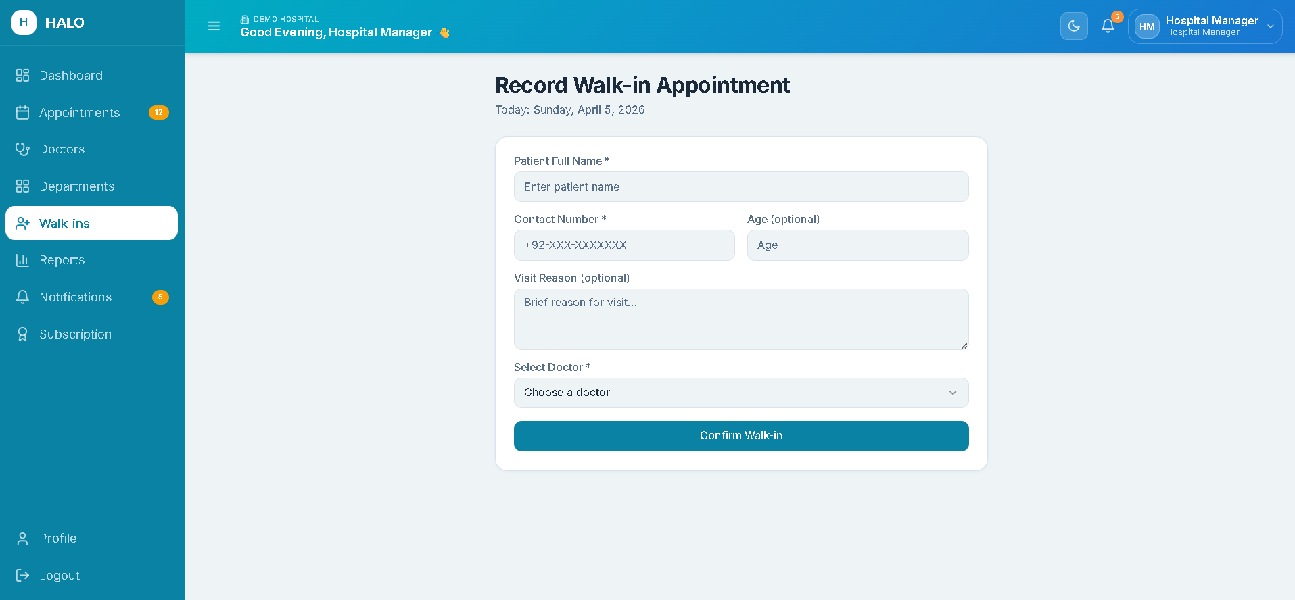
Figure 28 - Mockup M25 : Walk-in Patient Entry Form
Table 2.30: Functional Requirements Derived from Mockup M25 (Walk-in Patient Entry Form)
Feature (derived from UI) | Functional Requirement (FR-ID: Statement) | Business Rule
Patient Name and Contact Fields | FR6.13: The system shall require the Hospital Manager to enter the walk-in patient's full name and contact number to create a walk-in appointment. | Contact number must follow Pakistani format.
Doctor and Slot Selection | FR6.14: The system shall require the Hospital Manager to select the doctor and available time slot for the walk-in appointment from a live availability dropdown. | Only available slots (not already booked or blocked) must appear in the dropdown.
Visit Reason Field | FR6.15: The system shall provide an optional text field for the Hospital Manager to enter the patient's visit reason. | Visit reason is optional but limited to 200 characters.
Confirm Walk-in Button | FR6.16: The system shall create the walk-in appointment record with source = Walk-In, update the slot status to Booked, and display a success message with the appointment entry ID. | Walk-in creation must synchronize with the booking engine in real time.
Print / Share Slip Option | FR6.17: The system shall provide an option to print or share a brief appointment slip after walk-in creation, showing patient name, doctor, time, and ID. | Slip is optional. Must be generated as a printable HTML page in a new browser tab.

Module 7: Search & Filter
Mockup M26 : Appointment Search and Filter Screen
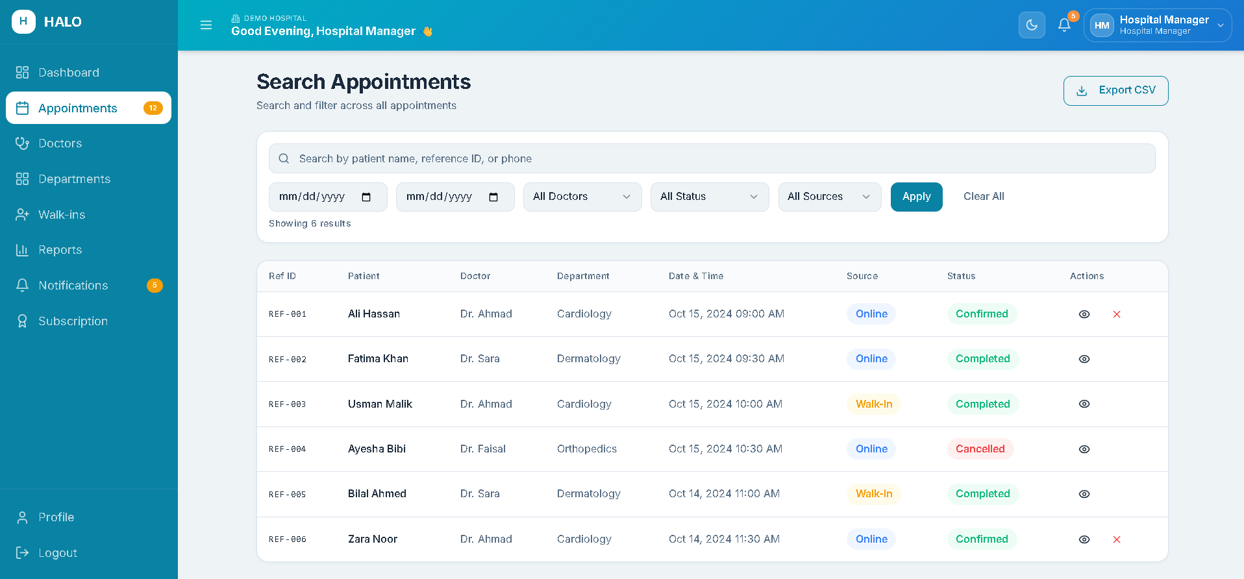
Figure 29 - Mockup M26 : Appointment Search and Filter Screen
Table 2.31: Functional Requirements Derived from Mockup M26 (Appointment Search and Filter)
Feature (derived from UI) | Functional Requirement (FR-ID: Statement) | Business Rule
Search Bar | FR7.1: The system shall allow the Hospital Manager to search appointments by patient name, reference ID, or contact number with results appearing as the user types. | Search must return results after a minimum of 3 characters are entered.
Date Range Filter | FR7.2: The system shall allow filtering of appointment results by a custom date range using a from-date and to-date picker. | Date range must not exceed 90 days.
Doctor Filter | FR7.3: The system shall allow filtering appointments by a selected doctor from a dropdown list of the hospital's doctors. | Dropdown must include an "All Doctors" option as default.
Status Filter | FR7.4: The system shall allow filtering appointments by status (Confirmed, Cancelled, Rescheduled, Completed, Walk-in). | Multiple status filters may be applied simultaneously.
Search Results Table | FR7.5: The system shall display filtered results in a table showing Reference ID, Patient Name, Doctor, Date & Time, Source, and Status, with a view detail action per row. | Table must support sorting by each column header.

Mockup M27 : Doctor and Department Search Screen
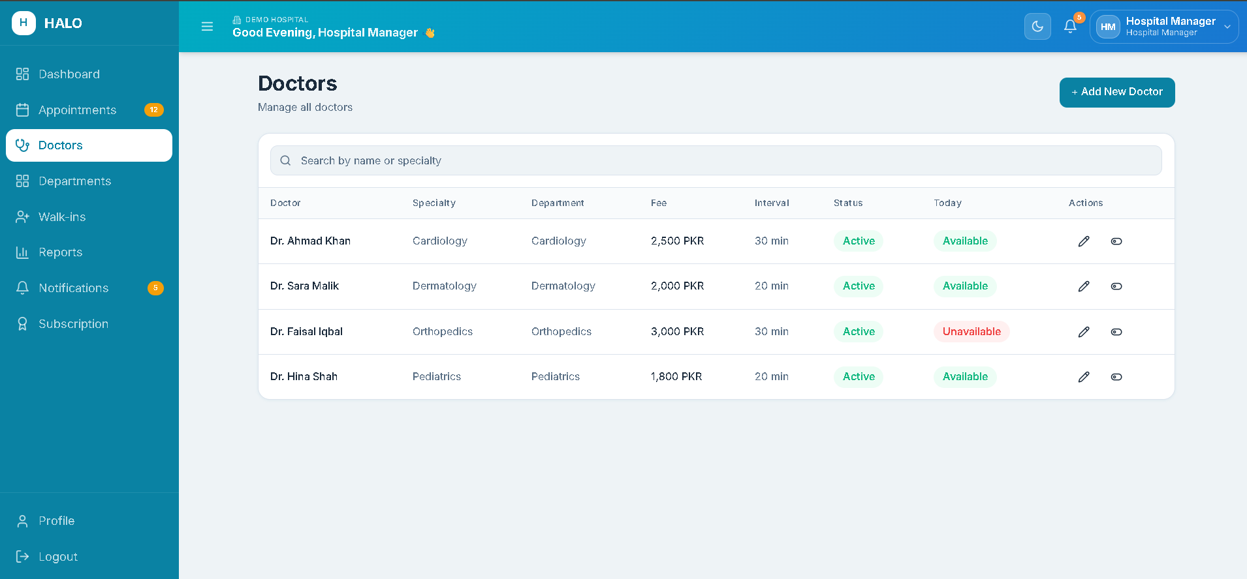
Figure 30 - Mockup M27 : Doctor and Department Search Screen
Table 2.32: Functional Requirements Derived from Mockup M27 (Doctor and Department Search)
Feature (derived from UI) | Functional Requirement (FR-ID: Statement) | Business Rule
Doctor Search Bar | FR7.6: The system shall allow the Hospital Manager to search doctors by name or specialty, displaying matching results in a live-filtered list. | Search activates after 2 characters.
Specialty Filter Chips | FR7.7: The system shall display specialty filter chips that allow the Hospital Manager to quickly filter doctors by specialty category. | Filter chips must be derived from the hospital's active specialties.
Doctor Card with Availability Indicator | FR7.8: The system shall display each doctor’s result as a card showing name, specialty, department, consultation fee, and a today's availability indicator (Available / Not Available). | Availability indicator must reflect the real-time schedule for the current day.
Department Filter Dropdown | FR7.9: The system shall allow filtering the doctor list by department. | Departments listed must be the hospital tenant's own configured departments.
Module 8: Report & Analytics
Mockup M28 : Admin Analytics Dashboard
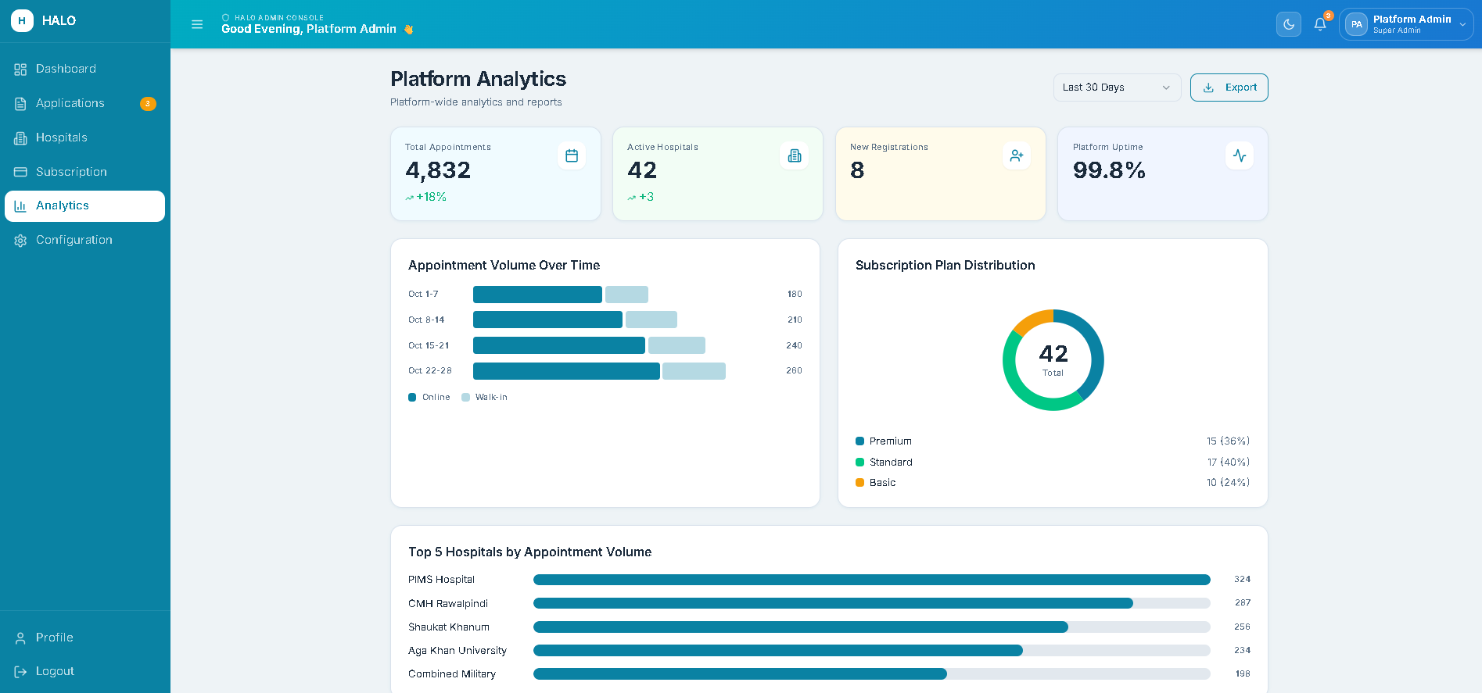
Figure 31 - Mockup M28 : Admin Analytics Dashboard
Table 2.33: Functional Requirements Derived from Mockup M28 (Admin Analytics Dashboard)
Feature (derived from UI) | Functional Requirement (FR-ID: Statement) | Business Rule
Appointment Volume Chart | FR8.1: The system shall display a line or bar chart showing total platform-wide appointment volume over a selected time period (daily, weekly, monthly). | Chart must be interactive and hovering a data point shows the exact count.
Active Hospitals Over Time Chart | FR8.2: The system shall display a chart showing the growth in active hospital registrations over time. | Chart must default to the last 6 months view.
Subscription Plan Distribution | FR8.3: The system shall display a pie or donut chart showing the distribution of hospitals across subscription plan tiers (Basic, Standard, Premium). | Chart must display both count and percentage for each tier.
Platform User Count Summary | FR8.4: The system shall display summary counts for total Hospital Manager accounts, total appointments processed all-time, and total platform uptime percentage. | Uptime percentage is calculated from the deployment monitoring log.
Date Range Selector | FR8.5: The system shall allow the Administrator to apply a global date range filter to all analytics charts on the dashboard simultaneously. | Minimum selectable range is 7 days. Maximum is 12 months.
Export Report Button | FR8.6: The system shall allow the Administrator to export the current analytics view as a PDF or CSV report. | Exported report must include the selected date range and all chart data.

Mockup M29 : Hospital Manager Analytics Dashboard
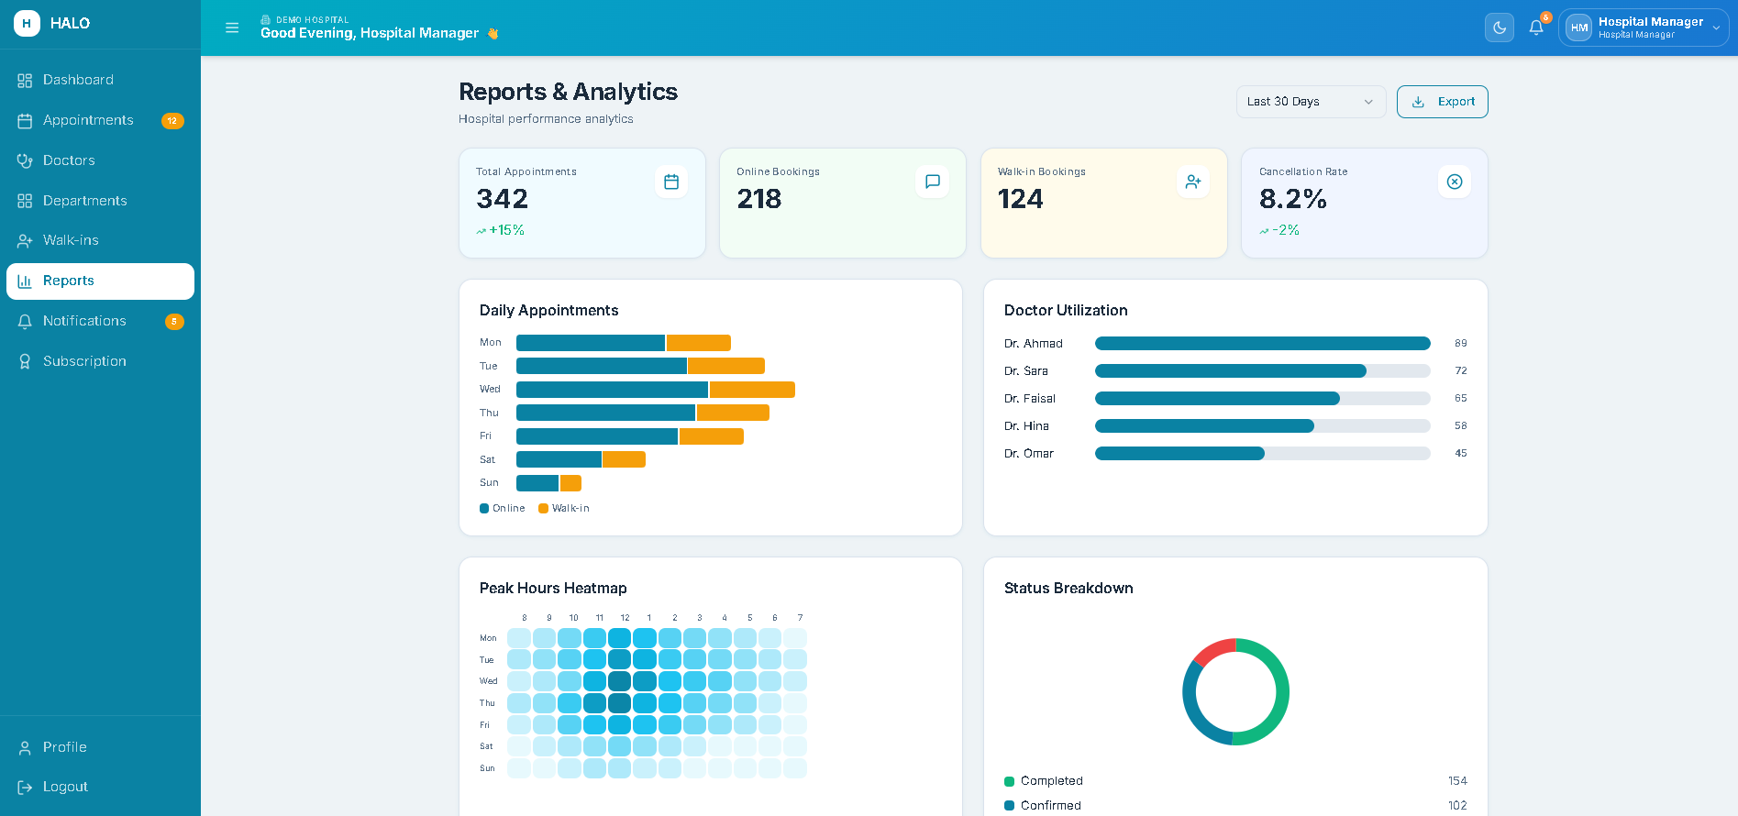
Figure 32 - Mockup M29 : Hospital Manager Analytics Dashboard
Table 2.34: Functional Requirements Derived from Mockup M29 (Hospital Manager Analytics Dashboard)
Feature (derived from UI) | Functional Requirement (FR-ID: Statement) | Business Rule
Daily Appointment Volume Chart | FR8.7: The system shall display a bar chart showing daily appointment counts (online vs walk-in) for the selected date range. | Chart must visually distinguish online bookings from walk-in entries using different colors.
Doctor Utilization Table | FR8.8: The system shall display a table ranking all hospital doctors by their appointment booking frequency, showing total appointments and average per day. | Table must be sortable by total appointments and doctor name.
Cancellation Rate KPI | FR8.9: The system shall display the appointment cancellation rate (cancelled / total × 100) as a percentage KPI card for the selected period. | Rate must be updated daily at midnight.
Peak Hour Heatmap | FR8.10: The system shall display a heatmap visualization showing appointment density by hour of day across the selected date range. | Heatmap must use a gradient from light (low density) to dark (high density).
Export Report Button | FR8.11: The system shall allow the Hospital Manager to export the analytics report as PDF or CSV for the selected date range. | Exported file must include hospital name, date range, all displayed KPIs, and chart data in tabular format.

Module 9: Notifications & Reminders
Mockup M30 : Notification Center Screen
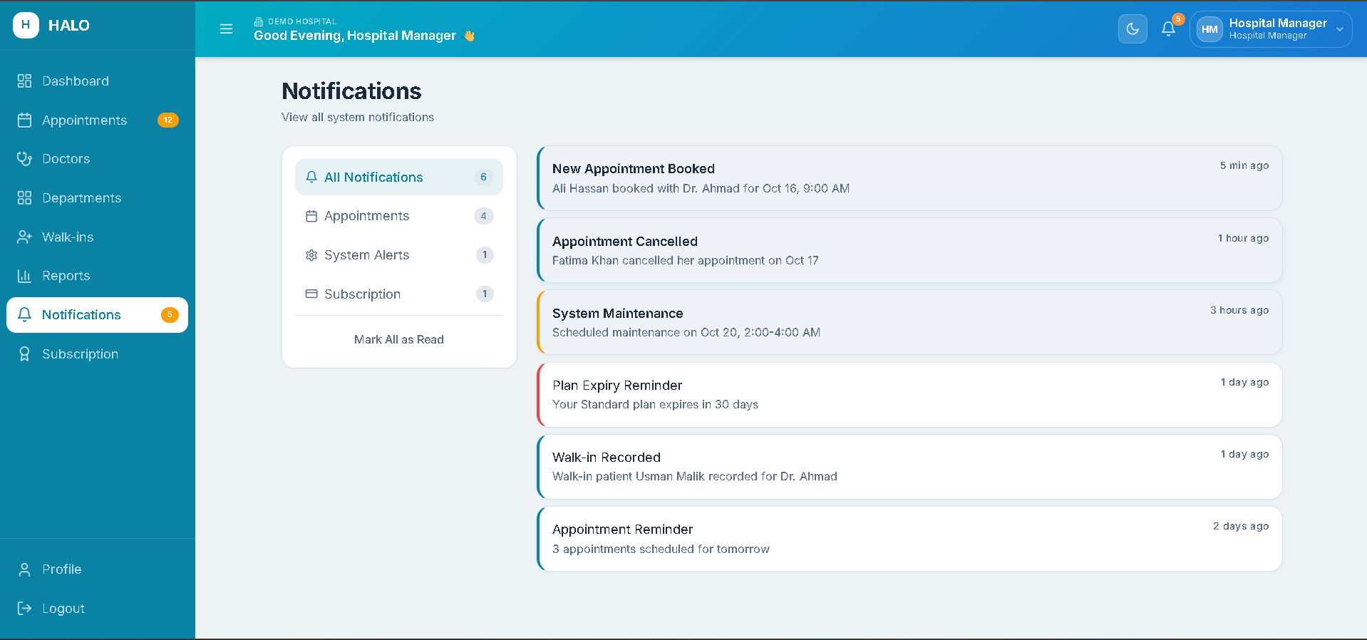
Figure 33 - Mockup M30 : Notification Center Screen
Table 2.35: Functional Requirements Derived from Mockup M30 (Notification Center)
Feature (derived from UI) | Functional Requirement (FR-ID: Statement) | Business Rule
Notification List | FR9.1: The system shall display all notifications for the logged-in user in a chronological list, showing notification type icon, title, message, and timestamp. | Unread notifications must be visually distinguished from read notifications (e.g., bold text, colored dot).
Mark as Read Action | FR9.2: The system shall allow the user to mark individual notifications as read, or mark all notifications as read with a single action. | Marking as read must update the unread badge count in the header immediately.
Notification Type Filters | FR9.3: The system shall allow filtering notifications by type: Appointments, System Alerts, Subscription, and All. | Default view shows All notification types.
Notification Delivery Status | FR9.4: The system shall display a delivery status indicator (Sent, Delivered, Failed) for each outgoing notification logged in the system. | Failed notifications must be visually flagged with a retry option where applicable.

Mockup M31 : Notification Preferences and Settings Screen
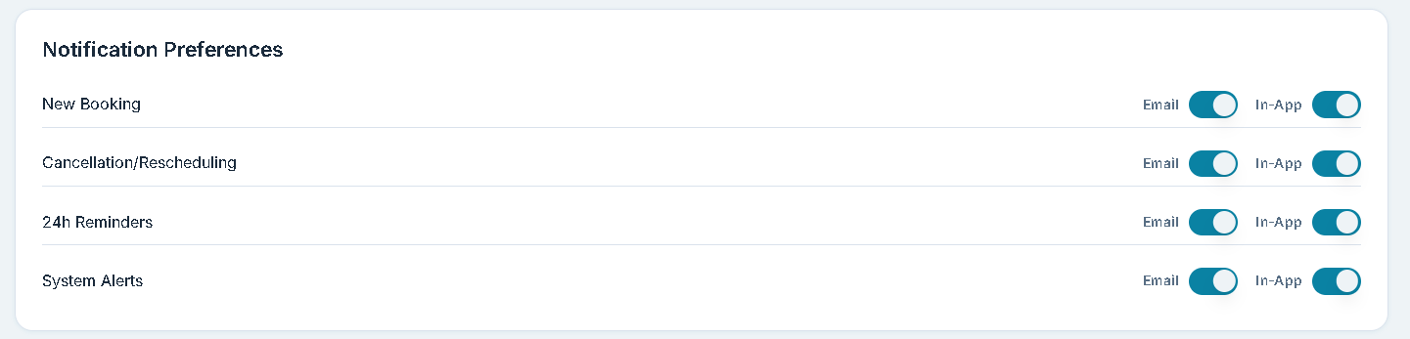
Figure 34 - Mockup M31 : Notification Preferences Screen
Table 2.36: Functional Requirements Derived from Mockup M31 (Notification Preferences)
Feature (derived from UI) | Functional Requirement (FR-ID: Statement) | Business Rule
Email Notification Toggles | FR9.5: The system shall allow the Hospital Manager to enable or disable email notifications for each event type: new bookings, cancellations, rescheduling, and 24-hour reminders. | At least one notification type must remain enabled.
In-App Notification Toggles | FR9.6: The system shall allow the Hospital Manager to enable or disable in-app notifications independently of email notifications for each event type. | In-app notifications for subscription expiry cannot be disabled.
Save Preferences Button | FR9.7: The system shall persist notification preference changes immediately and confirm with a success message. | Changes must take effect for all subsequent events generated after the save action.

Module 10: Billing & Subscription
Mockup M32 : Admin Subscription Management Screen
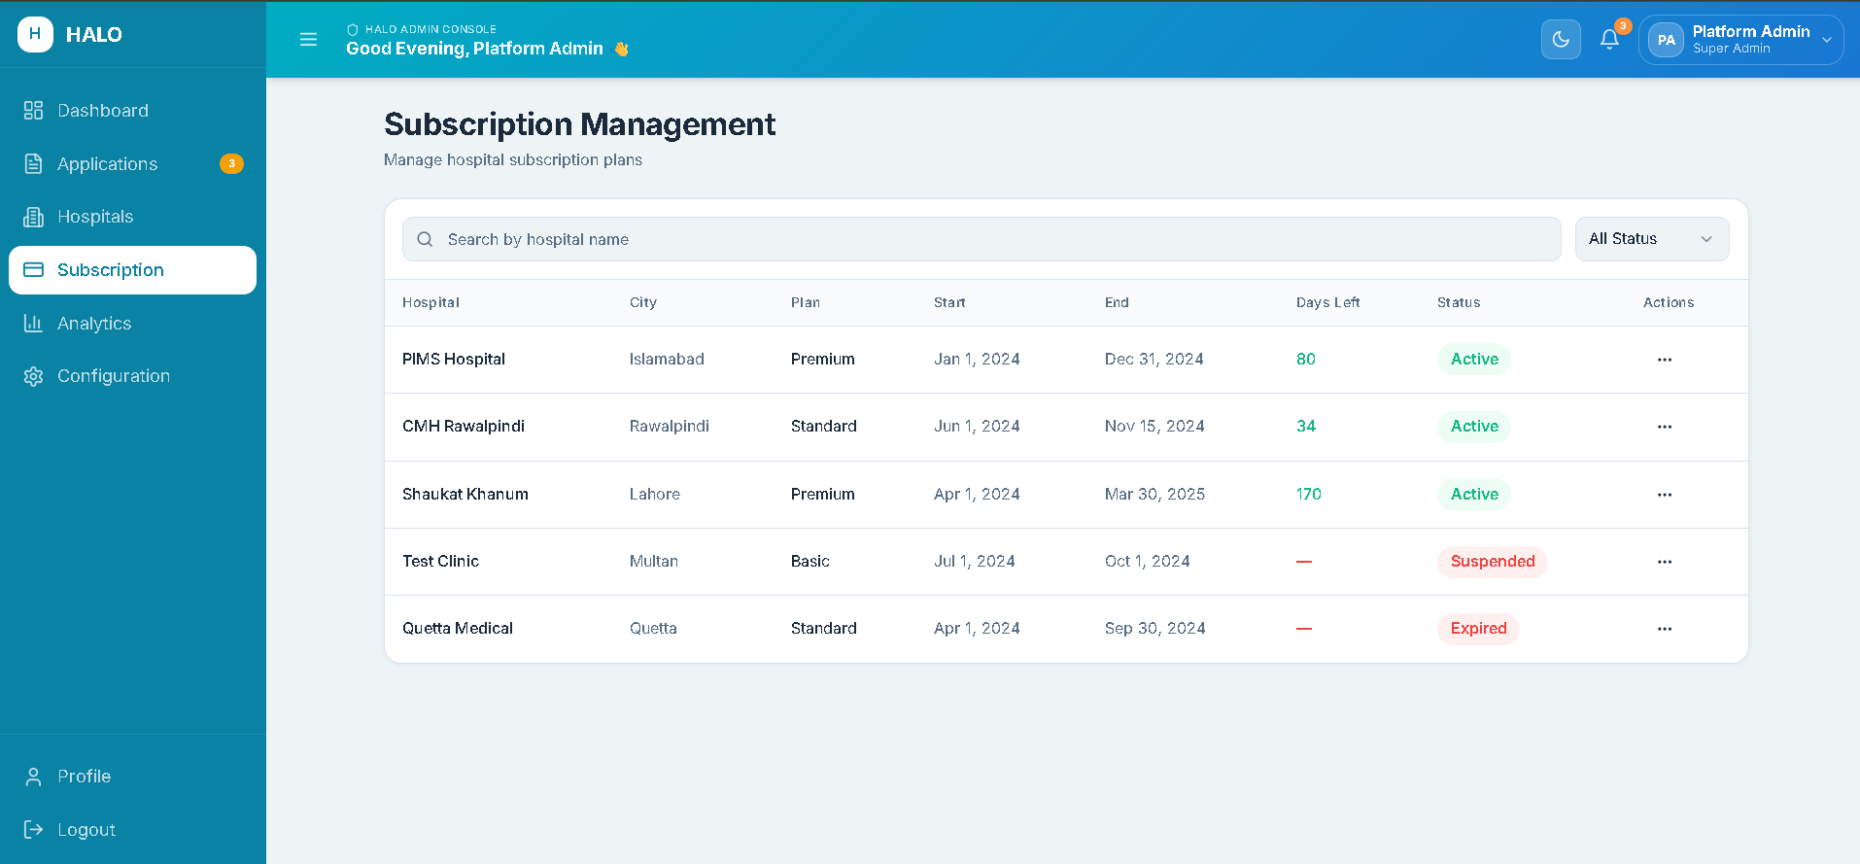
Figure 35 - Mockup M32 : Admin Subscription Management Screen
Table 2.37: Functional Requirements Derived from Mockup M32 (Admin Subscription Management)
Feature (derived from UI) | Functional Requirement (FR-ID: Statement) | Business Rule
Hospital Subscription Table | FR10.1: The system shall display all hospital tenants in a table showing Hospital Name, Current Plan, Plan Start Date, Plan End Date, and Status. | Table must be filterable by plan type and subscription status (Active, Expired, Suspended).
Assign New Plan Action | FR10.2: The system shall allow the Administrator to assign a subscription plan to a hospital that has no active plan or has an expired plan, by selecting a plan tier and start date. | Assigning a plan to a hospital with a current active plan must require confirmation of the replacement.
Extend Plan Action | FR10.3: The system shall allow the Administrator to extend an existing hospital subscription by selecting a new end date. | Extended end date must be after the current end date.
Suspend Plan Action | FR10.4: The system shall allow the Administrator to suspend a hospital's active subscription, immediately disabling its HALO widget and notifying the Hospital Manager. | Suspension must require a reason entry in a mandatory text field.
Subscription History View | FR10.5: The system shall display the full subscription history for a selected hospital, showing all plans assigned, their dates, and status changes in reverse chronological order. | History view is read-only. No editing of historical records is permitted.

Mockup M33 : Hospital Manager Subscription and Billing Screen
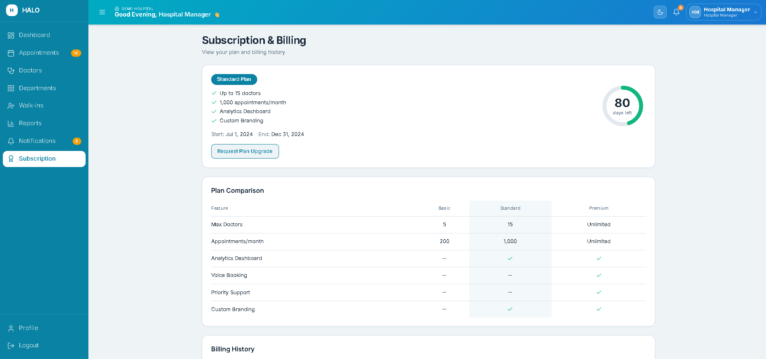
Figure 36 - Mockup M33 : Hospital Manager Subscription Screen
Table 2.38: Functional Requirements Derived from Mockup M33 (Hospital Manager Subscription Screen)
Feature (derived from UI) | Functional Requirement (FR-ID: Statement) | Business Rule
Current Plan Summary Card | FR10.6: The system shall display the hospital's current subscription plan name, features included, start date, end date, and days remaining as a summary card. | Days remaining must be calculated dynamically and displayed in real time.
Plan Comparison Table | FR10.7: The system shall display a side-by-side comparison of Basic, Standard, and Premium subscription plans showing included features, limits, and price. | Current active plan must be highlighted in the comparison table.
Upgrade Plan Request Button | FR10.8: The system shall allow the Hospital Manager to submit a plan upgrade request to the Administrator, including their preferred plan tier. | Downgrade requests are not supported. Upgrades are subject to Administrator approval.

Non-Functional Requirements
This section specifies non-functional requirements (NFRs) other than constraints and external interface requirements. Non-functional requirements define the quality attributes of the HALO system, such as reliability, usability, performance, and security.
Requirements.

Reliability
- The HALO platform shall achieve a minimum uptime of 99% measured on a monthly basis, excluding scheduled maintenance windows communicated at least 24 hours in advance.
- The AI conversational agent shall gracefully handle unrecognized inputs or pipeline failures by returning a fallback response to the patient rather than terminating the conversation session.
- Appointment booking transactions shall be ACID-compliant, ensuring that partial failures during slot allocation do not result in inconsistent database states such as double-bookings.
- In the event of a backend service failure, the system shall maintain patient session state for up to 5 minutes to allow reconnection without losing conversation context.

Usability
- The patient-facing conversational interface shall be operable by a first-time user without any prior training, requiring no more than 3 conversational turns to initiate a booking request.
- The system shall support voice interaction as a complete alternative to text interaction, ensuring that patients who cannot type can complete the full appointment booking flow through voice alone.
- The Hospital Manager dashboard shall display all key daily appointment information above the fold without requiring scrolling on a standard 1080p desktop display.
- Error messages and system prompts shall be presented in plain language in both English and Urdu, avoiding technical jargon.

Performance
- The AI agent shall respond to patient inputs within 3 seconds for text-based interactions under normal server load conditions.
- Voice recognition output shall be available to the conversational pipeline within 2 seconds of the patient completing a spoken utterance.
- The Hospital Manager dashboard shall load all daily appointment data within 4 seconds on a stable broadband connection.
- The appointment slot availability check shall complete within 1 second to ensure a seamless booking conversation flow.
- The system shall support at least 100 concurrent patient conversations without degradation in response time.

Security
- All user authentication shall use JWT tokens with a maximum token lifetime of 8 hours; tokens shall be invalidated on logout.
- All data transmission between clients and the HALO server shall be encrypted using TLS 1.2 or higher; plain HTTP connections shall be rejected.
- Patient data stored in the database shall be limited to: name, contact number, email address, age, and visit reason. No clinical or medical data shall be stored.
- Role-based access control shall enforce that a Hospital Manager can only access data belonging to their own hospital tenant. Cross-tenant data access attempts shall be logged and rejected.
- Passwords shall be stored using a strong cryptographic hashing algorithm. Plaintext passwords shall never be stored or logged.

External Interface Requirements
This section provides information to ensure that the HALO system will communicate properly with users and with external hardware or software elements.

User Interfaces Requirements
- The patient-facing conversational interface shall follow a clean, minimal design with a chat window, voice activation button, and hospital branding elements.
- Font sizes shall be a minimum of 14px for body text to ensure readability on mobile screens.
- The Hospital Manager dashboard shall use a sidebar navigation structure with clearly labeled sections: Dashboard, Doctors, Appointments, Walk-ins, Analytics, and Settings.
- The Admin dashboard shall use a top-navigation layout with sections: Hospitals, Subscriptions, Platform Settings, and Reports.
- Color-coded status indicators shall be used for appointment statuses: Green = Confirmed, Yellow = Pending, Red = Cancelled, Grey = Completed.

Software interfaces
- PostgreSQL Database: The HALO backend API (Node.js/Express.js) shall maintain a persistent connection to a PostgreSQL database instance for all structured data operations including appointments, doctor schedules, and hospital profiles.
- FastAPI AI Microservice: The Node.js API shall communicate with the Python/FastAPI AI microservice via authenticated internal HTTP API calls to process NLU requests, generate AI responses, and perform speech recognition.
- Whisper AI (Large-v3): The AI microservice shall interface with the locally hosted Whisper AI model for Urdu and English speech-to-text conversion during voice interactions.
- LangChain + Vicuna (Ollama): The AI microservice shall use LangChain (version 0.1.4) to orchestrate conversational dialogue with the locally hosted Vicuna 13B model served via Ollama.
- Email Service: The backend shall interface with an SMTP-compatible email service (e.g., SendGrid or SMTP relay) to dispatch appointment confirmations and reminders.
- WebRTC: Real-time voice input/output (microphone capture and audio playback) for the browser-based voice interaction mode is handled through the WebRTC API.

- Twilio Telephony API: The hospital-provided phone number channel is integrated via Twilio (or equivalent SIP/VoIP provider) to route incoming patient calls to the HALO AI voice agent.

Hardware interfaces
- The patient-facing voice interaction feature requires access to the patient's device microphone through browser-standard Web Audio API permissions. No proprietary hardware is required.
- The telephony-based interaction channel requires integration with a third-party telephony provider (e.g., Twilio) to route incoming calls to the HALO AI agent. Hardware PSTN infrastructure is managed by the telephony provider.

Communications interfaces
- Email confirmations and reminders shall be sent to the patient's provided email address and to the Hospital Manager's registered email. Emails shall include appointment details, reference ID, and a plain-text fallback for email clients that do not render HTML.
- In-app notifications shall be delivered to Hospital Manager sessions in real time using WebSocket connections managed by the Node.js backend.
- WebRTC shall be used for real-time audio streaming between the patient's browser and the HALO AI voice agent during web-based voice interactions.
- Telephony audio shall be streamed to the HALO AI agent via the telephony provider's API (e.g., Twilio Media Streams) for speech recognition and response synthesis.

References
Books
- K. Wiegers and J. Beatty. Software Requirements, 3rd ed. Redmond, WA: Microsoft Press, 2013, pp. 1–673.
- Sommerville. Software Engineering, 10th ed. Harlow, UK: Pearson Education, 2016, pp. 82–175.
- J. Jurafsky and J. H. Martin. Speech and Language Processing, 3rd ed. Upper Saddle River, NJ: Prentice Hall, 2023, pp. 1–638.
Articles in a Journal
- M. A. Khan and S. U. Rahman. "Challenges in healthcare appointment management in developing countries: A systematic review." Journal of Medical Systems, vol. 47, no. 6, pp. 1–18, Jun. 2023.
- Ahmed, T. Hussain, and F. Malik. "Conversational AI in healthcare: Applications, challenges, and future directions." International Journal of Medical Informatics, vol. 178, pp. 105–122, Oct. 2023.
- N. Raza, A. Hafeez, and B. Raza. "Digital health transformation in Pakistan: Barriers, enablers, and policy implications." Health Informatics Journal, vol. 29, no. 1, pp. 1–19, Jan. 2023.
Articles from Conference Proceedings (Published)
- Vaswani, N. Shazeer, N. Parmar, J. Uszkoreit, L. Jones, A. N. Gomez, L. Kaiser, and I. Polosukhin. "Attention is all you need," in Proc. 31st Conference on Neural Information Processing Systems (NeurIPS), Long Beach, CA, 2017, pp. 5998–6008.
World Wide Web
- OpenAI. "Whisper: Robust speech recognition via large-scale weak supervision." Internet: https://openai.com/research/whisper, Sep. 2022 [Mar. 2025].
- LangChain. "LangChain documentation: Building applications with LLMs through composability." Internet: https://docs.langchain.com, Jan. 2024 [Mar. 2025].
- Twilio Inc. "Twilio voice API documentation." Internet: https://www.twilio.com/docs/voice, Jan. 2024 [Mar. 2025].
- World Health Organization. "Digital health implementation framework for healthcare facilities." Internet: https://www.who.int/digital-health, Dec. 2023 [Mar. 2025].
- Pakistan Medical Commission. "Telemedicine guidelines and digital health regulations." Internet: https://www.pmc.gov.pk, Aug. 2023 [Mar. 2025].

Plagiarism Report
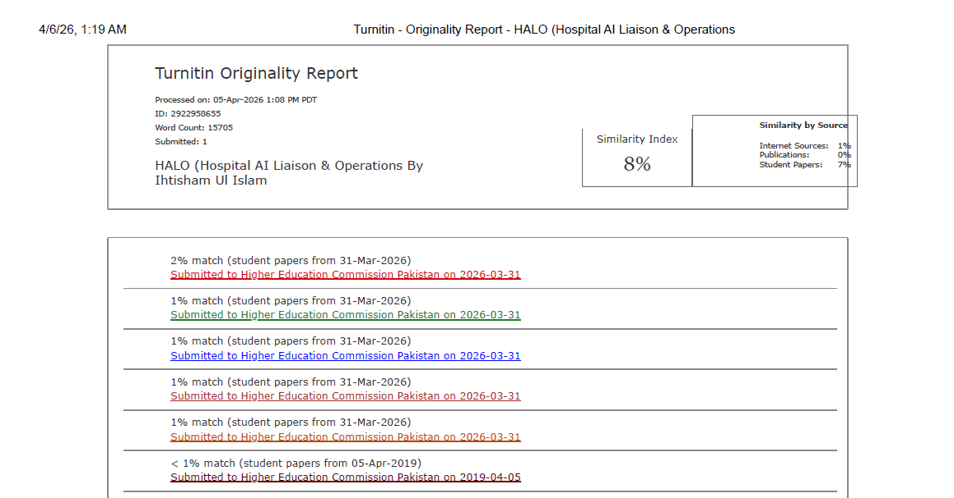
Figure 37 - Turnitin plagiarism report

