题目一：

设计一个函数模板，其中包括数据成员T a[n]以及对其进行排序的函数 sort( )，模板参数T可实例化成字符串。

C++提交的答案将被附加下面的main函数，提交时请不要包含main函数。

int main(){

        string Str[10]={"Zhang","Li","Wang","Qian","Zhao","Wu","Xu","Tang","Shen","Liang"};

        int Int[8]={20,12,0,-5,9,-18,6,11};

        double Dou[7]={3.07,8.12,-0.45,6,10,-9,7.29};

        Sort(Str,10);

        Sort(Int,8);

        Sort(Dou,7);

        Print(Str,10);

        Print(Int,8);

        Print(Dou,7);

        return 0;

}

答案代码：

#include<iostream>

using namespace std;

template<typename T>

void Sort (T \*a,int size)

{

    int i,work;

    T temp;

    for (int pass=1;pass<size;pass++)

    {

        work=1;

        for (i=0;i<size-pass;i++)

        {

            if(a[i]>a[i+1])

            {

                temp=a[i];

                a[i]=a[i+1];

                a[i+1]=temp;

                work=0;

            }

        }

        if(work) break;

    }

}

template<typename T>

void Print (T \*a,int size)

{

    int i;

    for (i=0;i<size-1;i++)

    {

        cout<<a[i]<<" ";

    }

    cout<<a[size-1]<<endl;

}

int main()

{

    string Str[10]={"Zhang","Li","Wang","Qian","Zhao","Wu","Xu","Tang","Shen","Liang"};

    int Int[8]={20,12,0,-5,9,-18,6,11};

    double Dou[7]={3.07,8.12,-0.45,6,10,-9,7.29};

    Sort(Str,10);

    Sort(Int,8);

    Sort(Dou,7);

    Print(Str,10);

    Print(Int,8);

    Print(Dou,7);

    return 0;

}

输出：

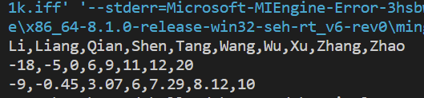

题目二：