**实验6： 继承与派生**

第一题：  
题目：  
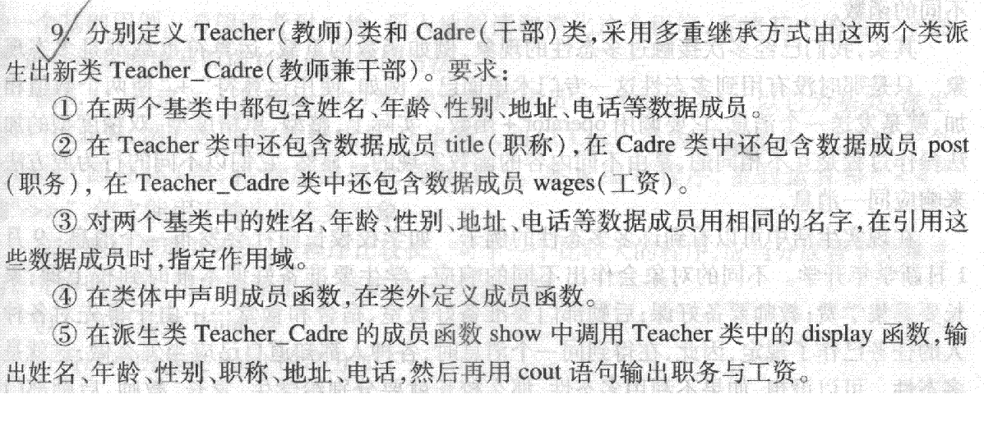

#### 输入

依次输入下述信息  
name  
age  
sex  
title  
post  
address  
tel  
wages

#### 输出

按下面顺序输出，但前面加描述  
name:  
age:  
sex:  
title:  
address:  
tel:  
post:  
wages:

答案：

#include<iostream>

#include<cstring>

#include <string>

using namespace std;

class Teacher

{

    protected:

    string name,sex,title;

    char address[100],tel[100];

    int age;

    public:

    Teacher(string n,int a,string s,string t,char add[],char te[])

    {

        name=n;

        age=a;

        sex=s;

        title=t;

        strcpy(address,add);

        strcpy(tel,te);

    }

    void display()

    {

        cout<<"name:"<<name<<endl;

        cout<<"age:"<<age<<endl;

        cout<<"sex:"<<sex<<endl;

        cout<<"title:"<<title<<endl;

        cout<<"address:"<<address<<endl;

        cout<<"tel:"<<tel<<endl;

    }

};

class Cadre

{

    protected:

    char address[100],tel[100];

    string name,sex;

    string post;

    int age;

    public:

    Cadre(string n,int a,string s,char add[],char te[],string p)

    {

        name=n;

        age=a;

        sex=s;

        strcpy(address,add);

        strcpy(tel,te);

        post=p;

    }

};

class Teacher_Cadre:public Teacher,public Cadre

{

    private:

    float wages=0;

    public:

    Teacher_Cadre(string n, int a, string s, string t, char add[], char te[], string p, float w):

        Teacher(n, a, s, t, add, te), Cadre(n, a, s, add, te, p)

        {

            wages = w;

        }

    void show();

};

void Teacher_Cadre::show()

{

    Teacher::display();

    cout<<"post:"<<Cadre::post<<endl;

    cout<<"wages:"<<wages<<endl;

}

int main()

{

    string n,s,t,p;

    char add[100],te[100];

    int a;

    float w;

    cin>>n>>a>>s>>t>>p;

    cin.ignore();

    cin.getline(add,100);

    cin.getline(te,100);

    cin>>w;

    Teacher_Cadre tc(n, a, s, t, add, te, p, w);

    tc.show();

    return 0;

}

输入和输出：

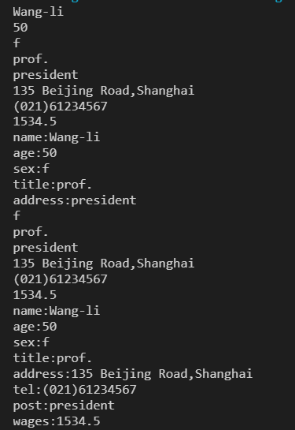

问题：

一开始用string定义了所有的变量，但是在实际输入的时候发现家庭住址哪里的空格会被识别为第二个变量开始的标志，就换成了getline（）函数。

第二题：  
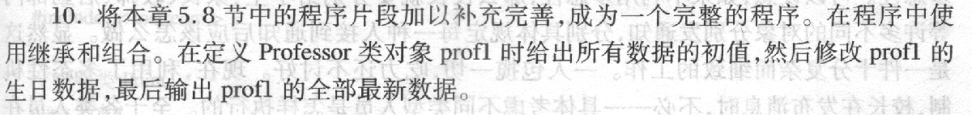

答案：

#include<iostream>

#include<string>

using namespace std;

class Teacher

{

    public:

    Teacher(){}

    Teacher(int n,string nam,char s,float a)

    {

        num=n;

        name=nam;

        sex=s;

        area=a;

    }

    void display()

    {

        cout << "num:" << num << endl;

        cout << "name:" << name << endl;

        cout << "sex:" << sex << endl;

    }

    void output()

    {

        cout << "area:" << area << endl;

    }

    protected:

    int num;

    string name;

    char sex;

    float area;

};

class BirthDate

{

    public:

    BirthDate(){}

    BirthDate(int y, int m, int d)

    {

        year = y;

        month = m;

        day = d;

    }

    void display_1()

    {

      cout << "birthday:" << month << "/" << day << "/" << year << endl;

    }

    private:

    int year;

    int month;

    int day;

};

class Professor : public Teacher

{

    public:

    Professor(int n, string nam, char s, float a, BirthDate bd) {

    num = n; name = nam; sex = s; area=a; birthday = bd;

    }

    void show()

    {

        display();

        birthday.display_1();

        output();

    }

    BirthDate birthday;

};

int main()

{

    int n;

    float a;

    int y,m,d;

    int y1,m1,d1;

    string nam;

    char s;

    cin>>n>>nam>>s>>y>>m>>d>>a;

    cin>>y1>>m1>>d1;

    cout<<"original data:"<<endl;

    BirthDate bd(y, m, d);

    Professor prof1(n, nam, s, a, bd);

    prof1.show();

    cout<<"new data:"<<endl;

    BirthDate nbd(y1, m1, d1);

    prof1.birthday = nbd;

    prof1.show();

    return 0;

}

输入输出：

