
KARNATAKA STATE COUNCIL FOR SCIENCE AND TECHNOLOGY
Indian Institute of Science campus, Bengaluru – 560 012
Telephone: 080 – 23341652, 23348849 || Email: spp@kscst.org.in
Website: www.kscst.org.in/spp.html or https://kscst.karnataka.gov.in/en
FORMAT FOR STUDENT PROJECT PROPOSAL FOR THE
50th SERIES OF STUDENT PROJECT PROGRAMME 2026 – 2027
(Celebrating the Golden Jubilee of KSCST’s flagship Student Project Programme)

CALL FOR PROJECT PROPOSALS FROM FINAL-YEAR STUDENTS
B.E. | B.Arch. | M.Tech. | M.Sc. | M.Tech. / M.Sc. (Agriculture) | MBA | MCA
NOTE:
- Project Proposal: Please download this MS Word Project Proposal format and fill in all the required details in the downloaded MS Word file itself. Insert relevant images or diagrams of your project wherever necessary. Obtain the required signatures and seals from the Project Guide, Head of the Department (HOD), SPP Coordinator (where applicable), and Principal/Head of the Institution in the relevant sections, and then convert the completed proposal into PDF format.
- Documents to be Uploaded: Please keep the following 3 separate scanned PDF files ready: (1) Project Proposal, (2) Declaration and Endorsement, and (3) details of the processing fee payment made through NEFT/UPI. Upload all three documents while filling out and submitting the Google Form.
- Verification of Details: Please ensure that all details provided in the Google Form are exactly the same as those mentioned in the Project Proposal. Carefully verify all information and uploaded documents before submitting the application.
Online Submission Period: 21 September 2026 to 30 November 2026 (5:00 PM).
https://forms.gle/VPPewZnbUhw1V8KdA
Instructions for Filling the Project Proposal
- Handwritten project proposals will not be accepted.
- Fill in all the required details in this MS Word proposal format. Insert photographs, figures, diagrams, flowcharts, tables, or illustrations wherever appropriate to explain the proposed work.
- After completing the proposal, convert the document into a single PDF file.
- Obtain the signatures and seals of the Project Guide, Head of the Department, SPP Coordinator (where applicable), and the Principal/Head of the Institution in the relevant sections before converting the proposal into PDF.
- Keep the following PDF documents ready before submitting the proposal through the Google Form:
  - Project Proposal (PDF) duly signed and approved.
  - Declaration signed by all student team members, the Project Guide, and the SPP Coordinator.
  - Endorsement issued on the Institution/Department Letterhead and duly signed by the Project Guide, SPP Coordinator, Head of the Department, and the Principal/Head of the Institution.
  - Processing Fee Payment Receipt (UPI/NEFT) of ₹1,180/- (₹1,000/- + 18% GST).
- The processing fee must be paid before submitting the project proposal. Ensure that the Transaction/UTR/Reference Number and other payment details entered in the proposal exactly match the uploaded payment receipt. Incorrect, incomplete, invalid, or unverifiable payment details, or non-payment of the processing fee, will render the project proposal liable for rejection.
- Submit the proposal only through the prescribed Google Form along with all the mandatory attachments. Hard copies of the project proposal should not be sent to KSCST.
- Before converting the proposal into PDF, delete all instructional notes, examples, suggestions, highlighted text, and any irrelevant content from this template. Ensure that the final proposal is complete, neatly formatted, and ready for evaluation.
- The Team Leader shall submit the completed project proposal only through the prescribed Google Form using the following link:
- Google Form: https://forms.gle/VPPewZnbUhw1V8KdA
- Ensure that all mandatory documents, including the duly signed project proposal, Declaration, Endorsement, and Processing Fee Payment Receipt, are uploaded before final submission. Incomplete applications or proposals submitted without the required documents will not be considered.
- KSCST shall not be responsible for delays or failure in submission due to internet connectivity issues, network failures, server problems, insufficient bandwidth, power interruptions, browser-related issues, or any other technical problems at the applicant's end.
- Applicants are strongly advised not to wait until the last date and time for submission. Complete the payment of the processing fee, prepare all required documents, and submit the proposal well in advance to avoid last-minute technical difficulties.
- No requests for extension of the submission deadline or consideration of delayed submissions due to technical or network-related issues will be entertained.
- The Google Form will be automatically disabled after the prescribed closing date and time, and no further submissions will be accepted thereafter.
* ~ * ~ *

PART–A: GENERAL INFORMATION
(Please fill in all details in UPPERCASE LETTERS, except for the Email ID.)
Project Title: GeoGuard: A Secure Geo-Tagged Image Authentication System Using Cryptographic Hashing and Digital Signatures

Keywords (5–8):

Broad Theme:
Select one of the 19 broad themes for Student Projects (SPP 50th Series).
Please select the one broad theme that most closely matches your proposed project. The 19 broad themes represent high-priority focus areas for Karnataka and are intended to encourage innovative, practical, and impactful student projects.
For detailed information about the 19 broad themes and their respective sub-themes, please visit the link provided below:
https://drive.google.com/drive/folders/1BmZ3ksrRA0GZ0SsBAnMR83tQL3VsMkkG?usp=drive_link
or www.kscst.org.in/spp.html
Note: Please select only one broad theme that is most relevant to your proposed project.
- Theme No.:
- Theme Name:
3. Sub-theme / Focus Area:
Institution Details:
- Name of Institution: S.G. Balekundri Institute of Technology.
- Course Name: Computer Science and Engineering.
- Department Name: Computer Science and Engineering.
- Affiliated University: Visvesvaraya Technological University
5. District of Your Institution: Belagavi
6. Complete Postal Address of the Institution with Pin code: 590010.
Project Guide Details:
- Project Guide Name: Dr. Shaheen Mujawar
- Project Guide Designation: Doctorate(Phd).
- Project Guide Department: Computer Science and Engineering.
- Project Guide Email id: shaheenm@sgbit.edu.in
- Project Guide Mobile Number: +91 97427 71004
Project Co-Guide (if applicable):
- Project Co-Guide Name: Prof. / Dr. / Mr. / Ms. / Mrs.
- Project Co-Guide Designation:
- Project Co-Guide Department:
- Project Co-Guide Email id:
- Project Co-Guide Mobile Number:
Student Team Details:

Sl. No. | Insert Passport-size Photograph | Name of the Student  (BLOCK LETTERS) | USN / Registration No. | Degree & Branch & Semester | Category as per College Records (SC/ST/  OBC/  General) | Mobile No. | Email Id
1. |  | Mr. Hemant Mandi | 2BU23CS | Degree: B.E  Branch: CSE  Semester:7th | Category 2A | +9188678 85078 | mandihemant04@gmail.com
2. |  | Mr.Suyog Hanamar | 2BU23CS156 | Degree: B.E  Branch: CSE  Semester:7th | OBC  Category1 | +919986821707 | hanamarsuyog@gmail.com
3. |  | Ms. Almas Pathan | 2BU23CS | Degree: B.E  Branch: CSE  Semester:7th | Category  2B | +9199452 69809 | Almaspathan2006@gmail.com
4. |  | Mr.Shubham Hiremath | 2BU23CS140 | Degree: B.E  Branch: CSE  Semester:7th | General | +91 94483 39846 | shubhamhiremath87@gmail.com

Note:
- The Name of each student and all other information furnished above shall be as per the official records of the College / Institution.
- The Category (SC / ST / OBC / GEN) shall be furnished strictly as per the College/Institution records. This information is collected only to ascertain the number of students from different categories who have submitted and/or been selected for projects. It shall not constitute or imply any reservation/quota in the selection or sanction of projects.
- A recent passport-size colour photograph, preferably taken within the last six months, shall be pasted/uploaded in the space provided for each student.
- Photographs shall be clear, front-facing and of good quality, with the student's face clearly visible.
- All student names shall be entered in CAPITAL LETTERS, exactly as they should appear on the certificates. The names shall be carefully checked for spelling and other errors. The same information will be used for preparation of certificates. KSCST shall not be responsible for errors in certificates arising from incorrect or misspelled names furnished in the proposal.
- The Team Leader shall be clearly indicated by adding “(TEAM LEADER)” against the respective student's name.
- A maximum of four students may be included in a project team.
- The details furnished in this section will be used by KSCST for student identification, project evaluation, official correspondence, and participation in the Annual State-Level Poster Presentation and Exhibition.
SPP Coordinator Details:
- SPP Coordinator Name: Prof. / Dr. / Mr. / Ms. / Mrs.
- SPP Coordinator Designation:
- SPP Coordinator Email:
- SPP Coordinator Mobile Number:

PART - B: PROJECT DESCRIPTION
Background and Need of the Project: (Maximum 300 words)
Describe
- Background
- Existing scenario
- Problem statement
- Need for the project
- Beneficiaries
Review of Existing Work:
Brief review of
- Existing technologies
- Commercial products
- Research papers
- Patents
- Existing solutions
Mention shortcomings and research gaps.
Problem Statement:
(Clearly define the problem proposed to be addressed.)

Objectives:
List the measurable objectives.
Example
- To design…
- To develop…
- To fabricate…
- To evaluate…
- To validate…
Innovation / Novelty:
Explain
- What is new?
- How is it different from existing work?
- Why is it innovative?
Proposed Methodology:
Provide
- Overall methodology
- Block Diagram / Flow Chart
- System Architecture
- Design approach
- Experimental plan
- Software/Hardware to be used
Expected Deliverables:
Examples
- Prototype
- Software
- Mobile App
- Web Portal
- Device
- Design
- GIS Database
- Decision Support Tool
- Business Model
- Standard Operating Procedure
Expected Outcomes and Impact:
Technical
Social
Environmental
Economic
Industrial
Academic
Potential users
Relevance:
Tick wherever applicable
□ SDGs (Sustainable Development Goals)
□ Karnataka Priority Sector
□ Rural Development
□ MSME
□ Agriculture
□ Healthcare
□ Water
□ Environment
□ Climate
□ Manufacturing
□ Smart Cities
□ Digital India
□ Startup
□ Women Empowerment
□ Others (Please Specify):
Work Plan (Please specify the month and tick ✓)
Activity | Month 1 | Month 2 | Month 3 | Month 4 | Month 5
Literature Survey
Design
Development
Testing
Validation
Final Report

Facilities Available:
Please mention the details of the available facilities under each category. If any facility is not available in your institution, please enter “NONE”.

1. Laboratory
2. Equipment
3. Software
4. Instruments
5. Workshop
6. Institutional facilities

Major Requirements for the Project:
List only the essential requirements. (Remove whichever is not relevant to the project)
Examples:
Hardware
- Sensors
- Microcontroller
- Motors
- Pumps
- Camera
- Batteries
- Solar Panel
Software
- MATLAB
- Python
- ANSYS
- SolidWorks
- ArcGIS
- QGIS
- TensorFlow
Consumables
- Chemicals
- Fabrication materials
- Electronic components
- Biological samples
Field Studies
- Travel
- Sample collection
- Surveys
Budget Estimate (Remove whichever is not relevant for the project):
Item | Estimated Cost (₹)
Equipment / Components
Consumables
Fabrication
Software / Cloud Services
Field Survey / Data Collection
Testing / Analysis
Miscellaneous
Total
The budget specified in the Google Form must align with the amounts indicated in the project proposal. If no cost is associated with a subhead, indicate Rs. 0/-.
Important Note
KSCST provides only a modest financial grant for projects recommended by the Expert Committee. The sanctioned financial assistance shall be in the range and maximum up to ₹10,000 per project (or such amount as may be decided by KSCST from time to time). Students and institutions are encouraged to utilize available laboratory facilities and institutional resources. Any expenditure beyond the sanctioned assistance shall be borne by the institution and/or the project team.
References:
Use IEEE / APA format.
(References: Cite all books, journal articles, conference papers, standards, reports, patents, and websites using either the IEEE or APA (7th Edition) referencing style consistently throughout the proposal. All in-text citations must correspond to the references listed at the end of the proposal.)
Minimum 5 references.
Preferably include
- Recent journal papers
- Conference papers
- Standards
- Government reports
- Books
- Patents
Processing Fee Payment Details:
Important Instructions:
- The processing fee of ₹1,180/- (₹1,000/- + 18% GST) shall be paid before filling in and submitting the Google Form.
- The processing fee shall be paid only through UPI or NEFT to the Karnataka State Council for Science and Technology (KSCST) before submission of the project proposal through the Google Form.
- Each project team shall pay a project registration fee of exactly ₹1,180/- (inclusive of 18% GST) per project proposal in a single transaction. Payments made through multiple transactions, including split payments such as ₹1,000/- + ₹180/-, shall not be accepted.
- The Transaction / UTR / Reference Number and other payment details entered in the Google Form must exactly match the details shown on the uploaded payment receipt. A scanned copy of the UPI / NEFT payment receipt shall be uploaded along with the project proposal.
- Project proposals submitted without payment of the prescribed processing fee, or with incorrect, incomplete, invalid, or unverifiable payment/transaction details, shall be liable for rejection without further correspondence.
- The processing fee is non-transferable and non-refundable under any circumstances, including withdrawal of the proposal, duplicate submission, rejection, non-selection for sponsorship, or cancellation of the proposal.
- Submission of a project proposal and payment of the processing fee does not confer any right to sponsorship or selection under the Student Project Programme. All proposals shall be evaluated on merit by the Expert Committee, and the decision of KSCST shall be final.
- Any dispute arising out of the submission of the project proposal, payment of the processing fee, evaluation process, sponsorship, or any matter connected with the Student Project Programme shall be subject to the exclusive jurisdiction of the competent courts at Bengaluru, Karnataka.
Payment Details:
- Mode of Payment: ☐ UPI ☐ NEFT
- Transaction / UTR / Reference Number:
- Date of Payment: ____ / ____ / ____
- Amount Paid: ₹1,180/-
- Name of Account Holder:
- Name of Bank (for NEFT):
- UPI ID Used:
Attachment:
☐ Copy of UPI Payment Receipt / NEFT Transaction Receipt enclosed.
Student Details with Signature:
Sl. No. | Name of Student  (Block Letters) | USN / Registration No. | Signature | Date
1. | HEMANT MANDI | 2BU23CS053
2. | SUYOG HANAMAR | 2BU23CS156
3. | ALMAS PATHAN | 2BU23CS014
4. | SHUBHAM HIREMATH | 2BU23CS140

(Name & Signature of  SPP Coordinator with Seal) | Name and signature of the  Project Guide with Seal:
Email id: | Email id: shaheenm@sgbit.edu.in
Contact No.: | Contact No.: +91 97427 71004
Mandatory Attachments
☐ Project Proposal (PDF) duly signed by the Project Guide, Head of the Department and Principal/Head of the Institution.
☐ Declaration and Endorsement by the Head of the Institution.
☐ Copy of the Processing Fee Payment Receipt (UPI/NEFT).
☐ Any other supporting documents, if applicable.

DECLARATION
(From the Project Team)
(To be signed by all student members, scanned, and uploaded along with the project proposal)

Project Details
Title of the Project: (IN CAPITAL LETTERS) GEOGUARD: A SECURE GEO-TAGGED IMAGE AUTHENTICATION SYSTEM USING CRYPTOGRAPHIC HASHING AND DIGITAL SIGNATURES.
Broad Theme: _______________________________________________
Sub-theme / Focus Area: _______________________________________________
Department: Computer Science and Engineering.
Institution: S.G. Balekundri Institute Technology.

We, the undersigned members of the above project team, hereby declare that the information furnished in this project proposal is true, complete, and correct to the best of our knowledge and belief.
We further declare that:
- The proposed project is our original work and has not been copied, purchased, or submitted previously to any agency or institution for financial assistance or academic evaluation.
- We shall execute the project under the guidance of our Project Guide using the facilities available at our institution and maintain the highest standards of academic integrity and professional ethics. We shall abide by the financial and project policies of our institution throughout the execution and completion of the project.
- We shall not indulge in plagiarism, fabrication, falsification, manipulation, or misrepresentation of data or results or other project-related information, or inappropriate use of AI tools, including ChatGPT and similar AI-based tools. Any violation shall render the proposal / project liable for rejection or cancellation, and may attract such further action as deemed appropriate by KSCST. We shall promptly inform KSCST, through the Project Guide or the SPP Coordinator, of any changes in the project title, objectives, methodology, or team composition after obtaining the necessary approvals.
- We understand that the processing fee of ₹1,180/- (₹1,000/- + 18% GST) has to be paid before submission of the proposal through the Google Form. We certify that the payment details furnished in the proposal are true and verifiable. We also understand that the processing fee is non-transferable and non-refundable, and that proposals submitted without payment or with incorrect, incomplete, or unverifiable payment details are liable to be rejected.
- We agree to participate in all stages of the Student Project Programme, including the Mid-term Evaluation, submission of the Synopsis and Final Project Report, and the Annual State-Level Poster Presentation and Exhibition, if selected.
- We understand that if the project is sanctioned and the team fails to participate in the Mid-term Evaluation, submit the required reports, or participate in the Annual State-Level Poster Presentation and Exhibition (if selected), KSCST reserves the right to recover the financial assistance released for the project.
- We authorize KSCST to use, publish, reproduce, archive, and disseminate the project title, abstract, photographs, videos, and other non-confidential information relating to the project for academic, educational, promotional, reporting, and publication purposes, with due acknowledgement wherever applicable.
- We understand that submission of the proposal and payment of the processing fee does not guarantee sponsorship. The decision of KSCST and the Expert Committee regarding evaluation and selection of project proposals shall be final and binding.
- We agree that any dispute arising out of the submission of this proposal or participation in the Student Project Programme shall be subject to the exclusive jurisdiction of the competent courts at Bengaluru, Karnataka.
We hereby affirm that we have carefully read and understood all the guidelines, terms, and conditions of the 50th Series Student Project Programme (SPP): 2026–2027, and agree to abide by them.
Note: The use of AI tools, including ChatGPT and similar AI-based tools, shall not be used to generate or substitute the core project work, technical content, experimental results, data, analysis, or conclusions. Any use of AI tools for limited assistance, such as language improvement or formatting, shall be appropriately verified by the students and project guide and the students shall remain fully responsible for the accuracy, originality, and authenticity of the submitted work.
Student Details
Sl. No. | Name of Student | USN / Registration No. | Signature | Date
1. | HEMANT MANDI | 2BU23CS053
2. | SUYOG HANAMAR | 2BU23CS156
3. | ALMAS PATHAN | 2BU23CS014
4. | SHUBHAM HIREMATH | 2BU23CS140

(Name & Signature of  SPP Coordinator with Seal) | Name and signature of the  Project Guide with Seal:
Email id: | Email id: shaheenm@sgbit.edu.in
Contact No.: | Contact No.: +91 97427 71004
ENDORSEMENT
(From the Institution)
(To be issued on the Institution/Department Letterhead, signed, scanned, and uploaded along with the project proposal)
This is to certify that:
- Mr. Hemant Mandi
- Mr. Suyog Hanamar
- Ms. Almas Pathan
- Mr. Shubham Hiremath

are bonafide final-year students of the Department of Computer Science and Engineering, pursuing final year at S.G. Balenkundri Institute of Technology(Name of the Institution).
The institution has scrutinized and approved this project proposal for submission to the Karnataka State Council for Science and Technology (KSCST) under the 50th Series Student Project Programme (SPP): 2026 - 2027.
We hereby certify and undertake that:
- The project proposal has been reviewed by the Department and recommended for submission under the appropriate SPP broad theme.
- The institution shall provide the necessary laboratory facilities, equipment, software, workshop, computing facilities, infrastructure, and academic guidance required for successful completion of the project.
- The Project Guide shall monitor the progress of the project and ensure its timely completion in accordance with the approved objectives and work plan.
- The institution shall facilitate the participation of the student team in the Mid-term Evaluation, submission of the Synopsis and Final Project Report, and the Annual State-Level Poster Presentation and Exhibition, if selected.
- If the project receives financial assistance from KSCST, the institution shall ensure that the grant is utilized exclusively for the approved project and that all financial and technical requirements prescribed by KSCST are duly complied with and will submit the Utilisation Certificate and Statement of Expenditure after the completion of the project.
- If the student team fails to complete the project, submit the required reports, participate in the Mid-term Evaluation, or participate in the Annual State-Level Poster Presentation and Exhibition (if selected), the institution agrees to cooperate with KSCST in recovering the financial assistance released for the project, wherever applicable.
- The institution certifies that the information furnished in this proposal is true and correct to the best of its knowledge.
(Name & Signature of  Project Guide with Seal) | (Name & Signature of  SPP Coordinator with Seal) | (Signature of HoD  with Seal)
Email  id: shaheenm@sgbit.edu.in | Email id: | Email id:
Contact No.: +91 97427 71004 | Contact No.: | Contact No.:

Institutional Certification: The institution certifies that this proposal has been scrutinized by the Department and the Institutional SPP Coordinator, and is recommended as one of the officially approved project proposals of the institution for submission under the KSCST 50th Series Student Project Programme (SPP): 2026 - 2027.

(Signature of the Principal with Seal)
Email id:
Contact No.:
DETAILS OF PROCESSING FEES MADE THROUGH
NEFT / UPI PAYMENT
(Note: Include this page in the softcopy of the student project proposal. The student team shall furnish the details in the Google Form. It is informed to the students to 1) keep ready the softcopy of the project proposal and other documents and 2) Furnish the payment made details as processing fees and 3) update the details in the Google Form on the same day of payment made to KSCST by NEFT / UPI payment).
For finance related queries, please contact KSCST accounts section: 080 – 23341652, 23348849, email: finance@kscst.org.in
- TITLE OF THE PROJECT | :
- NAME OF THE TEAM LEADER | :
- EMAIL ID | :
- CONTACT MOBILE NO. | :
PAYMENT MADE DETAILS
- BANK REF. NO. / UTR NO. / UPI No. (12 digits) | :
- TRANSACTION ID | :
- NAME OF THE SENDER / ACCOUNT HOLDER and CONTACT NUMBER | :
- NAME OF THE BANK | :
- PROCESSING FEES | : | Rs. 1,180/- (Inclusive of 18% GST)
- DATE OF PAYMENT MADE | :
- TIME | :
- MODE OF PAYMENT MADE  (NEFT / UPI, PLEASE SPECIFY) | :

(Name & Signature of  the team leader) | (Name & Signature of  Project Guide / SPP Co-ordinator / HOD  with Seal)
KARNATAKA STATE COUNCIL FOR SCIENCE AND TECHNOLOGY
Indian Institute of Science campus, Bengaluru
50th SERIES OF STUDENT PROJECT PROGRAMME (SPP)
(Note: This page is for information about bank details of KSCST to the student team and college / institution and not to include this page in the project proposal softcopy)

BANK ACCOUNT DETAILS OF KSCST
Name and address of the Institution | Karnataka State Council for Science and Technology, IISc Campus, Bangalore -560012
Account holder’s name / Designation | Secretary, Karnataka State Council for Science and Technology
Bank Account No. & Name of the bank | Current A/C No. 0683201000024  Canara Bank, IISc Campus Branch, Bangalore-560012
IFSC Code | CNRB0000683
MICR Code | 560015023
Bank Branch Address | Canara Bank, Indian Institute of Science, Bangalore-560012

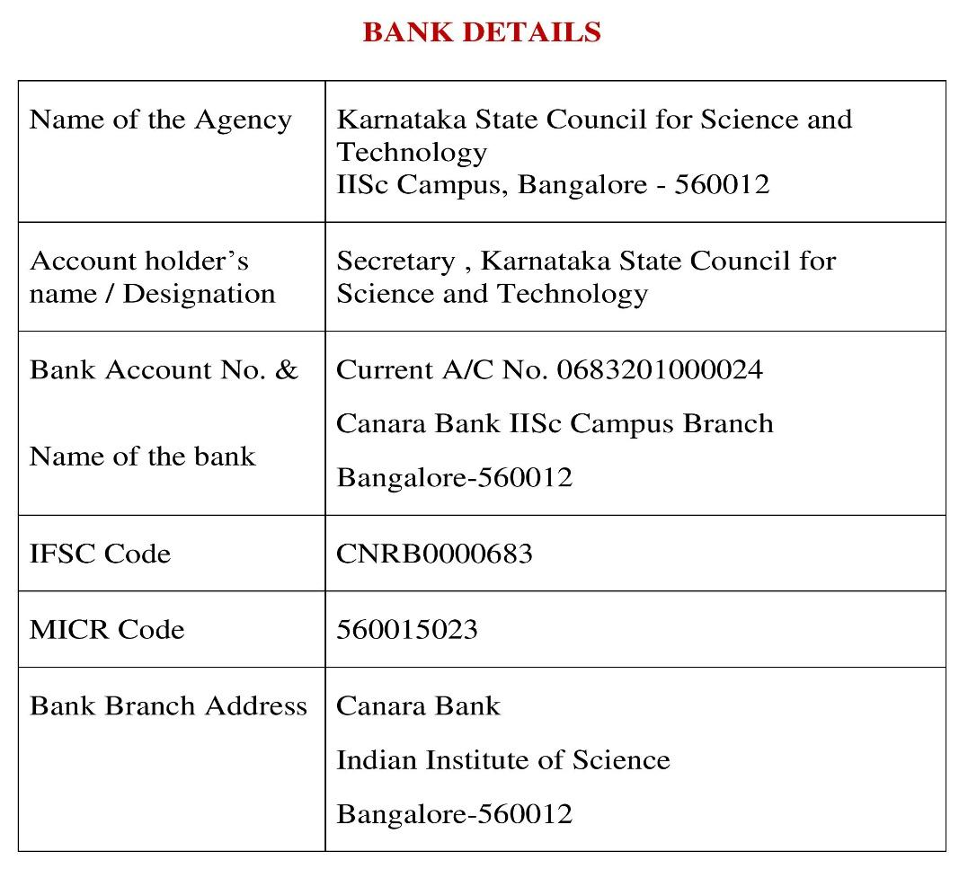
Note: For finance related queries, please contact KSCST accounts section: 080 – 23341652, 23348849 during office hours between 3.00 pm to 5 pm, email: finance@kscst.org.in with a copy to spp@kscst.org.in

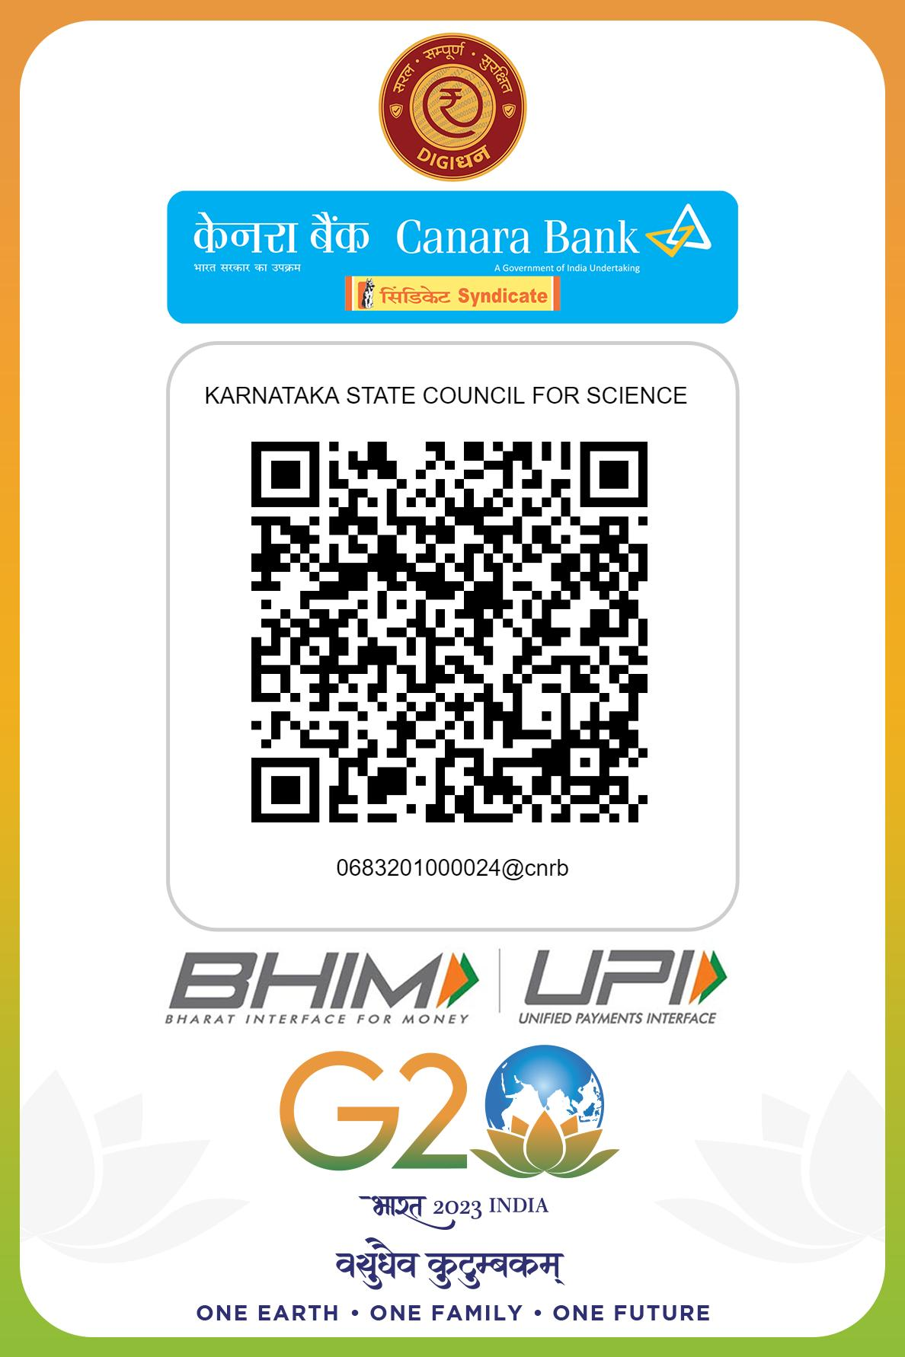
Note: For finance related queries, please contact KSCST accounts section: 080 – 23341652, 23348849 during office hours between 3.00 pm to 5 pm, email: finance@kscst.org.in with a copy to spp@kscst.org.in

