
KARNATAKA STATE COUNCIL FOR SCIENCE AND TECHNOLOGY
Indian Institute of Science campus, Bengaluru – 560 012
Telephone: 080 – 23341652, 23348849 || Email: spp@kscst.org.in
Website: www.kscst.org.in/spp.html or https://kscst.karnataka.gov.in/en
FORMAT FOR STUDENT PROJECT PROPOSAL FOR THE
50th SERIES OF STUDENT PROJECT PROGRAMME 2026 – 2027
(Celebrating the Golden Jubilee of KSCST’s flagship Student Project Programme)

CALL FOR PROJECT PROPOSALS FROM FINAL-YEAR STUDENTS
B.E. | B.Arch. | M.Tech. | M.Sc. | M.Tech. / M.Sc. (Agriculture) | MBA | MCA
NOTE:
- Project Proposal: Please download this MS Word Project Proposal format and fill in all the required details in the downloaded MS Word file itself. Insert relevant images or diagrams of your project wherever necessary. Obtain the required signatures and seals from the Project Guide, Head of the Department (HOD), SPP Coordinator (where applicable), and Principal/Head of the Institution in the relevant sections, and then convert the completed proposal into PDF format.
- Documents to be Uploaded: Please keep the following 3 separate scanned PDF files ready: (1) Project Proposal, (2) Declaration and Endorsement, and (3) details of the processing fee payment made through NEFT/UPI. Upload all three documents while filling out and submitting the Google Form.
- Verification of Details: Please ensure that all details provided in the Google Form are exactly the same as those mentioned in the Project Proposal. Carefully verify all information and uploaded documents before submitting the application.
Online Submission Period: 21 September 2026 to 30 November 2026 (5:00 PM).
https://forms.gle/VPPewZnbUhw1V8KdA
Instructions for Filling the Project Proposal
- Handwritten project proposals will not be accepted.
- Fill in all the required details in this MS Word proposal format. Insert photographs, figures, diagrams, flowcharts, tables, or illustrations wherever appropriate to explain the proposed work.
- After completing the proposal, convert the document into a single PDF file.
- Obtain the signatures and seals of the Project Guide, Head of the Department, SPP Coordinator (where applicable), and the Principal/Head of the Institution in the relevant sections before converting the proposal into PDF.
- Keep the following PDF documents ready before submitting the proposal through the Google Form:
  - Project Proposal (PDF) duly signed and approved.
  - Declaration signed by all student team members, the Project Guide, and the SPP Coordinator.
  - Endorsement issued on the Institution/Department Letterhead and duly signed by the Project Guide, SPP Coordinator, Head of the Department, and the Principal/Head of the Institution.
  - Processing Fee Payment Receipt (UPI/NEFT) of ₹1,180/- (₹1,000/- + 18% GST).
- The processing fee must be paid before submitting the project proposal. Ensure that the Transaction/UTR/Reference Number and other payment details entered in the proposal exactly match the uploaded payment receipt. Incorrect, incomplete, invalid, or unverifiable payment details, or non-payment of the processing fee, will render the project proposal liable for rejection.
- Submit the proposal only through the prescribed Google Form along with all the mandatory attachments. Hard copies of the project proposal should not be sent to KSCST.
- Before converting the proposal into PDF, delete all instructional notes, examples, suggestions, highlighted text, and any irrelevant content from this template. Ensure that the final proposal is complete, neatly formatted, and ready for evaluation.
- The Team Leader shall submit the completed project proposal only through the prescribed Google Form using the following link:
- Google Form: https://forms.gle/VPPewZnbUhw1V8KdA
- Ensure that all mandatory documents, including the duly signed project proposal, Declaration, Endorsement, and Processing Fee Payment Receipt, are uploaded before final submission. Incomplete applications or proposals submitted without the required documents will not be considered.
- KSCST shall not be responsible for delays or failure in submission due to internet connectivity issues, network failures, server problems, insufficient bandwidth, power interruptions, browser-related issues, or any other technical problems at the applicant's end.
- Applicants are strongly advised not to wait until the last date and time for submission. Complete the payment of the processing fee, prepare all required documents, and submit the proposal well in advance to avoid last-minute technical difficulties.
- No requests for extension of the submission deadline or consideration of delayed submissions due to technical or network-related issues will be entertained.
- The Google Form will be automatically disabled after the prescribed closing date and time, and no further submissions will be accepted thereafter.
* ~ * ~ *

PART–A: GENERAL INFORMATION
(Please fill in all details in UPPERCASE LETTERS, except for the Email ID.)
Project Title: GeoGuard: A Secure Geo-Tagged Image Authentication System Using Cryptographic Hashing and Digital Signatures

Keywords (5–8):
CONTENT PROVENANCE; IMAGE TAMPER DETECTION; PERCEPTUAL HASHING (dHASH); ECDSA DIGITAL SIGNATURES; GEOTAGGING; END-TO-END ENCRYPTION; MOBILE SECURITY; DIGITAL FORENSICS
Broad Theme:
Select one of the 19 broad themes for Student Projects (SPP 50th Series).
Please select the one broad theme that most closely matches your proposed project. The 19 broad themes represent high-priority focus areas for Karnataka and are intended to encourage innovative, practical, and impactful student projects.
For detailed information about the 19 broad themes and their respective sub-themes, please visit the link provided below:
https://drive.google.com/drive/folders/1BmZ3ksrRA0GZ0SsBAnMR83tQL3VsMkkG?usp=drive_link
or www.kscst.org.in/spp.html
Note: Please select only one broad theme that is most relevant to your proposed project.
- Theme No.: 4
- Theme Name: ARTIFICIAL INTELLIGENCE, DATA SCIENCE AND DIGITAL TECHNOLOGIES
3. Sub-theme / Focus Area: CYBER SECURITY, INFORMATION SECURITY AND DIGITAL FORENSICS
Institution Details:
- Name of Institution: S.G. Balekundri Institute of Technology.
- Course Name: Computer Science and Engineering.
- Department Name: Computer Science and Engineering.
- Affiliated University: Visvesvaraya Technological University
5. District of Your Institution: Belagavi
6. Complete Postal Address of the Institution with Pin code: S.G. BALEKUNDRI INSTITUTE OF TECHNOLOGY, SHIVABASAVANAGAR, BELAGAVI, KARNATAKA – 590010.
Project Guide Details:
- Project Guide Name: Dr. Shaheen Mujawar
- Project Guide Designation: Doctorate(Phd).
- Project Guide Department: Computer Science and Engineering.
- Project Guide Email id: shaheenm@sgbit.edu.in
- Project Guide Mobile Number: +91 97427 71004
Project Co-Guide (if applicable): NOT APPLICABLE
- Project Co-Guide Name: Prof. / Dr. / Mr. / Ms. / Mrs.
- Project Co-Guide Designation:
- Project Co-Guide Department:
- Project Co-Guide Email id:
- Project Co-Guide Mobile Number:
Student Team Details:

Sl. No. | Insert Passport-size Photograph | Name of the Student  (BLOCK LETTERS) | USN / Registration No. | Degree & Branch & Semester | Category as per College Records (SC/ST/  OBC/  General) | Mobile No. | Email Id
1. |  | Mr. Hemant Mandi | 2BU23CS053 | Degree: B.E  Branch: CSE  Semester:7th | Category 2A | +9188678 85078 | mandihemant04@gmail.com
2. |  | Mr.Suyog Hanamar | 2BU23CS156 | Degree: B.E  Branch: CSE  Semester:7th | OBC  Category1 | +919986821707 | hanamarsuyog@gmail.com
3. |  | Ms. Almas Pathan | 2BU23CS014 | Degree: B.E  Branch: CSE  Semester:7th | Category  2B | +9199452 69809 | Almaspathan2006@gmail.com
4. |  | Mr.Shubham Hiremath | 2BU23CS140 | Degree: B.E  Branch: CSE  Semester:7th | General | +91 94483 39846 | shubhamhiremath87@gmail.com

Note:
- The Name of each student and all other information furnished above shall be as per the official records of the College / Institution.
- The Category (SC / ST / OBC / GEN) shall be furnished strictly as per the College/Institution records. This information is collected only to ascertain the number of students from different categories who have submitted and/or been selected for projects. It shall not constitute or imply any reservation/quota in the selection or sanction of projects.
- A recent passport-size colour photograph, preferably taken within the last six months, shall be pasted/uploaded in the space provided for each student.
- Photographs shall be clear, front-facing and of good quality, with the student's face clearly visible.
- All student names shall be entered in CAPITAL LETTERS, exactly as they should appear on the certificates. The names shall be carefully checked for spelling and other errors. The same information will be used for preparation of certificates. KSCST shall not be responsible for errors in certificates arising from incorrect or misspelled names furnished in the proposal.
- The Team Leader shall be clearly indicated by adding “(TEAM LEADER)” against the respective student's name.
- A maximum of four students may be included in a project team.
- The details furnished in this section will be used by KSCST for student identification, project evaluation, official correspondence, and participation in the Annual State-Level Poster Presentation and Exhibition.
SPP Coordinator Details:
- SPP Coordinator Name: Prof. / Dr. / Mr. / Ms. / Mrs.
- SPP Coordinator Designation:
- SPP Coordinator Email:
- SPP Coordinator Mobile Number:

PART - B: PROJECT DESCRIPTION
Background and Need of the Project: (Maximum 300 words)
Describe
- Background
- Existing scenario
- Problem statement
- Need for the project
- Beneficiaries
Geotagged photographs are now routinely accepted as proof of where and when something happened: crop-loss claims, geotagging of rural assets, progress photos of public works, insurance surveys, proof of delivery and field inspection reports. However, the location and time stored in a photo's EXIF metadata can be rewritten in seconds with free tools, and image editors and generative-AI inpainting can add, remove or alter objects while the photo still looks completely natural [3], [4]. Popular "GPS map camera" apps only paint text onto the picture, which can itself be edited, while passive forensic detectors give probabilistic verdicts that weaken as generators change and are hard to explain to a non-expert.
Industry provenance standards such as C2PA Content Credentials are available only on a few flagship phones [1], a recent formal analysis reports gaps in their security [2], and the embedded proof is destroyed when photos are forwarded through messaging apps such as WhatsApp, which re-compress every image.
There is therefore a clear need for a low-cost, open, smartphone-based system that (i) records location and time truthfully at the moment of capture, (ii) makes any later change to the metadata or the picture mathematically provable and shows where it occurred, (iii) can be verified by anyone, offline, on an ordinary phone, and (iv) keeps the proof intact when the photo is shared. With the Bharatiya Sakshya Adhiniyam, 2023 now governing electronic evidence in India [18], such verifiable photographs are directly useful in legal and administrative work.
Beneficiaries: government field departments (agriculture, rural development, public works, revenue), farmers and insurance assessors, police and digital-forensic investigators, journalists and NGOs, MSMEs and logistics firms that need proof of delivery or inspection, and citizens submitting geo-tagged civic complaints.
Review of Existing Work:
Brief review of
- Existing technologies
- Commercial products
- Research papers
- Patents
- Existing solutions
Mention shortcomings and research gaps.
Existing technologies and commercial products
• GPS / timestamp camera apps: overlay location text on the image only; there is no cryptographic binding, so both the text and the scene can be edited without detection.
• C2PA Content Credentials (e.g., Google Pixel 10): signed manifests created in secure hardware [1]; limited to flagship devices, the manifest is stripped by chat apps, and a formal analysis of C2PA v2.2 found that several claimed security goals are not met [2]. It reports that a file changed, not where.
• Invisible watermarking (e.g., SynthID-Image): marks content at internet scale [6], but in the NeurIPS 2024 "Erasing the Invisible" competition the top teams removed watermarks from at least 89% of images [7].
Research papers
• Passive forensics: surveys of splicing, copy-move and AI-generated image detection [3], [4] and inpainting benchmarks such as COCO-Inpaint (238,302 images) [5] give probabilistic answers that need no capture-time cooperation but degrade with new generators.
• Perceptual hashing: robust hashes can be evaded by inpainting [8]; certified training improves robustness [9].
• Blockchain registries: Chain-Visage [10] and perceptual-hash registries [11] need an online ledger and a server for every verification.
• Platform security: 56% of Android apps that process sensitive data do not use trusted hardware [12]; smartphone GNSS can be spoofed, and raw-measurement consistency checks help [13].
Patents
• A detailed prior-art search on Google Patents and the Indian Patent Office (InPASS) database will be carried out in Month 1 to confirm novelty before any filing.
Comparison of existing solutions
Approach | Offline verify | Locates edit | Survives chat apps | Needs server
GPS overlay camera apps | No proof | No | Text only | No
C2PA in camera [1], [2] | Yes | No | No | No
Passive detectors [4], [5] | Yes | Probabilistic | Partly | No
Invisible watermark [6], [7] | Vendor tool | No | Partly | Vendor
Blockchain registry [10], [11] | No | Varies | Yes | Yes
GeoGuard (proposed) | Yes | Per tile | Via sealed send | Only to send

Shortcomings and research gaps
• No low-cost, open solution binds location, time AND pixel content at capture on ordinary Android phones.
• Existing schemes say only "modified"; they do not localise the edited region in a way a layperson can understand.
• Proof is lost when photos are shared through common messaging apps.
• Integrity ("is it unchanged?") is often confused with attribution ("who took it?").
• Mock-location (fake GPS) apps are not refused at capture time.
Problem Statement:
(Clearly define the problem proposed to be addressed.)

Geotagged photographs used as evidence cannot be trusted today: EXIF location and time can be rewritten, scene content can be edited or AI-inpainted without visible traces, overlay-stamp apps provide no proof, and the proof carried by existing provenance schemes is lost when photos are shared. The problem addressed is to design, develop and evaluate a low-cost Android-based system that (a) captures a photo only with a fresh, non-spoofed GPS fix, (b) cryptographically binds location, time and pixel content at the instant of capture, (c) lets anyone verify the photo offline and identifies which part was altered, (d) reports separately whether the photo is unchanged and who took it, and (e) delivers photos end-to-end so that the proof survives sharing, without having to trust any server.
Objectives:
List the measurable objectives.
Example
- To design…
- To develop…
- To fabricate…
- To evaluate…
- To validate…
O1. To design a tamper-evident capture pipeline that refuses capture without a GPS fix younger than 30 s or with a mock-location provider, burns a visible location/time stamp into the pixels, and signs a compact envelope (latitude, longitude, altitude, time, device hash, 1 stamp dHash + 16 scene-tile dHashes, public key) with ECDSA P-256.
O2. To develop an offline four-stage verifier (envelope, signature, stamp, 16 tiles) that names what failed and which tile was edited, targeting zero false alarms on untouched photos and detection of all edits covering 1/16 of the scene or more.
O3. To develop honest signer attribution with trust-on-first-use key pinning and four trust levels, so that a re-signed forgery is never shown as a known sender.
O4. To develop sealed end-to-end photo transfer (AES-256-GCM with ECDH + HKDF key wrapping) so that the received file is bit-identical to the signed file and the relay server stores only ciphertext.
O5. To develop the companion backend (Node.js, MongoDB): Google sign-in, username directory, sealed relay, server-verified payments, update channel and a PDF evidence report.
O6. To evaluate the system on a field dataset of at least 500 phone-captured photographs from Belagavi district under benign (re-compression, resizing, chat-app pipelines) and adversarial (clone, splice, AI inpainting, metadata edit, re-signing) transformations, and to reduce the benign false-alarm rate below that of the current prototype (11/56, 19.6%).
O7. To strengthen key protection using hardware-backed Android Keystore / StrongBox with key attestation where available, and to add GNSS consistency checks against location spoofing.
O8. To validate the system with end users (field staff, farmers, investigators) and document the results in the project report and a research publication.

Innovation / Novelty:
Explain
- What is new?
- How is it different from existing work?
- Why is it innovative?
What is new?
• Pixels + place + time signed together at capture: the visible stamp, 16 scene-tile fingerprints and GPS data are signed with ECDSA P-256, and the public key is itself inside the signed string, so anyone can verify offline with no server, account or blockchain.
• Edit localisation: a 4×4 grid of independent 64-bit difference hashes (dHash) plus one for the stamp shows exactly which region was edited (Fig. A), unlike a whole-file hash or C2PA, which report only "modified".
• Integrity separated from attribution: a forger who edits and re-signs with their own key gets a mathematically valid signature, but the app labels it "taken on another GeoGuard phone", never as the trusted sender.
• Encryption that preserves proof: sealed end-to-end transfer keeps the bytes identical, so the proof survives sharing, while the server sees only ciphertext.
• Truthful capture: stale (> 30 s) or mock-provider GPS fixes are refused outright instead of being recorded with a warning.
• Robust embedding: the 689-byte envelope is stored three times (EXIF, JPEG COM segment, end-of-file block).
How is it different and why is it innovative?
GeoGuard needs no special hardware, runs on low-cost Android phones, gives a binary and explainable verdict ("Photo edited – tile row 2, column 3") instead of a probability, and keeps working when the photo is shared. Measuring the real implementation also revealed and fixed a hashing-order defect (pixels were hashed before JPEG encoding), after which untouched photos score exactly zero distance on all 17 fingerprints.
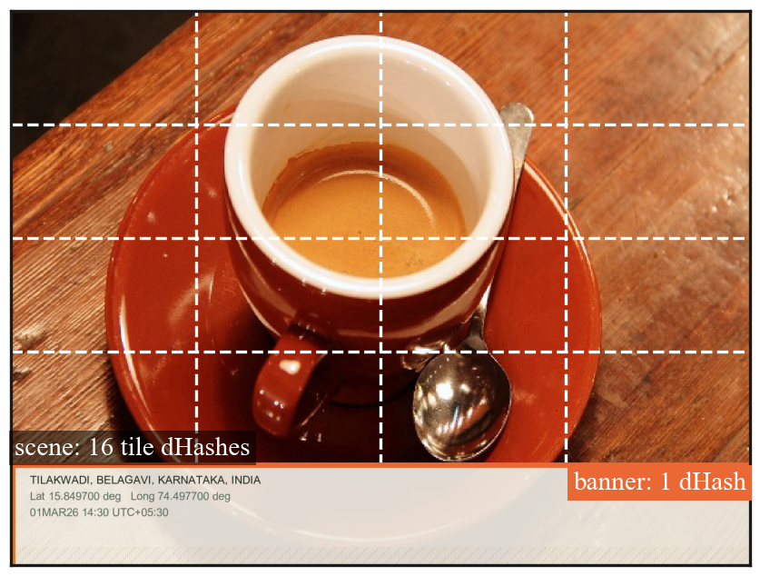
Fig. A. A frame produced by the GeoGuard capture code: the banner (stamp) is hashed once and the scene above it is hashed as 16 independent tiles.
Proposed Methodology:
Provide
- Overall methodology
- Block Diagram / Flow Chart
- System Architecture
- Design approach
- Experimental plan
- Software/Hardware to be used
Overall methodology
The project builds on a working prototype (GeoGuard v1.0.2: a Flutter Android app and a Node.js service, about 12,400 lines of code with 53 app and 15 server automated tests). The work follows an iterative design–build–measure cycle: literature and patent survey, threat model, design of the capture, verification and transfer protocols, implementation, laboratory evaluation on standard images, field data collection, extensions (hardware-backed keys, GNSS checks, multi-scale hashing), user validation and documentation.
System architecture
All cryptography that touches photos runs on the phone (Fig. B). The server never sees a plaintext photo; it verifies Google ID tokens, hosts the username directory, relays sealed photos through MongoDB GridFS, verifies Razorpay payments, and publishes app updates.
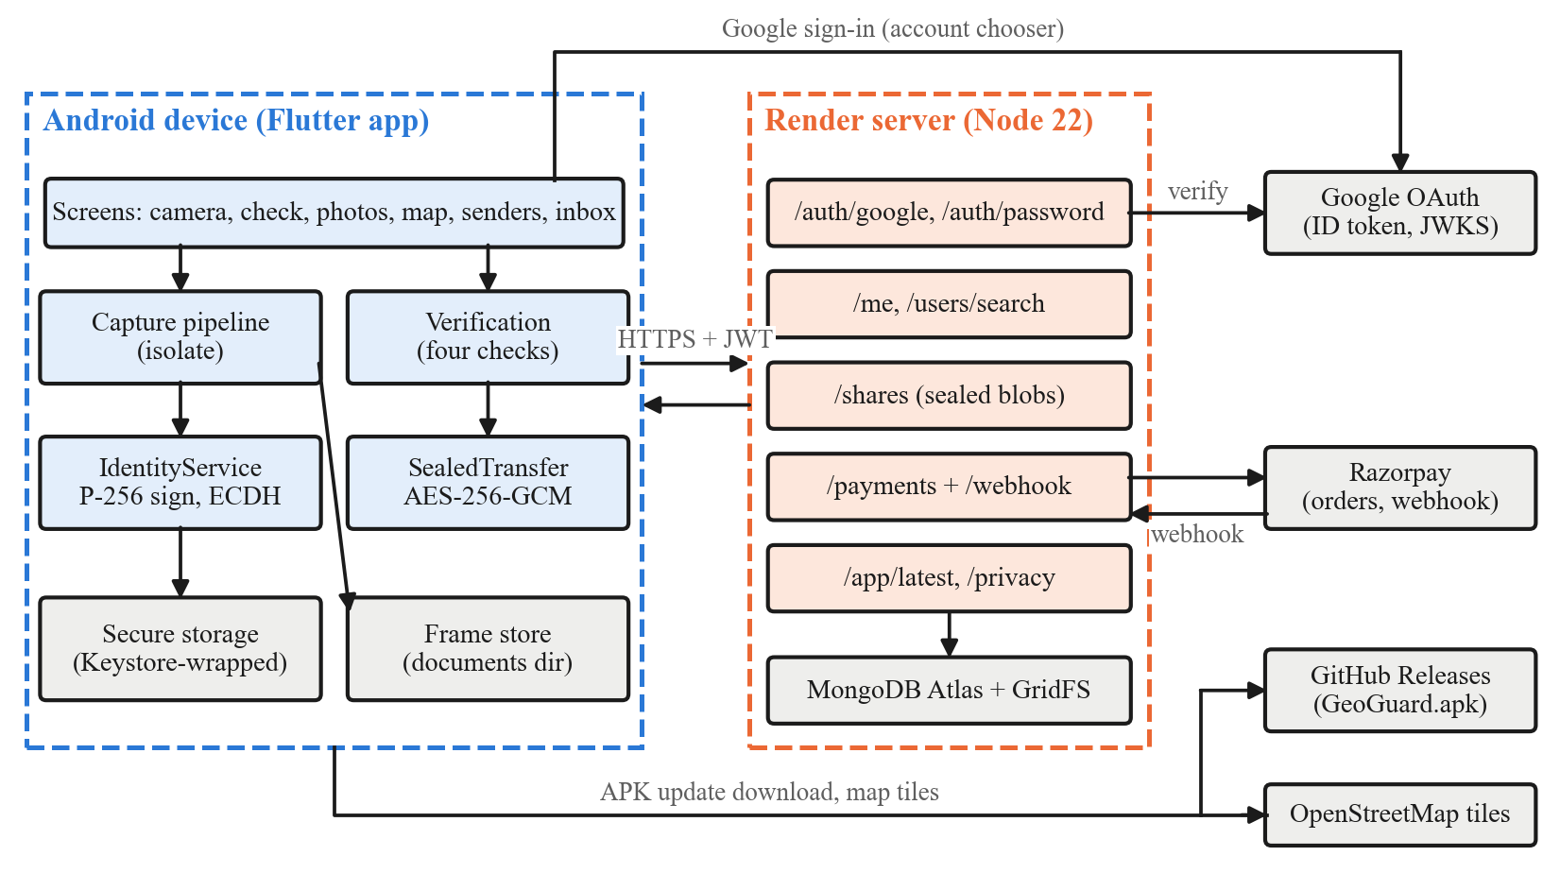
Fig. B. System architecture: the app performs all photo cryptography on the device; the server handles accounts, the directory, sealed relay and payments.
Design approach
1. Capture and signing (Fig. C): shutter enabled only with a fresh, non-mocked GPS fix; the stamp (place, latitude/longitude, local time) is burnt into the bottom 18% of the frame; a dHash is computed for the stamp and for each of 16 scene tiles (bit = 1 if Y(x,y) > Y(x+1,y) on a 9×8 resize); the envelope is signed with ECDSA P-256/SHA-256 (deterministic nonces, RFC 6979 [15]) and embedded in EXIF, a JPEG COM segment and an end-of-file block. Work runs in a background isolate.
2. Verification (Fig. D): find envelope → verify signature with the embedded public key → compare stamp Hamming distance (≤ 10/64) → compare every tile (≤ 10/64); the first failing stage is reported in plain language.
3. Attribution: "taken on this phone", "taken by <saved sender>", "taken on another GeoGuard phone" or "not real", using a pinned 16-character key fingerprint.
4. Sealed transfer (Fig. E): fresh 32-byte file key, AES-256-GCM [16]; key wrapped with HKDF [17] over ECDH with the recipient's key; SHA-256 of the ciphertext checked before decryption.
5. Backend: Google sign-in verified on the server, permanent usernames, server-side price table and constant-time Razorpay signature check, 90-day activity log storing verdicts only.
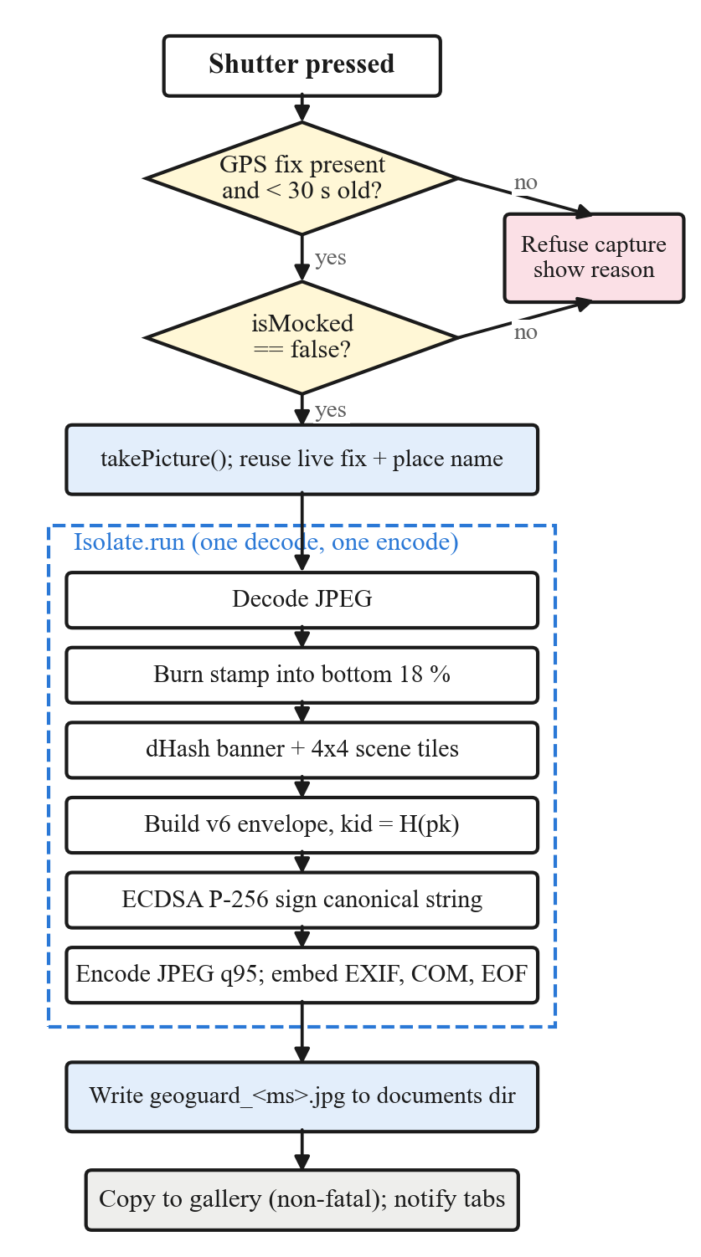 | 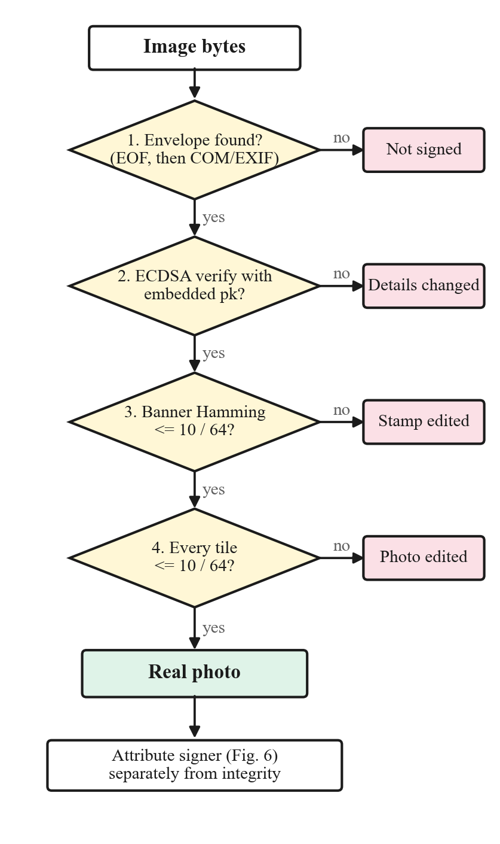
Fig. C. Capture pipeline. | Fig. D. Four-stage verification.

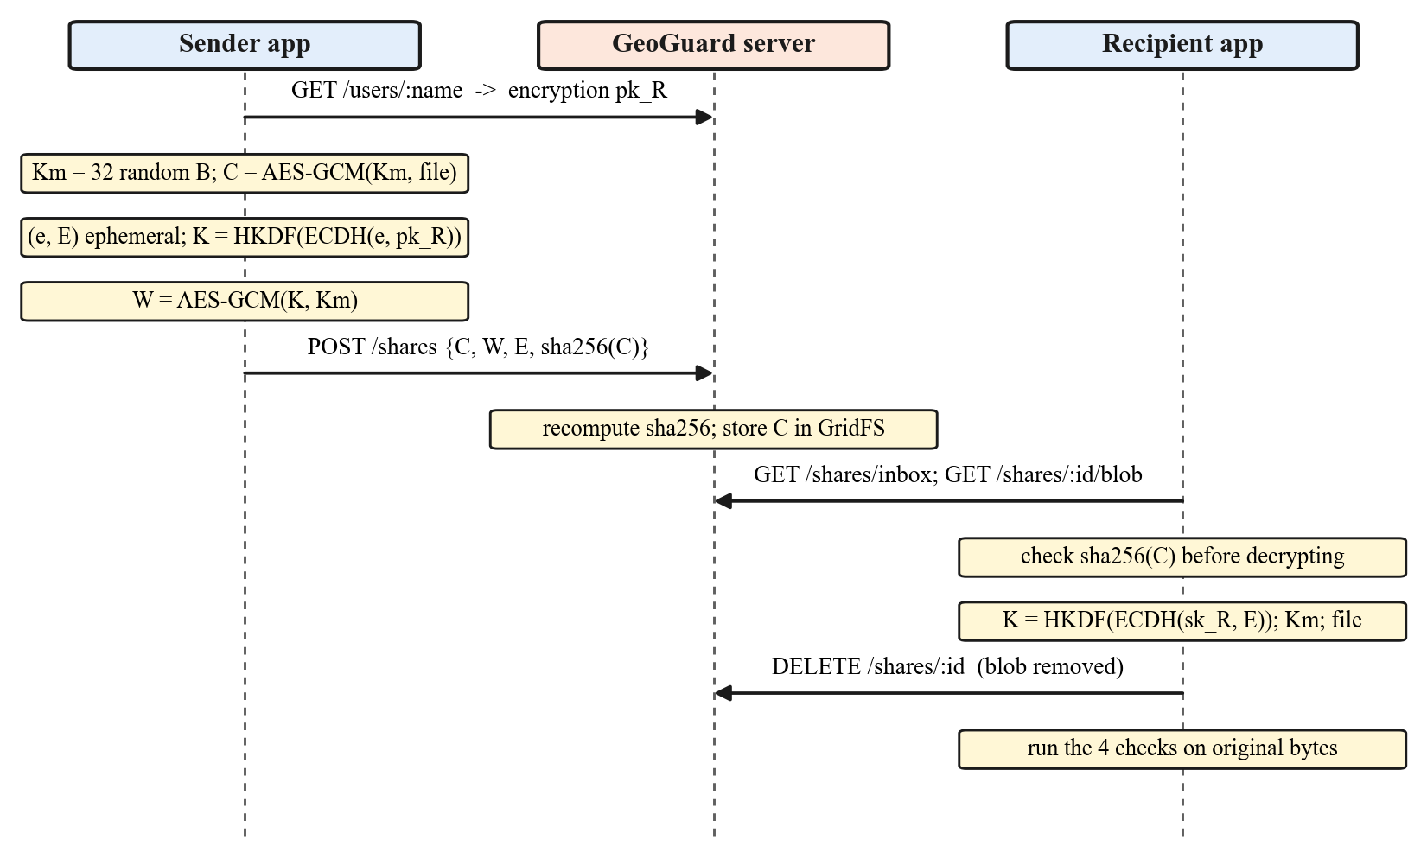
Fig. E. Sealed end-to-end transfer: the server stores only ciphertext and routing metadata.
Experimental plan
• Dataset: ≥ 500 photos captured with GeoGuard on at least two Android phones across urban, rural, farmland, indoor and low-light scenes in Belagavi district, plus standard test images.
• Benign transformations: JPEG quality 90/75/60/40, 50% resize, brightness change, blur, and real WhatsApp/Telegram "send as document" and "send as photo" pipelines.
• Attacks: cloning of 1/16, 1/64 and 1/256 of the scene, splicing, AI inpainting, stamp-text overwrite, latitude/time edit, re-signing with an attacker key, fake-GPS apps.
• Metrics: false-alarm rate, detection rate versus edit area, tile localisation accuracy, attribution accuracy, capture/verification latency on phones, and sealed-transfer overhead.
Software / Hardware to be used
• Software: Flutter 3.41 / Dart (pointycastle, image packages), Android Studio, Node.js 22 + Express, MongoDB Atlas, Render cloud hosting, Python (NumPy, scikit-image, Matplotlib) for evaluation, Git/GitHub.
• Hardware: Android smartphones with GNSS and camera (including one with StrongBox / hardware-backed keystore), laptops for development.

Expected Deliverables:
Examples
- Prototype
- Software
- Mobile App
- Web Portal
- Device
- Design
- GIS Database
- Decision Support Tool
- Business Model
- Standard Operating Procedure
• Mobile App: GeoGuard Android application (signed APK) with camera, verifier, photos/map view, saved senders and inbox.
• Software / Web service: Node.js backend deployed on the cloud with Google sign-in, username directory, sealed relay, payment verification and update channel.
• Evidence report: PDF verification report generated in the app, laid out after Section 63(4) of the Bharatiya Sakshya Adhiniyam, 2023 [18].
• Dataset and benchmark: field dataset of geo-tagged photographs with a tamper benchmark and evaluation scripts.
• Source code: complete source code with automated test suites (GitHub).
• Standard Operating Procedure: user manual / SOP for field staff on capturing, sharing and verifying photos.
• Documentation: final project report and a research paper in IEEE format.
Screenshots of the working GeoGuard app (prototype v1.0.2)
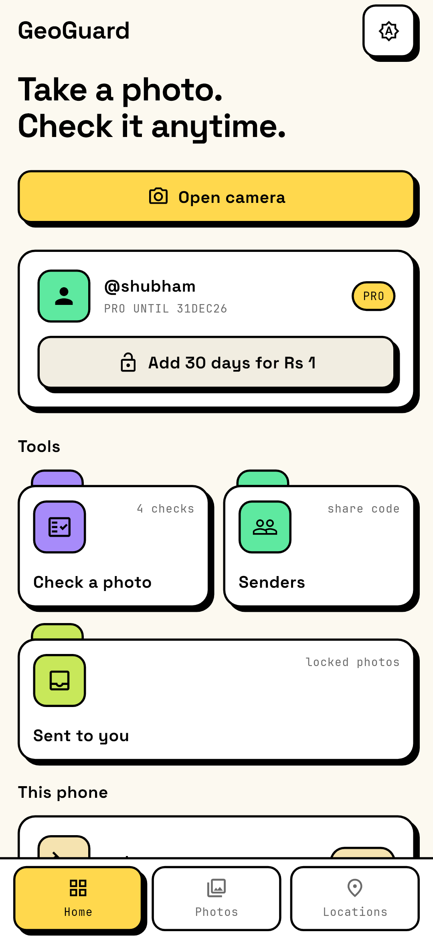 | 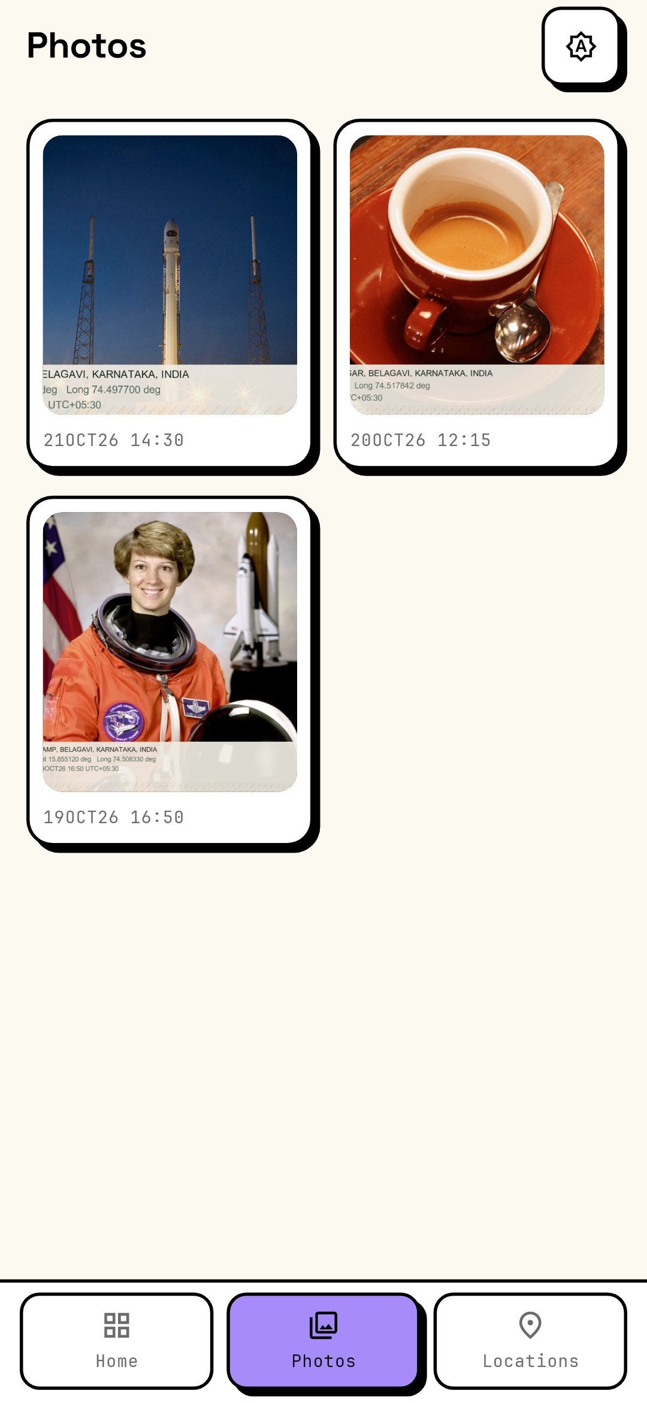 | 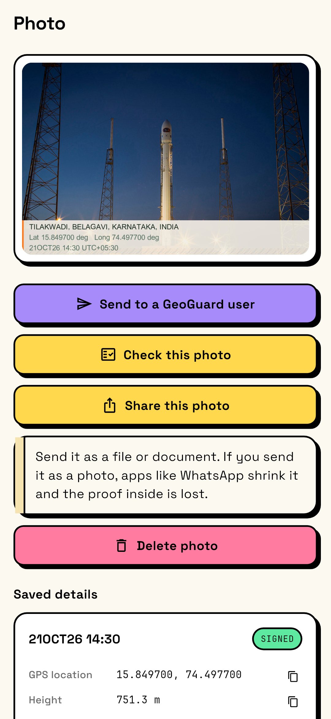
Fig. F. Home screen: camera, check a photo, senders, inbox. | Fig. G. Photos tab: only frames signed by GeoGuard are listed. | Fig. H. A signed photo with send, check, share and saved GPS details.

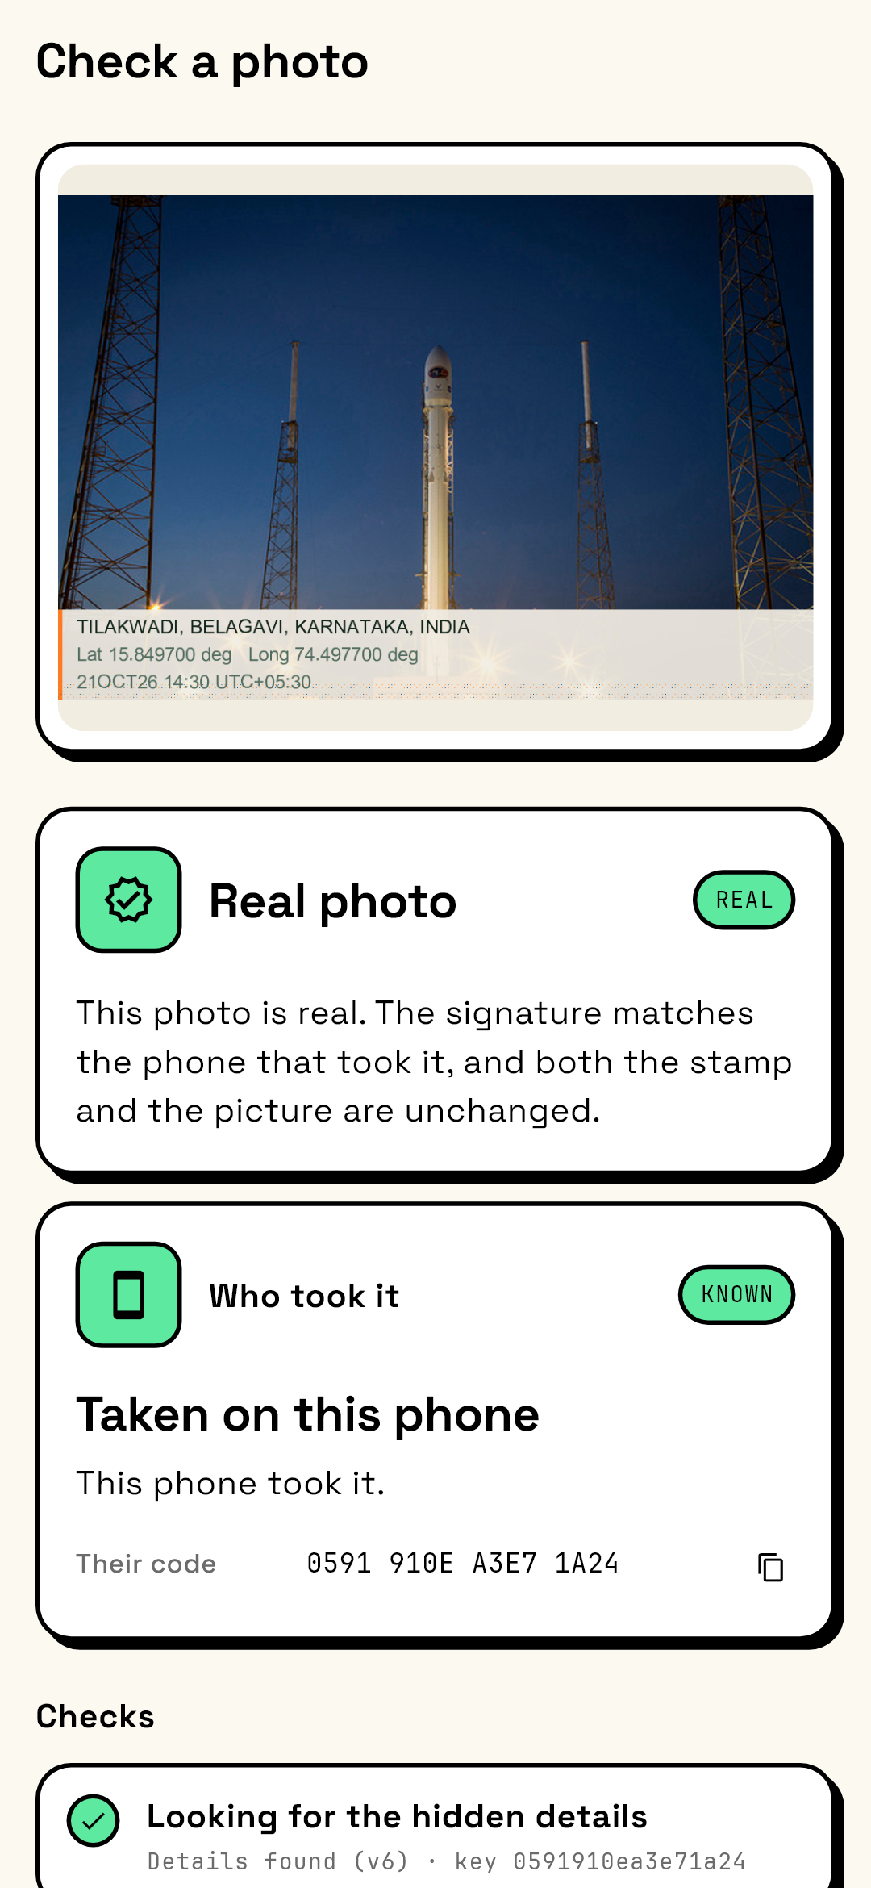 | 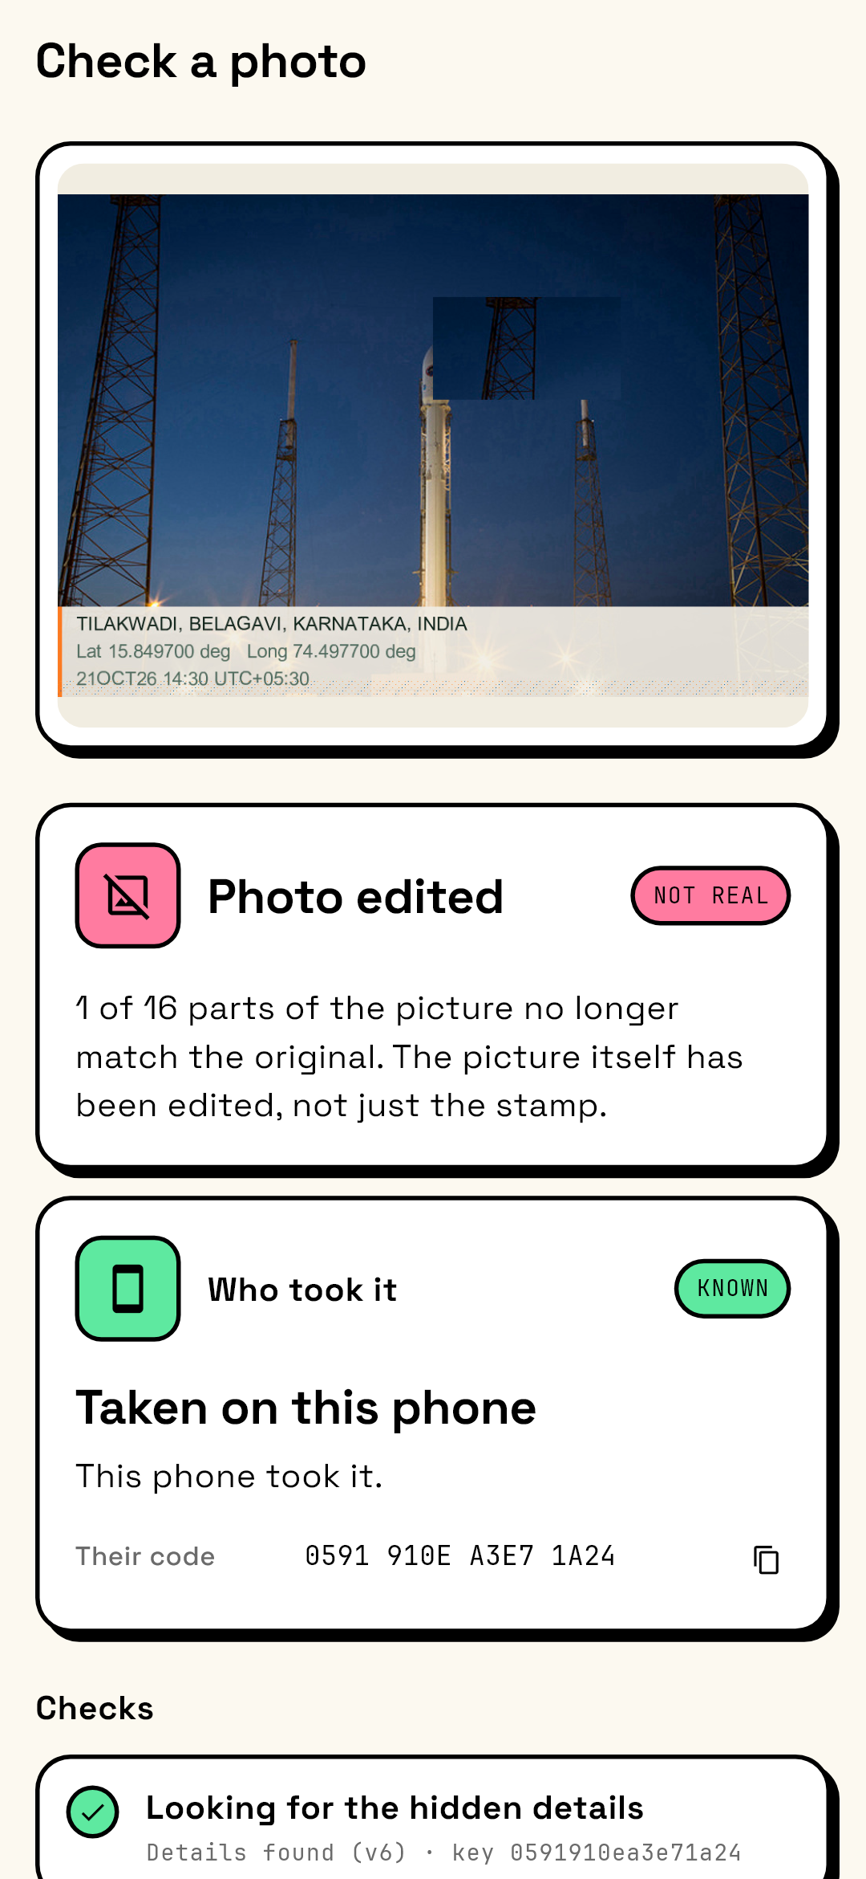
Fig. I. Untouched photo: "Real photo", taken on this phone. | Fig. J. One tile cloned: "Photo edited – 1 of 16 parts no longer match".

Expected Outcomes and Impact:
Technical
Social
Environmental
Economic
Industrial
Academic
Potential users
• Technical: a verifiable capture system whose prototype already shows untouched photos at exactly zero distance, detection of every 1/16-tile clone and splice and every latitude edit (7/7 each), correct attribution of all re-signed forgeries (7/7), ECDSA signing in 11.7 ms and verification in 17.0 ms, a 689-byte envelope, and only 28 bytes of sealing overhead.
• Social: trustworthy photographic evidence for citizens, farmers and field staff; fewer disputes over fake or edited photos; supports journalism and civic accountability.
• Environmental: fewer repeat field visits for re-inspection, saving travel and fuel; remote verification of geotagged site photos.
• Economic: reduces fraud in insurance claims, subsidy and work-progress payments; runs on existing low-cost phones with free capture and sharing.
• Industrial: proof of delivery, site inspection and asset audits for logistics, construction, insurance and MSMEs; potential for a startup offering verification services.
• Academic: an open, measurable reference implementation of capture-time provenance; research paper and dataset for further work in digital forensics.
• Potential users: agriculture and rural development departments, insurance companies, police and forensic labs, municipal corporations, courts, NGOs, journalists and delivery firms.

Relevance:
Tick wherever applicable
☑ SDGs (Sustainable Development Goals) – SDG 9 (Industry, Innovation and Infrastructure), SDG 16 (Peace, Justice and Strong Institutions)
☑ Karnataka Priority Sector
☑ Rural Development
☑ MSME
☑ Agriculture
□ Healthcare
□ Water
□ Environment
□ Climate
□ Manufacturing
☑ Smart Cities
☑ Digital India
☑ Startup
□ Women Empowerment
☑ Others (Please Specify): Cyber Security and Digital Forensics; Legal/Electronic Evidence (Bharatiya Sakshya Adhiniyam, 2023); Insurance and e-Governance
Work Plan (Please specify the month and tick ✓)
Activity | Month 1 (Jan 2027) | Month 2 (Feb 2027) | Month 3 (Mar 2027) | Month 4 (Apr 2027) | Month 5 (May 2027)
Literature Survey | ✓
Design | ✓ | ✓
Development |  | ✓ | ✓ | ✓
Testing |  |  | ✓ | ✓
Validation |  |  |  | ✓ | ✓
Final Report |  |  |  |  | ✓

Facilities Available:
Please mention the details of the available facilities under each category. If any facility is not available in your institution, please enter “NONE”.

1. Laboratory | Department of Computer Science and Engineering computer laboratories with internet / Wi-Fi.
2. Equipment | Desktop computers and laptops for development; team members' Android smartphones for testing.
3. Software | Flutter SDK, Android Studio, VS Code, Node.js, Python, Git (open-source / free); MongoDB Atlas and Render free tiers.
4. Instruments | NONE
5. Workshop | NONE
6. Institutional facilities | Central library, internet facility and seminar halls for reviews and demonstrations.

Major Requirements for the Project:
List only the essential requirements. (Remove whichever is not relevant to the project)
Examples:
Hardware
- Sensors
- Microcontroller
- Motors
- Pumps
- Camera
- Batteries
- Solar Panel
Software
- MATLAB
- Python
- ANSYS
- SolidWorks
- ArcGIS
- QGIS
- TensorFlow
Consumables
- Chemicals
- Fabrication materials
- Electronic components
- Biological samples
Field Studies
- Travel
- Sample collection
- Surveys
Requirements for this project
• Hardware: Android smartphones with GNSS and camera (one additional test device with StrongBox / hardware-backed keystore); development laptops (available).
• Camera: smartphone cameras (no separate camera required).
• Software: Flutter/Dart, Android Studio, Node.js 22, MongoDB Atlas, Render cloud hosting, Python (NumPy, scikit-image, Matplotlib), Git/GitHub.
• Consumables: None.
• Field Studies: local travel within Belagavi district to capture field photographs (urban, rural, farmland, indoor/low-light) and to conduct user trials.

Budget Estimate (Remove whichever is not relevant for the project):
Item | Estimated Cost (₹)
Equipment / Components | ₹ 5,500/-
Consumables | ₹ 0/-
Fabrication | ₹ 0/-
Software / Cloud Services | ₹ 3,000/-
Field Survey / Data Collection | ₹ 1,000/-
Testing / Analysis | ₹ 0/-
Miscellaneous | ₹ 500/-
Total | ₹ 10,000/-
The budget specified in the Google Form must align with the amounts indicated in the project proposal. If no cost is associated with a subhead, indicate Rs. 0/-.
Important Note
KSCST provides only a modest financial grant for projects recommended by the Expert Committee. The sanctioned financial assistance shall be in the range and maximum up to ₹10,000 per project (or such amount as may be decided by KSCST from time to time). Students and institutions are encouraged to utilize available laboratory facilities and institutional resources. Any expenditure beyond the sanctioned assistance shall be borne by the institution and/or the project team.
Justification: Equipment – one Android test smartphone with hardware-backed keystore (StrongBox) for hardware-key and GNSS testing; Software / Cloud – paid always-on cloud instance for the backend during field trials (about 5 months); Field survey – local travel for field photograph collection and user trials; Miscellaneous – printing of report and poster.
References:
Use IEEE / APA format.
(References: Cite all books, journal articles, conference papers, standards, reports, patents, and websites using either the IEEE or APA (7th Edition) referencing style consistently throughout the proposal. All in-text citations must correspond to the references listed at the end of the proposal.)
Minimum 5 references.
Preferably include
- Recent journal papers
- Conference papers
- Standards
- Government reports
- Books
- Patents
[1] Google, "How Pixel and Android are bringing a new level of trust to your images with C2PA Content Credentials," Google Security Blog, Sep. 10, 2025. [Online]. Available: https://security.googleblog.com/2025/09/pixel-android-trusted-images-c2pa-content-credentials.html
[2] E. Golaszewski et al., "Verifying provenance of digital media: Security analysis of C2PA and its implementation," IACR Cryptology ePrint Archive, Paper 2026/804, 2026.
[3] A. Mahara and N. Rishe, "Methods and trends in detecting AI-generated images: A comprehensive review," Comput. Sci. Rev., vol. 60, Art. no. 100908, 2026, doi: 10.1016/j.cosrev.2026.100908.
[4] V. Kadha, S. Bakshi, and S. K. Das, "Unravelling digital forgeries: A systematic survey on image manipulation detection and localization," ACM Comput. Surv., vol. 57, no. 12, pp. 1–36, 2025, doi: 10.1145/3731243.
[5] H. Yan, Y. Hong, J. Zhan, et al., "COCO-Inpaint: A benchmark for detecting and localizing inpainting-based image manipulations," arXiv:2504.18361, 2025.
[6] S. Gowal et al., "SynthID-Image: Image watermarking at internet scale," arXiv:2510.09263, 2025.
[7] M. Ding et al., "A technical report on 'Erasing the Invisible': The 2024 NeurIPS competition on stress testing image watermarks," in Adv. Neural Inf. Process. Syst. 38, 2025, pp. 16168–16199.
[8] M. Steinebach and Y. Yannikos, "Robust hashing meets inpainting," in Proc. Int. Conf. Availability, Reliability and Security (ARES), LNCS. Cham, Switzerland: Springer, 2025, pp. 255–270, doi: 10.1007/978-3-032-00635-6_15.
[9] Y. Yang, Q. Liu, C. Brix, H. Zhang, and Y. Cao, "CertPHash: Towards certified perceptual hashing via robust training," in Proc. 34th USENIX Security Symp., Seattle, WA, USA, 2025.
[10] J. Yang et al., "Chain-Visage: Blockchain-assisted visual content ownership and tamper tracing in CIoT multimedia ecosystems," IEEE Trans. Consum. Electron., vol. 72, no. 1, 2026, doi: 10.1109/TCE.2025.3647677.
[11] A. Mohit, B. Aggarwal, and C. Gondhalekar, "Provenance verification of AI-generated images via a perceptual hash registry anchored on blockchain," arXiv:2602.02412, 2026.
[12] J. Blessing, R. J. Anderson, and A. R. Beresford, "KeyDroid: A large-scale analysis of secure key storage in Android apps," Proc. Privacy Enhancing Technol. (PoPETs), 2026, arXiv:2507.07927.
[13] E. Takiguchi Medina and E. S. Lohan, "GNSS spoofing modeling and consistency-check-based spoofing mitigation with Android raw data," Electronics, vol. 14, no. 5, Art. no. 898, 2025, doi: 10.3390/electronics14050898.
[14] National Institute of Standards and Technology, "Digital Signature Standard (DSS)," FIPS PUB 186-5, Feb. 2023, doi: 10.6028/NIST.FIPS.186-5.
[15] T. Pornin, "Deterministic usage of the Digital Signature Algorithm (DSA) and Elliptic Curve Digital Signature Algorithm (ECDSA)," RFC 6979, IETF, Aug. 2013.
[16] M. Dworkin, "Recommendation for block cipher modes of operation: Galois/Counter Mode (GCM) and GMAC," NIST Special Publication 800-38D, Nov. 2007.
[17] H. Krawczyk and P. Eronen, "HMAC-based Extract-and-Expand Key Derivation Function (HKDF)," RFC 5869, IETF, May 2010.
[18] Government of India, "The Bharatiya Sakshya Adhiniyam, 2023 (Act No. 47 of 2023)," Ministry of Law and Justice, Dec. 2023.

Processing Fee Payment Details:
Important Instructions:
- The processing fee of ₹1,180/- (₹1,000/- + 18% GST) shall be paid before filling in and submitting the Google Form.
- The processing fee shall be paid only through UPI or NEFT to the Karnataka State Council for Science and Technology (KSCST) before submission of the project proposal through the Google Form.
- Each project team shall pay a project registration fee of exactly ₹1,180/- (inclusive of 18% GST) per project proposal in a single transaction. Payments made through multiple transactions, including split payments such as ₹1,000/- + ₹180/-, shall not be accepted.
- The Transaction / UTR / Reference Number and other payment details entered in the Google Form must exactly match the details shown on the uploaded payment receipt. A scanned copy of the UPI / NEFT payment receipt shall be uploaded along with the project proposal.
- Project proposals submitted without payment of the prescribed processing fee, or with incorrect, incomplete, invalid, or unverifiable payment/transaction details, shall be liable for rejection without further correspondence.
- The processing fee is non-transferable and non-refundable under any circumstances, including withdrawal of the proposal, duplicate submission, rejection, non-selection for sponsorship, or cancellation of the proposal.
- Submission of a project proposal and payment of the processing fee does not confer any right to sponsorship or selection under the Student Project Programme. All proposals shall be evaluated on merit by the Expert Committee, and the decision of KSCST shall be final.
- Any dispute arising out of the submission of the project proposal, payment of the processing fee, evaluation process, sponsorship, or any matter connected with the Student Project Programme shall be subject to the exclusive jurisdiction of the competent courts at Bengaluru, Karnataka.
Payment Details:
- Mode of Payment: ☐ UPI ☐ NEFT
- Transaction / UTR / Reference Number:
- Date of Payment: ____ / ____ / ____
- Amount Paid: ₹1,180/-
- Name of Account Holder:
- Name of Bank (for NEFT):
- UPI ID Used:
Attachment:
☐ Copy of UPI Payment Receipt / NEFT Transaction Receipt enclosed.
Student Details with Signature:
Sl. No. | Name of Student  (Block Letters) | USN / Registration No. | Signature | Date
1. | HEMANT MANDI | 2BU23CS053
2. | SUYOG HANAMAR | 2BU23CS156
3. | ALMAS PATHAN | 2BU23CS014
4. | SHUBHAM HIREMATH | 2BU23CS140

(Name & Signature of  SPP Coordinator with Seal) | Name and signature of the  Project Guide with Seal:
Email id: | Email id: shaheenm@sgbit.edu.in
Contact No.: | Contact No.: +91 97427 71004
Mandatory Attachments
☐ Project Proposal (PDF) duly signed by the Project Guide, Head of the Department and Principal/Head of the Institution.
☐ Declaration and Endorsement by the Head of the Institution.
☐ Copy of the Processing Fee Payment Receipt (UPI/NEFT).
☐ Any other supporting documents, if applicable.

DECLARATION
(From the Project Team)
(To be signed by all student members, scanned, and uploaded along with the project proposal)

Project Details
Title of the Project: (IN CAPITAL LETTERS) GEOGUARD: A SECURE GEO-TAGGED IMAGE AUTHENTICATION SYSTEM USING CRYPTOGRAPHIC HASHING AND DIGITAL SIGNATURES.
Broad Theme: 4. ARTIFICIAL INTELLIGENCE, DATA SCIENCE AND DIGITAL TECHNOLOGIES
Sub-theme / Focus Area: CYBER SECURITY, INFORMATION SECURITY AND DIGITAL FORENSICS
Department: Computer Science and Engineering.
Institution: S.G. Balekundri Institute Technology.

We, the undersigned members of the above project team, hereby declare that the information furnished in this project proposal is true, complete, and correct to the best of our knowledge and belief.
We further declare that:
- The proposed project is our original work and has not been copied, purchased, or submitted previously to any agency or institution for financial assistance or academic evaluation.
- We shall execute the project under the guidance of our Project Guide using the facilities available at our institution and maintain the highest standards of academic integrity and professional ethics. We shall abide by the financial and project policies of our institution throughout the execution and completion of the project.
- We shall not indulge in plagiarism, fabrication, falsification, manipulation, or misrepresentation of data or results or other project-related information, or inappropriate use of AI tools, including ChatGPT and similar AI-based tools. Any violation shall render the proposal / project liable for rejection or cancellation, and may attract such further action as deemed appropriate by KSCST. We shall promptly inform KSCST, through the Project Guide or the SPP Coordinator, of any changes in the project title, objectives, methodology, or team composition after obtaining the necessary approvals.
- We understand that the processing fee of ₹1,180/- (₹1,000/- + 18% GST) has to be paid before submission of the proposal through the Google Form. We certify that the payment details furnished in the proposal are true and verifiable. We also understand that the processing fee is non-transferable and non-refundable, and that proposals submitted without payment or with incorrect, incomplete, or unverifiable payment details are liable to be rejected.
- We agree to participate in all stages of the Student Project Programme, including the Mid-term Evaluation, submission of the Synopsis and Final Project Report, and the Annual State-Level Poster Presentation and Exhibition, if selected.
- We understand that if the project is sanctioned and the team fails to participate in the Mid-term Evaluation, submit the required reports, or participate in the Annual State-Level Poster Presentation and Exhibition (if selected), KSCST reserves the right to recover the financial assistance released for the project.
- We authorize KSCST to use, publish, reproduce, archive, and disseminate the project title, abstract, photographs, videos, and other non-confidential information relating to the project for academic, educational, promotional, reporting, and publication purposes, with due acknowledgement wherever applicable.
- We understand that submission of the proposal and payment of the processing fee does not guarantee sponsorship. The decision of KSCST and the Expert Committee regarding evaluation and selection of project proposals shall be final and binding.
- We agree that any dispute arising out of the submission of this proposal or participation in the Student Project Programme shall be subject to the exclusive jurisdiction of the competent courts at Bengaluru, Karnataka.
We hereby affirm that we have carefully read and understood all the guidelines, terms, and conditions of the 50th Series Student Project Programme (SPP): 2026–2027, and agree to abide by them.
Note: The use of AI tools, including ChatGPT and similar AI-based tools, shall not be used to generate or substitute the core project work, technical content, experimental results, data, analysis, or conclusions. Any use of AI tools for limited assistance, such as language improvement or formatting, shall be appropriately verified by the students and project guide and the students shall remain fully responsible for the accuracy, originality, and authenticity of the submitted work.
Student Details
Sl. No. | Name of Student | USN / Registration No. | Signature | Date
1. | HEMANT MANDI | 2BU23CS053
2. | SUYOG HANAMAR | 2BU23CS156
3. | ALMAS PATHAN | 2BU23CS014
4. | SHUBHAM HIREMATH | 2BU23CS140

(Name & Signature of  SPP Coordinator with Seal) | Name and signature of the  Project Guide with Seal:
Email id: | Email id: shaheenm@sgbit.edu.in
Contact No.: | Contact No.: +91 97427 71004
ENDORSEMENT
(From the Institution)
(To be issued on the Institution/Department Letterhead, signed, scanned, and uploaded along with the project proposal)
This is to certify that:
- Mr. Hemant Mandi
- Mr. Suyog Hanamar
- Ms. Almas Pathan
- Mr. Shubham Hiremath

are bonafide final-year students of the Department of Computer Science and Engineering, pursuing final year at S.G. Balenkundri Institute of Technology(Name of the Institution).
The institution has scrutinized and approved this project proposal for submission to the Karnataka State Council for Science and Technology (KSCST) under the 50th Series Student Project Programme (SPP): 2026 - 2027.
We hereby certify and undertake that:
- The project proposal has been reviewed by the Department and recommended for submission under the appropriate SPP broad theme.
- The institution shall provide the necessary laboratory facilities, equipment, software, workshop, computing facilities, infrastructure, and academic guidance required for successful completion of the project.
- The Project Guide shall monitor the progress of the project and ensure its timely completion in accordance with the approved objectives and work plan.
- The institution shall facilitate the participation of the student team in the Mid-term Evaluation, submission of the Synopsis and Final Project Report, and the Annual State-Level Poster Presentation and Exhibition, if selected.
- If the project receives financial assistance from KSCST, the institution shall ensure that the grant is utilized exclusively for the approved project and that all financial and technical requirements prescribed by KSCST are duly complied with and will submit the Utilisation Certificate and Statement of Expenditure after the completion of the project.
- If the student team fails to complete the project, submit the required reports, participate in the Mid-term Evaluation, or participate in the Annual State-Level Poster Presentation and Exhibition (if selected), the institution agrees to cooperate with KSCST in recovering the financial assistance released for the project, wherever applicable.
- The institution certifies that the information furnished in this proposal is true and correct to the best of its knowledge.
(Name & Signature of  Project Guide with Seal) | (Name & Signature of  SPP Coordinator with Seal) | (Signature of HoD  with Seal)
Email  id: shaheenm@sgbit.edu.in | Email id: | Email id:
Contact No.: +91 97427 71004 | Contact No.: | Contact No.:

Institutional Certification: The institution certifies that this proposal has been scrutinized by the Department and the Institutional SPP Coordinator, and is recommended as one of the officially approved project proposals of the institution for submission under the KSCST 50th Series Student Project Programme (SPP): 2026 - 2027.

(Signature of the Principal with Seal)
Email id:
Contact No.:
DETAILS OF PROCESSING FEES MADE THROUGH
NEFT / UPI PAYMENT
(Note: Include this page in the softcopy of the student project proposal. The student team shall furnish the details in the Google Form. It is informed to the students to 1) keep ready the softcopy of the project proposal and other documents and 2) Furnish the payment made details as processing fees and 3) update the details in the Google Form on the same day of payment made to KSCST by NEFT / UPI payment).
For finance related queries, please contact KSCST accounts section: 080 – 23341652, 23348849, email: finance@kscst.org.in
- TITLE OF THE PROJECT | : | GEOGUARD: A SECURE GEO-TAGGED IMAGE AUTHENTICATION SYSTEM USING CRYPTOGRAPHIC HASHING AND DIGITAL SIGNATURES
- NAME OF THE TEAM LEADER | :
- EMAIL ID | :
- CONTACT MOBILE NO. | :
PAYMENT MADE DETAILS
- BANK REF. NO. / UTR NO. / UPI No. (12 digits) | :
- TRANSACTION ID | :
- NAME OF THE SENDER / ACCOUNT HOLDER and CONTACT NUMBER | :
- NAME OF THE BANK | :
- PROCESSING FEES | : | Rs. 1,180/- (Inclusive of 18% GST)
- DATE OF PAYMENT MADE | :
- TIME | :
- MODE OF PAYMENT MADE  (NEFT / UPI, PLEASE SPECIFY) | :

(Name & Signature of  the team leader) | (Name & Signature of  Project Guide / SPP Co-ordinator / HOD  with Seal)
KARNATAKA STATE COUNCIL FOR SCIENCE AND TECHNOLOGY
Indian Institute of Science campus, Bengaluru
50th SERIES OF STUDENT PROJECT PROGRAMME (SPP)
(Note: This page is for information about bank details of KSCST to the student team and college / institution and not to include this page in the project proposal softcopy)

BANK ACCOUNT DETAILS OF KSCST
Name and address of the Institution | Karnataka State Council for Science and Technology, IISc Campus, Bangalore -560012
Account holder’s name / Designation | Secretary, Karnataka State Council for Science and Technology
Bank Account No. & Name of the bank | Current A/C No. 0683201000024  Canara Bank, IISc Campus Branch, Bangalore-560012
IFSC Code | CNRB0000683
MICR Code | 560015023
Bank Branch Address | Canara Bank, Indian Institute of Science, Bangalore-560012

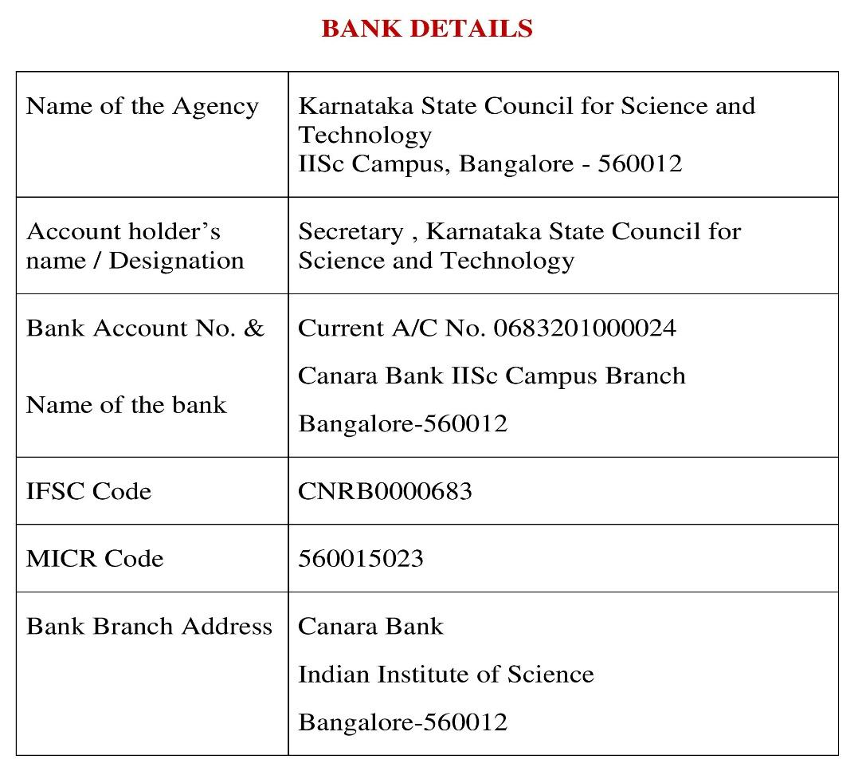
Note: For finance related queries, please contact KSCST accounts section: 080 – 23341652, 23348849 during office hours between 3.00 pm to 5 pm, email: finance@kscst.org.in with a copy to spp@kscst.org.in

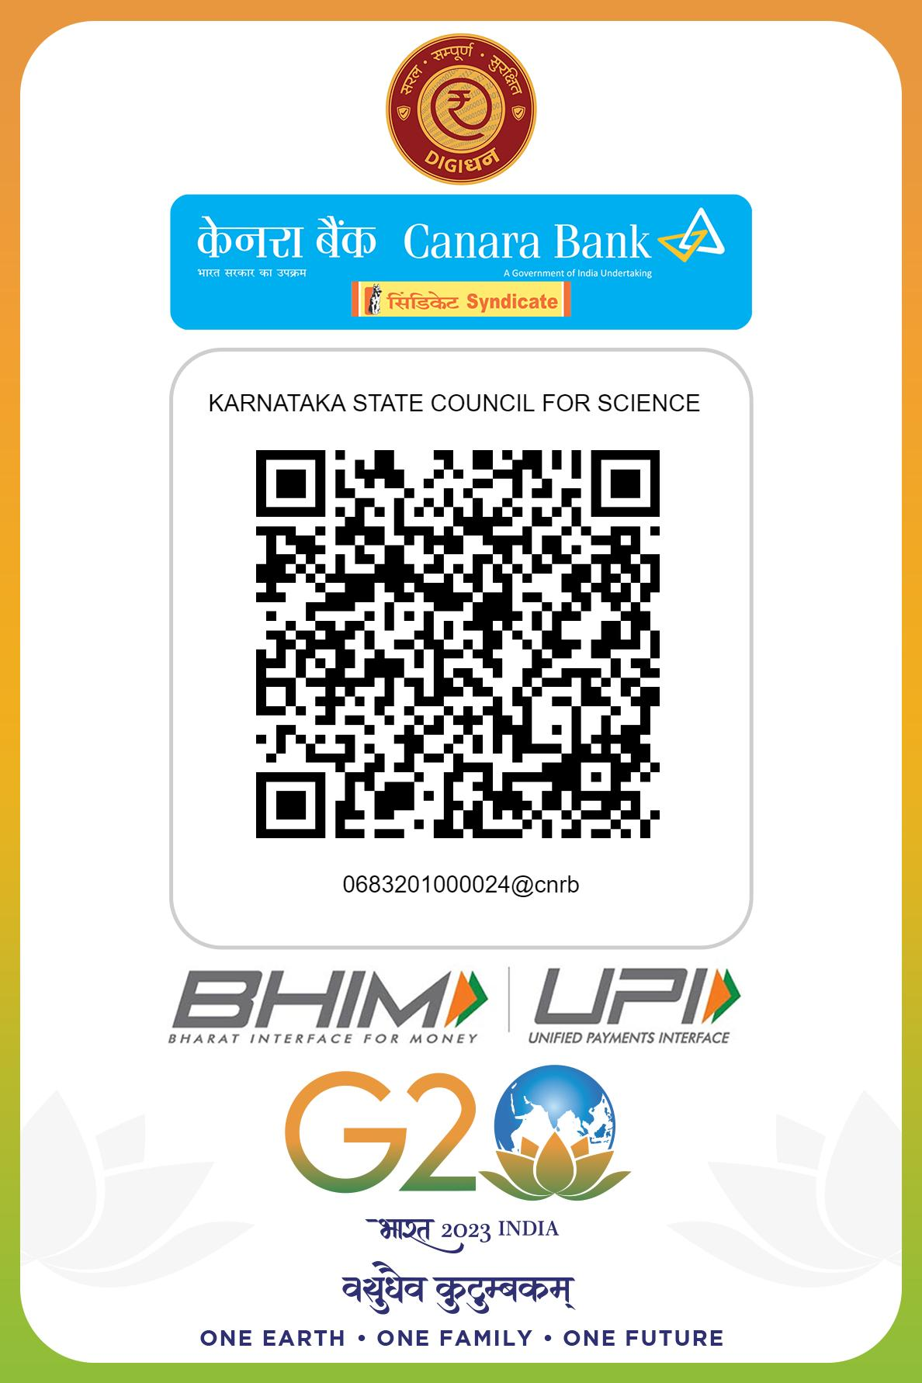
Note: For finance related queries, please contact KSCST accounts section: 080 – 23341652, 23348849 during office hours between 3.00 pm to 5 pm, email: finance@kscst.org.in with a copy to spp@kscst.org.in

