GeoGuard: Tamper-Evident Geotagged Smartphone Photography with Portable ECDSA Signatures, Tile-Level Perceptual Hashing and Sealed End-to-End Transfer
[Author Name 1], [Author Name 2], [Author Name 3]
[Department], [Institution], [City], India
[email addresses]
Abstract—Photographs are routinely offered as proof of where and when something happened, yet EXIF metadata can be rewritten in seconds and generative models can now fabricate or inpaint convincing scenes. We present GeoGuard, an open Android application and companion service that makes such tampering detectable without trusting any server. At capture time GeoGuard refuses stale or mock-provider GPS fixes, burns a human-readable location stamp into the pixels, computes a 64-bit difference hash (dHash) of the stamp and a 4×4 grid of independent dHashes over the scene, and signs the resulting envelope with an ECDSA P-256 key whose public half travels inside the photo. The envelope is embedded three times (EXIF, a JPEG COM segment and an end-of-file block), so any device can verify a photo offline. Verification separates two questions that are often conflated: whether the photo is unchanged (pure cryptography) and who took it (a trust-on-first-use pin of the signer’s key). Because messaging apps re-encode images and destroy embedded proof, GeoGuard also delivers photos sealed with AES-256-GCM under an ECDH-derived key, so the relay server stores only ciphertext and the received bytes are bit-identical to the signed file. We describe the full system, including Google sign-in, a username directory and server-verified Razorpay payments, and evaluate it on seven natural images under eight benign and seven adversarial transformations. Evaluation exposed a hashing-order defect that caused untouched photos to fail verification; after the fix untouched photos score exactly zero, benign false alarms fall from 13/56 to 11/56, and every 1/16-tile clone, splice and metadata edit is detected.
Index Terms—Content provenance, digital image forensics, perceptual hashing, ECDSA, end-to-end encryption, mobile security, geotagging, tamper detection.

I. Introduction
A photograph of a damaged roof, a delivered parcel or a site inspection used to be treated as evidence on its face. That assumption no longer holds. Location and time stored in EXIF can be rewritten with free tools and leave no trace; splicing, cloning and text edits can change what a photo shows; and diffusion models can now generate or inpaint photorealistic content at negligible cost [1], [2], [3]. Passive forensic detectors have improved rapidly [4], [5], [6], and inpainting-specific localisers are an active research area [7], [8], [9], [10], [11], but they return probabilities that degrade as generators change, and their verdicts are hard to explain to a non-expert.
An alternative to detecting manipulation after the fact is to bind a claim to the pixels at the moment of capture, so that any later change becomes provable. Industry has moved in this direction through the C2PA Content Credentials standard, which smartphone vendors now implement in the camera pipeline [12]. A recent formal analysis, however, reports that C2PA specifications and conforming implementations fail to achieve several of their claimed security goals [13], and provenance only helps if it survives the channels people actually use to share photos.
This paper presents GeoGuard, a geotagging camera and verifier built as a Flutter application with a small Node.js service. GeoGuard targets field users such as inspectors, insurance assessors and delivery staff who need a photo whose place and time can be checked by anyone, offline, and whose edits are located rather than merely suspected. Our contributions are:
- A capture pipeline that refuses untrustworthy GPS, burns a visible stamp into the pixels, and signs a compact envelope containing the coordinates, a stamp dHash and sixteen scene-tile dHashes with an ECDSA P-256 key whose public key is bound into the signed string (Section V).
- A four-stage verifier that reports what failed (metadata, stamp or a specific scene tile) and a separate signer-attribution model with four explicit trust levels (Section VI).
- A sealed transfer protocol that keeps photos bit-identical across the network, so the proof survives sharing, while the relay learns only ciphertext (Section VII).
- A complete, deployed account, directory, payment and update service in which the client never decides identity or entitlement (Section VIII).
- A measured evaluation of the real Dart implementation, including a defect we found and fixed in the order of hashing and encoding, with before/after results (Section X).

II. Related Work

A. Content provenance and secure capture
C2PA attaches signed manifests to media. Google’s Pixel 10 camera adds Content Credentials to every JPEG capture, generates and stores signing keys in a StrongBox security chip, uses a fresh key for each image, and reached Assurance Level 2 of the C2PA conformance programme [12]. Golaszewski et al. analysed C2PA version 2.2 with formal methods and found, among other issues, that generators and validators can disagree on the trusted timestamp of a signature [13]. GeoGuard is narrower than C2PA: it carries no edit history, but it is self-contained, runs on ordinary Android hardware, and its envelope is small enough (689 bytes) to embed redundantly.

B. Passive forensics and manipulation localisation
Surveys catalogue handcrafted and deep detectors for splicing, copy-move and generative edits [4], [5], [6], and for AI-generated imagery more broadly [1], [2], [3]. COCO-Inpaint contributes 238,302 inpainted images from six models [7]; End4 learns reconstruction and detection jointly [8]; InpDiffusion casts localisation as conditional mask generation [9]; DinoLizer separates VAE and diffusion artefacts [10]; and RADAR targets edits from 28 diffusion models [11]. These methods need no capture-time cooperation but give probabilistic answers. GeoGuard is complementary: it gives a binary, explainable answer for photos it captured and says nothing about photos it did not.

C. Watermarking
Invisible watermarks such as SynthID-Image mark generated content at internet scale [14]. Their robustness is contested: in the NeurIPS 2024 “Erasing the Invisible” competition the top teams removed watermarks from at least 89% of images while preserving quality [15], and a deep-image-prior baseline removes watermarks without any knowledge of the scheme [16]. GeoGuard therefore uses a signature for integrity and treats the pixels only as the object being fingerprinted.

D. Perceptual hashing
Perceptual hashes tolerate benign processing but can be attacked. Steinebach and Yannikos show that inpainting can push semantic changes past robust hashes or cause false matches [17]; CertPHash trains hashes with certified robustness against evasion and collision [18]; and Sun et al. harden deep perceptual hashes without retraining [19]. Our threat model differs from content-matching: the reference hashes are signed, so an attacker must keep every tile within tolerance of a fixed target rather than merely evade a database.

E. Ledgers and registries
Several systems anchor image fingerprints or watermarks on a blockchain: Chain-Visage traces ownership and tampering in consumer-IoT multimedia [20], PoWBWM combines proof-of-work with adaptive watermarking for tamper localisation [21], and a perceptual-hash registry verifies AI-generated images at upload time [22]. GeoGuard needs no ledger because the verifying key travels with the photo; a registry could be added for revocation.

F. Secure messaging and key distribution
GeoGuard’s transfer borrows the hybrid structure of messaging protocols. Recent work gives concrete security treatments of Signal’s handshake [23] and analyses its deniability [24]. Key transparency now protects WhatsApp and Messenger key directories [25], although users interviewed by Fischer et al. did not gain trust from it without explanation [26]. GeoGuard’s directory is a convenience; trust rests on a pinned fingerprint that users can compare aloud.

G. Platform security
KeyDroid analysed 490,119 Android apps and found that 56% of apps that self-report processing sensitive data do not use Android’s trusted hardware at all [27]. Smartphone GNSS can be spoofed below the operating system; consistency checks on raw pseudoranges mitigate spoofing when few satellites are affected [28]. Both results bound what an app-level system such as GeoGuard can claim, and we return to them in Section XI.
TABLE I
Comparison with related approaches
Approach | Offline verify | Locates edit | Survives chat apps | Needs server
C2PA in camera [12], [13] | Yes | No | No | No
Passive detectors [4], [7], [11] | Yes | Yes (prob.) | Partly | No
Invisible watermark [14], [15] | Vendor | No | Partly | Vendor
Blockchain registry [20], [22] | No | Varies | Yes | Yes
GeoGuard (this work) | Yes | Per tile | Via sealed send | Only to send

III. Threat Model and Design Goals
We consider an adversary who obtains a GeoGuard photo and wishes to present an altered version as genuine. The adversary can run any image editor, rewrite metadata, re-encode the file, strip or forge embedded data, generate their own GeoGuard keys, and observe or control the relay server and network. We assume the signing phone was not compromised at capture time and that its operating system reports GPS honestly; Section XI discusses both assumptions. Goals and the mechanisms that address them are summarised in Table II.
TABLE II
Design goals and mechanisms
Goal | Mechanism
G1 Truthful capture | Refuse no-fix, >30 s old and isMocked fixes
G2 Metadata integrity | ECDSA P-256 over canonical string
G3 Pixel integrity | Stamp dHash + 16 tile dHashes, signed
G4 Edit localisation | Per-tile Hamming distances
G5 Portable verification | Public key embedded and signed
G6 Honest attribution | Four trust tiers; TOFU pinning
G7 Proof survives sharing | Sealed AES-256-GCM transfer
G8 Server learns little | Ciphertext only; verdict-only logs
G9 Client cannot self-grant | Server-side token and payment checks

IV. System Architecture
Fig. 1 shows the two halves of the system. The Android application holds all cryptography that touches photos: the capture pipeline, the verifier, the identity service with its signing and key-agreement key pairs, and the sealed-transfer code. Photos live in the application’s documents directory; key material lives in flutter_secure_storage, whose values are encrypted under a key held by the Android Keystore. A build configured without a server runs entirely offline: capture, verification, sender pinning and share-as-file all work, and no feature is locked.
The server, a Node 22 Express service on Render, never sees a plaintext photo. It verifies Google ID tokens, issues 30-day session tokens, hosts the username directory, relays sealed photos through MongoDB GridFS, verifies Razorpay payments, records an activity log, and publishes the newest app build for an in-app update banner. Only the server holds the database credentials; the application talks to it over HTTPS, because any secret compiled into an APK is recoverable by unzipping it.
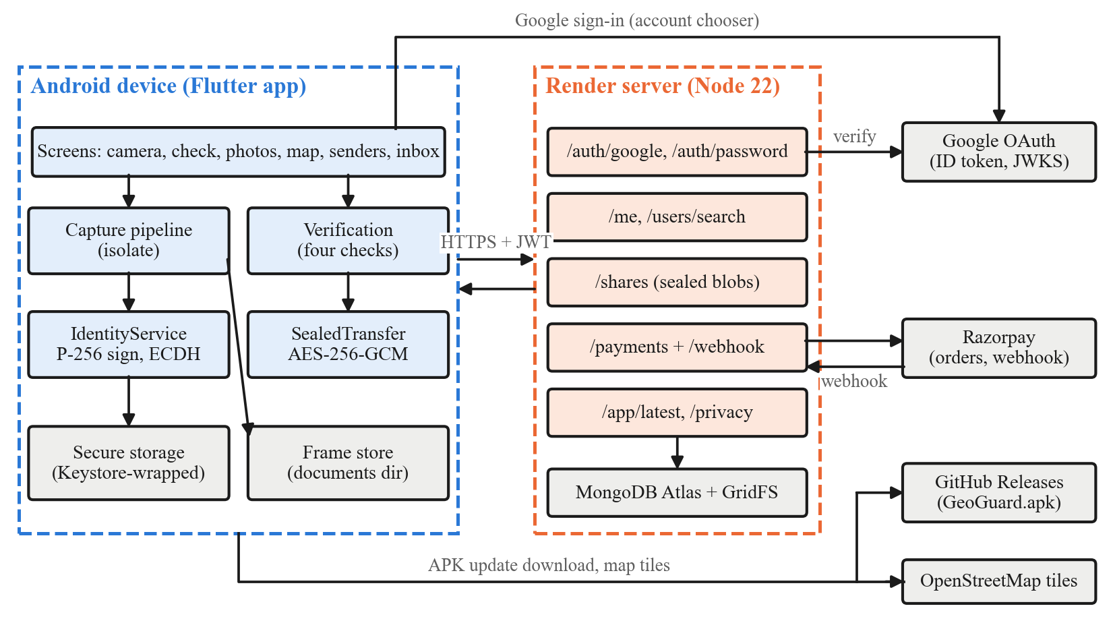
Fig. 1. System architecture. The app performs all photo cryptography on the device; the server handles accounts, the directory, sealed relay and payments, and never holds a key that can read or sign a photo.

V. Capture and Signing

A. Refusing untrustworthy fixes
The capture flow is shown in Fig. 2. The shutter is disabled until the viewfinder holds a GPS fix younger than 30 seconds; a fix whose Position.isMocked flag is set is refused outright rather than recorded with a caveat, because signing a spoofed coordinate would make the system vouch for a falsehood. The viewfinder reuses its live fix and its pre-resolved place name at the shutter, which removed a fresh best-accuracy fix and a network geocoding call from the critical path.

B. Visible stamp
The stamp occupies the bottom 18% of the frame (Fig. 3): a near-opaque panel, an accent bar and three lines giving the place name, latitude and longitude to six decimals, and local time with its UTC offset. Text height is a fixed fraction (2.2%) of image height so the stamp scales with resolution, and a solid panel is used because shadowed text fails on both bright sky and dark interiors.
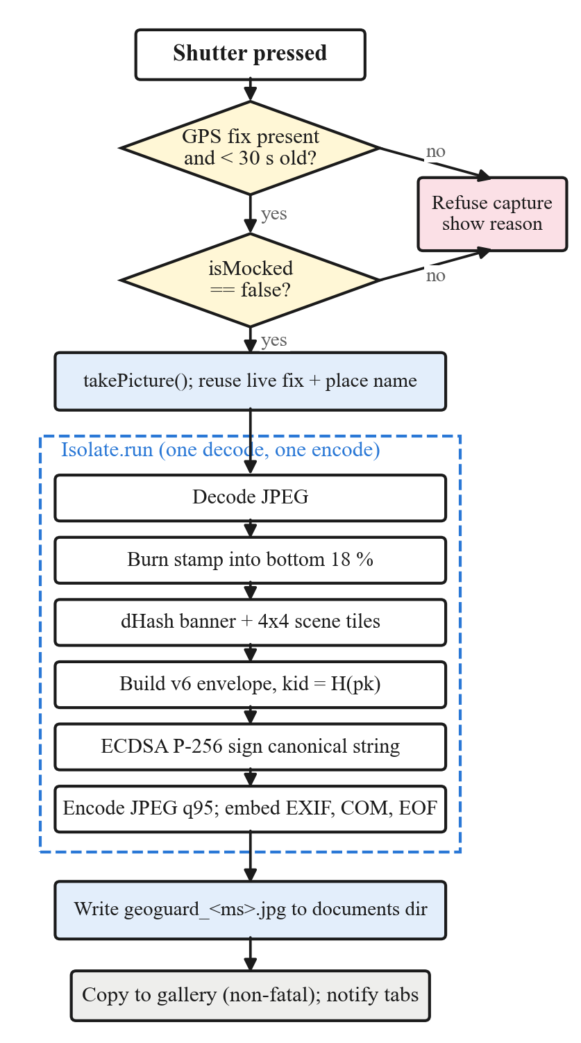
Fig. 2. Capture pipeline. Decisions refuse capture without a fresh, non-mocked fix; the dashed region runs in a background isolate so the interface never blocks.
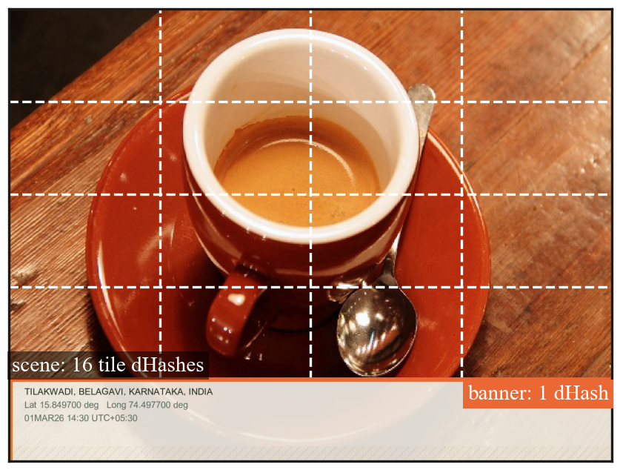
Fig. 3. A frame produced by the real capture code. The orange line marks the stamp banner, hashed once; the dashed grid marks the sixteen scene tiles, each hashed independently.

C. Perceptual fingerprints
A difference hash records gradient direction rather than intensity, which survives recompression but changes under edits. For a region resized to 9×8 pixels with luma Y, bit k = 8y + x of the 64-bit digest is
d[k] = 1 if Y(x, y) > Y(x+1, y), else 0 (1)
and two digests are compared by Hamming distance D = popcount(d₁ ⊕ d₂). GeoGuard hashes the banner once and the scene above it as a 4×4 grid of tiles. A single whole-image digest barely moves when one object is cloned out, whereas the tile containing the edit moves strongly, so tiling both improves sensitivity and locates the edit. A region is accepted when D ≤ τ with τ = 10 for the banner and for every tile.
Digests are serialised as two unsigned 32-bit halves. An earlier version printed the signed 64-bit integer, so any digest with its top bit set became a 17-character negative string that the comparison loop scored as distance zero, a silent false negative that a regression test now guards against.

D. Envelope and signature
The envelope (Fig. 4) holds latitude, longitude, altitude, a millisecond timestamp, a device hash, the banner digest, the sixteen tile digests, the base64 compressed public key pk (33 bytes), its identifier kid, the signature and a schema version (v = 6). The signed message is the canonical string
m = v6|lat|lon|alt|ts|dev|ph|st₁,…,st₁₆|pk (2)
and the signature is ECDSA over P-256 with SHA-256, written as r|s in hexadecimal. Because pk is inside m, an attacker cannot substitute their own key without invalidating the signature, and kid = SHA-256(pk) truncated to 16 hex characters is derived from it. Nonces are derived deterministically from the key and message (RFC 6979), which removes the need for a random source inside the isolate and avoids the nonce-reuse and nonce-leakage failures that break DSA-family signatures [29]. Earlier envelope versions (v3–v5) used HMAC-SHA256 with a device-derived key, which only the signing phone could check; they remain verifiable on that phone through a retained key ring.

E. Redundant embedding
The envelope is written three times: as the EXIF UserComment, as a JPEG COM (0xFFFE) segment inserted after the start-of-image marker, and as a tail block appended after the end-of-image marker. Different tools strip different locations, and decoders ignore the tail, so the photo still opens everywhere. The verifier tries the tail first, then a raw byte scan for the COM/EXIF marker with a brace-balanced JSON extractor.
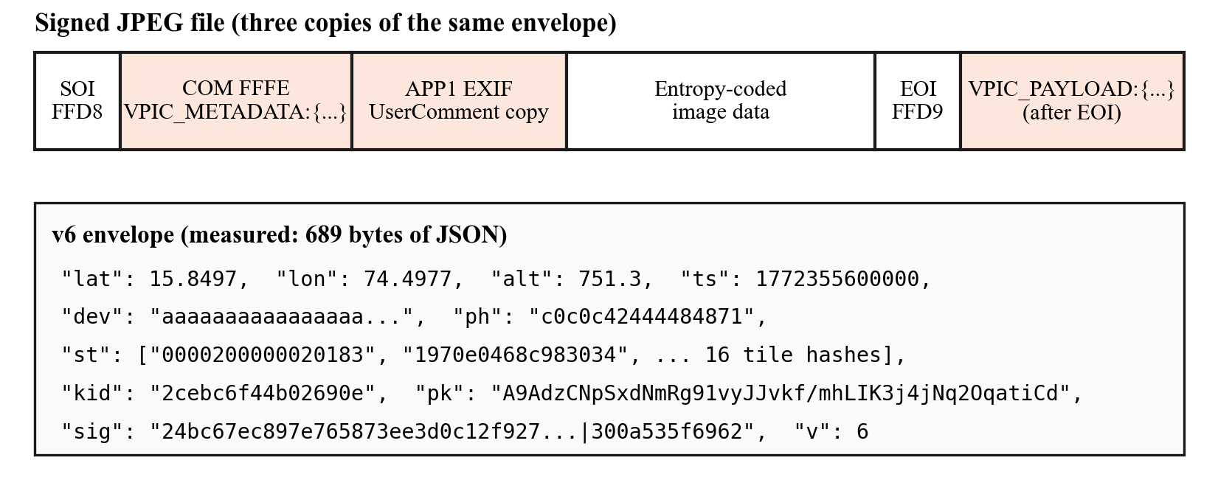
Fig. 4. Signed file layout and an actual v6 envelope produced by the implementation. The same 689-byte JSON is stored in three places.

F. Hashing the stored pixels
In version 1.0.1 the digests were computed on the in-memory stamped image and the file was then JPEG-encoded at quality 95. The verifier, however, hashes the decoded file. JPEG rounding alone could therefore move a low-texture tile past τ, and an untouched photo could read as “picture edited”. Version 1.0.2 encodes first, decodes the encoded bytes, hashes exactly those pixels, and then inserts the EXIF, COM and tail copies without re-encoding, so the hashed pixels are the stored pixels. A new regression test asserts that every digest of an untouched photo scores exactly zero; it fails on the old pipeline and passes on the new one.

VI. Verification and Attribution
Verification (Fig. 5) runs four stages and stops at the first failure, naming what failed. The signature is checked before any pixels are compared, because recorded digests are only meaningful once the signature has shown they were not swapped. The verdict is deliberately binary; the report lists the measurements behind it (Hamming distances, tiles over tolerance, which key verified) instead of blending them into a confidence score that would invite readers to treat a failed signature as a near pass.
A valid signature proves only that whoever holds the private key signed the photo, and anyone can generate a key. GeoGuard therefore answers attribution separately (Fig. 6): taken on this phone, taken by a saved sender, taken on another GeoGuard phone, or not real. A user who receives a photo can save its signer under a name; this pins the key’s 16-character fingerprint, shown in groups of four so two people can compare it aloud, in the manner of trust-on-first-use. The online directory can supply a key, but because a compromised directory could return an impostor’s key, the app warns when a fetched key contradicts a saved one instead of silently replacing it.
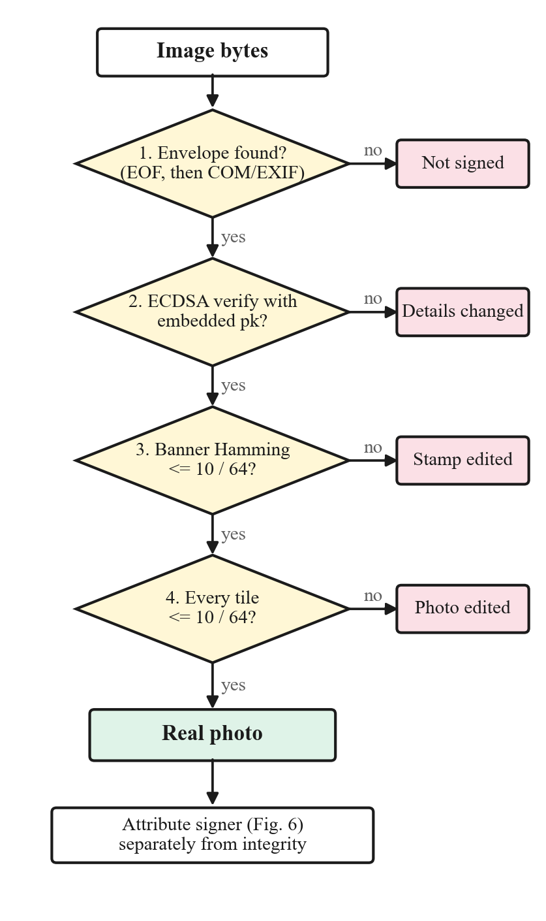
Fig. 5. Four-stage verification. Each failure exit names the cause shown to the user.
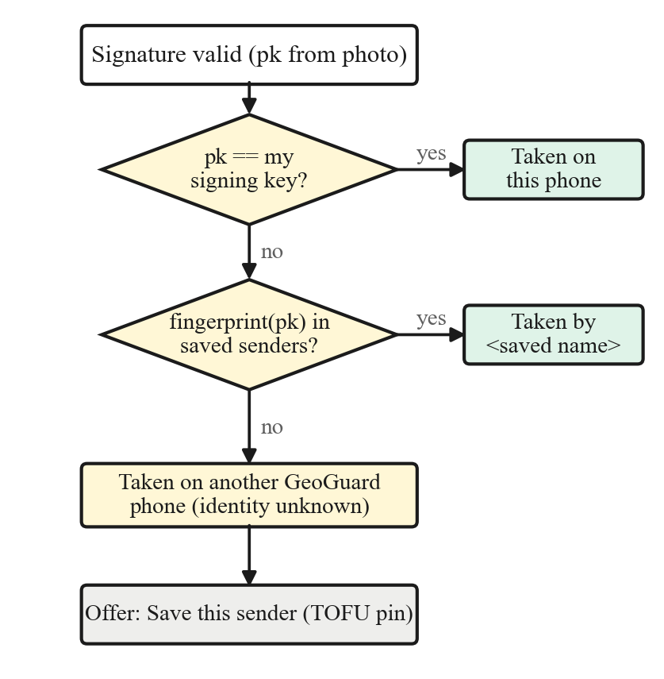
Fig. 6. Signer attribution, evaluated only after the signature is valid. An unknown key is never presented as a named person.

VII. Sealed End-to-End Transfer
Messaging apps that send an image “as a photo” re-encode it, which removes all three copies of the envelope. Sharing the file as a document preserves it, and remains the free path. For in-app delivery GeoGuard seals the original bytes (Fig. 7). The sender draws a fresh 32-byte file key K_{m} and encrypts the file with AES-256-GCM; it then generates an ephemeral P-256 key pair (e, E) and derives a wrapping key from the recipient’s encryption key pk_{R}:
K_{w} = HKDF( ECDH(e, pk_{R}), “GeoGuard-Share-v1” ) (3)
The wrapped key W = AES-GCM(K_{w}, K_{m}), the ephemeral public key E and SHA-256(C) of the ciphertext are uploaded with C. The recipient checks the hash before decrypting, so a truncated download is reported as a broken download rather than a forgery, repeats the agreement with its private key, and recovers the exact signed bytes, which then pass the ordinary four checks. Encryption keys are a separate P-256 pair from signing keys, and every photo uses fresh key material, so two sealed copies of the same photo are unlinkable on the server.
The server recomputes the ciphertext hash, caps blobs at 12 MB and 25 pending per recipient, scopes downloads and deletion to the addressed user, and deletes the blob once the recipient has saved it. Because the server cannot read the photo, it cannot re-encode it either; confidentiality is what keeps the proof intact.
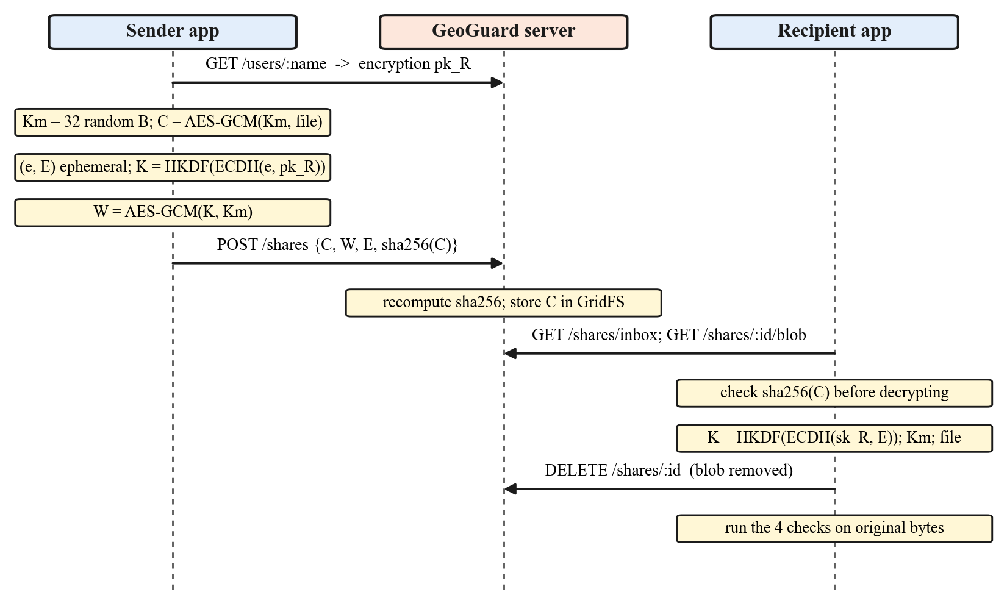
Fig. 7. Sealed transfer. The server stores only ciphertext and routing metadata and holds no key able to open it.

VIII. Accounts, Directory, Payments and Updates

A. Identity
Google sign-in returns an ID token that the app forwards; the server verifies its signature against Google’s published keys, its audience and its expiry, and keys the account on the stable subject identifier rather than the email address. The app never asserts who it is. Usernames are 3–20 characters of [a-z0-9_], lowercased, unique by database index, and permanent, because photos are addressed to them. The server derives each user’s fingerprint from the published key itself rather than accepting one from the client, and search results never include email addresses.

B. Payments
One plan unlocks verification and the PDF evidence report for 30 days; capture, share-as-file and sealed sending remain free. The flow in Fig. 8 keeps every decision on the server: the price lives in a server-side table, the server reproduces Razorpay’s HMAC with a secret the app never holds and compares it in constant time, and an atomic status change ensures that the app’s confirmation and the webhook, which often arrive together, extend the period only once.

C. Activity log and privacy
An events collection records sign-ups, sign-ins, username claims, key publication, orders, accepted and rejected payments, and sent, opened and checked photos, and expires after 90 days. When a check is reported, only the verdict is sent: no photo, coordinate or signature, and an automated test asserts that extra fields cannot be smuggled in.

D. Update channel
Because GeoGuard is distributed as an APK, the app asks the server for the newest build number and shows a download link to a fixed GitHub release URL. During this work we found that no release had been published, so the banner sent users to a missing file. The server now probes the asset before advertising a build and offers nothing while the link would fail; the probe is cached for ten minutes and covered by tests.
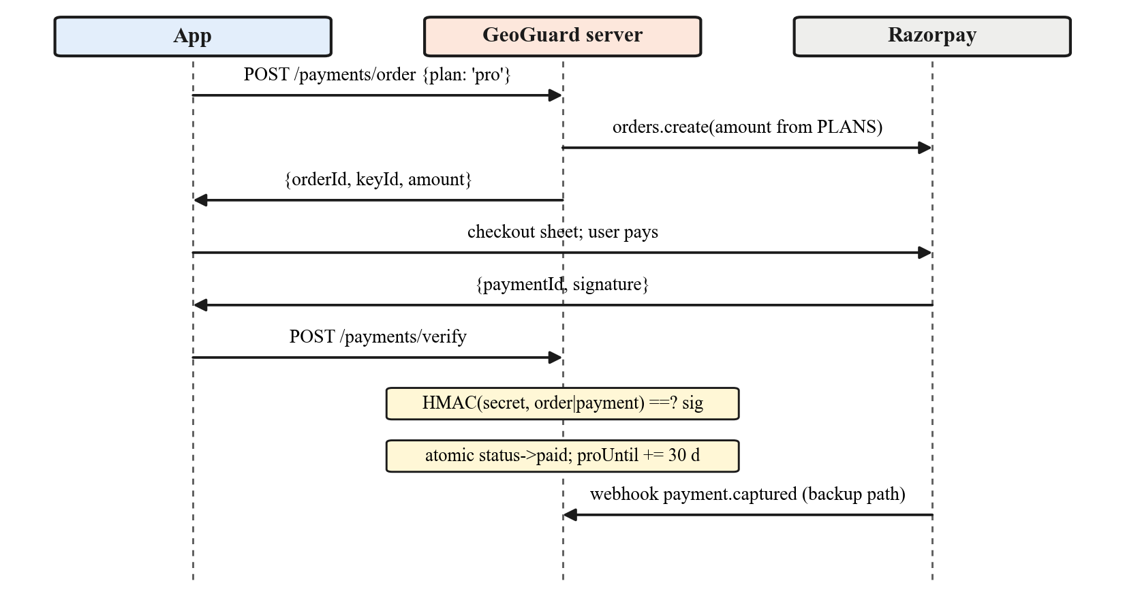
Fig. 8. Payment verification. Entitlement is granted only after the server reproduces the gateway signature; the webhook covers users who close the app mid-payment.

IX. Implementation
The client is written in Dart with Flutter 3.41, using pointycastle for ECDSA, ECDH, HKDF and AES-GCM and the pure-Dart image package for decoding, stamping and encoding, so the same code runs in a background isolate and on a desktop test host. The server uses Express, express-rate-limit, google-auth-library, jsonwebtoken and the MongoDB driver. Together the application and server sources tracked in the repository total about 12,400 lines. The Flutter suite has 53 unit tests and the server has 15 tests that run without a database (database-backed suites skip themselves when no cluster is configured); all pass. Release builds are signed with a single long-lived key, since Android installs an update only under the same signature and Google sign-in is registered to that key’s certificate.

X. Evaluation

A. Setup
We drove the real composeSignedFrame, VerificationService and SealedTransfer code from a test harness. Inputs were the seven natural photographs bundled with scikit-image (astronaut, chelsea, coffee, hubble_deep_field, immunohistochemistry, retina and rocket; 300–1411 pixels high). Each was signed by a key saved as the contact “Ravi”. Benign transformations were JPEG re-encoding at quality 90, 75, 60 and 40, halving the width, an 8% brightness increase and a radius-1 Gaussian blur. Adversarial transformations were cloning a region of 1/16, 1/64 or 1/256 of the scene area, splicing a 1/16 region from another image, overwriting the stamp text, editing the latitude field, and editing the scene then re-signing with an attacker’s own key. To isolate the perceptual checks we assume a worst-case attacker who preserves the tail copy of the envelope, so every transformed file still carries a valid signed envelope. Timings were measured on an AMD Ryzen 5 5600H host under the Dart JIT; they indicate relative cost, not phone latency.

B. Integrity results
Fig. 10 plots, for every image and transformation, the largest scene-tile distance and the banner distance that the verifier computed on the actual file, and Table III summarises the verdicts. With the fix, untouched photos score exactly zero on all seventeen digests. Re-encoding at quality 90 never triggers a false alarm, and quality 75–40 flags only the low-texture rocket image. Halving the resolution is the dominant false-alarm source (5/7): resampling shifts gradient directions in fine-textured tiles, which is the expected price of tile-level sensitivity. Across all benign cases, false alarms fall from 13/56 (23.2%) to 11/56 (19.6%).
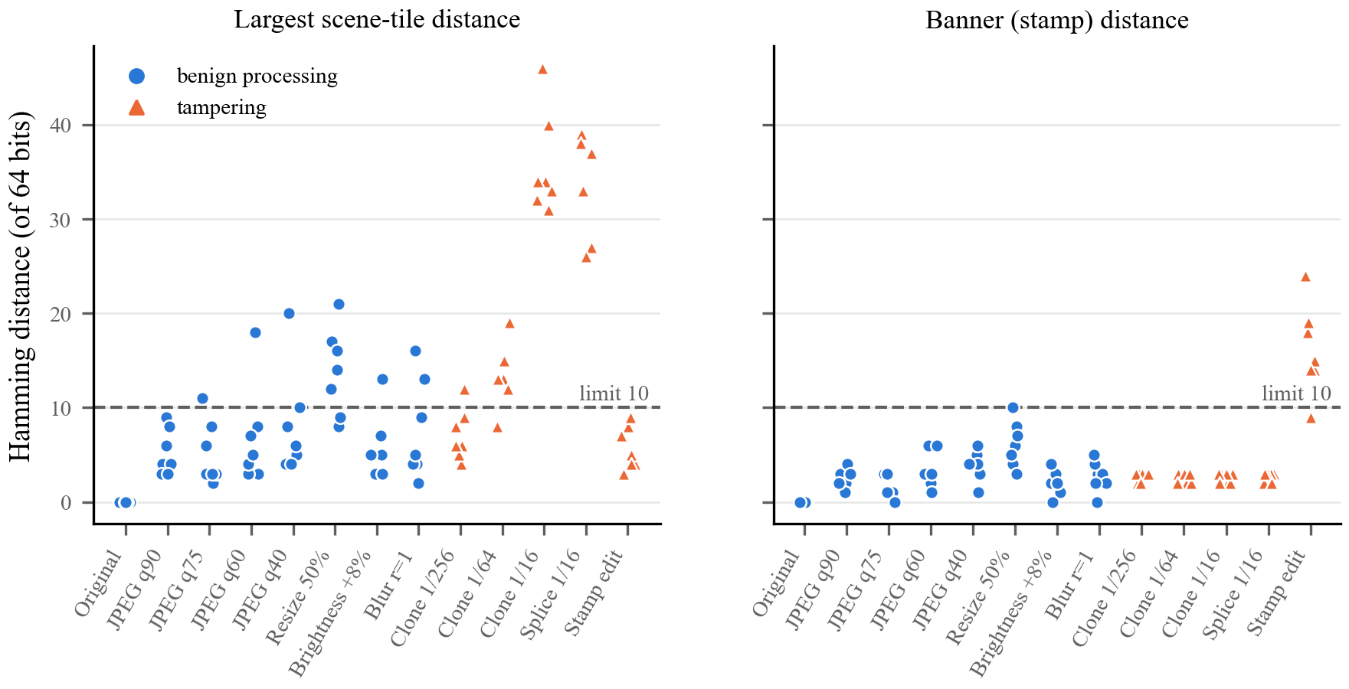
Fig. 10. Hamming distances computed by the verifier on the actual files (v1.0.2). Circles are benign processing and triangles are tampering; the dashed line is the tolerance τ = 10.
On the adversarial side, every 1/16 clone and 1/16 splice (7/7) and every latitude edit (7/7, by signature failure) is detected. Stamp overwrites are detected in 6/7 cases; the miss is the dark hubble_deep_field image, whose banner distance of 9 sits just under τ. Detection of smaller clones falls with area, to 6/7 at 1/64 and 1/7 at 1/256, which quantifies the known resolution limit of a 4×4 grid. Fig. 9 shows localisation on a 1600×1200 frame: a cloned tile scores 34 while every other tile and the banner score 0.
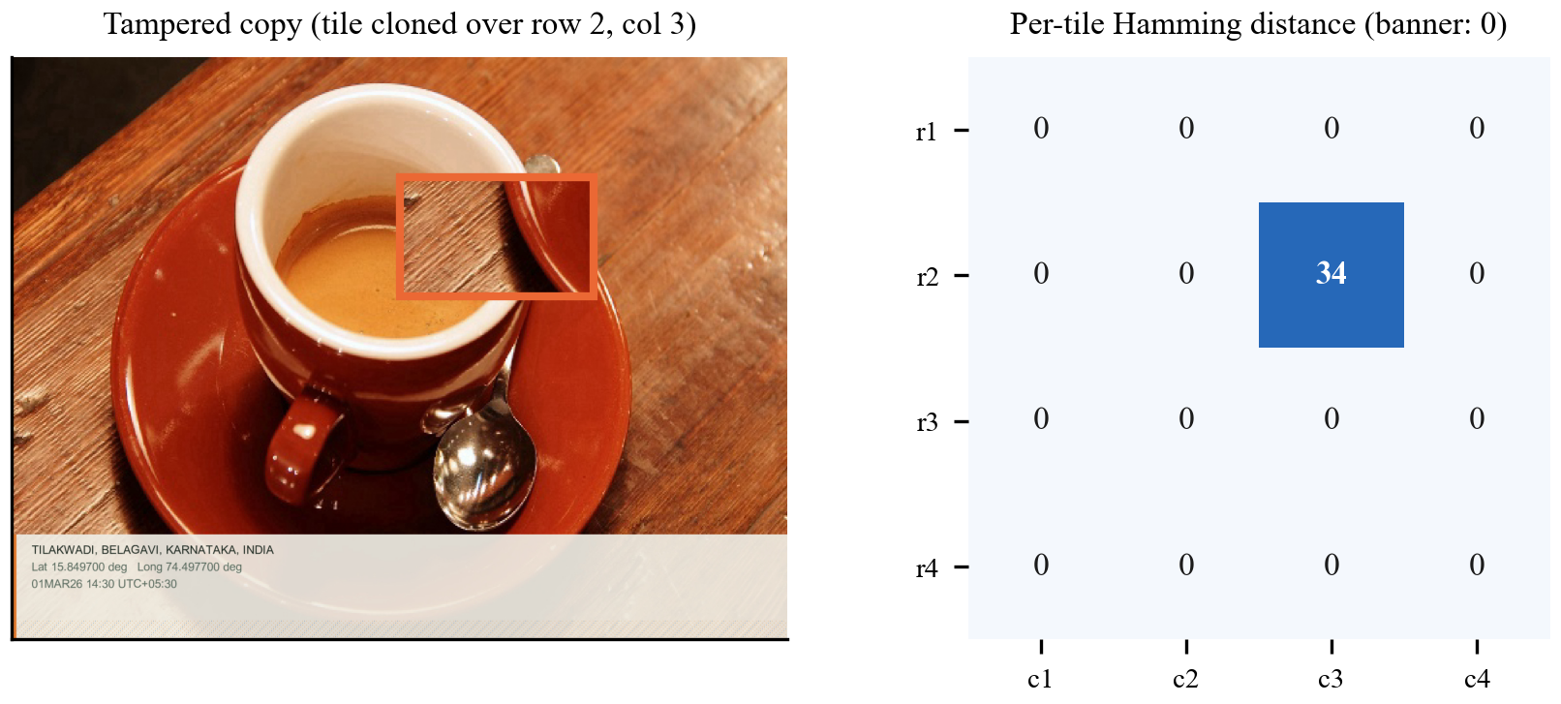
Fig. 9. Tamper localisation. Left: a tile copied over row 2, column 3. Right: per-tile distances from the verifier; only the edited tile exceeds the tolerance.
Editing and re-signing with an attacker key always yields a mathematically valid signature, as it must, but in all 7 cases the verifier labelled the signer “taken on another GeoGuard phone” rather than the pinned contact, so attribution separates a forgery from the genuine sender even when integrity checks pass.
TABLE III
Images flagged as not authentic (of seven)
Transformation | Kind | v1.0.1 | v1.0.2
Original, untouched | benign | 1/7 | 0/7
JPEG q90 | benign | 1/7 | 0/7
JPEG q75 | benign | 1/7 | 1/7
JPEG q60 | benign | 1/7 | 1/7
JPEG q40 | benign | 1/7 | 1/7
Resize 50% | benign | 5/7 | 5/7
Brightness +8% | benign | 1/7 | 1/7
Gaussian blur r = 1 | benign | 2/7 | 2/7
Clone 1/256 of scene | tamper | 2/7 | 1/7
Clone 1/64 of scene | tamper | 5/7 | 6/7
Clone 1/16 of scene | tamper | 7/7 | 7/7
Splice 1/16 of scene | tamper | 7/7 | 7/7
Stamp text overwrite | tamper | 6/7 | 6/7
Latitude field edit | tamper | 7/7 | 7/7

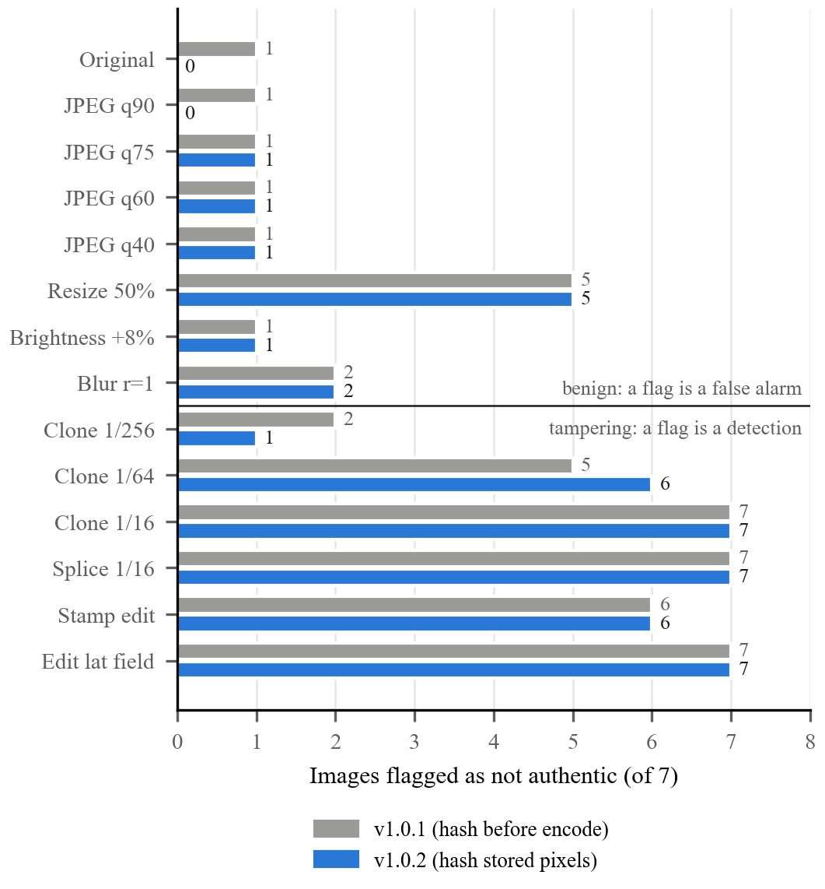
Fig. 11. Verdicts before and after hashing the stored pixels. Above the rule a flag is a false alarm; below it a flag is a detection.

C. Cost
Table IV reports medians of five capture runs and three transfer runs. On a 1280×720 frame, the size the camera plugin’s “high” preset produces on Android, signing and embedding took 728 ms, against 552 ms before the fix (32% for the extra decode). A synthetic 4032×3024 frame took 7.33 s. ECDSA itself is negligible: 11.7 ms to sign and 17.0 ms to verify. The envelope adds 689 bytes per copy, about 2.1 kB in total. Sealing adds exactly 28 bytes (a 12-byte nonce and a 16-byte tag), the opened file was bit-identical to the original and verified as authentic, and a recipient holding the wrong key was rejected. Pure-Dart AES-GCM is the slowest component, at roughly 379 kB/s; a platform cryptography backend is an obvious improvement.
TABLE IV
Measured cost (desktop host, Dart JIT, medians)
Operation | 1280×720 | 4032×3024
Capture v1.0.1 | 552 ms | 5.29 s
Capture v1.0.2 | 728 ms | 7.33 s
Pixel checks + extraction | 295 ms | 3.34 s
Signed file size | 384 kB | 2.97 MB
Seal / open | 1011 / 1029 ms | 7.50 / 7.30 s
ECDSA sign / verify | 11.7 / 17.0 ms | —

XI. Discussion and Limitations
Scope of the evaluation. Seven images and fifteen transformations are enough to expose the hashing-order defect and to show the qualitative behaviour of the tile scheme, but not to estimate error rates with confidence. A larger study with phone-captured frames and real chat-app pipelines is future work, as are inpainting attacks optimised against the tile digests [17], [18].
Key protection. The ECDSA key is generated in software and stored encrypted under a Keystore-held key; signing happens in application memory, not inside secure hardware. A rooted or compromised device can therefore leak the key, and there is no revocation. Moving signing into StrongBox or a TEE with key attestation, as recent phone cameras do [12], would strengthen the claim; KeyDroid shows that most apps do not yet do this [27].
Location truth. Refusing mock-provider fixes defeats ordinary fake-GPS apps but not a modified operating system or radio-level spoofing. Raw-measurement consistency checks [28] could be added where the hardware exposes them.
Attribution. Trust-on-first-use is only as good as the first contact. The directory is convenient but is a trust anchor; key transparency [25] would make silent key substitution detectable, although user studies suggest it must be explained to be valued [26].
Sensitivity. A 4×4 grid misses edits much smaller than a tile and is disturbed by resampling. Adaptive grids, multi-scale hashes or certified perceptual hashes [18], [19] are natural extensions.
Post-quantum migration. P-256 signatures are not quantum-resistant. ML-DSA is the standard replacement; vectorised implementations already run efficiently on ARMv9 [30], but its signatures are far larger than 64 bytes and its signing time varies with rejection sampling [31], [32], which matters for an envelope that must fit in a single JPEG COM segment.
Other findings. Reviewing the code we also found that installs created before encryption keys existed regenerate an unsaved encryption key on every launch, which can make photos sealed to such users unopenable; we report it as open. The evidence certificate laid out after Section 63(4) of the Bharatiya Sakshya Adhiniyam, 2023 is unsigned by design and has no legal effect until signed by the required persons.

XII. Conclusion
GeoGuard shows that an ordinary smartphone app can produce photos whose place, time and content are checkable by anyone, offline, with edits located to a tile and with attribution kept honest. Measuring the real implementation was essential: it revealed that hashing pixels before encoding made untouched photos fail, a defect invisible to unit tests on synthetic images, and the fix brought untouched photos to exactly zero distance while keeping every substantial edit detectable. Future work will move signing into secure hardware, add GNSS consistency checks, adopt a post-quantum signature that fits the envelope, and evaluate on phone-captured data at scale.
References
[1] A. Mahara and N. Rishe, “Methods and trends in detecting AI-generated images: A comprehensive review,” Comput. Sci. Rev., vol. 60, Art. no. 100908, 2026, doi: 10.1016/j.cosrev.2026.100908.
[2] R. Sunil, P. Mer, A. Diwan, R. Mahadeva, and A. Sharma, “Exploring autonomous methods for deepfake detection: A detailed survey on techniques and evaluation,” Heliyon, vol. 11, no. 3, Art. no. e42273, 2025, doi: 10.1016/j.heliyon.2025.e42273.
[3] B. Liu, B. Liu, T. Zhu, and M. Ding, “A review of deepfake and its detection: From generative adversarial networks to diffusion models,” Int. J. Intell. Syst., vol. 2025, Art. no. 9987535, 2025, doi: 10.1155/int/9987535.
[4] V. Kadha, S. Bakshi, and S. K. Das, “Unravelling digital forgeries: A systematic survey on image manipulation detection and localization,” ACM Comput. Surv., vol. 57, no. 12, pp. 1–36, 2025, doi: 10.1145/3731243.
[5] M. Munawar and M. Oussalah, “Deployable image forgery detection and localization: A comprehensive review and practitioner’s guide,” Expert Syst. Appl., vol. 311, Art. no. 131347, 2026, doi: 10.1016/j.eswa.2026.131347.
[6] P. Cisar, “Overview of digital image forgery detection,” Facta Univ., Ser. Electron. Energ., vol. 38, no. 4, pp. 581–603, 2025, doi: 10.2298/FUEE2504581C.
[7] H. Yan, Y. Hong, J. Zhan, et al., “COCO-Inpaint: A benchmark for detecting and localizing inpainting-based image manipulations,” arXiv:2504.18361, 2025.
[8] F. Wang, X. Wu, Z. Zhang, D. Huang, Y. Huang, and B. Wang, “End4: End-to-end denoising diffusion for diffusion-based inpainting detection,” arXiv:2509.13214, 2025.
[9] K. Wang, S. Niu, Q. Hao, and J. Zhang, “InpDiffusion: Image inpainting localization via conditional diffusion models,” in Proc. AAAI Conf. Artif. Intell., vol. 39, no. 7, 2025, pp. 7771–7779, doi: 10.1609/aaai.v39i7.32837.
[10] M. T. Doi, V. Itier, J. Butora, J. Boulanger, and P. Bas, “DinoLizer: Separating VAE and diffusion artifacts in generative inpainting localization,” arXiv:2511.20722, 2025.
[11] A. Costanzino, W. Bayliss, J. Sock, M. Gorriz Blanch, D. Horak, I. Laptev, P. Torr, and F. Pizzati, “Towards reliable identification of diffusion-based image manipulations,” in Proc. Adv. Neural Inf. Process. Syst. (NeurIPS), 2025.
[12] Google, “How Pixel and Android are bringing a new level of trust to your images with C2PA Content Credentials,” Google Security Blog, Sep. 10, 2025. [Online]. Available: https://security.googleblog.com/2025/09/pixel-android-trusted-images-c2pa-content-credentials.html
[13] E. Golaszewski, N. Krawetz, A. T. Sherman, E. Zieglar, S. K. Matukumalli, R. Yus, C. L. Kegley, M. Barthel, W. Bowman, B. Barot, and K. Kullman, “Verifying provenance of digital media: Security analysis of C2PA and its implementation,” IACR Cryptology ePrint Archive, Paper 2026/804, 2026.
[14] S. Gowal, R. Bunel, F. Stimberg, D. Stutz, G. Ortiz-Jimenez, et al., “SynthID-Image: Image watermarking at internet scale,” arXiv:2510.09263, 2025.
[15] M. Ding, B. An, T. Rabbani, C. Deng, A. Satheesh, S. Chakraborty, M. Saberi, Y. Wen, K. Sang, A. Agrawal, X. Zhao, M. Zhou, M.-A. Hartley, L. Li, Y.-X. Wang, V. Patel, S. Feizi, T. Goldstein, and F. Huang, “A technical report on ‘Erasing the Invisible’: The 2024 NeurIPS competition on stress testing image watermarks,” in Adv. Neural Inf. Process. Syst. 38, 2025, pp. 16168–16199.
[16] H. Liang, T. Li, and J. Sun, “A baseline method for removing invisible image watermarks using deep image prior,” Trans. Mach. Learn. Res., 2025, arXiv:2502.13998.
[17] M. Steinebach and Y. Yannikos, “Robust hashing meets inpainting,” in Proc. Int. Conf. Availability, Reliability and Security (ARES), Lecture Notes in Computer Science. Cham, Switzerland: Springer, 2025, pp. 255–270, doi: 10.1007/978-3-032-00635-6_15.
[18] Y. Yang, Q. Liu, C. Brix, H. Zhang, and Y. Cao, “CertPHash: Towards certified perceptual hashing via robust training,” in Proc. 34th USENIX Security Symp., Seattle, WA, USA, 2025.
[19] B. Sun, N. Kim, M. C. Chan, and J. Han, “Double down on defense: Strengthening deep perceptual hashes against evasion attacks without retraining,” arXiv:2608.03101, 2026.
[20] J. Yang, V. Govindarajan, G. Kumar, A. Shankar, Z. A. Shaikh, F. Arena, L. Y. Por, and K. Qi, “Chain-Visage: Blockchain-assisted visual content ownership and tamper tracing in CIoT multimedia ecosystems,” IEEE Trans. Consum. Electron., vol. 72, no. 1, 2026, doi: 10.1109/TCE.2025.3647677.
[21] P. Aberna and L. Agilandeeswari, “PoWBWM: Proof of work consensus cryptographic blockchain-based adaptive watermarking system for tamper detection applications,” Alexandria Eng. J., vol. 112, pp. 510–537, 2025, doi: 10.1016/j.aej.2024.10.016.
[22] A. Mohit, B. Aggarwal, and C. Gondhalekar, “Provenance verification of AI-generated images via a perceptual hash registry anchored on blockchain,” arXiv:2602.02412, 2026.
[23] K. Hashimoto, S. Katsumata, and T. Wiggers, “Bundled authenticated key exchange: A concrete treatment of (post-quantum) Signal’s handshake protocol,” in Proc. 34th USENIX Security Symp., 2025, IACR ePrint 2025/040.
[24] S. Katsumata, G. Niot, I. Tucker, and T. Wiggers, “Comprehensive deniability analysis of Signal handshake protocols: X3DH, PQXDH to fully post-quantum with deniable ring signatures,” in Proc. 34th USENIX Security Symp., 2025, pp. 6797–6816.
[25] D. George, A. Ignatyev, K. Lewi, Y. Long, and J. Lu, “Key transparency comes to Messenger,” Engineering at Meta, Nov. 20, 2025. [Online]. Available: https://engineering.fb.com/2025/11/20/security/key-transparency-comes-to-messenger/
[26] K. Fischer, M. Keil, A. Buckmann, and M. A. Sasse, “‘If you want to encrypt it really, really hardcore...’: User perceptions of key transparency in WhatsApp,” Proc. Privacy Enhancing Technol., vol. 2025, no. 4, pp. 1039–1054, 2025, doi: 10.56553/popets-2025-0170.
[27] J. Blessing, R. J. Anderson, and A. R. Beresford, “KeyDroid: A large-scale analysis of secure key storage in Android apps,” Proc. Privacy Enhancing Technol. (PoPETs), 2026, arXiv:2507.07927.
[28] E. Takiguchi Medina and E. S. Lohan, “GNSS spoofing modeling and consistency-check-based spoofing mitigation with Android raw data,” Electronics, vol. 14, no. 5, Art. no. 898, 2025, doi: 10.3390/electronics14050898.
[29] R. Wei, X. Tian, and X. Li, “DSA nonce vulnerabilities: An interactive analysis,” arXiv:2607.17107, 2026.
[30] H. Wei, W. Li, S. Shen, H. Yang, W. Guo, and Y. Zhao, “Vectorized SVE2 optimization of the post-quantum signature ML-DSA on ARMv9-A architecture,” IACR Cryptology ePrint Archive, Paper 2025/2208, 2025.
[31] S. Riou, J.-Y. Park, L. Anwar, A. Poschmann, and M. Hutter, “Apples, oranges, and signatures: Pitfalls and methodology in ML-DSA benchmarking,” IACR Cryptology ePrint Archive, Paper 2026/1333, 2026.
[32] R. Chhetri, S. Dhakal, and A. Gautam, “Benchmarking NIST-standardised ML-KEM and ML-DSA on ARM Cortex-M0+: Latency, rejection-sampling variance, and memory on the RP2040,” arXiv:2603.19340, 2026.

