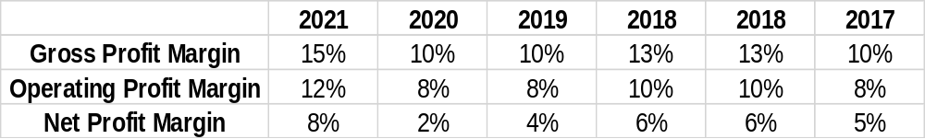
Gross Profit Margin has seen an overall growing trend over the five years in context. However, over the years 2019-2020 it decreased that could be due decrease in sales due the lockdowns and reasons behind the sales drop mentioned earlier.
Operating Profit Margin on the other hand has seen a different fluctuation from that of the the Gross Profit which is because the Gross Profit Maargin only incorporates the Cost of Goods sold which are directly linked with production and sales. Operating Profit Margin overall increased from 8% in 2017 to 12% in 2021. over the years 2019-2020 it decreased that could be due decrease in sales but the expenses didn’t decrease as much as the cost of goods sold therefore the Operating Profit Margin was lower in these years. It gained back and rose to 12% in 2021.

