**הנדסת תוכנה ואבטחת איכות תכנה במערכות מידע – מטלה 5**

Software Development Plan for “Hamka”



**החוג למערכות מידע אוניברסיטת חיפה**

**מגישים:**

|  |  |
| --- | --- |
| **מוחמד אדריס** | 314981598 |
| **אופיר סגל** | **205797210** |
| **שי בן חיים** | 308076553 |
| **ויאם שאהין** | 311182281 |

**State Design Pattern**

The main idea of State pattern is to **allow the object for changing its behaviour without changing its class.**Also, by implementing it, the code should remain cleaner without many if/else statements.

In our projects we used state design pattern to state when unique cell gets chosen by random, and the cell “get” a unique state:

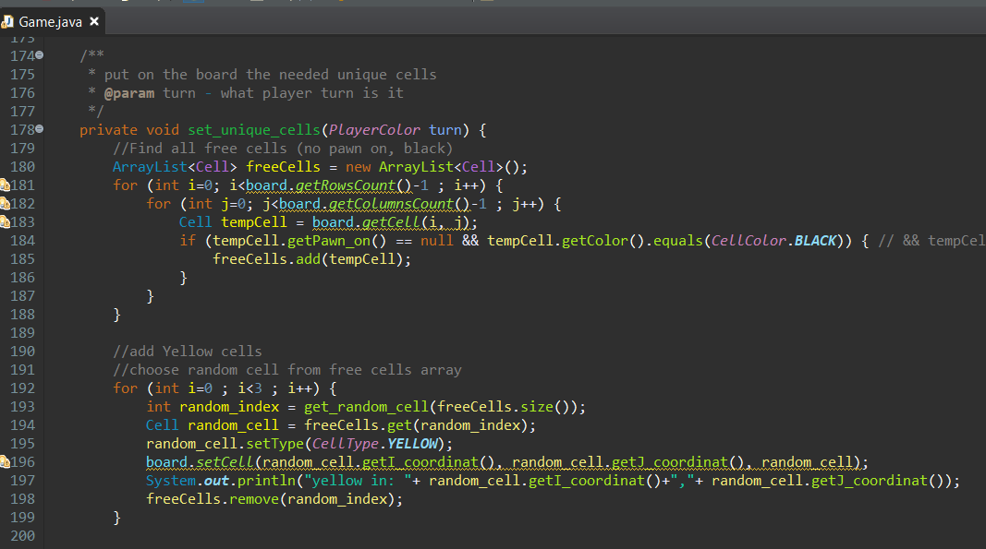

**Template Method Design Pattern**

Template method design pattern is to define an algorithm as a skeleton of operations and leave the details to be implemented by the child classes. The overall structure and sequence of the algorithm is preserved by the parent class.

In our project we used template method design pattern to defines a skeleton of an algorithm in the “Pawn” class and defers some steps to “Queen” subclass. “Queen” object gets all the ‘ability’ of the “Pawn” object, and get extra functionality declared in class.

Screen shots from the system code:

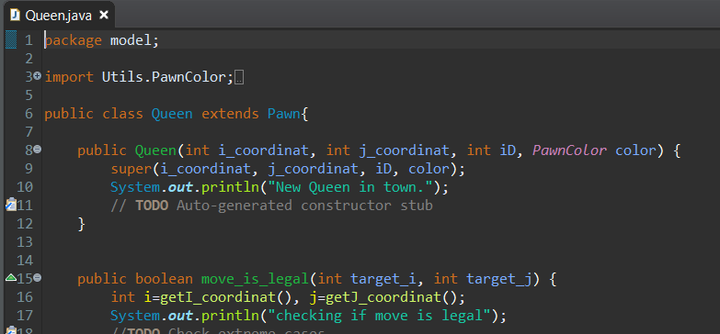

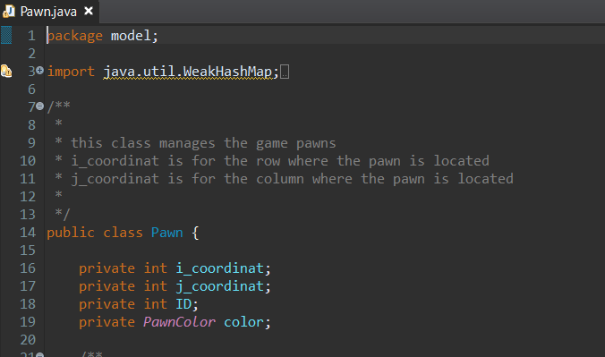

**Mediator Design Pattern**

**Mediator** is a behavioral design pattern that lets you reduce chaotic dependencies between objects. The pattern restricts direct communications between the objects and forces them to collaborate only via a mediator object.

In our project we used mediator design pattern in implementing the “Game” class. This class collaborate with other objects that connected to the actual game in our system. The communication located in the class to get management about the game and maintain rules and orders.

