**1. Find all players from team india**

**Query:  
  
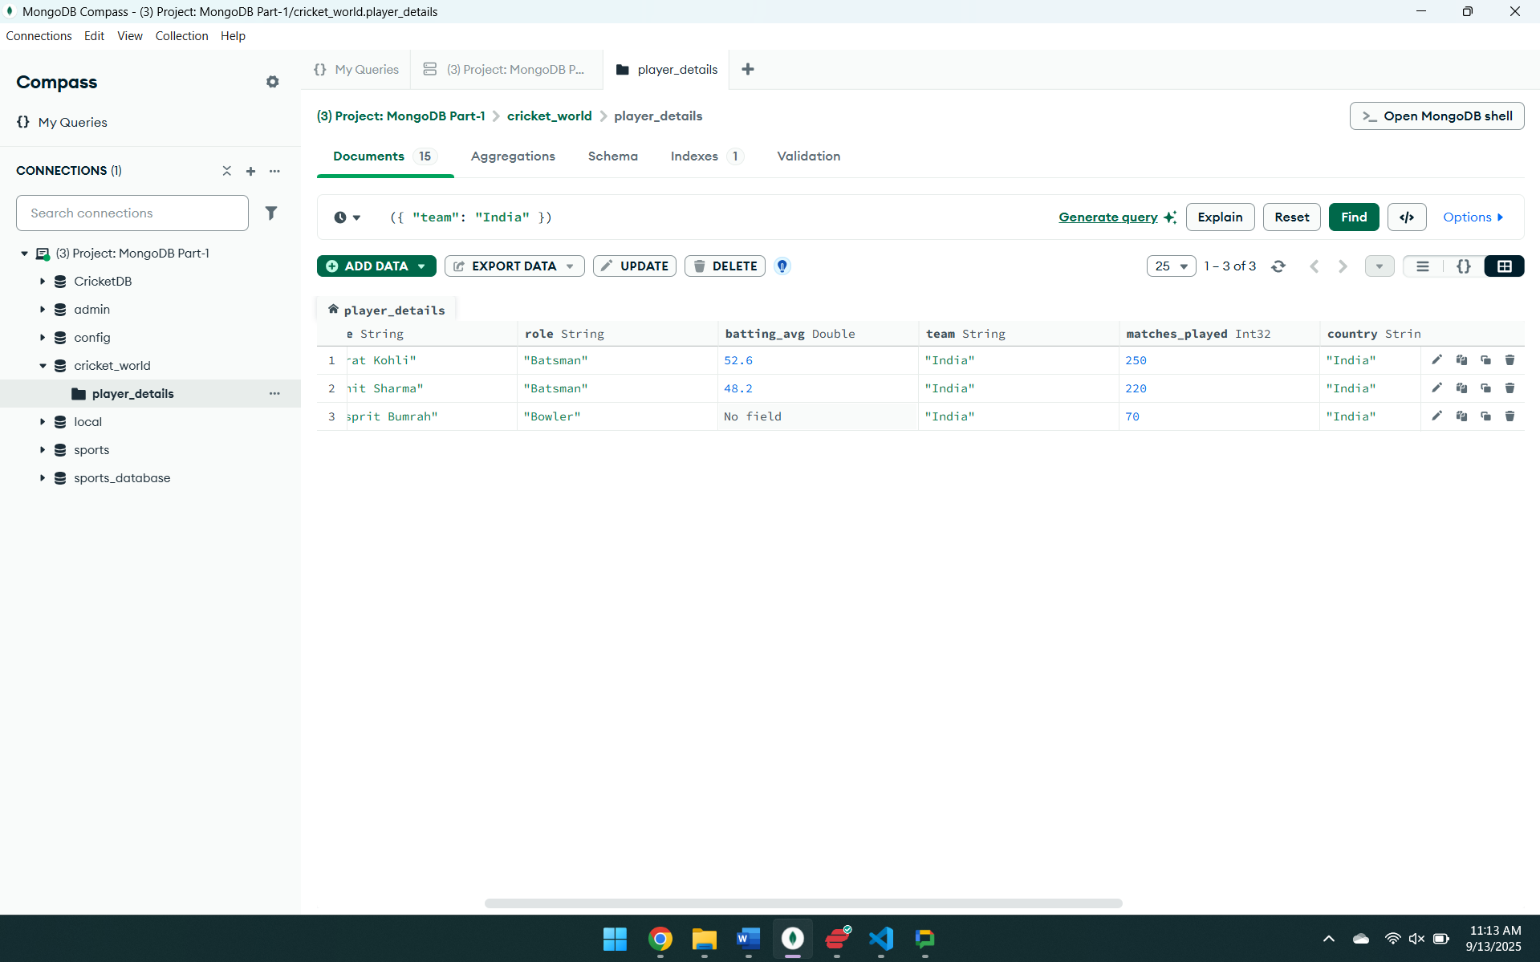**

**3. Get players who are all-rounders (both batting and bowling averages)**

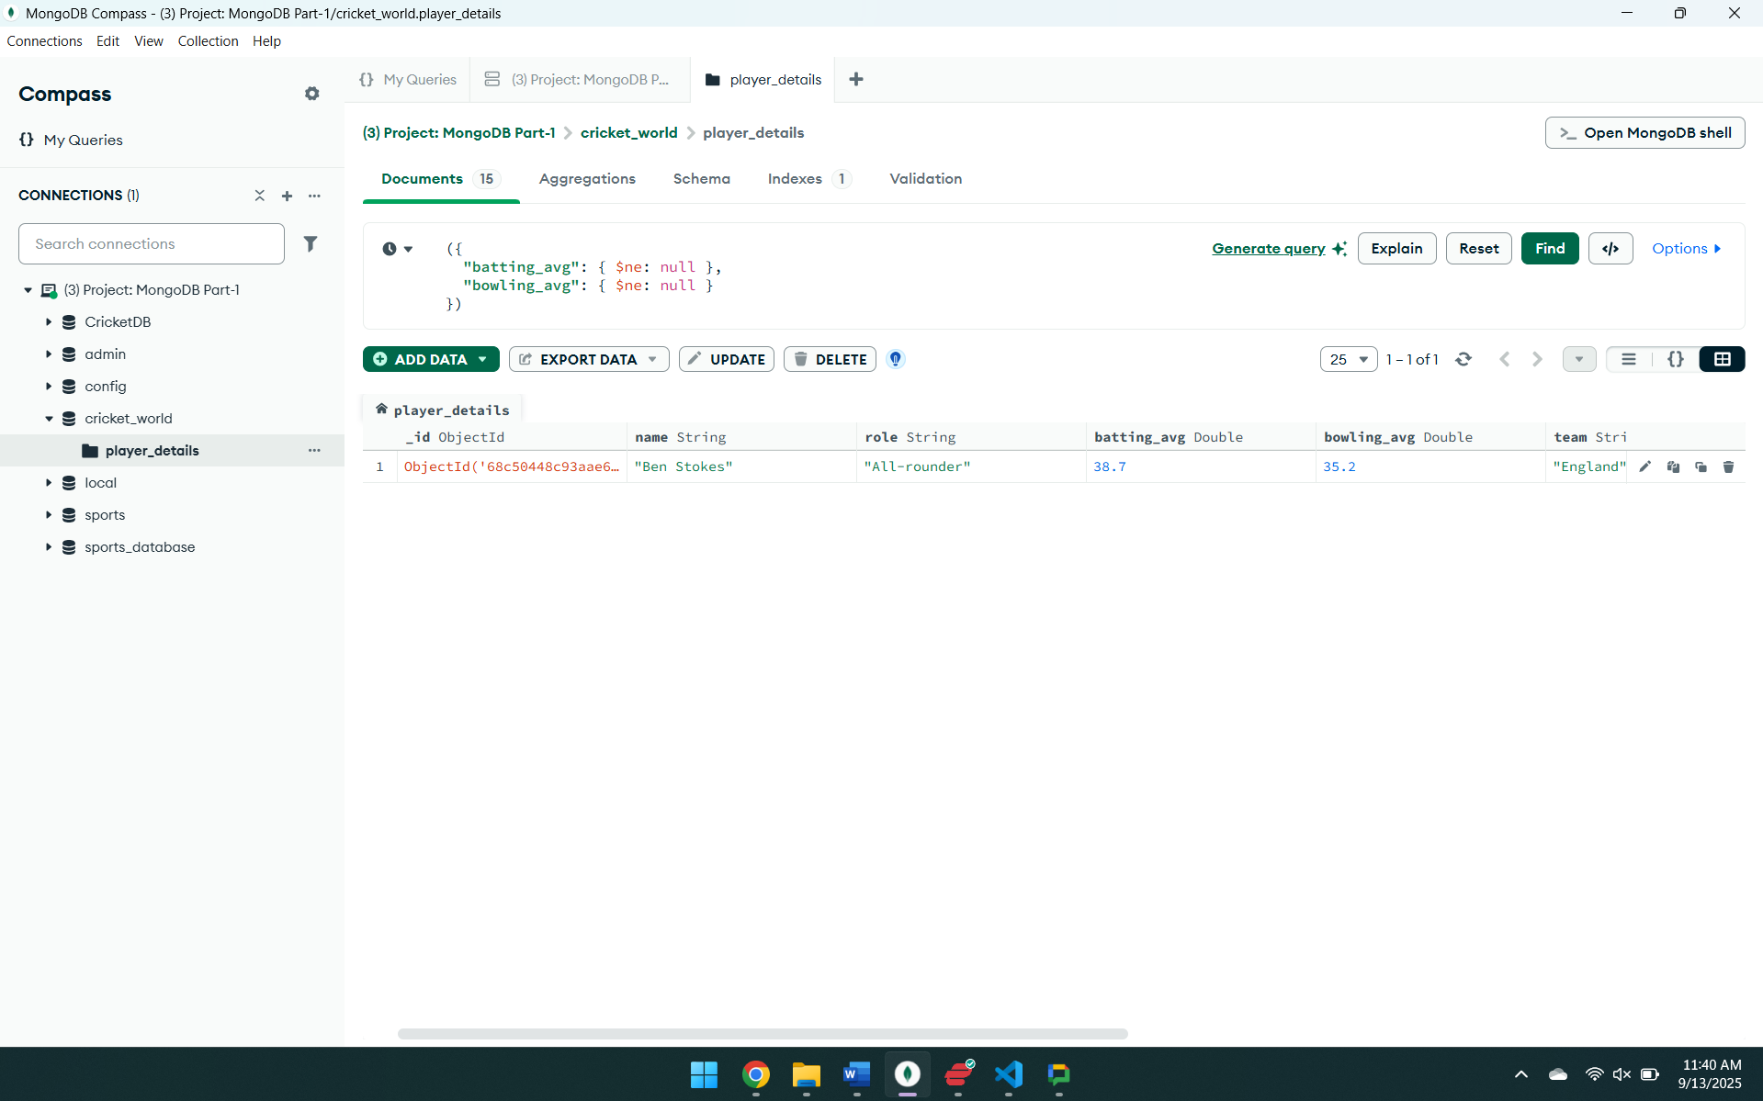

**4.Find all players who have a batting average between 40 and 50**

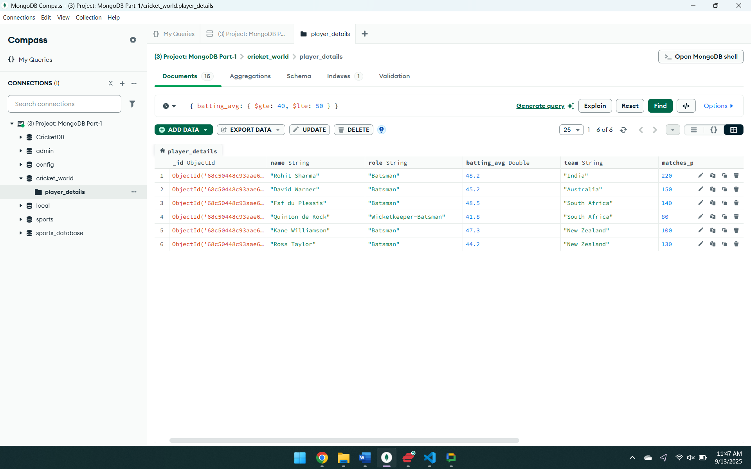

**5. Find players from a Australia are active**

