Код:

System.Reflection.Assembly assembly = System.Reflection.Assembly.GetExecutingAssembly();

MessageBox.Show(assembly.CodeBase, "CodeBase"); // или assembly.EscapedCodeBase – то-же

Результат:

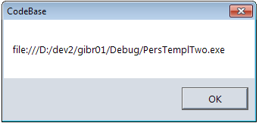

MessageBox.Show(assembly.Location, "assembly.Location");

Результат:

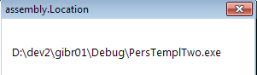

MessageBox.Show(assembly.FullName, "assembly.FullName");

Результат:

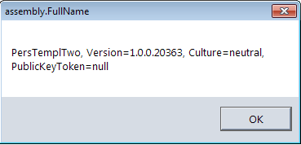

MessageBox.Show(assembly.ImageRuntimeVersion, "assembly.ImageRuntimeVersion");

Результат:

