Name: SHIVANG SINGH

Div: IC-C

Roll No: 49

Gr No- 11910405

Control Theory Lab4

Python Coding:

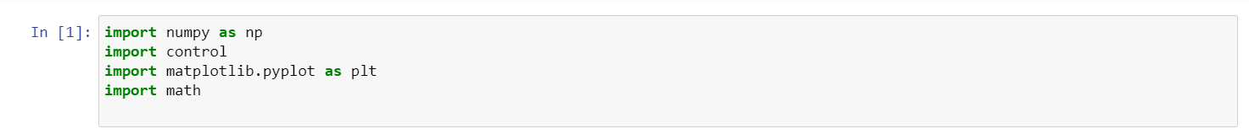

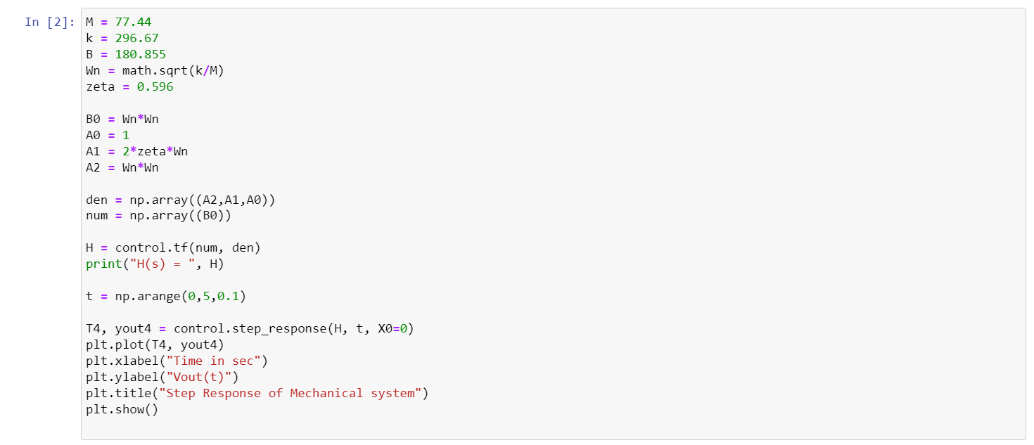

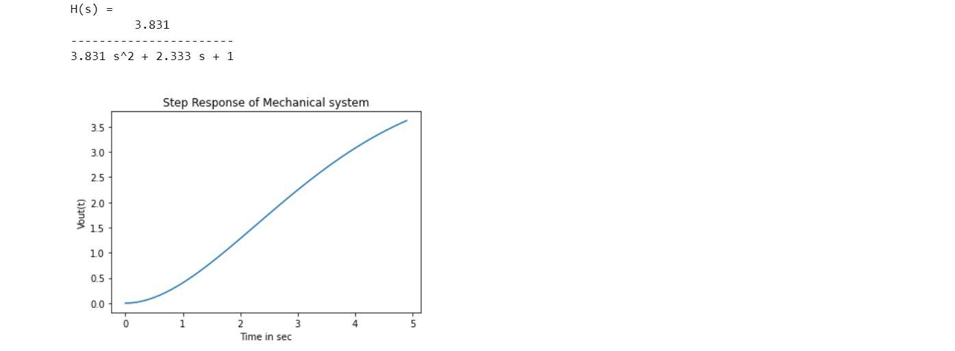

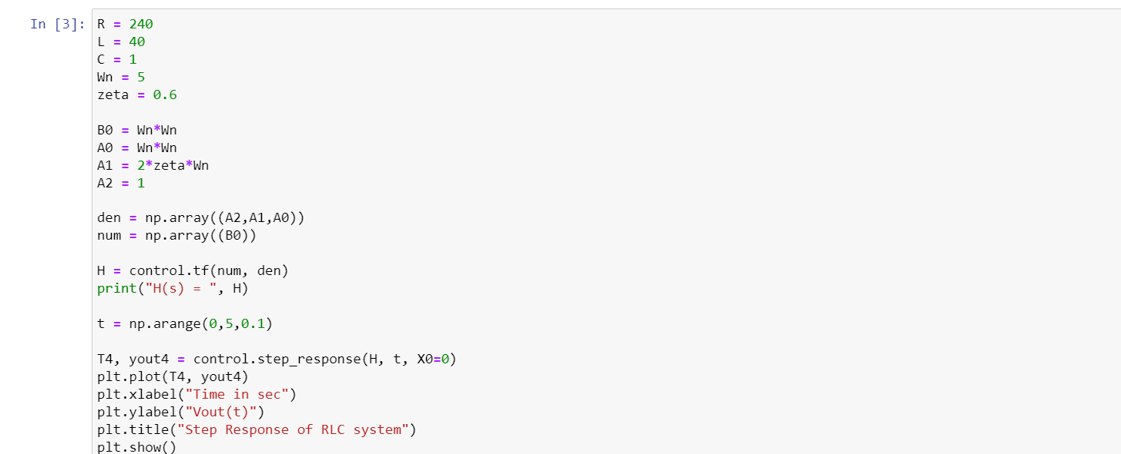

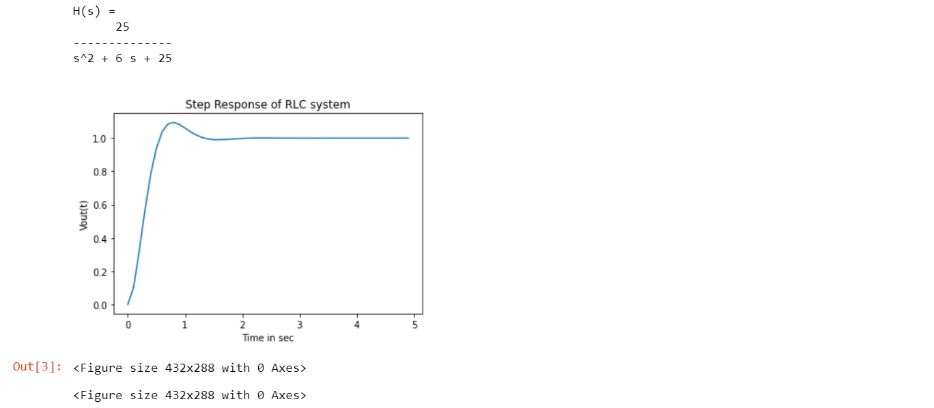

Learning Outcome:

1. 1st graph helps us to know how a plot zero graph is plotted with the given transfer function of a mechanical system and helps in easy visualization. In this we have also learned to plot the step response of the mechanical system using coding.
2. 2nd graph helps us to know how a plot zero graph is plotted with the given transfer function of a mechanical system and helps in easy visualization. In this we have also learned to plot the step response of the mechanical system using coding.