Name :- Aishwarya R. Satpute

Roll no :- 36

TY_IC_C

GR-No. 11911197

**Lab Assignment 10**

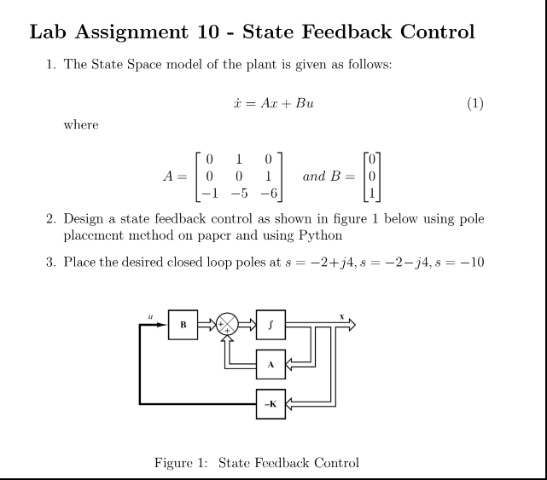

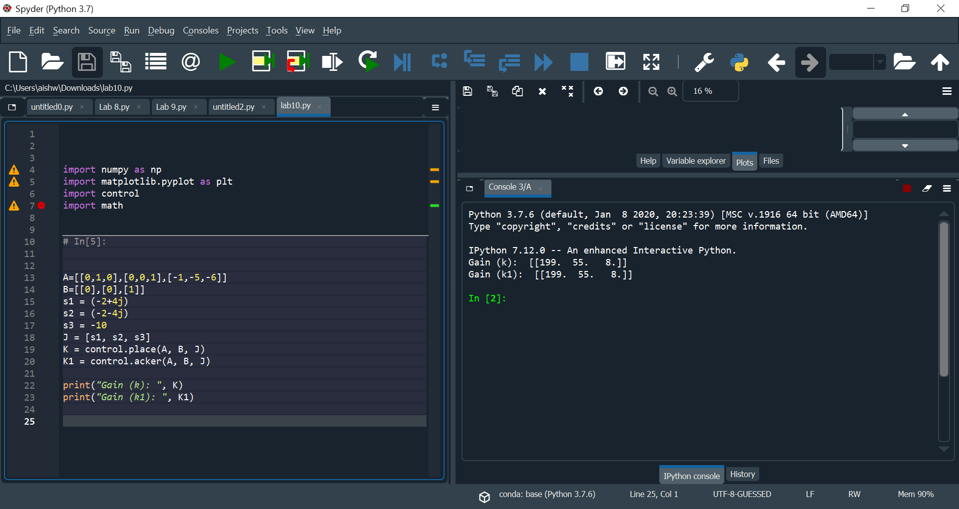

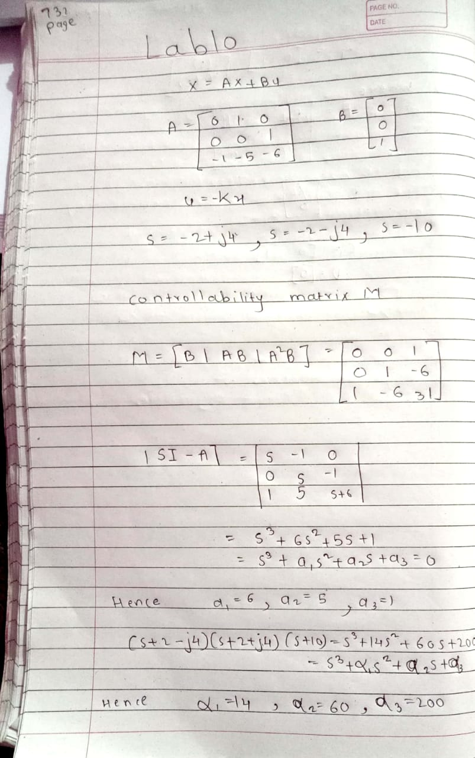

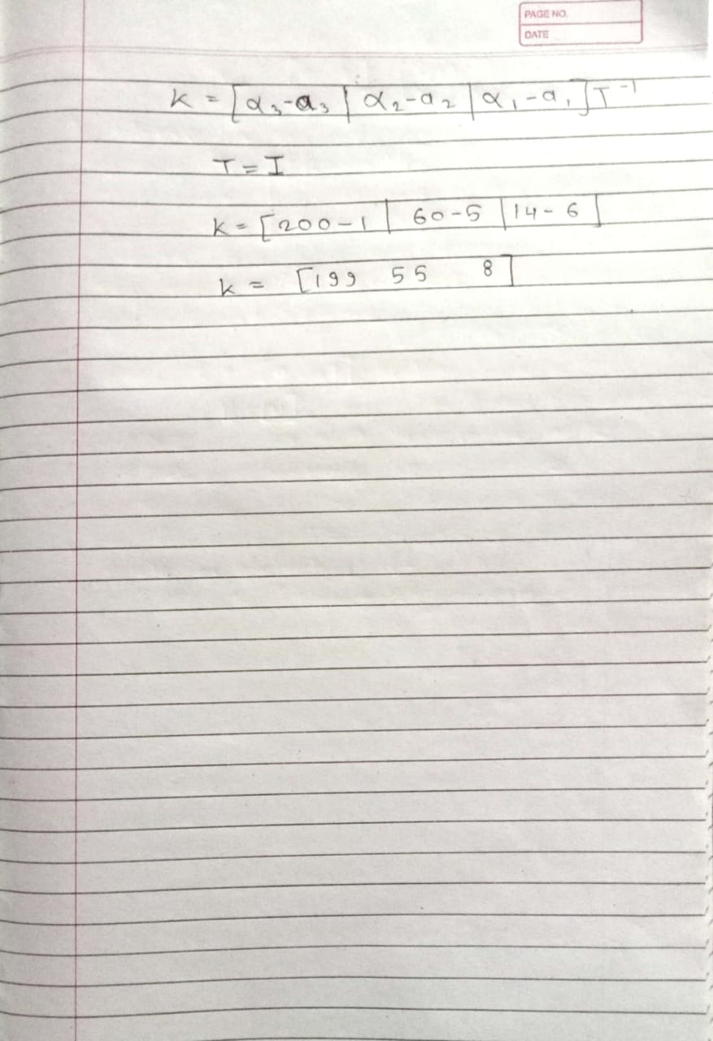

**Conclusion: -**

Conclusions: A state feedback controller gain matrix is obtained.

**Learning Outcomes:**

• Calculating the controllability matrix on paper in order to determine whether a state feedback controller can be applied on a system.

• Calculating the rank of controllability matrix.

• Using python functions to calculate the Controlability Matrix.

• Using Python function to get the State Feedback Gain Matrix