Name :- Aishwarya R. Satpute

Roll no :- 36

TY_IC_C

GR-No. 11911197

**Lab Assignment 9**

**Assignment Title: State Space Model to Transfer function and Step Response of the system**

**Q1**.

1. Obtain the State Space model of the system on paper and using Python.

• Consider the state variable as current i and voltage across the capacitor vc.

• Obtain the output state equations such that it would be possible to monitor output across capacitor and output across the resistor.

• Take R = 240Ω, C = 1mF, L = 40H

2. Convert the State space model to transfer function on paper and using Python.

3. Plot the step response of the system considers out across the capacitor and considering output across the resistor using Python?

Code and Code Screenshot: -

import control

import matplotlib.pyplot as plt

c = 0.001

L = 40

R = 240

A = [[0,1/c], [-1/L,-R/L]]

B = [[0],[1/L]]

C = [[1, 0],[0,R]]

D = 0

sys = control.ss(A, B, C, D)

print("STATE SPACE MATRICES : \n",sys)

tf = control.ss2tf(sys)

print("Transfer Function : \n", tf)

print(tf[0,0])

print(tf[1,0])

# control.step_response(tf[])

t, y = control.step_response(tf[0,0])

plt.plot(t, y)

# plt.title("Step Response 1")

# plt.xlabel("t")

# plt.ylabel("y")

t, y = control.step_response(tf[1,0])

plt.plot(t, y)

plt.title("Step Response 2")

plt.xlabel("t")

plt.ylabel("y")

plt.legend(["Step Response across Capacitor", "Step Response across Resistor"])

plt.show()

Output of Q1: -

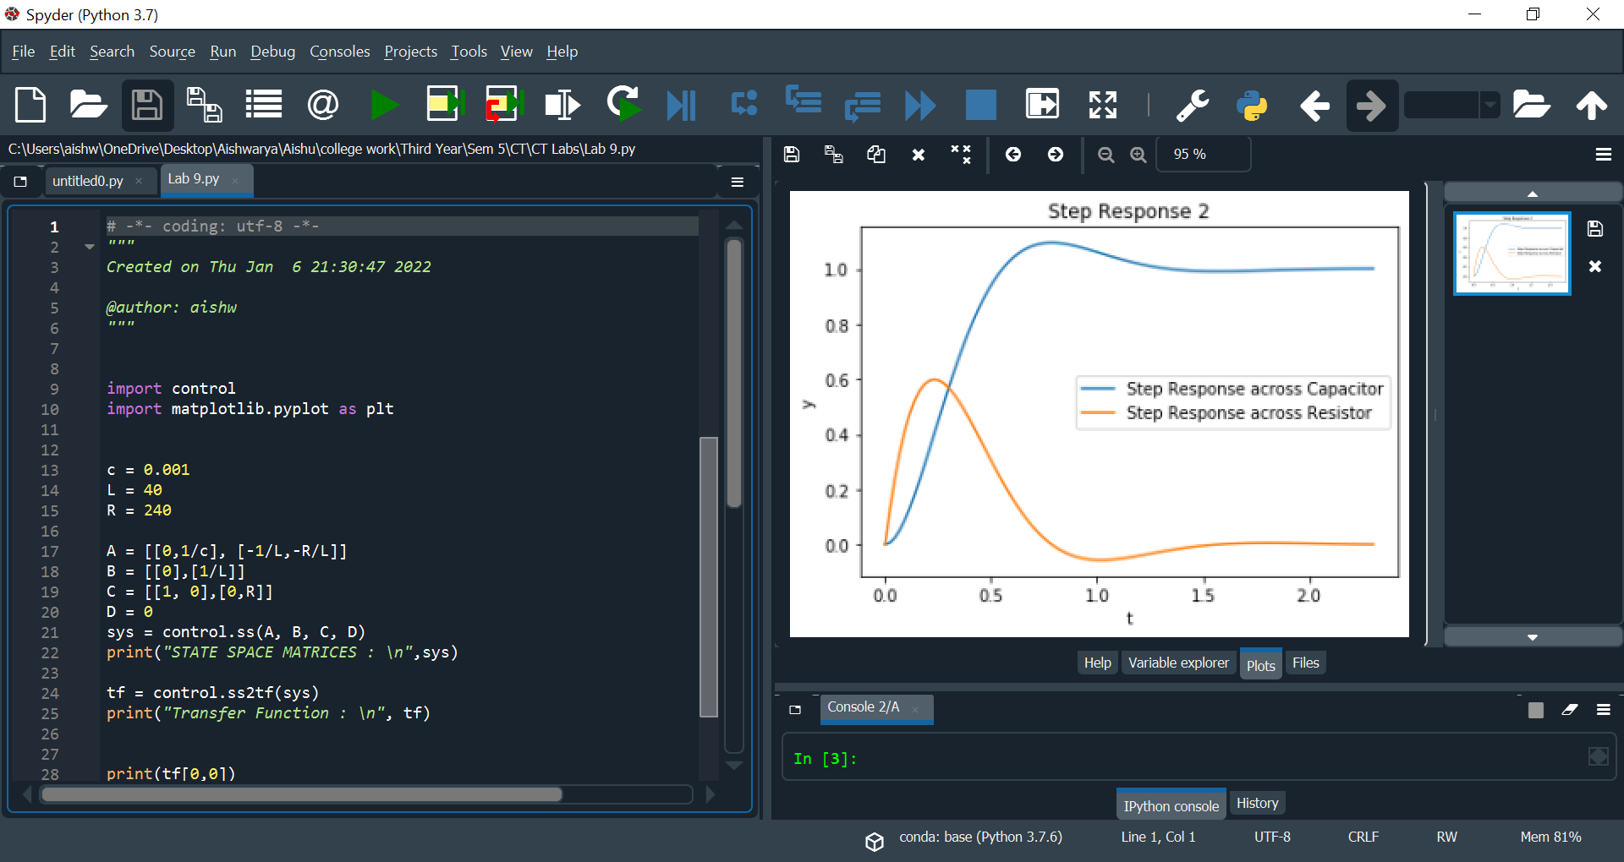

**Conclusion: -**

* We have learned how to plot State space graphs by writing code in Spyder, solving it on paper. This lab helped to know how Transfer function is used to get the values to plot. In this lab we have calculated the transfer function on paper for the state space and then we have computed the coding. In this lab we have also calculated different values if the matrix on paper
* In this lab we have also learned how to plot the step response of the state space model. In this lab we learned hoe the model can be converted in to transfer function and then plot graph across capacitor as well as resistor in single graph.
* In this we have also learned to find the different values of parameters in a state space model and the coding part as well. In this lab we learned hoe the model can be converted in to transfer function and then plot graph across capacitor as well as resistor in single graph. This graph helps us to know how a state space plot is plotted with the given transfer function of an open loop system and helps in easy visualization.