NAME: SHIVANG SINGH

DIV: IC-C

Roll NO- 49

GR No- 11910405

Control Theory LAB 1

Jupyter Notebook (Python) Coding:

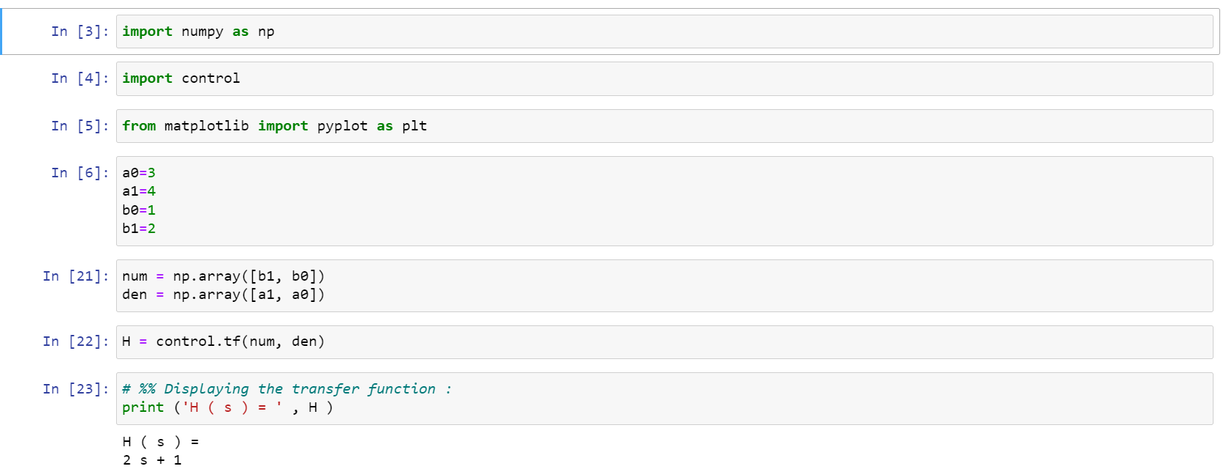

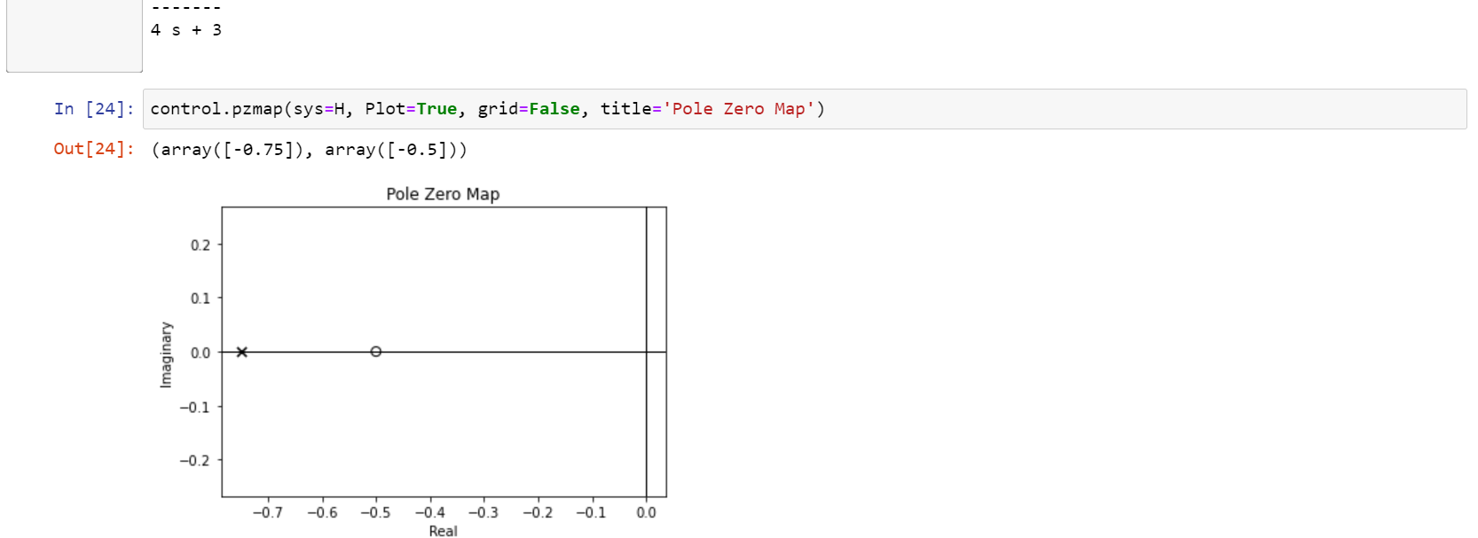

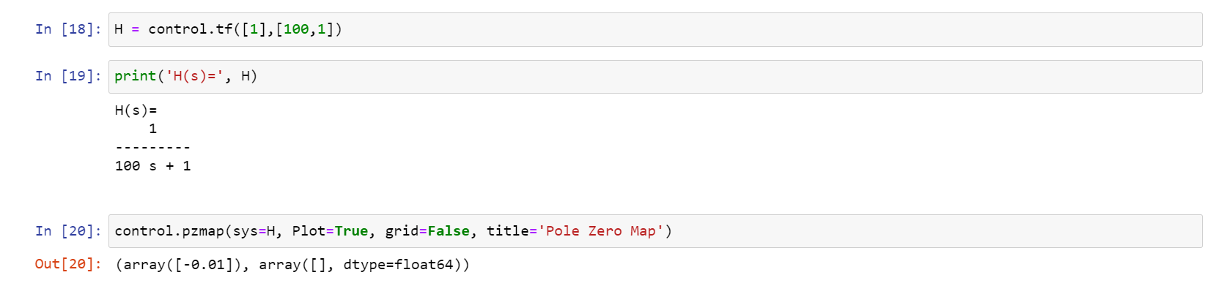

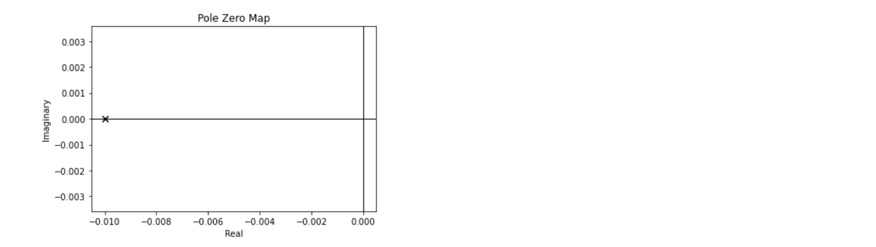

Hand Written:

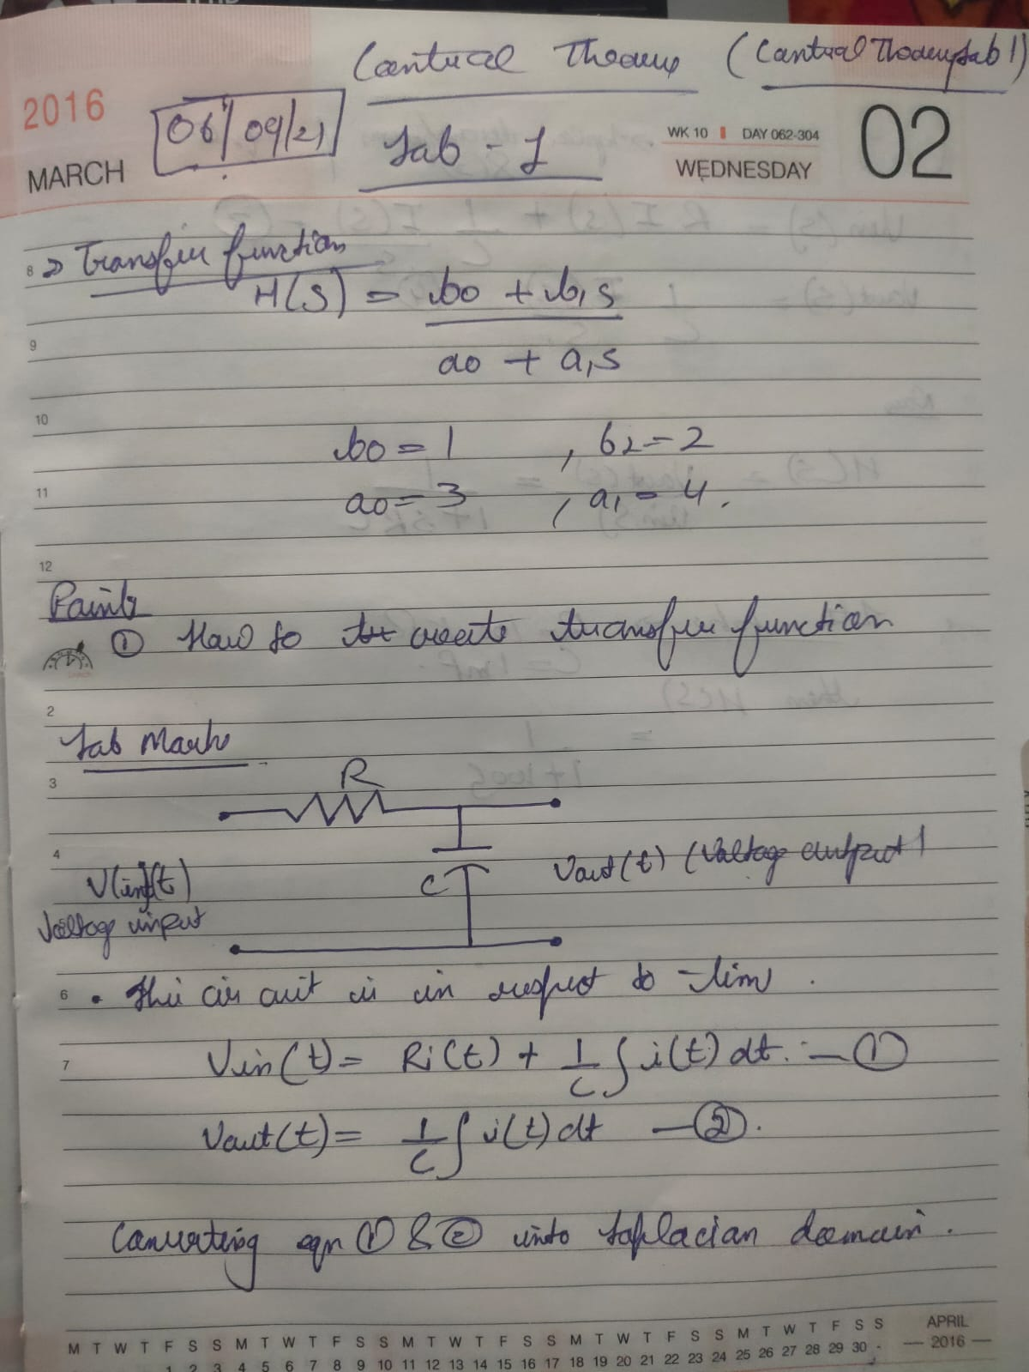

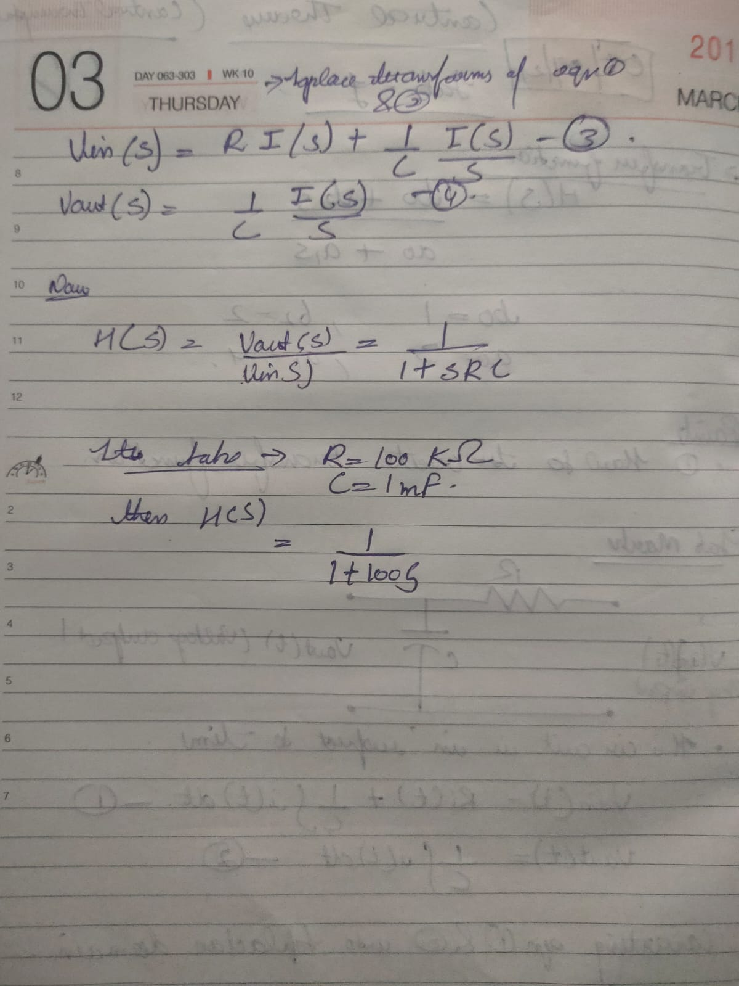

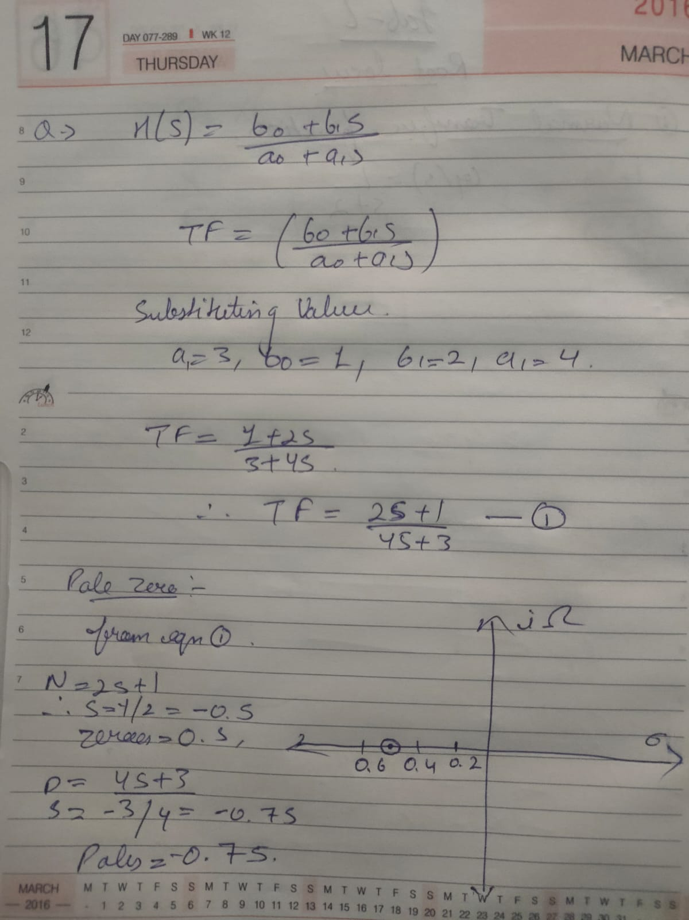

Learning Outcome:

1. We learned the concept of transfer function and how to plot their graphs for circuit like rc circuit etc.
2. understanding the concept of transfer function and pole zero plot.
3. It helps to know how transfer function is used to get the values to plot.