Shenzhen Shuangchi Technology Co., Ltd.
IOT-WiFi Module Introduction

Overview description
Shuangchi Wi-Fi module integrates wireless RF transceiver, basic network protocol and application communication protocol, and is connected to the downstream device through the serial port, so that it can be connected to the Wi-Fi A wireless access module for communication within a network. Using this module, users can connect home appliances or other devices to the Internet, enriching product functionality and improving product competitiveness.
Wi-Fi Module connection topology is shown below. On one hand, module is connected to the home appliance control system through the serial port. On the other hand, module can either work in STA mode, join the LAN where the wireless router is located, and thus connect to the WAN; or work in AP In this mode, it can be directly connected to mobile terminals such as mobile phones. However, for home appliance control systems, they only face simple serial port communication and do not need to worry about the details of network communication implementation.
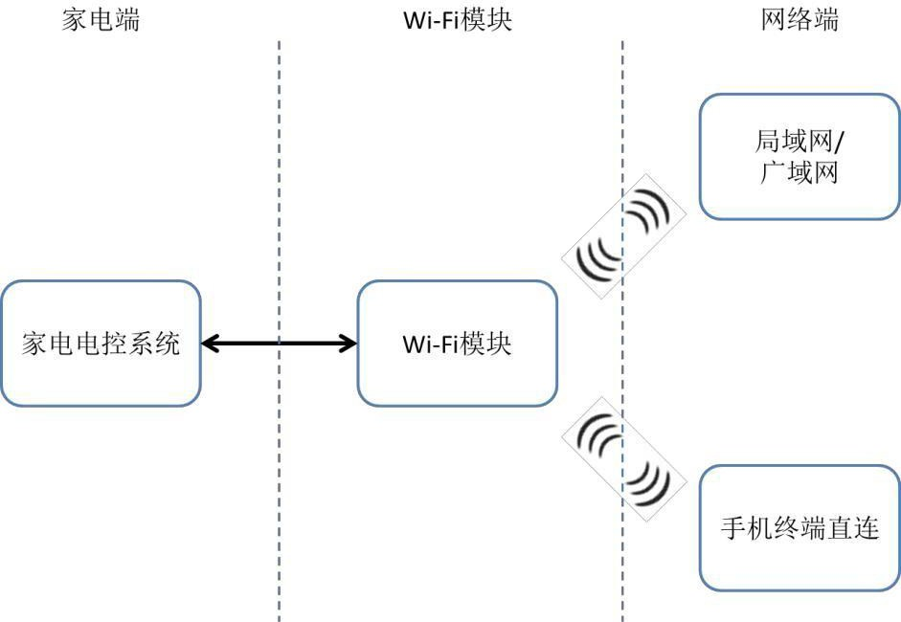
Data transparent transmission is Wi-Fi module's basic functionality. Transparent transmission means module only requires that transmitted messages conform to the communication protocol's encapsulation format, without parsing the specific content. Developers can freely define control protocols suitable for their own devices, ensuring the relative independence of their own protocols, facilitating R&D and subsequent upgrades.

Version | Date | ChangeLog | Production | Approve
v1.0 | 2014-05-30​ | First issuance | Ivy | Billy
v1.2 | 2014-09-15​ | PCB without housing | Ivy | Billy
v1.3 | 2014-11-17 | Increase IoT product design | Ivy | Billy
v1.4 | 2015-04-07​ | Increase IoT design | Ivy | Billy

Wi-Fi from a technical perspective Modules, including:
- Wi-Fi Module Hardware Specifications
- Wi-Fi Basic functions of module software
- Wi-Fi Serial communication protocol
- IoT Product Design Guidelines

Wi-Fi Module Hardware Specifications

Overview
Shuangchi Wi-Fi Module integrates wireless RF transceiver, basic network protocol and application communication protocol, and is connected to the downstream device through the serial port, enabling wireless access to communicate in the Wi-Fi network.
With this module, users can connect home appliances or other devices to the Internet, enriching product functions and improving product competitiveness.
This document mainly introduces Wi-Fi Module's electrical parameters, environmental parameters, RF parameters, circuit interface, mechanical dimensions, external labels, etc.
Shuangchi Wi-Fi Module includes 5V and 3.3V power supply versions. In terms of product form, there are two configurations: with or without a housing. Unless otherwise specified, this article describes the 5V housing version.
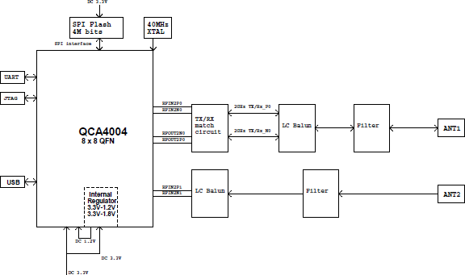
Principle Block Diagram

Basic electrical parameters

Parameter | Illustrate | Numerical | Condition
Vcc | Input voltage | 5V +/- 0.5% or | - -
Vcc | Input voltage | 3.3V +/- 0.5% | - -
Iavg | Average current | 65-80mA​ | Vcc = 5.0V
Imax | Peak current | 240mA | Vcc = 5.0V

Environmental conditions
Operating temperature: 0-85 ℃
Operating humidity: 5%-95%RH (non-condensing)
Storage temperature: -40-135 ℃
Storage humidity: 5%-95%RH (non-condensing)

RF parameters
WLAN standards | 802.11 b/g/n
Frequency range | 2.4-2.4835 GHz (ISM Frequency band)
Modulation method | DSSS, OFDM, DBPSK, DQPSK, CCK, 16-QAM, 64- QAM
Channel | 1- 14
Output power | 18 +/-2dBm @11b mode 14 +/-2dBm @11g mode  13 +/-2dBm @11n-HT20 Mode 12 +/-2dBm @11n-HT40 mode
Receive sensitivity | <-76 dBm @11b mode
Receive sensitivity | <-65 dBm @11g mode
Receive sensitivity | <-64 dBm @11n-HT20 mode
Receive sensitivity | <-61 dBm @11n-HT40 mode
Data transfer rate | Maximum 11Mbps @11b mode
Data transfer rate | Maximum 54Mbps @11g mode
Data transfer rate | Maximum 65Mbps @11n-HT20 mode
Data transfer rate | Maximum 135Mbps @11n-HT40 mode
Security Mechanism | 64/128/152 WEP​ encryption;
Security Mechanism | WPA-PSK/WPA2-PSK, WPA/WPA2 Security Mechanism
Antenna Type | Onboard antenna
Networking | STATION Mode, AP mode

Digital circuit interface

Hardware interface definition (using connecting wires)
Pin pitch | SIP 2.54mm
Device schematics | 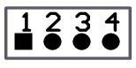
Pin Function
1 | VCC(5V or 3.3V)
2 | RX (WI-FI Module data input port)
3 | TX (WI-FI Module data output port)
4 | GND (ground)
Serial port parameters:
The baud rate defaults to 9600 and can be as high as 115200. Data bits 8 bit, parity bit none, stop bit 1 Bit.

Interface level:
5V digital circuit interface of module complies with CMOS level specifications are as follows:
Parameter | Illustrate | Numerical | Condition
VOL | Output low level threshold | <= 0.5V | VCC = 5V
VOH | Output high level threshold | >= 4.45V | VCC = 5V
VIL | Input low level threshold | <= 1.5V | VCC = 5V
VIH | Input high level threshold | >= 3.5V | VCC = 5V
3.3V digital circuit interface of module complies with LVCMOS level specifications are as follows:
Parameter | Illustrate | Numerical | Condition
VOL | Output low level threshold | <= 0.1V | VCC = 3.3V
VOH | Output high level threshold | >= 3.2V | VCC = 3.3V
VIL | Input low level threshold | <= 0.7V | VCC = 3.3V
VIH | Input high level threshold | >= 2.0V | VCC = 3.3V
At both input levels, the digital IO current allowed by the port is -10mA (sink current) ~10mA (source current), the flip rate is 2MHz.
Wi-Fi Module has passed the SRRC of the Ministry of Industry and Information Technology Certification.

Wi-Fi Basic functions of module software

Overview
Shuangchi Wi -Fi Module integrates wireless RF transceiver, basic network protocol and application communication protocol, and is connected to the downstream device through the serial port, so that it can Wi - Fi A wireless access module for communication within a network. Using this module, users can connect home appliances or other devices to the Internet, enriching product functionality and improving product competitiveness.
This document mainly introduces Wi-Fi main functions of module software.

Initialization process
After module is powered on and reset, it will enter the initialization state and read the electronic ID of the home appliance. After that, the network connection function will be provided. After that, module determines whether the network parameters have been configured. If so, it enters STA mode. If not configured, it enters AP mode.
AP In this mode, module generates a file named sctech_XX_yyyy wireless hotspot for mobile phone APP.
Connection, mobile APP tells module information about the route to which it will connect.
STA In this mode, module is connected to the user-specified router as a terminal device and uses DHCP to obtain its own IP address and achieve normal network communication.

Reconnecting after a router is disconnected
Module in STA When the connection with the router is lost in mode, it will immediately try to reconnect. If it fails after a certain number of retries, it will temporarily switch to AP mode to facilitate users to reconfigure routing information. Mode starts 150s later When the countdown ends, switch back to STA When a valid message is received in AP mode, the countdown is reset to 150s and starts again.

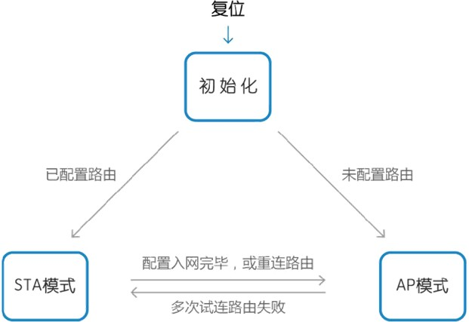

Configuring routing information
When module has not saved the routing configuration information, enter AP mode to create a wireless hotspot.
Mobile APP Connect to this hotspot and enter the router information (network SSID Then send a command to switch module to STA mode.
Module 1 enters STA mode, it will automatically connect to the specified route and obtain the IP from the route address,
This enables communication within the local area network.
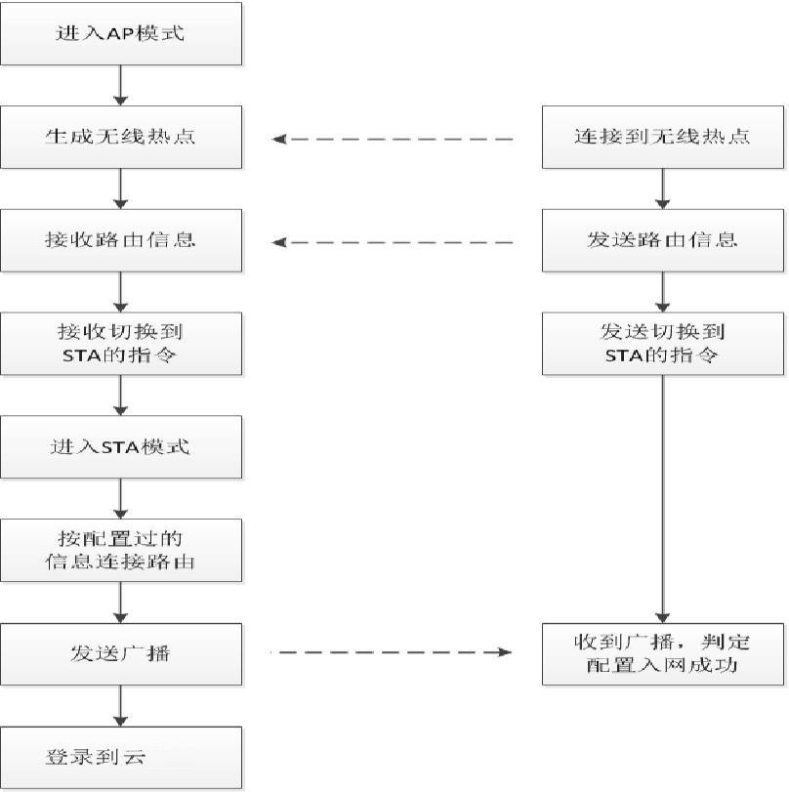
After connecting to the router, module automatically logs into the cloud server to realize WAN communication.

Connection to cloud server
Once module is connected to the router, it will automatically log in to the Meiyun server. The server's domain name is written in module's firmware and is resolved through the public DNS service.
After successful login, module sends heartbeat packets to the server at regular intervals, and the server returns a response. The server monitors the online and offline status of the home appliance through heartbeat. On the other hand, if module does not receive If module does not receive a heartbeat response from the server, it determines that it has been disconnected from the server. After disconnection, module will reconnect to the server after a delay.

Data transparent transmission
Wi-Fi Module acts as a bridge between the network (server and app) and home appliances, forwarding data packets from one end to the other. This function is called transparent data transmission. Transparent data transmission means that module is not concerned with the specific content of the transmitted message; it only requires that the message's external form conform to the encapsulation format required by the communication protocol. In other words, the Wi-Fi module acts only as a channel, and message content analysis is performed at both ends of the channel.
Two directions: uplink (from home appliance to network) and downlink (from network to home appliance). Uplink transparent transmission can be either requiring a response or not. The business process is shown in the figure below:

Uplink transparent transmission
(No response)


Uplink transparent transmission
(Response required)

Downlink transparent transmission

Module filters the types of transparently transmitted messages. Only specified message types can be transparently transmitted (whitelist). Other types of messages cannot pass through. For details on transparently transmitted message types, please refer to the Serial Port Communication Protocol.

Online Upgrade
When module is powered on, it will automatically query the server every day to see if there is any available firmware upgrade. If so, it will automatically download the upgrade file.
After the download is complete, module verifies the upgrade file. If the verification is wrong, it means that the downloaded upgrade file is damaged and module will not use it. If the verification is correct, module will modify the relevant internal configuration information and then
Run the upgraded new firmware after the first reset.
Module monitors the number of connections and data volume between the mobile phone and module to determine whether the current user's interaction with the home appliance is idle; when idle, module automatically resets and restarts to complete the firmware upgrade.

Serial communication protocol

Preface
Shuangchi Wi-Fi Module integrates wireless RF transceiver, basic network protocol and application communication protocol, and is connected to the downstream device through the serial port, so that it can be connected to the Wi-Fi A wireless access module for communication within a network. Using this module, users can connect home appliances or other devices to the Internet, enriching product functionality and improving product competitiveness.
the Wi-Fi used in IoT appliances Software design specifications for communication between module and home appliance, UART between module and home appliance Communication protocol, module processing of legal messages, module working status and software functions, etc.

Definition of terms
Wi-Fi Module: Implementing UART and Wi-Fi Communication conversion products, also referred to as module home appliance end /UART end in this article: Asynchronous serial communication link between the Wi-Fi module and the home appliance electronic control system
Network /Wi-Fi Terminal: Wi-Fi Module is connected to the local area network or wide area network through wireless, and the data link communicates with mobile terminals such as mobile phones or servers
STATION ： Wi-Fi A working mode of module, abbreviated as STA, module acts as a wireless network terminal end
AP : Wi-Fi A working mode of module, namely Access Point, module is connected as a wireless network point
Electronic ID : A unique identifier for IoT home appliances, similar to a product serial number.

1. Topology
In the figure, Wi-Fi Module is implemented through UART communication interface is connected to the home appliance control system. It is called the home appliance end, or UART on other hand, module either works on STA mode, added to wireless LAN where the router is located is connected to the WAN; or it works on AP. In this mode, it can be directly connected to mobile terminals such as mobile phones. However, for home appliance control systems, they only face simple serial port communication and do not need to worry about the details of network communication implementation.

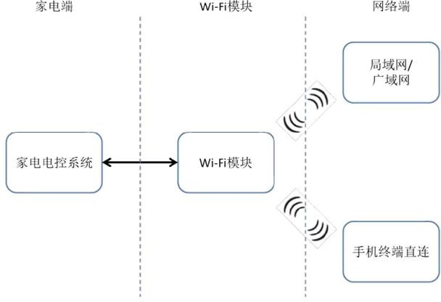
Wi-Fi Connection topology of modules

2. Communication protocol from module to home appliance

Underlying protocol
Wi-Fi communication between module and the home appliance control system adopts standard asynchronous serial communication (UART). Communication configuration: baud rate 9600 bit/s, data bit 8 bit, parity bit none, stop bit 1 bits, full duplex.
Wi-Fi smallest unit of communication between module and the home appliance is a data packet, or data frame, which is in a certain format.
A set of multiple bytes arranged in a sequence. The total length of the data packet should be less than or equal to 256 bytes.

Data format

Field division
Wi-Fi Communication data format between module and home appliance
 | Field |  |  | Length
 | Synchronous header |  |  | 1 BYTE
 | Message length |  |  | 1 BYTE
 | Appliance Type |  |  | 1 BYTE
 | Frame synchronization check |  |  | 1 BYTE
 | Reserved |  |  | 2 BYTE
 | Message ID |  |  | 1 BYTE
 | Framework Agreement Version |  |  | 1 BYTE
 | Home Appliance Protocol Version |  |  | 1 BYTE
 | Message type identifier |  |  | 1 BYTE
 | Message body |  |  | N BYTE
 | Message checksum |  |  | 1 BYTE
2.2.2 Field Description
2.2.2.1 | Synchronous header
Fixed to 0xAA.
2.2.2.2 | Message length
An unsigned integer of 8 bits. Its value is the number of bytes from the message length byte to the message check code byte; that is, message length = N + 10, where N is the number of bytes in the message body.

Appliance Type
Indicates the type of appliance. 0xFF Indicates the type of broadcast appliance, which can refer to any appliance.

Frame synchronization check
Frame synchronization check = message length XOR Appliance type. In time frame mode, the appliance can be filled with 0 when sending to module ; otherwise, a correct XOR value must be entered. See Section 4.3.
      - Reserved
The default fill is 0.

Message ID
The message identifier is used for message pairing. In continuous frame mode, the message identifier of the response message must be consistent with that of the request message.

Framework Agreement Version
This field identifies the protocol version used by the communicating parties. Currently unused, its value is irrelevant.

Home Appliance Protocol Version
Defined by home appliances. Currently unused, its value is irrelevant.

Message type identifier
The message type identifier is Wi-Fi basic command type for communication between module and the appliance. The message type identifier also serves as a response verification function. A typical appliance communication consists of two transmissions: a request and a response. If the response message type identifier value equals the request message type identifier value, it indicates that the message is a response to the request.

Home appliance message type identification list
Message Type | Type Identifier
Device control commands | 0x02
Device query command | 0x03
Device operating parameter reporting (no response) | 0x04
Equipment operating parameter reporting (requires response) | 0x05
Device abnormal event reporting (no response) | 0x06
Device electronic ID Get | 0x07
Reporting of device abnormal events (requires response) | 0x0A
Device networking notification | 0x0D
Device electronic ID Write | 0x11
SSID Rename | 0x12
Reading MAC Address | 0x13
Time calibration | 0x61
Home appliance query network and signal status | 0x63
Turn Wi-Fi on and off Signal Command | 0x68
Wi-Fi Parameter configuration | 0x6A
Home Appliance Query AP List | 0x6B
Wi-Fi Working mode switching | 0x81
Wi-Fi Module restart | 0x82
Wi-Fi Restore module to factory settings | 0x83
Home appliance model and basic information query | 0xA0

Message body
The message body contains data related to control, query, and abnormal data reporting for each product category. The length and content of the message body are defined separately for different home appliances. Wi-Fi module does not parse the content within the message body.
The maximum length of the message body is limited to 245 bytes.

Message checksum
Verification method: Message check code = ~sum (message length + appliance type + frame synchronization check + reserved + message identifier + framework protocol version + appliance protocol version + message type identifier + message body) + 1 ; that is, sum and then take the two's complement. If overflow occurs during the summation process, the overflow high bit is directly discarded.

2.2.3 Transmission Order
Within a byte, the transmission order is always low order first and high order last. The order between bytes is as follows
Down:
- For integer or floating point data, the low byte is in front and the high byte is in the back during transmission, that is, in little endian mode.
transmission;
- For string format data, it is transmitted in the order in which it is written, that is, byte by byte from left to right;
- For other structures composed of multiple bytes, according to the defined byte sequence number, start from Byte0 Start uploading
lose.

3. Message Processing

Messages received by module from the home appliance

Device operating parameter reporting (no response) — 0x04
Used for transparent transmission of data from the appliance to the network (no response required). Module does not respond to this type of message.
Analyze the content.

Device operating parameter reporting (response required) — 0x05
Used for transparent data transmission from the home appliance to the network (requiring a response). Module does not parse the content of this type of message. After receiving the response from the network, module returns a response to the home appliance.

Device abnormal event reporting (no response) — 0x06
Used for transparent transmission of data from the appliance to the network (no response required). Module does not respond to this type of message.
Analyze the content.

Device abnormal event reporting (response required) — 0x0A
Used for transparent data transmission from the home appliance to the network (requiring a response). Module does not parse the content of this type of message. After receiving the response from the network, module returns a response to the home appliance.

SSID Rename — 0x12

Only in AP After receiving the message, module will send the network hotspot SSID Change the name to the one specified in the message and clear the stored SSID and password information.
Uplink message:
byte | bit field | Meaning and value description
0 | 0-7​ | SSID Character length (N <= 32)
1- N | 0-7​ | SSID name
Downlink response:

byte | bit field | Meaning and value description
0 | 0-7​ | 0 : Rename successful; other: Failed.

Time calibration — 0x61
Uplink request message body:
byte | bit field | Meaning and value description
0-19​ |  | Reserve
Downlink response message body:
byte | bit field | Meaning and value description
0 | 0-7​ | Time - seconds (0~59)
1 | 0-7​ | Time - Minutes (0~59)
2 | 0-7​ | Time - hour (0~23)
3 | 0-7​ | Time - week (0~6) ; 0-6 Sunday to Saturday
4 | 0-7​ | Day (1~31)
5 | 0-7​ | Month (1st to 12th)
6 | 0-7​ | Year (00~99)
7 | 0-7​ | Time zone (default is 0x08)
8~19 | 0-7​ | Reserved, 0x00
    - Home appliance queries network and signal status — 0x63 Uplink request message body:
byte | bit field | Meaning and value description
0-19​ |  | Reserve
Downlink response message body:

byte | bit field | Meaning and value description
0 | 0-7​ | Module Type:
0 | 0-7​ | 0x00, RF module
0 | 0-7​ | 0x01, WI-FI Module
1 | 0-7​ | WI-FI Module working mode:
1 | 0-7​ | 0x01, Client mode
1 | 0-7​ | 0x02, Configuration Mode
1 | 0-7​ | 0x03, AP mode
2 | 0-7​ | WI-FI Signal Strength:

 |  | 0x00, no signal
 |  | 0x01, signal strength level 1 (weak)
 |  | 0x02, signal strength level 2
 |  | 0x03, signal strength level 3
 |  | 0x04, signal strength level 4 (strong)
 |  | 0xFF, WI- FI not supported
3- 6 | 0-7​ | WI-FI Module IP address
7 | 0-7​ | RF Signal Strength:
7 | 0-7​ | 0x00, no signal
7 | 0-7​ | 0x01, signal strength level 1 (weak)
7 | 0-7​ | 0x02, signal strength level 2
7 | 0-7​ | 0x03, signal strength level 3
7 | 0-7​ | 0x04, signal strength level 4 (strong)
7 | 0-7​ | 0x05, not registered (not associated with the gateway)
7 | 0-7​ | 0xFF, RF not supported
8 | 0-7​ | Router Status:
8 | 0-7​ | 0x00, connected to the wireless router (normal, others are abnormal)  0x01, not connected to wireless router  0x02, connecting to wireless router  0x03, password verification error  0x04, wireless router not found  0x05, IP cannot be obtained  0x06, wireless is unstable  0xFF, WI-FI Fault
9 | 0-7​ | Cloud service connection status:
9 | 0-7​ | 0x00, connected to the cloud service center (normal, others are abnormal)
9 | 0-7​ | 0x01, not connected to the cloud service center
9 | 0-7​ | 0x02, unstable Internet connection
9 | 0-7​ | 0x03, domain name resolution error
9 | 0-7​ | 0x04, Cloud service connection refused
9 | 0-7​ | 0x05, cloud service maintenance
9 | 0-7​ | 0xFF, cloud service failure
10 | 0-7​ | 0x00 : No connection / connection has been disconnected
10 | 0-7​ | 0x01 : Connected / Mobile terminal connected
11 | 0-7​ | TCP established by module Number of connections
12- 19 |  | Reserved, 0x00

Wi-Fi signal on /off command — 0x68
After receiving this command, module turns Wi-Fi on or off according to the message content. RF signal transmission and reception. Uplink message:

 | Byte | illustrate
 | 0 | 0 : Turn off Wi-Fi Signal transmission and reception;
 | 0 | 1 : Turn on Wi-Fi Signal transmission and reception;
 | 1 | Reserved, filled with 0
 | 2~19 | Reserved, filled with 0
Downlink message:
 | Byte | illustrate
 | 0 | 0 : Turn off Wi-Fi Signal transmission and reception;
 | 0 | 1 : Turn on Wi-Fi Signal transmission and reception;
 | 1 | Execution result. 0 - success, 1 - failure
 | 2~19 | Reserved, filled with 0

Wi-Fi Parameter Configuration — 0x6A
In AP In this mode, you can use the input device of the home appliance to input the SSID of the target router to which module needs to connect.
and password to Wi-Fi Module. Uplink message format:
byte | bit field | Meaning and value description
0 | 0-7​ | Encryption mode: 0=OPEN 1=WEP 2=WPA
1 | 0-7​ | SSID length
2 | 0-7​ | Password length
3- m |  | SSID content
(m +1) -n |  | Password content
Downlink message format:

byte | bit field | Meaning and value description
0 | 0~7 | 0 : Configuration successful 1 : Configuration failed
1 | 0~7 | Error Type
1 | 0~7 | 0 : No error
1 | 0~7 | 1: WI-FI Failed to save parameters due to hardware reasons
1 | 0~7 | 2 : SSID Length greater than 32 or less than 1
1 | 0~7 | 3 : PASSWORD Length less than 8 or greater than 32
1 | 0~7 | 4 : Encryption method error

Home appliance query AP list — 0x6B
Home appliances move to Wi-Fi Module requests the AP discovered by module After receiving the command, module scans the nearby APs and records the top 20 APs according to signal strength. APs​ SSID​ and encryption method, and then returns a response to the home appliance. The response message body length does not exceed 245 bytes.
Uplink message body format:

byte | bit field | Meaning and value description
0 | 0-7​ | reserve
Downlink message format:
byte | bit field | Meaning and value description
0 | 0-7​ | Total number of hotspots (N, N<=20)
1 | 0-7​ | Hotspot 1 name length (M1, Mi<=32)
2 | 0-7​ | Encryption mode: 0=OPEN 1=WEP 2=WPA
3~(2+M1) | 0-7​ | Hotspot 1 SSID name
… |  | Hotspot 2~ Hotspot N Information, each hotspot is  Format filling of 1 to (2 +M1) bytes

Wi-Fi Working mode switch (0x81)
This message is used to control Wi-Fi Module in AP and STA mode.​
After module sends a response frame to the home appliance, it switches to the AP based on the analysis result. or STA Status. Uplink message format:
byte | bit field | meaning
0 | 0~7 | 1 : Switch to AP model
0 | 0~7 | 2 : Switch to STA model
Downlink message format:

byte | bit field | meaning
0 | 0~7 | 0 : The mode has not changed;
0 | 0~7 | 1 : Already received data from STA Switch to AP
0 | 0~7 | model;
0 | 0~7 | 2 : Switched from AP to STA
0 | 0~7 | model.

    - Wi-Fi module restarts - 0x82 Module restarts after receiving this command. Uplink message: No message body.
Downlink response:

byte | bit field | Meaning and value description
0 | 0-70 : Heavy | Restart successful; 1 : Restart failed.

Wi-Fi module factory reset — 0x83
After receiving this command, module uses Flash data stored in the device will be restored to factory settings and the device will automatically restart.
Uplink message: No message body.

Downlink response:

byte | Bit field meaning | And value description
0 | 0-7 0 : Re | Bit success; 1 : Reset failed.

Messages sent by module to the home appliance

Device Control Command — 0x02
Used for transparent transmission of data from the network end to the home appliance end to control the actions of the home appliance.

Device query command — 0x03
Used for transparent data transmission from the network end to the home appliance end and querying the status of home appliances.

Device Electronic ID Acquisition — 0x07
ID information from the appliance during module initialization. For communication security reasons, this message can only be initiated by module to the appliance and must not be sent from the network to the appliance via data transparent transmission.
Downside:
byte | bit field | Meaning and value description
0 | 0-7​ | 0
Uplink message body format:
byte | bit field | Meaning and value description
0-31​ |  | Device electronic ID

Device networking notification — 0x0D
Whenever module's networking status (as shown in the table below) changes, the home appliance is notified of the latest networking status.
Downlink request:
byte | bit field | Meaning and value description
0 | 0-7​ | Module Type:
0 | 0-7​ | 0x00, RF module
0 | 0-7​ | 0x01, WI-FI Module
1 | 0-7​ | WI-FI Module working mode:
1 | 0-7​ | 0x01, Client mode
1 | 0-7​ | 0x02, Configuration Mode
1 | 0-7​ | 0x03, AP mode
2 | 0-7​ | WI-FI Signal Strength:
2 | 0-7​ | 0x00, no signal
2 | 0-7​ | 0x01, signal strength level 1 (weak)
2 | 0-7​ | 0x02, signal strength level 2
2 | 0-7​ | 0x03, signal strength level 3

 |  | 0x04, signal strength level 4 (strong)
 |  | 0xFF, WI- FI not supported
3- 6 | 0-7​ | WI-FI Module IP address
7 | 0-7​ | RF Signal Strength:
7 | 0-7​ | 0x00, no signal
7 | 0-7​ | 0x01, signal strength level 1 (weak)
7 | 0-7​ | 0x02, signal strength level 2
7 | 0-7​ | 0x03, signal strength level 3
7 | 0-7​ | 0x04, signal strength level 4 (strong)
7 | 0-7​ | 0x05, not registered (not associated with the gateway)
7 | 0-7​ | 0xFF, RF not supported
8 | 0-7​ | Router Status:
8 | 0-7​ | 0x00, connected to the wireless router (normal, others are abnormal)

 |  | 0x01, not connected to wireless router
 |  | 0x02, connecting to wireless router
 |  | 0x03, password verification error
 |  | 0x04, wireless router not found
 |  | 0x05, IP cannot be obtained
 |  | 0x06, wireless is unstable
 |  | 0xFF, WI-FI Fault
9 | 0-7​ | Cloud service connection status:
9 | 0-7​ | 0x00, connected to the cloud service center (normal, others are abnormal)
9 | 0-7​ | 0x01, not connected to the cloud service center
9 | 0-7​ | 0x02, unstable Internet connection
9 | 0-7​ | 0x03, domain name resolution error
9 | 0-7​ | 0x04, Cloud service connection refused
9 | 0-7​ | 0x05, cloud service maintenance
9 | 0-7​ | 0xFF, cloud service failure
10 | 0-7​ | 0x00 : No connection / connection has been disconnected
10 | 0-7​ | 0x01 : Connected / Mobile terminal connected
11 | 0-7​ | TCP between module and mobile terminal Number of connections
12- 19 |  | Reserved, 0x00
No uplink response.

Device Electronic ID Write — 0x11
Home appliance control software must support 0x11 Message processing. After receiving the downlink message, the appliance should new electronic ID is written into the Flash or EEPROM and a response is returned.
ID currently stored in itself, that is, if the electronic ID If the write is successful, the electronic IDs of the upstream and downstream should be the same. If the appliance fails to respond within 500ms, or the electronic ID of the response is different from the value to be written, it means that the programming has failed.
Downside:

byte | Bit field meaning | And value description
0-31​ |  | Device electronic ID
Uplink:

byte | bit field | Meaning and value description
0-31​ |  | Device electronic ID

Read MAC address — 0x13
After receiving this message, module replies with its own MAC Address. Uplink message:

byte | bit field | Meaning and value description
0 |  | Reserve
Downlink message:

byte | bit field | Meaning and value description
0-5​ |  | Module MAC address
Module MAC address is in long integer format and must be transmitted in little-endian mode.

    - Home appliance model and basic information query - 0xA0 downlink request:
byte | bit field | Meaning and value description
0-19​ |  | reserve
Upward return:

byte | bit field | Meaning and value description
0 | 0-7​ | reserve
1 | 0-7​ | Appliance main type, appliance type within the standard protocol, appliance type within the framework
1 | 0-7​ | Fill in your own type
2 | 0-7​ | The low byte of the appliance model code. The model code table for each business unit may be different.
3 | 0-7​ | Appliance model code high byte
4- 31 |  | reserve

IV. Precautions

Message types that the appliance must support
To ensure the normal operation of IoT appliances, they must support at least the following message types:
- Device electronic ID Get — 0x07
This message is used by module to request the electronic ID from the home appliance. information.
- Wi-Fi Module factory reset — 0x83
After receiving this command, module will be restored to factory settings and automatically restarted. Restoring the factory settings will return module software to the factory version and clear the electronic ID recorded by module. and network parameters. As shown in 2.2.1 As described in this section, the electronic control of IoT products must support the function of restoring network parameters to factory settings.
- Device Control Command — 0x02
The network side controls the home appliances through the 0x02 message.
- Device operating parameter reporting — 0x04/0x05
Terminal APP It is necessary to obtain the operating status of home appliances in real time, requiring home appliances to report their own operating parameter information through 0x04 or 0x05 messages when the operating status changes or at regular intervals.

- Device query command — 0x03
Used for transparent transmission of data from the network end to the home appliance end.
- Home appliance model and basic information query —0xA0 is used by mobile terminal apps to identify home appliances.

Data transparent transmission
Wi-Fi Module acts as a bridge between the network and the home appliance, forwarding data packets from one end to the other. This function is called data transparent transmission. During transparent transmission, the content of the serial protocol message body is not parsed.
Only data packets that comply with the communication protocol can be transparently transmitted. Module filters the types of transparently transmitted messages. Only specified message types can be transparently transmitted (whitelist), and other types of messages cannot pass. The whitelist is as follows:
- Only when the message body content is legal UART Package, and the message type is:
0x02 : Device control command
0x03 : Device query command
0xA0 : The appliance model and basic information can be transparently transmitted to the appliance.
- Only when the serial data sent by the appliance to module is a valid U ART Package, and the message type is:
0x04: Device operating parameter reporting (no response)
0x05: Device operating parameter reporting (response required)
0x06: Device abnormal event reporting (no response)
0x0A: Reporting of device abnormal events (requires response)
0x61: Time calibration
Module is allowed to transparently transmit to the network end.
The communication between module and the network is based on the " request - response " model. The transparent transmission process is as follows: (the black dot indicates the starting point of the data transparent transmission)

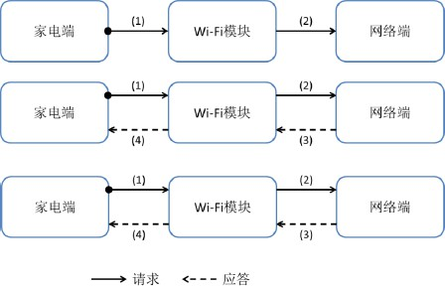

Serial data synchronization - time frame and continuous frame mode

Timeframe Scheme Introduction
Processing of module sending messages to the product:
      - Implementing UART frame synchronization check field of the message header;
      - UART message identifier field of the message header is non-zero;
      - The frame interval (the time from the end of one frame to the beginning of the next frame) is greater than or equal to 50ms ;
      - The network downlink transparent transmission instruction is a " sequential blocking " mechanism, that is: after module sends the downlink transparent transmission instruction to the home appliance, it will wait for the home appliance to respond, and the waiting timeout is 1 During the waiting period, new downlink transparent transmission is temporarily stored in the queue.
Module processes messages received from the product:
- Do not detect UART frame synchronization check field of the message header;
- UART message identifier field of the message header must be 0 ;
- No frame interval limit.

Introduction to continuous frame scheme
Processing of module sending messages to the product:
      - Implementing UART frame synchronization check field of the message header;
      - UART message identifier field of the message header is non-zero;
      - No frame interval limit;
      - The network downlink transparent transmission instruction is a " parallel " mechanism, that is: after module sends the downlink transparent transmission instruction to the home appliance, it will wait for the home appliance to respond, and the waiting timeout is 5 seconds.
The downlink transparent transmission message is sent to the home appliance as usual. Module processes the message received from the product:

- UART must be implemented frame synchronization check field of the message header is equal to the message length and the home
XOR value of electrical type;
- UART message identifier field of the message header must be a non-zero value; the home appliance sending a response frame must copy the message identifier field of the request frame, and the home appliance sending a request frame must assign a non-zero and changing message identifier ;

Compatibility scheme between time frame and continuous frame
Module reads the electronic ID response to the command is used to determine whether the serial port communication with the home appliance is a time frame or a continuous frame scheme. The specific processing is as follows:
      - Module sends read electronic ID A request, wherein the message identifier in the request packet is a non-zero value;
      - Module receives and reads electronic ID response is judged by the message identifier in the response packet.
If the message ID of the response packet is consistent with the message ID of the request packet, module and the home appliance communicate using continuous frames; if the message ID of the response packet is 0, module and the home appliance communicate using
time frame; if the response packet message identifier is non-zero and is inconsistent with the request packet message identifier, module determines that the response is wrong, which is equivalent to not obtaining the electronic ID.

IoT Product Design Guidelines

Overview
Shuangchi Wi-Fi Module integrates wireless RF transceiver, basic network protocol and application communication protocol, and is connected to the downstream device through the serial port, so that it can be connected to the Wi-Fi A wireless access module for communication within a network. Using this module, users can connect home appliances or other devices to the Internet, enriching product functionality and improving product competitiveness.
This document aims to provide electronic control hardware design, electronic control software design, electronic ID company provides specifications and suggestions on code management, product appearance and instructions, so as to facilitate the rapid and efficient development and production of IoT products and quickly achieve profitability.

Electronic control hardware design

Module Technical Specifications
Wi-Fi main technical specifications related to module hardware are shown in the following table:

Network Standards | IEEE 802.11 b/g/n
Wireless transmission rate | 802.11n : up to 135Mbps
Wireless transmission rate | 802.11g : up to 54Mbps
Wireless transmission rate | 802.11b : up to 11Mbps
Channel | 1- 14
Frequency range | 2.4-2.4835 GHz
Transmit power | 12-18 dBm
Operating voltage | 3.3V +/- 5%
Maximum operating current | 240mA
Serial port parameters
Baud rate | 9600
How it works | Full-duplex
Serial port settings | 8 data bits, 1 stop bit, no parity
Functional parameters
WI-FI Working Mode | Wireless network card STA Mode / Wireless Hotspot AP model
Wireless Security | 64/128/152 WEP​ encryption
Wireless Security | WPA-PSK/WPA2-PSK, WPA/WPA2 Safety
 | mechanism
For more details, please refer to Wi-Fi Module Hardware Specifications.

Interface level
5V digital circuit interface of module complies with CMOS level specifications are as follows:
parameter | illustrate | Numerical | condition
VOL | Output low level threshold | <= 0.5V | VCC = 5V
VOH | Output high level threshold | >= 4.45V | VCC = 5V
VIL | Input low level threshold | <= 1.5V | VCC = 5V
VIH | Input high level threshold | >= 3.5V | VCC = 5V
3.3V digital circuit interface of module complies with LVCMOS level specifications are as follows:
parameter | illustrate | Numerical | condition
VOL | Output low level threshold | <= 0.1V | VCC = 3.3V
VOH | Output high level threshold | >= 3.2V | VCC = 3.3V
VIL | Input low level threshold | <= 0.7V | VCC = 3.3V
VIH | Input high level threshold | >= 2.0V | VCC = 3.3V
At both input levels, the digital IO current allowed by the port is -10mA (sink current) ~10mA (source current), and the flip rate is 2MHz.
The connection between the electric control board and module must ensure that module interface meets the above requirements. In particular, the following situations should be noted :
- / pull-down / buffer resistors on the connection line, pay attention to the impact on the interface voltage and current;
- There is a filter capacitor on the connection line. Be careful not to make the capacitance too large, otherwise the IO Flip speed standard.

Electronic control software design

Restore network parameters to factory settings
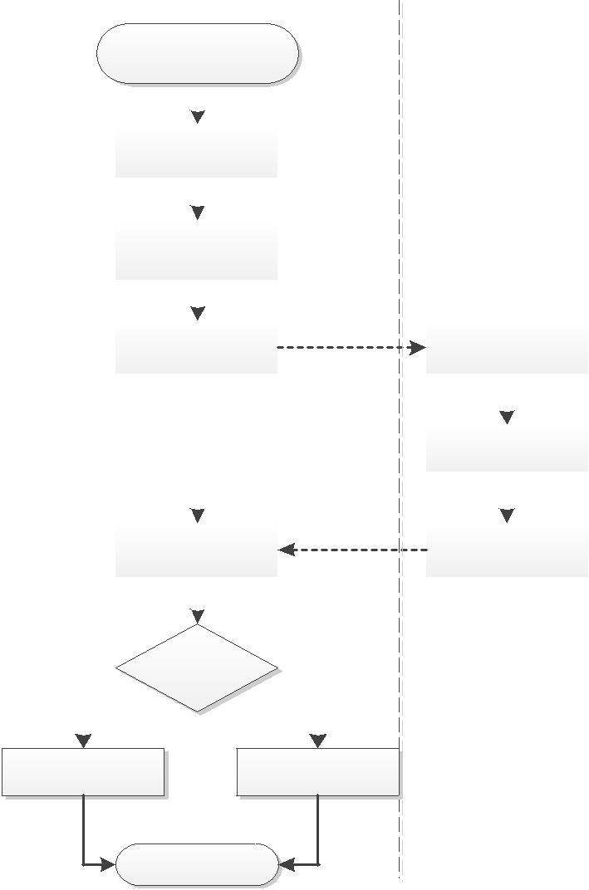
The electronic control of IoT products must support the function of restoring network parameters to factory settings, that is, the Wi-Fi Module returns to factory settings. One recommended method is to press and hold the [ Start / Switch / Power On ] button, then turn on the power and keep holding the button for 5 seconds. The electronic control design process can be referred to in the figure below:
通讯异常，状态指
示为红色慢闪
家电正常工作，状
态指示为黄色慢闪
结束

Home appliances |  |  | Wireless communication module
First, assume the product is wireless
Module communication is normal
Press [ Start / Switch / On]
[Machine ] key
Connect to 220V power supply and
Keep pressing for 5 seconds
Home appliance MCU sends clear |  |  | The communication module receives the clear
Network parameter commands |  |  | Remove network parameter command
 |  |  | Clear the router SSID,
 |  |  | Password, appliance ID
Wait 2 seconds to receive the clear |  |  | Return clear success command
Success command
Whether it has been cleared
Success Command
 | Y

Establishment and maintenance of serial communication services
Wi-Fi Module communicates with the home appliance's electronic control system using standard asynchronous serial communication. The electronic control software must ensure that a complete serial communication service is established within 3 seconds of the Wi-Fi module being powered on.
The home appliance control software must always keep the serial port communication open and correctly process the received and sent messages according to the IoT home appliance communication protocol. This is because under the condition of Internet connection, Wi-Fi The communication between module and the home appliance may occur at any time. The main things to do are:
1. Serial communication should be enabled all the time and not just for a specific period of time after power-on.
2. Serial communication errors such as verification failure, loss of control (serial port output is pulled low or high)
After the communication is complete, it should be able to automatically recover to normal working state without falling into permanent communication blockage.

Restarting, restoring factory settings, upgrading software, and switching AP/STA During the reset mode, module will pull down the serial line level for about 300ms due to its own reset. This should be taken into consideration when designing the home appliance software.

Communication Protocol
The communication between home appliances and modules must strictly comply with the serial communication protocol. For details, please refer to the "Serial Communication Protocol" document.
files.
Message types that the appliance must support
To ensure the normal operation of IoT appliances, they must support at least the following message types : (1) Device electronic ID acquisition - 0x07
electronic ID from the appliance. It is the unique identity of IoT appliances
will only be Network communication functionality will only be provided after that.
- Wi-Fi Module factory reset — 0x83
After receiving this command, module will be restored to factory settings and automatically restarted. Restoring the factory settings will return module software to the factory version and clear the electronic ID and network parameters recorded by module.
- Device Control / Query Commands — 0x02/0x03
The network side controls the home appliances through the 0x02 message.
- Device operating parameter reporting — 0x04/0x05
Mobile APP It is necessary to obtain the operating status of home appliances in real time, requiring home appliances to report their own operating parameter information through 0x04 or 0x05 messages when the operating status changes or at regular intervals.

Electronic ID code

1 Electronic ID Code Introduction
Electronic ID code is the unique identification of IoT home appliances and is the necessary certificate for the product to access the network.
It needs to be written to the home appliance control board in the form of firmware.

2 Electronic ID Code writing and printing reference process
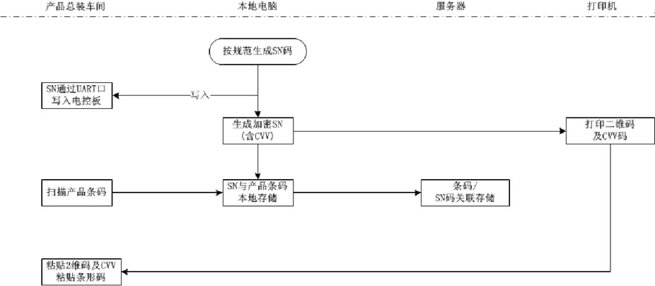
It is recommended to add QR code printing to the original product barcode scanning and pasting position, and write the electronic ID code into the product electronic control board, and scan the barcode into the computer and the electronic ID code is stored in the local machine and uploaded to the server at regular intervals. The process is shown in the figure below:

3. Write electronic ID via the port code
ID when burning the electronic control program in actual production, it is recommended that the production department adopt an online writing method of the electronic ID via the serial port.
It is recommended that the production department prepare a serial electronic ID programming tool is connected to the appliance's main control chip via a serial port (which can be the same serial port used to connect the appliance to the Wi-Fi module). The logic level of the serial port is determined based on the actual situation of the electronic control board. Note that the programming tool and the appliance's electronic control board share a common (digital) ground, as shown in the figure below.

The data format of the message serial communication protocol for writing electronic ID code through the serial port is specified. The message type is 0x11 (Please refer to "Serial Communication Protocol"). The home appliance control software must support the processing of 0x11 messages. After receiving the downlink message, the home appliance should write the new electronic ID to the Flash or EEPROM within 500ms and return a response. The electronic ID that the home appliance responds with is the electronic ID currently stored in itself, that is, if the electronic ID is written successfully, the message bodies of the uplink and downlink should be the same. If the home appliance fails to return a response within 500ms, or the electronic ID of the response is different from the value to be written, it means that the burning has failed. Example: Write electronic ID to the induction cooker ID = 000032000102030405060708W8980000 Send data packet: AA 2A EB 00 00 00 00
00 00 11 30 30 30 30 33 32 30 30 30 31 30 32 30 33 30 34 30 35 30 36 30 37 30 38
57 38 39 38 30 30 30 30 77

Certification section
1 SRRC Certification:
Using Wi-Fi final home appliance product of module must comply with the Ministry of Industry and Information Technology document (No. 20141 following information shall be marked on the equipment label or instruction manual:
This device contains the type approval code:
CMIIT Radio transmitter module with ID: XXXXYYZZZZ

