**Project: Interactive Visualization**

Shaaban, Mohammed Najib Ahmed

**Fatal Police Shootings in US from 2015 to 2021**

This is an application that visualizes Fatal Police Shooting, which describes the case counts of The States over the period of 5 years (2015-2021). This dataset records civilians shot and killed by on-duty police officers from 2015-2021.

The data used for this project include:

States

City

Date

Gender

Age

Body camera

Manner of deaths (e.g., shot & tasered)

Armed (e.g., gun, knife, vehicle ..etc)

Race, (e.g., white, black, Asian .. etc)

Mental health (whether or not the person has sign of mental illness)

Threat level (e.g., attack, steal .etc)

Flee ( e.g., car, foot, not fleeing .. etc)

Longitude & Latitude

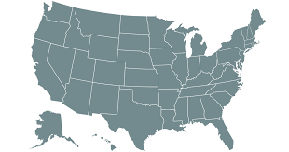

Total Cases in Texas:

200

Hover

Click

Asian

White

Black

Initially, users see a US choropleth, colored by the intensity of the cases in every state. When the user hovers, a tooltip appears to show the total cases in the states. When the user clicks, the choropleth will zoom, and a Sankey is drawn to show the breakdown of cases by race. So, this page will consist of two visualizations. The first one shows the intensity and total cases of each state and the second shows the breakdown of cases by race.

**Final Implementation**

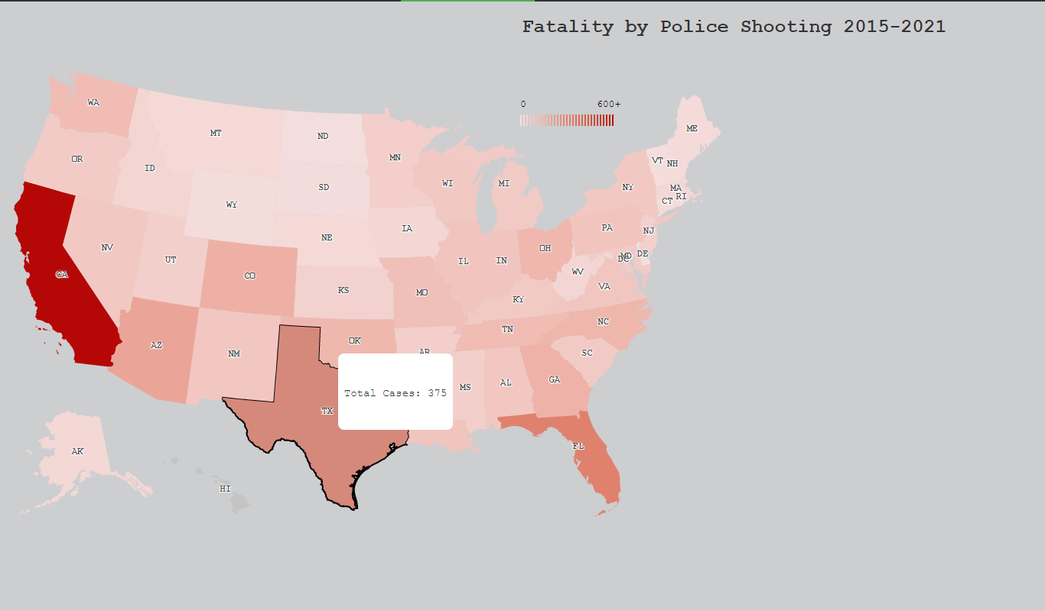

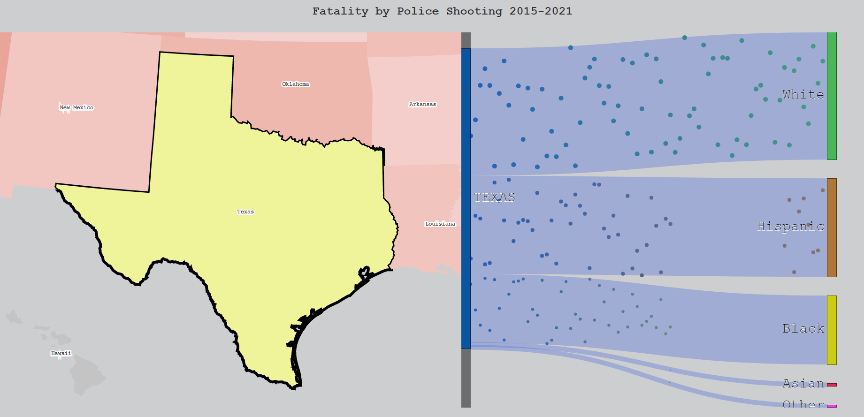

**Number of fatalities in the United States**

**by weapon, 2015-2021**

The second visualization is to show the number of fatalities in the United States by weapon from 2015 to 2021. The visualization initially shows the bubble chart which represents the number of cases per weapon. Each bubble of the chart represents a different weapon, and the size of the bubble represents the total number of cases holding the same weapon. The visualization initially shows an interactive bubble chart and its legend as shown on Figure 1.

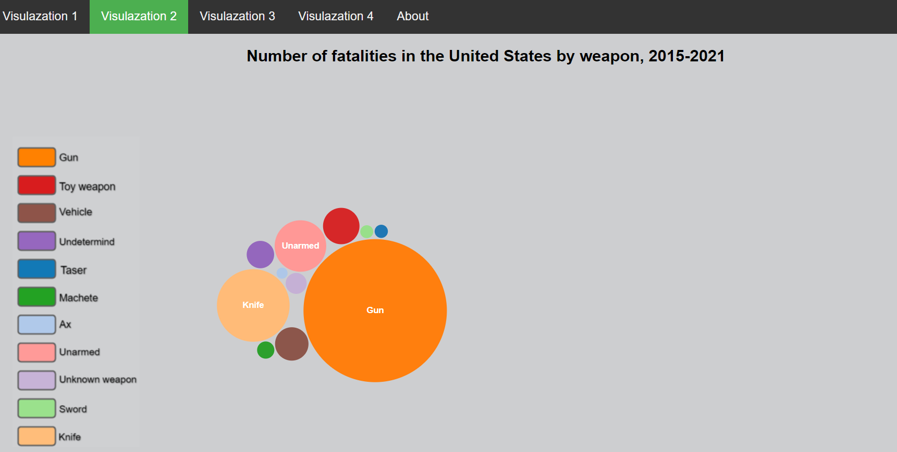

Figure1. Visualization 2 initial screen

Once the user hovers over the bubbles the visualization shows a tooltip small window to show the name of the weapon and the total number of cases and if the user clicks on a particular bubble another bar chart will appear to show the distribution of fatalities of the particular weapon per gender as shown on Figure 2.

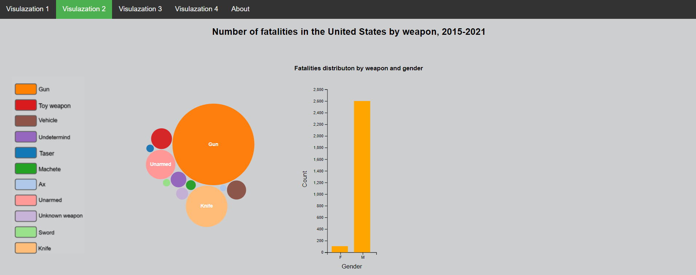

Figure 2. Visualization 2 barchart1

Once the user hovers over the bar chart the visualization shows a tooltip small window to show the name of the fatalities on the selected gender and if the user clicks on a particular bar another bar chart will appear to show the distribution of mental conditions of the fatalities of the selected gender as shown on figure 3.

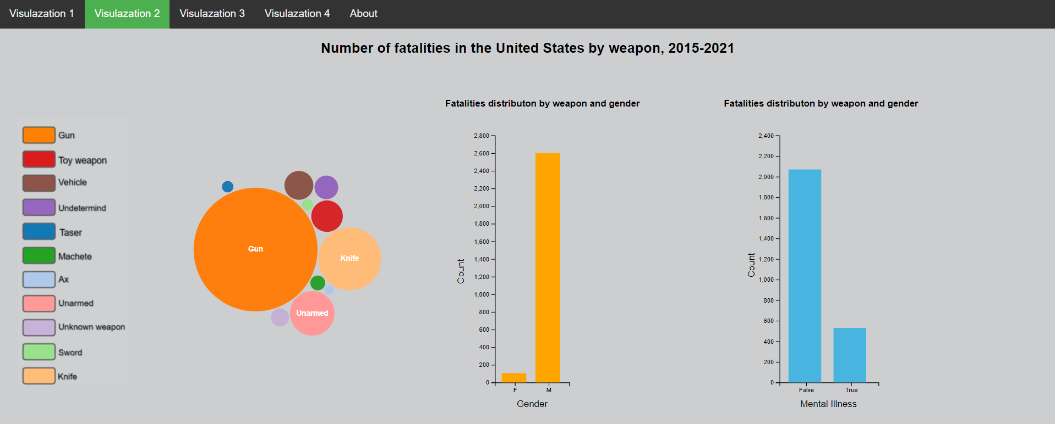

Figure 3. Number of fatalities in the United States by weapon, 2015-2021

Once the user hovers over the bars chart the visualization shows a tooltip small window to show the total number of facilities belonging to that particular bar.



Figure 4. Demo representation number of fatalities in the United States by weapon, 2015-2021

**Fatalities distribution by age**

**in the United States 2015-2021**

The third visualization is to show the fatalities distribution by age in the United States. The user views an interactive visualization with adorable initialization action and once the user hovers over the dots the visualization shows a small tooltip window that shows the value of the particular age as well as the total number of cases. The visualization shows the highest number of fatalities with 27 with a total number of cases of 163.



Figure 5. Fatalities distribution by age in the United States 2015 - 2021

**Fatalities distribution by race in the United States 2015-2021**

The third visualization is to show the fatalities distribution by race in the United States from 2015 - 2021. The user first views an interactive bar chart that shows the distribution of facilities per race, as shown in Figure 6.

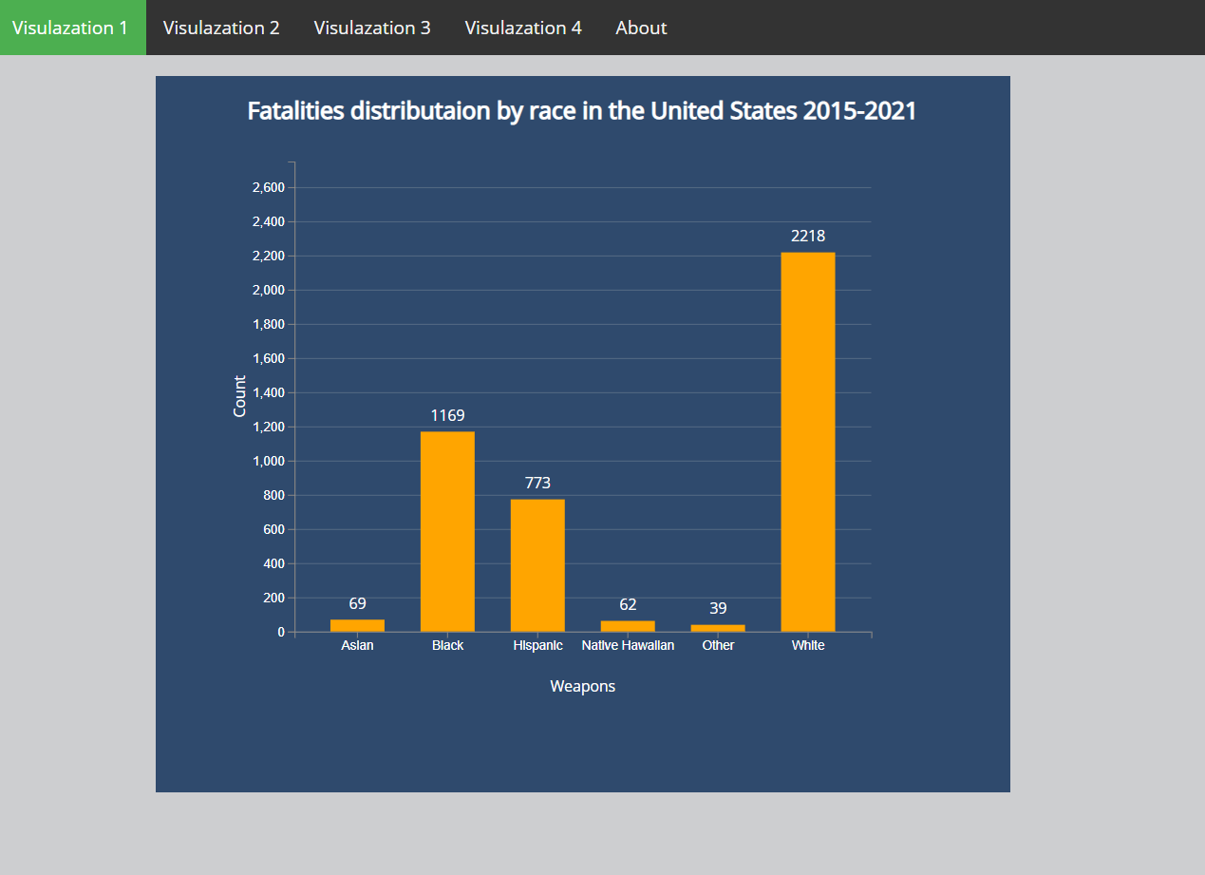

Figure 6. Fatalities distribution by race in the United States 2015 - 2021.

When the user hovers over the bars the visualization shows a horizontal line directly extending to the y-axis making it easier for the user to identify the exact y-value. When the user clicks on any race bar the visualization shows another bar chart that shows the specific race number of fatalities by fleeing approaches, as shown on Figure 7 below.

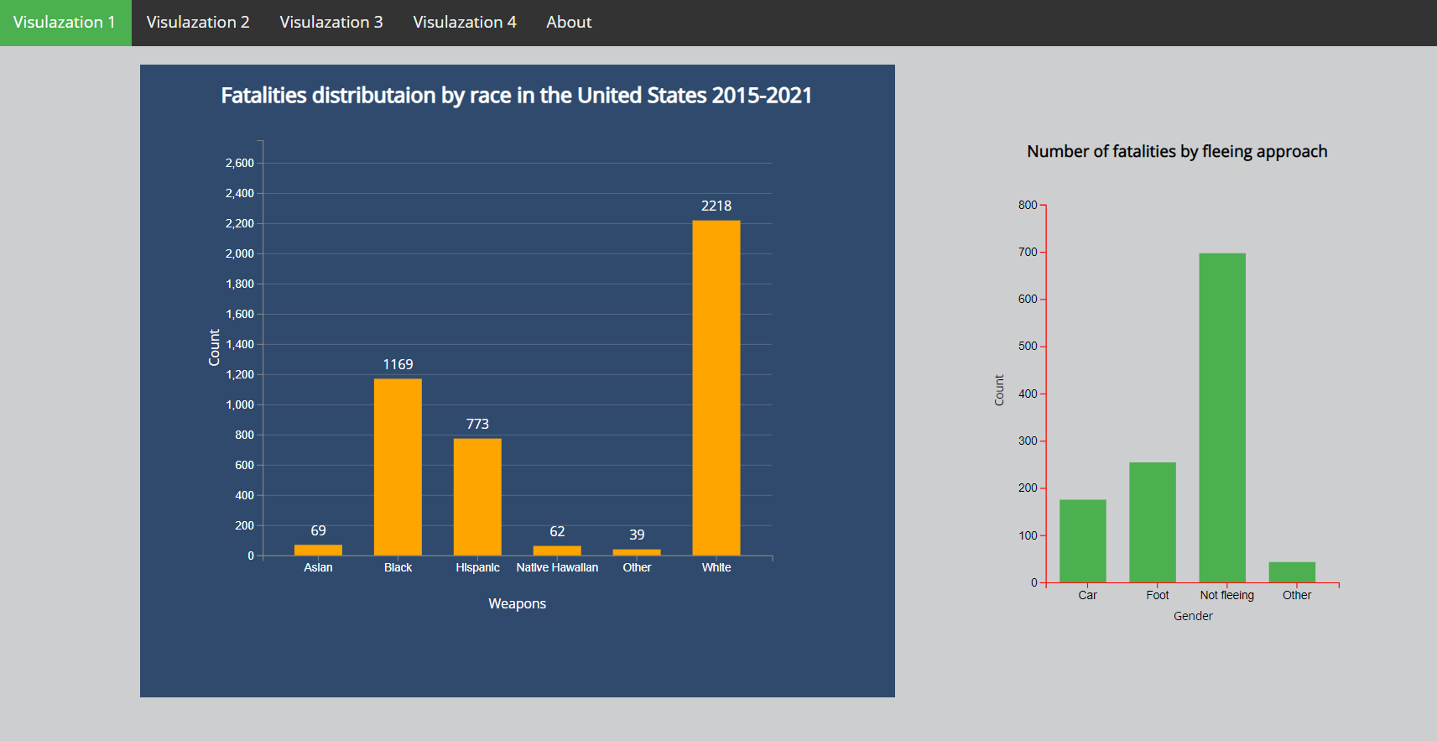

Figure 7. Number of fatalities by the fleeing approaches

When the user hovers over the bars the visualization shows a small tooltip window that shows the name of the particular flee approach together with the number number of cases.



Figure 8. Fatalities distribution by race in the United States 2015-2021