Predicting Customer Spending in E-Commerce

Business Analytics Project
Group Members:
- Lawrence Paglinawan
- Ugyen Thukzom
- Khondoker Shaan Muhammad
Audience: Online Retail Business Team

Abstract
This project explores the factors that influence customer spending behaviour in an e-commerce environment using the Retail Analysis Large Dataset from Kaggle. The dataset contains over 300,000+ transaction records and 30 variables related to customer demographics, purchasing activity, product details, location, and customer feedback. The main objective of the study is to determine whether customer spending is better explained by demographic characteristics or by behavioral and transaction-based patterns.

To address this objective, first the dataset was cleaned and prepared by removing irrelevant personal identifiers, handling missing values, removing duplicates, and transforming variables for analysis. Exploratory data analysis was then conducted to identify patterns in spending behavior across customer groups, product categories, and time-related variables. Several data mining techniques were also applied, such as Linear Regression, Random Forest Regression, Logistic Regression, Random Forest Classification, and K-Means Clustering.

The predictive models showed limited ability to explain or classify customer spending when relying mainly on demographic and general transactional features. In contrast, clustering produced more insightful customer groupings based on shopping behavior. The findings suggest that demographic variables such as age and income alone are not strong predictors of spending. Instead, behavioral patterns such as purchasing frequency, transaction value, and product-related preferences provide more useful information. Based on these results, the project recommends that online retailers adopt behavior-based segmentation and targeting strategies rather than relying on traditional demographic assumptions.

Introduction
An important challenge for online retail companies is to understand what drives customer spending. Many of them depend on broad categories such as age, gender, or income when making marketing and customer targeting decisions. However, customer spending behavior may be influenced more strongly by what customers buy, how often they purchase, and how their behavior changes over time. This project investigates whether demographic characteristics or behavioral patterns provide a better understanding of customer spending in an e-commerce environment.
This project uses the Retail Analysis Large Dataset from Kaggle, which contains roughly 300,000+ records and 30 variables describing customer information, transaction details, product characteristics, location, and customer feedback. Because of its size and variety, the dataset is suitable for both exploratory analysis and data mining. It provides an opportunity to investigate customer spending from multiple perspectives, including demographics, purchasing activity, and product preferences.

To answer the business question, the project has done a structured analysis process consisting of data preparation, exploratory data analysis, and model development. The data preparation stage involved cleaning the dataset, handling the missing values, removing duplicates, and selecting variables relevant to the business problem. Exploratory analysis was conducted to identify trends, overlaps, and relationships in customer spending. After this, we applied different approaches such as regression, classification, and clustering. Regression and classification were initially used to predict or categorize customer spending. However, their performance was limited, suggesting that the available demographic and general customer attributes did not strongly explain spending behavior. Because of this, the project shifted toward clustering to identify meaningful customer segments based on behavior. This change in approach was important because segmentation provided stronger business insight than forcing weak predictive results.

This project makes three main contributions. First, it presents a clean and structured analysis of a large retail dataset. Then it compares multiple data mining techniques to evaluate how well customer spending can be understood and modeled. Then lastly it translates the analytical findings into practical recommendations for an online retail companies. Overall, the result suggest that behavior-based segmentation is more useful than demographic-based targeting for understanding and influencing customer spending.

Dataset description
This study uses the Retail Analysis Large Dataset obtained from Kaggle. The dataset was selected because it is publicly available and large enough for meaningful business analytics. It also contains a broad range of variables relevant to customer spending behavior. It includes approximately 300,000+ records and 30 columns so it makes it suitable for exploratory analysis, predictive modeling, and customer segmentation. The dataset contains several categories of information. The columns contains as follows:
- Customer-related variables
- Age
- Gender
- Income
- Customer segment (new, regular, premium)
- Transaction-related variables
- Date
- Time
- Total purchases
- Amount
- Total amount
- Order Status
- Product-related variables
- Category
- Brand
- Product type
- Location-related variables
- City
- State
- Country
- Customer Feedback variables
- Ratings
This variety makes the dataset valuable for examining spending behavior from both business and analytical perspectives. The main target variable in this project is Total_Amount, which represents the total spending value of a transaction. This variable was initially used as the primary outcome for prediction in the regression and classification models. It is important to note that the Total_Amount from Amount. The Amount variable refers to the price of a single product, while the Total_Amount represents the overall price of the transaction. Since the goal of the project is to understand customer spending behavior at the transaction level, Total_Amount is the more appropriate variable for analysis.
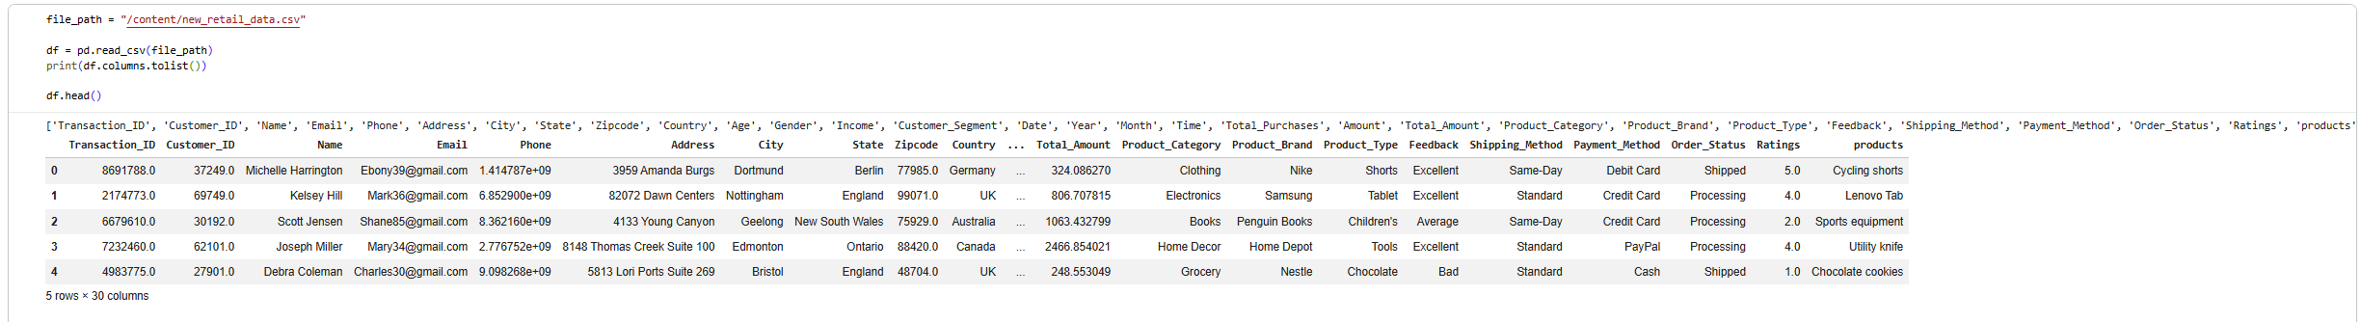
Figure 1. Sample rows from the dataset (df.head())
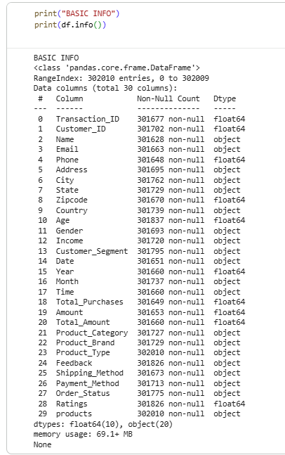
Figure 2. Dataset structure summary (df.info() or shape output)

Methodology
This project followed a structured data analytics process consisting of data preparation, exploratory data analysis (EDA), and multiple data mining techniques. The goal was to systemically evaluate whether customer spending could be more explained and predicted using available features, and to identify more effective approaches when predictive performance was limited.

Data Preparation
The dataset was first cleaned and prepared to ensure data quality and consistency. Several preprocessing steps were applied. Irrelevant personal columns were also removed as they do not contribute to the analysis to reduce noise. Rows with missing identifiers were also dropped to maintain data integrity. Missing values were handled using median imputation to minimize the impact of outliers. Duplicate records were identified and removed to avoid bias in the analysis. After cleaning, the dataset was transformed into a formate suitable for modeling. Numerical variables were scaled using standardization, and categorical variables were encoded using one-hot encoding. The dataset was then split into training and testing sets using an 80/20 ratio for model evaluation.
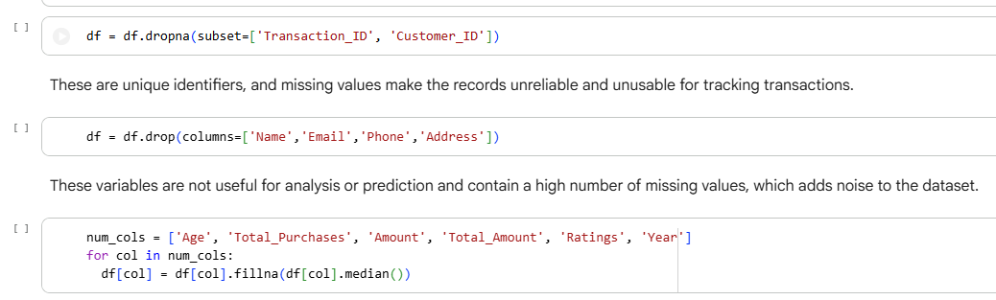
Figure 3: Data preprocessing methods.

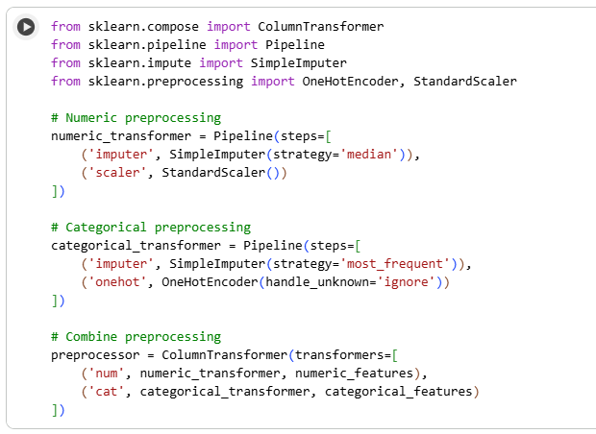
Figure 4: Preprocessing steps for numerical and categorical variables

Exploratory Data Analysis
EDA was conducted to identify patterns, relationships, and potential limitations in the dataset. Visualizations such as bar charts, box plots, and time based analysis were used to examine customer spending across different segments, age groups, and product categories. The analysis revealed significant overlap in spending behavior across demographic groups, particularly age. Customers from different age groups and segments showed similar spending distributions, suggesting that demographic variables alone are not strong indicators for predicting their spending behavior. Also, spending patterns varied across product categories and over time, indicating that customer behavior is dynamic and context-dependent.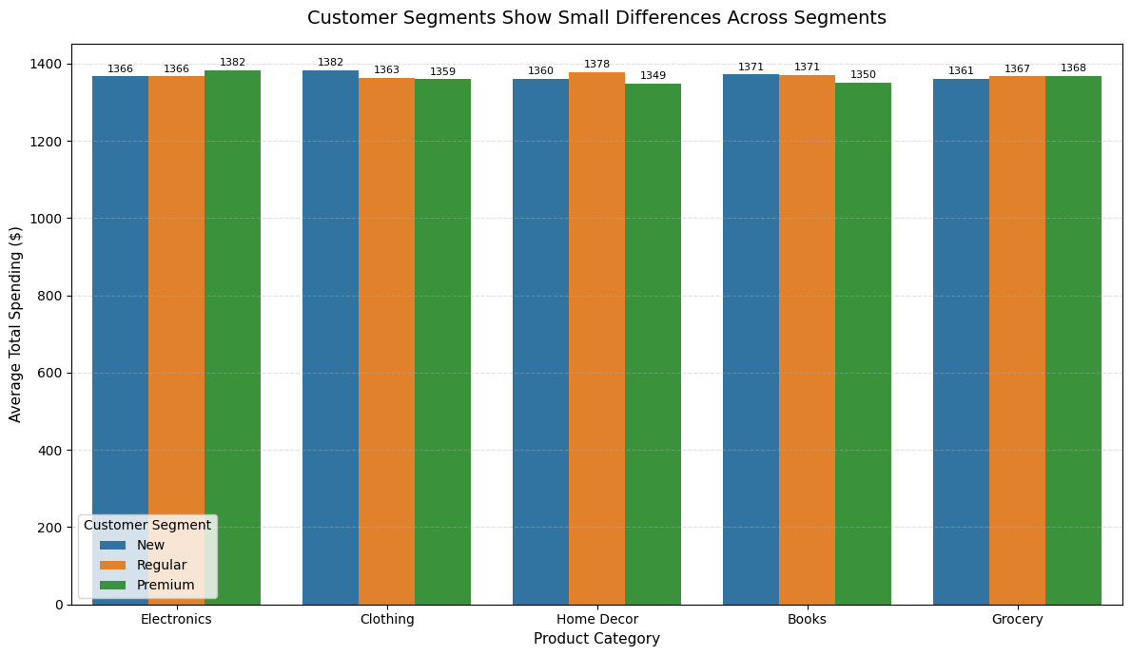
Figure 5: Grouped bar chart for customer segments’ avg total spending and product category
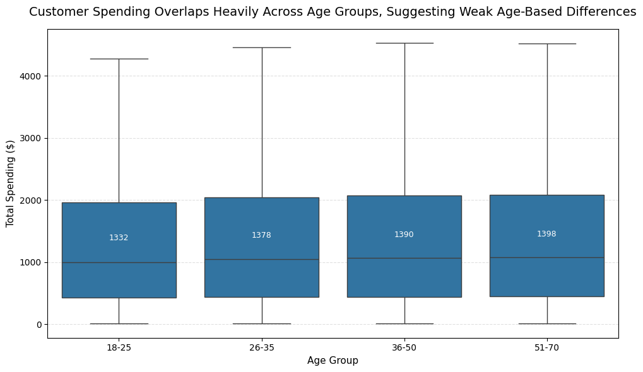
Figure 6: Boxplot for different age group’s avg total spending

Regression Modeling
Regression models were initially applied to predict using Total_Amount as the target variable. Two models were developed: Linear Regression and Random Forest Regressor. Both models were trained using selected features relevant to customer behavior and evaluated using standard performance metrics.
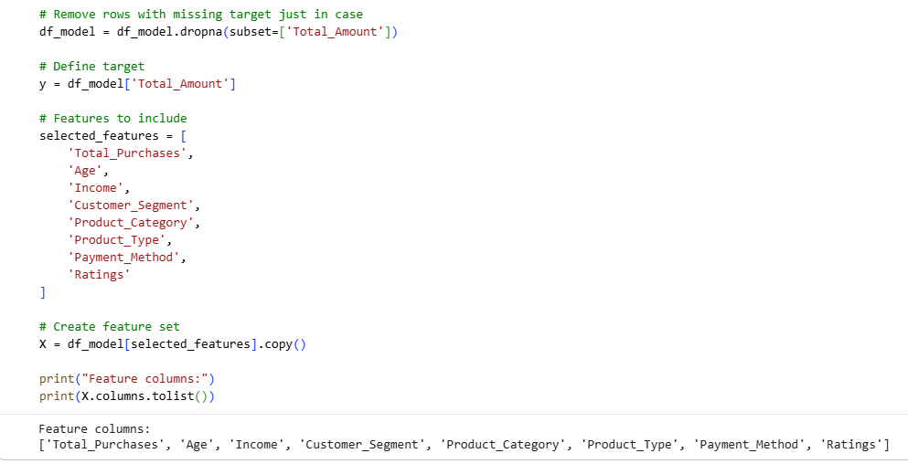
Figure 7: Code shows relevant features to use for regression models
The results showed moderate predictive performance, with both models achieving an R² value of approximately 0.42. This indicates that only about 42% of the variance in customer spending could be explained by the model, while 58% remained unexplained. The similarity in performance between Linear Regression and Random Forest suggests that the relationship between the features and the target variable is largely linear but weak. Overall, the regression results indicate that the available features are insufficient to accurately predict customer spending, limiting the usefulness of regression for this problem.
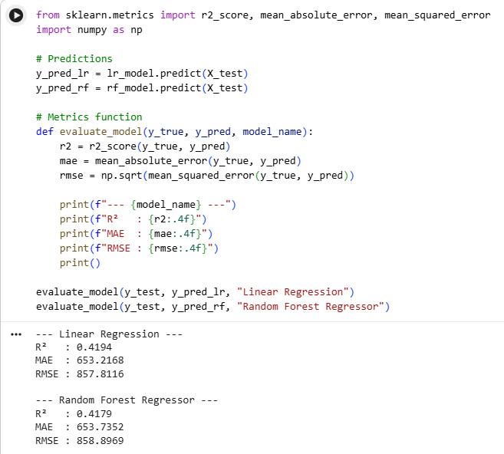
Figure 8: Both models performed poorly at predicting Total_Amount.
Even after applying cross-validation, both models consistently perform poorly, confirming that the lack of predictive power is not due to overfitting or random variation, but rather due to weak relationships between the features and the target variable. Overall, cross-validation confirms that the poor performance observed earlier is not due to overfitting or randomness, but rather due to weak relationships between the available features and the target variable.
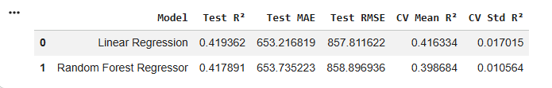
Figure 9: Both regression models’ performance did not improve even after applying cross-validation.

Classification Modeling
To explore an alternative approach, customer spending was categorized into three groups: Low, Medium, and High. This was done by transforming the continuous Total_Amount variable into a categorical variable called Spending_Class. The dataset showed class imbalance, with approximately half of the customers classified as medium spenders. To address this, class weights were adjusted using a balanced approach during model training.
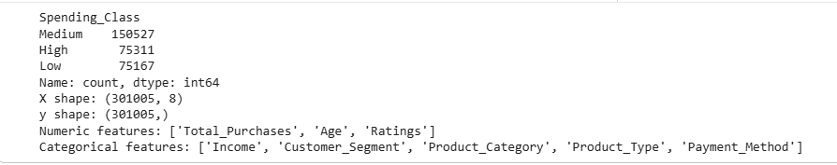
Figure 10: Distributions of spending_class, indicating class imbalance.
Two classification models were developed: Logistic Regression and Random Forest Classifier. Logistic Regression achieved an accuracy of approximately 52%, outperforming the Random Forest model, which achieved around 45% accuracy. While the models were somewhat effective at identifying low and high spenders, they struggled to accurately classify medium spenders.
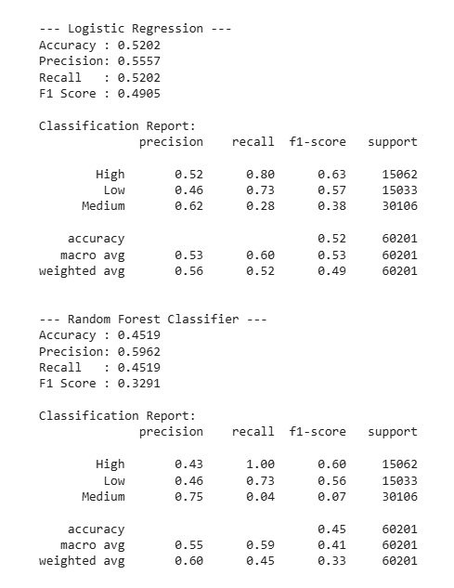
Figure 11: Classification models has slightly improved performance compared to regression models.
Although classification performance was slightly better than regression in terms of interpretability, the overall accuracy remained relatively low. This suggests that customer spending behavior does not fit well into discrete categories and may be better understood as a continuous or complex pattern.

Clustering
Due to the limited performance of both regression and classification models, the project shifted to an unsupervised learning approach using K-means clustering. This decision was based on the observation that customer spending is complex and not easily predictable using traditional supervised methods.
K-means clustering was applied to identify natural groupings of customers based on behavioral features such as spending amount, number of purchases, and customer ratings. Prior to clustering, numerical features were standardized to ensure equal contribution to distance calculations.
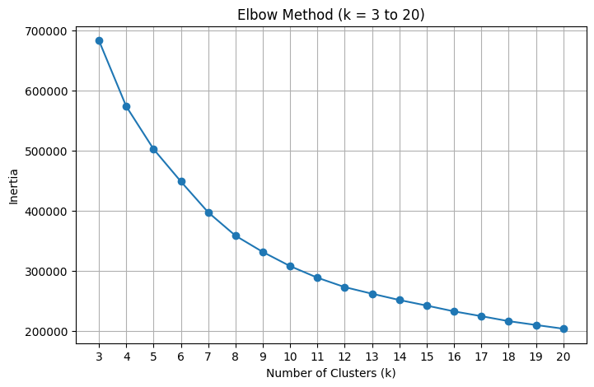
Figure 12: Elbow method was applied to determine the ideal number of clusters.
The optimal number of clusters was determined using the elbow method, which suggested that eight clusters provided a suitable balance between model complexity and interpretability. These clusters represent distinct customer segments based on purchasing behavior rather than demographic characteristics.
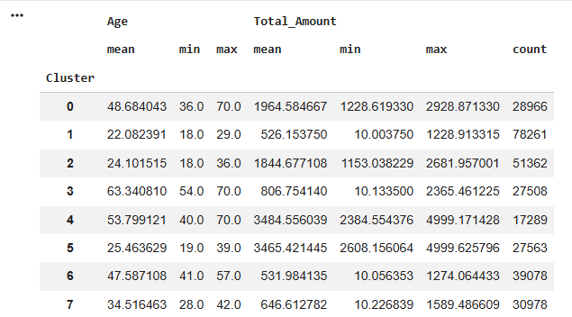
Figure 13: Clustered customers information
Clustering provided more meaningful insights compared to predictive models, as it revealed patterns in how customers behave rather than attempting to predict exact spending values. This approach aligns more closely with the project’s objective of understanding customer behavior for business decision-making.

Clustering Results and Customer Segmentation
Due to the limited performance of both regression and classification models, K-means clustering was applied to identify meaningful customer segments based on purchasing behavior. The model grouped customers into eight distinct clusters using behavioral features, including Total_Amount, Total_Purchases, and Ratings. The number of clusters (k = 8) was selected using the elbow method, which provided a balance between model simplicity and segmentation detail.
Unlike traditional approaches that rely on demographic variables, the clustering results revealed segments that are defined primarily by how customers behave, rather than who they are. This aligns with earlier findings from the exploratory data analysis, which showed significant overlap in spending across demographic groups.
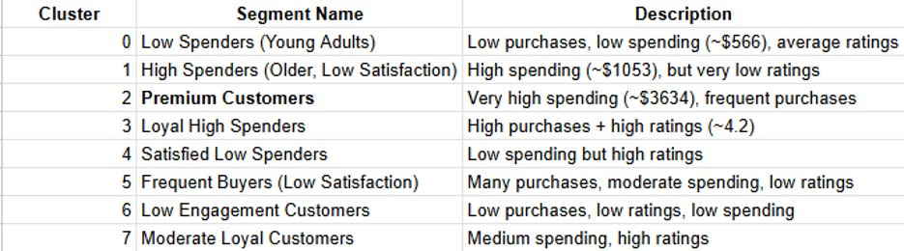
Figure 14: Clustered customers summary

Each cluster represents a unique type of customer behavior:
Customer Segments
- Cluster 0: Low Spenders (Young Adults)
Customers in this group make relatively few purchases and have low overall spending (approximately $566). Their ratings are average, indicating moderate satisfaction but low engagement.
- Cluster 1: High Spenders (Low Satisfaction)
This segment consists of customers with relatively high spending (around $1053) but very low ratings. This suggests dissatisfaction despite high purchase value, indicating a potential risk of churn.
- Cluster 2: Premium Customers
These are the highest-value customers, with very high spending (approximately $3634) and frequent purchases. This segment represents a key revenue driver for the business.
- Cluster 3: Loyal High Spenders
Customers in this group combine high purchase frequency with high satisfaction ratings (around 4.2). They are both valuable and loyal, making them an ideal target for retention strategies.
- Cluster 4: Satisfied Low Spenders
This segment includes customers with low spending but high ratings. While they are satisfied, their contribution to revenue is limited, suggesting an opportunity for upselling.
- Cluster 5: Frequent Buyers (Low Satisfaction)
These customers make many purchases and have moderate spending levels but report low satisfaction. This indicates potential issues with product quality or customer experience.
- Cluster 6: Low Engagement Customers
This group shows low spending, few purchases, and low ratings. These customers are disengaged and may require targeted re-engagement strategies.
- Cluster 7: Moderate Loyal Customers
Customers in this segment have moderate spending levels and relatively high satisfaction. They represent stable customers with potential for growth.

The clustering results reinforce the key finding of this project: customer behavior is more informative than demographic characteristics when explaining spending patterns. Customers are better differentiated by how often they purchase, how much they spend, and how satisfied they are, rather than by age or other demographic variables. Several important insights emerge from the segmentation:
- High spending does not always indicate satisfaction, as seen in clusters with high spending but low ratings.
- Customer loyalty is strongly associated with both purchase frequency and satisfaction.
- There are clear opportunities for both customer retention (e.g., loyal high spenders) and customer improvement (e.g., dissatisfied high spenders or frequent buyers with low ratings).
- Low-spending but satisfied customers represent potential growth opportunities through targeted promotions.
Overall, clustering provides a more meaningful and actionable understanding of customer behavior compared to predictive models, making it a valuable approach for business decision-making.

Business Recommendations
Based on the findings of the analysis, several practical recommendations can be made to help online retail businesses better understand and influence customer spending behavior. The results consistently show that customer behavior is a stronger driver of spending than demographic characteristics, suggesting that businesses should shift their focus toward behavior-based strategies.
First, companies must adapt to behavior-based targeting. Instead of relying on demographic variables such as age or income, businesses should segment customers based on purchasing behavior, including spending patterns, purchase frequency, and satisfaction levels. Behavioral segmentation allows for more accurate and meaningful targeting, leading to improved marketing effectiveness. Then focus on high-value customer segments. Customers identified as Premium Customers and Loyal High Spenders represent the most valuable segments in terms of revenue and engagement. Businesses should prioritize retaining these customers through personalized offers, loyalty programs, and exclusive promotions. Maintaining strong relationships with these segments can significantly impact overall revenue. Some people also has dissatisfaction, and companies must address it.
Some segments, such as High Spenders with Low Satisfaction and Frequent Buyers with Low Satisfaction, indicate that high spending does not always correspond to a positive customer experience. Businesses should investigate the causes of dissatisfaction, such as product quality, delivery issues, or customer service, and take corrective action to reduce the risk of losing these customers. Encouraging growth in low-spending segments also helps as segments such as Satisfied Low Spenders and Moderate Loyal Customers show potential for increased spending. Businesses can target these customers with promotions, discounts, or product recommendations to encourage higher purchase value while maintaining their satisfaction. Lastly, re-engage low-engagement customers. Customers with low spending, low purchase frequency, and low satisfaction represent a disengaged segment. Targeted marketing campaigns, such as limited-time offers, personalized recommendations, or reactivation emails, can be used to re-engage these customers and increase their activity.

Conclusion
Overall, this project demonstrates that customer spending behavior is complex and cannot be effectively explained using demographic characteristics alone. Instead, businesses should focus on understanding how customers interact with products and services over time. By adopting behavior-based segmentation and targeting strategies, online retailers can make more informed decisions, improve customer satisfaction, and increase long-term revenue.

