CSC241 - Assignment 2

Reading: Chapter 3

Instructions:
- Read the HW guidelines posted in d2l.depaul.edu > contents > admin.
- The file containing your solutions MUST be named hw2.py. In a comment, include the name(s) of any collaborators.
- Implement your solution to each of the problems below and include them in your file.
- To receive full credit, the names of files, functions and the output must be exactly as indicated here.
- Test your code by downloading the file hw2TEST.py in the same working folder , adding the following code to hw2.py, and running the module hw2.py. Make sure to fix all errors before you submit your hw2.py.
if __name__=='__main__':
import doctest
print( doctest.testfile('hw2TEST.py') )

Programming Problems:
- Implement a function returnThree that takes one argument, a string, and returns the first three characters of the string. If the string has length less than 3, then an empty string should be returned. The information below shows how you would call the function returnThree and what it would display for several sample parameters:
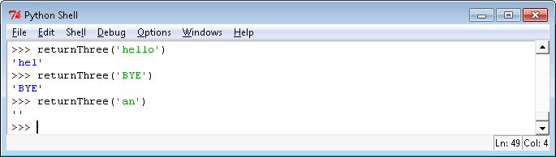

- Implement a function returnN that accepts two arguments, a string s and an integer n, and returns the first n characters of the string s. If the string has length less than n, then an empty string should be returned. The information below shows how you would call the function returnN and what it would display for a few different parameters:
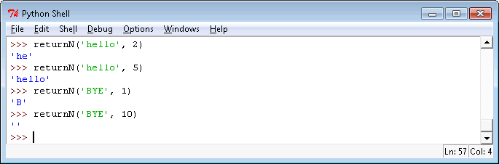
- Implement the function firstChars that takes accepts a list of strings and prints to the screen the first character of each string, one per line. If the list provided as a parameter is empty, the function prints a message to that effect. If any of the strings are empty, they are skipped in the display. The information below shows how you would call the function firstChars and what it would display for a couple of parameters:
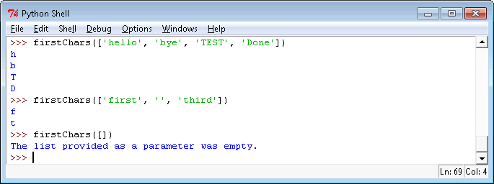
- Implement a function printGreater that takes two arguments, a list of numbers and a numeric value. It prints the numbers in the list that are greater than the value, all on one line with a space between them. If an empty list is provided as the first parameter, the function doesn't print anything. The information below shows how you would call the function printGreater and what it would display for some example parameters:
