**SCREENSHOT OF IMPLEMENATION OF K-MEANS CLUSTERING ON SMSSpamCollection Dataset on RapidMiner**

**SCREENSHOT OF EACH OPERATOR ARE LISTED BELOW:**

**Retrieve Operator:**

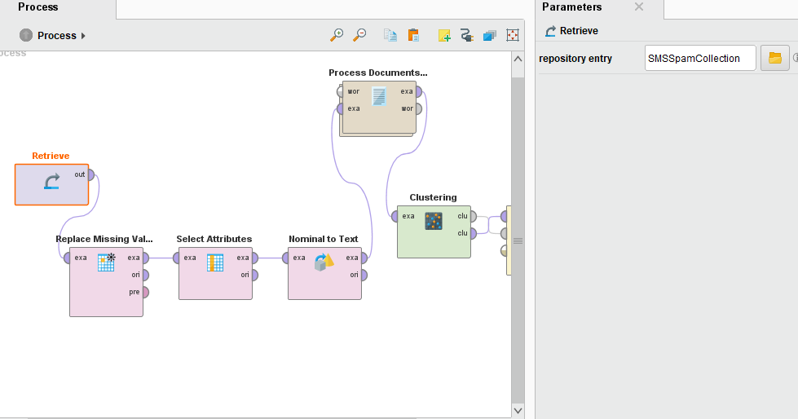

**Replace Missing Value Operator:**

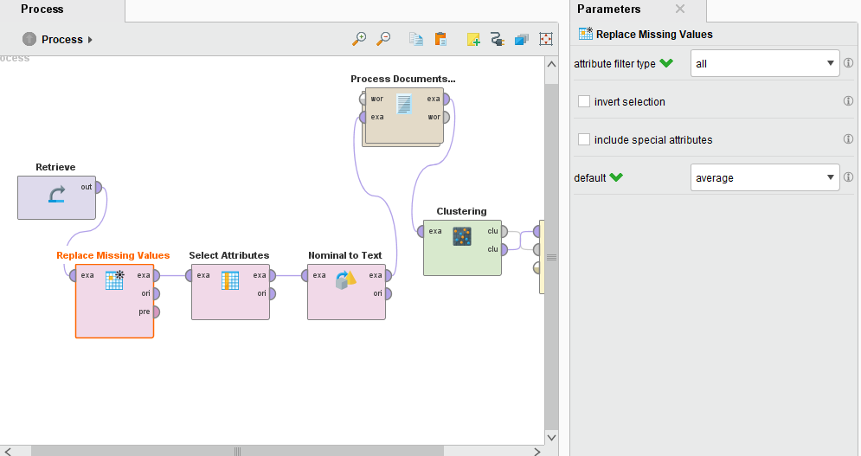

**Select Attributes Operator:**

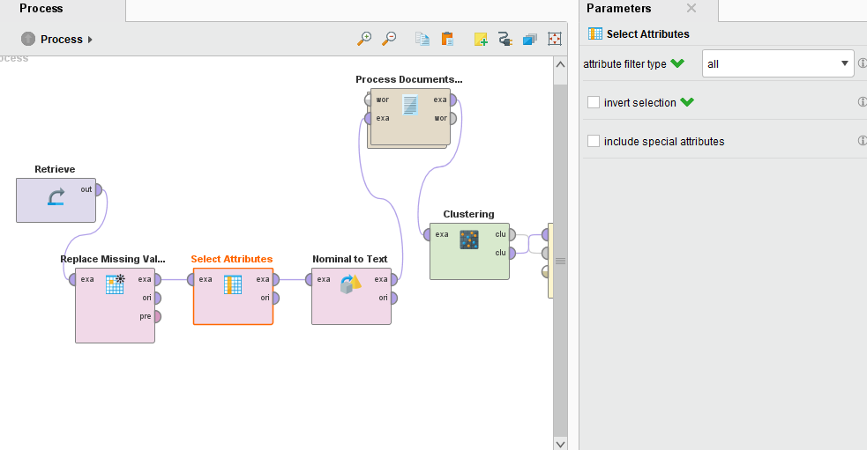

**Nominal to Text Operator:**

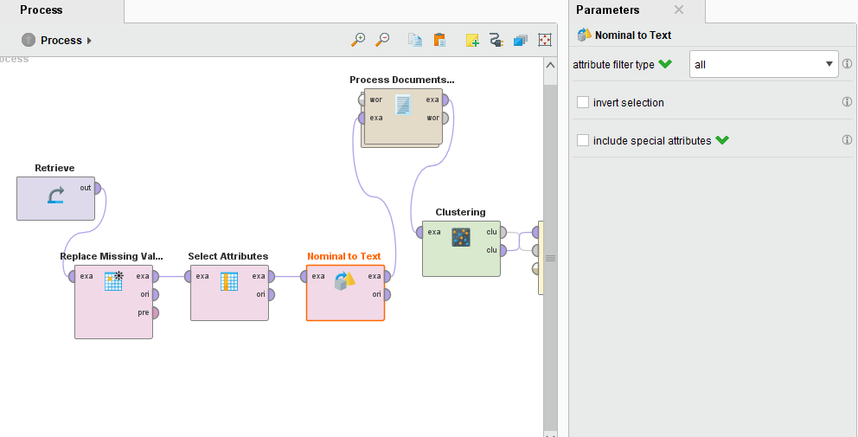

**Clustering (K-MEANS) Operator:**

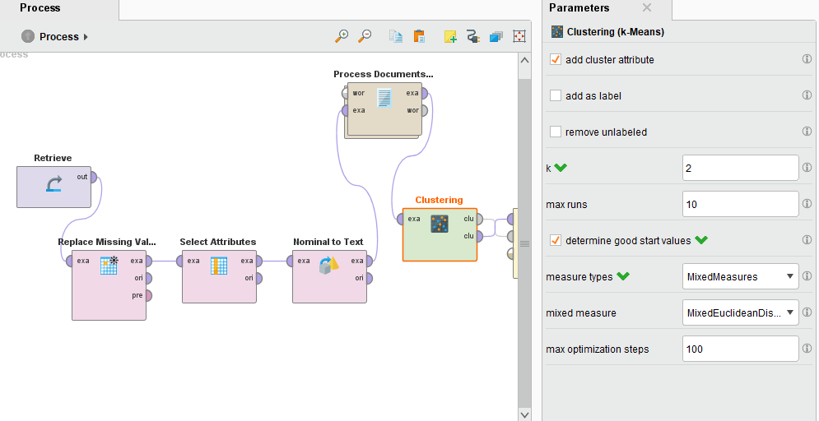

**Process Documents from Data Operator:**

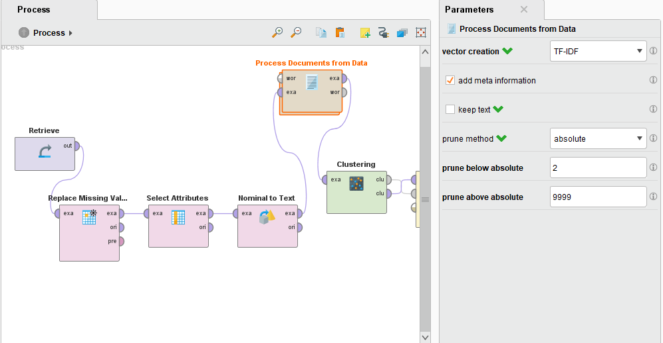

**Process Documents from Data Operator 🡪 Tokenize Operator:**

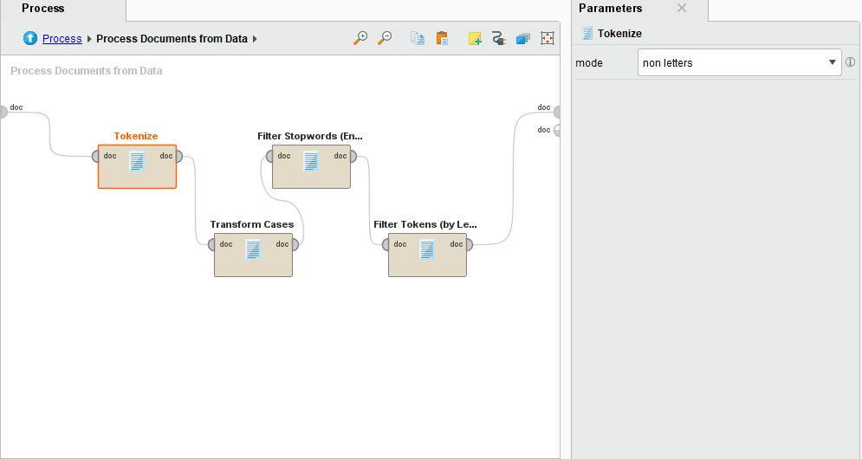

**Process Documents from Data Operator 🡪 Transform Cases Operator:**

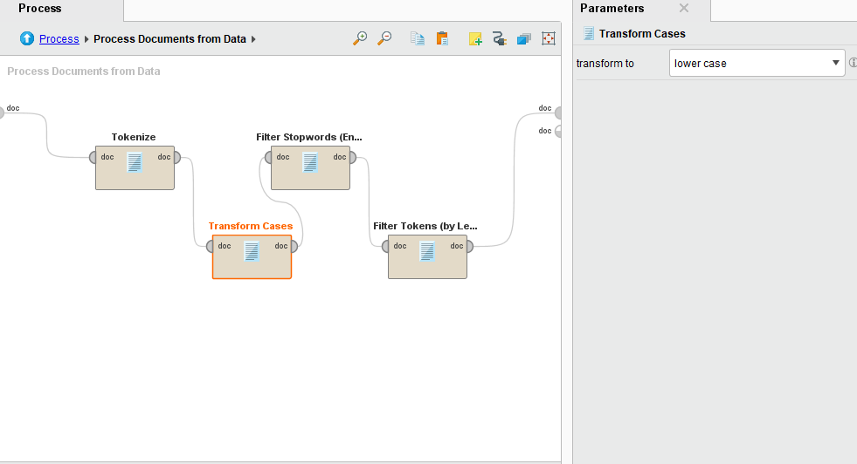

**Process Documents from Data Operator 🡪 Filter Stop words (English) Operator:**

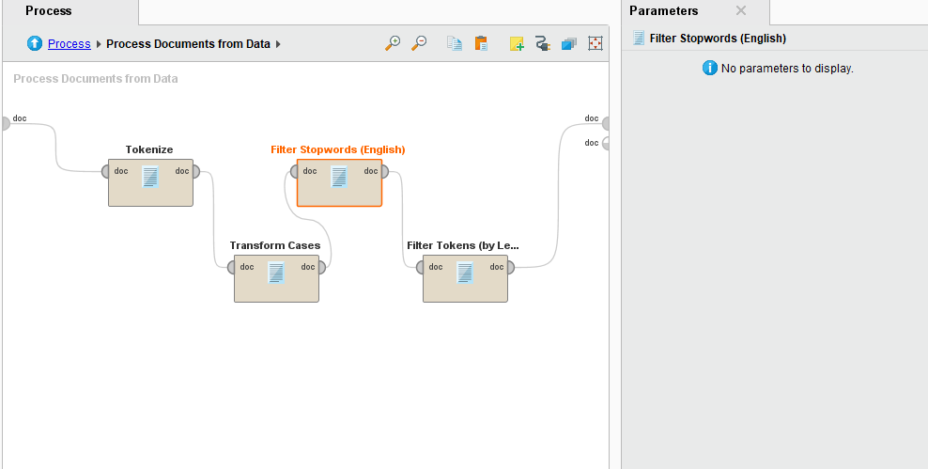

**Process Documents from Data Operator 🡪 Filter Tokens (by Length) Operator:**

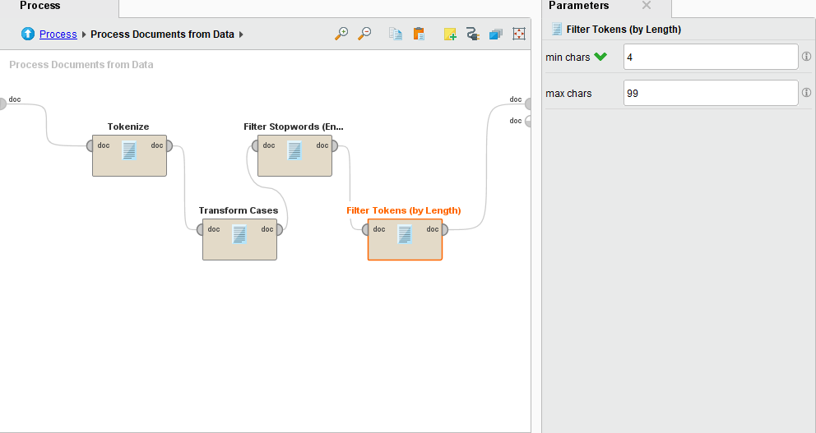

**Cluster Distance Performance Operator:**

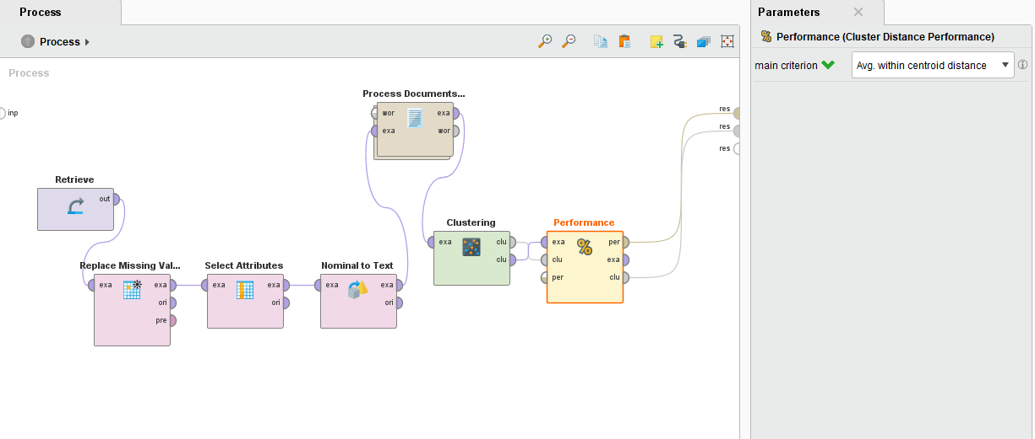

**Results:**

Cluster 0 is ham

Cluster 1 is spam

**Graph View:**

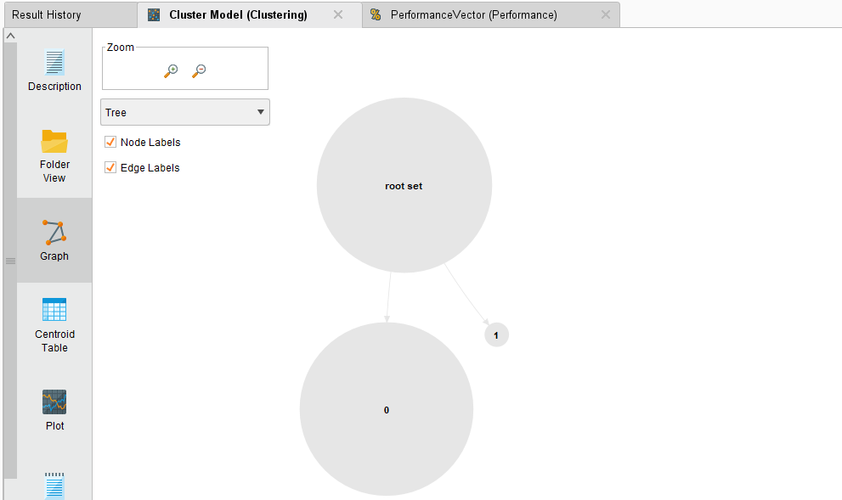

**Plot View:**

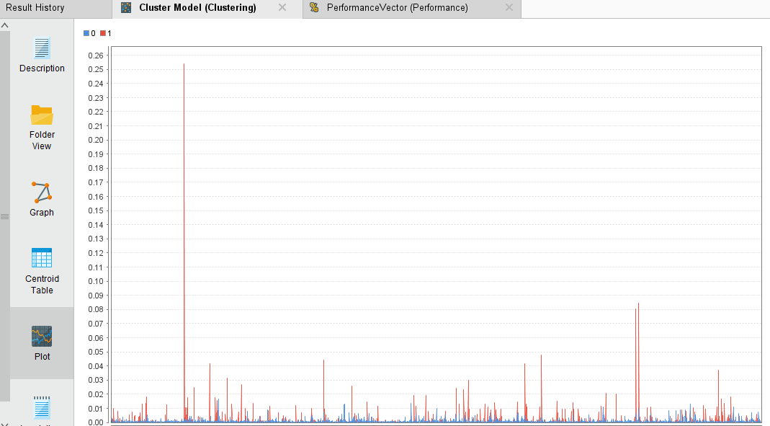

**Centroid Table (Some of them display in a following picture):**

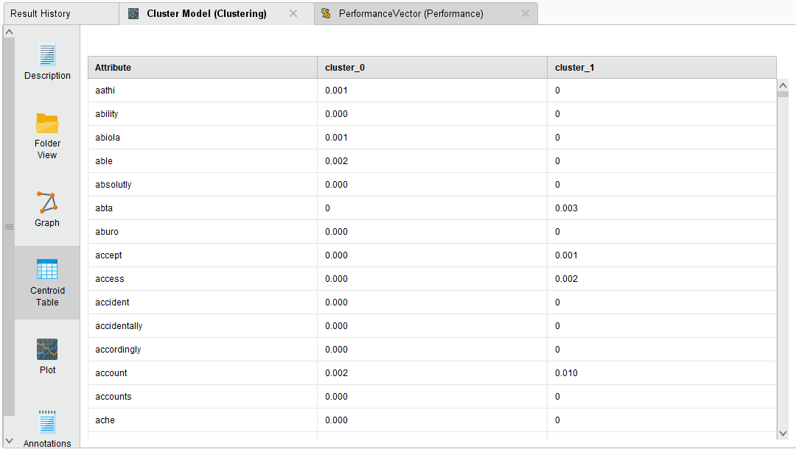

**Performance Vector by taking average of both clusters distance:**

**Performance Vector of cluster 0(ham):**

**Performance Vector of cluster 1(spam):**

