**INTRODUCTION**

You, Indiana Jones are on the ancient island of Nirnen, to seek the fabled treasure of the Incans. But as you get onto the beach on your ATV, you see your arch rivals a little distance away. Its a race to the treasure! Can you make it?



**The ISLAND:**

You start on the beaches of Nirnen and head deeper into the island. After journeying through treacherous sands and rocks, you enter the Valley of the Lost, so named after the lives that were lost due to the landslides that plague this area. As you leave this area, you notice that dislodging a particular rock will create a landslide which will block your rival’s path.

The tunnels: There is only one path deeper into the island- through a network of caves which appear to have been cut by flowing water. You can use your vehicle’s autopilot mode to safely cross this zone, or you may favor speed over safety and follow the markers which appear to have been placed on the ground by previous expeditions.

The lake: You exit the tunnels to find piles of treasure on the other side of a boiling lake. Upon closer inspection, you notice a narrow path climbing along the side of the lake. But the path is blocked by a deep chasm and the only way to cross the chasm is to push a boulder into it. You may brave the waters or climb the path to claim your treasure and everlasting glory!

**Arena Description:**

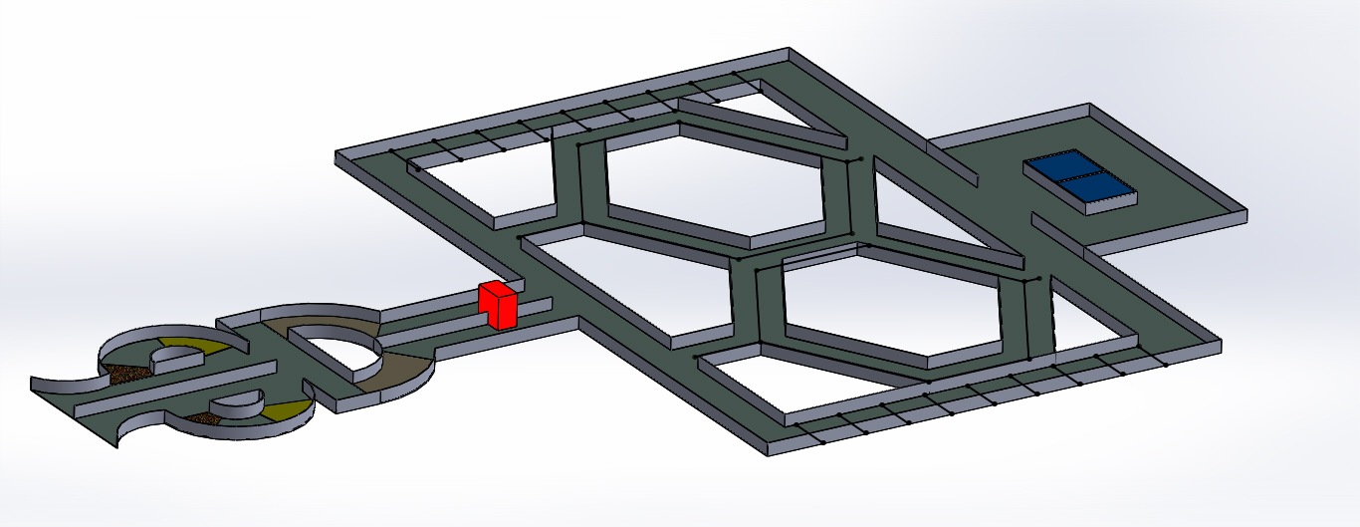

**Area 1:** This will consist of a track with a loop which will have areas of sand and gravel. Teams have to go around the loop and then proceed to the next zone.

The bots will have to traverse a D shaped track against crosswinds and turbulences. At the end of this zone, there is a block which can be pushed to block the other team’s track. The team whose path has been blocked will have to call for a reset. The bots have to stop at the end of the zone to begin the next part.

**The autonomous zone begins here.**

**Area 2**: The bots begin in area 2a or 2b as per the team’s choice.

**Zone 2a:** The bots have to wait for 5 seconds to see if a light turns on. If it turns on, they have to glow a red led and take the left fork. Else a green led must be activated and the bots must take the right fork. The bots must then proceed along the line drawn along the track to the end of the zone and stop for the next zone.

**Zone 2b:** In this zone, the bots will be controlled by the teams. The bots have to wait for 5 seconds and start moving when a light is turned on. A led must be glowed when the light is detected. This zone features black lines drawn across the path of the bot. A led must be glowed as the bot moves over the black lines. At the end of the zone, the bots have to scale a ramp of width 50cm.

**Area 3:** This zone is completely manual. Teams can choose to take path 4a or 4b.

**Path 3a:** The bots have to traverse a stretch of water and come onto solid ground to ring a buzzer or glow an led.

**Path 3b:** The bots have to push a key over a ramp onto the keyhole. Then they have to ring a buzzer or glow an led.

**SCORING:**

|  |  |  |
| --- | --- | --- |
| Zone 1 | Taking 90° turn | 20 |
| Crossing sand patch | 40 |
| Crossing gravel patch | 40 |
| Crossing loop completely | 50 |
| Taking 90° turn to exit the loop | 20 |
| Crossing Checkpoint 1 | 20 |
| Taking 90° turn | 20 Each |
| Crossing the curved path | 50 |
| Blocking opponent team's path | 40 |
| Zone 2a | Glowing correct led | 30 |
| Taking correct turn | 50 |
| Taking turns on hexagon | 50 Each |
| Zone 2b | Glowing correct led | 30 |
| Glowing led at strip | 30 Each |
| Scaling the ramp | 40 |
| Zone 3a | Entering water sucessfully | 30 |
| Exiting water sucessfully | 60 |
| Glowing led at strip | 30 |
| Zone 3b | Pushing key up the ramp | 50 |
| Placing key correctly at keyhole | 30 |
| Glowing led at strip | 30 |

**RULES**

**GENERAL**

1. Each team can have a maximum of **5 members** and all need not be from the same institution.

2. A participant is liable to disqualification in any of the following situations

1. The Aerobot design is different from the one submitted during TDP.

2. The Aerobot doesn’t conform to the rules and regulations.

3. The Coordinators find the Aerobot unsafe.

4. The Aerobot damages any part of the arena.

3. **Coordinator’s decision will be final and binding** on all participants on all issues.

4. **Problem Statement and Rules can be modified**. It is participant’s responsibility to keep checking the website for updates. Any change on the website will be highlighted.

**AEROBOT/ (AIR) VEHICLE**

1. The hovercraft dimension should be AT MOST **40cm x 40cm x 30cm** (length x breadth x height).

2. The weight of the hovercraft should NOT exceed **1.5** kilograms.

3. **Ready-to-Fly and Almost-Ready-to-Fly base vehicles/kits cannot be used**. The chassis needs to be constructed by the participant. Glass/carbon fibre sticks, servo-mount, motor-mount can be purchased and used if required. Contact the Coordinators for further clarification on this. Thrust equipment can be purchased: electric motors, servos, propellers, ESCs.

4. The track should not be used in any way for propulsion or rotation. Teams will be disqualified if they do so

5. **No ready-made electronic circuits** except for the RF CONTROLLER can be used. The electronics and control need to be designed and made by the participant. Only modules that can be purchased are sensors, ICs and RF Controllers. Development/evaluation boards e.g. Arduino boards can be used.

6. Once the hovercraft has commenced the autonomous mode, no wired or wireless control is allowed. Participant can only start the hovercraft after placing it back onto the track in any orientation necessary and after which he/she can intervene only at the halt zones or during interruptions.

7. The coordinators are not responsible of any problems with RF controller and extra time will not be given to adjust any problems, once the trial time has started.

8. It is preferred to have more than one frequency setting for the RF to avoid interference with the RF of other participants.

9. The battery power-pack used in the hovercraft should not exceed 12 V.

10. The hovercraft’s or glider’s functioning should not pose any safety issues for the onlookers.

11. The team cannot change the hovercraft before the round ends.

**TRIAL**

1. Each team is allotted a total of **10 minutes** for the trial to complete the problem statement inclusive of all interrupts, penalties etc. and 1min setup time before the trial begins.

2. The participant has to place the hovercraft inside the **START** zone before beginning. Hovercraft has to be started by a single switch operation or through RF controller and it needs to be resting on ground before pressing the start switch. No initial push or external force of any kind can be provided.

3. The state of the bulb may be different for every attempt and every trial starting at manual halt zone. The state will be decided by a computer program to generate random ON or OFF.

4. The state of the bulb may be different for every attempt and every trial starting at manual halt zone. The state will be decided by a computer program to generate random ON or OFF.

5. A trial (MANUAL OR AUTONOMOUS) of a particular team is considered to have ended, if any of the following happens:

1. If the total trial time of 10 minutes is over.

2. The team asks for the trial to be ended.