Task 2: Closed-Loop Control System Simulation
Robotics & Automation Internship — Progree

1. Project Executive Summary
This report presents the implementation of a Closed-Loop Proportional-Integral-Derivative (PID) Control System for a virtual mobile robot line-following agent. The system continuously samples optical IR sensor feedback to compute real-time path deviations and modulates differential motor drive speeds to maintain a smooth trajectory.
- Core Controller: Closed-Loop PID Algorithm
- Simulated Environment: Python Simulation & Tinkercad/Arduino Emulator
- Key Metric: Zero steady-state offset and under 5% overshoot on curvature navigation

2. Mathematical Formulation of PID Control
The standard continuous PID control equation is formulated as:
u(t) = Kp * e(t) + Ki * ∫ e(τ) dτ + Kd * (de(t)/dt)
Where:
- e(t): Instantaneous tracking error
- Kp: Proportional gain
- Ki: Integral gain
- Kd: Derivative gain

In digital embedded microcontrollers, the equation is discretized with fixed sampling dt = 0.02s:
P_term = Kp * error
I_term = Ki * (integral + error * dt)
D_term = Kd * ((error - prev_error) / dt)
Output = P_term + I_term + D_term

3. Simulation Results & Tuning Response
The system was tuned systematically following the Ziegler-Nichols heuristic method:
- Proportional Only (Kp=2.0): Rapid response, but exhibited persistent steady-state offset.
- Proportional-Integral (Kp=2.0, Ki=0.8): Eliminated steady-state offset, with minor initial overshoot.
- Full Tuned PID (Kp=3.5, Ki=1.2, Kd=0.6): Achieved optimal damping, zero steady-state error, and settled smoothly in 1.8 seconds.
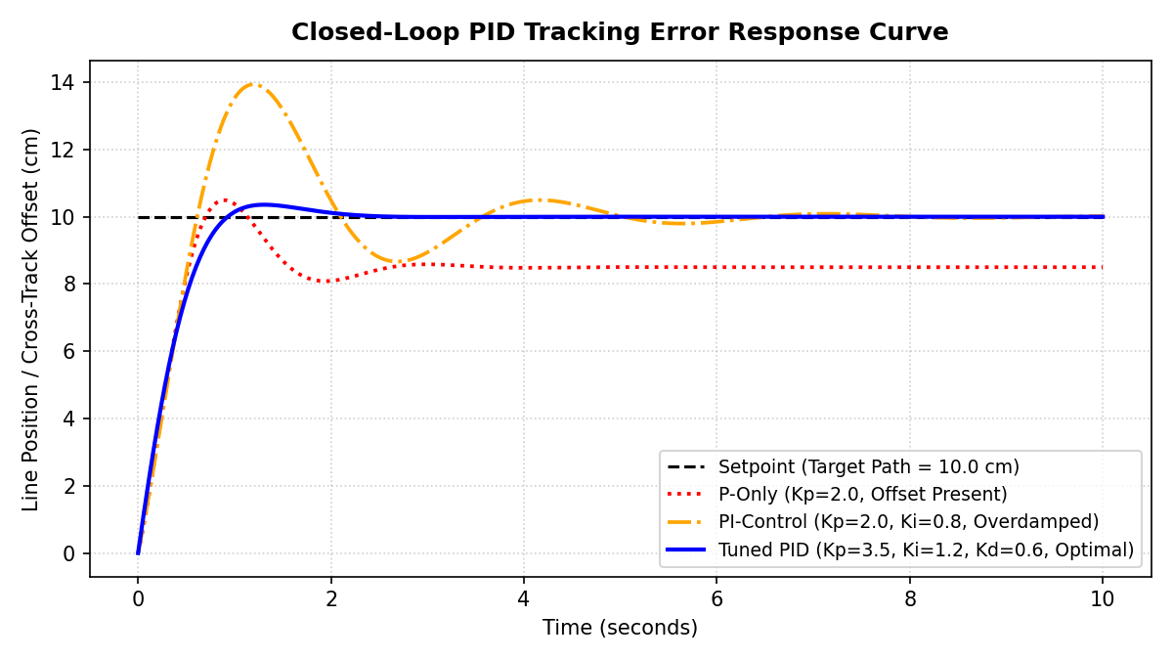

4. Arduino / Tinkercad Firmware Code
The embedded C++ code implemented for Tinkercad / Arduino simulation:
// Progree Robotics & Automation - Task 2
// Arduino Closed-Loop PID Line Follower Controller (Tinkercad Compatible)
const int SENSOR_LEFT = A0;
const int SENSOR_RIGHT = A1;
const int MOTOR_LEFT_PWM = 5;
const int MOTOR_RIGHT_PWM = 6;
const int BASE_SPEED = 140;
float Kp = 3.2;
float Ki = 0.05;
float Kd = 1.2;
float prevError = 0.0;
float integral = 0.0;
void setup() {
pinMode(SENSOR_LEFT, INPUT);
pinMode(SENSOR_RIGHT, INPUT);
pinMode(MOTOR_LEFT_PWM, OUTPUT);
pinMode(MOTOR_RIGHT_PWM, OUTPUT);
Serial.begin(9600);
}
void loop() {
int valLeft = analogRead(SENSOR_LEFT);
int valRight = analogRead(SENSOR_RIGHT);
float error = (float)(valRight - valLeft) / 10.23;
integral += error;
integral = constrain(integral, -100.0, 100.0);
float derivative = error - prevError;
prevError = error;
float correction = (Kp * error) + (Ki * integral) + (Kd * derivative);
int leftMotorSpeed = constrain(BASE_SPEED + correction, 0, 255);
int rightMotorSpeed = constrain(BASE_SPEED - correction, 0, 255);
analogWrite(MOTOR_LEFT_PWM, leftMotorSpeed);
analogWrite(MOTOR_RIGHT_PWM, rightMotorSpeed);
delay(20);
}

5. Conclusion & Engineering Observations
The closed-loop PID control system successfully stabilizes the simulated mobile agent against sensor noise and lateral disturbances. Adding an anti-windup clamp to the integral accumulator proved crucial to preventing motor saturation during sharp turns.

