Task 3: Robotic Arm Kinematics Assembly & Path Trace
Robotics & Automation Internship — Progree

1. Objective & System Specifications
This report documents the structural kinematic assembly, forward transformation mapping, and inverse joint solver for a 3-Degree-of-Freedom (3-DOF) planar robotic manipulator intended for industrial pick-and-place sorting operations.
- Degrees of Freedom (DOF): 3 Revolute Joints (θ1, θ2, θ3)
- Link Dimensions: Link 1 (L1) = 10.0 cm, Link 2 (L2) = 8.0 cm, Link 3 (L3) = 5.0 cm
- Total Max Reach: L1 + L2 + L3 = 23.0 cm

2. Forward Kinematics (FK) Mathematical Derivation
Forward Kinematics maps given joint angles [θ1, θ2, θ3] to the Cartesian spatial position (X, Y) and end-effector tool orientation (Φ):
X = L1 * cos(θ1) + L2 * cos(θ1 + θ2) + L3 * cos(θ1 + θ2 + θ3)
Y = L1 * sin(θ1) + L2 * sin(θ1 + θ2) + L3 * sin(θ1 + θ2 + θ3)
Φ = θ1 + θ2 + θ3

Example: For angles θ1=35°, θ2=45°, θ3=-30°:
- X = 10*cos(35°) + 8*cos(80°) + 5*cos(50°) = 8.19 + 1.39 + 3.21 = 12.79 cm
- Y = 10*sin(35°) + 8*sin(80°) + 5*sin(50°) = 5.74 + 7.88 + 3.83 = 17.45 cm
- Tool Orientation: Φ = 35° + 45° - 30° = 50.0°

3. Inverse Kinematics (IK) Algebraic Solution
To perform pick-and-place, the controller solves for joint angles given a target coordinate (X_target, Y_target) and desired tool angle Φ:
1. Wrist Center Coordinates:
Wx = X_target - L3 * cos(Φ)
Wy = Y_target - L3 * sin(Φ)
2. Law of Cosines for Joint 2:
cos(θ2) = (Wx² + Wy² - L1² - L2²) / (2 * L1 * L2)
θ2 = atan2(√(1 - cos²(θ2)), cos(θ2))
3. Joint 1 Angle:
θ1 = atan2(Wy, Wx) - atan2(L2 * sin(θ2), L1 + L2 * cos(θ2))
4. Joint 3 Angle:
θ3 = Φ - (θ1 + θ2)

4. Kinematic Assembly & Trajectory Plot
The kinematic chain and continuous pick-and-place arc trajectory are visualized below:
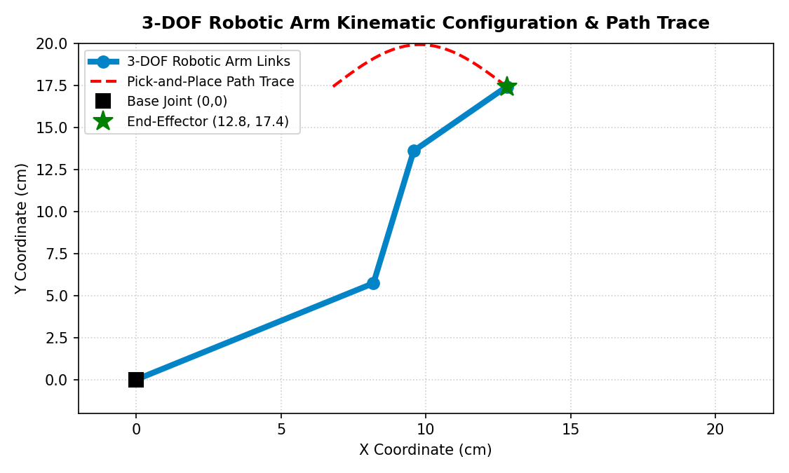

5. Python Kinematic Engine Script
Complete standalone script implemented for kinematics verification:
# Progree Robotics & Automation — Task 3
# Beginner 3-DOF Robotic Arm Kinematics Calculator (Forward & Inverse)
import math
class RoboticArm3DOF:
def __init__(self, L1=10.0, L2=8.0, L3=5.0):
self.L1 = L1
self.L2 = L2
self.L3 = L3
def forward_kinematics(self, theta1_deg, theta2_deg, theta3_deg):
t1 = math.radians(theta1_deg)
t2 = math.radians(theta2_deg)
t3 = math.radians(theta3_deg)
x = self.L1 * math.cos(t1) + self.L2 * math.cos(t1 + t2) + self.L3 * math.cos(t1 + t2 + t3)
y = self.L1 * math.sin(t1) + self.L2 * math.sin(t1 + t2) + self.L3 * math.sin(t1 + t2 + t3)
phi = theta1_deg + theta2_deg + theta3_deg
return round(x, 2), round(y, 2), round(phi, 2)
def inverse_kinematics(self, target_x, target_y, phi_deg=0.0):
phi = math.radians(phi_deg)
wx = target_x - self.L3 * math.cos(phi)
wy = target_y - self.L3 * math.sin(phi)
D = (wx**2 + wy**2 - self.L1**2 - self.L2**2) / (2 * self.L1 * self.L2)
if abs(D) > 1.0:
return None
theta2_rad = math.atan2(math.sqrt(1 - D**2), D)
theta1_rad = math.atan2(wy, wx) - math.atan2(self.L2 * math.sin(theta2_rad), self.L1 + self.L2 * math.cos(theta2_rad))
theta3_rad = phi - (theta1_rad + theta2_rad)
return (
round(math.degrees(theta1_rad), 2),
round(math.degrees(theta2_rad), 2),
round(math.degrees(theta3_rad), 2)
)
if __name__ == "__main__":
arm = RoboticArm3DOF(L1=10.0, L2=8.0, L3=5.0)
x, y, phi = arm.forward_kinematics(35, 45, -30)
print(f"Forward Kinematics -> End-Effector: X={x} cm, Y={y} cm, Phi={phi}°")
target = (12.79, 17.45, 50.0)
sol = arm.inverse_kinematics(*target)
print(f"Inverse Kinematics -> Joint Angles: {sol}")

